

Celebrating excellence in protecting children,
young people and families

Acknowledgement of Traditional Owners
The Department of Families, Fairness and Housing acknowledges the Traditional Owners of country throughout Victoria and pays respect and recognises the contribution from their Elders past and present.
We proudly acknowledge the strength and resilience of First Nation peoples as the world’s oldest living culture and the contribution of generations of Aboriginal leaders who have fought tirelessly for the rights of their people and communities.
We recognise the intergenerational consequences of colonisation, dispossession, child removal and other discriminatory government policies and acknowledge that the impacts and structures of colonisation still exist today.
Our Department is committed to addressing these impacts by embedding cultural safety and self-determination in all that we do so that Aboriginal Victorians
have decision making power and control to determine what is best for them. Aboriginal self-determination is a human right as enshrined in the United Nations Declaration on the Rights of Indigenous Peoples.
We are committed to developing strong and enduring self-determined partnerships with Aboriginal communities that will contribute to growing a prosperous, healthy and strong Victorian Aboriginal community.
Aboriginal and Torres Strait Islander Recognition statement
The Department of Families, Fairness and Housing pays respect and recognises the contribution of all Aboriginal and Torres Strait Islander people living and working in Victoria.
Throughout this document the term ‘Aboriginal’ is used to refer to both Aboriginal and Torres Strait Islander people.

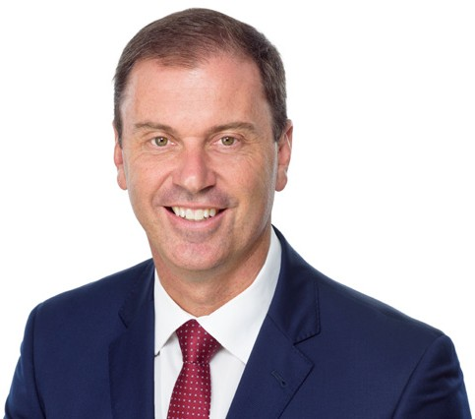

Message from the Minister
Welcome to the 2022 Victorian Protecting Children Awards. These prestigious awards are all about recognising you – the workers, carers, practitioners and community members who demonstrate excellence in protecting children, young people and families. You are the people who every day, work to keep children safe and families strong.
You all show such true professionalism, resilience, courage and dedication.
It is an honour to celebrate the achievements of all of you who work tirelessly day in and day out to make a difference for the children and families of the Victorian community.
The work you do can be challenging, but it leads to some remarkable outcomes. Your dedication makes a true difference to improving the lives of children, young people and families across the state and beyond. For this, I sincerely thank you all.
In the nineteenth year of these awards this year, there was a record number of nominations despite it being an especially busy and challenging time across the sector. It really shows just how much all your magnificent efforts deserve to be celebrated and how you all collaborate to support the community and each other.
This showcase booklet highlights our very deserving 2022 Victorian Protecting Children Awards winners, finalists and nominees.
On behalf of the Victorian community, I wish to congratulate everyone recognised in these awards and thank each and every one of you for your work to keep children safe and families strong.


Hon. Colin Brooks, MP
Minister for Child Protection and Family Services



Message from the Secretary
Over the past three years, our children and families services sector in Victoria has faced many challenges; from COVID-19 to natural disasters.
So much has been asked of you and your colleagues. Yet, despite the hardships, time and time again you have played your part in keeping children safe and families strong.
The work you carry out every day truly does matter. It helps children and their families build stability with the care and support they need and often changes the direction of young people’s futures.
The Victorian Protecting Children Awards are a wonderful way to pay tribute to the very best of this work over the past 12 months.
Through these awards, we raise awareness of the important work being done to protect, prevent and reduce harm to children and young people. We also celebrate you – the people and organisations who work tirelessly to achieve this.
I am pleased we are able to once again come together as a sector to celebrate the professionalism, attributes and dedication of practitioners, workers, carers and community members.
We know there is more to do, but we are proud of what we have been able to achieve together so far.
Congratulations to all our nominees, finalists and winners – your dedication to children and families is so appreciated.

Brigid Sunderland
Secretary

Contents
Content Warning: this booklet contains descriptive information on topics including child abuse and neglect, family violence, sexual assault, substance abuse, eating disorders, self-harm and mental
health concerns. This may be difficult for some readers. For support call Lifeline – 13 11 14.
Message from the Minister 3
Message from the Secretary 4
Robin Clark’s legacy 6
Awards 7
Robin Clark Leadership Award 7
Robin Clark Making a Difference Award 12
Minister’s Award for Innovation in Protecting Children 17
Chief Practitioner’s Award 22
Carer Award 26
Engaging Kids in School Award 31
Keeping At Risk Young People Safe Award 36
CREATE Positive Impacts Award 41
Child and Youth Empowerment Award –
Commission for Children and Young People 44
Leaving a Legacy Award 47
The Walda Blow Aboriginal Children and Young People Award 49
Nominees 51
Judges 53
Partners 55
Previous winners of Robin Clark Awards 56

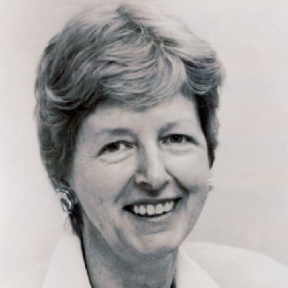

Robin Clark’s legacy
Robin Dennis Clark (1936–2001) was an inspirational and respected leader in child protection and care services across Australia in the 1980s and 90s.
The pre-eminent ‘Leadership’ and ‘Making a Difference’ awards are named in honour of her vision and great influence on child and family-related policy and practice in Victoria.
Robin worked broadly in evaluating, reviewing and designing child protection systems in Victoria, Queensland, New South Wales and the Australian Capital Territory.
She was driven by a commitment to social justice and belief in a fair and equitable society.
Robin had a genuine interest in others and helping child protection practitioners understand their role to achieve best practice. Robin’s wisdom and practicality have influenced a generation of workers in these fields.
Her goal of delivering excellent practice among those who work with children and families continues to live on today.

6 | 2022 Victorian Protecting Children Awards

Robin Clark Leadership Award
7
The winner of this pre-eminent award epitomises Robin Clark and her legacy of inspiring leadership and influential stewardship of child and family policy and practice in Victoria.
This award recognises an individual whose leadership inspires others to act wisely and care deeply about achieving the best outcomes for children, young people and their families.
Nominees in this category have a distinguished track record as visionary and transformative leaders in practice, policy, research or education.
Examples of work may include:
- a champion of system-wide reform leading to sustained improvement in the lives of children, young people and their families
- influencing the practice of others, through leadership, advocacy and mentoring
- empowering Aboriginal self-determination and cultural safety to achieve the best outcomes for Aboriginal children, young people and their families.
Nominees for the Robin Clark Leadership Award are highly respected individuals from government, the community or the children and families services sector.



Robin Clark Leadership Award
Winner
Deb Tsorbaris, Centre for Excellence in Child & Family Welfare Deb demonstrates outstanding sector leadership, powerful advocacy and an ability to bring together diverse stakeholder groups to champion the rights of
at risk children, young people and families. Deb insists on the best evidence being
used to underpin policies and programs, reforms and decision-making across all sectors. Through the establishment and development of the Outcomes, Practice and Evidence Network, Deb has overseen a significant cultural shift in
the way evidence is understood, translated and used.
Under Deb’s leadership the Centre for Excellence in Child and Family Welfare is widely recognised for its education and awareness raising in child rights, safety and wellbeing. Deb has forged mutually respected relationships with Aboriginal colleagues through Beyond Good Intentions, support for transitioning Aboriginal children to Aboriginal care, and arguing for proportionate fundings for Aboriginal Community Controlled Organisations.
Deb has long been a champion of children’s and young people’s voices being incorporated into policy and program decision-making, particularly young people in care and parents who have been involved in child protection. Further, Deb has led the innovative “Voice of Parents” project to provide a structured and safe avenue for parents to be heard.

8 | 2022 Victorian Protecting Children Awards

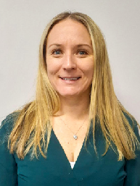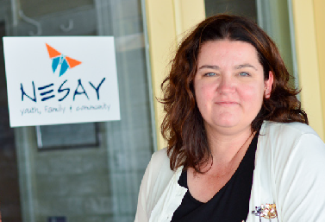

Finalists

Abbie McMurrick, MacKillop Family Services
A case manager with MacKillop in the Wimmera Southwest region, Abbie helps to empower children and young people when overcoming trauma they have experienced in their lives. Abbie’s advocacy for Therapeutic Life Story Work (TLSW) has led to life-changing outcomes for participants, some
of whom were unaware they were Aboriginal before taking part in TLSW. Participants have since made valuable connections to their community. With increasing needs from at risk young people, Abbie has stepped up and provided exceptional support to case managers to strengthen delivery.

Leah Waring, North East Support and Action for Youth (NESAY)
Leah demonstrates the highest level of commitment and passion to enable NESAY to thrive and grow. Leah is
dedicated to working with partners and other organisations and committed
to promoting excellence for all. Some examples include partnerships with Alpine Health for school counsellors and family therapy, with two schools for an onsite counsellor, and with Beyond Housing for programs. Leah has led
the creation of a Hub in Benalla, which brings together diverse services in the same building. Leah supports staff to innovate and is committed to ensuring children and young peoples’ voices are heard in support and services provided.
9

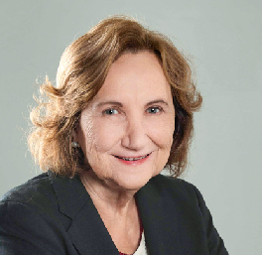

Finalists

Lisa Ranahan, Key Assets Victoria
Lisa has been the driving force in Key Assets Victoria for the past five years. Lisa has the solid belief that even the most complex of children, with the relevant and appropriate inputs and supports, can live and thrive in family- based care and transition to the next stages of their lives.
Lisa has led many impactful initiatives.
These include a successful tender for the Family Preservation and Reunification Response (FPRR) in partnership with Ramahyuck District Aboriginal Corporation in Inner
Gippsland and the development of the Enhanced Foster Care program which started in the West Division and has moved into the North Division due to its positive results.

Margarita Frederico AM, La Trobe University
Professor Margarita Frederico AM is an insightful and indefatigable advocate for Aboriginal family led decision making, children and families involved in child protection and therapeutic and family services fields. Margarita has educated social work students and graduates for many years, many of whom are in leading roles in child
welfare in Australia and other countries. An inaugural partner of Berry Street’s Take Two program, Margarita has
been critical to creating Take Two’s research and evaluation framework and developing and implementing impactful research in the child protection system.

10 | 2022 Victorian Protecting Children Awards



Phuong Truong, Department of Families, Fairness and Housing
In late 2021, 40 Afghan children without parents arrived in Melbourne from Afghanistan in response to
an emergency humanitarian crisis. Phuong led the Department’s humanitarian response, modelling responses to children at risk that has made positive differences to the children’s lives. Phuong’s approach is one of empowerment through information, choice and coaching.
Phuong ensured the children’s voices were heard and their healthcare and educational needs met. Wherever possible, Phuong ensured siblings were kept together, children were placed with people they knew, and assisted with parental visa applications.
Phuong also connected children with local soccer and LGBTQI+ groups where appropriate.

11

Robin Clark Making a Difference Award
Note: nominees for the Robin Clark Making a Difference Award are teams and
groups from government, the community or the children and families services sector.
12 | 2022 Victorian Protecting Children Awards
The team or group winners of this award embody Robin Clark’s vision and legacy of a well-connected community and service system contributing to better outcomes for children and their families.
This award recognises the exceptional contribution of a team or group of people who have worked to directly improve the lives of children, young people and families in Victoria. This can be in partnership or collaboration with government and non-government agencies.
The winners of this award strive to achieve excellence and their work shows insight, practicality and respect for the needs of children, young people and families, including supporting Aboriginal self-determination to achieve the best outcomes for Aboriginal children, young people and their families.
Nominees will demonstrate outstanding creativity, courage and collaboration. Examples of work may include:
- providing expert, strategic advice to improve support and decision making for children and young people in care
- championing the rights of carers, children and young people through the development and delivery of training, financial support, or new innovative models of care.

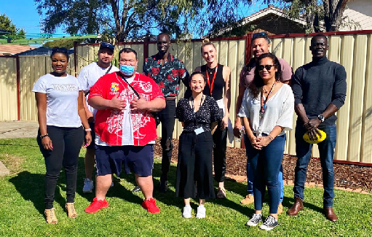Robin Clark Making a Difference Award
Winner

COVID-19 Emergency Response for Child and Young People (CERCY), MacKillop Family Services and Ability Assist
CERCY is an emergency response model providing safe accommodation to children and young people involved with child protection who need alternate care to safely isolate or quarantine due to COVID-19. The model started with one house in September 2020 and grew to six CERCY homes. Almost 150 people aged 0-17 years have been placed within the CERCY model. All staff in CERCY houses work tirelessly to ensure the health and wellbeing of children in their care, who were often required to isolate for up to 14 days.
CERCY maintained a consistent staffing group enabling staff to implement successful strategies to support unwell, scared or traumatised young people. The team work alongside any established care teams to minimise the possibility of further trauma.
Staff encouraged children and young people to participate in education, cooking and where appropriate develop independent living skills, as well as participate
in games, activities or watching movies. Many children and young people had
such a great experience, they went as far as making ‘thank you’ cards for the staff.
The CERCY team’s adaptability, cultural respect and child-centredness has contributed to the success of the model.

13

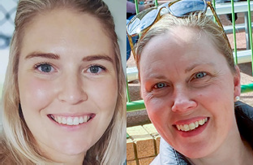

Finalists
Backpacks 4 Vic Kids (B4VK) Backpacks 4 Vic Kids (B4VK) is a registered not-for-profit, volunteer run
charitable organisation founded by
Chief Executive Officer, Sally Beard in 2014 with the aim of providing essential items such as clothing and toiletries
to children being placed in foster or kinship care. Placement is often with a stranger and happens quickly. The child has had to leave home without necessities; these can be medical
items, comfort toys or clean underwear. By providing such items, B4VK give children basic dignities, supports
and comfort during crisis. B4VK has provided over 22,000 backpacks to children experiencing relocation.

Case Management Team 2, Case Contracting and Junction Support Services (Wodonga), Department of Families, Fairness and Housing & Junction Support Services
Through collaboration, commitment and outstanding working relationships, these teams coordinated to support
a young person and family in a successful reunification process. The young person entered care in
September 2019, displaying challenging behaviours which resulted in them being placed in both 1:1 and unfunded placements for two and a half years.
Throughout the intervention, the young person’s voice was supported, with three key case managers developing positive relationships and in-depth understanding of them. The young person’s anxieties were considered and were able to be supported in a caring, compassionate and consistent way. The young person was successfully reunified with their family in January 2022.

14 | 2022 Victorian Protecting Children Awards

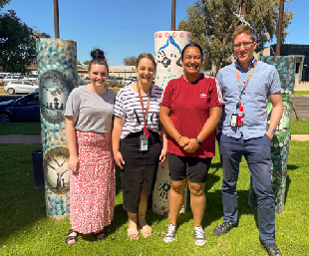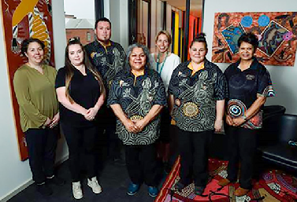

Family Preservation and Reunification Response Loddon and Mallee teams, MacKillop Family Services
These teams support families to live together safely and decrease the risk of children and young people entering
or re-entering care through a strengths- based and trauma-informed approach. The practitioners place families in the driver’s seat, encouraging them to
set their own goals and develop self- advocacy skills. One mother went from not believing they could reunify with their daughter, to believing they could achieve this, and actively calling up the practitioner to report on their progress against their goals. This example epitomises the way the teams see families as directors of their own futures.

Keeping Families Together Team, Child and Family Services (Cafs), Ballarat
This is an evidence-based, outcome- focused intensive child and family support model. In partnership with child protection, the Keeping Families Together team aims to keep children at home and to safely reunite children in care with their families. The team offer a diverse and holistic range
of services via a ‘one-stop’ referral point to discuss issues and build
a culturally sensitive service plan from the Cafs, Ballarat and District Aboriginal Cooperative (BADAC)
programs, reducing client engagement with statutory services. This unique approach enables practitioners to ‘walk alongside’ clients to support and strengthen families while ensuring children’s safety.
15



Finalists

Southern Melbourne Complex Care Team, Department of Families, Fairness and Housing
This team has been providing care of a delightful, curious and energetic
young person on a Care by Secretary Order who has multiple complex needs impacting their care, safety and stability. The team’s care involves a multiservice system response including Victorian Police, Ambulance Australia, Monash Medical Accident and Emergency, Allied Health, NDIS, placement agency staff and child protection. There were sometimes daily responses to ensure the safety of the young person and other people.
The team’s approach has resulted in reduced interventions to just a
handful of times in the last 12 months, improving the young person’s capacity to live safely at home and connect with community.

Southern Melbourne Child Protection Leadership Team, Department of Families, Fairness and Housing
The Southern Melbourne Child Protection Leadership Team has oversight responsibility of
approximately 2,000 children and young people. The past two years of challenges, continuous changes and staffing has required a reset of how leadership operated. To this
end, the leadership team developed a local mission statement to capture
intention, effort, purpose and priorities. This required reflection, examination, review and reconnecting our core values and beliefs to determine the approach of leadership required to best support, engage and lead through a critical time of transition and to create a template for going forward.

16 | 2022 Victorian Protecting Children Awards

Minister’s Award for Innovation in Protecting Children
17
This award recognises an individual, team or group demonstrating innovative approaches and creative intervention to achieve the best possible outcomes for children, young people and their families.
This innovation can be demonstrated across the child, youth and family services sector through case management, education, prevention and early intervention, or the provision of care to children and young people in care services (including secure welfare services).
Examples of work may include:
- developing new and innovative programs, or strengthening existing programs to improve outcomes for at risk children and young people
- working in different ways to achieve outcomes for high-risk youth
- embedding sustainable change within organisational practices to create more opportunities for at risk children and young people
- empowering Aboriginal self-determination and cultural safety to achieve the best outcomes for Aboriginal children, young people and their families.



Minister’s Award for Innovation in Protecting Children
Winner

Emma Toone, Berry Street
Emma has been instrumental in the implementation and growth of Child Parent Psychotherapy (CPP) across Victoria and Australia. The program focuses on some of the highest risk children aged 0-5 years and supports families to make sense of their experiences of trauma and violence. Emma’s leadership and advocacy has significantly contributed to the broader growth of this evidence-based model. Emma’s role in CPP implementation and workforce support has resulted in two-
thirds of CPP clinicians in Australia currently serving families in Victoria. More than 60 children and their carers have directly benefited from CPP delivery within Berry Street’s clinical therapeutic program, Take Two.
Emma’s broader advocacy has helped grow CPP to a point where 200 families nationally and 130 families in Victoria have been supported. Emma’s dedication to growing CPP is critical to meeting needs identified by several Royal Commissions. Emma has worked in partnership with the Australian Association for Infant Mental Health in SA to establish a national community of practice to support workforce sustainability. Emma’s contribution to building a pool of Take Two staff with CPP practice excellence has helped embed systemic change and improve outcomes for children and their families.

18 | 2022 Victorian Protecting Children Awards

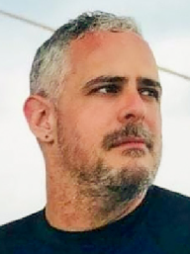

Finalists

Amanda Stacey and the Anglicare Victoria COMPASS team, Anglicare Victoria
Under the dedicated leadership of manager Amanda Stacey and team, the COMPASS initiative provides a two- year program to support young people successfully transition from care services to adulthood. COMPASS is also Australia’s largest social impact bond and aims to shift the balance of state government spending away from crisis management to early intervention.
The team supported one care leaver to get their first job, driving them to work each day before they obtained their driver’s licence, taking them to medical appointments and helping arrange mental health support. This example of early prevention means the care leaver can now live independently.
19

Barak Ben Or, OzChild
Barak has demonstrated ongoing diligence and integrity in working with families and leading a team. Barak set up and delivered a long-standing family-based therapy program and is committed to working with complex families presenting with mental health and family violence issues. Barak’s leadership has contributed to high staff morale and retention, ensuring treatment targets are met for families around managing conflict, reducing violence and abuse of alcohol and drugs. Barak’s work has directly contributed to a 90 per cent reduction
in child protection reports. Barak leads their team effectively and empowers families to thrive into the future.

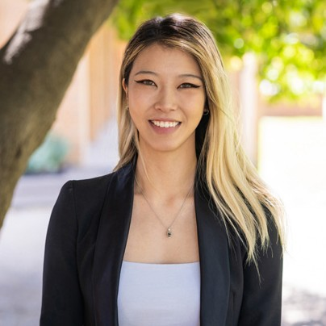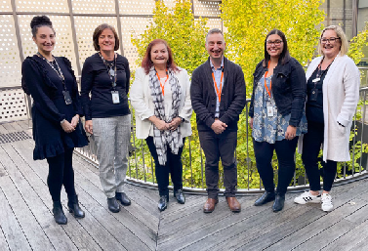

Finalists

Emily Unity, Royal Children’s Hospital
Emily’s advocacy champions system- wide reforms and ensures diverse lived experiences are at the heart of every project, policy and process. Emily
has identified, facilitated, developed and implemented new opportunities for accessibility and inclusivity for young voices. Most recently, Emily established a Lived Experience Engagement Strategy at the Royal Children’s Hospital to improve services and optimise outcomes at the hospital. Emily is committed to creating safe spaces where people with lived experience feel empowered and supported to be decision-makers. This includes creating cultural change within organisations and across the
sector to understand and recognise the value of the lived and living experience.

Integrated Family Services Leadership Team, Windermere Child & Family Services and the Parenting Research Centre
Through a partnership between Windemere and the Parenting Research Centre, a new practice framework called the Practitioner Coaching Framework (PCF) was developed
and adopted. This enabled a shared language for practice that enables practitioners to better communicate with each other about their client’s needs, progress and challenges. This has required a cultural shift from practitioners who have had to unlearn some habits and practices to develop new ones to enhance their problem- solving and capacity building. The team has demonstrated a real commitment to the new learning systems approach, and this is driving a more effective, evidence informed practice.

20 | 2022 Victorian Protecting Children Awards

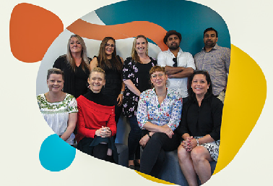

Lilydale Youth Hub Support Team, Lilydale Youth Hub
The Lilydale Youth Hub provides integrated care coordination for young people aged 12-25 in the Yarra Ranges area. Using an integrated model
of care to address multiple needs through a single contact, it provides a central point for a range of services to wrap around. One young person
referred to the Lilydale Youth Hub had a history of mental health concerns, substance use and charges relating to possessing illicit substances.
Counselling revealed the young person was being abused by their partner.
The team undertook a multi-agency risk assessment and management framework to work with police and agencies to provide ongoing support.

Positive Parenting Program (Triple P), Berry Street
The Positive Parenting Program is an evidence-based program
offering parents simple and practical strategies to build strong, healthy relationships and management of their children’s behaviour. In 2021 Berry Street became the first agency in Australia to deliver Triple P’s ‘Fear- Less’. Fear-Less was offered online and in-person seminars for parent groups and one-to-one support work. It strategically promoted Fear- Less to reach families that would not ordinarily access the service. More than 250 families were supported, with parents reporting becoming more effective emotion coaches
for their children and developing understanding of Cognitive Behavioural Therapy strategies and the value of flexible thinking.

21

Chief Practitioner’s Award
22 | 2022 Victorian Protecting Children Awards
The Chief Practitioner’s Award recognises an individual, team or group working in the Department of Families, Fairness and Housing child protection program who embodies best practice, commitment and leadership.
“I am delighted to present this year’s Chief Practitioner’s Award which celebrates excellence among remarkable child protection practitioners and acknowledges their ongoing leadership and commitment to improving the lives of children and young people across the state. Child protection practice relies upon a strong collaborative client-centred approach and sound professional judgement. This year’s winner and finalists represent some truly inspiring examples of practice.” – Kirstie-Lee Lomas, Acting Chief Practitioner

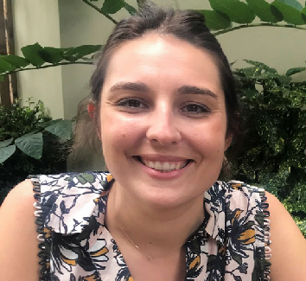Chief Practitioner’s Award
Winner

Natasha Sergent, East Division
Natasha is a navigator for the Aboriginal Family Preservation Response (AFPR) program and works collaboratively with the Victorian Aboriginal Child Care Agency (VACCA).
Natasha is innovative and consistently explores new ways to increase the visibility of the AFPR program and strengthen the partnership between Child Protection, Lakidjeka, Aboriginal Community Controlled Organisations and families.
Natasha developed a monthly newsletter which highlights the program activities, celebrates professional practice and the strong collaboration in achieving positive outcomes for families.
Natasha provided guidance and support to an AFPR worker and child protection practitioner over eight months, where the parents were working towards reunification of their three children. The parents had advocated strongly to be part of the AFPR program, identifying they felt ready to make the necessary changes.
A readiness assessment undertaken by Natasha and Lakidjeka determined the parents’ demonstrated motivation and readiness for engagement with the program.
The strong partnership between Natasha, the AFPR worker and child protection led to positive outcomes for the family. There was a gradual transition for the children to be reunified into parental care with ongoing support from the VACCA, AFPR program and child protection. This year, the family were able to spend their first Mother’s Day together in three years.

23

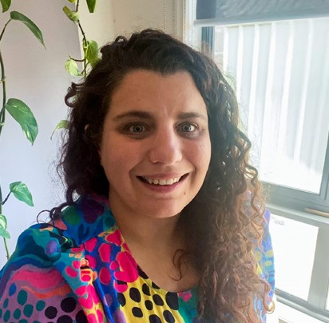

Finalists
Chloe Desira, West Division Chloe demonstrates exceptional leadership, promotes Aboriginal
self-determination and works in true
partnership with Aboriginal agencies, community and families making decisions together for Aboriginal children. Chloe has built positive relationships with Aboriginal agencies, specifically Victorian Aboriginal Child Care Agency (VACCA) and Kirrip House and holds a deep respect for the knowledge of the staff within these agencies, drawing on this expertise to support work with Aboriginal families.
Chloe’s leadership and drive has been instrumental in increasing the number of robust individualised cultural plans, designed to deepen connection to culture, for Aboriginal children in care and has strengthened the team’s cultural awareness and safety.

Claudia Evans, South Division Claudia excels in collaboration with professionals and families. Claudia’s
commitment shows in exceptional
case management of an unborn child at risk where the mother had travelled interstate. Claudia was available to assist After Hours interstate teams
to locate the mother. Claudia’s risk assessment was the basis of interstate legal proceedings which enabled the child to be returned to Victoria, where they were placed in kinship care with their sibling. This was the result of Claudia’s tireless work, collaboration and leadership, essentially leading three child protection teams towards this shared outcome.

24 | 2022 Victorian Protecting Children Awards

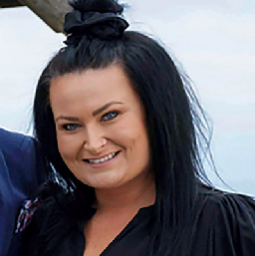

Mary Taouk, Statewide Services Group
Mary’s influential leadership, drive for continuous service improvement and advocacy ensures exemplary support to children, young people and families. Mary undoubtedly demonstrates best practice, commitment and leadership. Mary prioritises staff retention by working with leaders and practitioners to identify and focus on activities which promote a positive workplace culture. Staff receive quality focused supervision and wellbeing and professional development. Mary’s unit has maintained 100% supervision compliance over the last quarter.
These commitments resulted in a more experienced intake workforce and ensured a quality service response is provided.
25
Sharni Credlin, North Division Sharni is an outstanding practice leader working in sexual exploitation.
Sharni works alongside care teams
and Victoria Police to create safety and support for at risk young people. Sharni’s work recently led to the establishment of a successful covert sting operation by police, leading
to the arrest of a sex offender who was grooming children. Sharni has developed and implemented a monthly community of practice
program across Loddon Mallee which supports practitioners to build their capabilities. Sharni demonstrates best practice, excelling at listening to the voices and views of young people and supporting others to do the same.

Carer Award
26 | 2022 Victorian Protecting Children Awards
This award recognises assessed and approved kinship, foster and permanent carers, both past and present, who have made a significant contribution to the lives of children and young people in care.
Examples of work may include:
- going above and beyond to provide exceptional care, support and stability to a child or young person
- overcoming challenges to advocate for children and young people’s needs and creating a positive effect on young lives
- demonstrating an understanding of the importance of connection to culture and kin for children and young people in care, and working with agencies and child protection to prioritise this connection
- empowering Aboriginal self-determination and cultural safety to achieve the best outcomes for Aboriginal children, young people and their families.

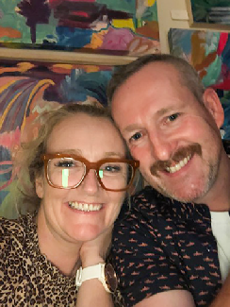Carer Award
Winner

Toni and Paul Gauntlet, MacKillop Family Services
Toni and Paul are foster carers of two teenagers who presented with very significant mental health concerns. This led to inpatient stays, suicide attempts, significant dissociation and splits of personality as well as long periods of struggling to eat, talk or sleep. Their advocacy and dedication to these teenagers has helped them
to thrive far beyond the proposed outcomes expected by professional assessments. They have shown exceptional effort and care in every way, providing a safe and nurturing environment and building lasting, meaningful relationships.
Toni and Paul’s consistent encouragement has supported the teenagers to be confident in their educational skills, resilience to challenges and increased their motivation to succeed. Both teenagers have reached a point of ongoing stabilisation. As a result of their time with Toni and Paul, the teenagers attend
school full time and have stable and manageable mental health. They have also achieved goals such as joining the school student representative council, making friends, joining local and state sports teams, winning competitions and one was made a class captain. Toni and Paul’s willingness to make changes has ensured the needs of the teenagers are met and they are now both healthy and capable.

27

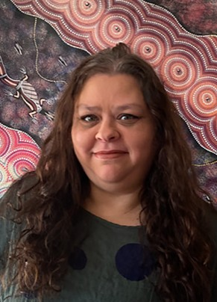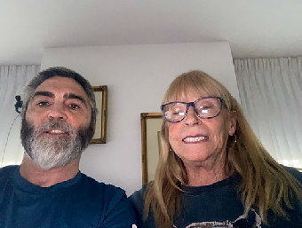

Finalists

Amanda (Ama) Hargreaves, Anglicare Victoria
Ama is caring for three young siblings from an especially traumatic background. Ama balances their
physical and mental health needs, and ensures they remain connected to their maternal and paternal families. The siblings are thriving in Ama’s care. Ama views the cultural needs of the siblings as paramount to their healing and reconnection to kin, Country and spirit. Ama continues to develop skills and knowledge of trauma informed care
by attending recommended training. Ama is connected with services and the local school, creating relationships to support the siblings’ transition to school and later, high school.

Brian Taylor and Patricia Cody, Berry Street Foster Care
Brian and Patricia have been foster carers since 2013, providing exceptional care, dedication and compassion to many children and young people. Brian and Patricia
willingly attend training and accept support to help them manage behavioural issues from the children, which has included both verbal and physical abuse. They have made significant changes to their own lives, such as moving closer to a child’s services and, at times, giving up employment to best support the children in their care. The children’s families have expressed deep gratitude for the great care provided by Brian and Patricia.

28 | 2022 Victorian Protecting Children Awards

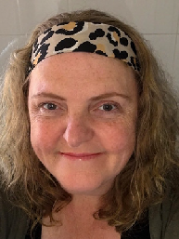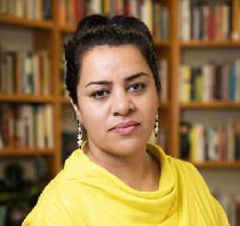

Helen Sutton, Child and Family Services
Helen has been a carer for 13 years, including the permanent carer for a young person who has recently
turned 18. Helen has supported them
to complete year 12, apply for university and engage in paid employment.
Helen also has provided respite care for other children in foster care placements. Helen helped one child
regain a sense of security, regulate their emotions and behaviours and resume full-time schooling. The child was then diagnosed in December 2021 with a rare terminal cancer. Helen is supporting them by travelling for treatment and helping them understand the treatment and side effects.
29
Shokoofeh Azar, Carer Shokoofeh is a nurturing carer and tireless advocate for the children in
their care. Shokoofeh is caring for two
siblings through the refugee minor program and actively supporting
a relationship with their third sibling. The children’s teachers report they are thriving at school, both in terms of learning and social connections, and have excellent attendance. Shokoofeh helps the siblings access professional supports, ensures their culture and religious beliefs are understood
and respected, and provides access to cultural and language support.
Shokoofeh demonstrates love and wisdom in their approach to caring.

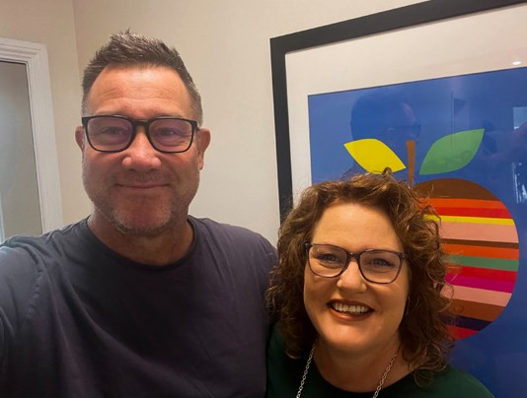

Finalists

Vanessa Michel and Hamish Millar, MacKillop Family Services
Vanessa and Hamish are exceptional carers who, in three years, have transformed the life of a young person with a complex trauma history. The young person had been in care for five years and was non-communicative, withdrawn, did not have friends and was unhappy at school. Now the young person is happy, friendly and received a full scholarship for Year 12 at one of
the region’s top schools. This progress is due to their carers’ love, nurturing and support. With Vanessa and Hamish’s encouragement, the young person has developed a deep sense of cultural pride and belonging in their community.

30 | 2022 Victorian Protecting Children Awards

Engaging Kids in School Award
31
This award recognises education is fundamental to the development of individuals and families and helps build a strong community.
The winners of this award are an individual, team or group who have supported children and young people in their schooling journey or introduced young children to early years and pre-school programs.
Nominees are committed to the very best outcomes for children and young people and demonstrate their ability to work with the education and child protection systems.
Examples of work may include:
- mentoring or supporting children in care to engage with schooling
- developing creative approaches to bringing the education and child protection systems together
- encouraging participation in early years and pre-school activities
- encouraging access to mainstream education, vocational education (VET), job training or skill building programs
- empowering Aboriginal self-determination and cultural safety to achieve the best outcomes for Aboriginal children, young people and their families.

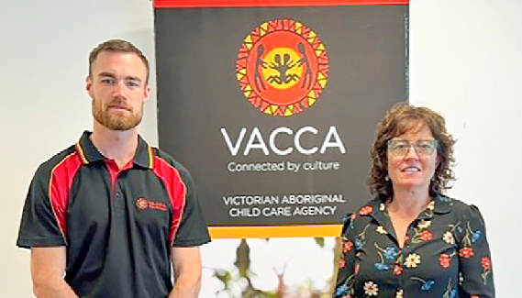

Engaging Kids in School Award
Winner
VACCA Education Team, Victorian Aboriginal Child Care Agency In 2020, the Victorian Aboriginal Child Care Agency (VACCA) created a small, dedicated Education team to enhance the provision and quality of learning
opportunities and supports for Aboriginal children and young people. The team
has engaged case workers and carers to develop a greater sense of shared ownership for improving educational outcomes, developed a VACCA-wide Education Working Group, a targeted communication plan, and user-friendly and culturally strong education resources. A new, comprehensive education strategy is also being implemented so children and young people supported through VACCA’s programs successfully engage in education. They are supported to celebrate their cultural identity, and develop the skills to participate fully in society.
Since the team was established, there have been increased rates of individual education plans and school attendance. In one example, the team worked collaboratively to make complex assessments to help a young child re-engage with school. The team also developed resources to support children with developmental concerns and diverse learning needs. These resources support Aboriginal families to navigate the early years system and promote the importance of reaching out and getting support as early as possible. The team creatively and effectively build educational awareness and capability for workers and carers.

32 | 2022 Victorian Protecting Children Awards

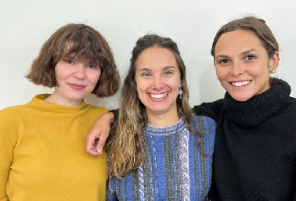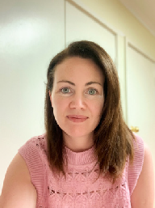

Highly Commended

Education Pathways Program, Launch Housing
The Education Pathways Program (EPP) supports primary and kindergarten-aged children experiencing homelessness to engage in education. In the
2021-22 financial year, the EPP team supported 106 children and their families. The EPP facilitators have backgrounds in social work and have undergone additional training in child development, childhood trauma and trauma-informed teaching and learning. Recent data on participant outcomes shows 90 per cent of children referred to EPP have been
supported with enrolments in school or kindergarten. All have been supported with education-related material aid and 80 per cent have been referred to additional services such as counselling.
33
Finalists

Brona Walshe, MacKillop Family Services
Brona consistently models exemplary practice and provides outstanding leadership. As an education specialist for the Keep Embracing Your Successes (KEYS) program, Brona supports five young people across two residential houses. Each of the young people had disengaged for more than 12 months before entering the program. Brona provides education support and helps create pathways and partnerships to support the young people to re-engage with and continue their education.
Brona supported four residents with enrolling and attending school within two weeks. Brona has also
implemented and coordinated relevant services and programs to ensure each young person was prioritised.

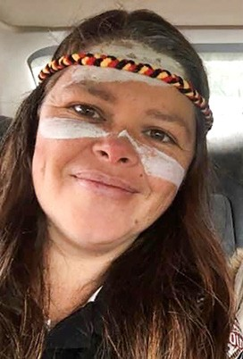

Finalists

Kiley Walkerden, Victorian Aboriginal Child Care Agency
Kiley is a senior youth worker at the Victorian Aboriginal Childcare Agency in Ovens Murray. Most of the young people Kiley works with have been involved with the child protection system and completely disengaged from education during COVID-19. Kylie led, planned and facilitated online Koorie Youth Group sessions, bringing participants together to connect, learn and immerse themselves in a cultural activity. Kiley also arranged a kinship placement for a teen and navigated financial assistance. Kiley worked
with Centrelink and assisted with an application for a birth certificate and Medicare card to allow the young person to enrol at TAFE.

Lisbeth De Kok, OzChild Libby is the teacher for OzChild’s Treatment Foster Care Oregon
(TFCO) program, an evidence-based
specialised foster care program for children aged 7-11. Some of the
children Libby works with have been disengaged from school for lengthy periods. Libby seeks to identify alternative settings where needed, considering an individual’s needs, ability, and motivations. Libby ensured all children were able to attend on-site learning during Victoria’s lockdowns. Progressive achievement tests in numeracy and literacy show significant improvements in nearly all children who complete the program and this can be largely attributed to Libby’s efforts in engaging the children in school.

34 | 2022 Victorian Protecting Children Awards

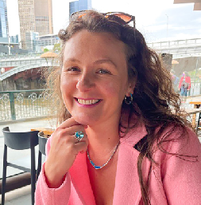

Luke Hayes, Parkville College Luke is a hospitality teacher who brings literacy and numeracy into
classes in a fun and creative way.
Luke developed an education based healthy eating program to improve young people’s physical and mental health outcomes and support them to develop independent living skills. One young person was struggling in the community, misusing substances, engaging in high-risk behaviours, and often missing from care. They lacked stability, motivation, and inspiration and had not attended an educational facility for some time.
Luke helped them make better food choices and engage with others, and the young person now plans to work in hospitality.
35
Veronika Shlimkevych, WAYSS Veronika supports children who have experienced family violence
to feel valued, empowered, safe and
have the best chance of engaging with their learning. Veronika works closely with families and educational settings (early learning centres, kindergartens and schools) to enrol children, settle them in and purchase items they need to succeed. Veronika advocated for a bullied teenager to attend a school out of their zone. The teen is now happily settled and their mother feels empowered to advocate and take control of managing the teen’s education.

Keeping At Risk Young People Safe Award
36 | 2022 Victorian Protecting Children Awards
This award recognises an individual, team or group that goes above and beyond to support at risk youth. The winner of this award prioritises empowering young people in the decision-making process and assists them to achieve their goals.
Examples of work may include:
- an individual, team or group which goes above and beyond the expectations of their role to assist at risk young people with gaining access to the support
they need. This may be for important life skills, independent living, employment pathways, education-based support, culturally appropriate care, mental health and substance abuse
- implementation of programs that improve outcomes for at risk young people
- empowering Aboriginal self-determination and cultural safety to achieve the best outcomes for Aboriginal children, young people and their families.

Keeping At Risk Young People Safe Award
Winner

Emily Nester, Berry Street
Emily has been led coordinator for the Multi Agency Support Team (MAST) – a youth crime prevention partnership model in the Ballarat area, since 2017. Emily’s efforts have seen the model lift practice standards across the sector. All in-scope children at risk of contact with the justice system are now being seen, heard and supported within the local service system.
Emily established the MAST Panel, a solution-focused platform comprising of clinical, welfare, drug and alcohol, disability and education sector leaders,
all collaborating to build the strengths of children, young people and their families.
Emily also co-designed the referral processes with the local Orange Door and created a MAST Plan for children focusing on causations of offending and protective factors in children’s lives. Emily initiated a partnership with Federation University to inform activities, capture outcomes and increase understanding of project strengths and barriers. Emily works collaboratively with multiple agencies, supporting them to strengthen protective factors for at risk children and families. Emily has been instrumental in challenging language used within the sector when referring to at risk children. Emily has developed a new Community Connector program to train university students as mentors, connecting them to children who lack positive adult mentors in their lives.

37

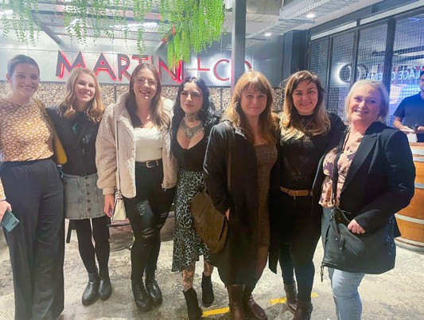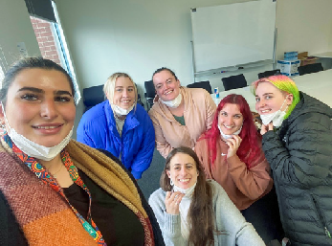

Highly Commended

Phipps Crescent Residential Care House, Berry Street
Berry Street’s Phipps residential care team has worked intensively over 12 months to keep a young person with high-risk behaviours safe in the home and community. The team established a strong relationship based on trust, predictability and consistency.
They empowered the young person to identify goals and needs, engage
with mental health supports, re-engage in education and encouraged their artistic passions. The young person’s diversity was celebrated with the
team facilitating their engagement with a rainbow group to foster peer relationships. With the support of
a targeted care package, the young person reunited with their family
in another state.
Finalists

Clarendon Street (North) Team, MacKillop Family Services
The Clarendon team is a collaborative, cohesive unit which has excelled
at supporting a young person at extremely high-risk who was exhibiting significant self-harming behaviours.
The team created a homely, welcoming atmosphere and supported the young person to access the critical supports and therapeutic interventions needed. The team are highly skilled and trained to work in a high-risk environment.
They have a strong knowledge of the young person’s support plan and crisis support responses. Three years later, the young person is completing work experience, has reconnected with family and is studying to pursue a career caring for animals.

38 | 2022 Victorian Protecting Children Awards

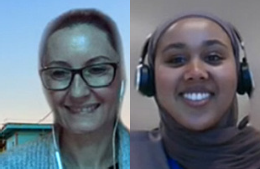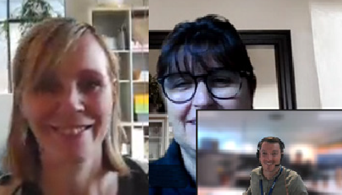

Lisa Sheasby, CareChoice CareChoice has been working with Victorian complex contingency clients
in care services since 2016, supporting
more than 50 children. Lisa’s role as Child and Youth Manager is integral to delivering high-level, quality supports for children and young people
with complex needs. One example involves a complex contingency client sectioned multiple times by the police, and admitted due to mental health concerns. Lisa advocated for the young person to stay in secure welfare during assessment. The young person’s risk-taking behaviours reduced,
their emotional and mental health improved and they developed positive relationships with family and carers.

MB Care Team, Department of Families, Fairness and Housing, Lighthouse Foundation and Austin Health
This team has supported a traumatised young person who came to child protection with dissociative behaviours, a history of impulsivity and a lack of empathy. When the young person was discharged after three months in hospital, the team was tasked with finding a placement. Through persistence and hard work, Lighthouse established a specialised placement option. Using a therapeutic overlay, a team approach was set
up with daily meetings and input from various key practitioners and clinicians. As a result of consistent
care and treatment, the frequency and severity of incidents reduced and the young person is rebuilding trust with their family.

39

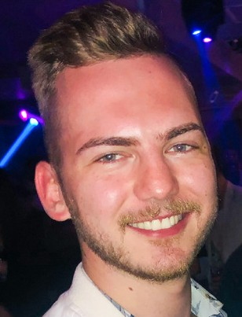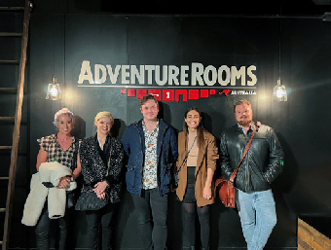

Finalists

Michael Carroll, Department of Families, Fairness and Housing
Michael supports and advocates to ensure the safety and wellbeing of the highest risk young people in Victoria.
In one case, Michael worked intensely for six months with an Aboriginal young person who identified as non-binary.
Michael helped them explore their identity, culture and reconnect with their Aboriginal community. Michael ensures young people have access to the services they need, engaging medical, education and alcohol and
drug services in a timely and supportive manner. Michael’s collaborative style has led to young people leaving secure care with clearer assessments of need and a sense of direction.

Western Region Intensive Case Management Services (ICMS), Berry Street
The Western Region Intensive Case Management Services (ICMS) provides case management to high-risk
youth, subject to child protection intervention. Over the past year, ICMS has supported 15 young people. Three of the young people have transitioned to independent living supported by Home Stretch. One young person recently gave birth and has been supported through
a Targeted Care Package. Several of the young people have acquired
an enhanced capacity to self-protect and have reunified with family. The team builds trusting relationships with young people and skilfully works with child protection, support services, youth justice, National Disability Insurance Scheme (NDIS) and young people’s families.

40 | 2022 Victorian Protecting Children Awards

CREATE Positive Impacts Award
41
This award gives Aboriginal and non-Aboriginal children and young people aged 8 - 25 years the opportunity to nominate someone such as a carer, support worker or agency who has made a positive difference to their lives, particularly through assisting them to have a voice within the out-of-home care system.
Note: this award is managed by the CREATE Foundation and was judged by a committee of children and young people.


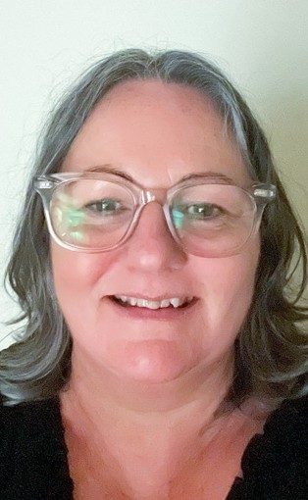

CREATE Positive Impacts Award
Winner

Kellie Addicoat, MacKillop Family Services
Kellie has been recognised by a young person as one of the most amazing people and advocates they have ever met – a friend, carer, motivator and maternal figure. Kellie started as a casual worker for the then 10-year-old and eventually began working respite, becoming the full-time carer of the young person’s home.
“I will forever value the work Kellie did for me and my foster siblings…she gave me the experience of many kids my age I was sad I couldn’t get from my own family… Kellie is a home, she’s a mother to all of us.”
Years later, Kellie has guided the young person through their education, played a vital role keeping them on track with year 12 during lockdown, gone with them
to pick up the keys to their first apartment, helped them move into their new home and assisted in creating their leaving care plan to best achieve their goals.
“Kellie always goes above and beyond for young people in their care… Kellie is like a soothing balm, the sound of waves crashing ashore and the sense of floating that comes with a nap in the sun after a long day of swimming.”

42 | 2022 Victorian Protecting Children Awards

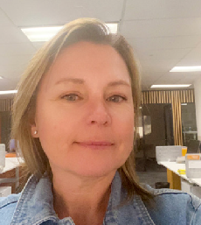

Highly Commended Gillian Walker, OzChild
Gillian has been recognised by a young person as going above and beyond
as a case worker, more than they had ever experienced. They credited Gillian’s kindness, compassion, love
and decency for the fundamental skills that make them who they are today. “Gilly always checked in, called and made sure I was okay, not only with
my placement but at school [talking to teachers if I was being bullied], with my mental health and wellbeing… Gillian will always be a role model to me, I looked up to Gilly and I continue to as she’s the most remarkable and admirable woman I know”.
43

Child and Youth Empowerment Award – Commission for Children and Young People
44 | 2022 Victorian Protecting Children Awards
This award was established by the Principal Commissioner for Children and Young People and recognises an individual, team or organisation who has achieved excellence in realising children’s and young people’s right to meaningfully participate in matters affecting them.
Note: this award is managed by the Commission for Children and Young People.


Child and Youth Empowerment Award – Commission for Children and Young People
Winner

Ministerial Youth Advisory Group (MYAG)
Since 2019, the Ministerial Youth Advisory Group (MYAG) has provided a forum for young people aged 14 to 22 from the CREATE Foundation to meet bi-monthly with the Minister for Child Protection and Family Services and senior DFFH representatives to provide advice on improvements to the out-of-home care system.
Through the MYAG, children and young people with lived experience in out-of- home care have had the opportunity to have their voices heard and use their expertise to influence change. The team consists of Bree, Ben, Karen, Danni, Cat, Marcelle, Kiara, Jacob, Dakota, Kiara, Harper, Jesse, Dee Dee, Alex, Tash, Hayley and Ella.
Since its inception, the MYAG has identified numerous significant issues requiring attention and has provided important advice on how to best support children and young people during the COVID-19 pandemic. Through MYAG, young people with experience in the care system shaped amendments to legislation about out-of- home care and highlighted experiences of young people leaving care and the need for greater support and choices.
The MYAG’s efforts have highlighted the value children and young people bring when they have the chance to share expertise with policy makers and can shape the legislation, policies and programs that affect them.

45

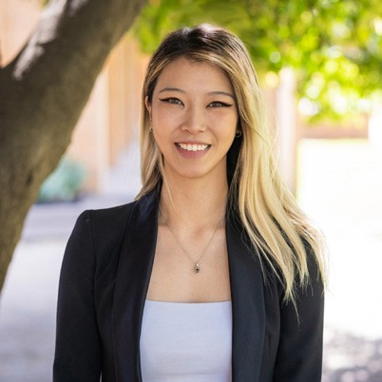

Finalists

North East Melbourne Area Case Management Team 3, Department of Families, Fairness and Housing
The North East Melbourne Area Case Management Team 3 (North Division, Department of Families, Fairness and Housing) is an impressive group of practitioners. Together, the team have gone to extraordinary lengths to ensure the voice of a young child, affected by extreme tragedy was considered in all the decisions made about them.
With careful consideration, the team empowered the child to articulate their needs and preferences, supported their meaningful participation in decisions and consistently placed them at the centre of their work.

Emily Unity, Royal Children’s Hospital
Emily’s advocacy has been transformational for children, young people, families and carers at the Royal Children’s Hospital (RCH). Emily champions reform to ensure lived experience is at the heart of every project, policy and process.
Emily has overseen the design, implementation and evaluation of lived experience projects including establishing a Lived Experience Engagement Strategy. This engages children, young people, families and carers as ‘experts by experience’
in a paid and supported capacity. Emily’s work focuses on diversity and inclusion, with a passion for bringing diverse views together.

46 | 2022 Victorian Protecting Children Awards

Leaving a Legacy Award
47
This award recognises the people who have made a significant contribution to the child, youth, and family services sector throughout their career as well as making an impact on their local community.
‘Leaving a Legacy’ acknowledges those who have positively contributed to the sector and whose remarkable achievements should be highlighted.
Note: This award is managed by The Centre for Excellence in Child and Family Welfare.
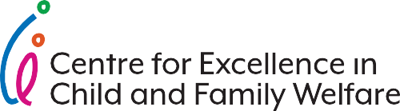

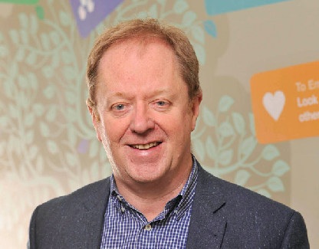

Leaving a Legacy Award

Winner Gerard Jones
The Centre for Excellence’s Leaving a Legacy Award goes to Gerard Jones, former Deputy CEO at MacKillop – a true pioneer in child and family services. Gerard passed away earlier this year, but his legacy lives on.
Gerard’s many achievements included:
- Directing the redevelopment of residential care services and leading the development and implementation of the Therapeutic Residential Care Model, while at the Victorian Department of Human Services.
- Leading the residential care capital project redesign which improved the living environment of residential homes.
- Building valued partnerships across the sector and between agencies – notably, forming trusted relationships with Aboriginal communities across Australia
- Bringing the Sanctuary Model to Australia.
- Project managing a $13 million progressive major redevelopment at Malmsbury Youth Justice Centre.
- Leading the redevelopment of MacKillop Education schools in Victoria and the trauma-informed approach to education, now known as ReLATE.
- Serving as an active Board Member to the Centre for several years.
The Centre would like to remember Gerard Jones for his life-long commitment to improving the lives of at risk children and young people.

48 | 2022 Victorian Protecting Children Awards

The Walda Blow Aboriginal Children and Young People Award
49
This award recognises contributions of an Aboriginal person, persons or organisations in Victoria to the safety and wellbeing of Aboriginal children and young people.
Note: this award is managed by the Commission for Children and Young People.


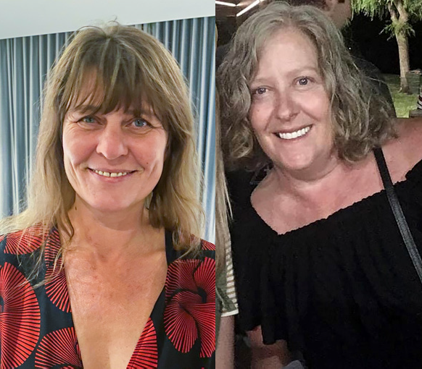

The Walda Blow Aboriginal Children and Young People Award
Winner

North East Melbourne Practice Leader Aboriginal Family Led Decision Maker Convenors, Department of Families, Fairness and Housing
Vicki Ross, an Aboriginal woman from South Australia and Amanda Tully, a Gomeroi woman from New South Wales, are powerful trailblazers leading the way to ensure the voices of Aboriginal children, their families and community are heard. Their strong relationship with the Victorian Aboriginal Child Care Agency (VACCA)
Community Convenors enables conversations with families to occur, for voices to be heard and for culture, community and family to be prioritised.
One example of this was when Vicki and Amanda, along with VACCA Community Convenors, reunified a young child with their grandmother and siblings on Country in Cairns. This young child had spent their young life in care and through the dedication and persistence of Amanda and Vicki, was introduced to siblings, extended family and remains with their grandmother in Cairns.
Vicki and Amanda are a formidable team facilitating family meetings, which reconnect children with families and culture. They say they are privileged to share families’ journeys, they are ‘taught by culture’ and effectively guide colleagues to deeply listen, support and learn.
Vicki and Amanda are led by culture and teach us that we must be guided by the voices of families and children to determine their own futures.

50 | 2022 Victorian Protecting Children Awards

Nominees
Congratulations to all the nominees in the 2022 Victorian Protecting Children Awards who have been recognised for their demonstrated excellence in protecting children, young people and families.

Alice O’Brien, Berry Street
Amy Norder, Department of Families, Fairness and Housing Anastassia Runciman, Key Assets
Andrew McSweeney, Living Learning Australia ASTERIA Family Approach, ASTERIA Services Inc ASTERIA Out of Home Care, ASTERIA Services Inc
Child Safe Australia in partnership with Jayneen Sanders resources, Childsafe Australia
Chrissy Ripper, Uniting Gippsland Cliff Hillier, Key Assets
Donna Mercieca, Department of Families, Fairness and Housing Drouin Secondary College Inclusion Team, Drouin Secondary College
ELAA Child Safety and Wellbeing Champions, Early Learning Association Australia Emily White, OzChild
Gail Ridlington, Department of Families, Fairness and Housing Hannah Newson, MacKillop Family Services
James Cumming, Reservoir East Primary School Karen and Neil McGovern, OzChild
Kim and Annie McCasker, Victorian Aboriginal Child Care Agency (VACCA)
Leading and Supporting a Complex Care Team, Department of Families, Fairness and Housing
Lisa and Jason Dowsell, Key Assets
Living Free Project, TaskForce Community Agency

51

Nominees
LOOKOUT Education Support Centre Staff, Department of Education and Training Marlene Slocom, Centre Director in Early Childhood
Matt and Sarah Lynch, Mallee Accommodation and Support Program (MASP) Maureen and Charles Davies, Mallee Family Care
Melissa and Uche Njoku, Uniting Victoria and Tasmania LTD Mike Norman, Carer
Mitchell Pether, Department of Families, Fairness and Housing Peta-Jane Ralph, MacKillop Family Services
Ros Smail, MacKillop Family Services Sarah and Tom O’Brien, Key Assets
Sarah Gibbins and Josh Dennis, MacKillop Family Services Sharon Cooper, Victorian Aboriginal Child Care Agency (VACCA) Sheryl Darragh, Key Assets
Southern Melbourne Area Leaving Care Project Working Group, Department of Families, Fairness and Housing
Steven Cassidy, Department of Families, Fairness and Housing Suzanne and Robert Pickard, Berry Street
Tracy Smit, Anglicare Victoria
West Out of Home Care Team, Key Assets Wia Seeary, MacKillop Family Services

52 | 2022 Victorian Protecting Children Awards

Judges
We had 18 judges, across four panels who assessed the nominations and recommended the finalists and winners to the Minister for Child Protection and Family Services. We thank the judges who generously gave their time.

Anita Morris
Statewide Family Violence Principal Practitioner, Community Operations and Practice Leadership Division, Department of Families, Fairness and Housing
Anne King
Executive Director Partnerships & Advocacy, OzChild
Chris Asquini
Former Deputy Secretary, Community Operations and Practice Leadership Division, Department of Families, Fairness and Housing
Dan Christie
Acting Manager, Fostering Connections, Centre for Excellence in Child and Family Welfare
Danny O’Kelly
Deputy Secretary, Community Operations and Practice Leadership Division, Department of Families, Fairness and Housing
Dr. Lisa J Griffiths
OzChild Chief Executive Officer and Board Chair of the Centre for Excellence in Child & Family Welfare
Gill Callister
Chief Executive Officer, Mind Australia
Julie Warren
Acting Statewide Principal Practitioner, Community Operations and Practice Leadership Division, Department of Families, Fairness and Housing
53

Judges
Kirstie-Lee Lomas
Acting Chief Practitioner and Executive Director, Office of Professional Practice, Operations Support Group, Community Operations and Practice Leadership Division, Department of Families, Fairness and Housing
Leesa Waters
Deputy Chief Executive Officer, National Association for Prevention of Child abuse and Neglect (NAPCAN)
Michael Perusco
Chief Executive Officer, Berry Street
Muriel Bamblett
Chief Executive Officer, Victorian Aboriginal Child Care Agency (VACCA)
Natalie Tillinger
Statewide Principal Practitioner Children and Families, Office of Professional Practice, Community Operations and Practice Leadership Division, Department of Families Fairness and Housing
Paul McDonald
Chief Executive Officer, Anglicare Victoria
Ruby Warber
Statewide Principal Practitioner, Community Operations and Practice Leadership Division, Department of Families, Fairness and Housing
Sam Patterson
Director Community Engagement, MacKillop Family Services
Sue Sealey
Deputy Chief Executive Officer, Anglicare Victoria
Tessa Hughes
Team Manager, Carer Information and Support Service, Foster Care Association of Victoria (FCAV)

The integrity of the awards required judges to make every effort to avoid actual or perceived conflicts of interest. If a relationship existed between a judge and a nominated organisation or individual, the judge abstained from judging that nomination.

54 | 2022 Victorian Protecting Children Awards

Partners


CREATE
CREATE Foundation would like to acknowledge the carers, workers, and agencies that play a huge role in supporting children and young people to have their voices heard within the out-of-home care sector. When these children and young people speak
up they facilitate change not only for themselves but also for the system as a whole. Thanks for being the backbone for this change, your support has not gone unnoticed.


Centre for Excellence in Child and Family Welfare Inc.
As the peak body for Victoria’s child and family services, the Centre is proud to celebrate the 2022 Victorian Protecting Children Awards. The Awards honour the hard work of our member organisations in supporting families and working with government, to keep children safe.


Commission for Children and Young People
The Commission for Children and Young People is committed to celebrating good practice in child protection and child and family services. Our partnership in these awards provides the opportunity to acknowledge services and individuals who are putting in extra effort to protect and support the rights of Victorian
children and young people.

55

Previous winners of Robin Clark Awards

Robin Clark Memorial Award for Changing the Definition of Family (2011-2014)
Margaret Pawsey | 2011
Cindy Lehmann | 2012
Dorothy Bamblett | 2012
Bev Briety | 2013
Debbie Yarnold | 2013
Stephen Thomas and Rachel Kent | 2014
Wendy Henry | 2014
Robin Clark Memorial Carer Award (2015-2018)
Crystal Sheehan | 2015
Natalie Borg | 2015
Lowana Searle | 2016
Helen Fox | 2016
Kerryn and Stephen Longmuir | 2017
Leonie and Doug Tate | 2018
Robin Clark Memorial Award for Making a Difference with Children, Young People and Families Award (2002-2019)
Sofie Serafingos | 2002
Vonda Coyne | 2002
Yvonne Luke | 2003
Christine Connors | 2004
Veronica Hunt | 2005
Peter Locke | 2005
Mark Watt | 2005
Faye Stanesby | 2006
Carol Taylor | 2006
Lisa Abbott | 2007
Joy Stewart | 2007
56 | 2022 Victorian Protecting Children Awards

Dr. Peter Eastaugh | 2008
Mara Long | 2008
Veronica Martin | 2009
Robyn Di Virgillo | 2009
Ruth Dorman | 2010
Sebastian LaSpina | 2010
Maureen Smythe | 2011
Sarah Covill | 2011
Jim Allen | 2012
Helen Landau and Rosemary Paterson | 2012
Maree Corbo | 2013
Youth and Family Services Team, UnityCare ReGen | 2013
Supporting Kids and Youth, Victorian Association for the Care and Resettlement of Offenders | 2014
Bobby Cunningham | 2015
CREATE Foundation – Victoria Team | 2016
Anita Pell | 2017
Aboriginal Children in Aboriginal Care Pilot, Bendigo and District Aboriginal Cooperative | 2018
The Family Drug Treatment Court | 2019
57

Robin Clark Making a Difference Award (2021-present)
Staughton Road – MacKillop Family Services | 2021
Robin Clark Memorial Award for Inspirational Leadership in the Field (2002-2019)
Sherrie Coote | 2002
Muriel Cadd | 2003
Glenys Bristow | 2003
Heather Ploeger | 2004
Dr. Lynda Campbell | 2004
Margaret Chipperfield | 2005
Nola Ganly | 2006
Paul Linossier | 2007
Michael Nauthton | 2007
Sandie de Wolf | 2008
Robyn Miller | 2010
Joanna Eccleston | 2011
Michael O’Kelly | 2011
Connie Salamone | 2012
Marg Hamley | 2012
Noel McNamara | 2013
Micaela Cronin | 2014
Denise Harrison | 2015
Jenny Glare | 2016
Paul McDonald | 2017
Building the Resilience of Children and Young People Living in Residential Out of Home Care, Soula Kontomichalos and Richard Watkins | 2018
Karen Hogan | 2019
Robin Clark Leadership Award (2021-present)
Beth Allen | 2021

58 | 2022 Victorian Protecting Children Awards

To receive this publication in an accessible format phone 03 8850 6165 using the National Relay Service 13 36 77 if required, or email <protectingchildren.awards@ dffh.vic.gov.au>.
Authorised and published by the Victorian Government, 1 Treasury Place, Melbourne.
© State of Victoria, Australia, Department of Families, Fairness and Housing September 2022. This publication may contain images of deceased Aboriginal and Torres Strait Islander peoples. In this document, ‘Aboriginal’ refers to both Aboriginal and Torres Strait Islander people.
ISBN 978-1-76096-979-0 (Print)

ISBN 978-1-76096-980-6 (pdf/online/MS word)
Available at <https://www.dffh.vic.gov.au/victorian-protecting-children-awards> Printed by Doculink Australia, Port Melbourne (2201159)

59



