
Victorian Senior Practitioner report 2025–26
OFFICIAL

Contact us to receive this document in another format. Please phone (03) 9096 8427 or email VictorianSeniorPractitioner@dffh.vic.gov.au
If you are d/Deaf, hard of hearing, or have a speech/communication difficulty please contact us through your preferred National Relay Service (NRS) call channel Then, provide the NRS with our phone number [(03) 9096 8427]. For more information, visit About the National Relay Service
Authorised and published by the Victorian Government, 1 Treasury Place, Melbourne.
© State of Victoria, Australia, Department of Families, Fairness and Housing, October 2026
ISSN 2653-0260 (online/PDF/Word)
Available at DFFH Victorian Senior Practitioner annual reports https://www.dffh.vic.gov.au/publications/victorian-senior-practitioner-annual-reports
(2607626)
Cover art: winning artwork Colour My World by Richelle McMahon from the Barbara Donovan & Sarah Guilfoil Art Competition Award. The awards are sponsored by Victoria State Government and were presented at the VALID Having a Say Conference 2026.


Message from the Senior Practitioner
The Senior Practitioner’s work rests on one commitment: that people with disability are heard, respected and supported to live with choice, dignity and meaning.
The Victorian Senior Practitioner report 2025–26 reflects a year of continued progress in strengthening the quality, consistency and impact of our practice. An important part of that work has been improving how we collect, understand and use data. We do this not only to measure activity but to understand outcomes and show the difference our work makes in people’s lives. Better data and stronger evidence allow us to identify:
- what is working
- where improvement is needed
- how we can continually strengthen practice and safeguards.
Our focus on outcomes and impact is central to this approach. Data must tell us more than what services have been delivered or processes completed. It should help us understand whether:
- people are experiencing greater choice and control
- restrictive practices are being reduced
- safeguards are effective
- the system and services around people are supporting positive and meaningful change.
It is then used to highlight areas for improvement and focus.
For this report we are using our Strengthening safeguards plan to guide reporting and future work plans. The plan provides a framework for building capacity and improving practice across the sector. It is organised around 5 practice pillars:
- Client voice and self-determination
- Practice leadership and sector capability
- Data, evidence and impact
- Systems, processes and technology
- Culture and capability.
These pillars are deliberately interconnected. Strong safeguards depend not only on sound policies and systems but on:
- capable people
- effective leadership
- meaningful participation
- a culture that is willing to learn from evidence and experience.
As we look ahead, our challenge is to continue turning:
- information into insight
- insight into action
- action into measurable improvements in the lives of people with disability.
You will see this report has noticeable changes when compared with previous years. This is due to us making necessary adaptations to how we collect, report and use data and information to improve practice. We will also be seeking more feedback from our key stakeholders, the sector and those with lived or living experience.
I acknowledge the commitment of the Senior Practitioner team, people with disability, families, carers and supporters, practitioners, providers, advocates and government partners. Their experience, expertise and leadership continue to shape this work. Their contribution is essential to strengthening safeguards. It also ensures our collective efforts result in meaningful and lasting change in people’s lives.

Kylie Bowden
Victorian Senior Practitioner
Contents
Message from the Senior Practitioner 3
Safeguarding practice – Senior Practitioner plan 2026–2030 6
Role of the Senior Practitioner 7
Year in review 2025–26 8
Restrictive practices snapshot 2025–2026 8
Practice leadership and training snapshot 2025–2026 8
Data, evidence and impact 9
Authorised use of restrictive practices among disability service providers and NDIS providers 9
Authorised use of restrictive practices among disability service providers and NDIS providers – First Nations 10
Authorised use of restrictive practices among disability service providers and NDIS providers – restrictive practice type 12
Compulsory treatment data 20
Practice leadership and sector capability 25
Strengthening the role of the APO project 25
Authorised Program Officer Professional Learning and Development course 26
Restrictive practices reduction training 26
Workshops 27
Compulsory treatment forums and compulsory treatment APO Community of Practice 28
Supporting forensic disability clients effectively 28
TAC project 29
Completed projects 29
Client voice and self-determination 30
Client case study: Successful reduction of significant restrictive practices 30
Client Voice project – review of the Independent Person 31
Lived experience perspectives of supervised treatment orders – article 32
STO clinical practice review framework project 32
Self-determination 33
Enhanced safeguarding through improved systems, processes and technology 35
Restrictive practices audit review 35
Desktop reviews 35
Consultations 37
Culture and capability 39
The Senior Practitioner Seminar 39
Annual Satisfaction Survey 39
Looking ahead 41
Appendix: Senior Practitioner plan 2026–2030 figure description 42

Safeguarding practice – Senior Practitioner plan 2026–2030
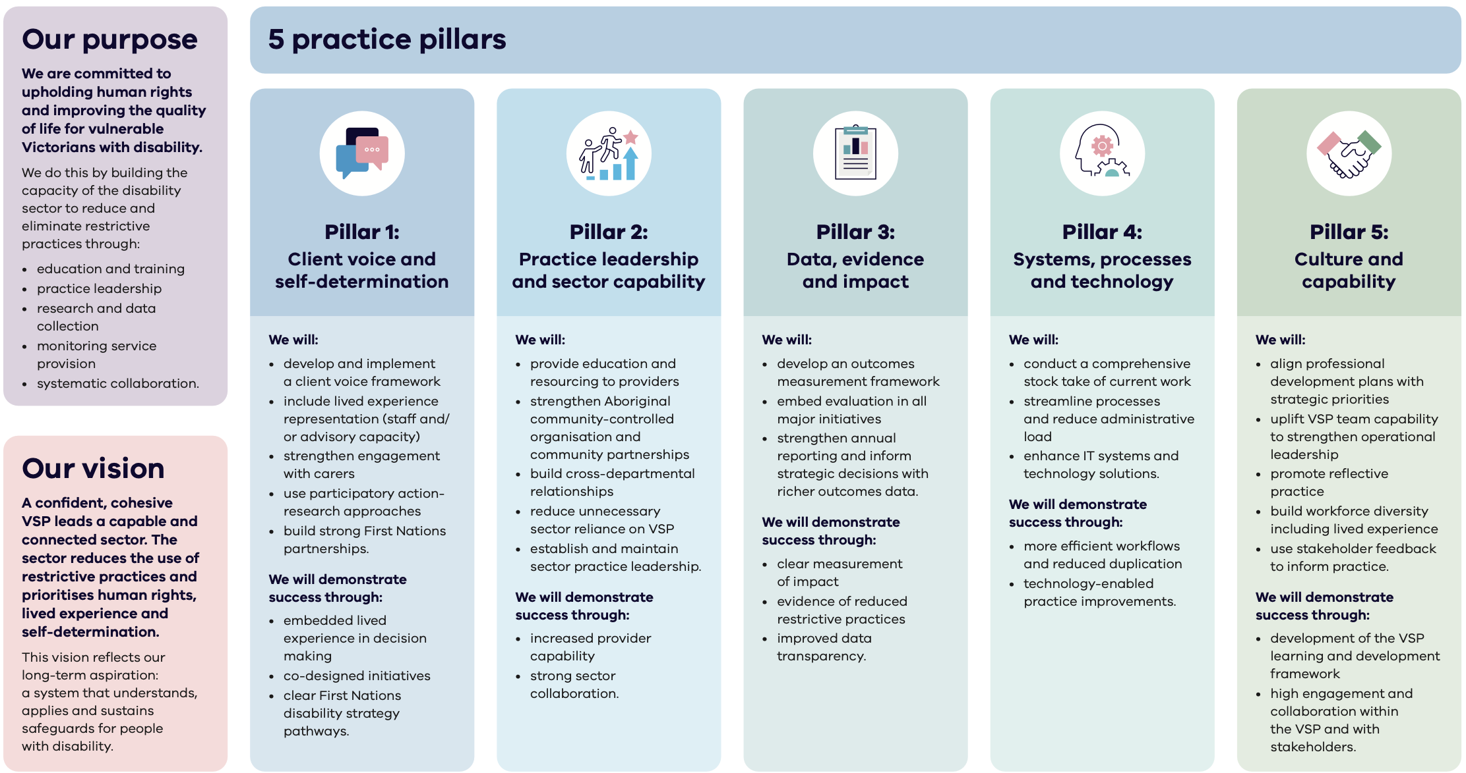
Refer to Appendix: Senior Practitioner plan 2026–2030 figure description for a transcription of this infographic.

Role of the Senior Practitioner
The Disability Act 2006 (Vic) established the role of Victorian Senior Practitioner. The role protects the rights of people with disability who are subjected to restrictive practices, including:
- physical restraint
- seclusion
- environmental restraint
- chemical restraint
- mechanical restraint.
Of these restrictive practices, Authorised Program Officers (APOs) authorise chemical restraint and environmental restraint. These practices do not need secondary approval from the Senior Practitioner. Higher impact restrictive practices, such as mechanical restraint, physical restraint and seclusion, all need secondary approval from the Senior Practitioner.
The Disability Act mandates that the Senior Practitioner:
- develops guidelines and standards for restrictive practices and compulsory treatment
- conducts research into the use of restrictive practices and compulsory treatment
- provides relevant education – for example, about human rights and positive behaviour support – to all stakeholders involved in supporting people with disability.
The Disability Act also mandates specific responsibilities of the Senior Practitioner to:
- approve and monitor treatment plans developed for people subjected to compulsory treatment
- oversee the carrying out of supervised treatment orders (STOs)
- issue lawful directions to disability services on any law, policy or practice, where relevant, to a compulsory treatment order matter
- publish information on the performance of the Senior Practitioner’s functions each year, including data on the use of restrictive practices and compulsory treatment.
This report covers the 2025–26 financial year, from July 2025 to June 2026. It outlines trends and themes in the use of restrictive practices for that period. It also describes how our safeguarding activities have affected the lives of people with disability.

Year in review 2025–26

Restrictive practices snapshot 2025–2026
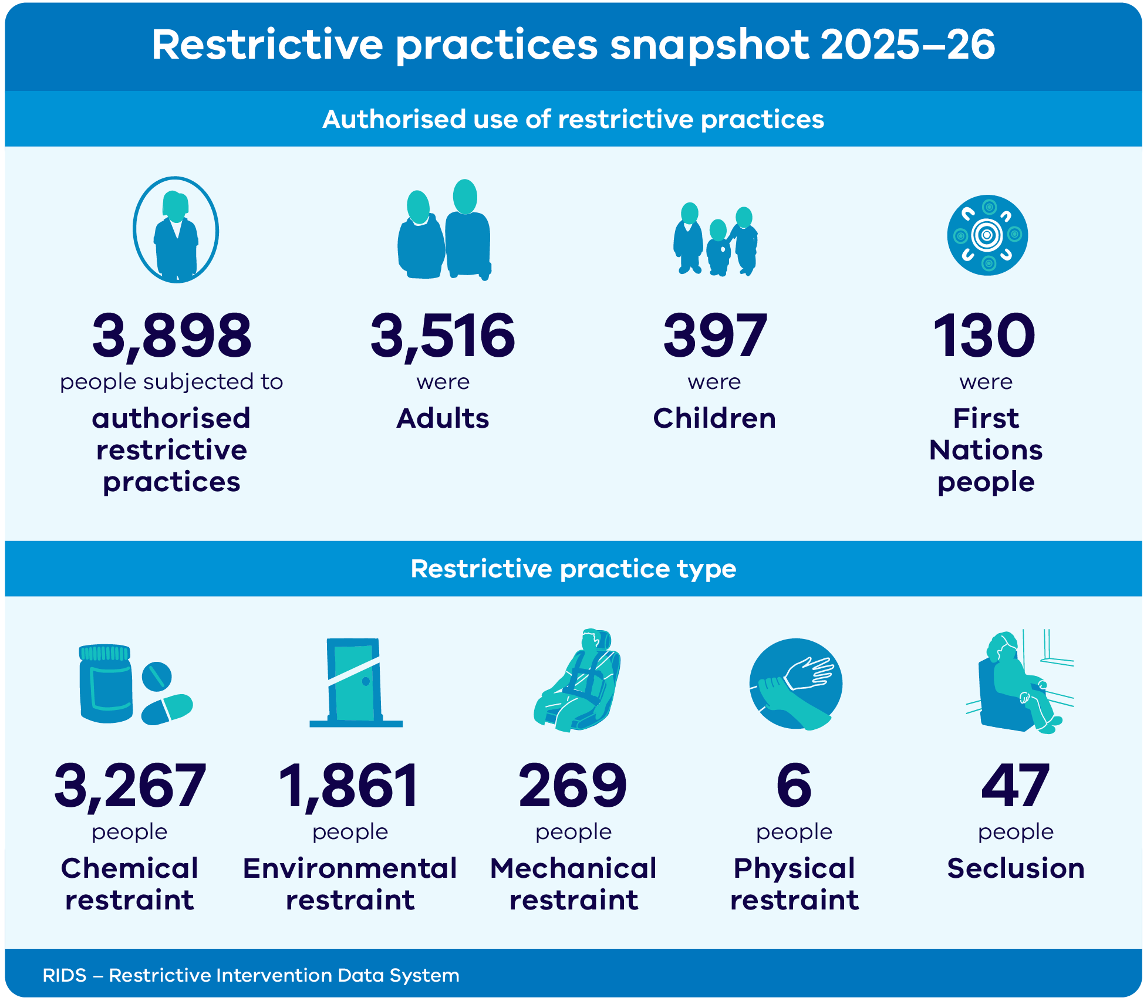

Practice leadership and training snapshot 2025–2026
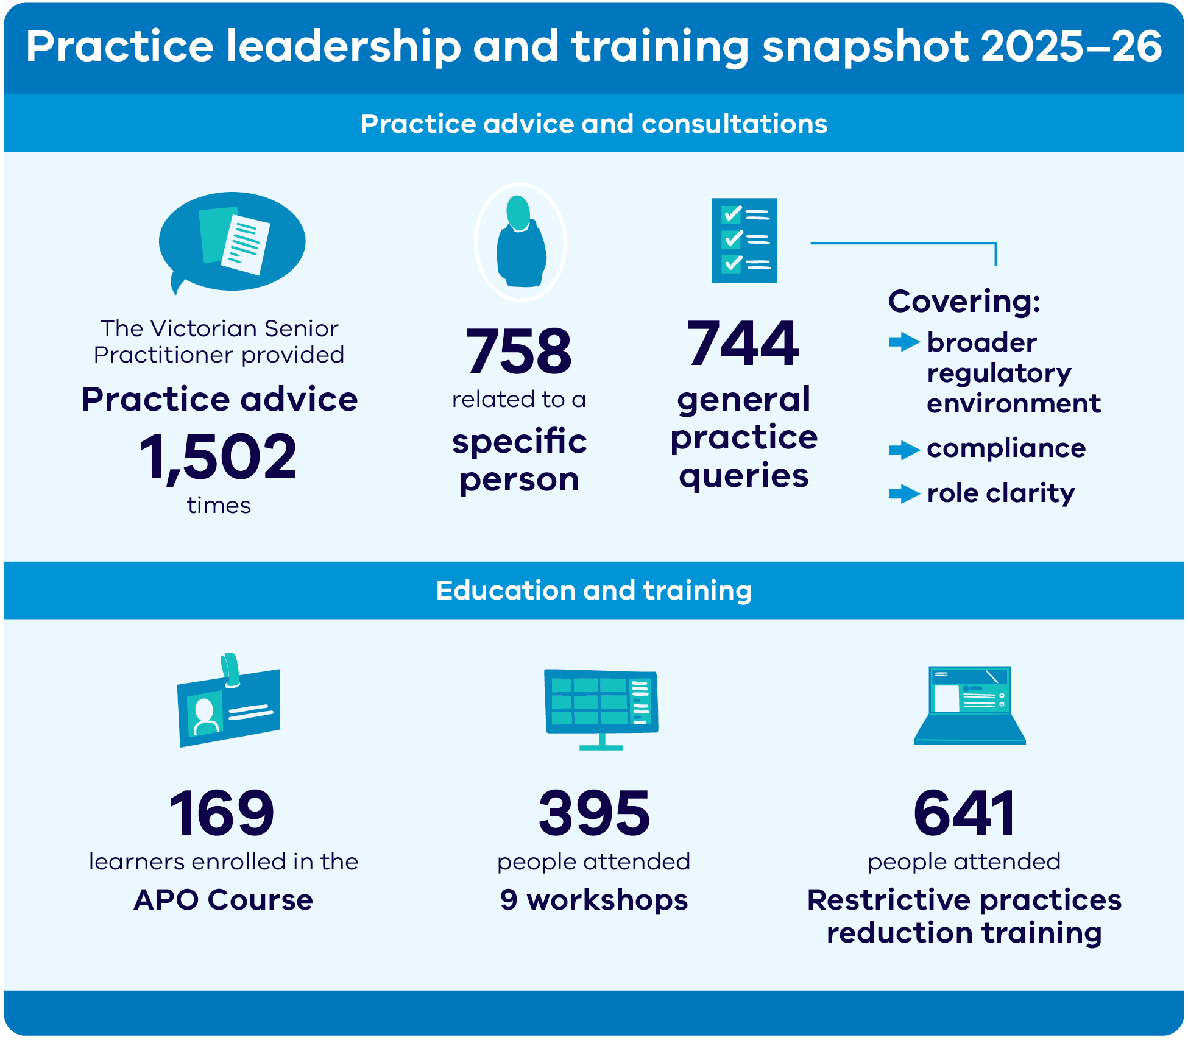

Data, evidence and impact
The core function of the Senior Practitioner is to oversee, rather than authorise, the use of restrictive practices. This has been the case since the NDIS began. The Senior Practitioner reviews behaviour support plan (BSP) submissions with proposed restrictive practices. This is to ensure they comply with legal requirements, including:
- the use of the regulated restrictive practice is necessary to prevent risk of physical harm to self or others
- that it is the least restrictive practice option
- that there is evidence of planning for reducing and eliminating the regulated restrictive practice.

Authorised use of restrictive practices among disability service providers and NDIS providers
This section presents general findings for restrictive practices authorised in 2025–26. It compares this year’s results with previous years (Tables 1a and 1b). All tables show only the past 5 years of data, starting from 2021–22.
Table 1a: Number of people subjected to authorised restrictive practices in Victoria, 2021–22 to 2025–26
Year | All
2021–22 | 2,335
2022–23 | 2,679
2023–24 | 3,142
2024–25 | 3,527
2025–26 | 3,898

Key findings – number of people subjected to authorised restrictive practices
- In 2025–26 restrictive practices were authorised for 3,898 people.
- The number of people subjected to authorised restrictive practices was 11% higher than last year. This is a smaller increase on the previous year, which saw a 12% rise.
- Like last year, the main driver for the increase is the number of new providers registered on the Restrictive Intervention Data System (RIDS). There were 1,105 authorised providers on RIDS at the end of 2025–26. This is a net increase of 240 providers (28%) from 2024–25 (865).
- Mirroring the prior 2 years, the rise in authorisations is due to chemical and environmental restraints.

Table 1b: Number of children and adults subjected to authorised restrictive practices in Victoria, 2021–22 to 2025–26
Year | Children | Adults
2021–22 | 261 | 2,080
2022–23 | 271 | 2,415
2023–24 | 312 | 2,834
2024–25 | 355 | 3,179
2025–26 | 397 | 3,516
Note: Within a period, the total count of people may not equal the sum of people by age group. This is because a person may have had more than one plan in that period. Or, they may have been different ages on the dates when those plans were authorised or approved. Age was calculated as being a person’s age on the date when their plan was authorised or approved.

Key findings – number of children and adults subjected to authorised restrictive practices
- In 2025–26 there were 42 more children with authorised restrictive practices in their BSPs than the previous year. This is a 12% increase.
- In 2025–26 there were 337 more adults with authorised restrictive practices in their BSPs than the previous year. This is an 11% increase.
- The increase in adults subjected to restrictive practices in 2025–26 was smaller than in the 3 previous years. The year-on-year increase in adults subjected to restrictive practices was 12% in 2024–25, 17% in 2023–24 and 16% in 2022–23.

Authorised use of restrictive practices among disability service providers and NDIS providers – First Nations
This section presents authorised restrictive practice use by First Nations status. It compares 2025–26 with previous years (Tables 2a, 2b and 2c).
Table 2a: Number of people subjected to authorised restrictive practices, by First Nations status, 2021–22 to 2025–26
Year | First Nations | Other | Total
2021–22 | 61 | 2,274 | 2,335
2022–23 | 72 | 2,607 | 2,679
2023–24 | 88 | 3,054 | 3,142
2024–25 | 108 | 3,419 | 3,527
2025–26 | 130 | 3,768 | 3,898
Table 2b: Percentage of people subjected to authorised restrictive practices, by First Nations status, 2021–22 to 2025–26
Year | First Nations (%) | Other (%)
2021–22 | 2.6 | 97.4
2022–23 | 2.7 | 97.3
2023–24 | 2.8 | 97.2
2024–25 | 3.1 | 96.9
2025–26 | 3.3 | 96.7
Table 2c: Percentage of people subjected to authorised restrictive practices, by age bracket and First Nations status, 2021–22 to 2025–26
Year | Adults  First Nations/Other (%) | Children  First Nations/Other (%)
2021–22 | 2.2/97.8 | 6.1/93.9
2022–23 | 2.3/97.7 | 6.3/93.7
2023–24 | 2.4/97.6 | 6.1/93.9
2024–25 | 2.7/97.3 | 6.5/93.5
2025–26 | 2.8/97.2 | 7.8/92.2

Key findings – authorised use of restrictive practices: First Nations
- The percentage of people recorded as First Nations is small. First Nations people represent about 3% of all people authorised for restrictive practices.
- First Nations children as a percentage of all children authorised for restrictive practices in 2025–26 was 7.8%. This is a rise of over 1% from the previous year. The same figure for First Nations adults was 2.8%. This is less than half of the figure for First Nations children.
- First Nations children aged 0 to 14 are more than twice as likely as other children to live with a disability.
- First Nations children are also over-represented in out-of-home care. They make up nearly 30% of children in care. This is despite representing under 2% of Victoria’s child population. The Victorian Senior Practitioner does not oversee restrictive practices in out-of-home care.
- Considering these statistics, it is possible that service providers are only reporting on those children who identify as First Nations. The figures reported above may be an under-representation.

Authorised use of restrictive practices among disability service providers and NDIS providers – restrictive practice type
This section presents the findings for specific restrictive practices authorised in 2025–26 (Tables 3 to 10). In some tables, percentages – rather than absolute numbers – are reported. This is to ensure the comparability of results with previous years. The first part of this section presents findings on restrictive practices that do not need the Senior Practitioner’s secondary approval. This includes chemical restraint and environmental restraint. The second part presents findings on restrictive practices that need secondary approval from the Senior Practitioner. This includes mechanical restraint, seclusion and physical restraint.

Restrictive practices that do not need secondary approval from the Senior Practitioner
Chemical restraint and environmental restraint do not need the Senior Practitioner’s secondary approval before use. APOs authorise these.

Chemical restraint
Table 3: Number of people with chemical restraint authorised in their BSP, by administration type, 2021–22 to 2025–26
Year | Total people –  PRN | Total people –  routine | Percentage –  PRN | Percentage –  routine | Total people
2021–22 | 744 | 1,768 | 39.5 | 93.8 | 1,884
2022–23 | 768 | 2,039 | 35.1 | 93.3 | 2,185
2023–24 | 957 | 2,360 | 37.1 | 91.6 | 2,577
2024–25 | 1,095 | 2,693 | 37.5 | 92.2 | 2,922
2025–26 | 1,202 | 3,025 | 36.8 | 92.6 | 3,267
Note: PRN refers to pro re nata, which means as needed.
Within each period, the total count of people is less than the sum of people per administration type. This is because some people will have been subjected to both types of administration in that period.
Table 4: Percentage of people with chemical restraint authorised in their BSP, by drug class, 2021–22 to 2025–26
Drug type | 2021–22 | 2022–23 | 2023–24 | 2024–25 | 2025–26
Antidepressant | 37.2 | 36.0 | 35.2 | 34.8 | 33.8
Antipsychotic | 75.7 | 73.3 | 72.9 | 71.7 | 71.0
Benzo or other sedative | 42.7 | 41.4 | 43.6 | 45.3 | 45.5
Menstrual suppressant | 6.2 | 5.7 | 5.5 | 4.7 | 4.1
Mood stabiliser | 25.6 | 24.9 | 23.3 | 22.9 | 22.1
Psychostimulant | 2.9 | 2.4 | 1.8 | 1.6 | 1.4
Note: Percentages will add to more than 100%. This is because most people experienced 2 or more chemical restraints each year. Also, this table does not include all drug classes.

Key findings – chemical restraint
- There has been a 12% increase in the number of people subjected to authorised chemical restraint compared with 2024–25 (3,267 people up from 2,922 people).
- But the year-on-year increase is smaller than in the previous year (a 12% increase in 2025–26 compared with a 13% increase in 2024–25).
- Antipsychotic and sedative medications were the most used chemical restraints.
Winning artwork My Voice by Kyra Drummond from the Barbara Donovan & Sarah Guilfoil Art Competition Award. The awards are sponsored by Victoria State Government and were presented at the VALID Having a Say Conference 2026.

Table 5: Number of people with antilibidinal medication authorised in their BSP, 2021–22 to 2025–26
Year | Submission type | Cyproterone acetate | Dutasteride | Finasteride | Triptorelin | Total
2021–22 | Treatment plan | 2 | 0 | 0 | 5 | 6
2021–22 | NDIS | 6 | 0 | 0 | 1 | 7
2021–22 | Total | 8 | 0 | 0 | 6 | 13
2022–23 | Treatment plan | 2 | 0 | 0 | 5 | 6
2022–23 | NDIS | 10 | 1 | 0 | 1 | 11
2022–23 | Total | 12 | 1 | 0 | 6 | 17
2023–24 | Treatment plan | 1 | 0 | 0 | 5 | 5
2023–24 | NDIS | 9 | 0 | 0 | 1 | 10
2023–24 | Total | 10 | 0 | 0 | 6 | 15
2024–25 | Treatment plan | 0 | 0 | 0 | 4 | 4
2024–25 | NDIS | 7 | 0 | 1 | 3 | 11
2024–25 | Total | 7 | 0 | 1 | 6 | 14
2025–26 | Treatment plan | 0 | 0 | 0 | 2 | 2
2025–26 | NDIS | 6 | 0 | 0 | 1 | 7
2025–26 | Total | 6 | 0 | 0 | 3 | 9
Note: For each plan type within a period, the total count of people may not equal the sum of people by generic drug name. This is because an individual may have been authorised for more than one type of generic drug for each type of plan within a period.
This report includes only anti-androgen medications with clearly documented indication for antilibidinal use. We excluded other potential antilibidinal medications, such as selective serotonin reuptake inhibitors. This is because their use for this purpose is not always confirmed.

Key findings – antilibidinal medication
- The number of people subjected to antilibidinal medication in 2025–26 decreased by 36% compared with the previous year (from 14 people in 2024–25 to 9 people in 2025–26).
- The number of people subjected to antilibidinal medication has almost halved in the past 3 financial years, from 17 people in 2022–23 to 9 people in 2025–26.
- All participants receiving triptorelin (within treatment plans and NDIS BSPs) are under the care of the Glaser Clinic. The clinic oversees their treatment including regularly assessing clinical appropriateness and relevant therapeutic monitoring.

Environmental restraint
Tables 6a to 6c show a year-on-year comparison of providers’ applications for approval of environmental restraint and detail:
- what is to be restricted (for example, outside access, food and drink)
- how the restriction is to be applied (for example, via a locked door or surveillance).
Table 6a: Number of people with environmental restraint authorised in their BSP, 2021–22 to 2025–26
Year | Total people
2021–22 | 1,329
2022–23 | 1,443
2023–24 | 1,620
2024–25 | 1,752
2025–26 | 1,861
Table 6b: Percentage of people subjected to authorised environmental restraint, by sub-types (what is restricted), 2021–22 to 2025–26
Restraint type | 2021–22 | 2022–23 | 2023–24 | 2024–25 | 2025–26
Access (other) | 23.3 | 23.1 | 25.8 | 25.1 | 24.8
Activity | 9.0 | 9.8 | 8.3 | 9.2 | 8.9
External access | 53.0 | 51.6 | 49.8 | 47.6 | 48.7
Food and drink | 38.8 | 37.3 | 34.0 | 32.3 | 32.1
Household items | 30.5 | 27.6 | 30.3 | 30.2 | 30.8
Internal access | 38.5 | 33.3 | 28.8 | 25.5 | 24.7
Personal item | 22.5 | 21.3 | 18.8 | 19.7 | 20.8
Privacy | 8.7 | 8.4 | 5.2 | 4.5 | 4.1

Table 6c: Percentage of people subjected to authorised environmental restraint, by means of restraint (how is it restricted), 2021–22 to 2025–26
Restraint means | 2021–22 | 2022–23 | 2023–24 | 2024–25 | 2025–26
Applied (other) | 38.6 | 39.4 | 36.3 | 34.8 | 34.4
Disabled utility | 3.6 | 3.6 | 2.9 | 3.4 | 3.3
Locked abode door | 61.2 | 59.0 | 57.2 | 54.7 | 55.7
Locked item door | 46.5 | 39.4 | 40.2 | 38.2 | 38.2
Object out of reach | 9.9 | 8.5 | 9.0 | 9.0 | 10.6
Removed object | 17.2 | 18.0 | 21.8 | 22.4 | 24.3
Supervision | 23.3 | 23.7 | 19.2 | 16.9 | 16.6
Surveillance | 5.3 | 5.3 | 4.4 | 4.1 | 3.8
Note: Surveillance technology refers to devices that collect information about a person through electronic means. Examples include closed circuit television, motion sensor alarms and GPS devices. Surveillance technology may lead to environmental restrictive practice.

Key findings – environmental restraint
- The year saw a 6% increase in the number of people subjected to authorised environmental restraint(s) from the previous year. It went from 1,752 people in 2024–25 to 1,861 people in 2025–26.
- Across the past 3 years, restricted access to external areas and access to specific food or drink were the most common restrictions (49% and 32% respectively).
- Consistent with this pattern, the most common way to restrict the environment is locking doors. In 2025–26, 56% of authorisations involved a locked abode door.

Restrictive practices that need secondary approval from the Senior Practitioner
Under s 143 of the Disability Act, a regulated restrictive practice in the form of seclusion, physical restraint or mechanical restraint needs Senior Practitioner approval. This is in addition to an APO authorising the restrictive practice.

Mechanical restraint
Table 7 shows the numbers of people with approved mechanical restraint in their BSP. Table 8 shows the percentages of different mechanical restraints subtypes approved.
Table 7: Total number of people with authorised mechanical restraint in their BSP, 2021–22 to 2025–26
Year | Total people
2021–22 | 265
2022–23 | 283
2023–24 | 292
2024–25 | 281
2025–26 | 269
Table 8: Percentage of people with authorised mechanical restraint in their BSP, by sub-types, 2021–22 to 2025–26
Restraint type | 2021–22 | 2022–23 | 2023–24 | 2024–25 | 2025–26
Bedrail | 3.4 | 2.1 | 1.0 | 2.1 | 1.5
Clothing | 25.3 | 25.8 | 28.4 | 33.5 | 35.7
Cuffs | 0.4 | 0.7 | 0.7 | 0.4 | 0.4
Furniture | 1.5 | 1.1 | 0.3 | – | –
Gloves | 7.2 | 6.4 | 5.5 | 6.4 | 6.3
Harnesses | N/A | N/A | 29.1 | 33.8 | 37.9
Helmet | 5.3 | 5.6 | 5.8 | 6.4 | 6.7
Other | 45.7 | 41.3 | 33.6 | 25.3 | 22.3
Splints | 3.4 | 2.8 | 2.1 | 1.8 | 1.5
Straps | 38.1 | 39.6 | 25.0 | 21.4 | 15.2
Wheelchair | 9.1 | 8.1 | 12.0 | 8.9 | 5.9

Key findings – mechanical restraint
- The number of people subjected to authorised mechanical restraint in 2025–26 decreased by 4.3% compared with the previous year. It went from 281 people in 2024–25 to 269 people in 2025–26.
- The number of people subjected to authorised mechanical restraint has fallen over the past 2 years. This followed a sustained increase in mechanical restraint from 2018–19 to 2023–24.
- The use of straps declined for a third year in a row. It went from 21.4% to 15.2%.
- Wheelchair restraint increased from 8.1% to 12.0% in 2023–24. In 2024–25 it decreased to 8.9%. It continued to decrease in 2025–26 to 5.9%.
- Harness use continued to increase from 33.8% in 2024–25 to 37.9% in 2025–26. Restrictive clothing use also increased from 33.5% in 2024–25 to 35.7% in 2025–26.
- For the past 2 years, the Senior Practitioner has promoted practice guidance on appropriate mechanical restraint use. This has occurred during targeted conversations with all new APOs registered on RIDS.
- Recent APO education has focused on delineating the difference between device/equipment use for therapeutic purposes and their use for influencing a person’s behaviour as a restrictive practice.
- The Senior Practitioner is encouraged by the continued reduction in mechanical restraint use.

Seclusion
Table 9 shows the numbers of people with authorised seclusion in their BSP over the past 5 years.
Table 9: Total number of people with authorised seclusion in their BSP, 2021–22 to 2025–26
Year | Adult | Child | Total people
2021–22 | 64 | 16 | 79
2022–23 | 75 | 15 | 89
2023–24 | 63 | 6 | 69
2024–25 | 58 | 0 | 58
2025–26 | 47 | 0 | 47
Note: A person may have been subjected to authorised seclusion both before and after becoming an adult in the same financial year. As such, they may be counted as both a child and an adult in the same financial year. This means the total number of people in any given financial year may not add up to the sum of the separate categories.

Key findings – seclusion
- The year saw a 19% decrease in the number of people subjected to authorised seclusion. There has been a 47% decrease over the past 3 years.
- In 2025–26 approvals for the use of seclusion fell by 23 for participants who had been approved to use seclusion in the previous financial year.
- Most submissions no longer contained seclusion in the restrictive practice schedule. This is because the practice had either stopped, due to changed practice (including change in environment). Or it had been removed from the schedule because seclusion had not been used for at least 12 months.
- Some submissions no longer include authorised seclusion. Any future emergency use would be reported as an unauthorised restrictive practice to the NDIS Quality and Safeguards Commission.
- Two submissions included the concurrent use of environmental restraint and seclusion to a level of restriction similar to the definition of detention. The Senior Practitioner will continue to work with service providers on these complex cases.
- A change in service provider may result in gaps in authorisation. The Senior Practitioner monitors when this occurs. The aim is to support continuity for the person and to ensure the right approvals are in place.
- In 2024–25 the Senior Practitioner noted that locked doors, supervision in the community and electronic surveillance were common for participants with a psychosocial disability. The Senior Practitioner intends to focus on this issue in 2025–26. Over the past year, the Senior Practitioner worked with the NDIS Quality and Safeguards Commission, and with other states and territories. Together, we are working to define restrictive practice subtypes more consistently across the country. This work also aims to improve data collection. This is an essential first step in addressing this complex issue.
- The Senior Practitioner is encouraged by the decrease in the number of people subjected to authorised seclusion. However, the Senior Practitioner does not have access to NDIS Quality and Safeguards Commission data on the actual use of seclusion, including emergency use. Next year, the Senior Practitioner will support providers to improve data collection on the use of seclusion, particularly on the frequency and duration of use. Further guidance will be provided in due course.
- The Senior Practitioner will also partner with providers to explore factors contributing to the use of seclusion. This will include:
  - individual characteristics of people subjected to seclusion
  - environmental factors
  - workforce and organisational drivers.

Physical restraint
Table 10 shows the number of people with authorised physical restraint in their BSP over the past 5 years.
Table 10: Total number of people with authorised physical restraint in their BSP, 2021–22 to 2025–26
Year | Total people
2021–22 | 41
2022–23 | 39
2023–24 | 10
2024–25 | 4
2025–26 | 6

Key findings – physical restraint
- The number of people subjected to authorised physical restraint in 2025–26 was higher than in 2024–25.
- The number of people subjected to authorised physical restraint has significantly decreased over the past 4 years. There were only 6 people in the state with authorised physical restraint in their BSP in 2025–26.
- The Senior Practitioner does not have access to the NDIS Quality and Safeguards Commission data on the actual use of physical restraint. The Senior Practitioner is therefore not aware of the use of any unauthorised physical restraint reported to the commission.
- Next year, the Senior Practitioner will revise the physical restraint direction paper. This is part of putting in place recommendations from a physical restraint project. A key focus will be to improve understanding of the nuances in definitions of emergency use versus planned use of physical restraint. This work will be informed by available data and practice examples from the sector.

Compulsory treatment data
Compulsory treatment is treatment of a person with an intellectual disability who poses a significant risk of serious harm to another person. A person may be admitted to a residential treatment facility (RTF) under a court order. Or, they can live in a disability residential service in the community under an STO.
Part 8 of the Disability Act allows civil detention to be provided in the community under an STO. The Act defines detention as:
- physically locking a person in any premises
- constantly supervising or escorting a person to prevent the person from exercising freedom of movement.
This part of the Disability Act also legislates for court-mandated detention in an RTF through orders, including:
- residential treatment orders
- parole
- custodial supervision orders
- extended supervision orders
- security orders.
This section outlines the key data concerning people subjected to compulsory treatment.
- Forty people were subjected to compulsory treatment during 2025–26 – 3 fewer people than last year. This included 3 people who were, at times during the year, on extended leave from their RTF.
- Twenty-two people were subjected to STOs at some time during 2025–26. This included 5 people on interim STOs for part of the year. The interim orders included people already on an STO. For these people, the Victorian Civil and Administrative Tribunal (VCAT) made a short order to fit their needs while scheduling a hearing.
- The year saw one new STO made. At the end of 2025–26, 16 people were subjected to an STO. This is 5 fewer than the number of people on an STO at the end of 2024–25.
Table 11 shows that by 30 June 2026, 8 people experienced compulsory treatment at the RTF Fairfield:
- Two people had a supervision order under the Serious Offenders Act 2018 (Vic).
- One person had a residential treatment order.
- Four people had custodial supervision orders under the Crimes (Mental Impairment and Unfitness to be Tried) Act 1997 (CMIA).
- One person had a parole order.
Table 11: Number of people subjected to compulsory treatment at the RTF Fairfield, by order type, 2025–26
Order type | July 2025 | Admitted during  2025–26 | Transitioned during  2025–26 | June 2026
Residential treatment order | 1 | 1 | 1 | 1
Supervision order, including interim, under the Serious Offenders Act | 1 | 1 | 0 | 2
Custodial supervision order under the CMIA | 3 | 1 | 0 | 4
Security order | 2 | 0 | 2 | 0
Parole order | 0 | 1 | 0 | 1
Extended leave | 1 | 0 | 1 | 0
Total | 7 in RTF Fairfield, 1 on extended leave | 4 admitted to RTF Fairfield | 3 exited, 1 transition to non-custodial supervision order following extended leave | 8 people at RTF Fairfield, none on extended leave
Table 12: Number of people subjected to compulsory treatment at the RTF Bundoora, by order type, 2025–26
Order type | July 2025 | Admitted during  2025–26 | Transitioned during  2025–26 | June 2026
Supervision order, including interim, under the Serious Offenders Act | 1 | 0 | 1 | 0
Custodial supervision order under the CMIA | 3 | 1 | 2 | 2
Parole order | 0 | 1 | 1 | 0
Total | 4 | 2 | 4 | 2

Compulsory treatment restrictive practice data
Table 14 shows the number of people subjected to compulsory treatment who had a new treatment plan approved in 2025–26. The table breaks down the number by order type and the restrictive practice types in those plans.
In 2025–26, 51% of people in compulsory treatment with a new treatment plan had a plan that included chemical restraint.
Table 14: Number of people subjected to compulsory treatment who had a new treatment plan approved in 2025–26, by order type and restrictive practice types contained in those plans
Restrictive practice type | STO, including interim | Supervision order, including interim | Custodial supervision order under the CMIA | Security order | Residential treatment order | Parole order | Total
Chemical restraint | 13 | 1 | 2 | 1 | 0 | 1 | 18
Seclusion | 6 | 0 | 0 | 0 | 0 | 0 | 6
Environmental restriction | 20 | 3 | 7 | 1 | 2 | 2 | 35
Physical restraint | 0 | 0 | 0 | 0 | 0 | 0 | 0
Mechanical restraint | 1 | 0 | 0 | 0 | 0 | 0 | 1
Total people who had a new plan approved | 20 | 3 | 7 | 1 | 2 | 2 | 35
Note: The table only includes restrictive practices approved in a treatment plan. It does not include any data on emergency restraint use.
All people under compulsory treatment will have an element of supervision (an environmental restriction) in their treatment plan. They will therefore be subjected to at least one restrictive practice by default.

Revocation and expiry of supervised treatment orders
The Senior Practitioner, an APO or the person subjected to the STO can apply to VCAT to revoke the STO (s 196 of the Disability Act). VCAT can revoke the order if the STO criteria are no longer satisfied. (The STO criteria are detailed in the VES case study below.)
The APO must say whether they intend to apply for another order at least 60 days before an order expires. They must inform:
- the person subjected to the order
- the Senior Practitioner
- the Public Advocate.
If the APO does not plan to make another application, the order can expire. But this is only if the Senior Practitioner and Public Advocate agree. The Senior Practitioner might consider that an STO is still needed to prevent a significant risk of serious harm to another person. If so, the Senior Practitioner and/or the Public Advocate can direct the APO to make an application.
In 2025–26 VCAT revoked 3 STOs; 3 orders were allowed to expire. VCAT agreed that not all the s 193(1A) criteria continued to be met for these participants. Below is a summary of the themes related to these revocations and expiries.

Revocations
- At the time of revocation, clients’ ages ranged from 24 to 57 years.
- The average length of time on an STO at the time of revocation was about 12 years.
- VCAT revoked STOs due to legislative criteria no longer being met. The criteria no longer met included:
  - no longer posing a significant risk of harm to others that could not be reduced by using less restrictive means
  - it was no longer necessary to detain the person to ensure compliance with the treatment plan.
- Ongoing restrictive practices could be included and authorised within an NDIS comprehensive behaviour support plan (CBSP).

Expiries
- At the time of expiry, clients’ ages ranged from 38 to 45 years.
- For 2 people whose STO expired, the average length of time spent under an STO was about 17 years.
- Data in 2 cases showed significant reductions in the frequency and intensity of behaviours of concern over time. This suggests a reduction in the significant risk of harm they posed to others.
- Ongoing restrictive practices could be included and authorised within a CBSP.
- One STO expired due to the person being incarcerated. A reapplication would be prepared as part of his transition back into the community.
The Senior Practitioner will continue to provide safeguarding and restrictive practice oversight for anyone moving from a compulsory treatment plan to the less restrictive CBSP under Pt 7 of the Act. This oversight will continue for 6 to 12 months after an STO expires or is revoked. This process will also be put in place for people moving from an RTF to the community.

Quality-of-Life
The right to enjoy quality in life is upheld by:
- the United Nations Convention on the Rights of Persons with Disabilities
- the Victorian Charter of Human Rights and Responsibilities Act 2006
- the Disability Act.
Quality-of-life is experienced when basic needs are met and opportunities are afforded.
Assessing quality-of-life for a person subjected to an STO is important. This is because it gives the person’s voice and views a place in decisions about their life. Quality-of-life assessments also help service providers and behaviour support practitioners create person-centred treatment plans and proactive interventions.
However, a quality-of-life assessment is only one tool to consider when looking holistically at their circumstances. The Compulsory Treatment team highlights the need to consider other sources of information. These includes, for example, risk assessments and functional capacity assessments. Including information from a range of sources helps service providers and behaviour support practitioners to create person-centred treatment plans. Plans should include targeted proactive interventions that result in:
- functional skill development
- positive quality of life outcomes.
In turn, this will reduce restrictive practice use.
Under the Disability Act, the services provided to the person in a treatment plan must:
- benefit the person
- substantially reduce the significant risk of serious harm they may pose to others.
Assessing a person’s quality of life can provide one aspect of evidence that the treatment, interventions and support are benefitting the person.
Seventeen out of the 22 people subjected to an STO in 2025–26 had at least one quality-of life measure administered. Data were not collected on the reason a quality-of-life assessment was not completed. The Compulsory Treatment team continues to focus on care teams completing these assessments. It now gives a formal direction to do this within treatment plan certificates. The Senior Practitioner provides these certificates when approving a treatment plan. The Senior Practitioner also offers feedback about individual quality-of-life assessment results in care team meetings. The aim is to target the lowest-scoring areas in the treatment plan, turning them into specific skill-building goals.
The quality-of-life measures most frequently used were:
- the Quality-of-Life Questionnaire (QoL-Q, Schalock & Keith 2004)
- the Personal Wellbeing Index – Intellectual Disability 3rd Edition (PWI-ID, Cummins & Lau, 2005).
For each of these measures, a higher total score indicates greater quality-of-life.
Over the next reporting period, the Senior Practitioner and Compulsory Treatment team will focus on:
- QoL data collection
- comparing scores over time
- measuring improvements (or lack of) to quality-of-life for people subjected to compulsory treatment.

Practice leadership and sector capability
This section describes various education and training opportunities provided to NDIS and disability service providers in 2025–26. This includes online and virtual opportunities. Through such opportunities, the Senior Practitioner can promote best practice and support professional development across the disability sector.

Strengthening the role of the APO project
APOs perform a valuable role in safeguarding the rights of people with disability. In 2023–24 the Senior Practitioner partnered with the University of Melbourne to build the capacity of the APO workforce.

Deliverables: 2023 to 2025
Over the 3 years since the project began, the Senior Practitioner has:
- developed a micro-credentialed course for APOs (refer below)
- introduced the desktop review process to provide support to APOs in identifying and authorising restrictive practices
- developed a suite of e-learning modules, which are available on the Senior Practitioner – eLearning modules webpage
- launched an annual program of online webinars and workshops (more information below).

Deliverables: 2025–26
In 2025–26 the Senior Practitioner completed the ‘Strengthening the role of the APO’ project and delivered 2 final resources for APOs.

APOs Victoria e-Manual
The APOs Victoria e-Manual is an online manual. The manual is a key resource for APOs. It brings together up-to-date information and tools that APOs have identified as essential to their practice.

APOs Victoria Communities of Practice
In 2025–26 the Senior Practitioner and University of Melbourne launched a 12-month Communities of Practice program. APO leaders will deliver the program throughout 2026–27. The program will provide a forum for learning, discussion and establishing networks. It will promote best practice and connection among APOs across Victoria. The Communities of Practice is co-designed with APOs. It is underpinned by participatory action research through ongoing monitoring, evaluation and learning. This will help ensure the program meets agreed learning goals. This means we constantly adjust the program to better meet APOs’ needs during peer-to-peer learning.
An evaluation of this professional development program is currently underway. Reporting on this evaluation will feature in the next annual report.

Authorised Program Officer Professional Learning and Development course
APOs play a key role in authorising regulated restrictive practices. But until recently, there was no formal training to help prepare potential APOs for their role.
In 2019–20 the Senior Practitioner partnered with the University of Melbourne to develop a short online course for APOs. The course is called the Authorised Program Officer Professional Learning and Development course. The original course’s objective was to equip APOs with foundational knowledge and skills necessary to effectively exercise their legislative responsibilities in authorising and approving regulated restrictive practices.
In 2024–25 the Senior Practitioner worked with the University of Melbourne to redevelop the course into a micro-credentialled course. Over the past financial year, 169 APOs completed the micro-credentialled course. Also, more than 1,000 APOs have enrolled in various iterations of the APO course since its launch 7 years ago.
The University of Melbourne will deliver a full evaluation of the learning outcomes and impact of the updated course in September 2026. We have received anecdotal feedback that many APOs have gained invaluable knowledge that has in turn strengthened their practice. One APO wrote:
‘One of the most powerful shifts in my practice has been learning to establish fadeout plans from the very beginning rather than waiting until the later stages.’
This proactive approach had helped her to ‘better uphold the rights, dignity and safety of participants while supporting sustainable long-term outcomes’.
In 2026–27 the Senior Practitioner will work with the University of Melbourne to further refine the course. The intention is to turn the course into a shorter, online and self-paced course that learners can complete when it suits them. The condensed version of the course will continue to include information about the APOs’ legislative, regulatory and policy environment. It will also cover how APOs can meet their obligations under the Disability Act.

Restrictive practices reduction training
The Senior Practitioner continued to provide training to the sector on:
- understanding restrictive practices
- the authorisation process
- supervised treatment orders
- how to work towards reducing and eliminating restrictive practices.
In 2025–26 the Senior Practitioner team presented to 641 people including:
- NDIS-registered behaviour support providers
- NDIS-registered disability service providers
- Department of Families, Fairness and Housing staff
- other Victorian Government departmental staff.

Workshops
In 2025–26 the Senior Practitioner delivered 9 workshops on various topics, such as:
- restrictive practices
- the authorisation process
- practice leadership.
These workshops reached 362 people and were well received, based on evaluations from each session (Table 15).
Feedback from workshop evaluations informed future workshops. For example, participants asked for more case studies or examples within workshops. So we redesigned our workshops in the second part of the year to accommodate these requests. Similarly, training sessions needed to be targeted at different experience levels. Therefore, we targeted workshops run in late 2025–26 at recently appointed APOs. We will continue to evaluate APOs’ support and learning needs. This will inform workshops, webinars and training resources to ensure sustained practice uplift for all APOs.
Table 15: Evaluation of interactive workshops delivered by the Senior Practitioner in 2025–26
Topic | No umber of attendees | Overall satisfaction rating (%) | Overall usefulness rating (%) | Gain in confidence (%)
Identifying and reducing environmental restraint | 40 | 91 | 97 | 19
Chemical restraint (with Victorian Dual Disability Service) | 42 | 85 | 85 | 45
Addressing the barriers to reduction of chemical restraint | 59 | 91 | 91 | 22
Identifying and reducing environmental restraint | 42 | 83 | 83 | 14
Developing effective fade out plans | 43 | 77 | 72 | 18
Legislative requirements for authorisation of restrictive practices | 30 | 93 | 87 | 22
Addressing the barriers to reduction of chemical restraint | 39 | 97 | 96 | 19
Legislative requirements for authorisation of restrictive practices | 33 | 94 | 97 | 43
Identifying and reducing environmental restraint | 34 | 100 | 100 | 42

Compulsory treatment forums and compulsory treatment APO Community of Practice
The Senior Practitioner also supports the disability sector with online compulsory treatment forums. There were 4 such forums in 2025–26. The forums covered a range of topics, including:
- the way in which reducing unauthorised restrictive practices is a shared responsibility – presented by the NDIS Quality and Safeguards Commission
- modes of data collection, data use and data modelling – presented by an experienced behaviour support practitioner
- a new case management tool presented by Forensic Disability Services, called the Forensic Disability Support and Treatment Assessment and Review Tool (FD Start). This tool is an evidence-based case management tool that Forensic Disability Services recently introduced to provide consistency of service regardless of staff discipline. It is based on theory and evidence, and it aims to improve clients’ quality of life.
The Senior Practitioner used the forum to launch a new treatment plan and implementation report template. There was also a renewed focus in these compulsory treatment forums on data and the ways it might be used. This included, for example, using data from implementation reports and incident reports to inform treatment planning.
In 2025–26 the Senior Practitioner launched a Community of Practice for APOs working with people under compulsory treatment. The Community of Practice offers APOs an opportunity to network, share insights and work together to explore and solve recurrent issues related to compulsory treatment. Two Communities of Practice ran during this reporting period.

Supporting forensic disability clients effectively
In 2025–26 the Senior Practitioner partnered with Elements Assessment Behaviour Consulting to develop 4 e-learning modules for disability support workers who work with forensic disability clients. This cohort includes a broad range of people. Their behaviours pose a risk of harm to themselves or others, which can draw the attention of police and the justice system. This in turn increases the risk of these clients becoming involved in the criminal justice system.
The project completed in March 2026. There are 4 modules for staff supporting people with a disability at risk of, or already, in contact with the justice system. These are forensic disability clients. The e-learning modules aim to increase capacity and capability across the disability sector.
The e-learning modules are a deliverable of the Review of the Implementation of Supervised Treatment Orders Project. Recommendation 2 from the project was to develop strategies to improve skills across the workforce and set professional standards. These 4 e-learning modules are free and publicly available.
Next year the Senior Practitioner will look to develop more e-learning modules. These will be for disability support workers who support children and young people. Specifically, those whose behaviours could bring them in contact with the criminal justice system – or already have. We also plan to develop dual-disability e-learning modules. These will offer guidance on supporting adults and young people who have a neurodevelopmental or cognitive impairment alongside a mental health condition.
Over the coming year, the Senior Practitioner will also look to work alongside Family Safety Victoria to develop further e-learn modules to cover the Multi-Agency Risk Assessment and Management (MARAM) Framework. These will guide disability support workers on how to identify, assess, report and manage family violence in the disability sector.

TAC project
In 2025 the Transport Accident Commission (TAC) engaged the Senior Practitioner to pilot its restrictive practice policy. The project provides safeguards for 41 TAC and WorkSafe Victoria (WSV)-funded providers that were previously registered under the Human Services Register. It also establishes clear guidelines for the use of restrictive practices to protect clients’ human rights and promote choice and control.
The project focused on providing education and general guidance to TAC/WSV-funded disability service providers and allied health professionals. The key topics of the education were:
- correctly identifying restrictive practices
- behaviour support planning
- promoting the reduction and elimination of restrictive practices.
The TAC pilot project concluded in December 2025. We have delivered a final report to the TAC.

Completed projects
The Senior Practitioner conducts research into restrictive practices and compulsory treatment. The Senior Practitioner has a long history of partnering with the sector and tertiary institutions to fulfil this function.
As well as the projects outlined in other parts of this report, in 2025–26 the Senior Practitioner completed the following projects:
- Chemical restraint project: a multidisciplinary approach to deprescribing
- Physical restraint project: a 10-year review of the physical restraint direction paper
- SPECTROM: Process evaluation of a practice leadership mentoring model project
- Building foundations for rights-based behaviour support in the disability sector.
The final outcomes and any rollout strategies taken from these projects will be shared with the sector in 2026–27.

Client voice and self-determination

Client case study: Successful reduction of significant restrictive practices
VES is a male client living in supported independent living (SIL) who has a moderate intellectual disability. He also has a long history of complex behaviours that resulted in involvement with the criminal justice system. This included custodial sentences and community-based orders. This has resulted in VES becoming institutionalised. For example, he has relied on staff to take on tasks rather than being taught how to do them. He did things in a particular way because that is how they had always been done. VES experienced high levels of restrictive practice use over an extended period.
The restrictive practices used included restrictions leading to one-to-one staff supervision when accessing the community. An alarm alerted staff to the door opening. The support arrangement needed a high degree of coordination, consistency and engagement with several services to reduce the risk of VES becoming re-involved in the justice system.
Because VES was under constant supervision and subject to door alarms, the Senior Practitioner determined that VES was being detained outside any authorising legislative framework. We worked with the service provider to consider whether the restrictions could be immediately or gradually reduced. It became clear this could not happen because VES was institutionalised and relied heavily on staff. With guidance from the Senior Practitioner, the service provider then applied for an STO. The reduction in restrictive practices then needed to follow VES’s will and preference. They had to reflect his understanding of how the reduction or fade-out process would occur.
VCAT decided that VES did not meet the criteria for an STO. However, VCAT found that the provider was detaining VES. As a result, the Senior Practitioner directed the provider to stop detaining VES within a defined timeframe using a structured, risk-informed and human-rights-based approach.
Over 12 months, the service provider ran a graduated plan to give VES much greater independent access to the community. The Senior Practitioner oversaw this work, with support from VES’s broader care team. Through this process VES’ confidence increased. He can now:
- leave his property on his own (for example, an occasional walk in his local area)
- switch the door alarm on and off (although he prefers it on overnight because he lives near a main road)
- shop for groceries on his own
- visit low-risk settings alone – for example, cafés and restaurants
- attend AFL football and cricket matches
- get more involved in his community.
VES learning the alarm fade-out plan was a significant highlight. The overnight door alarm transitioned from staff-controlled activation every night to VES managing this himself. This slowly increased from one night per week to 7. Progression was based on behavioural stability and ongoing monitoring.
Community access progressed from constant one-to-one supervision to line-of-sight supervision. It then progressed to standby supervision where a staff member is in the vicinity.

VES’s next goal is to go on an interstate holiday. He has also increased family contact. This is a key ongoing goal for the family.
The service provider continues to work with VES to meet his ongoing disability support needs and identify capacity-building opportunities. The remaining restrictive practices VES is subjected to are now contained in a CBSP. These are authorised under Pt 7 of the Disability Act and are less restrictive than an STO.

Client Voice project – review of the Independent Person
The Independent Person (IP) plays a key role under the Disability Act. It oversees and safeguards the use of regulated restrictive practices. The Senior Practitioner partnered with La Trobe University on the ‘Client voice: a review of the Independent Person project’. The La Trobe University research team delivered its final report at the end of 2025.

The final report
The key finding from the final report is that IPs are highly valued for safeguarding people subjected to restrictive practices. However, the role is not reaching its potential or working as first intended by the Disability Act.
The final report has 6 recommendations to address the barriers limiting the role’s safeguarding potential:
- Have a last resort option available for people having difficulty finding an IP.
- Provide guidance on the distinction between the role of an IP versus advocacy services.
- Provide clarity in expectations and suitability for the IP role.
- Increase the capacity of IPs and support for their role.
- Influence the broader regulatory and behaviour support system to improve understanding of the role of the IP.
- Take action to address the social isolation of people with disabilities subjected to regulated restrictive practices.
Of the 6 recommendations, the Senior Practitioner supports 5 in part or in principle. We support the sixth in principle, though carrying it out it falls outside our remit.

Implementation plan
We worked with the Department of Families, Fairness and Housing on a project implementation plan. The plan includes the following actions that the Senior Practitioner will take across the next year:
- Conduct research to better understand the scope of the problem of IP of last resort.
- Model the policy and budgetary implications for setting up a program that provides an IP of last resort.
- Develop resources for APOs, service providers, people with disability and people who might take on the role of the IP with clear information about the IP’s role and responsibilities.
- Produce clearer guidance for APOs, disability service providers and IPs about fulfilling the role.
- Create a dedicated webpage for hosting all IP resources. Build in a process to regularly review all resources to ensure they remain fit for purpose.
- Improve data collection on the IP role through system enhancements to RIDS.
- Conduct an annual survey of IPs to better understand and capture key challenges. This data will help refine resources and guidance referred to above.
- Streamline processes for addressing queries about IPs to the Senior Practitioner team. Set up a simplified pathway on the Senior Practitioner webpage.

Lived experience perspectives of supervised treatment orders – article
In 2025–26 the RMIT/Swinburne University research team that delivered a review of the implementation of STOs project published ‘Lived experience perspectives of supervised treatment orders’. The article draws on interviews with people subjected to STOs. It was published in the Australian Journal of Human Rights.
The article touches on the way in which STOs can result in indefinite detention. It explores the experiences and preferences of people with intellectual disability who are subjected to STOs. Six people with lived experience of STOs were interviewed about their experience of being subjected to an STO. Data were analysed using descriptive qualitative analysis. Overall, STOs were viewed negatively. They were characterised by onerous restrictions and demands for personal responsibility with limited opportunity for increasing independence. Participants felt that restrictions limited the pathway to living safely in the community, describing them as disproportionate and inflexible.
As part of the Senior Practitioner’s plan to address issues raised in the article, we have launched the STO clinical practice review farmwork project (refer below).

STO clinical practice review framework project
Sixteen people were subjected to an STO in 2025–26. Of these, 11 have been under supervised treatment for more than 8 years. Moreover, a snapshot during this reporting period shows the average amount of time for a person on an STO is more than 10 years (Figure 1).
Figure 1: Length of time clients have been subjected to a supervised treatment order
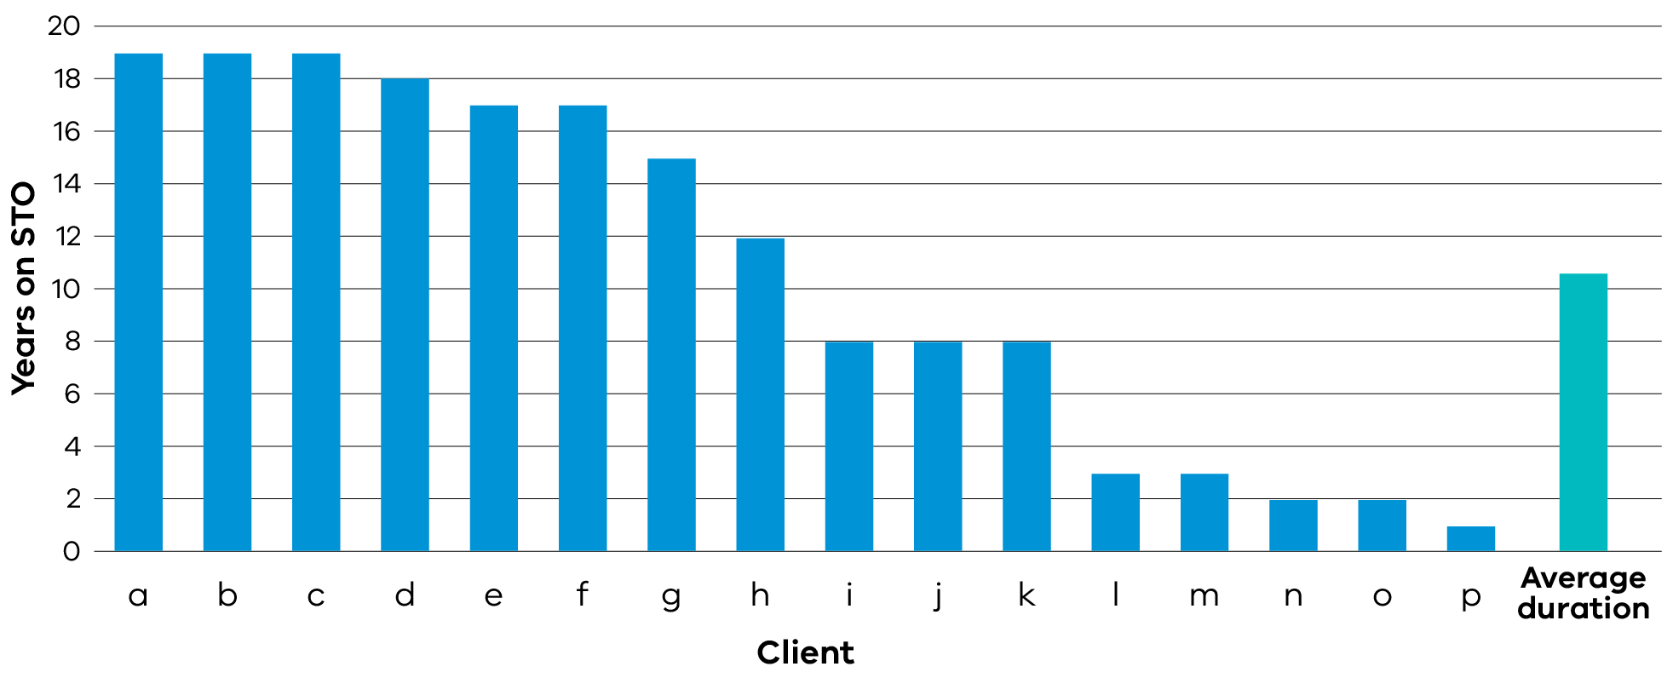
Note: This graph represents a snapshot in time of the STO cohort. These figures are current as of 30 June 2026.
STOs provide safeguarding oversight and human rights considerations, but they are a civil order and not intended to be ongoing. The intent of compulsory treatment under Pt 8 of the Disability Act is to provide targeted treatment to people who are, or need to be, detained. This treatment aims to reduce the significant risk of serious harm they pose to others. The aim is to deliver individualised treatment within a highly restrictive context while protecting the human rights of people subjected to compulsory treatment.
The Senior Practitioner has partnered with Code Black Psychology on a project to guide the review and reduction of restrictive practices for people subject to an STO. This work goes beyond what is needed under the legislation. The framework will also guide the Senior Practitioner to identify and help service providers to overcome barriers to moving people to less restrictive forms of support. The review framework will be based on 3 quality control review processes. It will provide clinical direction to step down and fade out planning for restrictive practices. These quality control review processes will include:
- risk mitigation audit to support guidance on serious harm to others
- structured fade out and step-down guidance to create benefit
- connecting the behavioural pattern to guidance on the need for restrictions
The project started in April this year and will be completed by December 2026. The framework will be an internal document, however extra resources will be developed to share with the sector. This will also include gathering feedback from stakeholders including people with lived experience.

Self-determination
The Senior Practitioner is committed to improving safeguards for First Nations communities. An essential part of this process is ensuring accurate and meaningful data is captured in RIDS. For the past 2 years, the Senior Practitioner has reported on data that shows several First Nations people, including children, are subjected to restrictive practices. Next year, a key focus for the Senior Practitioner is to embed self-determination and cultural safety in our work – including our work with First Nations people with disability who experience restrictive practices.
We will work to build stronger partnerships with First Nations–led organisations. We will seek out, and amplify, the voices of First Nations people with disability. This will include highlighting examples of good work already occurring both at the state and national levels. This foundation will help the Senior Practitioner develop a clearer First Nations disability strategy that supports appropriate services and delivers equitable outcomes for First Nations people with disability.

Winning artwork See Me Hear Me by Laura Trist from the Barbara Donovan & Sarah Guilfoil Art Competition Award. The awards are sponsored by Victoria State Government and were presented at the VALID Having a Say Conference 2026.


Enhanced safeguarding through improved systems, processes and technology

Restrictive practices audit review
The Senior Practitioner can investigate, audit and track restrictive practices and compulsory treatment. Under s 27(2)(c) of the Disability Act, these powers allow the Senior Practitioner to:
- visit and inspect any premises where a restrictive practice or compulsory treatment may occur
- request information relating to the restrictive practice
- see any person subjected to a restrictive practice or compulsory treatment.
These special powers enhance safeguarding by the Senior Practitioner. They also offer an opportunity to work directly with providers to improve the lives of people with disability. This is through supporting them to reduce and eliminate restrictive practices. In 2025–26 the Senior Practitioner conducted 8 audits:
- 4 audits of SIL providers
- 1 audit of a day service provider
- 3 service-wide audits.
A recurring theme in these audits was the lack of an appropriate environment that:
- supported best practice
- promoted independence
- promoted residential conditions consistent with community standards.
In 2025–26, as part of this work, the Senior Practitioner spent a week visiting registered NDIS providers in the Mallee region. She met with participants subjected to restrictive practices. The visits gave her the chance to hear directly from participants about the impact of restrictive practices. The Mallee visit resulted in 2 of the service-wide audits mentioned above. The audits aimed to provide more support and information to 2 small, newly established providers.
The Senior Practitioner will continue to visit rural and regional areas over the coming year.

Desktop reviews
In 2025–26 the Victorian Senior Practitioner conducted 209 desktop reviews of authorisations of chemical and environmental restraint. The first aim was to ensure appropriate APO decision-making. The second aim was to offer practice guidance to help reduce restrictive practices.
We chose BSPs based on the level of restriction authorised. The BSPs focused on participants subjected to polypharmacy and multiple environmental restraints. We referred participants at high risk of polypharmacy or on medications with unclear indications to the Victorian Dual Disability Service for a second opinion. We also focused on reviewing decisions made by new providers (APOs) to ensure consistency in practice.
The desktop review process revealed the following:
- Providers met the legislative criteria for authorisation only 13% of the time.
- 21% of submissions had unidentified chemical or environmental restraints that needed re-submission and then authorisation.
- 5% of submissions had an unidentified restrictive practice that needed secondary approval from the Senior Practitioner.
- 23% of submissions did not meet requirements under the NDIS Rules 2018. The key reasons are in Figure 2.
Figure 2: Reasons for not meeting requirements under NDIS Rules 2018
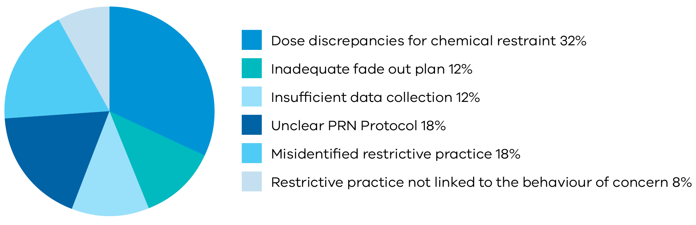

Key findings – desktop reviews
- A total of 209 desktop reviews started in 2025–26.
- Of those, 206 had closure outcomes recorded (Figure 3). Three desktop reviews started but did not have a closure outcome recorded because:
  - 1 client passed away
  - 2 clients left or changed their provider.
- Of the 206 desktop reviews, 22% of authorisations had more than one reason for not meeting the criteria.
Figure 3: Closure outcomes in 2025–26
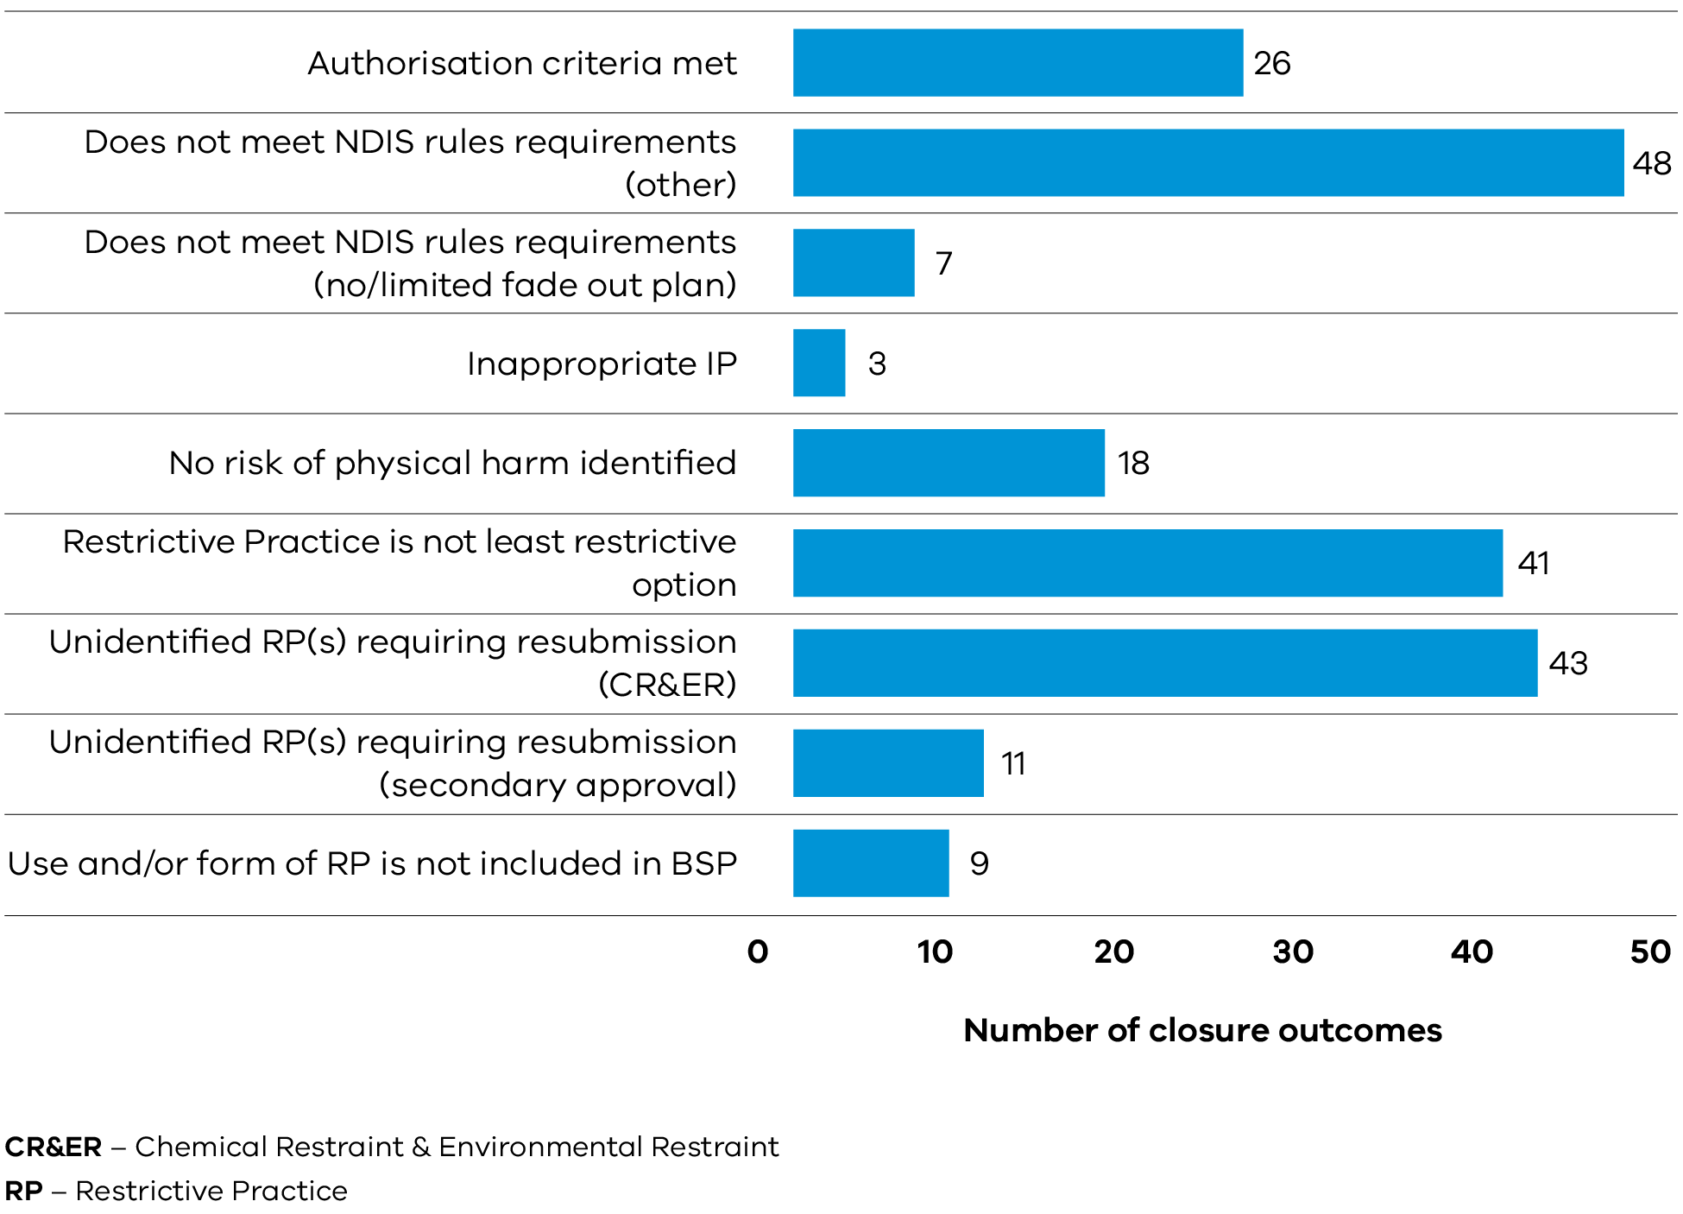

Consultations

Practice advice and consultations – Integrated Practice Advisory team
The Senior Practitioner continues to advise the sector on positive behaviour support and regulated restrictive practices.
In 2025–26 the Integrated Practice Advisory team provided practice advice 1,502 times. This represents a 17% decrease on the previous year. Of those, 758 instances related to a specific person with a BSP. The other 744 instances were general practice queries. Around one-third of all requests for consultation were from APOs. Another third came from behaviour support practitioners. The final third were from people working in other roles.
Most queries are general, covering:
- the broader regulatory environment
- compliance
- role clarity.
The Senior Practitioner will use this information to see how our other practice leadership and sector capability uplift activities can support this sector need.
The Senior Practitioner also provides internal consultation to the department’s frontline workforce. This includes Child Protection and Housing. In 2025–26 the Senior Practitioner provided 24 consultations to child protection practitioners across 9 areas. The key themes from these consultations were:
- children and young people with a disability presenting with increasing complex behaviours of concern
- family and carer burnout, or fragmented service system responses that have resulted in notifications to Child Protection
- Increasing awareness of what defines restrictive practice use by residential providers and requests for advice on alternative less restrictive practices.
Winning artwork Safe Nest by Jason Vu from the Barbara Donovan & Sarah Guilfoil Art Competition Award. The awards are sponsored by Victoria State Government and were presented at the VALID Having a Say Conference 2026.


Culture and capability

The Senior Practitioner Seminar
Each December the Senior Practitioner holds an annual seminar. The seminar gives the Senior Practitioner an opportunity to:
- engage with the Victorian disability sector
- provide updates about research projects
- come together to share strategies for reducing and eliminating restrictive practices.
In 2025 more than 130 people attended the seminar in person. Another 200 people joined online.
The 2025 seminar opened with a focus on the lived experience of people subjected to restrictive practices. This included a yarn with a First Nations man about his experiences of restrictive practices and his life in an RTF. A second man talked about his experiences of being on an STO and his move to independent living.
Another highlight was a panel discussion on multidisciplinary collaboration in the medication review process. The panel included:
- Andrew Pridding (Nurse Practitioner, Victorian Dual Disability Service)
- Dr Danny Sullivan (Clinical Director, Forensicare)
- Dr David Huppert (Deputy Chief Psychiatrist, Department of Health)
- Dr Susan Schlicht (General Practitioner).
A vibrant discussion arose on how behaviour support practitioners might work better with prescribers to overcome barriers to reducing psychotropic medication use. Dr Sullivan outlined the limitations of long-term use of psychotropic medications including potential harms. Dr Schlicht also shared a real-world example of supporting a person with disability and complex needs to reduce psychotropic medications. This included practical tips for clinicians.
Our seminar evaluation showed that more than 60% of survey respondents considered the participant’s stories and experiences a highlight. We will build on that by continuing to amplify the voices of people with disability subjected to restrictive practices in future seminars.
We will also consider feedback from the evaluation on improvements, such as:
- adding more interactive sessions and using tools that would allow the organisers to address common questions throughout the day
- having shorter presentations to cover a broader range of topics
- focusing on real-life case studies and good news stories
- including more specialised panels or workshops on common themes.

Annual Satisfaction Survey
In December 2025 the Senior Practitioner conducted our first annual satisfaction survey. The survey is a yearly pulse check with the sector to gauge progress and assess impact. There were 188 respondents to the survey. Overall, the survey results point to a strong appreciation of the Senior Practitioner’s commitment to upholding human rights and providing valuable guidance on using restrictive practices.
Common themes were that the Senior Practitioner provides:
- valuable guidance and good quality factsheets – ‘the VSP create a safe space to raise questions and seek direction’
- prompt responses and a commitment to improving practice – ‘I like the promptness’ and the ‘honesty about what is expected in terms of compliance’
- tailored advice and support – ‘VSP office conducting online meetings and follow-up meetings with providers supporting complex presentation regarding [restrictive practices]’.
The survey results also highlighted some key areas for improvement. Results suggested several ways for the Senior Practitioner to foster a more connected relationship with the sector. Key themes were:
- systems and processes – improving and streamlining data systems and the authorisation process
- sector engagement – improving consistency and clarity in practice advice, including clearly defining expectations on legislative compliance
- education and practice uplift – focusing education on practical applications based on clinical and legislative guidance for service providers.
Some respondents said the Senior Practitioner webpage is cumbersome and difficult to navigate. In response, we have begun overhauling the webpage. The project will turn the webpage into an easy-to-navigate information hub that includes:
- more information about the Senior Practitioner's responsibilities and powers
- up-to-date, evidence-informed resources
- information on practice guidance and compliance
- on-demand learning resources.
The revised webpage will launch in October 2026. Adding new resources and information will be an ongoing process.
The Senior Practitioner is committed to strengthening how we measure and evaluate impact. We are also looking at how we use stakeholder feedback to inform and improve practice. To this end, we are planning to embed evaluations in all major initiatives. The annual satisfaction survey will continue to be one way to identify areas for improvement and drive changes. Another will be looking at ways to more effectively gain feedback from those with lived and living experience.

Looking ahead
The Victorian Senior Practitioner has begun planning activities for next year and beyond. We are focusing on 3 phases:
- building the foundation
- strengthening impact
- realising our ambition.
This approach recognises that sustainable change must include sequencing and ongoing reflection.
Key priorities for the coming year include:
- co-developing a First Nations disability voice framework alongside people with lived and living experience
- improving data collection focused on outcome measurement, including IT system upgrades
- translating data into evidence-informed practice
- developing practice guidance to assist the sector to reduce and eliminate restrictive practices.
We look forward to celebrating carrying out the Strengthening safeguards plan over the coming years.
Winning artwork Disability Pride 2025 by Gavin J Porter from the Barbara Donovan & Sarah Guilfoil Art Competition Award. The awards are sponsored by Victoria State Government and were presented at the VALID Having a Say Conference 2026.


Appendix: Senior Practitioner plan 2026–2030 figure description

Our purpose
We are committed to upholding human rights and improving the quality of life for vulnerable Victorians with disability.
We do this by building the capacity of the disability sector to reduce and eliminate restrictive practices through:
- education and training
- practice leadership
- research and data collection
- monitoring service provision
- systematic collaboration.

Our vision
A confident, cohesive Senior Practitioner leads a capable and connected sector. The sector reduces the use of restrictive practices and prioritises human rights, lived experience and self-determination.
This vision reflects our long-term aspiration: a system that understands, applies and sustains safeguards for people with disability.

Five practice pillars

Pillar 1: Client voice and self-determination
We will:
- develop and implement a client voice framework
- include lived experience representation (staff and/or advisory capacity)
- strengthen engagement with carers
- use participatory action-research approaches
- build strong First Nations partnerships.
We will demonstrate success through:
- embedded lived experience in decision-making
- co-designed initiatives
- clear First Nations disability strategy pathways.

Pillar 2: Practice leadership and sector capability
We will:
- provide education and resourcing to providers
- strengthen Aboriginal Community Controlled Organisation and community partnerships
- build cross-departmental relationships
- reduce unnecessary sector reliance on the Senior Practitioner
- establish and maintain sector practice leadership.
We will demonstrate success through:
- increased provider capability
- strong sector collaboration.

Pillar 3: Data, evidence and impact
We will:
- develop an outcomes measurement framework
- embed evaluation in all major initiatives
- strengthen annual reporting and inform strategic decisions with richer outcomes data.
We will demonstrate success through:
- clear measurement of impact
- evidence of reduced restrictive practices
- improved data transparency.

Pillar 4: Systems, processes and technology
We will:
- conduct a comprehensive stocktake of current work
- streamline processes and reduce administrative load
- enhance IT systems and technology solutions.
We will demonstrate success through:
- more efficient workflows and reduced duplication
- technology-enabled practice improvements.

Pillar 5: Culture and capability
We will:
- align professional development plans with strategic priorities
- uplift Senior Practitioner team capability to strengthen operational leadership
- promote reflective practice
- build workforce diversity including lived experience
- use stakeholder feedback to inform practice.
We will demonstrate success through:
- developing the Senior Practitioner learning and development framework
- high engagement and collaboration within the Senior Practitioner’s office and with stakeholders.
Return to Safeguarding practice – Senior Practitioner plan 2026–2030.

https://www.accesshub.gov.au/about-the-nrs/nrs-call-numbers-and-links
https://www.accesshub.gov.au/about-the-nrs
Australian Bureau of Statistics (2017) Survey of Disability, Ageing and Carers, 2009 and 2012, ABS, Canberra.
Productivity Commission (2024) Closing the gap annual data compilation report, Productivity Commission, Canberra.
https://www.dffh.vic.gov.au/victorian-senior-practitioner-elearning-modules.
https://apovic.com.au/.
Refer to the Authorised Program Officers Victoria Communities of Practice https://apovic.com.au/guide/communities-of-practice?lang=en
Refer to the Senior Practitioner – eLearning modules webpage https://www.dffh.vic.gov.au/victorian-senior-practitioner-elearning-modules.
Thomas S, Sullivan D and Daffern M (2026) ‘Lived experience perspectives of Supervised Treatment Orders’, Australian Journal of Human Rights, 1–7. https://doi.org/10.1080/1323238X.2026.2691335

