
Victorian Senior Practitioner report 2021–2022
Easy English summary


Cover: Artwork by Hanna Wilkinson, a winner of
the Barbara Donovan Art Competition Award at the
Having a Say Conference 2012 (Theme: ‘My Life My Way’)
To receive this publication in another format phone 9096 8427, using the National Relay Service 13 36 77 if required, or email VictorianSeniorPractitioner@dffh.vic.gov.au.
Authorised and published by the Victorian Government,
1 Treasury Place, Melbourne.
© State of Victoria, Australia, Department of Families,
Fairness and Housing, February 2023.
ISSN 2653-0260 (online/PDF/Word)
Available at the Victorian Senior Practitioner web page
<https://www.dffh.vic.gov.au/victorian-senior-practitioner>.
(2211363 – cover, artwork)

A message from the Victorian Senior Practitioner
Welcome to my report. My name is Mandy Donley. I work with a team of people.
This is our Plain English Annual Report. This report is about our work from July 2021 to June 2022. In the rest of the report, I will write 2021–2022.
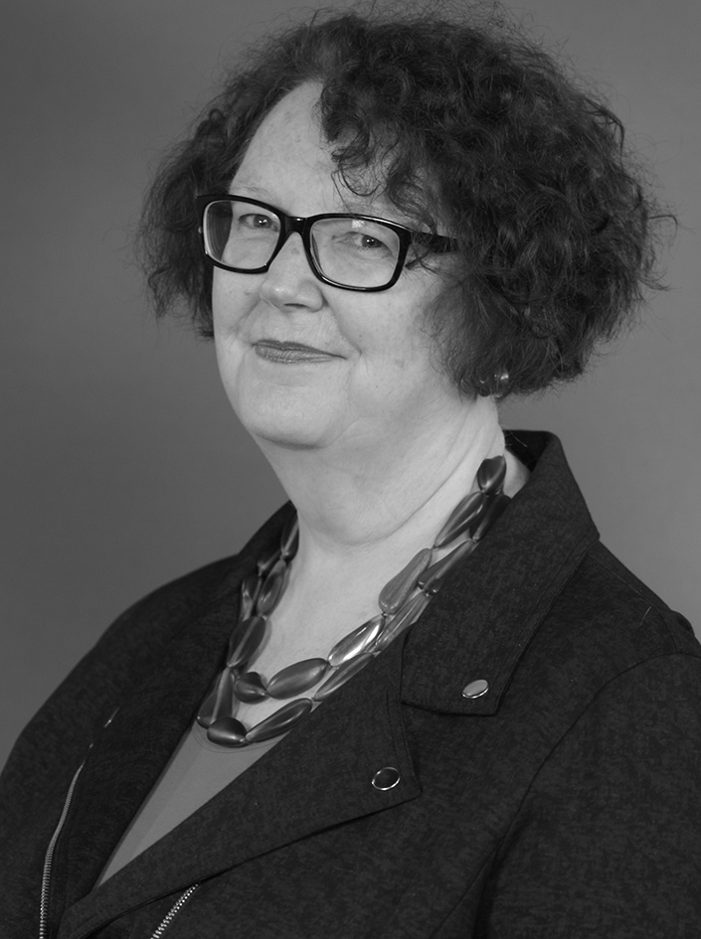

This year there were two Victorian Senior Practitioners. Frank Lambrick was the Senior Practitioner from June to December 2021. I became the Senior Practitioner in April 2022.
I will do my best to protect the rights of people with a disability in Victoria who have restrictive practices.
The rules about restrictive practices vary across different states and territories of Australia. The rules are changing to make them more similar across Australia. The changes can be difficult for people to understand.
Most people with disability in Victoria who have restrictive practices get support from the NDIS. Some information about restrictive practices goes to the NDIS. Some information goes to me as the Senior Practitioner.
We keep learning about people with disability in Victoria who have restrictive practices.

We worked on 4 special projects this year:
- Listening to what people with disability say about restrictive practices and our work
- Helping Authorised Program Officers do a good job
- Reducing chemical restraint
- Working with people with supervised treatment orders.
Thank you to all the staff who work for me. Thank you to the families and services who work with us.
Mandy Donley
Victorian Senior Practitioner

Contents
A message from the Victorian Senior Practitioner 3
Restrictive practices 7
The job of the Victorian Senior Practitioner 8
Important numbers in the report 9
Knowing about the restrictive practice used with people with disability in Victoria 10
Restrictive practices approved in Victoria 10
Behaviour support plans 11
Visiting services to see if restrictive practices are being used 12
Compulsory treatment 13
Learning more about restrictive practices through special projects 14
Teaching other people about supporting people who use behaviours of concern 16
Working with other people to help reduce the use of restrictive practices 17
Making things better by writing and talking about restrictive practices 18

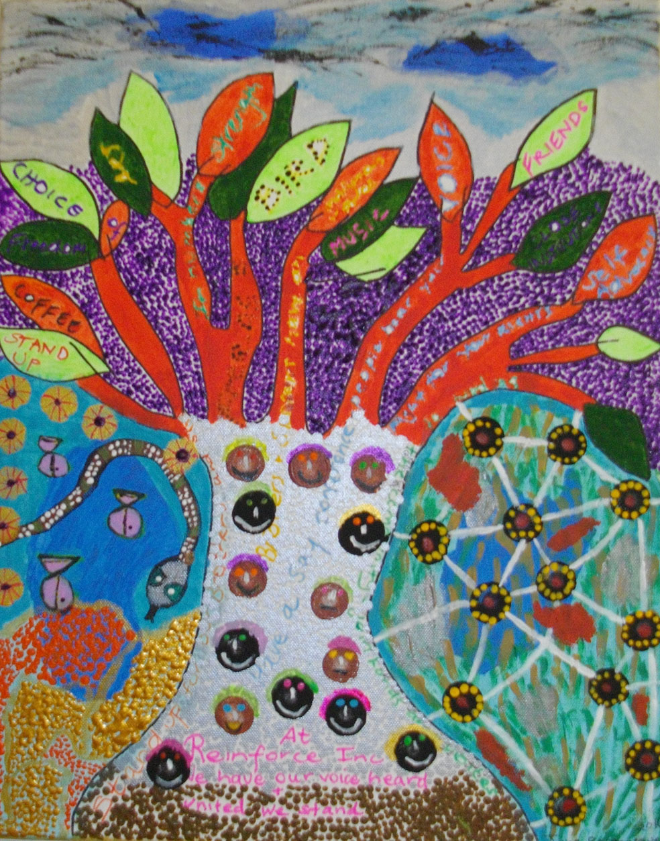
Artwork by Jane Rosengrave, a winner of the Barbara Donovan Art Competition Award at the Having a Say Conference 2016 (Theme: ‘Ready, Set, Connect!’)

Restrictive practices
Restrictive practices are things done to another person to stop them from doing behaviours of concern.
A behaviour of concern might be a behaviour like hurting yourself or hurting another person. It might be a behaviour like deliberately breaking furniture.
Restrictive practices are things that restrict the rights of a person using behaviours of concern. There are a few different types of restrictive practices: chemical, mechanical, physical, environmental, and seclusion.
- Chemical restraint is medication given to someone to stop them doing a behaviour. It does not include medications for health problems or mental illness.
- Mechanical restraint is use of equipment to stop someone moving. Mechanical restraint could be a bodysuit that stops someone touching their body, or a splint to stop someone moving their arm. A seatbelt and buckle guard used in a car is not a mechanical restraint.
- Physical restraint is another person strongly holding someone to stop them from moving. It is different from helping someone gently.
- Environmental restraint is changing a person’s house or space so they cannot get to their things freely. For example, locking the door so someone cannot get their food or technology is environmental restraint.
- Seclusion is locking someone in a room so they cannot get out.

The job of the Victorian Senior Practitioner
The job of the Senior Practitioner is to protect the rights of people with disability in Victoria who have restrictive practices.
Victoria has had a Senior Practitioner since 2006, when the Disability Act started. In 2019 there was a change in the Disability Act because NDIS started. The changes said what we must do and what the NDIS must to do.
This year, the Act said that we must:
- Know about the restrictive practices used with people with disability in Victoria
  - Say yes or no to disability services when they ask for permission to use restrictive practices
  - Give special instructions to disability services if there are worries about restrictive practices
  - Talk with the NDIS Commission
- Write guidelines about the safest way to use restrictive practices
- Learn more about restrictive practices by doing special projects
- Teach people about restrictive practices and supporting people who use behaviours of concern.
The Senior Practitioner has an important role for people in compulsory treatment. Compulsory treatment is when somebody from the law courts has said that that someone with a disability has broken the law and must have specific treatment. The Senior Practitioner must see treatment plans and know about any restrictive practice that will be used with these people.
This report is about how we did these jobs from July 2021 to June 2022.

Important numbers in the report
- The number of people who we said could have
restrictive practices 2,335
- The number of people who had different types
of restrictive practices:
  - Chemical restraint 1,884
  - Environmental restraint 1,329
  - Mechanical restraint 265
  - Seclusion 79
  - Physical restraint 41
- The number of times we have helped people
with their questions 2,838
- The number of people trained by us 150
- The number of care team meetings that we went to 185
- The number of VCAT hearings that we went to 47

Knowing about the restrictive practice used with people with disability in Victoria
One of the jobs of the Senior Practitioner is knowing about restrictive practices in Victoria.

Restrictive practices approved in Victoria
We make the decision about when restrictive practices can be used with Victorians who get NDIS supports. This is sometimes called authorisation and approval. Services send us an application to use a restrictive practice with a person.
The application must:
- Name the restrictive practice
- Name why the restrictive practice is needed, and is the best choice for the person (this is sometimes called the least restrictive option)
- Show a plan for using less restrictive practice over time.
We said ‘yes’ to the applications for 2,335 people. There were 261 children and 2,080 adults.
Chemical restraint was the most asked for restrictive practice. Many of the people were given antipsychotic medication, but they did not have a diagnosed psychotic illness. The medication was given to change their behaviour. Many people were given medications to make them sleepy and change their behaviour.
265 people had applications for mechanical restraint, such as clothes or straps that stopped them from moving their body. The number of people with mechanical restraint has increased.
79 people were given approval to have seclusion to control their behaviour.
41 people had physical restraints. This means people held their body strongly to stop them from moving. We need to learn why physical restraint is increasing.
Environmental restraints were approved in the houses or services of 1,329 people. People had locked doors, and food or things locked away.

Behaviour support plans
A behaviour support plan is a written report about a person with a disability who uses behaviours of concern. It is a plan that says how staff should support the person. It should be a plan that says that restrictive practices will only be used after all other planning and responses have been tried. This is called using the least restrictive option.
A behaviour support plan contains lots of information.
We know that behaviour support plans that are written well can help to improve people’s lives.
The Senior Practitioner uses a special checklist called the Behaviour Support Plan – Quality Evaluation II or BSP-QEII to measure how good a behaviour support plan is.
The Senior Practitioner looked at some of the plans using the BSP-QEII to check if they had the right information in them.
This year’s plans were better than last years. The plans were written by NDIS registered Behaviour Support Practitioners.

Many of the plans included:
- A clear description of the behaviour
- The things that happened right before behaviours or concern; these are sometimes called trigger or setting events
- Some ways to fix the triggers and settings
- Some ways to calm down behaviours of concern when they were happening.
Many of the plans could be made better by:
- Better information about supporting new skills and great behaviours
- Clear goals for teams to achieve
- Clear plan of how the team will work together
- Clear language that is easier for support teams to read.

Visiting services to see if restrictive practices are being used
We visited services to see what restrictive practices were used. We talked to the services about what we saw.
We visited services when we were concerned about restrictive practice use. We visited services when we were concerned that support teams were not following behaviour support plans.
Sometimes we saw services using restrictive practices without permission.
We saw that some people with disabilities needed better health support. We saw that some teams needed more support to follow behaviour support plans. We saw many restrictive practices being used with children.

Compulsory treatment
The Victoria Senior Practitioner helps people who have compulsory treatment. Compulsory treatment is a special law for people with an intellectual disability who are at serious risk of hurting other people. The law says the person must have specific treatment.
Some people with compulsory treatment must live in specific services. This is called a supervised treatment order. A person might be living in locked doors and be watched all the time if they leave the house.
48 people had compulsory treatment this year. 24 of the people had supervised treatment orders.
Four people did not need a supervised treatment order any more during the year; they could move about freely. But three different people went to jail for crime.
Nearly all the people with compulsory treatment were men. Many of them had been violent to other people.
All of the people had restrictive practices. They had locked doors. Many of them had medication to change their behaviour. Some of the people had seclusion plans.

Learning more about restrictive practices through special projects
The Senior Practitioner does special projects to learn more about restrictive practices.
We worked with the University of Melbourne on two different training programs for behaviour support practitioners and Authorised Program Officers. Hundreds of people will do these training programs.
We worked with residential aged care providers who support people with disabilities and use restrictive practices. We knew that 34 people getting support from NDIS were living in aged care and had restrictive practices. We taught them about laws about restrictive practices. We talked to them about working with us about restrictive practices.

I, Mandy Donley, started four other new projects.

1. Reducing the use of medications for moods and behaviours
A government report said there was too much mood and behaviour changing medication being used with people with disability and older people.
This project is about teaching people about using mood and behaviour medications for the wrong reasons. It is about doing things better.

2. Authorised Program Officers
Authorised Program Officers are people in disability services who look at behaviour support plans before sending the plans to us. This year, many of the plans that Authorised Program Officers sent were not good enough. We had to send them back to them to fix them.
We will work more with Authorised Program Officers to help them do their job better.

3. Supervised treatment orders
There are some people who have had supervised treatment orders for more than 10 years. Nobody is meant to be on a treatment order for so long. We want to understand what is going wrong for some people.

4. A client voice at the Senior Practitioner
We believe that people with disability who have restrictive practices should be able to talk to us about what they think. We are calling this ‘a client voice framework’. We are learning about the best way to have a client voice.

Teaching other people about supporting people who use behaviours of concern
One of the jobs of the Senior Practitioner is to give training and education.
We ran a lot of training about restrictive practices. We taught more than 150 people:
- What restrictive practices are
- When restrictive practices can be used
- The permission that is needed to use restrictive practices
- Reducing the use of restrictive practices.
We also ran training about the ARMIDILO assessment tool. This is special questionnaire about the risks and how to manage a person with an intellectual disability who might do sexual crimes. We talked with people who did ARMIDILO training in the past years.

Artwork by Ben Chew, a winner of the Barbara Donovan
Art Competition Award at the Having a Say Conference 2020
(Theme: ‘A good life – are we there yet!’)

Working with other people to help reduce the use of restrictive practices
The Senior Practitioner works with other services to share information, learn together, and do new projects.
Here are the things that we did this year.

Answering questions
Every day people call and email us to ask questions about restrictive practices. We were contacted 2,763 times this year. We are getting more questions every year.

Helping at complex client meetings
We went to 64 meetings for people with disability who were very complex.

Compulsory treatment training
We ran 2 big training sessions on compulsory treatment.

Care team meetings for people under compulsory treatment
The compulsory treatment team works with lots of people who support people in compulsory treatment. The team went to 185 care team meetings. They had many other conversations about the people. The team went to 47 VCAT hearings and 2 hearings at the Supreme Court of Victoria.

Making things better by writing and talking about restrictive practices
Every year we hold a big presentation to tell people about our work. We share information about other good things that are happening for people.
This year we ran the session online. More than 150 people watched the presentations.

Artwork by Brady Freeman, a winner of the Barbara Donovan
Art Competition Award at the Having a Say Conference 2017
(Theme: ‘Leading YOUR Life’)



