
Victorian Senior Practitioner report 2021–22


Cover: Artwork by Hanna Wilkinson, a winner of the Barbara Donovan Art Competition Award at the Having a Say Conference 2012 (Theme: ‘My Life My Way’)
To receive this publication in another format phone 9096 8427,
using the National Relay Service 13 36 77 if required, or email VictorianSeniorPractitioner@dffh.vic.gov.au.
Authorised and published by the Victorian Government, 1 Treasury Place, Melbourne.
© State of Victoria, Australia, Department of Families, Fairness and Housing, February 2023.
ISSN 2653-0260 (online/PDF/Word)
Available at the Victorian Senior Practitioner web page
<https://www.dffh.vic.gov.au/victorian-senior-practitioner>.
(2211363 – cover, figures, artwork)

Message from the Victorian Senior Practitioner

Welcome to the 2021–22 Senior Practitioner report. The report describes the functions and achievements of the work of the Victorian Senior Practitioner during the 2021–22 financial year. It was a busy year that was bookended with the retirement of Dr Frank Lambrick in December 2021 and my own appointment to the position in April 2022.
I would like to thank Frank for his exceptional work in protecting the rights of people with disabilities subject to restrictive practices. Frank (along with others, including Dr Lynne Webber) was awarded the 2020 Australasian Research Prize for his work on the journal article ‘Factors associated with long-term use of restrictive interventions’ (Richardson, Webber & Lambrick). This was a well-deserved accolade for an important piece of work that helps protect and safeguard the rights of people with disability.


It was an honour to be appointed Senior Practitioner in April this year. I will do my best to protect the rights of people with disability subject to restrictive practice to the greatest extent possible. As we are all aware, the National Disability Insurance Scheme (NDIS) Quality and Safeguards Commission regulates behaviour support practice in Australia. Currently, each jurisdiction operates in its own way to reduce and eliminate the use of restrictive practices within its own authorisation framework. As we work towards a nationally consistent model, it is important that we acknowledge that this can be a difficult landscape to navigate for all our stakeholders.
The transition of our safeguarding mechanisms to the NDIS began on 1 July 2019 with the transfer of approximately 2,600 people (over two years) to NDIS service providers. This process is now almost complete. Only about 15 people were transferred from state-funded (in-kind) services in 2021–22.
From our monitoring of restrictive practices over 2021–22, we know that the number of people authorised for chemical restraint trended lower immediately after the introduction of the NDIS. However, chemical restraint has since begun to rise again, although it has yet to return to pre-2019 levels. Also, like the trends in previous years, antipsychotic and sedative medications continue to be the most commonly authorised chemical restraints.
This year, we embarked on four new projects. One is targeted at amplifying client voice in all the work we do, and another is aimed at capacity building for authorised program officers. A third project is aimed at reducing chemical restraint and a fourth comprises an internal review of how supervised treatment orders are implemented in Victoria. These projects are all at various stages of development and more information about each one of these projects can be found in the projects section of this report. We are also in the early stages of conceptualising a fifth project to mark 10 years since the release of the Senior Practitioner physical restraint direction paper, which was released in May 2011. This direction paper was replaced on 10 September 2019 by the Senior Practitioner physical restraint direction paper: guidelines and standards. This project will examine the changes that were necessary due to the amendments to the Disability Act 2006 and the impact those changes have had on safeguards in Victoria for the use of physical restraint.

I would like to take this opportunity to thank all our staff for the dedicated work they have undertaken during the year. Over the past few years, the environment we are working in has become increasingly complex, and the ongoing commitment of all our staff to protecting the rights of people with disabilities subject to restrictive practices and compulsory treatment has been outstanding. I would also like to acknowledge the contributions of people with disability, families, carers advocates, our colleagues, project partners, internal and external stakeholders, disability and NDIS service providers, and professionals who collaborate with us in our work. We look forward to continuing this work over the coming years.
Mandy Donley
Victorian Senior Practitioner
Contents
Message from the Victorian Senior Practitioner 3
The role of the Senior Practitioner 7
Snapshots of the 2021-2022 annual report 8
Monitoring and evaluating practice 9
Authorisation and approval of restrictive practices 9
Behaviour support plan quality evaluations 18
Restrictive practices audit review 19
Compulsory treatment 19
Compulsory treatment data 20
Victorian Civil and Administrative Tribunals hearings 24
Projects to deliver evidence-informed outcomes 25
Enabling Quality Behaviour Support Planning online course 25
Online training for authorised program officers 25
Residential aged care project 26
Four new projects in development 27
Promoting best practice through professional development 28
Restrictive practices reduction training 28
ARMIDILO-S and ARMIDILO-G training 28
Supporting best practice through advice, partnerships and consultation 29
Practice advice and consultations 29
Compulsory treatment practice forums 29
Care team meetings, case consultations and VCAT hearings 30
Informing public debate and opinion 31
The Senior Practitioner Seminar 2021 31
References 32
Appendix: Data tables for figures 33


Artwork by Jane Rosengrave, a winner of the Barbara Donovan Art Competition Award
at the Having a Say Conference 2016 (Theme: ‘Ready, Set, Connect!’)

The role of the Senior Practitioner
The Senior Practitioner role was established in 2006 when the Victorian Parliament enacted the Disability Act 2006 (the Act). The Senior Practitioner is responsible for protecting the rights of people with disability who are subject to restrictive practices such as restraint and seclusion, and compulsory treatment.
The Act was amended in 2019. The Disability (NDIS Transition) Amendment Act 2019 made amendments to the Act to enable Victoria to meet its obligations under the NDIS quality and safeguarding framework. Changes also ensure safeguards for people with disability in Victoria were not diminished during the transition to the full scheme under the NDIS.
Key amendments to the Act included:
- providing a process for authorising and prohibiting the use of restrictive practices by the Senior Practitioner for NDIS participants
- enabling the Senior Practitioner to give directions to registered NDIS providers and to notify the NDIS Quality and Safeguards Commission of matters relating to restrictive practices
- enabling the transfer and disclosure of information relating to registered NDIS providers and NDIS participants.
The Act continues to mandate:
- development of guidelines and standards for restrictive practices and compulsory treatment
- research into the use of restrictive practices and compulsory treatment
- provision of relevant education – for example, about human rights and positive behaviour support – to workers involved in supporting people with disability.
The Act also mandates specific responsibilities of the Senior Practitioner to:
- approve and monitor treatment plans developed for people subject to compulsory treatment
- oversee the implementation of supervised treatment orders
- issue lawful directions to disability services on any law, policy or practice, where relevant, to a compulsory treatment order matter.
The purpose of this report is to outline trends in the use of restrictive practices, compulsory treatment and behaviour support planning. It also describes how our safeguarding activities have specifically improved the lives of people with disability over the course of the financial year from July 2021 to June 2022.

Snapshots of the 2021-2022 annual report
Figure 1: Restrictive practices (authorised and approved) snapshot
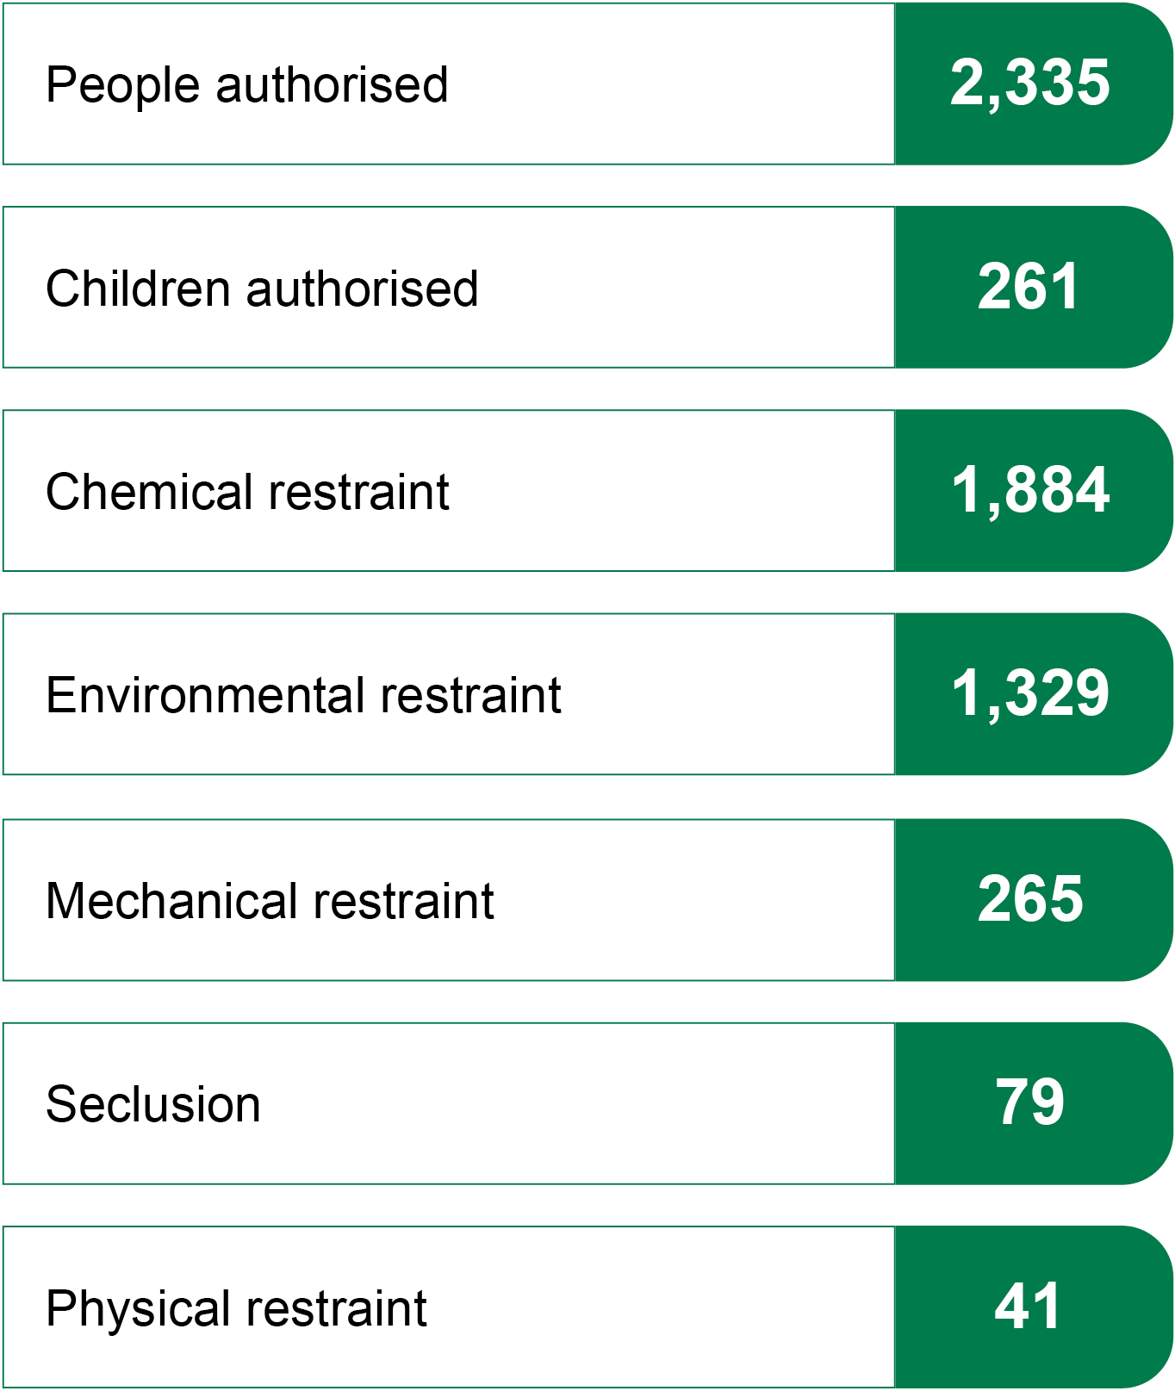
Refer to the Appendix for the Figure 1 data table
Figure 2: Practice leadership and training snapshot
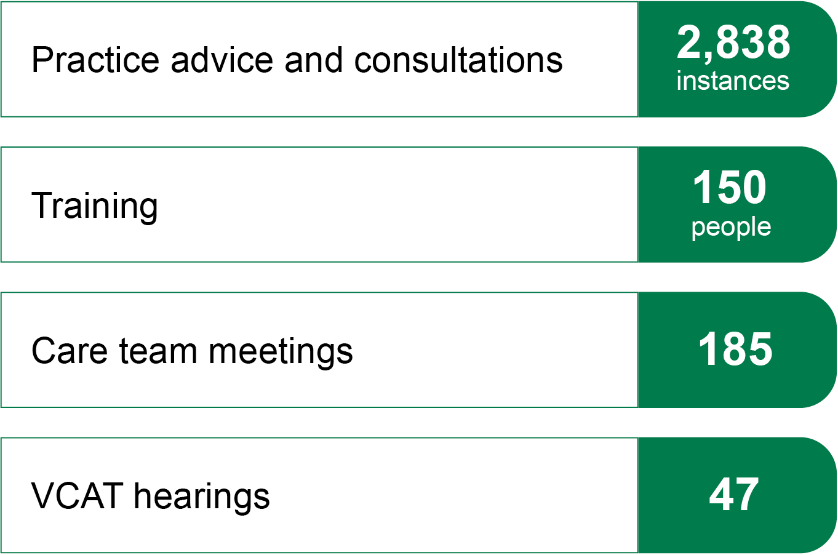
Refer to the Appendix for the Figure 2 data table

Monitoring and evaluating practice
A function of the Victorian Senior Practitioner is ‘to evaluate and monitor the use of restrictive practices across services and to recommend improvements in practice to the Minister and the Secretary’ (Disability Act, s 24(1)(h)). The first part of this section of the annual report details the authorisation of restrictive practices from NDIS-registered service providers and the quality of behaviour support plans (BSPs) received from NDIS service providers. The second part of this section reports on the use of compulsory treatment in Victoria.
In previous annual reports the Senior Practitioner has provided figures on the reported use of restrictive practices by services who received state funding. However, with the transition to the NDIS now almost complete, very few state-funded (in-kind) services exist. For instance, in 2021–22 only about 15 people were transferred from state-funded services onto the NDIS, compared with about 1,100 in the previous year. Given such small numbers, this report does not include standalone figures on the reporting of restrictive practices to the Restrictive Intervention Data System (RIDS) by state-funded (in-kind) services in Victoria. Rather, these figures have been incorporated into the overall authorisation and approval figures. Moreover, this report (and all future annual reports) will focus in more detail on figures concerning the authorisation and approval of restrictive practices for NDIS participants in Victoria. Such an approach is appropriate because it ultimately reflects the core business of the Senior Practitioner in the new environment characterised by a rapidly maturing NDIS.
Data on the use of chemical restraint, mechanical restraint and seclusion have been collected since 2008–09. Data on physical restraint have been collected since 2011–12. Data on the use of environmental restraint were only captured for the first time in 2020–21.

Authorisation and approval of restrictive practices
For NDIS participants in Victoria, the Senior Practitioner is responsible for approving the use of seclusion, mechanical restraint and physical restraint, and for authorising chemical and environmental restraint.
The Senior Practitioner and the Integrated Practice Advisory team review applications to use restrictive practices to ensure compliance with the following legislative requirements:
- The use of the regulated restrictive practice is necessary to prevent harm to self or others.
- It is the least restrictive practice option under the circumstances.
- There is evidence of planning for reducing the regulated restrictive practice.

Authorised and approved use of restrictive practices
in disability service providers – general
This section of the report presents some general, or overall, findings for restrictive practices approved and authorised by the Senior Practitioner in 2021–22 in comparison with previous years (Tables 1 and 2). For historical data relating to state-funded services, authorised program officers (APOs) authorised restrictive practices.

Table 1: Number of people authorised and approved to be subject
to a restrictive practice in Victoria, 2017–18 to 2021–22
Year | State-funded | NDIS | All
2017–18 | 2,300 | – | 2,300
2018–19 | 2,324 | – | 2,324
2019–20 | 1,239 | 442 | 1,574
2020–21 | 1,040 | 1,760 | 2,178
2021–22 | 85 | 2,268 | 2,335

Key findings
- In the period from 1 July 2021 to 30 June 2022, the Senior Practitioner approved or authorised the use of restrictive practices for 2,335 people.
- The number is consistent with previous years – notwithstanding the lower numbers in 2019–20. This one-year reduction in the number of authorisations is due to the transition in reporting and authorisation practice – and providers needing a few months to understand and adjust to the myriad changes in their obligations – rather than any change in underlying practice.
- The relative stability in total authorisations suggests that over the past two years there have been fewer approvals and authorisations for seclusion, chemical, mechanical and physical restraint. These have been offset by an increase in authorisations for environmental restraint.
Table 2: Number of children and adults authorised and approved
for restrictive practices, 2017–18 to 2021–22
Year | Children | Adults
2017–18 | 509 | 1,804
2018–19 | 484 | 1,849
2019–20 | 270 | 1,308
2020–21 | 276 | 1,912
2021–22 | 261 | 2,080

Key findings
- Over the past three years there has been a significant drop in the authorisation and approval of restrictive practices for children. By contrast, the number of authorised restrictive practices for adults has stayed relatively stable over the same period.
- The drop in the number of children subject to restrictive practices is more likely due to a shift in funding streams for this cohort, rather than a meaningful drop in the use of restrictive practices for children.
- Mainstream services not funded under the NDIS, such as child protection, have no reporting obligations to the NDIS Commission. This means that NDIS-funded BSPs for children in out-of-home care do not need authorisation from the Senior Practitioner.

Authorised and approved use of restrictive practices
in disability service providers – specific
This section of the report presents the findings for specific restrictive practices approved and authorised by the Senior Practitioner in 2021–22 (Tables 3 to 11). In some of the tables below, percentages – rather than absolute numbers – are reported. This has been done to maximise comparability of results with previous years. Also, for ease of viewing, all graphs (except those on physical restraint) show only the past five years of data, starting from 2017–18. Complete tables from 2008–09 are available on request from the Senior Practitioner.

Chemical restraint
Chemical restraint, as defined in Part 1(3) – Definitions (1) of the Act, refers to ‘the use of medication or chemical substance for the primary purpose of influencing a person’s behaviour. It does not include the use of medication prescribed by a medical practitioner for the treatment of, or to enable treatment of, a diagnosed mental disorder, a physical illness or a physical condition’.
Table 3: Total number of people authorised for chemical restraint, 2017–18 to 2021–22
Year | Total people
2017–18 | 2,138
2018–19 | 2,143
2019–20 | 1,417
2020–21 | 1,778
2021–22 | 1,884
Table 4: Percentage of people authorised for chemical restraint who
were authorised for different types of chemical restraint, 2017–18 to 2021–22
Drug type | 2017–18 | 2018–19 | 2019–20 | 2020–21 | 2021–22
Antidepressant | 40.4 | 41.9 | 43.0 | 38.9 | 37.2
Antipsychotic | 71.1 | 72.8 | 74.3 | 75.3 | 75.7
Benzo and other sedatives | 35.6 | 37.8 | 39.8 | 44.3 | 42.7
Menstrual suppression | 2.4 | 2.8 | 2.8 | 3.8 | 3.3
Mood stabiliser | 25.7 | 26.0 | 26.0 | 26.1 | 25.6
Psychostimulants | 12.2 | 11.1 | 7.9 | 4.8 | 2.9
Note: Percentages will add to more than 100 per cent because most people were subject to two or more chemical restraints each year and not all drug classes are included in this table.

Key findings
- There has been a six per cent increase in the number of people authorised for chemical restraint compared with 2020–21 (1,884 people, up from 1,778 people). This is likely due to residual confusion among some providers about updated authorisation procedures.
- There has been a slight decrease (1.6 per cent) in the authorisation of Benzo/other sedatives, though that number still remains slightly higher than pre NDIS transition levels.
- The number of people authorised for chemical restraint in 2021–22 is lower than the numbers for the years preceding the transition to the NDIS (where the Senior Practitioner took over responsibility for authorisation from APOs).
- Like trends in previous years, antipsychotic and sedative medications were the most commonly authorised chemical restraints. (Three in four people authorised for chemical restraint were authorised for antipsychotic medication: 43 per cent for benzodiazepines and other sedatives.)
- The Senior Practitioner will be monitoring the upward trend of antipsychotic use closely over the next year, with plans to assess ways in which the sector can be supported to reduce their use.

Mechanical restraint
Mechanical restraint, as defined in Part 1(3) – Definitions (1) of the Act, refers to ‘the use of a device to prevent, restrict, or subdue a person’s movement for the primary purpose of influencing a person’s behaviour but does not include the use of devices for therapeutic or non-behavioural purpose’.
Table 5: Total number of people approved for mechanical restraint, 2017–18 to 2021–22
Year | Total people
2017–18 | 169
2018–19 | 192
2019–20 | 134
2020–21 | 258
2021–22 | 265
Table 6: Total number of people approved for mechanical restraint in respite
and supported accommodation services, 2017–18 to 2021–22
Year | Respite | SSA
2017–18 | 59 | 80
2018–19 | 67 | 100
2019–20 | 28 | 93
2020–21 | 37 | 191
2021–22 | 32 | 187
Table 7: Percentage of people approved for mechanical restraint
with different types of mechanical restraints, 2017–18 to 2021–22
Restraint type | 2017–18 | 2018–19 | 2019–20 | 2020–21 | 2021–22
Bedrail | 2.4 | 7.3 | 6.5 | 5.1 | 3.4
Clothing | 45.0 | 40.1 | 34.6 | 24.5 | 25.3
Cuffs | 1.2 | 1.6 | 1.9 | 0.8 | 0.4
Furniture | 0.6 | 1.0 | 2.8 | 1.2 | 1.5
Gloves | 7.1 | 5.7 | 7.5 | 6.2 | 7.2
Helmet | 7.1 | 6.3 | 7.5 | 7.0 | 5.3
Other | 18.3 | 19.8 | 21.5 | 42.8 | 45.7
Splints | 7.7 | 7.8 | 6.5 | 4.3 | 3.4
Straps | 21.3 | 24.5 | 29.9 | 43.6 | 38.1
Wheelchair | 6.5 | 7.8 | 8.4 | 8.9 | 9.1

Key findings
- The number of people approved for mechanical restraint in 2021–22 has remained stable compared with the previous year (258 in 2020–21, 265 in 2021–22).
- Over this period, the number of people approved for mechanical restraint is significantly higher compared with earlier years. (For example, the number of people approved for mechanical restraint in 2021–22 is 38 per cent higher than in 2018–19.)
- This increase is driven primarily by supported accommodation services, whose approval numbers increased from 100 in 2018–19 to 187 in 2021–22.
- These findings reflect providers better identifying practice (rather than change in actual practice). That is to say that although some providers have become better at identifying – and therefore seeking approval for – mechanical restraint, approvals for some types – buckle guards and harnesses in particular – remain confused. For example, what constitutes restrictive practice versus safe transportation is still unclear to some providers. Service providers have been encouraged to seek specialist assessment and prescription for straps, clothing and other potential forms of mechanical restraint to ensure therapeutic use and – while this advice is pending – to seek approval for and report their use as restrictive practice.
- The percentages of use of most other types of mechanical restraints were similar to previous years.

Seclusion
Seclusion, as defined in Part 1(3) – Definitions (1) of the Act, refers to the ‘sole confinement of a person with disability in a room or a physical space at any hour of the day or night where voluntary exit is prevented, or not facilitated, or it is implied that voluntary exit is not permitted’.
Table 8: Total number of people approved for seclusion, 2017–18 to 2021–22
Year | Total people
2017–18 | 56
2018–19 | 69
2019–20 | 51
2020–21 | 85
2021–22 | 79

Key findings
- There was a slight seven per cent reduction in the number of people approved for seclusion in 2021–22 compared with 2020–21 (79 people in 2021–22 compared with 85 in 2020–21).

Physical restraint
Physical restraint, as defined in Part 1(3) – Definitions (1) of the Act, refers to ‘the use or action of physical force to prevent, restrict or subdue movement of a person’s body, or part of their body, for the primary purpose of influencing their behaviour. Physical restraint does not include the use of a hands-on technique in a reflexive way to guide or redirect a person away from potential harm/injury, consistent with what could reasonably be considered the exercise of care towards a person’.
Physical restraint has been reported to the Senior Practitioner since July 2011. From 1 July 2019 the requirement for using physical restraint changed from an emergency and planned emergency basis to a PRN basis (pro re nata – as needed/required). This change was in line with the Senior Practitioner’s physical restraint direction, which was modified to reflect this change. This change means that approval data is only available for past three financial years (Figures 3 and 4).

Figure 3: Number of people approved for physical restraint, 2011–12 to 2021–22
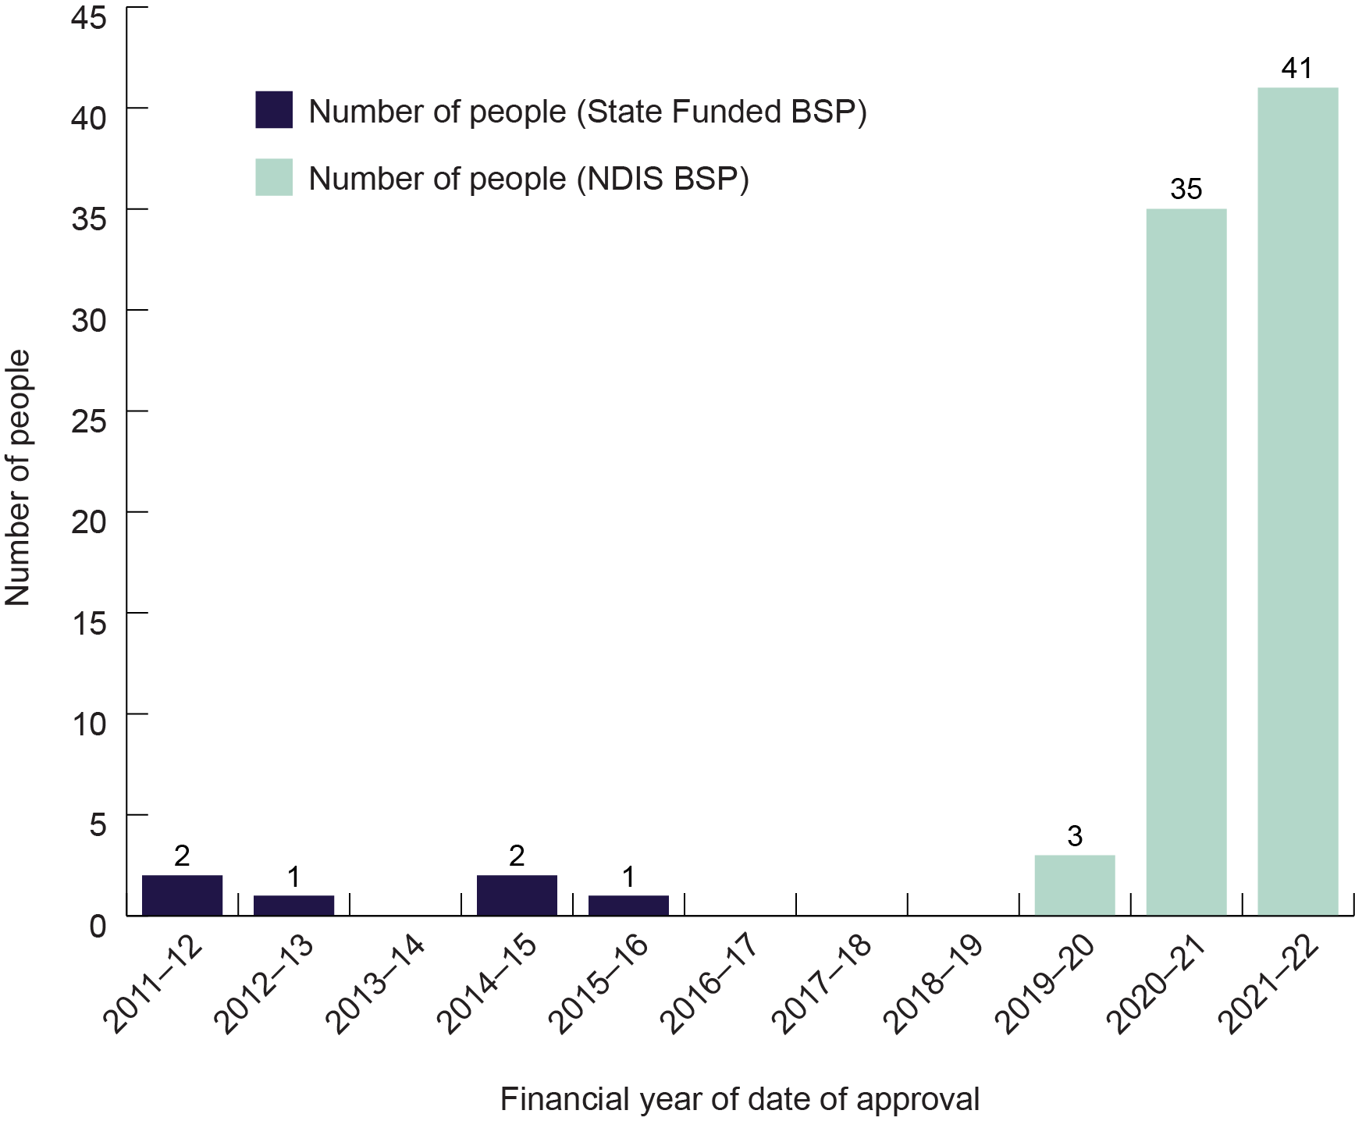
Refer to the Appendix for the Figure 3 data table
Figure 4: Reported use of physical restraint by Victorian disability providers,
2011–12 to 2021–22
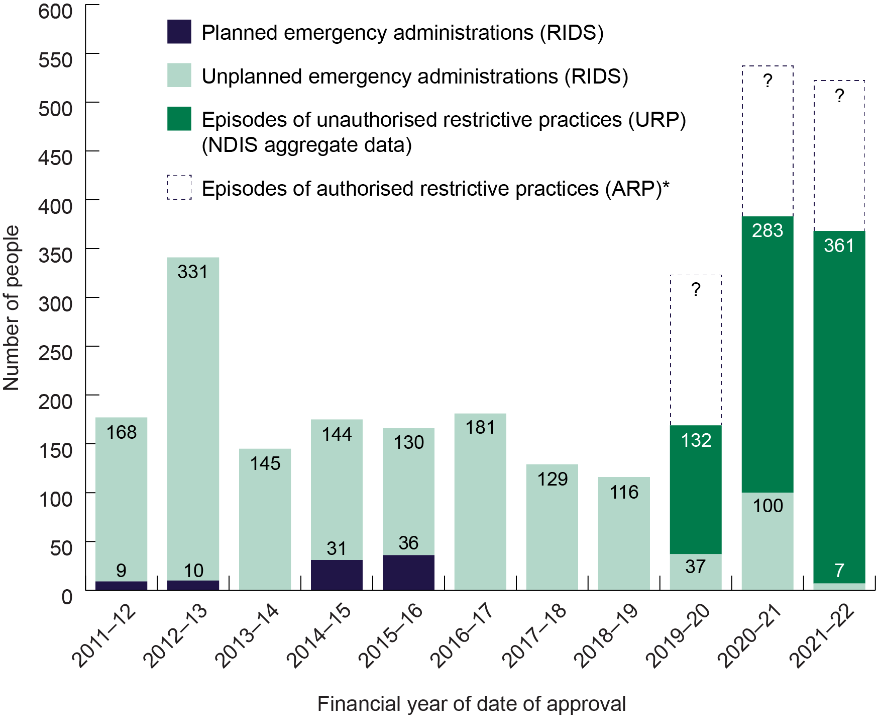
* Column heights for episodes of authorised restrictive practices are not indicative of actual numbers, because NDIS data on these episodes have not been made available to the Senior Practitioner.
Refer to the Appendix for the Figure 4 data table

Key findings
- In the past two financial years, there has been a very significant increase in the number of people approved to be subject to physical restraint. Three approvals were made in 2019–20, which is consistent with the average number of approvals for the previous decade. However, there were 35 approvals for 2020–21 and 41 in 2021–22.
- The question the data raises is whether the recent shift in practice, which allows for physical restraint to be authorised in BSPs, leads to a reduction in use of physical restraint because appropriate positive behaviour support strategies are outlined therein to mitigate behaviours of concern. Or does allowing physical restraint to be authorised in BSPs result in an increase in the use of physical restraint because it normalises, or paves the way, for its use?
- This question will be examined in the Senior Practitioner’s 10-year review of the physical restraint direction paper.

Environmental restraint
Environmental restraint, as defined in Part 1(3) – Definitions (1) of the Act, refers to a ‘restraint, which restricts a person’s free access to all parts of their environment, including items or activities’.
The Senior Practitioner began authorising environmental restraint in the financial year 2019-20, although RIDS was only modified in 2020 to enable entry of environmental restraint directly into the system. In the first full reporting year (2020–21) after the above-mentioned modifications to RIDS, 1,235 people were to be subject to environmental restraint. A year later the number of people authorised to be subject to environmental restraint has risen to 1,329 (Table 9). Tables 10 and 11 show year-on-year comparison of providers’ applications for approval of environmental restraint and have detail about:
- what is to be restricted (for example, outside access, food and drink)
- how the restriction is to be applied (for example, via locked door or surveillance).
Table 9: Total people authorised for environmental restraint
Year | Total people
2017–18 | –
2018–19 | –
2019–20 | 232
2020–21 | 1,235
2021–22 | 1,329

Table 10: Percentage of people authorised for environmental restraint
with different types of environmental restraints in 2020–21 to 2021–22
Restraint type | 2020–21 | 2021–22
Access (other) | 34.0 | 23.3
Activity | 8.7 | 9.0
External access | 56.8 | 53.0
Food and drink | 45.9 | 38.8
Household | 33.5 | 30.5
Internal access | 43.6 | 38.5
Personal item | 24.6 | 22.5
Privacy | 6.6 | 8.7
Table 11: Percentage of people authorised for environmental restraint
with different means of environmental restraints in 2020–21 to 2021–22
Restraint means | 2020–21 | 2021–22
Applied (other) | 35.2 | 38.6
Disabled utility | 4.0 | 3.6
Locked abode door | 67.4 | 61.2
Locked item door | 54.1 | 46.5
Object out of reach | 10.0 | 9.9
Removed object | 18.0 | 17.2
Supervision | 23.5 | 23.3
Surveillance | 5.7 | 5.3

Key findings
- There has been an eight per cent increase in the number of people authorised for environmental restraint over the past year (from 1,235 people in 2020–21 to 1,329 people in 2021–22). While the Senior Practitioner only has complete data for two full financial years, the figures are largely stable. This may reflect a growing awareness across the sector about what constitutes environmental restraint.
- Across the past two years, authorisations were granted most commonly to restrict access to external and internal areas (in the past year affecting 53 per cent and 39 per cent of people authorised for environmental restraint respectively) and access to specific food or drink (39 per cent).
- Consistent with this pattern, the most common authorised means of restricting the environment is locked doors (61 per cent of authorisations in the past year involved a locked abode door).
- 5.3 per cent of people authorised for environmental restraint in the past year were authorised for surveillance.

Behaviour support plan quality evaluations
This section of the report focuses on the quality of BSPs received from NDIS service providers. Any person subject to restrictive practices in Victoria must have a BSP or, if they have a compulsory treatment order, a treatment plan. The Senior Practitioner uses the Behaviour Support Plan Quality Evaluation II tool (Browning-Wright et al. 2003) to objectively assess the quality of BSPs received from disability services. The BSP-QE II was validated by the Senior Practitioner in 2011 as a reliable assessment of the quality of BSPs for adults with intellectual disability living in Victoria (Webber et al. 2011a; 2011b). The Senior Practitioner also found that better quality BSPs leads to less use of restrictive practices (Webber et al. 2012).
In 2021–22, there was a specific focus on reviewing NDIS-registered providers’ comprehensive BSPs requiring secondary approval. These reviews were undertaken using the BSP-QE II. The average QE-II score of these plans was 15.5, which is higher than scores from previous years (which have usually ranged between 10 and 13). It should be noted, however, that this score is not directly comparable to previous years because the score is derived from a review of BSPs written by NDIS-registered behaviour support practitioners only. In previous years, the score was derived from a review of BSPs from a variety of Victorian disability services.
Nevertheless, it is important to note that a score of 15.5 is above the minimum score of 13, which evidence has shown is integral to effectively reducing restrictive practices.

Key findings
Most BSPs assessed using the QEII tool described:
- observable and measurable behaviours of concern
- underlying triggers and the common settings where the behaviours occurred
- environmental supports that address triggers and setting events
- appropriate de-escalation strategies.
Research indicates that understanding the function of the behaviours of concern and the trigger/setting events, together with the use of environmental support, is essential for minimising the use of restraint and seclusion.
All BSPs assessed show that more work is needed on providing:
- information on how positive behaviour and skill building will be positively reinforced
- a description of the behavioural goals to be achieved so the support team is clear on what they intend to achieve over the life of the BSP (such as increasing the use of functionally equivalent replacement behaviour and decreasing the use of behaviours of concern)
- a clear plan for how the support team should work together, communicate and review the progress of the behavioural goals.
Also, BSPs reviewed in 2021–22 continued to be overly long and contained jargon and complex language. The needs of support staff implementing BSPs must be considered because they can be time-poor. To ensure BSPs are user friendly for support staff, some behaviour support practitioners provided an easy-read one-page ‘dos and don’ts’ protocol to support the staff implementing the BSP.

Restrictive practices audit review
Under the Act, the Victorian Senior Practitioner has powers to investigate, audit and monitor the use of restrictive practices and compulsory treatment (Disability Act, s 27(2)(c)).
Audits are used to identify and examine the use of restrictive practices by disability service providers and NDIS providers. When necessary, recommendations and directions are made to providers to see a reduction in use of restraints.
With the lasting impact of the COVID-19 pandemic and the Victorian Chief Health Officer directions over the past 12 months, the Senior Practitioner’s Integrated Practice Advisory team completed its audit function using dynamic desktop reviews and site visits, when permitted by public health directions.
The disability service providers and NDIS providers were selected for audit due to concerns for the unauthorised use of restrictive practices and staffing teams facing barriers to implementing BSPs as required to reduce the use of restrictive practices. These concerns were raised externally by people involved in the support of the person subject to restrictive practices, or internally from a review of BSPs submitted to the RIDS database.

Key findings
Results from these audits showed several prominent themes:
- frequent use of restrictive practices without an authorised BSP in place
- use of unauthorised environmental restrictive practices not included in authorised BSPs
- need for regular and ongoing allied health and medical reviews, particularly when psychotropic medication is prescribed to manage behaviours of concern
- high numbers of children being subject to restrictive practices
- improvements needed to support staff to implement skill-building strategies listed in BSPs.

Compulsory treatment
In the context of this report, compulsory treatment refers to treatment of a person with an intellectual disability who is at risk of perpetrating serious violence to another person. A person may be admitted to a residential treatment facility (RTF) under a court order or a live-in disability residential service in the community under a supervised treatment order.
In Victoria there are two RTFs. There is the Intensive Residential Treatment Program (IRTP). And there is the Long-Term Residential Program (LTRP), which became an RTF on 1 July 2020 following a change in legislation. Both RTFs are managed by Forensic Residential Services, which forms a part of Forensic Disability Services in the Department of Families, Fairness and Housing.
Part 8 of the Disability Act allows civil detention to be provided in the community under a supervised treatment order. Detention under the Act is defined as:
- physically locking a person in any premises
- constantly supervising or escorting a person to prevent the person from exercising freedom of movement.
This part of the Act also legislates for court-mandated detention in an RTF through orders including residential treatment orders, parole, custodial supervision orders, extended supervision orders and security orders.
This section of the report outlines the key data concerning people subject to compulsory treatment.

Compulsory treatment data
Forty-eight people were subject to compulsory treatment during 2021–22, including four people who were on extended leave from custodial supervision orders under the Crimes (Mental Impairment and Unfitness to be Tried) Act 1997 (CMIA). This was the same number of people as last year.
There have been 24 people subject to supervised treatment orders for the period of 1 July 2021 to 30 June 2022. This includes five people who were subject to interim supervised treatment orders for part of the year.
The interim orders included people who had already been subject to supervised treatment orders but VCAT deemed it necessary to make a short order for all parties to work through issues before returning to VCAT for a supervised treatment order to be determined, or where a person was not legally represented.
No new people were subject to supervised treatment orders over the year, and four orders were revoked. This is an increase on the previous year, when only one was revoked.
Twenty-four people were subject to a supervised treatment order at the end of 2021–22. This is four fewer people who were subject to such as order at the end of 2020–21.
There were 10 people subject to compulsory treatment during the year in the IRTP, which is three fewer than the previous reporting year.
No one was subject to a residential treatment order at the residential treatment facilities during the year. One person was admitted to the IRTP under a custodial supervision order under CMIA during the year. One person from the IRTP was granted extended leave from their custodial supervision orders under the CMIA and transitioned to Kookaburra House, a disability residential service.
Three people were subject to custodial supervision orders under the CMIA at the IRTP for the whole reporting period, compared with five people last year. Additionally, there were two people who transitioned from extended leave from their custodial supervision orders to non-custodial supervision orders during the year.
Table 12 shows that by 30 June 2022, eight people were subject to compulsory treatment at the IRTP:
- Three people were subject to a supervision order under the Serious Offenders Act 2018.
- One person was subject to a security order.
- Four people were subject to custodial supervision orders under the CMIA.

Table 12: Number of people subject to compulsory treatment at the IRTP, by order type, Victoria, 2021–22
Order type | July 2021 | Admitted / transitioned to order type or extended leave during  2021–22 | Discharged / transitioned from order type or extended leave during 2021–22 | June 2022
Residential treatment order | 0 | 0 | 0 | 0
Supervision order, including interim, under the Serious Offenders Act | 4 | 0 | 1 | 3
Supervision order under the Serious Sex Offenders (Detention and Supervision) Act 2009 | 0 | 0 | 0 | 0
Custodial supervision order under the CMIA | 4 | 1 | 2 | 4
Security order | 1 | 0 | 0 | 1
Extended leave | 3 | 1 | 2 | 2
Total | 9 in IRTP, 3 on extended leave | 1 admission to IRTP, 1 granted extended leave | 1 discharge from IRTP, 2 transitions to NCSOs following extended leave | 8 people at IRTP, 2 on extended leave
NCSO = Non-custodial supervision order
Table 13 captures the types of orders people were subject to during the reporting period at the LTRP.
By 30 June 2022, five people were subject to compulsory treatment at the LTRP:
- Two people were subject to supervision orders under the Serious Offenders Act.
- Three people were subject to custodial supervision orders under the CMIA.
- One person passed away in the period.

Table 13: Number of people subject to compulsory treatment at the LTRP, by order type, Victoria, 2021–22
Order type | July 2021 | Admissions during  2021–22 | Discharges during  2021–22 | June 2022
Supervision order, including interim, under the Serious Offenders Act | 1 | 1 | 0 | 2
Custodial supervision order under the CMIA | 4 | 1 | 2 | 3
Total | 5 | 2 | 2 | 5

Assessment orders
An APO may apply to the Senior Practitioner for an assessment order to be made for a person with an intellectual disability living in a residential service. If it is necessary to detain the person to prevent a significant risk of serious harm to another person and assessments need to be undertaken to enable the urgent development of a treatment plan, the Senior Practitioner may make an assessment order once for a person, for a maximum of 28 days. In 2021–22 no assessment orders were made. The last assessment order was made in 2016–17.

Client demographic data
Of the 48 people subject to a compulsory treatment order in 2021–22, 47 were male and one was female. There have only been four females subject to compulsory treatment since 2008–09.
In 2021–22 the primary types of offending behaviour that resulted in people being subject to a supervised treatment order were sexual violence and violence (non-sexual).
The average age of people subject to compulsory treatment in 2021–22 was 41 years (as of 30 June 2022), ranging from 21 to 73 years. This is a similar age profile to the previous two years.
Table 14: Number of people subject to supervised treatment orders in Victoria, by accommodation type, 30 June 2022
Accommodation type | Number of people subject to supervised treatment orders
Non-departmental SFDA | 8
Other departmental accommodation including disability accommodation services and SFDA | 1
Transitioned from DAS to NDIS providers | 10
Other community services organisations | 9
Total | 28
DAS = disability accommodation services; SFDA = specialist forensic disability accommodation

Compulsory treatment restrictive practice data
Table 15: Number of people subject to compulsory treatment who had a new treatment plan approved in 2021–22, by order type and restrictive practice types contained in those plans
Restrictive practice type | Supervised treatment order, including interim | Supervision order, including interim | Custodial supervision order under CMIA (including people on leave) | Security order | Total
Chemical restraint | 17 | 2 | 2 | 1 | 23
Seclusion | 6 | 0 | 0 | 0 | 6
Environmental restriction | 28 | 6 | 11 | 1 | 46
Physical restraint | 0 | 0 | 0 | 0 | 0
Mechanical restraint | 0 | 0 | 0 | 0 | 0
Total people who had a new plan approved | 28 | 6 | 11 | 1 | 46
Table 15 only includes restrictive practices approved within a treatment plan. It does not include any data related to the use of restraints in an emergency.
In 2021–22, of all people subject to a supervised treatment order who had a new treatment plan approved in the period:
- 61 per cent had a treatment plan that contained chemical restraint. This percentage is lower than the 81 per cent of all non-compulsory treatment people who had a plan containing chemical restraint authorised in the period.
- 21 per cent had a treatment plan that contained seclusion. This percentage is higher than the three per cent of all non-compulsory treatment people who had a plan containing seclusion authorised in the period.

Revocation
The Senior Practitioner, an APO or the person who is subject to the supervised treatment order can apply to VCAT to have their treatment plan reviewed and the order can be revoked.
The Senior Practitioner and VCAT must review supporting documentation before a supervised treatment order expires to determine whether the person continues to meet the legal criteria for a supervised treatment order and civil detention. The APO and the Senior Practitioner prepare separate submissions to VCAT to show how the person no longer meets all the criteria for a supervised treatment order.
During 2021–22, four supervised treatment orders were revoked.

Victorian Civil and Administrative Tribunals hearings
A VCAT hearing is convened with:
- the person being considered for a supervised treatment order
- their legal representative
- the Office of the Public Advocate
- a Senior Practitioner representative
- the APO
- any relevant supporting staff from the person’s disability residential services.
If VCAT is satisfied that the criteria for a supervised treatment order are met, it will make an order for up to one year, at which point it will be reviewed.
The VCAT hearings held about compulsory treatment matters in 2021–22 comprised:
- reviews for supervised treatment orders, including interim orders (which can be made until a supervised treatment order is determined)
- treatment plan reviews for people under compulsory treatment in RTFs
- material change hearings when a variation to a plan was requested that would increase restrictions
- revocation of supervised treatment orders.
VCAT hearings changed from face-to-face hearings to online hearings from the end of March 2020 due to COVID-19 restrictions and have remained online since. Staff from the Compulsory Treatment team attended all open hearings.

Projects to deliver evidence-informed outcomes
A function of the Senior Practitioner is ‘to undertake research into restrictive interventions and compulsory treatment and provide information on practice options to disability support providers’ (Disability Act, s 24(1)(g)).
In 2021–22 the Senior Practitioner continued to work with the University of Melbourne to refine and deliver two evidence-informed training programs – Enabling Quality Behaviour Support Planning and Authorised Program Officer (APO) Training. These programs aim to build capacity in the disability workforce.
At the beginning of 2022, the Senior Practitioner also partnered with the NDIS Commission (VIC Behaviour Support team), the Aged Care Quality and Safety Commission and the Department of Health to engage residential aged care providers supporting NDIS participants subject to restrictive practices in Victoria and invited them to attend tailored education sessions. Details of these three projects can be found below.

Enabling Quality Behaviour Support Planning online course
The first iteration of this course, developed in partnership with Scope and the University of Melbourne, was delivered for the first time in 2020–21, although not as originally intended due to complications caused by COVID-19. Following the course rollout, the data were reviewed for an evaluation. The review included recommendations for the future support needs of behaviour support practitioners, as well as how current practitioners can maintain and consolidate their knowledge and skills.
In 2021–22 the original training program was updated to including new course content and a new face-to-face tutorial plan. The overarching aim of this course is to increase the pool of advanced specialist behaviour support practitioners in Victoria and to improve the quality of BSPs developed for clients with complex support needs.
The enhanced course is now an eight-week online course that has an overall time commitment of about 80 hours. It also requires participants to attend weekly 90-minute group tutorials. At the end of the course, participants complete a written exam and submit a BSP for assessment. The course will be delivered to 180 practitioners next year.

Online training for authorised program officers
APOs play a critical role in authorising restrictive practices. APOs are required to authorise the use of all restrictive practices in their organisation and ensure BSPs are implemented. The Senior Practitioner acts as a complementary safeguard to the NDIS Commission to authorise or approve regulated restrictive practices.
In 2020–21 the Senior Practitioner partnered with the University of Melbourne to develop and facilitate the online training pilot program ‘Introduction to critical issues for APOs approving behaviour support plans’. The objective of the training was to equip APOs with foundational knowledge and skills necessary to effectively exercise their statutory responsibilities in authorising regulated restrictive practices. In doing so, the lives of people with disability would be improved as well as the safety of staff delivering support.

The pilot program was well received, and each semester of the course was oversubscribed. Given the success of the pilot program and the ongoing demand among Victoria’s APO population for training, the Senior Practitioner has since funded a multi-year proposal for the University of Melbourne to deliver the course to 2025. The new contract involved implementing significant changes to the course that were broadly aimed at improving the online learning experience and enhancing its research/evaluation component. These changes were completed in 2021–22. The enhanced APO online training program will be delivered to 200 APOs (50 per semester) over the next four years.
In 2021–22 the training was delivered to 251 registered learners. The Senior Practitioner is continuing to consider the feasibility of making the program available to all APOs on an ongoing basis, subject to a final evaluation report.

Residential aged care project
In December 2020 residential aged care (RAC) providers delivering services to NDIS participants in their facilities automatically became registered NDIS providers. This means RAC providers are now required to meet the obligations of the National Disability Insurance Scheme Act 2013 (NDIS Act) and the NDIS (Provider Registration and Practice Standards) Rules 2018, in relation to the NDIS participants they support.
In Victoria, the Senior Practitioner is responsible for the authorisation and approval of the use of restrictive practices by NDIS-registered service providers and also for assisting such providers to reduce the use of restrictive practices wherever possible.
There were approximately 200 NDIS-registered Victorian RAC providers as of December 2020. In February 2022 RIDS indicated there were 17 NDIS registered RAC providers supporting 34 NDIS participants subject to restrictive practices.
The transition to the NDIS marks a considerable shift for RAC providers supporting NDIS participants. In acknowledgement of this shift, along with the impact of the COVID-19 pandemic among Victoria’s aged care sector and the unprecedented pressures faced by RAC providers and their aged care workforce, the Senior Practitioner’s office initiated this project. The project aims to support RAC providers and equip them to meet their legal obligations and standards in Victoria.
As part of the project, the Senior Practitioner partnered with the NDIS Commission (VIC Behaviour Support team), the Aged Care Quality and Safety Commission and the Department of Health to engage RAC providers supporting NDIS participants subject to restrictive practices and invited them to attend tailored education sessions.
These partnerships continue to seek alignment between aged care and disability sector requirements at a higher level, to better assist RAC providers supporting NDIS participants to meet the obligations of the NDIS Act, the NDIS (Provider Registration and Practice Standards) Rules and the Disability Act.
To date, the project has consulted with four major RAC providers in Victoria to regulate the use of restrictive practices among NDIS participants in RAC settings.

Four new projects in development
In April 2022 Mandy Donley was appointed to role of Victorian Senior Practitioner. Since her appointment, she has instigated four more projects. All four projects are all in the early stages of development but are summarised below.

Project 1: Reducing the use of psychotropic medication for behaviour support
In November 2021 the Aged Care Quality and Safety Commission, the NDIS Commission and the Australian Commission on Safety and Quality in Health Care released a joint statement on the inappropriate use of psychotropic medicines to manage the behaviours of people with disability and older people. The statement recognised that inappropriate use of psychotropic medication was a safety and quality issue across the healthcare sector and that psychotropic medicines were being overprescribed and overused. In 2021–22 the Senior Practitioner instigated a project (still in development) to address this area of concern. The overarching aim of this project is to promote a multidisciplinary approach to reduce inappropriate psychotropic use, supported by educating and upskilling the relevant workforce.

Project 2: Strengthening the role of APOs
In the April–June quarter of 2021–22, the Senior Practitioner refused 39 per cent of NDIS Interim and Comprehensive submissions. The high number of refusals creates extra work for all parties. As a result, the Senior Practitioner instigated a project aimed at strengthening role of APOs. This project aims to provide structured practice leadership and advice to the sector through regular educational webinars and interactive workshops to build the capacity and capability of the implementing providers and APOs.

Project 3: Internal review of the implementation
of supervised treatment orders
Senior Practitioner data shows that of the 24 clients currently subject to a supervised treatment order in Victoria, 11 have been subject to supervised treatment for more than 10 years. Supervised treatment orders provide oversight and human rights consideration, but they were never intended to be ongoing measures. As a result, the Senior Practitioner has instigated a project to explore this issue. This project (still in development) entails an internal review of the processes underpinning the use of supervised treatment orders in Victoria.

Project 4: Implementing a client voice framework
at the Victorian Senior Practitioner
Following her appointment as Senior Practitioner in April 2022, Mandy Donley noted that there was, at times, a conspicuous absence of client voice in some of the Senior Practitioner's work. As such, the Senior Practitioner has started a project aimed at addressing this area of concern. The project (still in development) entails an international literature review to explore existing models for including client voice in government organisations, non-government organisations, service providers and other entities. The project will assess existing models and consider which, if any, should be implemented to better include client voice in the work of the Senior Practitioner.

Promoting best practice through professional development
A function of the Senior Practitioner is ‘to provide education and information with respect to restrictive interventions and compulsory treatment to disability service providers’ (Disability Act, s 24(1)(b)).
This section of the report describes various education and training opportunities that were given to disability support providers in 2021–22 including online and virtual opportunities.

Restrictive practices reduction training
The Restrictive Practices Authorisation team continued to provide training to the sector on understanding restrictive practices and the circumstances under which restrictive practices can be used. Where possible, restrictive practices audits and training were combined to provide a more streamlined approach.
Like last year, there was a focus in 2021–22 on establishing a collaborative working relationship with APOs and behaviour support practitioners at new service providers. Such an approach provided training recipients with an opportunity to enhance their understanding of the role of the Senior Practitioner, regulated restrictive practices and the integral role that APOs play in the authorisation process for submitted BSPs.
The Integrated Practices Advisory team presented to more than 150 people in 2021–22, which included:
- registered aged care providers
- National Positive Behaviour Support
- GenU’s Positive Behaviour Support team
- Possability
- NDIS-registered behaviour support providers
- NDIS support coordinators and local area coordinators
- the Victorian Neuropsychology Rehabilitation Service
- Allay Occupational Therapy.

ARMIDILO-S and ARMIDILO-G training
The Assessment of Risk and Manageability of Individuals with Developmental and Intellectual Limitations who Offend – Sexually (ARMIDILO-S) is a risk assessment and management tool that has been specifically developed for offenders with an intellectual disability.
Risk assessment and management is a central consideration for compulsory treatment when working with offenders with an intellectual disability.
The Senior Practitioner organises regular training sessions on administering and interpreting this assessment tool. These are conducted by the principal author of the assessment, the University of Canberra’s Professor Doug Boer. The Senior Practitioner sponsored one training session each of ARMIDILO-S and ARMIDILO-G in 2021–22, and individual consultancy was also provided on request.
Professor Boer and Dr Frank Lambrick also conduct ARMIDILO-S user group sessions. These sessions are targeted at previous participants of the workshops and aim to maintain and enhance practice skills in using the assessment tool and in general risk management. One ARMIDILO-S user group session was conducted this year.

Supporting best practice through advice, partnerships and consultation

Practice advice and consultations
A function of the Senior Practitioner is ‘to develop links and access to professionals, professional bodies and academic institutions for the purpose of facilitating knowledge and training in clinical practice for people working with persons with a disability’ (Disability Act, s 24(1)(f)).
During 2021–22 the Integrated Practice Advisory team provided 2,763 instances of practice advice. Of those instances, 1,799 were general advice about behaviour support, use of restrictive practices and the Victorian authorisation and approval process. There were 869 enquiries directly related to the authorisation of restrictive practices in a person’s BSP. A further 86 related to concerns about operational service provision by registered providers. Nine requests were received for targeted tailored organisational education and training.
In 2018–19 there were 1,145 instances of practice advice and 2,169 instances in 2019–20. Evidently, there is a rising demand across the sector for general and more individually tailored advice and guidance in behaviour support. As with the previous year, there was also a notable increase in enquiries that related to people with complex presentations, comorbid diagnoses and involvement of several service systems.
In addition, representatives from the Senior Practitioner’s office took part in 64 complex client consultations with broader care teams and inter-departmental panels.

Compulsory treatment practice forums
The Compulsory Treatment team conducted two online practice forums in 2021–22. Membership of these forums is open to staff working with compulsory treatment clients, including APOs, clinicians, direct care (disability) staff and representatives from the Office of the Public Advocate and VCAT.
The forums focus on information sharing about compulsory treatment, addressing and promoting practice, and supporting professional networking. In previous years the forums have covered a variety of topics including the Forensic Disability Statewide Assessment Service, strengthening proposed reduction plans against treatment goals, and the issues around the NDIS transition, specifically funding processes.
The first forum in 2021–22 focused on all compulsory treatment processes and included an update on potential amendments to the Disability Act. The second forum offered an opportunity for the Compulsory Treatment team to introduce the new Senior Practitioner to stakeholders and reviewed a variety of issues around chemical restraint in relation to compulsory treatment.
The Compulsory Treatment team has received positive feedback from participants about these forums.

Care team meetings, case consultations and VCAT hearings
The Compulsory Treatment team supports the sector by engaging in case consultations and attending care team meetings for people subject to compulsory treatment.
The team prioritises attendance at care team meetings based on the person’s presentation such as:
- the presence of significant problematic behaviour that requires intervention
- transitioning from the IRTP to the community or between community providers
- significant issues with implementing a treatment plan
- the presence of significant service gaps that affect risk management and meeting the client’s need
- multiple diagnoses that contribute to a complex presentation
- recent use of seclusion and physical restraint
- when a client is noncompliant with an order, if the client is on a new order, revocation or preparation for revocation, and if the client is going through a transition period (with accommodation, support services and clinical support).
The Compulsory Treatment team attended 185 care team meetings during the reporting period. Usually, attendance at a care team meeting is in person. However, in 2021–22 attendance at some care team meetings was via online platforms. In addition to the care team meetings, the Compulsory Treatment team conducted 25 detailed consultations and a further 50 quick advice consultations.
In 2021–22 the team also attended 47 VCAT hearings – one of which lasted 11 days – and two Supreme Court hearings.

Informing public debate and opinion

The Senior Practitioner Seminar 2021
Every year the Victorian Senior Practitioner Seminar is held to provide feedback and information about the progress of projects being undertaken or commissioned by the Senior Practitioner, as well as to share any information about changes in the system.
In 2021 the Senior Practitioner Seminar was held online due to the interruptions wrought by the COVID-19 pandemic. The seminar featured a presentation by Dr Jeffrey Chan and Dr Mikaela Jorgensen on some of the pertinent issues around managing challenging behaviour. Another presentation, by Professor Keith McVilly, explored the issues he and his team had encountered in developing and evaluating the University of Melbourne’s online training course for APOs.
In spite of the pandemic, the seminar was a tremendous success. More than 150 people attended online.

Artwork by Brady Freeman, a winner of the Barbara Donovan Art Competition Award
at the Having a Say Conference 2017 (Theme: ‘Leading YOUR Life’)

References
Browning-Wright D, Saren D, Mayer GR 2003, The behavior support plan – quality evaluation guide, viewed 23 October 2014 at Positive Environments, Network of Trainers website, http://www.pent.ca.gov.
Richardson B, Webber LS, Lambrick F 2020, ‘Factors associated with long-term use of restrictive interventions’, Journal of Intellectual & Developmental Disability, 45(2):159–166.
State Government of Victoria 2006, Disability Act 2006, at Victorian Legislation and Parliamentary Documents website, http://www.legislation.vic.gov.au.
Webber L, McVilly K, Fester T, Chan J 2011a, ‘Factors influencing quality of behaviour support plans and the impact of plan quality on restrictive intervention use’, International Journal of Positive Behavioural Support, 1(1), pp. 24–31.
Webber LS, McVilly K, Fester T, Zazelis T 2011b, ‘Assessing behaviour support plans for Australian adults with intellectual disability using the “Behavior Support Plan Quality Evaluation II” (BSP-QE II)’, Journal of Intellectual and Developmental Disability, 36, pp.1–5.
Webber L, Richardson B, Lambrick F, Fester T 2012, ‘The impact of the quality of behaviour support plans on the use of restraint and seclusion in disability services’, International Journal of Positive Behavioural Support, 2(2), pp. 3–11.

Artwork by Ben Chew, a winner of the Barbara Donovan Art Competition Award
at the Having a Say Conference 2020 (Theme: ‘A good life – are we there yet!’)

Appendix: Data tables for figures

Figure 1: Restrictive practices snapshot
Item | Number
People authorised | 2,335
Children authorised | 261
Chemical restraint | 1884
Environmental restraint | 1329
Mechanical restraint | 265
Seclusion | 79
Physical restraint | 41
Return to text following Figure 1

Figure 2: Practice leadership and training snapshot
Item | Number
Practice advice and consultations | 2838 instances
Training | 150 people
Care team meetings | 185
VCAT hearings | 47
Return to text following Figure 2

Figure 3: Number of people approved for physical restraint, 2011–12 to 2021–22
Financial year  of date of approval | Number of people  (State Funded BSP) | Number of people  (NDIS BSP)
2011–12 | 2 | –
2012–13 | 1 | –
2013–14 | – | –
2014–15 | 2 | –
2015–16 | 1 | –
2016–17 | – | –
2017–18 | – | –
2018–19 | – | –
2019–20 | – | 3
2020–21 | – | 35
2021–22 | – | 41
Return to text following Figure 3

Figure 4: Reported use of physical restraint by Victorian disability providers,
2011–12 to 2021–22
Financial year  of date of approval | Planned emergency administrations (RIDS) | Unplanned emergency administrations (RIDS) | Episodes of unauthorised restrictive practices (URP) | Episodes of authorised restrictive practices (ARP)
2011–12 | 9 | 168 | – | –
2012–13 | 10 | 331 | – | –
2013–14 | – | 145 | – | –
2014–15 | 31 | 144 | – | –
2015–16 | 36 | 130 | – | –
2016–17 | – | 181 | – | –
2017–18 | – | 129 | – | –
2018–19 | – | 116 | – | –
2019–20 | – | 37 | 132 | ?
2020–21 | – | 100 | 283 | ?
2021–22 | – | 7 | 361 | ?
Figure 4 is not indicative of actual numbers, because NDIS data on episodes of authorised restrictive practices have not been made available to the Senior Practitioner.
Return to text following Figure 4



