
Senior Practitioner report
2016–2017
Plain English

To receive this publication in an accessible format phone 9096 8427, using the National Relay Service 13 36 77 if required,or email the Office of Professional Practice <officeofprofessionalpractice@dhhs.vic.gov.au>
Authorised and published by the Victorian Government, 1 Treasury Place, Melbourne.
© State of Victoria, Department of Health and Human Services, April 2018
Except where otherwise indicated, the images in this publication show models and illustrative settings only, and do not necessarily depict actual services, facilities or recipients of services. This publication may contain images of deceased Aboriginal and Torres Strait Islander peoples.
In this document, ‘Aboriginal’ refers to both Aboriginal and Torres Strait Islander people. ‘Indigenous’ or ‘Koori/Koorie’ is retained when part of the title of a report, program or quotation.
ISSN: 2204-7204 (online)
Available at the Office of Professional Practice website <https://www.dhhs.vic.gov.au/office-professional-practice>
(1712010)

Cover: ‘Reach for the Stars’, painting by Sarah Guilfoil
Sometimes life is difficult.
It feels like climbing up the hill.
Obstacles like rocks
may lay in your path.
Despite it all we have to be strong.
If we try we can reach for the stars.
The artworks used in this report are by winners of the 2017 VALID Annual ‘Having a Say’ conference Art Competition sponsored by the Senior Practitioner.

Message from the Senior Practitioner, Frank Lambrick
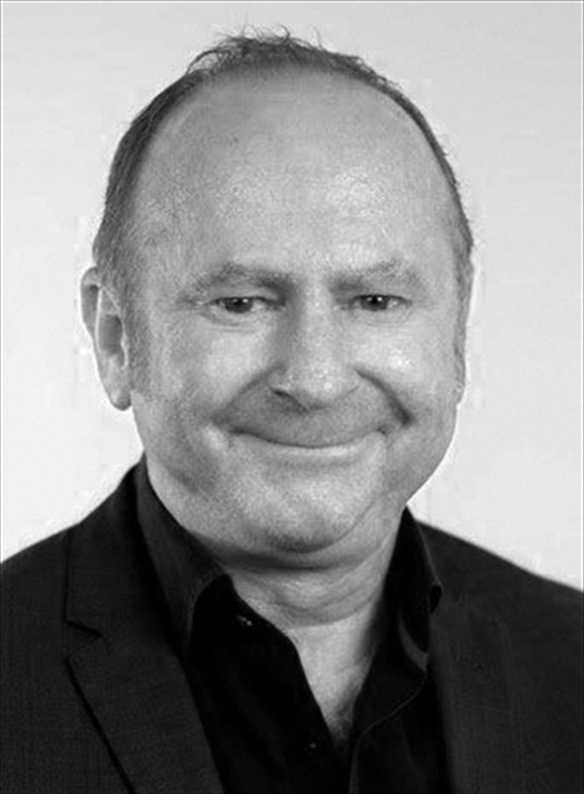
Hello. My name is Frank Lambrick. I am the Senior Practitioner for Disability. I work with a team of people.
This is my report about our work. This report is about what we did from July 2016 to June 2017. This is sometimes called an annual report.
There have been lots of changes for people with disabilities this year. The National Disability Insurance Scheme or NDIS has started for lots of people in Victoria. The NDIS has changed some of the work we do. It has changed what we have to do for people who have compulsory treatment plans.
This year we have been doing more work for children in schools. We are looking at what restrictive interventions happen in schools. We are teaching people about restrictive interventions. We want to decrease restrictive interventions in schools.

One of our big jobs that we keep doing is counting restrictive interventions that happen in Victoria to children and adults with disabilities. The number of people with restrictive interventions this year was about the same as last year.
We also made a new tool this year called the Restrictive Intervention Self Evaluation Tool or RISET. RISET is on the internet. People can use the tool to work out if something is a restrictive intervention or not. It gives people information about the law.
It has been a busy year.
Thank you to all the staff who work for me. Thank you to the families and services that work with us.
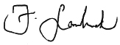
Dr Frank Lambrick
Senior Practitioner – Disability
Contents
Message from the Senior Practitioner, Frank Lambrick 4
The job of the Senior Practitioner 9
Restrictive interventions 10
Numbers of people with restrictive interventions in Victoria in 2016–2017 12
Restrictive interventions in Victoria 13
Behaviour support plans 14
Visiting services to see restrictive interventions 15
Compulsory treatment 16
Learning more about restrictive interventions through special projects 19
1. The restrictive intervention group study 19
2. Restrictive Interventions Self Evaluation Tool 20
3. Mechanical restraint project 20
4. Assisting services to use their information 21
5. Organising and using Senior Practitioner information 21
6. Helping doctors learn 21
7. The Roadmap project 22

Teaching other people about supporting people who use behaviours of concern 24
Teaching about behaviour support plans 24
RIDS training sessions 24
Teaching about restrictive interventions 25
Teaching about people with intellectual disability who break the law 25
Working with other people to help reduce use of restrictive interventions 26
Compulsory treatment practice workshops 26
Compulsory treatment newsletters 26
Case consultation 26
Work with the Department of Education and Training 27
Student projects 28
New reports 28
Making things better through writing and talking about restrictive interventions 29


‘Jellyfish Gathering’, painting by Brady Freeman
Brady’s work – whatever the basis –
is giving him voice to express his
personality, develop his skills,
grow in confidence and pride and
participate in the professional art world
as a respected artist.

The job of the Senior Practitioner
This report is about the job of the Senior Practitioner. It is about the Senior Practitioner’s work from July 2016 to June 2017.
This report is written in Plain English. We have a complex copy that you can read too.
The Senior Practitioner is a special job. It is a job that was written about in the Disability Act 2006. The main job of the Senior Practitioner is to protect the rights of people with disabilities who have restrictive interventions.
The Act said that the Senior Practitioner must do some special things.
The Senior Practitioner must:
- Know about the restrictive interventions used with people with disabilities in Victoria
- Teach people about restrictive interventions and supporting people who use behaviours of concern
- Learn more about restrictive interventions by doing special projects and research.
The Senior Practitioner has an important role for people under compulsory treatment. Compulsory treatment is when the law courts have said that someone with a disability has broken the law and must have specific treatment.
Learning more is sometimes called doing research. We do a lot of important research. We have been counting restrictive interventions in Victoria for 10 years. We can do research on things that change and things that stay the same.
This report is about how we did these important jobs.
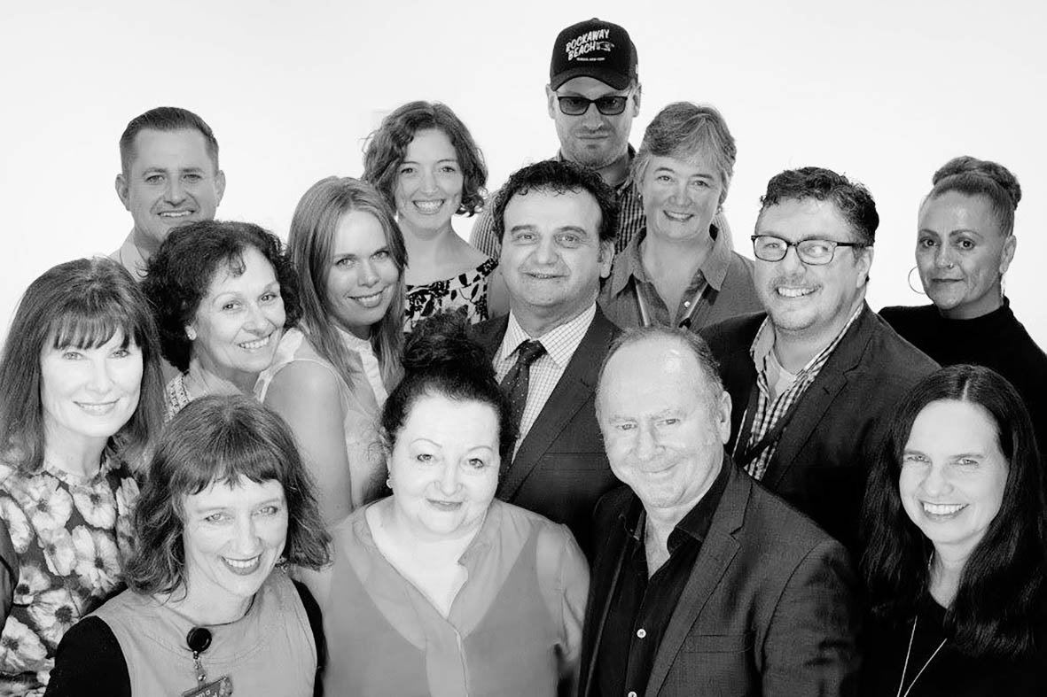
The Senior Practitioner team

Restrictive interventions
Restrictive interventions are things done to another person to stop them from doing behaviours of concern.
A behaviour of concern might be a behaviour like hurting themselves or hurting another person. It might be behaviours like deliberately breaking furniture.
Restrictive interventions are things that restrict the rights of a person using behaviours of concern. There are a few different types of restrictive interventions: chemical, mechanical, physical, and seclusion.
- Chemical restraint is medication given to someone just to stop them doing a behaviour. It does not include medications for health problems or mental illness.
- Mechanical restraint is use of equipment to stop someone moving. Mechanical restraint could be a bodysuit that stops someone touching their body, or splints to stop someone moving their arm. A seatbelt and buckle guard used in a car is not a mechanical restraint.
- Physical restraint is another person strongly holding someone to stop them from moving. It is not the same as helping someone gently.
- Seclusion is locking someone in a room so they cannot get out.

Numbers of people with restrictive interventions in Victoria in 2016–2017
One of the jobs of the Senior Practitioner is knowing about restrictive interventions in Victoria.
Disability service providers must tell us if they use any restraint with the people they support.
They must tell us:
- The name of the person restrained
- If the person is male or female
- The person’s disability
- The type of restraint used.
Disability service providers must show us the person’s behaviour support plan. A behaviour support plan is a written plan. Behaviour support plans must say:
- The behaviour of concern
- Why the behaviour might happen
- What the staff will do to help the person
- Any restrictive interventions.
All people who are restrained must have a behaviour support plan or a treatment plan.
This part of the Annual Report is about restraint use, behaviour support plans, and compulsory treatment in Victoria July 2016 to June 2017.

Restrictive interventions in Victoria
Disability service providers must tell us about all the restrictive interventions that they use.

Number of people restrained
2,328 people with disabilities were restrained this year. This is nearly the same as in 2015–2016.
Most of the people that we heard about lived in group homes. Group homes are sometimes called shared supported accommodation services.
There were more males restrained than females.

Chemical restraint
Chemical restraint is the use of tablets or medicine to control someone’s behaviours of concern.
Chemical restraint is the type of restraint used the most.
More than 2,000 people were chemically restrained every day this year. They were given tablets or medicine to control their behaviour.
More than 300 people had medication for their behaviour only sometimes. This is can be called PRN chemical restraint.
More than 900 people had emergency chemical restraint. Emergency chemical restraint is the sudden use of medication to control behaviour when the person does not have a behaviour support plan. This was about the same number as people as last year.
There were lots of different types of medications used for chemical restraint. More than half of the people who had chemical restraint took more than one type of medication. Many of the people with autism took more than one type of medication that affected their behaviour.

Mechanical restraint
Mechanical restraint is the use of clothes, straps, or other things to stop a person from moving their body.
About 140 people had mechanical restraints this year. This is more people than last year.

Seclusion
Seclusion is being locked in a room or place where you cannot get out.
55 people were secluded this year. This was more than last year.

Physical restraint
Physical restraint is holding or blocking somebodies body with force. Physical restraint stops people from moving about.
102 people were physically restrained this year. This is more people than last year.

Behaviour support plans
A behaviour support plan is a written document about a person with a disability. It is a plan for how staff should support a person who uses behaviours of concern. It is a plan that says that restrictive interventions will only be used after all other things are tried.
A behaviour support plan contains lots of information.
In 2016–2017 there were 2,794 behaviour support plans sent to us.

Behaviour support plans that are written well
We know that well written plans can help improve people’s lives.
We have been working to improve behaviour support plans.
The Senior Practitioner uses a special checklist called the Behaviour Support Plan – Quality Evaluation II or BSP-QEII to measure how good the behaviour support plans are.
The Senior Practitioner looked at 88 plans to check if they had the information in them.
The plans from this year were a little bit worse than last year’s. They got a lower score on the BSP-QEII.
Services need more training on how to write good behaviour support plans.

Visiting services to see restrictive interventions
The Senior Practitioner visited 24 places to see if restrictive interventions were being used. We visited group homes, day services, and respite homes. We visited services in the country and cities.
There were some problems in the services:
- Some people were not allowed to leave their home, but there was no clear reason written down about why
- Services did not share a person’s behaviour support plan with their other services (for example, the house did not share the plan with the day service)
- Lots of people still did not understand what restrictive interventions were
- Some people had trouble finding out from doctors why someone was being given medication.
We have written a new form for people taking tablets. The form is for doctors to fill in. The doctor must say why a person needs medication. It is important for doctors to know if something is chemical restraint or not.
There were some particular problems for new disability support services in Victoria:
- Some people did not know much about the Disability Act
- Services that came from other states did not know about the rules in Victoria
- People did not know about restrictive interventions.
We have a tool on the internet. It is called the Restrictive Interventions Self Evaluation Tool or RISET. RISET will help people learn about restrictive interventions.

Compulsory treatment
The Senior Practitioner also helps people who are on compulsory treatment. Compulsory treatment is a special law. It is a law that says a person must have treatment for their behaviour.
Compulsory treatment is given to some people with intellectual disabilities who are at risk of hurting other people. They are people who might have hurt other people before. They have been in trouble with the law.
People on compulsory treatment live in the community or residential treatment centres. There is one residential treatment centre in Victoria. People living in the community have a supervised treatment order. These people are watched most of the time, and may be in a place that has locked doors.
The Senior Practitioner looks at the treatment plans of people on compulsory treatment. The Senior Practitioner asks whether the treatment will help the person.

People on compulsory treatment in the community in 2016–2017
There were 31 people on compulsory treatment living in the community this year. They were all men.
The people had hurt other people or had set fires.
20 of the people on compulsory treatment had restrictive interventions. Some had chemical restraint. Some had seclusion and some had physical restraint.
The Senior Practitioner looked very carefully at the restrictive interventions used with people on compulsory treatment. The team looked at any changes made to a person’s treatment plan.
The Senior Practitioner is also involved if a person does not need to be on compulsory treatment any more. Two people did not need to be on compulsory treatment anymore. One person went to prison. One person did not need compulsory treatment any more.
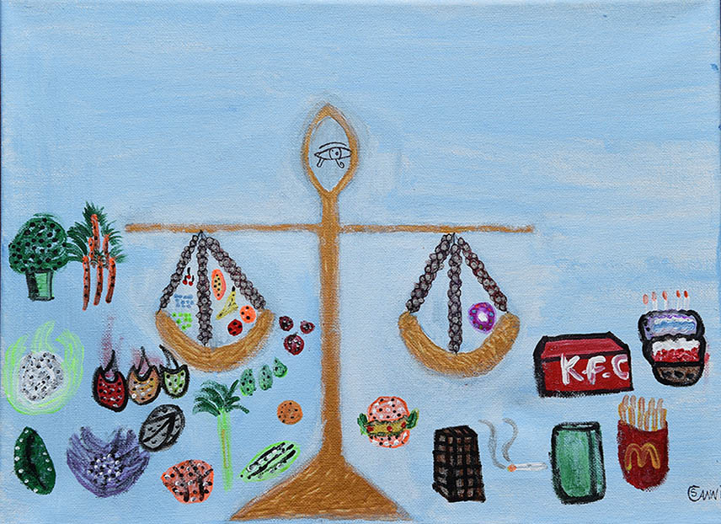
‘Watch What You Eat’, painting by Steve Canning
Lead your life – feel think,
BE HEALTHY.
I feel healthy.
I think about being healthy.
I want the whole world to be healthy
– Everything in balance.

Learning more about restrictive interventions through special projects
This year staff at the Senior Practitioner did seven special projects.

1. The restrictive intervention group study
We wanted to understand what happened to people over a few years so we did a special project.
We looked at the 1,414 people who had restrictive interventions in 2008 to 2010. Then we looked at what happened to the same people in 2013 to 2015.
Three out of every four people from 2008 to 2010 were still having restrictive interventions five years later. Lots of these people had autism and had difficulties communicating using speech.
One out of every four people, or 544 people, were not reported to have restrictive interventions five years later.
We wanted to find out what happened to these 544 people. We sent questionnaires to people to find out what happened.
We found out that many of the people didn’t need restrictive interventions any more. The positive behaviour support planned helped to stop restrictive intervention use.
We found out the some of the people got treated for a medical problem – their medication was for a medical problem instead of behaviour.
Some people didn’t know why the change had happened.

2. Restrictive Interventions Self Evaluation Tool
We knew that disability services needed to learn more about restrictive interventions.
We made a website called the Restrictive Interventions Self Evaluation Tool, or RISET.
RISET was for teaching disability services about restrictive interventions in Victoria.
When you go onto RISET you can choose what sort of restrictive intervention you want to learn about.
RISET contained lots of questions to get people thinking about restrictive interventions. It has examples of things that might happen at work. The reader has to decide if something is a restrictive intervention or not. They have to decide if they would have to let the Senior Practitioner know about that example or not.
People went to the website nearly 3,000 times.

3. Mechanical restraint project
We have been doing a special project looking at mechanical restraint for four years.
Last year we got assessments done on some people with mechanical restraint.
This year we worked with the disability support services to help them use the assessment.

4. Assisting services to use their information
Disability support services send us lots of information. We think the information is very useful.
Disability support services can get special reports from the information they send us. We asked them what sort of reports would help them best. They told us what sort of reports they want.
We will set up easy ways for them to get the reports in 2018.

5. Organising and using Senior Practitioner information
Every year the Senior Practitioner gets a lot of information about people with disabilities. We must make sure that information is kept safe – we know that information is private.
We keep doing a project called a data warehouse project. This project looks at how we store and use information.

6. Helping doctors learn
In 2014–2015 we made online training for doctors. The training was about working with people with intellectual disabilities who used behaviours of concerns.
This year we looked at how to training was used.
We found out that the doctors who used the training thought it was excellent. But we found out that not enough doctors did the training.
We will work to make the training easier to get onto and use.

7. The Roadmap project
The Roadmap for Achieving Dignity without Restraint is a special project involving many people.
More work was done on the Roadmap project. Changes were made to it so that it can help more people have lives without restraints.
The Roadmap project will be looking at changes for 150 people with disabilities.
The Roadmap project may be used in other places across Australia.

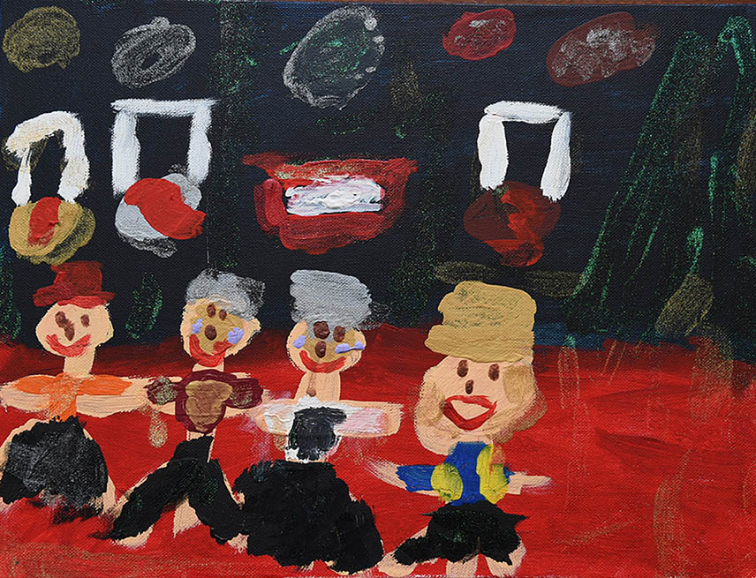
‘Smile on the Dial’, painting by Tom Leembruggen
The Tri State Games Theme Nights
are lots of fun.
We receive our medals,
we dance the night away and
everyone has a ‘smile on their dial’.

Teaching other people about supporting people who use behaviours of concern
The Senior Practitioner thinks that learning is important for making things better. People need to learn about behaviours of concern. They need to learn about restrictive interventions. They need to learn about the rights of people with disabilities.
The Senior Practitioner’s team do a lot of teaching. They teach a lot of different people. They teach a lot of different things.

Teaching about behaviour support plans
Every person who has restrictive interventions must have a behaviour support plan. A behaviour support plan is a report about the person’s behaviour, helping the person, and the restrictive intervention that may be used.
We made a workshop for staff to teach them about writing good behaviour support plans. The workshop goes for one day.
250 people did the workshop this year.

RIDS training sessions
Disability services must let us know when restrictive interventions are used. They let us know on an internet system called the Restrictive Interventions Data System or RIDS
We taught many people how to use RIDS.
We have also run training on the compulsory treatment
e-treatment plan.

Teaching about restrictive interventions
We taught people about restrictive interventions. We taught about chemical, physical, mechanical, and other restrictive interventions.

Teaching about people with intellectual disability who break the law
We work with some people who have intellectual disability who have broken the law. These people have rights.
Sometimes people might break the law again; sometimes they won’t. We try to find out the chance of people breaking the law again. This is sometimes called a risk assessment. We have a risk assessment called the ARMIDILO-S. This looks particularly a people who do sexual crimes.
We ran two teaching sessions on the ARMIDILO-S.

Working with other people to help reduce use of restrictive interventions
The Senior Practitioner works with other services to share information, learn together, and do new projects.
Here are some of the things that the Senior Practitioner did this year.

Compulsory treatment practice workshops
The compulsory treatment team had four workshops for people working with people under compulsory treatment. People learnt new things at the workshops and could talk to each other to make new working teams.

Compulsory treatment newsletters
The compulsory treatment team sent out four newsletters. The newsletters shared new information, new resources, and told people what the compulsory treatment team was doing.

Case consultation
The compulsory treatment team have an important job in going to team meetings about people on compulsory treatment. They answer lots of questions about what they law says must happen. They can go to hundreds of meetings each year about people under compulsory treatment.

Work with the Department of Education and Training
A practice leader from the Senior Practitioner continued to work with the Department of Education and Training. The Department of Education and Training are in charge of primary and secondary schools in Victoria.
The practice leader has been learning about what happens for children with disabilities in Victorian schools.
They have been talking to schools about restrictive interventions. They have been working with schools to think about reducing restrictive interventions in schools.
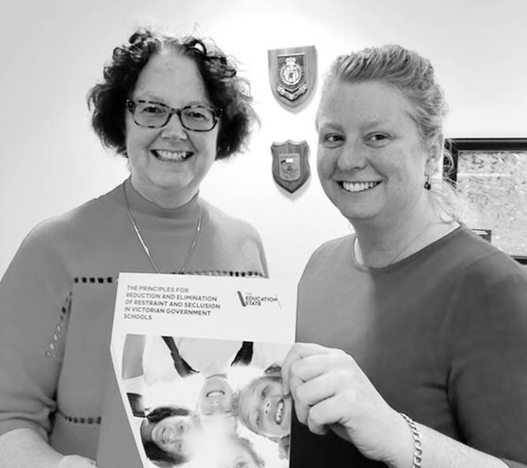
Mandy Donley from the Senior Practitioner
team and Moira Buchholtz from the
Department of Education and Training
We worked together with the Department to write a guide call Policy guidance, procedures and resources for the reduction and elimination of restraint and seclusion in Victorian Government schools. The guide will help teachers know about the human rights of children and how to help children who use behaviours of concern.

Student projects
Two occupational therapy students have been working with the Senior Practitioner on a project about women with intellectual disabilities and their periods. They have looked at the way some services respond to women’s periods, in particular, use medication and operations to stop periods. These can be restrictive interventions.
Other students did projects looking at how people who did not use speech could express when they are in pain.

New reports
We worked with different services to write important reports.
- A report about helping people with autism who walk away from home or other places and may go missing
- A report about what to do when people with autism and intellectual disabilities do sexual behaviours that might harm themselves or others. The report also looks at how to avoid the behaviours happening.
- A report about locking doors in disability support services – when it can and cannot happen.

Making things better through writing and talking about restrictive interventions
We let people know about best ways to support people who use behaviours of concern. We let people know about restrictive interventions.
We talked at a lot of conferences about our work. We talked at conferences in Australia and oversees.

