

Image description:Branding banner with Victorian Disability Awards 2022 written in white text on a dark grey background. Top right hand corner has a mixed colour pattern with purple, pink, teal, blue and yellow. Top right hand edge has solid teal triangle.

**The Department of Families, Fairness and Housing and the Office for Disability invite you to attend the 2022 Victorian Disability Awards Ceremony.**  
  
Thank you for nominating someonefor the Victorian Disability Awards this year. They have been shortlisted as a finalist. As a nominator, we request your attendance at the Victorian Disability Awards Ceremony.  
  
**Event details**  
**When:** Wednesday 24 August, 1pm - 4pm. A light lunch will be served from 1pm - 2pm.  
**Where:** Conversation Quarter, State Library of Victoria  
328 Swanston Street, Melbourne  
**Dress code:** Smart casual  
**RSVP:** by Sunday 31 July, 2022 via the Eventbrite link: <<https://www.eventbrite.com.au/e/98132740669>>  
**Ticketing:** Please note this event is invite only, each finalist and nominator will receive an invitation.

**Getting there:**  
By car  
The State Library doesn't have onsite parking, but there is paid street parking on La Trobe Street and several car parks close by at Melbourne Central and QV. There are three accessible parking spaces outside the venue on La Trobe Street.  
  
By public transport  
Train – Melbourne Central station is directly opposite the Library's Swanston Street entrance.  
Tram – Ten tram routes take you directly to the entrance on Swanston Street.  
Bus – The nearest stops are in Lonsdale, Russell and Exhibition streets.  
  
See Public Transport Victoria <[https://www.ptv.vic.gov.au](https://www.ptv.vic.gov.au/)> for more information.  
  
Venue Map  
To access a map of the venue see the State Library of Victoria page <<https://www.slv.vic.gov.au/visit/library-map/>>

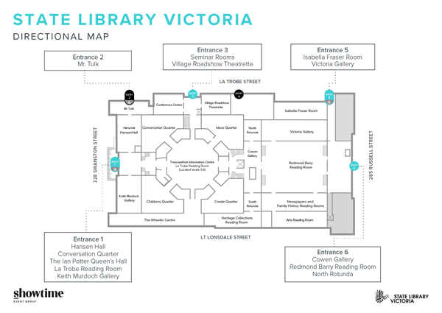

Image description: Black and white directional map of the State Library of Victoria showing navigation to the Conversation Quarter off Entrance 3 which is located on La Trobe Street.  
  
**When you arrive:**  
The Conversation Quarter is accessed via Entrance 3. Ramp access is on La Trobe Street, near the corner of Swanston Street. Attendees can be dropped off on La Trobe Street.

**Accessibility**  
If you have any accessibility requirements, please note it in your response on Eventbrite. The venue is wheelchair accessible. Auslan interpreters, captioning and a hearing loop will be in use throughout the event.

Kind regards,  
Awards Secretariat  
[awards@dffh.vic.gov.au](mailto:awards@dffh.vic.gov.au)03 8850 6164

To receive this document in another format, phone 8850 6164, using the National Relay Service 13 36 77 if required, or email <[awards@dffh.vic.gov.au](mailto:awards@dffh.vic.gov.au)>

Authorised and published by the Victorian Government, 1 Treasury Place, Melbourne.

© State of Victoria, Australia, Department of Families, Fairness and Housing, February 2022.

Except where otherwise indicated, the images in this document show models and illustrative settings only, and do not necessarily depict actual services, facilities or recipients of services. This document may contain images of deceased Aboriginal and Torres Strait Islander peoples.

In this document, ‘Aboriginal’ refers to both Aboriginal and Torres Strait Islander people. ‘Indigenous’ or ‘Koori/Koorie’ is retained when part of the title of a report, program or quotation.