Victorian Carer Strategy 2025–2035

Accessible



To receive this document in another format, email the Carers team at: [VictorianCarerStrategy@dffh.vic.gov.au](mailto:VictorianCarerStrategy@dffh.vic.gov.au).

Authorised and published by the Victorian Government, 1 Treasury Place, Melbourne.

© State of Victoria, Australia, Department of Families, Fairness and Housing, October 2025.

Except where otherwise indicated, the images in this document show models and illustrative settings only, and do not necessarily depict actual services, facilities or recipients of services. This document may contain images of deceased Aboriginal and Torres Strait Islander peoples.

In this document 'First Nations' refers to both Aboriginal and Torres Strait Islander people.

**ISBN** 978-1-76130-893-2 **(Print)**

**ISBN** 978-1-76130-894-9 **(pdf/online/MS word)**

Available at DFFH – Victorian Carer Strategy

https://www.dffh.vic.gov.au/publications/victorian-carer-strategy

Printed by Southern Impact (Commercial Print), Mount Waverley. (2508423)

Acknowledgement

We acknowledge the Traditional Owners of Country throughout Victoria and pay respects to their Elders past and present. We acknowledge that Aboriginal self-determination is a human right and recognise the hard work of many generations of Aboriginal people.

We also acknowledge the lived and living experience of people with unpaid care responsibilities, from all ages, identities, and cultural backgrounds, their families and their communities.

# The artwork in this strategy



## Creation story – *Caring is Our Way*

In the beginning, when the stars were still finding their place in the sky, the Spirit of Care walked softly across Country. Everywhere it stepped, life began to bloom — rivers curved through the land, the earth breathed with colour, and stories were born. The people gathered in circles, their hearts open, their hands ready to give and receive.

Two groups emerged — one carrying journeys of challenge and strength, and the other surrounding them with love, patience, and gentle hands. Together they formed a powerful balance, a living heartbeat of kinship and care that moved like the tide — always flowing, always returning.

Above, the great Emu stretched across the sky, watching over the land and guarding the Emu Egg — the heart of new life and renewal. The ancestors placed it there as a reminder that care is not just something we do — it is who we are. It flows through generations, through Country, through every act of kindness and connection.

The river winds between sky and earth, linking all things — people, land, spirit, and story. It reminds us that care travels in many directions: from old to young, from community to Country, from one heart to another.

This is our way — to hold, to guide, to protect, and to love. Just as our ancestors cared for the land, we care for one another. It is not duty — it is culture, it is life, it is who we are.

## About the artist

Madison Connors is a proud Yorta Yorta, Dja Dja Wurrung, and Gamilaroi woman. She is also an artist, mother, and founder of Yarli Creative. Madison is based in Naarm (Melbourne) and is originally from north-east Victoria. Madison’s work is deeply grounded in identity, lived experience, and culture.

This artwork speaks to care, connection, and community. The values that sit at the heart of who we are. Madison’s creative journey is shaped by her own realisation that she had been a carer all along — for her dad and for her neurodivergent daughter. Through that understanding, she came to see that caring is not separate from culture; it is an extension of it.

Her work celebrates the strength found in love and the quiet power of those who hold, nurture, and protect others. It honours the way care moves through kinship, through generations, and across Country. Just as her ancestors cared for the land and sky, Madison is continuing a responsibility that endures today.

# Message from the Minister for Carers and Volunteers

Recognising, empowering and supporting Victorians with a care role is vital. It builds stronger, healthier and more inclusive communities.

Most Victorians will need care at some point in our lives.

There are more than 750,000 unpaid carers in Victoria who provide vital support to family or friends. They help those with disability, chronic or mental illness, age-related conditions or other care needs. And this number is growing.

Having a care role can be very rewarding but also comes with unique challenges. Carers want the chance to explore their own goals and interests, as well as support in their care roles.

The *Victorian Carer Strategy 2025–2035* sets out the Victorian Government’s commitment to work with carers, key service providers and community. Together, they aim to improve the health and wellbeing of carers throughout the state.

It will help us coordinate our efforts to empower and support carers, in the right place, at the right time.

Because when carers benefit, everyone benefits.

I would like to acknowledge carers for their immense contributions. Not only do they support the people they care for, but also the wider Victorian community.

Together we can create a state that respects and values all carers.



**Ros Spence MP**  
Minister for Carers and Volunteers

Contents

The artwork in this strategy 3

Creation story – *Caring is Our Way* 3

About the artist 3

Message from the Minister for Carers and Volunteers 5

About the strategy 7

Building on strengths, learning from carers 8

What we’ve heard from carers and their families 8

What’s working for people with a care role 8

Common concerns for people with a care role 9

What can we improve 9

Victorians with a care role 10

Carers are diverse 10

Each care role and care relationship is unique 10

Note about terminology 11

Every carer and care experience is different 11

Key data about carers 13

Demographic data 13

A pathway for action 14

What we want to achieve 15

What we stand for 16

What we will focus on 17

Awareness, recognition and respect 17

Quality services in the right place, at the right time 19

Participation, connection and opportunity 22

Recognise and support First Nations care relationships 24

How we will track our progress for the Victorian Carer Strategy 2025–2035 27

# About the strategy

The *Victorian Carer Strategy 2025–2035* (the strategy) is about carers, their lives, and the rewards and challenges of providing care to people who need it.

The strategy shows how the Victorian Government will recognise and support carers. It sets out how we will bring the Victorian *Carers Recognition Act 2012* to life.

Our shared vision is to value Victorians in care roles. We want carers to have better health and wellbeing.

We will work with care support providers, services, communities, carers and their families towards this vision.

Over 750,000 Victorians are unpaid carers. They support family members, friends and others in their communities. Around a third of these carers provide care to more than one person.

We expect that by the end of 2025, more than 1 million people will have a care role in Victoria. Most unpaid carers are women, but many men have a care role too, and carers are from all gender identities.

Carers contribute so much to Victoria’s economy, society and communities. This refreshed strategy aims to reflect the experiences of all unpaid carers in Victoria.

It is a call to action to government, services, systems and communities. We need to better recognise, value and support carers, no matter who they are or where they live.

# Building on strengths, learning from carers

The *Victorian Carer Strategy 2025–2035* has been developed with carers and the organisations that support them.

The strategy was first released in 2018. It included key priorities for people with a care role:

* improved recognition
* better health and wellbeing
* more access to support
* participation in study and work
* financial stability.

We know these priorities are still important, and we have made some good progress.

Carers are getting more support from services and within their local communities. They also have more options for flexible employment and study.

An independent evaluation in 2024 found the strategy needed a ‘refresh’ to stay relevant for all Victorian carers.

To help us update the strategy, we heard from:

* carers from different identities, ages, backgrounds and circumstances, and their families
* services that help carers and the people they care for
* carer advocacy groups
* different parts of government, including education, health, and employment.

We also looked at:

* the Commonwealth Government’s *National Carer Strategy*
* data from carer surveys
* other evidence and research.

**We want to build on what is working and respond to what carers have told us.**

## What we’ve heard from carers and their families

### What’s working for people with a care role

* Having someone who knows the system and can guide carers through it.
* Flexible and local support from people who understand the caring role.
* Practical help such as transport.
* Flexibility for work and study.
* High quality respite and counselling support in the right places at the right time.
* The informal support that carers find in their communities.

### Common concerns for people with a care role

* Financial stress, both short and long term. This is especially true for carers who are women and gender diverse.
* Finding it hard to maintain their own health and wellbeing, including social connection.
* Difficulty finding help when they need it.
* Difficulty finding help for the person they care for.
* Impacts on work and study because of their care role.
* Lack of support for ‘hidden carers’.

### What can we improve

* Better help earlier on for people with a care role and their families.
* Support for carers to fulfil their care role and also thrive in other aspects of their lives.
* Planning that takes carers’ changing needs into account, with services working together better.
* Help with the impacts of caring on finances, education and employment.
* More opportunities for carers to have a say about the support they receive.
* Reduce barriers to getting help, including in rural and regional areas.
* More culturally appropriate and inclusive services.
* More community and workforce awareness about caring and people with a care role.

# Victorians with a care role

## Carers are diverse

People with a care role are of all ages and can be as young as 4 years old.

Carers come from many different cultural backgrounds and identities, including First Nations communities. Carers may have disabilities or chronic health issues and may need care themselves.

Some people think of unpaid care as a ‘women’s issue’. We know this is not true. Everyone benefits from the work of unpaid carers, and not all unpaid carers are women. We have a shared responsibility to value and support all carers.

People with a care role live in all parts of Victoria. They live in metropolitan, suburban, rural and regional areas. Carers are everywhere!

## Each care role and care relationship is unique

A carer can help a friend, family member, loved one, neighbour or someone else in their community. Families of carers are often an important part of their support network. Families may also feel some of the effects of the care role.

Not all care roles are full time or ongoing, some are temporary or happen from time to time. Many people care for more than one person. People with care needs may have more than one carer supporting them.

Care needs are unique and can change over time. They may be medical, physical, psychological, emotional or social. A child, young person or adult may have care needs due to one or more of the following:

* disability or neurodivergence
* mental illness
* drug or alcohol dependency
* terminal or chronic illness
* age-related care needs.

Each carer brings unique strengths, experiences and knowledge to their care role. People develop many extra skills through caring.

## Note about terminology

In this strategy, the terms ‘person with a care role’, ‘carer’ and ‘unpaid carer’ mean the same thing. They refer to everyone in Victoria with unpaid care roles.

But, we know that not everyone with an unpaid care role thinks of themselves as a ‘carer’.

This might be because they are ‘hidden carers’. Some carers don’t think of themselves as having a care role. For some, this may be because of stigma linked to the term.

In some cultures and communities, the term carer is not used. Some people prefer to use different language, such as ‘supporter’.

An unpaid carer may still receive a carer payment, allowance or pension. They may also receive other Commonwealth and state supports. These carers are still considered to be ‘unpaid carers’.

The Strategy is focused on informal, unpaid care roles, and does not cover foster care, permanent care or statutory kinship care roles. However, we know people with these formal care roles may also have unpaid care responsibilities.

## Every carer and care experience is different

Carers’ identities, experiences and backgrounds influence how they experience their care role. These factors also affect whether they can get the support they need.Some carers find it hard to get help due to discrimination based on their identity or situation. Sometimes services are not inclusive for them or the person they are caring for. This could include:

* An LGBTQIA+ carer giving inclusive and respectful support to a loved one. They may struggle to find services that include and welcome them both.
* Carers in rural Victoria supporting someone in their community who would otherwise be alone. But there may not be local respite options to give them a break or help them get back into study.
* A young carer supporting a parent with mental health care needs. The young carer often misses school. They can’t find flexible support to balance caring and learning.
* An Aboriginal or Torres Strait Islander person with a care role supporting several people on country. But they can’t access culturally safe services that respect First Nations ways of caring.
* An older carer supporting their partner who was recently diagnosed with dementia. But they’re also dealing with their own health issues. They can’t find support to manage both their health and their care role.
* A person with a care role who has recently arrived in Australia to support a family member. But they haven’t received clear information about available help or how to get it.

We need to break down the barriers that prevent some carers from getting the help and support they need.

Figure 1: Diversity of carer roles and identities (source: *National Carer Strategy 2024–34*)[1]

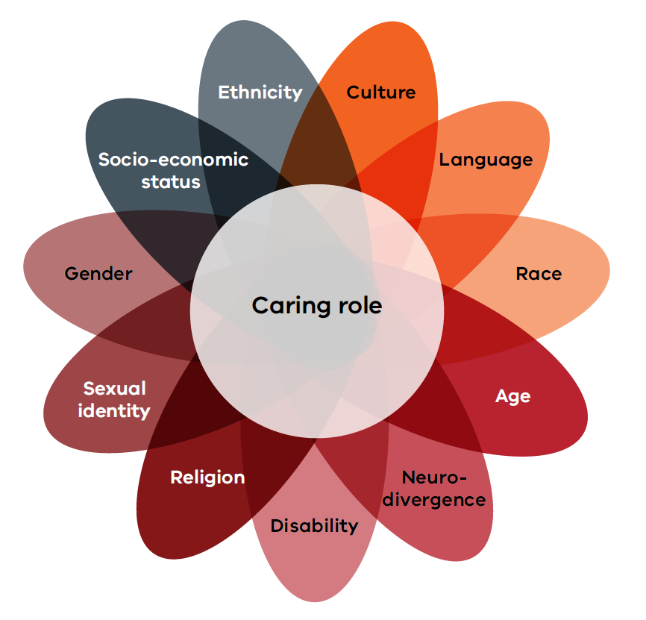

## Key data about carers

* More than 758,500 people with an unpaid care role. That number is estimated to increase to more than 1 million by the end of 2025.[2]
* One in 7 Victorians have an unpaid care role[3]. This number is likely to be an underestimate as many people with a care role do not identify as carers.

### Demographic data

* 68% of carers providing the most support are women
* Of people with a caring role more broadly 54% are women and 46% are men.
* People as young as 4 years old can have a caring role (Little Dreamers). The number of young carers is rising in Victoria and across Australia. There has been an increase from 9% to 13%.
* More than 197,000 of Victorian carers are aged 65 years and over.
* 12.4% of Aboriginal and Torres Strait Islander people report having an unpaid care role. This number is likely lower than the true figure as care roles are seen as an important cultural duty.[4]
* 311,800 Victorian carers live in regional or rural areas. This can make it more difficult for them to access support.
* Carers from marginalised communities are often overlooked and not well represented in data. Such communities include First Nations, culturally and linguistically diverse, and LGBTIQA+ carers.[5]

# A pathway for action

| What we want to achieve | What we stand for | What we will focus on |
| --- | --- | --- |
| Victorians with a care role are valued and have better health and wellbeing. | * Welcoming and inclusive * Always improving * Listening to carers * Sharing responsibility * Working together | **Awareness, recognition and respect**   * People with a care role are recognised, respected and valued. * Communities and services understand the importance and diversity of care roles and relationships. * Carers have a say in how services work – for them and the people they care for.   **Quality services in the right place, at the right time**   * People with a care role and their families are supported as early as possible. * Services are easy to find and access for carers, no matter where they live. * Services work together to provide flexible, connected support.   **Participation, connection and opportunity**   * People with a care role have greater financial security. * Workplaces, study and school environments are carer-friendly. * Carers have opportunities for social, cultural and community connection.   **Recognise and support First Nations care relationships**   * First Nations communities have what they need to provide self-determined support to people with a care role. * Services are culturally safe for First Nations carers and families. * Barriers to accessing support for First Nations carers are addressed. |

## What we want to achieve

Victorians with a care role are valued and have better health and wellbeing.

We value all carers and the important role they play in Victoria.

Carers have told us that they want support to take part in all aspects of their lives, not just their care role.

Carers should have choice and a say in how they receive support to:

* keep on caring
* have a say in decisions about the person or people they care for
* be safe and healthy, financially well, and socially and culturally connected
* take part in education and training, employment, and other passions and interests.

Having a care role can be rewarding. But it can also affect the physical, social and mental health and wellbeing of carers and their families. It can also bring financial stress.

For some people with care roles, being healthy and well can feel out of reach.

We want carers to have better health and wellbeing, whatever that means for them.

‘Sometimes feel like I’m being put in a box and not being seen as a whole person – a person with a caring role, with a disability myself, and as a young person.’ – A young carer

‘First of all, the caring role and my partner's health are so inextricably linked. So, it's hard to talk about what the caring is without talking about what he needs as well, because what he needs then helps me to have respite and do my job.’ – A carer of a person with dementia

‘There is no time for personal health and wellbeing. It took me 3 months to get to a breast screen. All medical appointments revolve around the person with the disability.’ – A carer

## What we stand for

We know we can’t do this alone – valuing carers is everybody’s responsibility.

We will work with care support providers, services, and with communities, carers and their families to achieve the strategy’s vision.

The following key principles will guide our work.

**Figure 2: What we stand for**

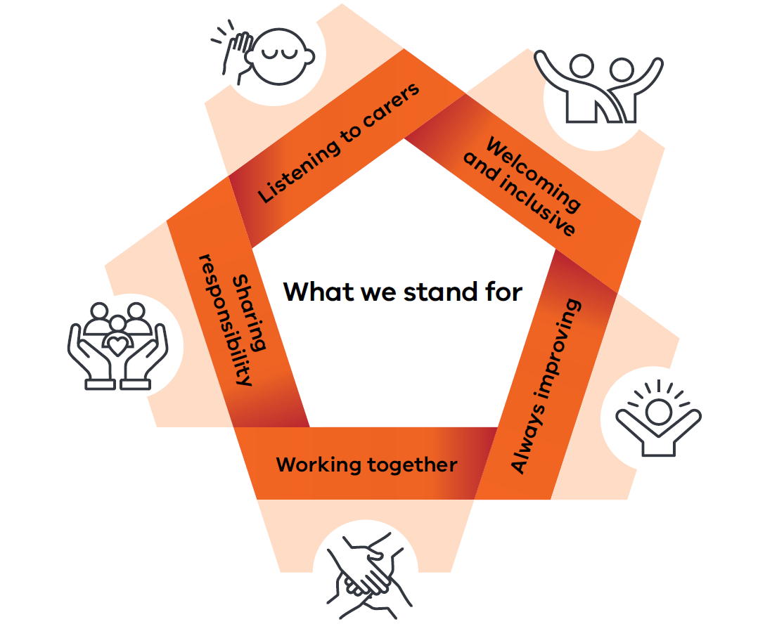

* **Welcoming and inclusive:** Support for carers should be visible, inclusive and accessible to people with a care role, from all identities, ages and circumstances. This means removing barriers, including discrimination based on gender identity, disability, age or cultural background.
* **Always improving:** Services and support should keep improving. This means we need to seek feedback from carers and use data to understand what’s working, and what needs to change.
* **Working together:** Support for carers should be flexible and responsive to their needs. This means government, communities and services should work together to coordinate and integrate support.
* **Sharing responsibility:** It is everyone’s responsibility to help improve carers’ health and wellbeing. This means all services should recognise, respect and support people with a care role.
* **Listening to carers:** Supports and services should be designed and delivered in partnership with carers. This means listening to and valuing diverse carer voices and experiences.

## What we will focus on

### Awareness, recognition and respect

Carers told us they want to be better recognised and respected. Some people do not think of themselves as ‘carers’ but still want respect and support in their care role.

Service systems should identify and recognise ‘hidden’ carers, and help connect them with support, if they need it.

Carers want to have a say in the support and services they receive. They also want a voice in decisions that affect their care role and the people they care for.

We will work to reduce stigma and improve awareness and recognition of the valuable role of carers, whatever their age, identity, circumstances or background.

#### Action areas: awareness, recognition and respect

* People with a care role are recognised, respected and valued.
* Communities and services understand the importance and diversity of care roles and relationships.
* Carers have a say in how services work – for them and the people they care for.

‘The grief. You never get over the grief of what you lose when your loved one gets a diagnosis. Losing your identity when you become a carer. Being left out of things because you can’t do everything you want to do when you’re a carer.’ – A person with a care role

‘It is very hard to continue to keep up when you are caring for someone constantly. People’s understanding is lacking in knowledge on what is involved in a carer’s life. Recognition and support aren’t there at all.’ – A carer of a person with acquired brain injury

#### Case study: Caring for Rainbow Carers

LINE Wangaratta delivered the Caring for Rainbow Carers project.

This project focussed on the regional and rural shires of Wangaratta, Mansfield, Benalla, Indigo and Alpine. The project supported LGBTIQA+ carers or carers of people who identify as LGBTIQA+.

The project boosted safe social connection for LGBTIQA+ carers. It also helped services learn more about issues affecting carers and people with care needs who identify as LGBTIQA+. This includes trans and gender diverse young people with disabilities.

LINE Wangaratta worked with local services and networks like Beechworth Community Health, Wangaratta Open Door Neighbourhood House and the Connecting Carers Locally Network. Together they created referral pathways and a stronger regional carer network. They helped improve support connections for LGBTIQA+ carers.

‘It’s helped me understand my own needs as an unpaid carer better. I’ve been able to access the carer allowance, and receive a carer card, and feel a lot more confident to reach out for support. So, personally I feel much more confident to say, “I’m a carer”.’ – A carer

**The Victorian Government partners with local organisations to connect carers in their communities.**

#### Case study: Peter Mac carer initiative

The Peter MacCallum Cancer Centre (Peter Mac) implemented a support initiative for those caring for people with cancer. This includes a carer support officer, carer psychology service and a monthly carers circle. The initiative has supported over 450 carers. The carers circle has an average of 16 monthly attendees.

Evaluation showed that carers value the tailored support. They appreciate the safe and consistent care.

This initiative has connected carers with information and support services. It has helped them feel validated and more confident in their caring role. They also feel better supported to manage their mental health.

‘I appreciated having support regarding the different stages of change, adjusting to my husband’s diagnosis. The psychologist was compassionate to where I was at, each time we met. I felt seen and heard, which was important to me as I was getting lost in the carer role and home and family roles.’ – A person with a care role

**The Victorian Government’s Support for Carers program funds Peter Mac’s carer initiative.**

### Quality services in the right place, at the right time

Carers have told us it can be hard to find support for themselves, their families and those they care for.

Carers told us the service system can sometimes feel like a maze – and they are not sure where to go for help. Sometimes services don’t meet their needs.

Some people with a care role face extra challenges getting the right support. This can be because of their age, gender identity, disability, geographic location, their language or cultural background.

We will work together so carers and their families get the right supports. This will happen when and where they need it, and as early as possible.

#### Action areas: quality services

* People with a care role and their families are supported as early as possible.
* Services are easy to find and access for carers, no matter where they live.
* Services work together to provide flexible, connected support.

‘I think there's plenty of information there. But it's having the energy and the headspace and the time to be able to delve into it deeply.’ – A carer of a person with dementia

‘I feel extremely cut off from my community. I know there's particular issues in regional areas, but … please don't dismiss the issues in metro areas as well because my isolation is huge.’ – A person with a care role

‘Having someone partner with me to identify support needs, organise these supports and assist with … planning to relieve the admin load helps me.’ – A neurodiverse carer and/or carer of a person who is neurodiverse

‘Carers do amazing things but there is rarely enough time to fit it all in. And figuring out what’s available and how to get it is one of the biggest challenges so many of us face. Carers Victoria is committed to making the system of supports work for carers, rather than carers having to figure out and work the systems themselves.’ – Judith Abbott, CEO, Carers Victoria

#### Case study: Carers Victoria

Carers Victoria is the peak body for unpaid carers in Victoria. It has operated for over 30 years. The organisation is passionate about leading change to improve the lives of Victorian carers.

The Carers Victoria Statewide Carer Advisory Service gets around 250 calls each week. Carers call for help, advice and support. For many, navigating a complex service system can take almost as much time as a full-time job. This leaves little time for them to focus on their own health and wellbeing.

Skilled Carers Victoria staff help carers understand support options available to them. They also help carers understand the support options for those they care for, which could include aged care, mental health and health care.

The impact for carers accessing the service can be profound. For some carers, this may be the first time someone has listened to them. Often just knowing they are not alone can be an enormous help.

‘It’s been reassuring to know that there’s someone to turn to during challenging times. The staff have been kind and understanding, and the resources shared have made a real difference. Thank you for being a reliable source of help.’ A carer

**Carers Victoria is a key partner funded by the Victorian Government.**

#### Case study: Different Journeys

The demands of unpaid caring were overwhelming for Megan. She is an autistic person who lives in a regional area. Megan felt alone, undeserving of support, and uncertain about what to do next. Her health and wellbeing were deteriorating. Her family was fragmenting, and she had become isolated from her community.

Then, Different Journeys introduced Megan to a carer peer support officer. This is someone with lived experience in supporting family members with complex needs. Those needs can include significant mental health challenges. For the first time, Megan felt validated, heard and understood. She was no longer alone.

Megan received respectful, ongoing trauma-informed support. It was always at Megan’s own pace. Different Journeys helped her navigate the complex service system. The support officers use their own lived experience as service users and their strong local partnerships. With that, they empowered Megan to access the support she and her family needed. Step by step, she regained her confidence. She rediscovered her strengths and began advocating for herself and her family.

Today, Megan is part of a carer peer support network. She now feels connected and receives respite. Megan is working toward her goal of returning to part-time employment. By supporting Megan as a carer, Different Journeys supported her whole family. They are more aware of the services available and more confident in accessing them. They are now more hopeful about the future. Together, they are re-engaging with community life.

‘I am completely overwhelmed by the help and assistance you've afforded me. This is exactly the information I've been desperate for, and I fear I don't have the words to express just how grateful I am. So a big and huge thank you, for all of your insight, support, kindness and hard work. This has made the world of difference for me and my family.’ – Megan

**The Victorian Government’s Additional Respite for Carers initiative funds Different Journeys.**

### Participation, connection and opportunity

Carers want to feel valued and supported, and not only for their care role. They also want opportunities for social and community connection.

Carers want to achieve financial security for themselves and their families. Costs associated with their care role can get in the way of this. It can also be tricky to balance getting or keeping a paid job with caring.

Women and gender diverse people are already more likely to earn less. They are also more likely to be in unpaid care roles.

Many carers want to engage in flexible study and paid employment opportunities. This includes supporting young carers – aged between 4 and 25 – in school, education and training.

We will work to ensure people with a care role can take part in all areas of their lives.

#### Action areas: participation, connection and opportunity

* People with a care role have greater financial security.
* Workplaces, study and school environments are carer-friendly.
* Carers have opportunities for social, cultural and community connection.

‘Belonging to a carer support group in the community is very helpful. It is important for sharing and caring in a non-judgemental environment. You feel less isolated and can enjoy socialising.’ – A person with a care role

‘Since returning to work and being able to negotiate flexible work conditions, I feel like a completely different person. I am contributing to super and more importantly, I feel validated. People around me value me. It’s been life changing.’ – A carer

‘It is people who are going through the same thing that's where you get your best support … because they totally understand. You don't have to try and explain or pretend because they've been through it too.’ – A carer of a person with dementia

#### Case study: Little Dreamers

Sarah had severe anxiety and stress when they first connected with Little Dreamers. Sarah began to see how their family’s life was different to others. Their family had to balance school, hospital visits and their sibling’s changing health needs.

With Little Dreamers’ support, Sarah received a Dream Experience. It was an unforgettable evening seeing their favourite performer live from the front row. It was a powerful moment of recognition, joy and relief.

Sarah has become a regular participant in Little Dreamers’ school holiday programs. These programs offer a safe space for Sarah to connect with peers with similar experiences. They also get much-needed respite from daily responsibilities.

Today, Sarah is thriving. With the right support at the right time, they are growing in confidence and building friendships. They are learning to balance their caring role with being a teenager.

Sarah’s journey is a powerful example of how tailored support enables young carers to take part in all areas of life. Little Dreamers’ programs help build resilience and reduce isolation, so that young carers feel seen, supported and valued.

‘Little Dreamers gave me time to just be a kid. I didn’t have to explain my situation. Everyone just got it.’

* Sarah

**The Victorian Government’s Support for Carers and Additional Respite for Carers programs fund Little Dreamers.**

### Recognise and support First Nations care relationships

Aboriginal and Torres Strait Islander people with a care role told us they want more culturally safe services. These services should meet the unique needs and long history of care relationships in First Nations communities.

We will work to improve access to and quality of services for First Nations carers and families. This includes removing the unique barriers First Nations communities face in getting support.

We want to ensure that Aboriginal and Torres Strait Islander people with a care role, their families and communities can exercise self-determination in their caring journey.

#### Action areas: First Nations care relationships

* First Nations communities have what they need to provide self-determined support to people with a care role.
* Services are culturally safe for First Nations carers and families.
* Barriers to accessing support for First Nations carers are addressed.

‘Aboriginal communities have long traditions of caring for one another, but broken and fragmented systems have made that much harder for our Mob than it should be.’ – Jill Gallagher AO, CEO, Victorian Aboriginal Community Controlled Health Organisation

#### Case study: Wathaurong Aboriginal Cooperative

Wathaurong Aboriginal Cooperative focusses on a flexible, responsive model. It prioritises accessibility and cultural safety. This approach addresses the unique needs of First Peoples carers and families.

Their Respite for Carers program provides personalised support plans. It supports First Peoples carers and their families across all points of respite. This includes overnight and emergency options, life skills and wellness programs, advocacy and capacity building, and transport.

The respite program delivers culturally safe and enriching activities. They include:

* cultural storytelling and yarning circles
* art therapy and craft workshops
* outdoor nature-based walks
* gardening.

The program commits to self-determined, culturally safe and holistic care. It aims to support First Nations communities by honouring their cultural values and community connections.

‘The respite support provided by Wathaurong (Balert Care) gave me the space to reconnect with my culture and community. The yarning circles and art therapy helped me feel seen and supported in ways I hadn’t experienced before.’ – A carer

**The Victorian Government’s Additional Respite for Carers initiative funds Wathaurong Aboriginal Cooperative.**

#### Case study: ACES

The Aboriginal Community Elders Services (ACES) delivers the Elders Carers Respite Support program. ACES is proud to be First Nations-led. It delivers culturally appropriate and holistic services. These services promote health, wellbeing and empowerment for First Peoples carers and their families.

The program honours the rich cultural heritage of First Nations communities. It also addresses the unique needs and challenges of First Peoples carers. This is through service design that is inclusive, respectful and responsive.

Self-determined respite activities include:

* yarning circles
* pamper days
* cultural ceremonies
* storytelling
* art and craft.

These activities help reduce stress, prevent burnout and allow carers to recharge their energy. The program sees connection to cultural heritage as vital. It helps Elders with a care role feel a sense of identity, pride and belonging. It also fosters meaningful connections to culture, community and country. This builds supportive relationships and chances to share experiences with other Elders carers.

The program also offers free round-the-clock, accessible support to First Peoples carers and Elders. It includes overnight and emergency respite options and a 24/7 hotline. Carers receive information and links to local resources, expert advice and emotional support, to boost their health and wellbeing.

**The Victorian Government’s Additional Respite for Carers initiative funds ACES.**

#### Our People, Our Way

Aboriginal Community Controlled Organisations (ACCOs) in Victoria provide holistic, culturally grounded support that wraps around Aboriginal and Torres Strait Islander people across the life course. Our work is grounded in the understanding that when our families are strong, our communities are strong. We walk with our people through every season of life – celebrating births, grieving losses, navigating systems, and advocating for change.

Aboriginal and Torres Strait Islander people are proud of the responsibilities we carry to care for each other. We sustain them with trust, dignity, and respect. But when systemic injustices cause stress, our ACCOs step in to provide additional support and advocacy. Our model is there to prevent and alleviate the stress that often comes from navigating fragmented and culturally unsafe systems. When families face food insecurity, we don’t just make referrals – we put food on the table. Where transport is a barrier to school, appointments, or community connection – we get behind the wheel ourselves. Where financial insecurity weighs heavily, we offer practical support to build financial capability and stability.

This work is not transactional. It is enriched by time, trust, and life-long relationships. Our staff belong to the communities they serve. They understand the unspoken histories behind each family’s story. They are uniquely placed to see things that are invisible to mainstream systems. These are grandparents raising grandchildren, aunties supporting family members with disability, young people caring for Elders – people whose unpaid care is shaped by cultural obligations, intergenerational connections, and love. We see their labour not as a burden, but as a source of strength – yet we also know it must be recognised and supported.

This is why we must be resourced to provide culturally safe and responsive wrap-around services to the people in our communities who hold unpaid caring responsibilities. The support we provide must be integrated into the health, housing, justice, disability, and family services that ACCOs already deliver. Carers do not experience their responsibilities in neat categories – they live at the intersection of systems. To meet their unique needs, support must be flexible, responsive, and culturally enriched.

**– Victorian Aboriginal Community Controlled Health Organisation**

# How we will track our progress for the Victorian Carer Strategy 2025–2035

The *Victorian Carer Strategy 2025–2035* focusses on collaboration. It brings together services, communities and all levels of government to better support carers.

We want everyone to join forces to make a bigger impact.

Action plans will guide the strategy’s delivery. This includes key programs like the Victorian Support for Carers Program and Victorian Carer Card.

We will work with organisations that have important data. This will help us better understand the experiences of carers, the people they care for and the systems they use.

We will use all this information to see what’s working, what isn’t and what needs to change.

We will share updates and stories on the Victorian Government’s website. This way, the community can stay informed about what’s happening.

And most importantly, we will keep listening to people with a care role about their wants and needs so we can keep improving.

1. Commonwealth of Australia, *National Carer Strategy 2024–2034*, 2024.
2. Australian Bureau of Statistics, *Survey of Disability, Ageing and Carers*, 2022.
3. Carers Victoria, [Key Information About Carers in Victoria](https://carersvictoria.org.au/becoming-careraware/key-information-about-carers-in-victoria/,), https://carersvictoria.org.au/becoming-careraware/key-information-about-carers-in-victoria/, 2022, accessed 17 September, 2025.
4. Gayaa Dhuwi (Proud Spirit) Australia, *Inquiry into the Recognition of Unpaid Carers*, 2023.
5. AIFS (Australian Institute of Family Studies), *Building the evidence base for the National Carer Strategy Rapid review of the evidence*, report prepared by Sibly C and Andersson C, Australian Government, 2023