

NORTH RICHMOND PRECINCT
COMMUNITY GRANTS PROGRAM 2023 – 2024
Using Grants Gateway
OFFICIAL
Grants Gateway is the department’s online grant application system. All applications must be lodged through Grants Gateway to be eligible for funding. If you are having trouble registering, contact the North Richmond Precinct Team: engagenorthrichnmond@dffh.vic.gov.au / 0477 765 743.

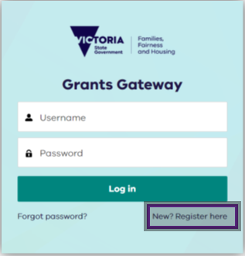
Step 1. Register
If you applied for a North Richmond
Precinct Grant in the previous (2023)
round, you are already registered. If
you can’t remember your password,
enter your email address then click
‘forgot password’.
Otherwise, select New? Register here

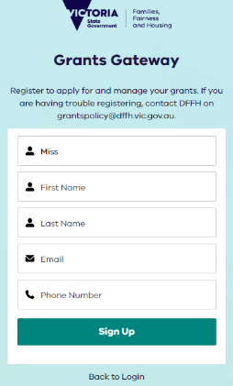

Step 2. Enter details
Enter your details, and select Sign Up.

Step 3. Confirm email address
Check for a confirmation email for the registered account. Open your email inbox and search for subject line ‘Welcome to Grants Gateway’ email from No Reply Salesforce noreply@salesforce.com
on behalf of Grants Gateway.

Step 4. Choose password
Create a password for your account. The password must be:
- 13 characters
- 1 letter
- 1 number
- 1 special character
Confirm your password by retyping it and then select Change Password.
Congratulations! You now have access to Grants Gateway.

Navigating Grants Gateway
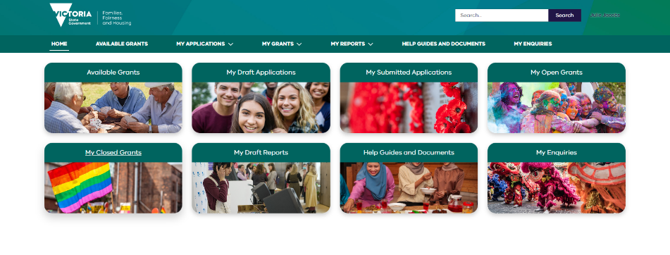
3
2
1

4
- Available Grants – scroll through to find the North Richmond grant you are applying for.
- My Draft Applications – this is where your application will be saved until you submit it.
- My Submitted Applications – any previous grant applications you have submitted through Grants Gateway will be here.
- Help Guides and Documents – resources to help you use Grants Gateway

- Available grants: scroll through to find the North Richmond grant you are applying for.
- My draft applications: where you application is saved until you submit it.
- My submitted applications: previous applications you have submitted through Grants Gateway are saved here.
- Help guides and documents: resources to help you use Grants Gateway.

