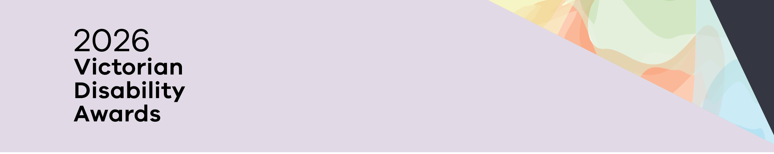

2026 Victorian Disability Awards
Finalists
OFFICIAL
Contents
Finalists - Advocacy for People 2
Finalists - Disability Pride Champion 2
Finalists - Leadership in co-design 2
Finalists - Lifetime Achievement Award 2

Finalists - Advocacy for People
Association for Children with Disability
Lani Dinh
Traveller’s Aid Australia

Finalists - Disability Pride Champion
William Ward-Boas, VALID
Cooper Smith, DJ and producer

Finalists - Leadership in co-design
Best Care for People with Communication Disability in Health Emergencies, cross-sector partnership between Scope Australia, Ambulance Victoria, Monash Health and Latrobe Regional Health
Metro Trains Community Education Program, Metro Trains Melbourne
Fleur O’Hare, Centre for Eye Research Australia

Finalists - Lifetime Achievement Award
Amanda Robinson, NGO Training Centre
Nimo Hersi, Inclusion and Diversity Training

To receive this document in another format, phone 1300 880 043 or email awards@dffh.vic.gov.au.
If you are d/Deaf, hard of hearing, or have a speech or communication difficulty, please contact us through your preferred National Relay Service (NRS) call channel – see Access Hub's NRS call numbers and links web page:
https://www.accesshub.gov.au/about-the-nrs/nrs-call-numbers-and-links.
Then give the NRS our phone number: 1300 880 043.
For more information, visit Access Hub's About the National Relay Service (NRS) web page:
https://www.accesshub.gov.au/about-the-nrs.
Authorised and published by the Victorian Government, 1 Treasury Place, Melbourne.
© State of Victoria, Australia, Department of Families, Fairness and Housing, October 2026
ISBN 978-1-76171-277-7 (pdf/online/MS word)
Available at https://www.dffh.vic.gov.au/victorian-disability-awards.

