

|  |
| --- |
| Mapping languages spoken in Victoria |
| Regional Victoria |
| OFFICIAL |

|  |
| --- |
| **Mapping languages spoken in Victoria** Regional Victoria |
|  |

|  |
| --- |
|  |
| To receive this document in another format, [email the Stakeholder Engagement and Innovation team](mailto:multicultural.communications@vic.gov.au) <engagement@dffh.vic.gov.au>.  Authorised and published by the Victorian Government, 1 Treasury Place, Melbourne.  © State of Victoria, Australia, Department of Families, Fairness and Housing, June 2023.  In this document, ‘Aboriginal’ refers to both Aboriginal and Torres Strait Islander people.  **ISBN** 978-1-76130-077-6 **(pdf/online/MS word)**  Available at [Mapping the languages spoken in Victoria](https://www.dffh.vic.gov.au/mapping-languages-spoken-victoria) <https://www.dffh.vic.gov.au/mapping-languages-spoken-victoria>. |
|  |

Contents

Mapping languages spoken in Victoria 1

Key trends 6

Data limitations 9

English proficiency is self-reported 9

Regions analysed 9

Languages chosen 9

Disclosure risks 10

Country of birth 11

English proficiency in language communities in regional Victoria 12

Comparing languages with low English proficiency in metropolitan Melbourne 15

Where do people with low English proficiency live? 16

Important languages with higher English proficiency 47

Greek 47

Italian 48

Punjabi 49

Most spoken languages per Statistical Area 4 50

Ballarat 50

Bendigo 51

Geelong 52

Hume 54

Latrobe – Gippsland 55

North West 57

Shepparton 58

Warrnambool and South West 60

Sex and English language proficiency 62

Language proficiency and age 67

Age group 10–19 years 68

Age group 20–29 70

Age group 30–39 71

Age group 40–49 72

Age group 50–59 74

Age group of 60+ 75

Appendix 1: Countries of birth of migrant and refugee communities in regional Victoria (excluding Australia) 79

Summary

This report explores the languages spoken in regional Victoria to help you better understand multilingual communities. This information is useful for planning policies, projects, communications and engagement.

Since the last Census in 2016, Victoria’s population has grown by 600,000 people. The number of residents born overseas grew to almost 35 per cent (2,274,824 people). While many migrants and refugees settle in regional Victoria, most still live in metropolitan Melbourne (almost four out of five).[1]

Many people in regional Victoria speak Mandarin, Italian and Punjabi, but this is changing. The 2021 Census showed the number of people speaking Asian and African languages (including those with low English proficiency) is overtaking those who speak European languages.

Overall, more language communities reported higher levels of low English proficiency. While some languages no longer rank as highly, their level of English proficiency has not changed since the last Census. They have simply been overtaken by other languages in population size and are therefore not included in the list.

This report analyses 2021 Census data to better understand the demographics of people who report low English proficiency in regional Victoria. How well new migrants and refugees speak English can affect successful settlement, wellbeing and self-sufficiency.[2] Understanding English proficiency across the population also helps governments to plan and deliver services that meet community needs. This includes sharing public health and emergency response information.

## Key trends

* In all regional areas, the most common language communities are growing. This means that more people are speaking a language other than English at home.
* By location – Low English proficiency is most common in Geelong, Shepparton and North West Victoria (Grampians, Mildura, Murray River – Swan Hill). These regions are closely followed by Latrobe – Gippsland.
* By language – Karen, Rohingya and Burmese have the most speakers with low English proficiency in regional Victoria. This is the same as in the 2016 Census. In the 2021 Census, Hazaraghi speakers reported a 12 per cent decrease in levels of low English proficiency. Additionally, more Mandarin, Cantonese, Min Nan and Chinese nfd speakers reported lower English proficiency compared with 2016.[3]
* European languages are generally growing more slowly than South and Southeast Asian languages. In many regional areas South and Southeast Asian language communities are now some of the larger language communities.
* Nepali is a growing language community. Nepali is in the top 30 most common languages in seven out of eight regions analysed in 2021 compared with one region in 2016. Even though the community grew rapidly, low English proficiency decreased from 10 per cent in 2016 to 8.8 per cent (1,803 people) in 2021.
* Women have lower English proficiency than men for most languages.
* Older people generally report lower English proficiency. English language proficiency commonly stays the same or declines in people between the ages of 40 and 59.

Introduction

The Victorian Department of Families, Fairness and Housing contracted the Social Policy Group to map languages spoken in the state of Victoria. This map will inform how the Victorian Government communicates and engages with multicultural communities. This is part of a two-report series, with the other report focusing on metropolitan Melbourne.

The 2021 Census tells us that 7.3 per cent of people (115,530 people) in regional Victoria speak a language other than English at home. While most migrants and refugees move to Melbourne, many also choose to live in regional Victoria.

It is important to know how well someone speaks English as well as what language they speak at home. Some people may speak a language other than English at home and have high English proficiency, while others may speak English ‘not well’ or ‘not well at all’ **(low English proficiency)**. It is the latter group that needs targeted communication and engagement, including translation, interpreting, plain and Easy English.

People with low English proficiency can experience more challenges in settling into Australian society. For example, they can face barriers in:

* finding work
* navigating government systems
* accessing healthcare
* making social connections.[4]

How to use this report

This report is designed to help public servants, service providers, community organisations and researchers to better understand multicultural communities in Victoria. You can use the information in this report to inform projects, policies and communications. This report includes:

* the top languages spoken at home in regions of regional Victoria, including those communities whose speakers self-report as having low English proficiency.
* maps of where language communities whose speakers report low English proficiency live in regional Victoria
* the differences in English proficiency across sexes across the top 30 languages with low English proficiency
* the differences in English proficiency of language communities across age groups.

While the Census data is a reliable source of information, it has limitations. You can read more about data limitations below. If you can, you should supplement the Census data with your own data about the communities you are trying to reach. This could include client or user information. You can also work with community organisations and peak bodies to learn more about the communities you are trying to reach.

# Data limitations

## English proficiency is self-reported

When using the data in this report, please keep in mind that levels of English proficiency are self-reported. People may overestimate or underestimate their ability. Many people did not answer the question about English proficiency at all in the 2021 Census. Some people may not have completed the 2021 Census because they have low English proficiency and did not have anyone to help them. This may be particularly important while investigating the language proficiency differences between sexes.

## Regions analysed

This report uses 2021 Census data to map out languages spoken across regional Victoria. To do this, we split regional Victoria into eight regions:

* Ballarat
* Bendigo
* Geelong
* Hume
* Latrobe – Gippsland
* North West
* Shepparton
* Warrnambool and South West.

This is based on Statistical Area Level 4 (SA4).[5]

Regional Victoria has smaller and more spread-out populations of people who speak a language other than English at home than metropolitan Melbourne. This means we need to analyse larger areas to get meaningful results. Statistical Area Level 4 (SA4) is the most reasonable and significant scale to use to analyse data for regional Victoria. If we analysed data by Local Government Area (LGA) in regional Victoria, some population and language groups would be excluded from the data sets.

Figure 1: Map of regions analysed in this report.

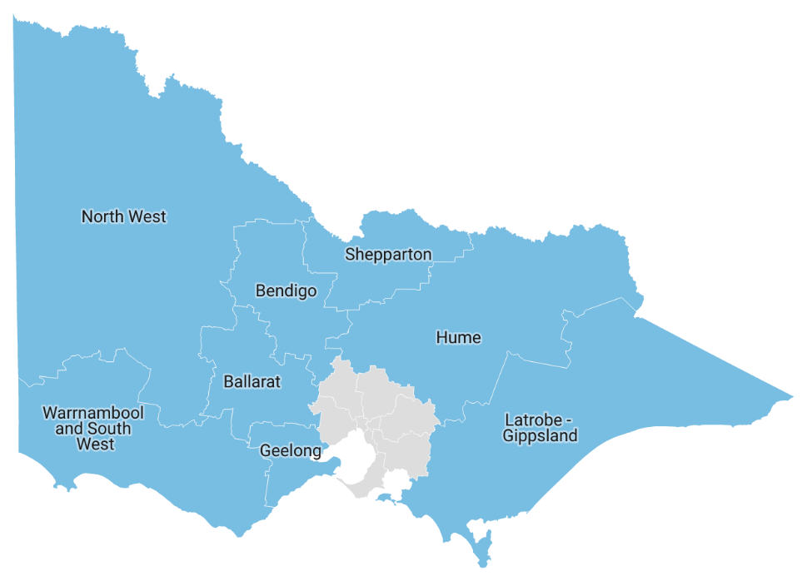

## Languages chosen

This report focuses on languages spoken by people from migrant and refugee backgrounds. It is designed to help government departments understand multicultural communications and their communication needs. This means groups that reported the following languages were not included:

* ‘Not stated’
* ‘Non-verbal, so described’
* ‘Inadequately described’
* ‘Sign languages, nec’[6]
* ‘Key Word Sign Languages’
* ‘Auslan’
* ‘Sign languages, nfd’[7]

## Disclosure risks

Some of the Census data used to create this report may contain identity risks. The Australian Bureau of Statistics (ABS) must ensure it does not disclose identifiable information about a person, household or business. One of the ways they do this is suppression – removing cells that are a disclosure risk from the table. This stops users from using data to reidentify a person. This is particularly relevant for the analysis of small language communities, especially when analysing language proficiency by sex and age.

For more information, refer to [Treating aggregate data](https://www.abs.gov.au/about/data-services/data-confidentiality-guide/treating-aggregate-data) <https://www.abs.gov.au/about/data-services/data-confidentiality-guide/treating-aggregate-data> on the ABS website.

# Country of birth

The main languages spoken in regional Victoria (apart from English) are Mandarin, Italian and Punjabi, followed by other South-Asian languages or Arabic. This is similar to what was reported in previous Census data.

The 2021 Census data did not show changes in country of birth compared with the 2016 Census. England, New Zealand and India are still the most popular country of birth other than Australia who live in regional Victoria, followed by the Philippines.

While this follows the national trend, there are some differences. First, people born in China are the ninth largest community in regional Victoria, but they are the third largest nationally. Additionally, in regional Victoria people born in the Netherlands are the fifth largest group, while they are the 28th largest group nationally.

In regional Victoria, people born in England are the largest group of people born overseas. This differs from metropolitan Melbourne, where people born in India are the largest group of people born overseas. Further, New Zealand is the second largest group in regional Victoria compared with the fifth in metropolitan Melbourne. Finally, people born in the Philippines and the Netherlands are in the top 5 for regional Victoria where they are not for metropolitan Melbourne.

Figure 2: Countries of birth of migrant and refugee communities in regional Victoria (excluding Australia) 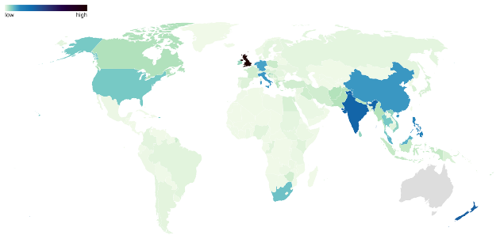

Corresponding values for Figure 2 can be found in Appendix 1.

# English proficiency in language communities in regional Victoria

Figure 3 provides an overview of languages with self-reported low English proficiency in regional Victoria. The graph below shows the percentage of people living in regional Victoria over 10 years of age who speak a language other than English at home and reported speaking English ‘not well’ or ‘not at all’.

Figure 3: Top 30 language communities with highest levels of low English proficiency

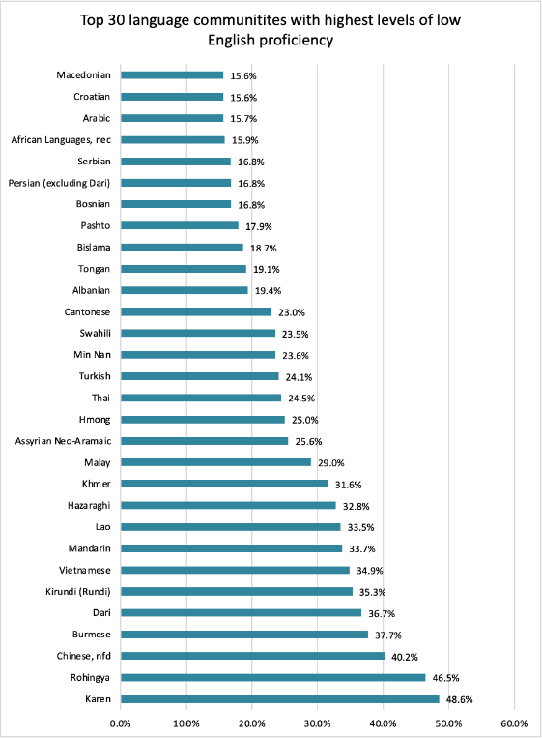

Table 1: Top 30 language communities with highest levels of low English proficiency

| Language | Level of low English proficiency | Total number of speakers |
| --- | --- | --- |
| Karen | 48.6% | 2,393 |
| Rohingya | 46.5% | 71 |
| Chinese, nfd | 40.2% | 194 |
| Burmese | 37.7% | 268 |
| Dari | 36.7% | 496 |
| Kirundi (Rundi) | 35.3% | 85 |
| Vietnamese | 34.9% | 2,970 |
| Mandarin | 33.7% | 7,961 |
| Lao | 33.5% | 161 |
| Hazaraghi | 32.8% | 1,676 |
| Khmer | 31.6% | 452 |
| Malay | 29.0% | 1,424 |
| Assyrian Neo-Aramaic | 25.6% | 90 |
| Hmong | 25.0% | 56 |
| Thai | 24.5% | 1,983 |
| Turkish | 24.1% | 1,409 |
| Min Nan | 23.6% | 123 |
| Swahili | 23.5% | 863 |
| Cantonese | 23.0% | 1,675 |
| Albanian | 19.4% | 547 |
| Tongan | 19.1% | 654 |
| Bislama | 18.7% | 91 |
| Pashto | 17.9% | 195 |
| Bosnian | 16.8% | 327 |
| Persian (excluding Dari) | 16.8% | 773 |
| Serbian | 16.8% | 1,251 |
| African Languages, nec | 15.9% | 63 |
| Arabic | 15.7% | 3,015 |
| Croatian | 15.6% | 2,716 |
| Macedonian | 15.6% | 1,466 |

Most languages with more than 20 per cent of speakers reporting low English proficiency are from:

* East Asia
* South-east Asia
* Afghanistan.

Some languages have a lower percentage of low English proficiency, but there may still be as many people with low English proficiency due to the high number of speakers of those languages. We have included Greek, Italian and Punjabi later in this report for this reason.

Compared with the 2016 Census data, English proficiency improved for the Afghan community. This is especially true for Hazaraghi speakers who report a 12 per cent decrease in low English proficiency. Dari, Nepali and Macedonian also reported a small decrease (both of 2 per cent).

Many languages have more speakers reporting low English proficiency compared with 2016. Thai and Chinese, nfd report a large increase, increasing by 10 and 9 per cent respectively. Tongan and Swahili both report an increase of 7 per cent. Khmer, Mandarin, Vietnamese and Persian (excluding Dari) all report a slight increase of less than 5 per cent.

Languages associated with earlier migration trends to Australia, such as Turkish, Albanian, Serbian and Croatian, report no changes compared with 2016. English proficiency levels stayed the same for Cantonese and Arabic.

Overall, data suggests that there are more languages reporting high levels of low English proficiency. In the 2016 Census data the lowest percentages in the top languages were between 12 and 8 per cent. This increased to 17 and 16 per cent for 2021. This means that some languages are no longer included in the above list, yet their overall level of English proficiency has not changed.

## Comparing languages with low English proficiency in metropolitan Melbourne

Half of the top 30 language communities who report low levels of English proficiency remain the same for both metropolitan Melbourne and regional Victoria. Most of them report higher levels of low English proficiency across regional Victoria, with the exceptions of Khmer-, Assyrian Neo-Aramaic- and Cantonese-speaking communities. The other half of the languages on the top 30 list differ between regional Victoria and metropolitan Melbourne. This could be because there are more language communities reporting low English proficiency in metropolitan Melbourne.

Some languages with low levels of English proficiency across Victoria have a much higher percentage of the population with low English proficiency in regional Victoria. For example, 22 per cent of Kirundi (Rundi) speakers report low English proficiency in metropolitan Melbourne compared with 35 per cent in regional Victoria. This is similar for Dari. For most languages, the differences are 2 to 8 per cent with regional Victoria generally reporting a higher percentage of speakers with low English proficiency.

## Where do people with low English proficiency live?

Some languages with low English proficiency are spread across regional Victoria. These include:

* Cantonese
* Vietnamese
* Chinese (nfd)
* Mandarin
* Khmer
* Thai
* Arabic
* Croatian.

For some languages, all speakers with low English proficiency live in one area. Those are:

* Assyrian Neo Aramaic – Geelong
* Hmong – Hume
* African languages, nec – Ballarat.

Languages from the Balkans (Albanian, Serbian, Macedonian, Bosnian and Croatian) have speakers with low English proficiency spread across most of regional Victoria. The exception is Bosnian for which speakers reporting low English proficiency mainly reside in Geelong.

Of the languages analysed, Geelong has more than 50 language communities reporting low English proficiency. More than 40 language communities in North West and Latrobe – Gippsland reported low levels of English proficiency as well. The area that has the least number of language communities reporting low English proficiency (20 communities) is Warrnambool and South West.

### Karen

Figure 4: Level of low English proficiency of Karen-speaking community by statistical area of regional Victoria

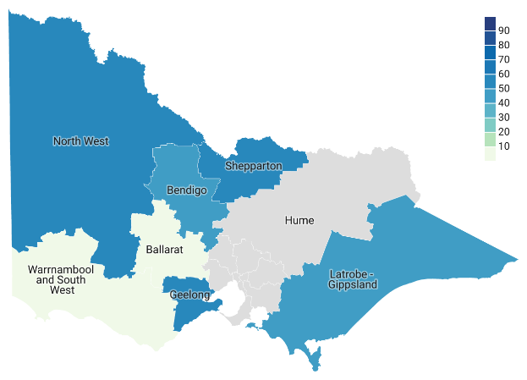

Table 2: Level of low English proficiency of Karen-speaking community by statistical area of regional Victoria

|  |  |  |
| --- | --- | --- |
| SA4 | Total number of speakers | Low English proficiency |
| Ballarat | 3 | 0% |
| Bendigo | 1302 | 47% |
| Geelong | 769 | 51% |
| Hume | 0 | – |
| Latrobe – Gippsland | 35 | 46% |
| North West | 275 | 52% |
| Shepparton | 8 | 50% |
| Warrnambool and South West | 10 | 0% |

### Chinese, nfd

Figure 5: Level of low English proficiency of Chinese, nfd-speaking community by statistical area of regional Victoria

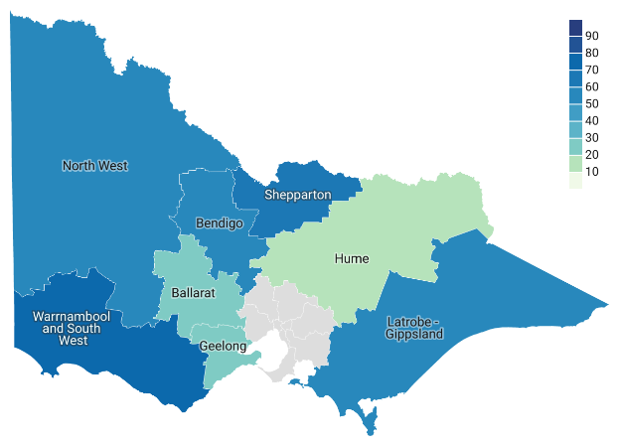

Table 3: Level of low English proficiency of Chinese, nfd-speaking community by statistical area of regional Victoria

|  |  |  |
| --- | --- | --- |
| SA4 | Total number of speakers | Low English proficiency |
| Ballarat | 15 | 20% |
| Bendigo | 9 | 56% |
| Geelong | 42 | 12% |
| Hume | 25 | 12% |
| Latrobe – Gippsland | 20 | 50% |
| North West | 45 | 64% |
| Shepparton | 19 | 63% |
| Warrnambool and South West | 27 | 74% |

### Kirundi (Rundi)

Figure 6: Level of low English proficiency of Kirundi (Rundi)-speaking community by statistical area of regional Victoria

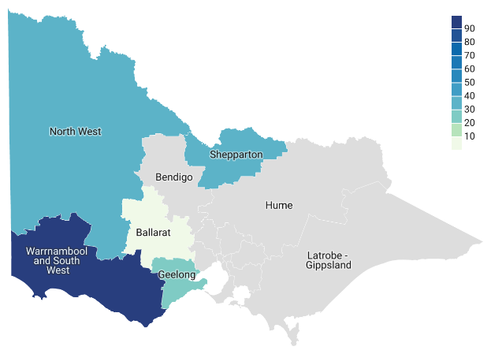

Table 4: Level of low English proficiency of Kirundi (Rundi)-speaking community by statistical area of regional Victoria

|  |  |  |
| --- | --- | --- |
| SA4 | Total number of speakers | Low English proficiency |
| Ballarat | 4 | 0% |
| Bendigo | 0 | – |
| Geelong | 13 | 23% |
| Hume | 0 | – |
| Latrobe – Gippsland | 0 | – |
| North West | 45 | 36% |
| Shepparton | 28 | 39% |
| Warrnambool and South West | 5 | 100% |

### Rohingya

Figure 7: Level of low English proficiency of Rohingya-speaking community by statistical area of regional Victoria

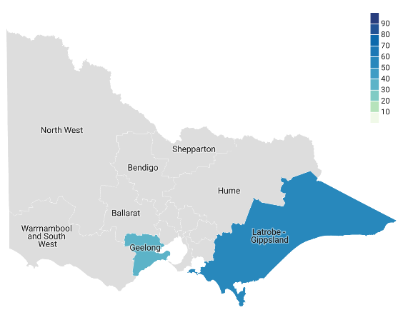

Table 5: Level of low English proficiency of Rohingya-speaking community by statistical area of regional Victoria

|  |  |  |
| --- | --- | --- |
| SA4 | Total number of speakers | Low English proficiency |
| Ballarat | 0 | – |
| Bendigo | 0 | – |
| Geelong | 35 | 31% |
| Hume | 0 | – |
| Latrobe – Gippsland | 32 | 50% |
| North West | 0 | – |
| Shepparton | 0 | – |
| Warrnambool and South West | 0 | – |

### Dari

Figure 8: Level of low English proficiency of Dari-speaking community by statistical area of regional Victoria

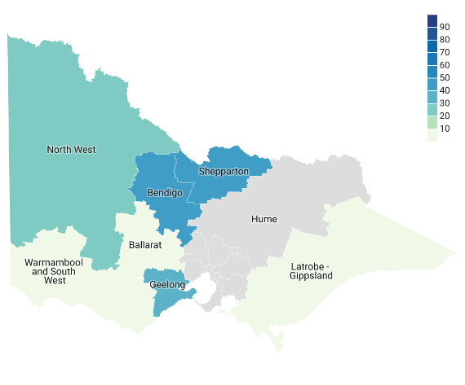

Table 6: Level of low English proficiency of Dari-speaking community by statistical area of regional Victoria

|  |  |  |
| --- | --- | --- |
| SA4 | Total number of speakers | Low English proficiency |
| Ballarat | 5 | 0% |
| Bendigo | 58 | 53% |
| Geelong | 172 | 31% |
| Hume | 0 | – |
| Latrobe – Gippsland | 3 | 0% |
| North West | 69 | 28% |
| Shepparton | 184 | 46% |
| Warrnambool and South West | 5 | 0% |

### Burmese

Figure 9: Level of low English proficiency of Burmese-speaking community by statistical area of regional Victoria

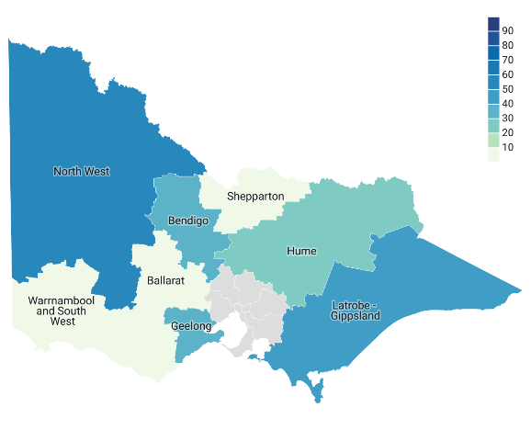

Table 7: Level of low English proficiency of Burmese-speaking community by statistical area of regional Victoria

|  |  |  |
| --- | --- | --- |
| SA4 | Total number of speakers | Low English proficiency |
| Ballarat | 4 | 0% |
| Bendigo | 44 | 30% |
| Geelong | 74 | 43% |
| Hume | 20 | 30% |
| Latrobe – Gippsland | 81 | 47% |
| North West | 36 | 58% |
| Shepparton | 10 | 0% |
| Warrnambool and South West | 6 | 0% |

### Vietnamese

Figure 10: Level of low English proficiency of Vietnamese-speaking community by statistical area of regional Victoria

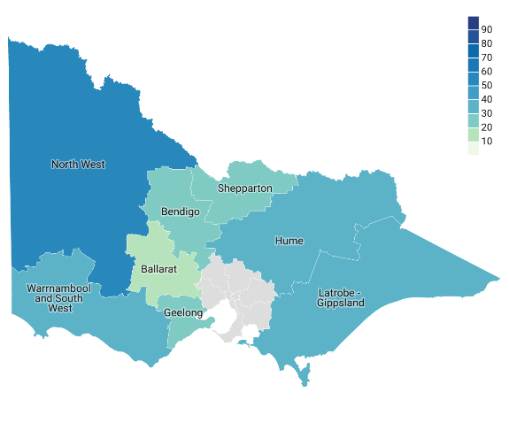

Table 8: Level of low English proficiency of Vietnamese-speaking community by statistical area of regional Victoria

|  |  |  |
| --- | --- | --- |
| SA4 | Total number of speakers | Low English proficiency |
| Ballarat | 208 | 14% |
| Bendigo | 180 | 22% |
| Geelong | 804 | 25% |
| Hume | 262 | 37% |
| Latrobe – Gippsland | 444 | 34% |
| North West | 789 | 53% |
| Shepparton | 136 | 29% |
| Warrnambool and South West | 180 | 32% |

### Hazaraghi

Figure 11: Level of low English proficiency of Hazaraghi-speaking community by statistical area of regional Victoria

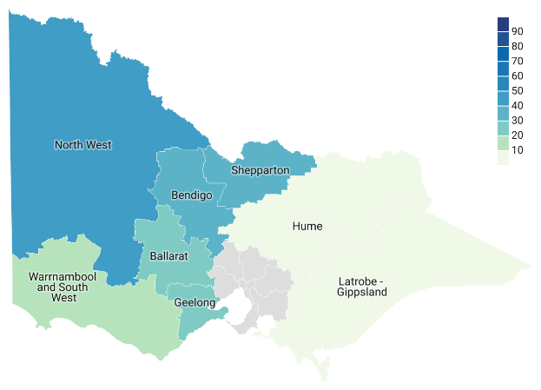

Table 9: Level of low English proficiency of Hazaraghi-speaking community by statistical area of regional Victoria

|  |  |  |
| --- | --- | --- |
| SA4 | Total number of speakers | Low English proficiency |
| Ballarat | 22 | 27% |
| Bendigo | 50 | 36% |
| Geelong | 571 | 27% |
| Hume | 10 | 0% |
| Latrobe – Gippsland | 8 | 0% |
| North West | 320 | 42% |
| Shepparton | 675 | 35% |
| Warrnambool and South West | 22 | 18% |

### Mandarin

Figure 12: Level of low English proficiency of Mandarin-speaking community by statistical area of regional Victoria

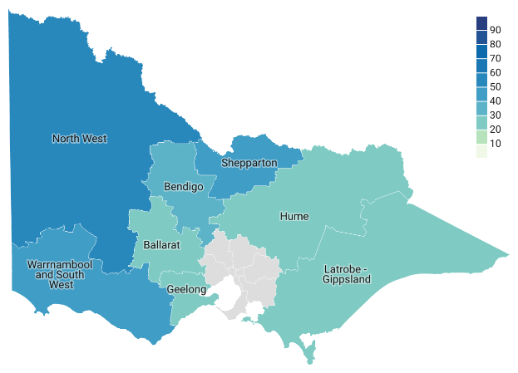

Table 10: Level of low English proficiency of Mandarin-speaking community by statistical area of regional Victoria

|  |  |  |
| --- | --- | --- |
| SA4 | Total number of speakers | Low English proficiency |
| Ballarat | 906 | 21% |
| Bendigo | 617 | 31% |
| Geelong | 1951 | 20% |
| Hume | 593 | 26% |
| Latrobe – Gippsland | 874 | 27% |
| North West | 1557 | 53% |
| Shepparton | 851 | 42% |
| Warrnambool and South West | 656 | 46% |

### Lao

Figure 13: Level of low English proficiency of Lao-speaking community by statistical area of regional Victoria

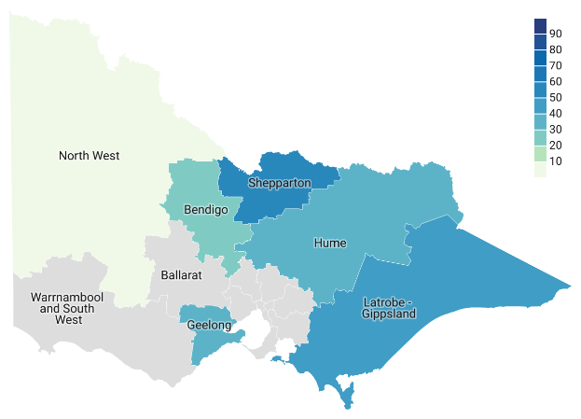

Table 11: Level of low English proficiency of Lao-speaking community by statistical area of regional Victoria

|  |  |  |
| --- | --- | --- |
| SA4 | Total number of speakers | Low English proficiency |
| Ballarat | 0 | – |
| Bendigo | 15 | 27% |
| Geelong | 66 | 38% |
| Hume | 35 | 31% |
| Latrobe – Gippsland | 7 | 43% |
| North West | 12 | 0% |
| Shepparton | 24 | 50% |
| Warrnambool and South West | 0 | – |

### Khmer

Figure 14: Level of low English proficiency of Khmer-speaking community by statistical area of regional Victoria

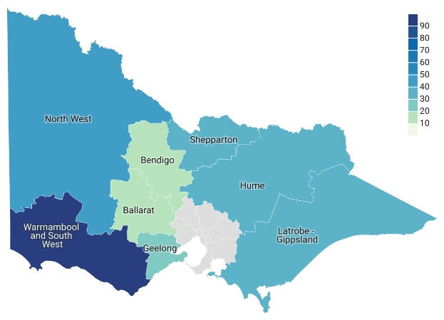

Table 12: Level of low English proficiency of Khmer-speaking community by statistical area of regional Victoria

|  |  |  |
| --- | --- | --- |
| SA4 | Total number of speakers | Low English proficiency |
| Ballarat | 29 | 17% |
| Bendigo | 31 | 13% |
| Geelong | 80 | 23% |
| Hume | 59 | 39% |
| Latrobe – Gippsland | 84 | 33% |
| North West | 126 | 43% |
| Shepparton | 36 | 36% |
| Warrnambool and South West | 3 | 100% |

### Malay

Figure 15: Level of low English proficiency of Malay-speaking community by statistical area of regional Victoria

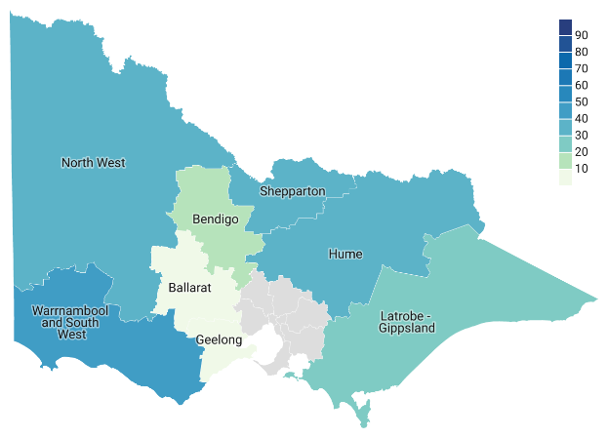

Table 13: Level of low English proficiency of Malay-speaking community by statistical area of regional Victoria

|  |  |  |
| --- | --- | --- |
| SA4 | Total number of speakers | Low English proficiency |
| Ballarat | 37 | 0% |
| Bendigo | 70 | 17% |
| Geelong | 86 | 5% |
| Hume | 47 | 30% |
| Latrobe – Gippsland | 71 | 20% |
| North West | 726 | 35% |
| Shepparton | 377 | 29% |
| Warrnambool and South West | 25 | 40% |

### Swahili

Figure 16: Level of low English proficiency of Swahili-speaking community by statistical area of regional Victoria

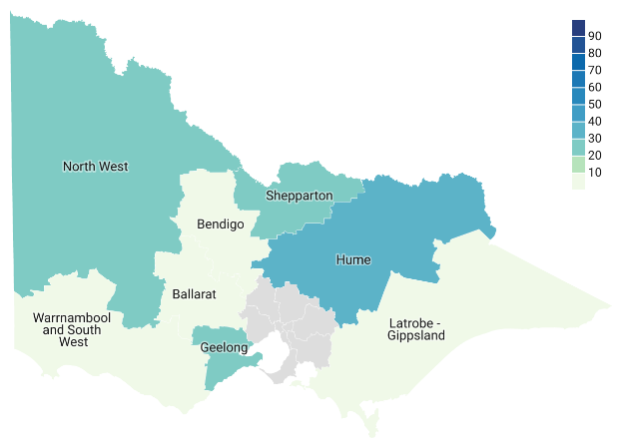

Table 14: Level of low English proficiency of Swahili-speaking community by statistical area of regional Victoria

|  |  |  |
| --- | --- | --- |
| SA4 | Total number of speakers | Low English proficiency |
| Ballarat | 23 | 0% |
| Bendigo | 30 | 0% |
| Geelong | 197 | 19% |
| Hume | 235 | 37% |
| Latrobe – Gippsland | 27 | 0% |
| North West | 59 | 24% |
| Shepparton | 254 | 24% |
| Warrnambool and South West | 21 | 0% |

### Hmong

Figure 17: Level of low English proficiency of Hmong-speaking community by statistical area of regional Victoria

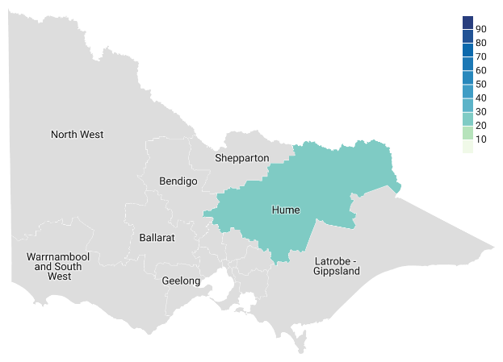

Table 15: Level of low English proficiency of Hmong-speaking community by statistical area of regional Victoria

|  |  |  |
| --- | --- | --- |
| SA4 | Total number of speakers | Low English proficiency |
| Ballarat | 0 | – |
| Bendigo | 0 | – |
| Geelong | 0 | – |
| Hume | 57 | 25% |
| Latrobe – Gippsland | 0 | – |
| North West | 0 | – |
| Shepparton | 0 | – |
| Warrnambool and South West | 0 | – |

### Thai

Figure 18: Level of low English proficiency of Thai-speaking community by statistical area of regional Victoria

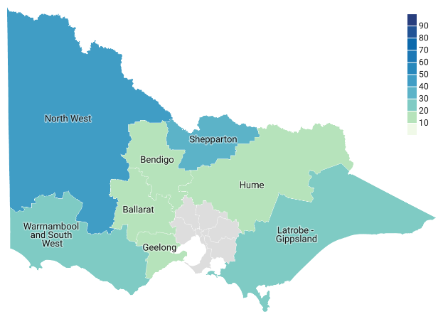

Table 16: Level of low English proficiency of Thai-speaking community by statistical area of regional Victoria

|  |  |  |
| --- | --- | --- |
| SA4 | Total number of speakers | Low English proficiency |
| Ballarat | 161 | 11% |
| Bendigo | 128 | 16% |
| Geelong | 409 | 16% |
| Hume | 223 | 17% |
| Latrobe – Gippsland | 357 | 25% |
| North West | 345 | 46% |
| Shepparton | 247 | 32% |
| Warrnambool and South West | 148 | 19% |

### Turkish

Figure 19: Level of low English proficiency of Turkish-speaking community by statistical area of regional Victoria

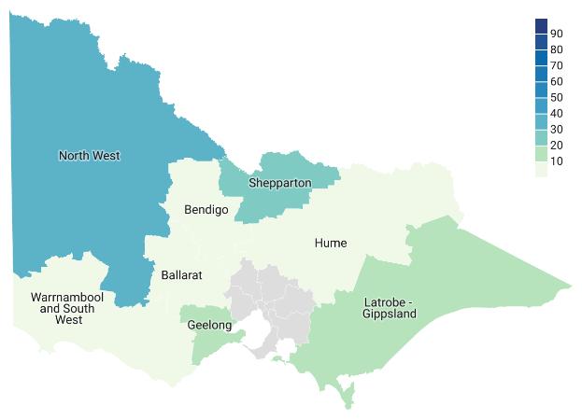

Table 17: Level of low English proficiency of Turkish-speaking community by statistical area of regional Victoria

|  |  |  |
| --- | --- | --- |
| SA4 | Total number of speakers | Low English proficiency |
| Ballarat | 33 | 9% |
| Bendigo | 38 | 8% |
| Geelong | 327 | 17% |
| Hume | 43 | 7% |
| Latrobe – Gippsland | 68 | 10% |
| North West | 436 | 34% |
| Shepparton | 444 | 27% |
| Warrnambool and South West | 22 | 0% |

### Cantonese

Figure 20: Level of low English proficiency of Cantonese-speaking community by statistical area of regional Victoria

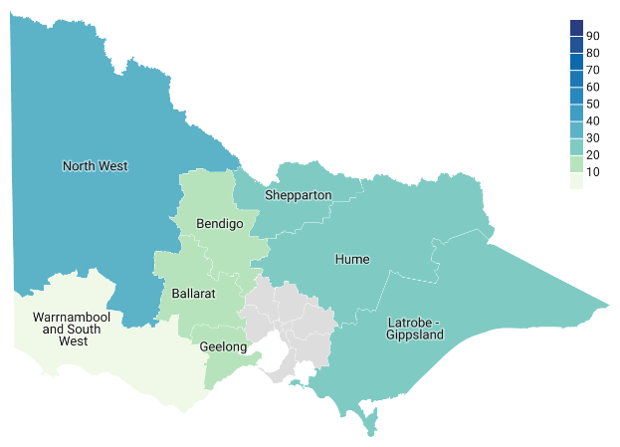

Table 18: Level of low English proficiency of Cantonese-speaking community by statistical area of regional Victoria

|  |  |  |
| --- | --- | --- |
| SA4 | Total number of speakers | Low English proficiency |
| Ballarat | 179 | 20% |
| Bendigo | 164 | 16% |
| Geelong | 470 | 16% |
| Hume | 129 | 26% |
| Latrobe – Gippsland | 253 | 26% |
| North West | 261 | 38% |
| Shepparton | 172 | 28% |
| Warrnambool and South West | 51 | 6% |

### Min Nan

Figure 21: Level of low English proficiency of Min Nan-speaking community by statistical area of regional Victoria

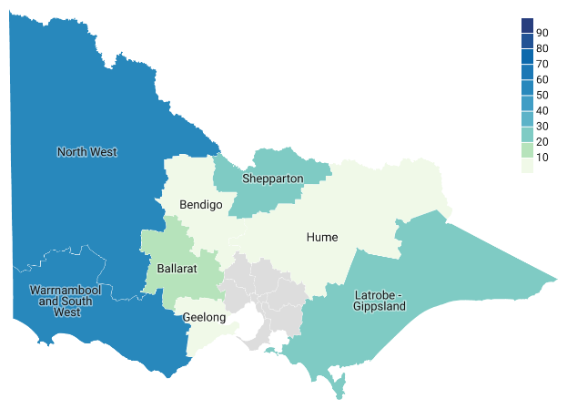

Table 19: Level of low English proficiency of Min Nan-speaking community by statistical area of regional Victoria

|  |  |  |
| --- | --- | --- |
| SA4 | Total number of speakers | Low English proficiency |
| Ballarat | 17 | 18% |
| Bendigo | 6 | 0% |
| Geelong | 30 | 0% |
| Hume | 8 | 0% |
| Latrobe – Gippsland | 11 | 27% |
| North West | 6 | 50% |
| Shepparton | 13 | 23% |
| Warrnambool and South West | 24 | 54% |

### Assyrian Neo-Aramaic

Figure 22: Level of low English proficiency of Assyrian Neo-Aramaic-speaking community by statistical area of regional Victoria

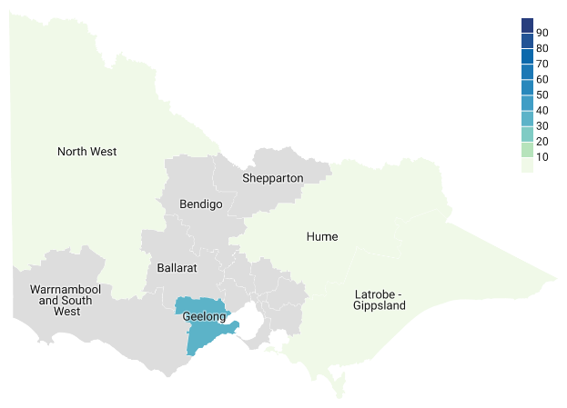

Table 20: Level of low English proficiency of Assyrian Neo-Aramaic-speaking community by statistical area of regional Victoria

|  |  |  |
| --- | --- | --- |
| SA4 | Total number of speakers | Low English proficiency |
| Ballarat | 0 | – |
| Bendigo | 0 | – |
| Geelong | 65 | 35% |
| Hume | 8 | 0% |
| Latrobe – Gippsland | 9 | 0% |
| North West | 3 | 0% |
| Shepparton | 0 | – |
| Warrnambool and South West | 0 | – |

### Pashto

Figure 23: Level of low English proficiency of Pashto-speaking community by statistical area of regional Victoria

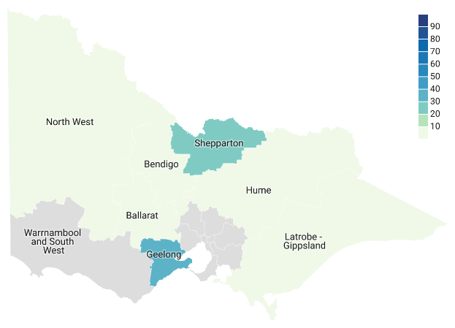

Table 21: Level of low English proficiency of Pashto-speaking community by statistical area of regional Victoria

|  |  |  |
| --- | --- | --- |
| SA4 | Total number of speakers | Low English proficiency |
| Ballarat | 4 | 0% |
| Bendigo | 11 | 0% |
| Geelong | 121 | 26% |
| Hume | 1 | 0% |
| Latrobe – Gippsland | 8 | 0% |
| North West | 12 | 0% |
| Shepparton | 52 | 21% |
| Warrnambool and South West | 0 | – |

### Albanian

Figure 24: Level of low English proficiency of Albanian-speaking community by statistical area of regional Victoria

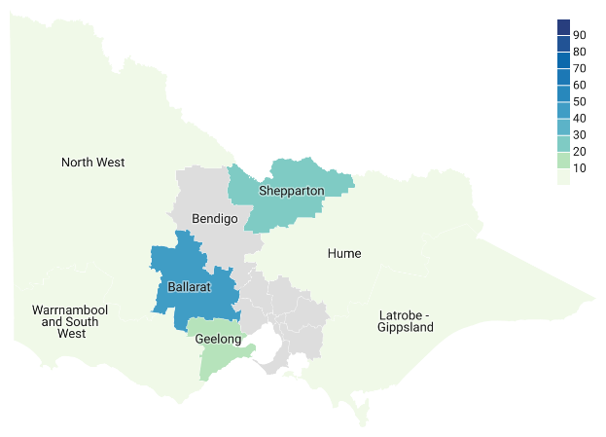

Table 22: Level of low English proficiency of Albanian-speaking community by statistical area of regional Victoria

|  |  |  |
| --- | --- | --- |
| SA4 | Total number of speakers | Low English proficiency |
| Ballarat | 17 | 41% |
| Bendigo | 0 | – |
| Geelong | 70 | 13% |
| Hume | 5 | 0% |
| Latrobe – Gippsland | 8 | 0% |
| North West | 7 | 0% |
| Shepparton | 426 | 19% |
| Warrnambool and South West | 12 | 0% |

### Tongan

Figure 25: Level of low English proficiency of Tongan-speaking community by statistical area of regional Victoria

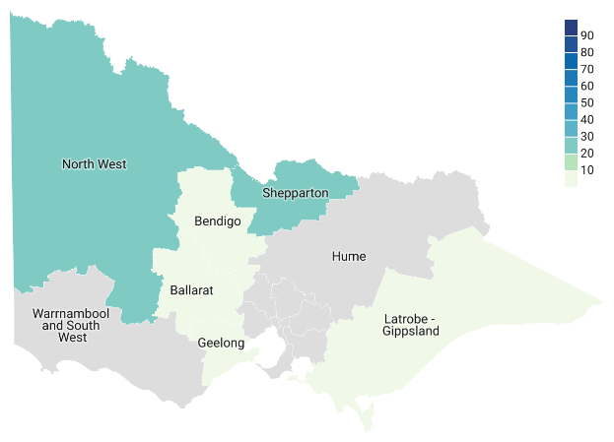

Table 23: Level of low English proficiency of Tongan-speaking community by statistical area of regional Victoria

|  |  |  |
| --- | --- | --- |
| SA4 | Total number of speakers | Low English proficiency |
| Ballarat | 15 | 0% |
| Bendigo | 16 | 0% |
| Geelong | 45 | 0% |
| Hume | 0 | – |
| Latrobe – Gippsland | 28 | 0% |
| North West | 510 | 22% |
| Shepparton | 40 | 23% |
| Warrnambool and South West | 0 | – |

### Persian (excluding Dari)

Figure 26: Level of low English proficiency of Persian-speaking (excluding Dari) community by statistical area of regional Victoria

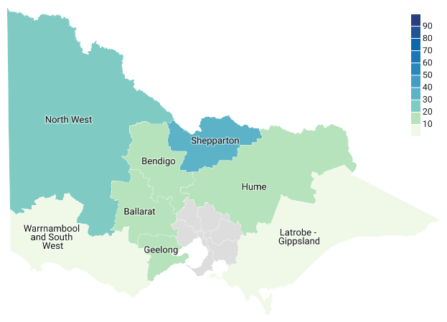Table 24: Level of low English proficiency of Persian (excluding Dari)-speaking community by statistical area of regional Victoria

|  |  |  |
| --- | --- | --- |
| SA4 | Total number of speakers | Low English proficiency |
| Ballarat | 75 | 20% |
| Bendigo | 53 | 19% |
| Geelong | 410 | 14% |
| Hume | 41 | 12% |
| Latrobe – Gippsland | 29 | 0% |
| North West | 47 | 28% |
| Shepparton | 86 | 35% |
| Warrnambool and South West | 17 | 0% |

### Serbian

Figure 27: Level of low English proficiency of Serbian-speaking community by statistical area of regional Victoria

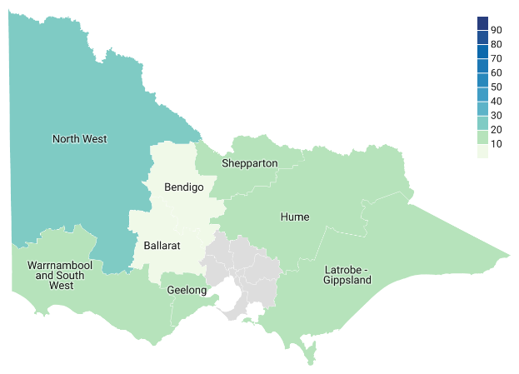

Table 25: Level of low English proficiency of Serbian-speaking community by statistical area of regional Victoria

|  |  |  |
| --- | --- | --- |
| SA4 | Total number of speakers | Low English proficiency |
| Ballarat | 128 | 8% |
| Bendigo | 34 | 0% |
| Geelong | 776 | 18% |
| Hume | 93 | 11% |
| Latrobe – Gippsland | 130 | 12% |
| North West | 34 | 26% |
| Shepparton | 44 | 14% |
| Warrnambool and South West | 18 | 17% |

### Arabic

Figure 28: Level of low English proficiency of Arabic-speaking community by statistical area of regional Victoria

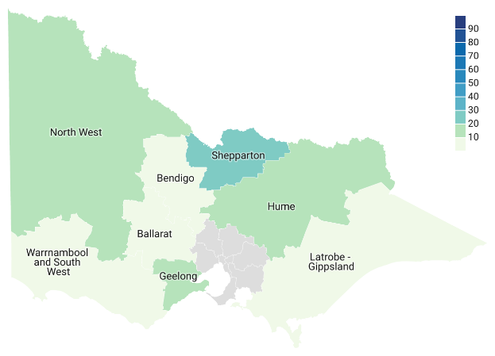

Table 26: Level of low English proficiency of Arabic-speaking community by statistical area of regional Victoria

|  |  |  |
| --- | --- | --- |
| SA4 | Total number of speakers | Low English proficiency |
| Ballarat | 201 | 5% |
| Bendigo | 205 | 3% |
| Geelong | 785 | 13% |
| Hume | 150 | 10% |
| Latrobe – Gippsland | 268 | 10% |
| North West | 157 | 20% |
| Shepparton | 1146 | 25% |
| Warrnambool and South West | 112 | 4% |

### Bosnian

Figure 29: Level of low English proficiency of Bosnian-speaking community by statistical area of regional Victoria

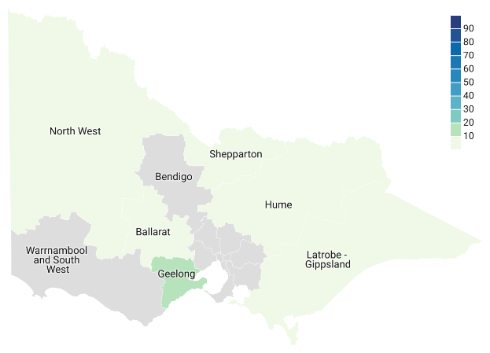

Table 27: Level of low English proficiency of Bosnian-speaking community by statistical area of regional Victoria

|  |  |  |
| --- | --- | --- |
| SA4 | Total number of speakers | Low English proficiency |
| Ballarat | 15 | 0% |
| Bendigo | 0 | – |
| Geelong | 228 | 19% |
| Hume | 9 | 0% |
| Latrobe – Gippsland | 49 | 10% |
| North West | 3 | 0% |
| Shepparton | 8 | 0% |
| Warrnambool and South West | 0 | – |

### Bislama

Figure 30: Level of low English proficiency of Bislama-speaking community by statistical area of regional Victoria

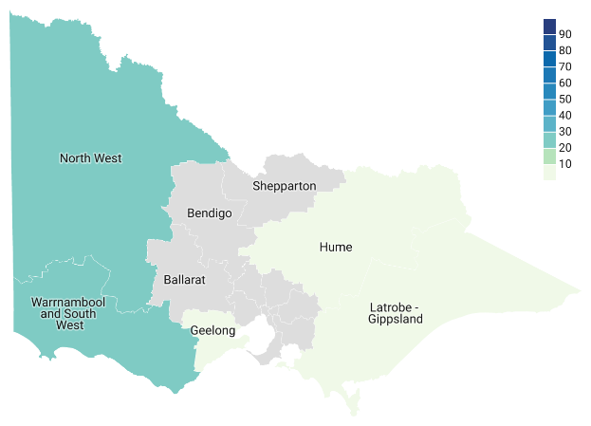

Table 28: Level of low English proficiency of Bislama-speaking community by statistical area of regional Victoria

|  |  |  |
| --- | --- | --- |
| SA4 | Total number of speakers | Low English proficiency |
| Ballarat | 0 | – |
| Bendigo | 0 | – |
| Geelong | 5 | 0% |
| Hume | 5 | 0% |
| Latrobe – Gippsland | 13 | 0% |
| North West | 52 | 23% |
| Shepparton | 0 | – |
| Warrnambool and South West | 17 | 24% |

### Croatian

Figure 31: Level of low English proficiency of Croatian-speaking community by statistical area of regional Victoria

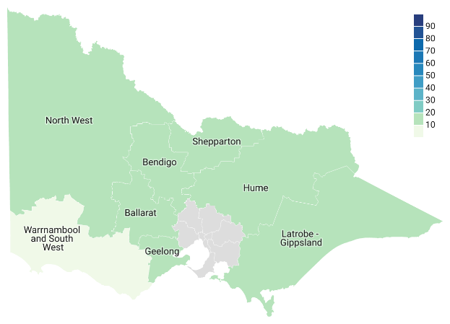Table 29: Level of low English proficiency of Croatian-speaking community by statistical area of regional Victoria

|  |  |  |
| --- | --- | --- |
| SA4 | Total number of speakers | Low English proficiency |
| Ballarat | 172 | 14% |
| Bendigo | 65 | 17% |
| Geelong | 1919 | 16% |
| Hume | 182 | 11% |
| Latrobe – Gippsland | 181 | 12% |
| North West | 93 | 14% |
| Shepparton | 69 | 17% |
| Warrnambool and South West | 32 | 9% |

### African languages, nec

Figure 32: Level of low English proficiency of African languages, nec-speaking community by statistical area of regional Victoria

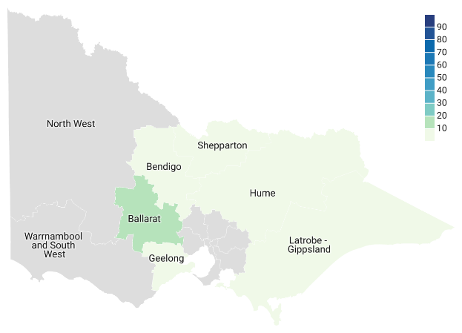Table 30: Level of low English proficiency of African languages, nec-speaking community by statistical area of regional Victoria

|  |  |  |
| --- | --- | --- |
| SA4 | Total number of speakers | Low English proficiency |
| Ballarat | 8 | 13% |
| Bendigo | 5 | 0% |
| Geelong | 14 | 0% |
| Hume | 8 | 0% |
| Latrobe – Gippsland | 7 | 0% |
| North West | 0 | – |
| Shepparton | 9 | 0% |
| Warrnambool and South West | 0 | – |

### Macedonian

**Figure 33: Level of low English proficiency of Macedonian-speaking community by statistical area of regional Victoria**

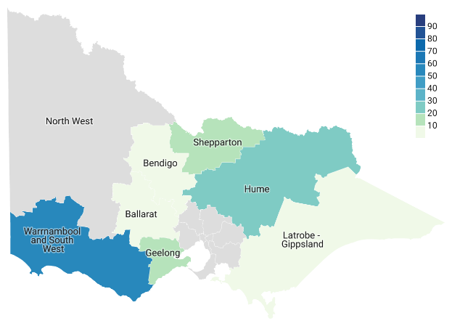Table 31: Level of low English proficiency of Macedonian-speaking community by statistical area of regional Victoria

|  |  |  |
| --- | --- | --- |
| SA4 | Total number of speakers | Low English proficiency |
| Ballarat | 72 | 8% |
| Bendigo | 30 | 0% |
| Geelong | 1075 | 18% |
| Hume | 37 | 22% |
| Latrobe – Gippsland | 46 | 7% |
| North West | 16 | – |
| Shepparton | 190 | 11% |
| Warrnambool and South West | 9 | 56% |

# Important languages with higher English proficiency

Greek, Italian and Punjabi are three of the most commonly spoken languages in Victoria. However, their speakers overall have a higher level of English proficiency, so they did not make the top 30 list above. We have included these languages below for your information. Please note, while they have higher proficiency overall, they still have significant levels of low English proficiency in some areas.

## Greek

Figure 34: Level of low English proficiency of Greek-speaking community by statistical area of regional Victoria

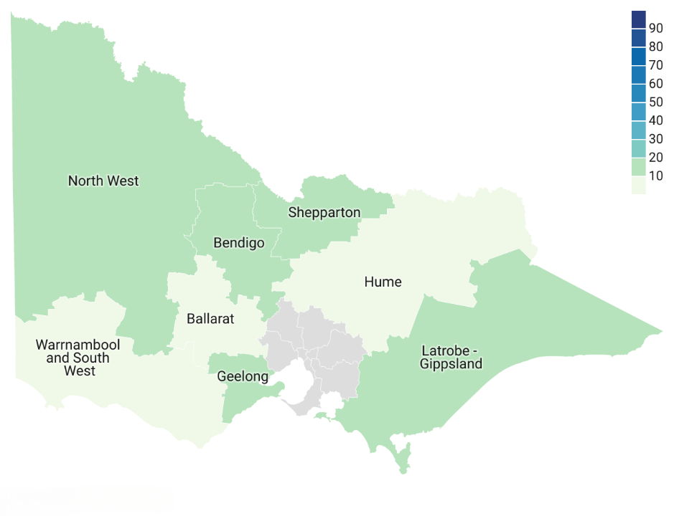

Table 32: Level of low English proficiency of Greek-speaking community by statistical area of regional Victoria

|  |  |  |
| --- | --- | --- |
| SA4 | Total Number of Speakers | Low English proficiency |
| Ballarat | 238 | 8.40% |
| Bendigo | 284 | 11.62% |
| Geelong | 1184 | 12.16% |
| Hume | 244 | 7.79% |
| Latrobe – Gippsland | 697 | 14.78% |
| North West | 425 | 14.12% |
| Shepparton | 286 | 13.29% |
| Warrnambool and South West | 129 | 7.75% |

## Italian

Figure 35: Level of low English proficiency of Italian-speaking community by statistical area of regional Victoria

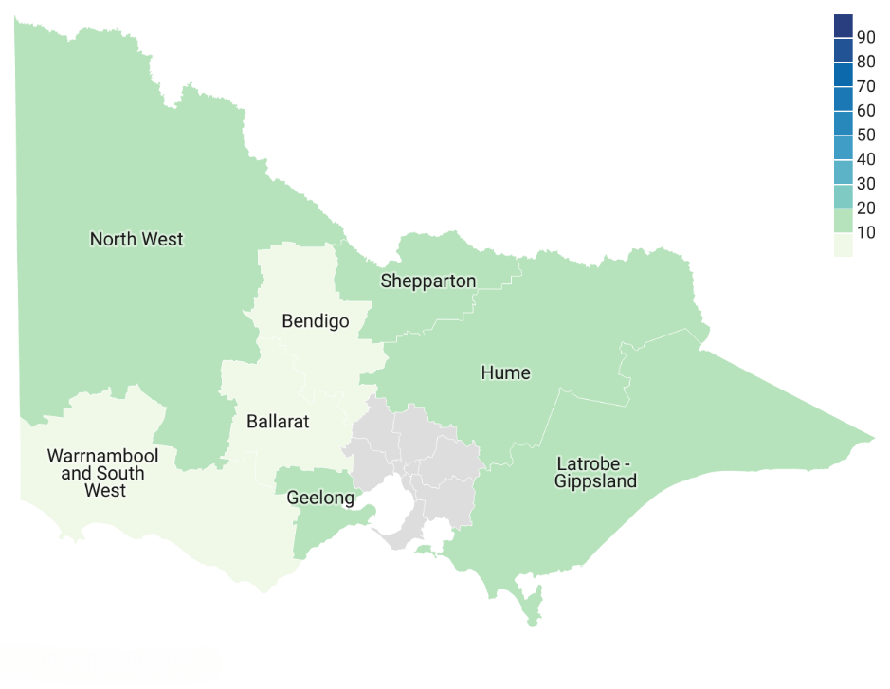

Table 33: Level of low English proficiency of Italian-speaking community by statistical area of regional Victoria

|  |  |  |
| --- | --- | --- |
| SA4 | Total Number of Speakers | Low English proficiency |
| Ballarat | 335 | 5.67% |
| Bendigo | 334 | 5.39% |
| Geelong | 2320 | 10.99% |
| Hume | 1160 | 10.69% |
| Latrobe – Gippsland | 1562 | 11.40% |
| North West | 1272 | 12.42% |
| Shepparton | 1549 | 12.98% |
| Warrnambool and South West | 129 | 2.33% |

## Punjabi

Figure 36: Level of low English proficiency of Punjabi-speaking community by statistical area of regional Victoria

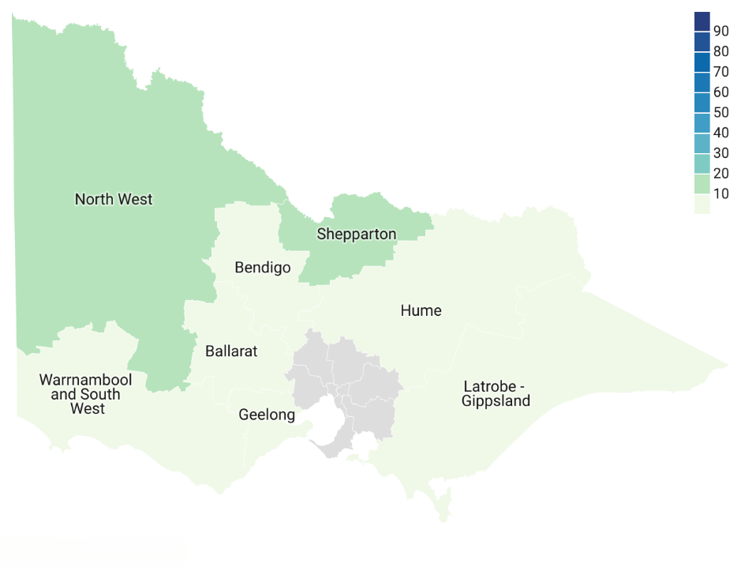

Table 34: Level of low English proficiency of Punjabi-speaking community by statistical area of regional Victoria

|  |  |  |
| --- | --- | --- |
| SA4 | Total Number of Speakers | Low English proficiency |
| Ballarat | 807 | 6.32% |
| Bendigo | 497 | 6.44% |
| Geelong | 2174 | 7.73% |
| Hume | 457 | 8.32% |
| Latrobe – Gippsland | 600 | 6.83% |
| North West | 803 | 12.70% |
| Shepparton | 1756 | 15.26% |
| Warrnambool and South West | 156 | 8.97% |

# Most spoken languages per Statistical Area 4

The tables below show the top 30 languages spoken with low English proficiency per Statistical Area 4 in regional Victoria according to 2021 Census data.

## Ballarat

Table 35: Top 30 languages spoken in Ballarat

| Language | Number of speakers | Level of low English proficiency |
| --- | --- | --- |
| English | 153675 | 0% |
| Mandarin | 1071 | 21% |
| Punjabi | 807 | 6% |
| Malayalam | 494 | 6% |
| Hindi | 415 | 5% |
| Italian | 335 | 6% |
| Spanish | 318 | 5% |
| German | 308 | 1% |
| Tagalog | 290 | 2% |
| Filipino | 282 | 3% |
| Nepali | 275 | 5% |
| Urdu | 252 | 10% |
| Greek | 238 | 8% |
| Vietnamese | 236 | 15% |
| Sinhalese | 234 | 4% |
| Arabic | 228 | 6% |
| Japanese | 216 | 11% |
| Dutch | 205 | 0% |
| French | 202 | 3% |
| Cantonese | 197 | 19% |
| Thai | 179 | 12% |
| Croatian | 177 | 14% |
| Telugu | 167 | 0% |
| Tamil | 149 | 2% |
| Serbian | 132 | 11% |
| Bengali | 130 | 6% |
| Maltese | 125 | 3% |
| Gujarati | 124 | 6% |
| Russian | 101 | 12% |
| Nuer | 98 | 0% |

In Ballarat, Mandarin has the highest percentage and highest number of speakers with low English proficiency.

Besides the language communities listed in the table above, there are smaller communities (less than 30 speakers) with high levels of low English proficiency. Such language communities are: Chinese nfd (20 per cent), Hazaraghi (27 per cent), Albanian (41 per cent) and Wu (100 per cent). These communities may not be able to rely on informal translations or word of mouth.

Since 2016, South Asian language communities have overtaken European ones, while Mandarin remains the largest language community. Some communities have more than doubled in size, including speakers of:

* Punjabi
* Nepal
* Telugu
* Malayalam
* Urdu
* Sinhalese
* Tamil
* Bengali
* Gujarati
* Spanish.

## Bendigo

Table 36: Top 30 languages spoken in Bendigo

| Language | Number of speakers | Level of low English proficiency |
| --- | --- | --- |
| English | 147380 | 0% |
| Karen | 1593 | 43% |
| Mandarin | 714 | 31% |
| Malayalam | 526 | 8% |
| Punjabi | 497 | 6% |
| Italian | 334 | 5% |
| Tagalog | 307 | 3% |
| Filipino | 294 | 0% |
| Greek | 284 | 12% |
| German | 269 | 2% |
| Arabic | 240 | 3% |
| Hindi | 230 | 3% |
| Spanish | 216 | 6% |
| French | 215 | 5% |
| Sinhalese | 205 | 9% |
| Vietnamese | 205 | 24% |
| Cantonese | 181 | 17% |
| Dutch | 156 | 0% |
| Nepali | 143 | 5% |
| Thai | 134 | 15% |
| Urdu | 126 | 3% |
| Afrikaans | 124 | 2% |
| Indonesian | 106 | 10% |
| Japanese | 97 | 3% |
| Tamil | 92 | 3% |
| Dinka | 89 | 24% |
| Telugu | 82 | 0% |
| Bengali | 82 | 0% |
| Dari | 79 | 48% |
| Gujarati | 78 | 9% |

Languages for which 10 per cent or more of speakers report low English proficiency in Bendigo are Karen, Mandarin, Greek, Vietnamese, Cantonese, Thai, Indonesian, Dinka and Dari. Karen and Dari both report percentages over 40 per cent. It is important to note however that there are 1,593 Karen speakers compared with 79 Dari speakers.

There are smaller language communities in Bendigo that report high levels of low English proficiency (20 per cent or more); Korean (23 per cent), Lao (27 per cent), Burmese (80 per cent), Hazaraghi (32 per cent), Ukrainian (32 per cent), Tetum (43 per cent), Chinese nfd (56 per cent), Burmese and related languages nec (75 per cent) and Tibetan (100 per cent).

Like in Ballarat, Asian languages are starting to overtake European language communities in the languages we analysed. While most of the European languages are still growing, they are growing slower than others. Some languages associated with more traditional migrant communities – Hungarian, Croatian and Maltese – are no longer in the top 30. Karen, Malayalam, Punjabi, Sinhalese, Vietnamese, Nepali, Urdu, and Dari have doubled in size since 2016. The Karen-speaking community grew from 675 speakers in 2016 to 1,593 in the 2021. Dinka is also becoming more prevalent compared with 2016.

## Geelong

Table 37: Top 30 languages spoken in Geelong

| Language | Number of speakers | Level of low English proficiency |
| --- | --- | --- |
| English | 277053 | 0% |
| Italian | 2320 | 11% |
| Mandarin | 2245 | 20% |
| Punjabi | 2174 | 8% |
| Croatian | 2048 | 16% |
| Greek | 1184 | 12% |
| Macedonian | 1135 | 18% |
| Spanish | 991 | 12% |
| Hindi | 984 | 3% |
| Vietnamese | 929 | 26% |
| Arabic | 927 | 13% |
| Karen | 921 | 48% |
| Serbian | 864 | 19% |
| German | 818 | 3% |
| Tagalog | 805 | 2% |
| Malayalam | 784 | 7% |
| Filipino | 702 | 2% |
| Urdu | 667 | 7% |
| Hazaraghi | 660 | 27% |
| French | 617 | 5% |
| Telugu | 587 | 3% |
| Sinhalese | 541 | 4% |
| Cantonese | 517 | 16% |
| Dutch | 489 | 1% |
| Persian (excluding Dari) | 478 | 17% |
| Polish | 471 | 11% |
| Tamil | 471 | 8% |
| Thai | 467 | 17% |
| Gujarati | 411 | 5% |
| Nepali | 386 | 5% |

In Geelong, half of the 30 largest language communities report that 10 per cent or more of their speakers have low English proficiency. There are only two other regional areas (North West and Shepparton) that report more language communities with lower English proficiency. Languages associated with European migration to Australia after World War II (Italian, Croatian, Greek, Macedonian, and Polish), report higher levels of low English proficiency in Geelong compared with other areas analysed.

Similarly, there are also many smaller communities (below top 30) with low English proficiency:

* Nuer (20 per cent)
* Serbo-Croatian/Yugoslavian, so described (20 per cent)
* South Asian languages nfd (21 per cent)[8]
* Chinese nfd (21 per cent)
* Swahili (23 per cent)
* Amharic (27 per cent)
* Khmer (27 per cent)
* Pashto (30 per cent)
* Assyrian Neo-Aramaic (31 per cent)
* Burmese and related languages nec (31 per cent)
* Dari (31 per cent)
* Rohingya (31 per cent)
* Lao (38 per cent)
* Burmese (38 per cent)
* Kirundi (Rundi) (57 per cent).

In Geelong, Italian remains the largest community (other than English). European languages still have many speakers, but their growth is much slower than South and Central Asian languages. For example, Punjabi has grown from 653 speakers in 2016 to 2174 in 2021. Malayalam, Hazaraghi, and Sinhalese-speaking communities have all doubled in size. Urdu, Tamil, Gujarati, Telegu and Nepali have made their way into the top 30.

## Hume

Table 38: Top 30 languages spoken in Hume

| Language | Number of speakers | Level of low English proficiency |
| --- | --- | --- |
| English | 163188 | 0% |
| Italian | 1160 | 11% |
| Mandarin | 640 | 26% |
| German | 511 | 1% |
| Punjabi | 457 | 8% |
| Nepali | 387 | 20% |
| Tagalog | 331 | 4% |
| Vietnamese | 314 | 35% |
| Filipino | 306 | 4% |
| Swahili | 290 | 37% |
| French | 258 | 6% |
| Spanish | 249 | 8% |
| Thai | 246 | 17% |
| Greek | 244 | 8% |
| Hindi | 222 | 3% |
| Malayalam | 217 | 10% |
| Croatian | 187 | 11% |
| Arabic | 172 | 13% |
| Dutch | 168 | 0% |
| Sinhalese | 149 | 3% |
| Cantonese | 139 | 28% |
| Urdu | 117 | 3% |
| Afrikaans | 115 | 0% |
| Japanese | 103 | 0% |
| Serbian | 93 | 11% |
| Polish | 89 | 4% |
| Telugu | 83 | 5% |
| Gujarati | 80 | 4% |
| Tamil | 75 | 5% |
| Russian | 73 | 0% |

While Hume reports similar trends to Geelong, Ballarat and Bendigo, a point of difference is that Hume does not have a large Karen-speaking population. Hume also has a larger Nepali community of which 20 per cent reports low levels of English proficiency.

Murrinh-Patha (21 per cent), Macedonian (22 per cent), Hmong (25 per cent), Burmese (26 per cent), Czech (26 per cent), Lao (31 per cent), Fijian (34 per cent), Khmer (37 per cent), and Malay (38 per cent) are the smaller language communities in Hume that report high levels of low English proficiency.

We can observe a significant increase in African language communities compared with 2016 with Afrikaans and Swahili having more than doubled in Hume. Similar to other areas, Punjabi and Mandarin are becoming some of the largest communities. However, growth in Hume seems to be steady across most languages, except for Vietnamese which did not make the top 30 in 2016 but is now one of the 10 largest communities.

## Latrobe – Gippsland

Table 39: Top 30 languages spoken in Latrobe – Gippsland

| Language | Number of speakers | Level of low English proficiency |
| --- | --- | --- |
| English | 264484 | 0% |
| Italian | 1562 | 11% |
| Mandarin | 1006 | 27% |
| German | 731 | 2% |
| Greek | 697 | 15% |
| Punjabi | 600 | 7% |
| Filipino | 530 | 2% |
| Vietnamese | 520 | 31% |
| Spanish | 515 | 9% |
| Tagalog | 512 | 4% |
| Malayalam | 487 | 7% |
| Dutch | 474 | 2% |
| Thai | 393 | 24% |
| Sinhalese | 319 | 3% |
| French | 317 | 2% |
| Arabic | 307 | 8% |
| Afrikaans | 282 | 5% |
| Hindi | 280 | 4% |
| Maltese | 270 | 4% |
| Polish | 267 | 11% |
| Cantonese | 264 | 25% |
| Tamil | 205 | 9% |
| Urdu | 199 | 10% |
| Croatian | 181 | 12% |
| Hungarian | 152 | 14% |
| Indonesian | 150 | 10% |
| Japanese | 150 | 19% |
| Russian | 148 | 13% |
| Serbian | 136 | 11% |
| Nepali | 126 | 8% |

While almost half of the top 30 language communities in La Trobe – Gippsland have a significant number of speakers (> or equal to 10 per cent) with low English proficiency, it follows general trends across other regional areas. However, one difference that can be observed is the level of low English proficiency among the Japanese-speaking community in comparison to other SA4s.

Smaller communities with higher levels of low English proficiency for this area are Korean (20 per cent), Malay (20 per cent), Min Nan (27 per cent), Zomi (31 per cent), Khmer (34 per cent), Rohingya (35 per cent), Hazaraghi (38 per cent), Karen (41 per cent), Oromo (43 per cent), Lao (43 per cent), Bandjalung (50 per cent), and Chinese nfd (50 per cent).

In comparison to 2016 Census data, the difference in size between the five largest language communities (other than English) and the others has significantly decreased. Four of those five languages remain the same with Punjabi replacing Dutch in 2021.

In general, data suggests that language communities in Latrobe – Gippsland are growing at a steadier rate compared with other regional areas resulting in the 30 most commonly spoken languages remaining similar to 2016 with the exception of Nepali which is included in 2021. South and South-East Asian languages are the exception with some of them having doubled in size (Malayalam, Thai, Sinhalese, Urdu and Indonesian).

## North West

Table 40: Top 30 languages spoken in North West

| Language | Number of speakers | Level of low English proficiency |
| --- | --- | --- |
| English | 129262 | 0% |
| Mandarin | 1670 | 53% |
| Italian | 1272 | 12% |
| Vietnamese | 892 | 50% |
| Punjabi | 803 | 13% |
| Malay | 769 | 35% |
| Tongan | 575 | 22% |
| Turkish | 472 | 35% |
| Greek | 425 | 14% |
| Malayalam | 394 | 9% |
| Tagalog | 390 | 4% |
| Thai | 366 | 46% |
| Hazaraghi | 362 | 41% |
| Karen | 350 | 49% |
| Filipino | 339 | 5% |
| Cantonese | 269 | 38% |
| Nepali | 208 | 7% |
| Afrikaans | 185 | 2% |
| Arabic | 181 | 19% |
| Samoan | 163 | 15% |
| German | 162 | 5% |
| Hindi | 161 | 2% |
| Khmer | 147 | 42% |
| Spanish | 146 | 5% |
| Tamil | 144 | 13% |
| Indonesian | 140 | 28% |
| Sinhalese | 124 | 7% |
| Fijian | 121 | 2% |
| French | 117 | 8% |
| Urdu | 114 | 4% |

More than half (17) of the 30 most commonly spoken languages in North West report high levels of low English proficiency. Further, the percentages of speakers reporting to speak English ‘not well’ or ‘not at all’ is much higher. In nine language communities more than one third of the population self identifies as having low English proficiency. This is significantly more than in any other regional area. Of note are Mandarin, Vietnamese where the level of low English proficiency is half or more.

Similarly, the smaller communities also tend to report very high levels of low English proficiency: Bislama (23 per cent), Serbian (26 per cent), Dari (27 per cent), South Asian languages nfd (57 per cent), Persian (excluding Dari) (28 per cent), Kirundi (Rundi) (29 per cent), Zomi (38 per cent), Romanian (38 per cent), Min Nan (50 per cent), Burmese (54 per cent), Chinese nfd (58 per cent), Tibetan (60 per cent), Kinyarwanda (Rwanda) (70 per cent), Acehnese (100 per cent), Solomon Islands Pijin (100 per cent), and Gilbertese (100 per cent).

While the language landscape in North West reports some consistencies with 2016, there are some significant changes. Firstly, Mandarin overtook Italian as the largest language community which is unique in that only in one other SA4 has the largest language community changed since 2016. Additionally, the Pacific languages such as Fijian and Samoan have been added to the 30 most commonly spoken languages indicating that the Pacific community in North West has grown significantly.

Similar to other regions South and Southeast Asian languages have grown significantly since 2016 with Punjabi, Vietnamese, Malay, Thai and Indonesian more than doubling its number of speakers.

## Shepparton

Table 41: Top 30 languages spoken in Shepparton

| Language | Number of speakers | Level of low English proficiency |
| --- | --- | --- |
| English | 112315 | 0% |
| Punjabi | 1756 | 15% |
| Italian | 1549 | 13% |
| Arabic | 1508 | 26% |
| Mandarin | 929 | 42% |
| Hazaraghi | 814 | 36% |
| Malayalam | 559 | 7% |
| Albanian | 500 | 20% |
| Turkish | 490 | 26% |
| Filipino | 475 | 2% |
| Tagalog | 446 | 2% |
| Malay | 424 | 30% |
| Swahili | 339 | 26% |
| Greek | 286 | 13% |
| Thai | 276 | 31% |
| Hindi | 233 | 7% |
| Dari | 232 | 45% |
| Urdu | 231 | 5% |
| Sinhalese | 228 | 8% |
| Samoan | 217 | 9% |
| Gujarati | 216 | 13% |
| Macedonian | 201 | 10% |
| Tamil | 185 | 9% |
| Cantonese | 185 | 29% |
| Vietnamese | 155 | 27% |
| Nepali | 153 | 11% |
| German | 147 | 3% |
| Spanish | 124 | 10% |
| Persian (excluding Dari) | 104 | 34% |
| Indonesian | 101 | 17% |

Like Geelong and North West, many of the largest language communities report higher levels of low English proficiency. While Shepparton has the most language communities where 10 per cent or more of its members report to speak English ‘not well’ or ‘not at all’, the number of communities where more than a third has low levels of English proficiency is limited compared with North West.

The smaller communities with high levels of low English proficiency in Shepparton are: Korean (21 per cent), Min Nan (23 per cent), Bisaya (24 per cent), Kirundi (Rundi) (39 per cent), Pashto (24 per cent), Serbo-Croatian/Yugoslavian so described (25 per cent), Khmer (36 per cent), Karen (50 per cent), Lao (50 per cent), and Chinese nfd (63 per cent).

The five most common language communities in Shepparton have largely remained to same compared with 2016 albeit larger in size, except for Turkish which has been overtaken by Hazaraghi. Further, Punjabi has overtaken Italian as the largest language community. Asian languages in Shepparton follow a similar trend as other regions where their size has significantly increased with Malayalam, Thai, Urdu, Gujarati and Tamil reporting more than double the number of speakers in the 2021 Census. Additionally, Malay, Vietnamese, Nepali and Indonesian have become part of the 30 biggest language communities.

## Warrnambool and South West

Table 42: Top 30 languages spoken in Warrnambool and South West

| Language | Number of speakers | Level of low English proficiency |
| --- | --- | --- |
| English | 114940 | 0% |
| Mandarin | 742 | 46% |
| Filipino | 247 | 1% |
| Vietnamese | 204 | 33% |
| Tagalog | 189 | 4% |
| Thai | 172 | 23% |
| Sinhalese | 158 | 2% |
| Punjabi | 156 | 9% |
| Spanish | 155 | 5% |
| German | 154 | 0% |
| Malayalam | 142 | 8% |
| Dutch | 138 | 2% |
| Nepali | 138 | 4% |
| Afrikaans | 134 | 0% |
| Greek | 129 | 8% |
| Italian | 129 | 2% |
| Arabic | 120 | 3% |
| French | 118 | 4% |
| Hindi | 97 | 0% |
| Japanese | 95 | 3% |
| Indonesian | 83 | 5% |
| Cantonese | 58 | 5% |
| Bisaya | 56 | 5% |
| Korean | 53 | 28% |
| Samoan | 47 | 11% |
| Tamil | 46 | 13% |
| Shona | 43 | 0% |
| Russian | 42 | 21% |
| Tetum | 41 | 0% |
| Polish | 37 | 0% |

Language communities in Warrnambool and South West generally report high levels of English proficiency, including for languages where higher levels of low English proficiency are reported in other SA4s. Further, the communities are smaller compared with other areas.

Similar to other areas there are also smaller communities with high levels of low English proficiency. For this SA4, it is important to keep in mind that these language communities have fewer than 40 speakers: Bislama (24 per cent), Khmer (30 per cent), Kirundi (Rundi) (100 per cent), Ukrainian (30 per cent), Malay (40 per cent), Min Nan (54 per cent), Macedonian (56 per cent), and Chinese nfd (74 per cent).

Like in the other areas, the European languages have been overtaken by Asian ones due to no or minimal growth in the number of speakers. Language communities in Warrnambool and South West that have significantly increased in size are the Vietnamese, Punjabi, Thai, Sinhalese, Spanish and Malayalam-speaking communities. Especially the Vietnamese and Punjabi-speaking communities increased by a considerable amount increasing from 53 to 204 and from 34 to 156 respectively.

# Sex and English language proficiency

For many of the languages analysed, women report lower English proficiency than men. This could be because these women:

* lacked formal education before arriving in Australia
* are not working in Australia (working often helps improve English skills)
* have less opportunities to learn English in Australia, because of family and childcare responsibilities[9]
* lack confidence – women tend to underestimate their abilities and performance. This might influence how they report their English proficiency in the Census.

There are also data limitations that likely impacted the analysis in this section. Some languages report 0 per cent low English proficiency for male or female speakers. This could be because the Australian Bureau of Statistics withheld this data to protect privacy. Please refer to the Data limitations section in this report for more information.

While this data is a useful starting point, we recommend doing more research to improve your understanding of sex and English language proficiency in the community you are trying to reach.

**Figure 36** and **Table 43** show the languages with the biggest differences in low English proficiency between sexes in regional Victoria.

For most of the languages in which men report to have higher levels of low English proficiency, there are **no** women reporting to speak English ‘not well’ or ‘not at all’. Exceptions are Bosnian, Malay, Thai and Tongan.

While most languages have a difference between 5 and 10 per cent, Hmong and Pashto have an exceptionally big difference in English proficiency of close to 20 per cent between male and female speakers. Other languages with larger differences are Khmer and Tongan.

**Figure 37** and **Table 44** show difference by sex in low English proficiency amongst top 30 languages with low English proficiency in regional Victoria.

For top languages reporting low English proficiency, 40 per cent of language communities show men to have worse levels of English proficiency than women (Kirundi, Min Nan, Mandarin, Cantonese, Chinese nfd, Malay, Thai, Bosnian, Rohingya, Burmese, Bislama and Tongan). Chinese languages in particular generally show men reporting worse levels of English proficiency compared with women.

More than half of the languages in the 30 languages most commonly reporting low English proficiency, also are among the 30 languages reporting the highest gap between men and women. The remainder of languages with low English proficiency all report differences of less than 5 per cent.

Figure 37: Highest differences in low English proficiency by sex in communities of more than 50 speakers over 10 years old

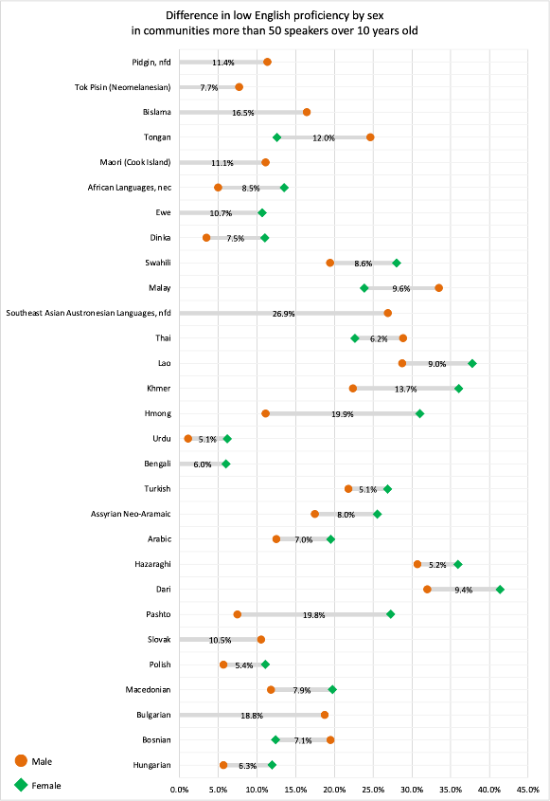

Table 43: Difference in low English proficiency by sex in communities of more than 50 speakers over 10 years old[10]

|  |  |  |  |
| --- | --- | --- | --- |
| Language | Level of low English proficiency – female | Level of low English proficiency – male | Difference |
| Hungarian | 12.0% | 5.7% | 6.3% |
| Bosnian | 12.4% | 19.5% | 7.1% |
| Bulgarian | 0.0% | 18.8% | 18.8% |
| Macedonian | 19.8% | 11.8% | 7.9% |
| Polish | 11.1% | 5.7% | 5.4% |
| Slovak | 0.0% | 10.5% | 10.5% |
| Pashto | 27.3% | 7.5% | 19.8% |
| Dari | 41.4% | 32.0% | 9.4% |
| Hazaraghi | 36.0% | 30.7% | 5.2% |
| Arabic | 19.6% | 12.5% | 7.0% |
| Assyrian Neo-Aramaic | 25.5% | 17.5% | 8.0% |
| Turkish | 26.9% | 21.8% | 5.1% |
| Bengali | 6.0% | 0.0% | 6.0% |
| Urdu | 6.2% | 1.1% | 5.1% |
| Hmong | 31.0% | 11.1% | 19.9% |
| Khmer | 36.1% | 22.4% | 13.7% |
| Lao | 37.8% | 28.8% | 9.0% |
| Thai | 22.7% | 28.9% | -6.2% |
| Southeast Asian Austronesian Languages, nfd | 0.0% | 26.9% | 26.9% |
| Malay | 23.8% | 33.5% | -9.6% |
| Swahili | 28.0% | 19.5% | 8.6% |
| Dinka | 11.0% | 3.5% | 7.5% |
| Ewe | 10.7% | 0.0% | 10.7% |
| African Languages, nec | 13.5% | 5.0% | 8.5% |
| Maori (Cook Islands) | 0.0% | 11.1% | 11.1% |
| Tongan | 12.6% | 24.7% | 12.0% |
| Bislama | 0.0% | 16.5% | 16.5% |
| Tok Pisin (Neomelanesian) | 0.0% | 7.7% | 7.7% |
| Pidgin, nfd | 0.0% | 11.4% | 11.4% |

Figure 38: Difference in low English proficiency of top 30 identified languages with lowest English proficiency by sex in communities of more than 50 speakers over 10 years old

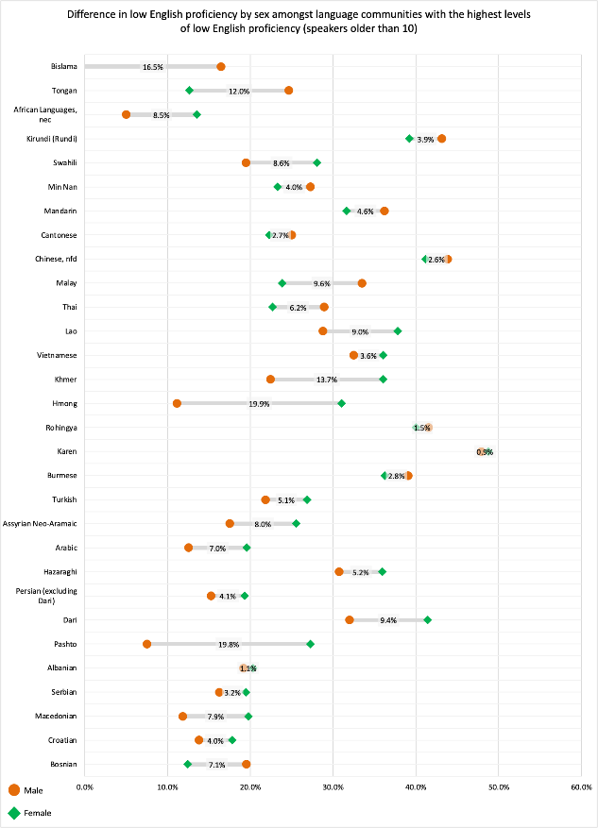

Table 44: Difference in low English proficiency of top 30 identified languages with lowest English proficiency by sex in communities of more than 50 speakers over 10 years old

|  |  |  |  |
| --- | --- | --- | --- |
| Language | Level of low English proficiency – female | Level of low English proficiency – male | Difference |
| Bosnian | 12.4% | 19.5% | -7.1% |
| Croatian | 17.8% | 13.8% | 4.0% |
| Macedonian | 19.8% | 11.8% | 7.9% |
| Serbian | 19.5% | 16.2% | 3.2% |
| Albanian | 20.3% | 19.2% | 1.1% |
| Pashto | 27.3% | 7.5% | 19.8% |
| Dari | 41.4% | 32.0% | 9.4% |
| Persian (excluding Dari) | 19.3% | 15.2% | 4.1% |
| Hazaraghi | 36.0% | 30.7% | 5.2% |
| Arabic | 19.6% | 12.5% | 7.0% |
| Assyrian Neo-Aramaic | 25.5% | 17.5% | 8.0% |
| Turkish | 26.9% | 21.8% | 5.1% |
| Burmese | 36.2% | 39.1% | -2.8% |
| Karen | 48.8% | 47.9% | 0.9% |
| Rohingya | 40.0% | 41.5% | -1.5% |
| Hmong | 31.0% | 11.1% | 19.9% |
| Khmer | 36.1% | 22.4% | 13.7% |
| Vietnamese | 36.1% | 32.5% | 3.6% |
| Lao | 37.8% | 28.8% | 9.0% |
| Thai | 22.7% | 28.9% | -6.2% |
| Malay | 23.8% | 33.5% | -9.6% |
| Chinese, nfd | 41.2% | 43.8% | -2.6% |
| Cantonese | 22.3% | 25.0% | -2.7% |
| Mandarin | 31.6% | 36.2% | -4.6% |
| Min Nan | 23.3% | 27.3% | -4.0% |
| Swahili | 28.0% | 19.5% | 8.6% |
| Kirundi (Rundi) | 39.2% | 43.1% | -3.9% |
| African Languages, nec | 13.5% | 5.0% | 8.5% |
| Tongan | 12.6% | 24.7% | -12.0% |
| Bislama | 0.0% | 16.5% | -16.5% |

# Language proficiency and age

2021 Census data shows that most migrants living in regional Victoria are 30 to 39 years old. The percentage has slightly increased by 4 per cent, this is consistent with the 2016 Census data. Similarly, 20- to 29-year-olds remain the second largest group, closely followed by 40- to 49-year-olds.

There may be limitations to the data used in this section. This is because of risk of potentially releasing identifiable information about a person, particularly in small language communities. For more information, refer to the Data limitations section.

Figure 39: Age distribution of speakers speaking a language other than English at home in regional Victoria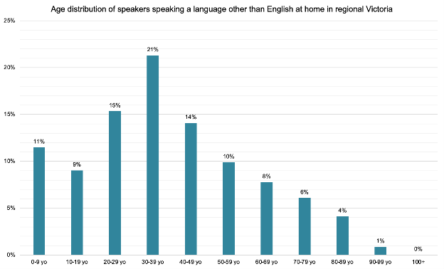

Table 45: Age distribution of speakers speaking a language other than English at home in regional Victoria

| Age | Level of low English proficiency |
| --- | --- |
| 0–9 years | 11% |
| 10–19 years | 9% |
| 20–29 years | 15% |
| 30–39 years | 21% |
| 40–49 years | 14% |
| 50–59 years | 10% |
| 60–69 years | 8% |
| 70–79 years | 6% |
| 80–89 years | 4% |
| 90–99 years | 1% |
| 100+ years | 0% |

Arabic, Cantonese, Hazaraghi, Karen, Malay, Mandarin and Persian (excluding Dari) speakers report higher levels of low English proficiency across all ages. For these languages More than 10 per cent of speakers report low English proficiency from the age of 20. More than 94 per cent of Karen and Hazaraghi speakers older than 60 report low English proficiency.

Similarly, Indonesian has speakers with lower levels of English proficiency across all age groups. However, only more than 10 per cent of 40- to 59-year-olds report low English proficiency.

All these languages – except Indonesian – are included in the 30 languages with the highest percentage of speakers with low English proficiency. Other languages in the top 30 might not show up in this age analyses for a number of reasons including, but not limited to, data only being available for a low number of speakers of a particular age group and thus being excluded due to privacy concerns and people not recording their age.

Older age groups tend to have a higher percentage of speakers reporting low English proficiency. The percentage of people with low English proficiency stays the same or declines between the ages of 40 and 59 for many languages. However, for those languages the percentage of speakers speaking English ‘not well’ or ‘not at all’ increases again for speakers aged over 60.

Languages associated with older migration patterns – with the exception of Greek and Turkish – tend to only report high percentages of low English proficiency for age groups older than 50. Languages spoken in the Balkans (Albanian, Serbian, Bosnian, Croatian and Macedonian) follow a similar trend.

This could explain the difference in top 30 languages with highest percentage of speakers with low English proficiency of 2021 with the 2016 Census. Languages that have dropped out of the top 30 – Ukrainian, Greek, Italian, Polish, Nepali, Hungarian, Punjabi and Spanish – mainly report low English proficiency for older age groups (60+). Migration to Australia of younger age groups speaking Asian languages could therefore have overtaken the aging population of whom their children would generally report higher levels of English proficiency having grown up in Australia.

Below is an overview of age groups and languages for which that age group reports low English proficiency. Please note that some languages may be excluded for privacy reasons.

## Age group 10–19 years

Figure 40 with corresponding table 46 show the levels of English proficiency amongst culturally and linguistically diverse population aged 10–19, where language communities report low English proficiency.

Figure 40: Languages with low English proficiency of age group 10–19 years, with more than 50 speakers

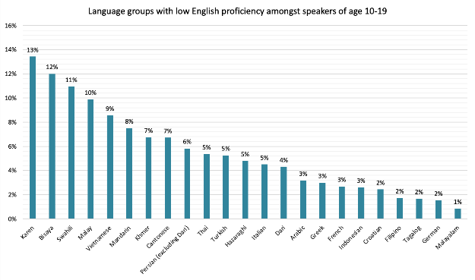Table 46: Languages with low English proficiency of age group 10–19 years, with more than 50 speakers

| Language | Low level of English proficiency |
| --- | --- |
| Karen | 13% |
| Bisaya | 12% |
| Swahili | 11% |
| Malay | 10% |
| Vietnamese | 9% |
| Mandarin | 8% |
| Khmer | 7% |
| Cantonese | 7% |
| Persian (excluding Dari) | 6% |
| Thai | 5% |
| Turkish | 5% |
| Hazaraghi | 5% |
| Italian | 5% |
| Dari | 4% |
| Arabic | 3% |
| Greek | 3% |
| French | 3% |
| Indonesian | 3% |
| Croatian | 2% |
| Filipino | 2% |
| Tagalog | 2% |
| German | 2% |
| Malayalam | 1% |

## Age group 20–29

Figure 41 with corresponding table 47 show the levels of English proficiency amongst culturally and linguistically diverse population aged 40–49, where language communities report low English proficiency.

Figure 41: Languages with low English proficiency of age group 20–29 years, with more than 50 speakers

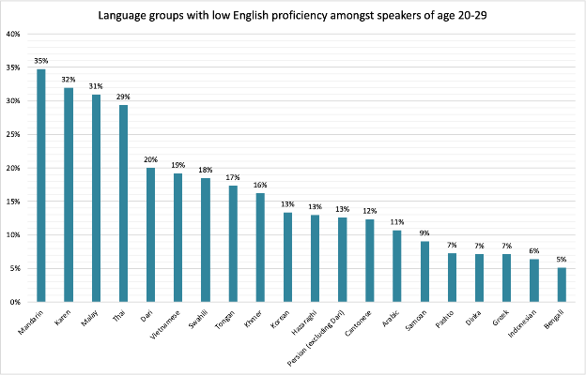

Table 47: Languages with low English proficiency of age group 20–29 years, with more than 50 speakers

| Language | Low level of English proficiency |
| --- | --- |
| Mandarin | 35% |
| Karen | 32% |
| Malay | 31% |
| Thai | 29% |
| Dari | 20% |
| Vietnamese | 19% |
| Swahili | 18% |
| Tongan | 17% |
| Khmer | 16% |
| Korean | 13% |
| Hazaraghi | 13% |
| Persian (excluding Dari) | 13% |
| Cantonese | 12% |
| Arabic | 11% |
| Samoan | 9% |
| Pashto | 7% |
| Dinka | 7% |
| Greek | 7% |
| Indonesian | 6% |
| Bengali | 5% |

## Age group 30–39

Figure 42 with corresponding table 48 shows the levels of English proficiency amongst culturally and linguistically diverse population aged 30–39, where language communities report low English proficiency.

Figure 42: Languages with low English proficiency of age group 30–39 years, with more than 50 speakers

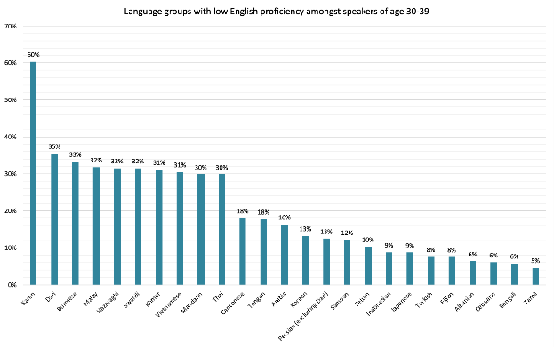

Table 48: Languages with low English proficiency of age group 30–39 years, with more than 50 speakers

| Language | Low level of English proficiency |
| --- | --- |
| Karen | 60% |
| Dari | 35% |
| Burmese | 33% |
| Malay | 32% |
| Hazaraghi | 32% |
| Swahili | 32% |
| Khmer | 31% |
| Vietnamese | 31% |
| Mandarin | 30% |
| Thai | 30% |
| Cantonese | 18% |
| Tongan | 18% |
| Arabic | 16% |
| Korean | 13% |
| Persian (excluding Dari) | 13% |
| Samoan | 12% |
| Tetum | 10% |
| Indonesian | 9% |
| Japanese | 9% |
| Turkish | 8% |
| Fijian | 8% |
| Albanian | 6% |
| Cebuano | 6% |
| Bengali | 6% |
| Tamil | 5% |

## Age group 40–49

Figure 43 with corresponding table 49 shows the levels of English proficiency amongst culturally and linguistically diverse population aged 40–49, where language communities report low English proficiency.

Figure 43: Languages with low English proficiency of age group 40–49 years, with more than 50 speakers

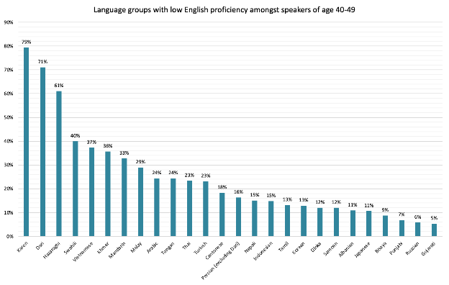Table 49: Languages with low English proficiency of age group 40–49 years, with more than 50 speakers

| Language | Low level of English proficiency |
| --- | --- |
| Karen | 79% |
| Dari | 71% |
| Hazaraghi | 61% |
| Swahili | 40% |
| Vietnamese | 37% |
| Khmer | 36% |
| Mandarin | 33% |
| Malay | 29% |
| Arabic | 24% |
| Tongan | 24% |
| Thai | 23% |
| Turkish | 23% |
| Cantonese | 18% |
| Persian (excluding Dari) | 16% |
| Nepali | 15% |
| Indonesian | 15% |
| Tamil | 13% |
| Korean | 13% |
| Dinka | 12% |
| Samoan | 12% |
| Albanian | 11% |
| Japanese | 11% |
| Bisaya | 9% |
| Punjabi | 7% |
| Russian | 6% |
| Gujarati | 5% |

## Age group 50–59

Figure 44 with corresponding table 50 shows the levels of English proficiency amongst culturally and linguistically diverse population aged 50–59, where language communities report low English proficiency.

**Figure 44: Languages with low English proficiency of age group 50–59 years, with more than 50 speakers**

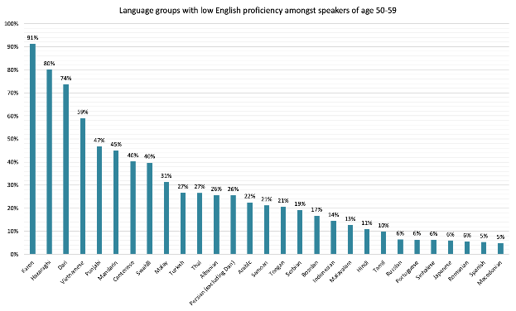Table 50: Languages with low English proficiency of age group 50–59 years, with more than 50 speakers

| Language | Low level of English proficiency |
| --- | --- |
| Karen | 91% |
| Hazaraghi | 80% |
| Dari | 74% |
| Vietnamese | 59% |
| Punjabi | 47% |
| Mandarin | 45% |
| Cantonese | 40% |
| Swahili | 40% |
| Malay | 31% |
| Turkish | 27% |
| Thai | 27% |
| Albanian | 26% |
| Persian (excluding Dari) | 26% |
| Arabic | 22% |
| Samoan | 21% |
| Tongan | 21% |
| Serbian | 19% |
| Bosnian | 17% |
| Indonesian | 14% |
| Malayalam | 13% |
| Hindi | 11% |
| Tamil | 10% |
| Russian | 6% |
| Portuguese | 6% |
| Sinhalese | 6% |
| Japanese | 6% |
| Romanian | 6% |
| Spanish | 5% |
| Macedonian | 5% |

## Age group of 60+

People aged over 60 years are grouped together due to data limitations related to the protection of peoples’ privacy.

Figures 45 and 46 with corresponding table 51 show the levels of English proficiency amongst culturally and linguistically diverse population aged 60+, where language communities report low English proficiency.

Figure 45: Languages with low English proficiency of age group 60+ years, with more than 50 speakers, part 1

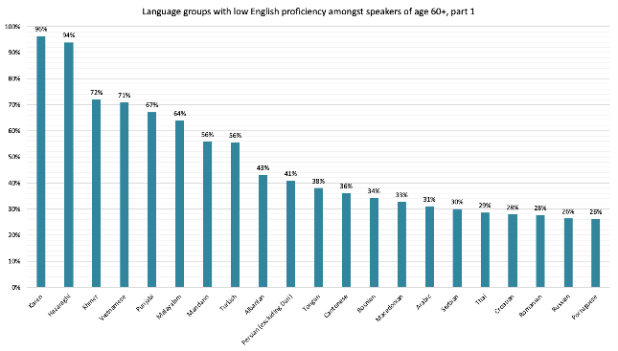Figure 46: Languages with low English proficiency of age group 60+ years, with more than 50 speakers, part 2

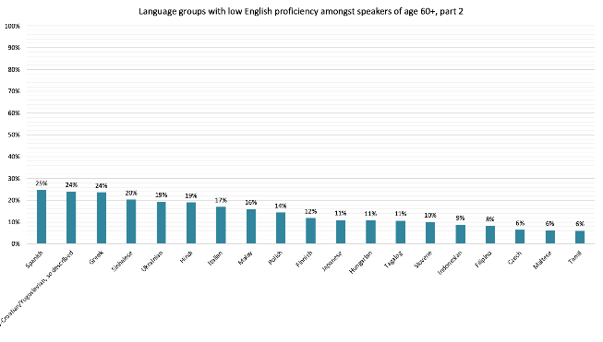

Table 51: Languages with low English proficiency of age group 50–59 years, with more than 50 speakers

| Language | Low level of English proficiency |
| --- | --- |
| Karen | 96% |
| Hazaraghi | 94% |
| Khmer | 72% |
| Vietnamese | 71% |
| Punjabi | 67% |
| Malayalam | 64% |
| Mandarin | 56% |
| Turkish | 56% |
| Albanian | 43% |
| Persian (excluding Dari) | 41% |
| Tongan | 38% |
| Cantonese | 36% |
| Bosnian | 34% |
| Macedonian | 33% |
| Arabic | 31% |
| Serbian | 30% |
| Thai | 29% |
| Croatian | 28% |
| Romanian | 28% |
| Russian | 26% |
| Portuguese | 26% |
| Spanish | 25% |
| Serbo-Croatian/Yugoslavian, so described | 24% |
| Greek | 24% |
| Sinhalese | 20% |
| Ukrainian | 19% |
| Hindi | 19% |
| Italian | 17% |
| Malay | 16% |
| Polish | 14% |
| Finnish | 12% |
| Japanese | 11% |
| Hungarian | 11% |
| Tagalog | 11% |
| Slovene | 10% |
| Indonesian | 9% |
| Filipino | 8% |
| Czech | 6% |
| Maltese | 6% |
| Tamil | 6% |

# Appendix 1: Countries of birth of migrant and refugee communities in regional Victoria (excluding Australia)

| Country of birth | Number of people | Percentage of people born outside Australia |
| --- | --- | --- |
| England | 41471 | 21.29% |
| New Zealand | 16247 | 8.34% |
| India | 15463 | 7.94% |
| Philippines | 9480 | 4.87% |
| Netherlands | 6901 | 3.54% |
| Italy | 6700 | 3.44% |
| Germany | 6209 | 3.19% |
| Scotland | 6208 | 3.19% |
| China (excludes SARs and Taiwan) | 5373 | 2.76% |
| Malaysia | 5243 | 2.69% |
| South Africa | 4186 | 2.15% |
| United States of America | 3691 | 1.89% |
| Thailand | 3690 | 1.89% |
| Vietnam | 3011 | 1.55% |
| Sri Lanka | 2883 | 1.48% |
| Ireland | 2689 | 1.38% |
| Croatia | 2349 | 1.21% |
| Canada | 1967 | 1.01% |
| Afghanistan | 1898 | 0.97% |
| Pakistan | 1854 | 0.95% |
| Myanmar | 1823 | 0.94% |
| Malta | 1712 | 0.88% |
| Greece | 1664 | 0.85% |
| Nepal | 1632 | 0.84% |
| Northern Ireland | 1377 | 0.71% |
| Taiwan | 1348 | 0.69% |
| Indonesia | 1332 | 0.68% |
| Wales | 1229 | 0.63% |
| Poland | 1140 | 0.59% |
| Iraq | 1036 | 0.53% |
| France | 1001 | 0.51% |
| North Macedonia | 986 | 0.51% |
| Iran | 978 | 0.50% |
| Fiji | 975 | 0.50% |
| Zimbabwe | 967 | 0.50% |
| South Eastern Europe, nfd | 950 | 0.49% |
| Turkey | 946 | 0.49% |
| Austria | 885 | 0.45% |
| Hong Kong (SAR of China) | 884 | 0.45% |
| Singapore | 853 | 0.44% |
| Serbia | 826 | 0.42% |
| Egypt | 767 | 0.39% |
| Japan | 766 | 0.39% |
| Korea, Republic of (South) | 696 | 0.36% |
| Papua New Guinea | 688 | 0.35% |
| Bosnia and Herzegovina | 681 | 0.35% |
| Mauritius | 642 | 0.33% |
| Hungary | 632 | 0.32% |
| Bangladesh | 591 | 0.30% |
| Spain | 563 | 0.29% |
| Samoa | 512 | 0.26% |
| Kenya | 501 | 0.26% |
| Cambodia | 476 | 0.24% |
| Tonga | 470 | 0.24% |
| Congo, Democratic Republic of | 466 | 0.24% |
| Switzerland | 458 | 0.24% |
| Nigeria | 451 | 0.23% |
| Brazil | 445 | 0.23% |
| Chile | 415 | 0.21% |
| Colombia | 403 | 0.21% |
| Argentina | 383 | 0.20% |
| Inadequately described | 383 | 0.20% |
| Sweden | 377 | 0.19% |
| Cyprus | 375 | 0.19% |
| Russian Federation | 371 | 0.19% |
| Romania | 365 | 0.19% |
| Denmark | 359 | 0.18% |
| Slovenia | 354 | 0.18% |
| Lebanon | 351 | 0.18% |
| Albania | 345 | 0.18% |
| Sudan | 332 | 0.17% |
| Ukraine | 294 | 0.15% |
| Finland | 287 | 0.15% |
| Belgium | 275 | 0.14% |
| South Sudan | 272 | 0.14% |
| Portugal | 260 | 0.13% |
| Timor-Leste | 249 | 0.13% |
| Syria | 247 | 0.13% |
| United Arab Emirates | 238 | 0.12% |
| United Kingdom, Channel Islands and Isle of Man, nfd | 237 | 0.12% |
| Czechia | 202 | 0.10% |
| Laos | 188 | 0.10% |
| Congo, Republic of | 188 | 0.10% |
| Saudi Arabia | 182 | 0.09% |
| Vanuatu | 178 | 0.09% |
| Kuwait | 174 | 0.09% |
| Tanzania | 169 | 0.09% |
| Ethiopia | 165 | 0.08% |
| Zambia | 162 | 0.08% |
| Solomon Islands | 144 | 0.07% |
| Eastern Europe, nfd | 141 | 0.07% |
| Latvia | 140 | 0.07% |
| Peru | 138 | 0.07% |
| Mexico | 138 | 0.07% |
| Israel | 136 | 0.07% |
| Bhutan | 136 | 0.07% |
| Uganda | 135 | 0.07% |
| Burundi | 126 | 0.06% |
| Norway | 124 | 0.06% |
| Uruguay | 122 | 0.06% |
| Ghana | 118 | 0.06% |
| Bulgaria | 113 | 0.06% |
| El Salvador | 104 | 0.05% |
| Lithuania | 99 | 0.05% |
| Venezuela | 91 | 0.05% |
| Cook Islands | 89 | 0.05% |
| Malawi | 84 | 0.04% |
| Slovakia | 78 | 0.04% |
| Estonia | 77 | 0.04% |
| Morocco | 66 | 0.03% |
| Jordan | 63 | 0.03% |
| Libya | 58 | 0.03% |
| Somalia | 58 | 0.03% |
| Namibia | 57 | 0.03% |
| Botswana | 53 | 0.03% |
| Seychelles | 50 | 0.03% |
| Nauru | 48 | 0.02% |
| Bahrain | 47 | 0.02% |
| Brunei Darussalam | 47 | 0.02% |
| Southern Asia, nfd | 47 | 0.02% |
| Kosovo | 45 | 0.02% |
| Gaza Strip and West Bank | 42 | 0.02% |
| Qatar | 40 | 0.02% |
| Montenegro | 39 | 0.02% |
| Algeria | 39 | 0.02% |
| Kiribati | 37 | 0.02% |
| Trinidad and Tobago | 35 | 0.02% |
| Kazakhstan | 34 | 0.02% |
| Liberia | 33 | 0.02% |
| Isle of Man | 31 | 0.02% |
| Guernsey | 31 | 0.02% |
| Guatemala | 31 | 0.02% |
| Jamaica | 31 | 0.02% |
| Belarus | 30 | 0.02% |
| Oman | 30 | 0.02% |
| Sierra Leone | 30 | 0.02% |
| Ecuador | 29 | 0.01% |
| Togo | 29 | 0.01% |
| Jersey | 28 | 0.01% |
| Rwanda | 28 | 0.01% |
| Macau (SAR of China) | 24 | 0.01% |
| Bolivia | 24 | 0.01% |
| Tunisia | 22 | 0.01% |
| Gibraltar | 21 | 0.01% |
| Bermuda | 19 | 0.01% |
| Yemen | 18 | 0.01% |
| Moldova | 17 | 0.01% |
| Guyana | 17 | 0.01% |
| Eritrea | 17 | 0.01% |
| Cameroon | 16 | 0.01% |
| Mozambique | 15 | 0.01% |
| Samoa, American | 14 | 0.01% |
| Kyrgyzstan | 14 | 0.01% |
| Uzbekistan | 14 | 0.01% |
| Southern and East Africa, nfd | 14 | 0.01% |
| Luxembourg | 13 | 0.01% |
| Guinea | 13 | 0.01% |
| Mongolia | 12 | 0.01% |
| Georgia | 12 | 0.01% |
| Iceland | 11 | 0.01% |
| Azerbaijan | 11 | 0.01% |
| Maldives | 10 | 0.01% |
| Cuba | 10 | 0.01% |
| North Africa, nfd | 9 | 0.00% |
| Honduras | 9 | 0.00% |
| Bahamas | 9 | 0.00% |
| Haiti | 9 | 0.00% |
| Madagascar | 9 | 0.00% |
| New Caledonia | 8 | 0.00% |
| South America, nfd | 8 | 0.00% |
| Angola | 8 | 0.00% |
| Puerto Rico | 7 | 0.00% |
| Benin | 7 | 0.00% |
| Cote d'Ivoire | 7 | 0.00% |
| Nicaragua | 6 | 0.00% |
| Gambia | 6 | 0.00% |
| Eswatini | 6 | 0.00% |
| Australian Antarctic Territory | 5 | 0.00% |
| Caribbean, nfd | 5 | 0.00% |
| Lesotho | 5 | 0.00% |
| French Polynesia | 4 | 0.00% |
| Greenland | 4 | 0.00% |
| Middle East, nfd | 4 | 0.00% |
| Maritime South-East Asia, nfd | 4 | 0.00% |
| Suriname | 4 | 0.00% |
| Panama | 4 | 0.00% |
| Barbados | 4 | 0.00% |
| St Lucia | 4 | 0.00% |
| Senegal | 4 | 0.00% |
| Norfolk Island | 3 | 0.00% |
| Micronesia, Federated States of | 3 | 0.00% |
| Niue | 3 | 0.00% |
| Tokelau | 3 | 0.00% |
| Tuvalu | 3 | 0.00% |
| Liechtenstein | 3 | 0.00% |
| Armenia | 3 | 0.00% |
| Paraguay | 3 | 0.00% |
| Costa Rica | 3 | 0.00% |
| Cayman Islands | 3 | 0.00% |
| Dominican Republic | 3 | 0.00% |
| Curacao | 3 | 0.00% |
| Central and West Africa, nfd | 3 | 0.00% |
| Djibouti | 3 | 0.00% |

1. Australian Bureau of Statistics (2022). *Snapshot of Victoria*. Australian Bureau of Statistics. Retrieved December 20, 2022, from https://www.abs.gov.au/articles/snapshot-vic-2021
2. Department of Social Services (2017). ‘*Building a New Life in Australia (BNLA): The Longitudinal Study of Humanitarian Migrants’* and Blake L., et al. (2019). The Impact of oral English proficiency on humanitarian migrants’ experiences of settling in Australia. *International Journal of Bilingual Education and Bilingualism*, 22:6, 689–705.
3. ‘nfd’ stands for not further defined. This term is used in Census data when only enough information is provided to partially categorise a response.
4. Department of Social Services (2017). *Building a New Life in Australia (BNLA): The Longitudinal Study of Humanitarian Migrants’.*
5. Statistical Area Level 4 (SA4) is the largest sub-State regions in the Australian Statistical Geography Standards (ASGS).
6. ‘nec’ stands for not elsewhere classified. It allows for responses that don’t fit into a suitable category to be included.
7. ‘nfd’ stands for not further defined. This term is used in Census data when only enough information is provided to partially categorise a response.
8. Nfd stands for ‘Nor further defined’. This definition is used when there is only enough information given to partially identify the category.
9. Piller, I. (2019). What makes it hard for migrants to learn the language of their new home? OpenLearn Free Learning from The Open University.   
   Harmony Alliance (2019). A strategic approach to improving employment outcomes of women from migrant and refugee backgrounds in Australia.
10. Some languages show 0 per cent in this table. This is done to due to identity risks. For more information, see Disclosure risks in this document.