

|  |
| --- |
| Mapping languages spoken in Victoria |
| Metropolitan Melbourne |
| OFFICIAL |

|  |
| --- |
| Mapping languages spoken in Victoria  Metropolitan Melbourne |
|  |

|  |
| --- |
|  |
| To receive this document in another format, [email the Stakeholder Engagement and Innovation team](mailto:multicultural.communications@vic.gov.au) <engagement@dffh.vic.gov.au>.  Authorised and published by the Victorian Government, 1 Treasury Place, Melbourne.  © State of Victoria, Australia, Department of Families, Fairness and Housing, June 2023.  In this document, ‘Aboriginal’ refers to both Aboriginal and Torres Strait Islander people.  **ISBN** 978-1-76130-076-9 **(pdf/online/MS word)**  Available at [Mapping the languages spoken in Victoria](https://www.dffh.vic.gov.au/mapping-languages-spoken-victoria) <https://www.dffh.vic.gov.au/mapping-languages-spoken-victoria>. |
|  |

Contents

Summary 7

Key trends 7

Introduction 9

How to use this report 10

Data limitations 11

English proficiency is self-reported 11

Regions analysed 11

Languages chosen 12

Disclosure risks 13

Country of birth 14

English proficiency among language communities in metropolitan Melbourne 15

Comparing language communities with low English proficiency with regional Victoria 18

Distribution of English proficiency levels across LGAs 19

Metropolitan Melbourne LGAs with low English proficiency 20

Where do people with low English proficiency live? 24

Important languages with higher English proficiency 83

Greek 83

Arabic 85

Italian 87

Punjabi 89

Languages spoken in LGAs of metropolitan Melbourne and level of low English proficiency 91

Banyule 91

Bayside 92

Boroondara 93

Brimbank 95

Cardinia 96

Casey 97

Darebin 98

Frankston 99

Glen Eira 101

Greater Dandenong 102

Hobsons Bay 103

Hume 104

Kingston 106

Knox 107

Manningham 108

Maribyrnong 109

Maroondah 110

Melbourne 112

Melton 113

Monash 114

Moonee Valley 115

Mornington Peninsula 117

Moreland 118

Nillumbik 119

Port Phillip 120

Stonnington 122

Whitehorse 123

Whittlesea 124

Wyndham 125

Yarra 127

Yarra Ranges 128

Sex and English language proficiency 130

The variations of English proficiency among different age groups 137

Appendix 1: Country of birth of metropolitan Melbourne population 140

Appendix 2: Top 30 languages in metropolitan Melbourne reporting low English proficiency 150

Appendix 3: English Language proficiency among age groups of top 30 language groups reporting low English proficiency 152

Appendix 4: English language proficiency by sex and LGA of the top 30 language communities reporting low English proficiency 155

# Summary

This report explores the languages spoken in metropolitan Melbourne to help you better understand multilingual communities. This information is useful for planning policies, projects, communications and engagement.

Since the last Census in 2016, Victoria’s population has grown by 600,000 people. The number of residents born overseas grew to almost 35 per cent (2,274,824 people). Similar to 2016, most people still live in metropolitan Melbourne (almost four out of five).[1]

In many parts of Melbourne, a large number of the people were born in China, India, the United Kingdom and New Zealand. Similarly, language profiles across local government areas (LGAs) are similar for most LGAs. Some language communities have changed in size from 2016 to 2021.

While there are more people reporting that they speak a language other than English at home, English proficiency levels for the top 30 languages with lowest English proficiency have either stabilised or improved. There are a few exceptions including Assyrian Neo-Aramaic, Chinese, nfd[2] and Lao.

This report analyses 2021 Census data to better understand the demographics of people who reported low English proficiency in metropolitan Melbourne. How well new migrants and refugees speak English can affect successful settlement, wellbeing and self-sufficiency.[3] Understanding English proficiency across the population also helps governments to plan and deliver services. This includes sharing public health and emergency response information.

## Key trends

* The most common countries of birth did not change from 2016 to 2021. However, the number of people born in these countries living in Melbourne increased. The only exception was for people born in England, which saw a small decrease.
* Many different language communities report to speak English ‘not well’ or ‘not at all’ can be found in outer north, north-west and inner south-east areas in metropolitan Melbourne.
* Zomi, Karen, Rohingya, Chin Haka and Burmese have the highest percentage of speakers with low English proficiency. However, languages spoken in Burma have reported fewer people reporting to speak English ‘not well’ or ‘not at all’. Assyrian Neo-Aramaic, Chinese, nfd and Lao language communities reported more speakers with low English proficiency.
* The size of most common language communities is increasing, except for Italian. The Italian-speaking community has reported a decrease in numbers across all LGAs. German, Hungarian, Maltese and Macedonian–speaking communities also reported a decrease in numbers compared with 2016 for most, but not all, LGAs.
* Women reported having lower English proficiency than men, except for in the Mongolian, Romany, Tibetan and Gaelic (Scotland) language communities.
* Older age groups tend to have a higher percentage of speakers reporting low English proficiency. More than 80 per cent of people over the age of 80 reported speaking English ‘not well’ or ‘not at all’ for more than half of the 30 languages analysed.

# Introduction

The Department of Families, Fairness and Housing has contracted The Social Policy Group to map the key languages spoken in Victoria. The purpose of the exercise is to inform the Victorian Government’s communication and engagement strategies for multicultural communities. This report is the first part of a two-report series and focuses on metropolitan Melbourne. The second report focuses on regional Victoria.

According to the Census 2021, more than 34 per cent of people in metropolitan Melbourne speak a language other than English at home and more than a quarter of the people living in metropolitan Melbourne were born overseas.

For the purposes of developing a communication and engagement strategy for multicultural communities, languages spoken at home is not the only important (or even most relevant) factor for government to consider. Some people speak a language other than English at home but still speak English well or very well. Others may speak English ‘not well’ or ‘not well at all’ **(low English proficiency)**. It is the latter group that needs targeted communication and engagement from the government, including translation of key information.

People with low English proficiency can experience more challenges in settling into Australian society. For example, they can have more difficulties finding work, could be isolated socially and face particular challenges in receiving health care.

# How to use this report

This report is designed to help public servants, service providers, community organisations and researchers to better understand multicultural communities in Victoria. You can use the information in this report to inform projects, policies and communications. This report:

* provides an overview of the top languages spoken at home in local government areas (LGAs) of metropolitan Melbourne, including those whose speakers self-reported as having low English proficiency
* identifies the top languages whose speakers self-reported as having low English proficiency and maps the geographical spread of those speakers across metropolitan Melbourne
* identifies differences in English proficiency for men and women
* identifies differences in English proficiency for different age brackets.

While the Census data is a reliable source of information, it has limitations. You can read more about data limitations below. If you can, you should supplement the Census data with your own data about the communities you are trying to reach. This could include client or user information. You can also work with community organisations and peak bodies to learn more about the communities you are trying to reach.

# Data limitations

## English proficiency is self-reported

When using the data in this report, please keep in mind that levels of English proficiency are self-reported. People may overestimate or underestimate their ability. Many people did not answer the question about English proficiency at all in the 2021 Census. In metropolitan Melbourne, 236,253 individuals did not state which language they use at home, from which 207,503 also did not state their English language proficiency. Some people may not have completed the 2021 Census because they have low English proficiency and did not have anyone to help them. This may be particularly important while investigating the language proficiency differences between sexes.

## Regions analysed

This report uses 2021 Census data to map languages spoken across Melbourne. To do this, we split the city into LGAs:

Banyule, Bayside, Boroondara, Brimbank, Cardinia, Casey, Darebin, Frankston, Glen Eira, Greater Dandenong, Hobsons Bay, Hume, Kingston, Knox, Manningham, Maribyrnong, Maroondah, Melbourne, Melton, Monash, Moonee Valley, Moreland (now known as ‘Merri-bek’), Mornington Peninsula, Nillumbik, Port Phillip, Stonnington, Whitehorse, Whittlesea, Wyndham, Yarra and Yarra Ranges.

Figure 1: Map of regions analysed in this report

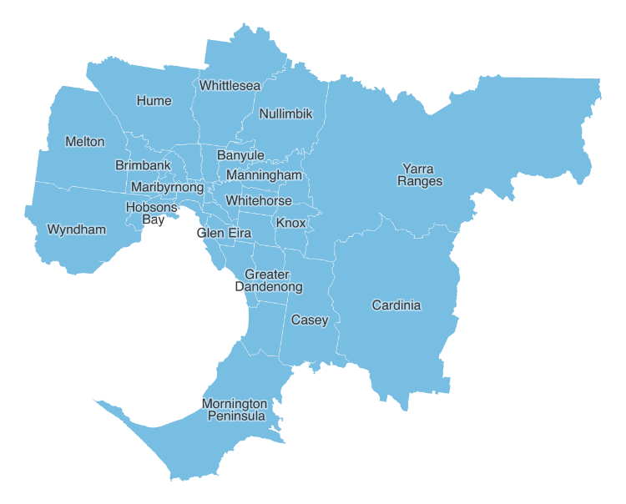

## Languages chosen

This report focuses on languages spoken by people from migrant and refugee backgrounds. It is designed to help government departments understand multicultural communications and their communication needs. This means groups that reported the following languages were not included:

* ‘Not stated’
* ‘Non-verbal, so described’
* ‘Inadequately described’
* ‘Sign languages, nec’[4]
* ‘Key Word Sign Languages’
* ‘Auslan’
* ‘Sign languages, nfd’[5].

## Disclosure risks

Some of the Census data used to create this report may contain identity risks. The Australian Bureau of Statistics (ABS) must ensure it does not disclose identifiable information about a person, household or business. One of the ways they do this is suppression – removing cells that are a disclosure risk from the table. This stops users from using data to reidentify a person. This is particularly relevant for the analysis of small language communities, especially when analysing language proficiency by sex and age.

For more information, refer to [Treating aggregate data](https://www.abs.gov.au/about/data-services/data-confidentiality-guide/treating-aggregate-data) <https://www.abs.gov.au/about/data-services/data-confidentiality-guide/treating-aggregate-data> on the ABS website.

# Country of birth

The 2021 Census data shows that most people born outside of Australia are from India, China, England or Vietnam. This is closely followed by people from New Zealand. While this follows a similar trend as national numbers, there are some differences. Nationally, England still takes the top spot, closely followed by India and China. However, in metropolitan Melbourne most people were born in India or China. Further, data showed that, nationally, many people were born in New Zealand. In metropolitan Melbourne, more people were born in Vietnam than in New Zealand.

If we compare this with regional Victoria, we find that while there are similarities, there are some differences too. People born in China are only the ninth biggest community in regional Victoria. Also, people born in the Philippines, the Netherlands and Italy make up some of the largest communities in regional Victoria. Whereas in metropolitan Melbourne, Vietnam, China and Sri Lanka are more commonly listed as countries of birth.

It is important to note that while some countries might rank higher in regional Victoria, there are still more people born in that country living in metropolitan Melbourne. For example, England is ranked third in metropolitan Melbourne (132,912 people) compared with first in regional Victoria (41,471).

The top countries of birth (India, China, England, Vietnam and New Zealand) have not changed compared with the 2016 Census data. The only change is that the number of people born in these countries has grown compared with 2016. People born in England is an exception.

Figure 2: Countries of birth in metropolitan Melbourne (Australia excluded) 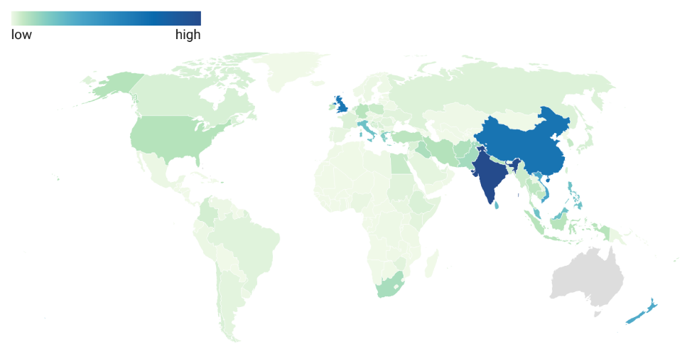

Corresponding values can be found in Appendix 1.

# English proficiency among language communities in metropolitan Melbourne

Figure 3 provides an overview of languages with self-reported low English proficiency in metropolitan Melbourne. The graph shows the percentage of people living in metropolitan Melbourne aged over 10 years old who spoke a language other than English and reported they spoke English ‘not well’ or ‘not at all’. Please note that only language communities that reported 50 or more speakers are included.

Figure 3: Low English proficiency in the language communities of 50 people or more and aged over 10 years old

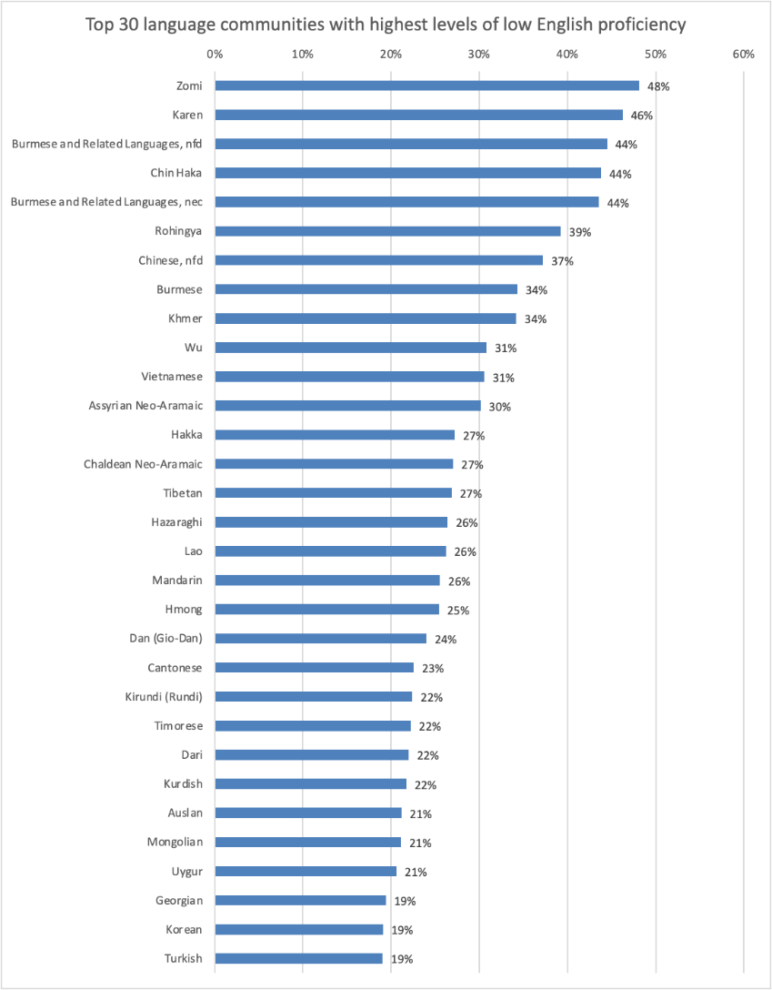

The top 30 language communities with the highest levels of low English proficiency are listed in Table 1.

Table 1: Top 30 language communities with the highest levels of low English proficiency

| Language | Level of low English proficiency | Total number of speakers |
| --- | --- | --- |
| Zomi | 48% | 619 |
| Karen | 46% | 3,448 |
| Burmese and Related Languages, nfd | 44% | 335 |
| Chin Haka | 44% | 3,132 |
| Burmese and Related Languages, nec | 44% | 1,821 |
| Rohingya | 39% | 293 |
| Chinese, nfd | 37% | 2,436 |
| Burmese | 34% | 4,514 |
| Khmer | 34% | 15,393 |
| Wu | 31% | 1,084 |
| Vietnamese | 31% | 103,465 |
| Assyrian Neo-Aramaic | 30% | 10,148 |
| Hakka | 27% | 5,090 |
| Chaldean Neo-Aramaic | 27% | 7,730 |
| Tibetan | 27% | 510 |
| Hazaraghi | 26% | 14,338 |
| Lao | 26% | 1,663 |
| Mandarin | 26% | 184,348 |
| Hmong | 25% | 535 |
| Dan (Gio-Dan) | 24% | 75 |
| Cantonese | 23% | 74,628 |
| Kirundi (Rundi) | 22% | 165 |
| Timorese | 22% | 333 |
| Dari | 22% | 9,614 |
| Kurdish | 22% | 1,487 |
| Auslan | 21% | 2,582 |
| Mongolian | 21% | 317 |
| Uygur | 21% | 354 |
| Georgian | 19% | 67 |
| Korean | 19% | 13,945 |

The languages for which more than a third of its speakers reported low English proficiency are predominantly languages spoken in Burma (Karen, Burmese and related languages, Chin Haka, Rohingya and Burmese). However, it is important to remember that although some languages reported a higher percentage of low English proficiency, there may still be a significant overall cohort with low English proficiency due to the high number of speakers of a particular language.

When we compare the data with 2016 Census data, we find that most language communities in the top 30 reported either similar or decreased percentages of low English proficiency. A few improvements of note are listed below.

* The Rohingya language community reported that 60 per cent of its speakers had low English proficiency in 2016, which improved to 39 per cent in 2021.
* The Chin Haka language community reported that 56 per cent of its speakers had low English proficiency in 2016, which improved to 44 per cent in 2021.
* The Burmese and related languages (nfd) community reported that 59 per cent of its speakers with low English proficiency in 2016, which improved to 45 per cent in 2021.

While this is only a small number, certain language communities reported an increase in the percentage of speakers reporting lower levels of English proficiency.

* The Assyrian Neo-Aramaic language community reported that 26 per cent of its speakers had low English proficiency in 2016, which increased to 30 per cent in 2021.
* The Chinese, nfd reported that 15 per cent of its speakers had low English proficiency in 2016, which increased to 19 per cent in 2021.
* The Lao language community reported that 23 per cent of its speakers had low English proficiency in 2016, which increased to 27 per cent in 2021.

## Comparing language communities with low English proficiency with regional Victoria

If we compare the levels of English proficiency of language communities in metropolitan Melbourne with regional Victoria, we find that more languages reported higher percentages of speakers who speak English ‘not well’ or ‘not at all’. While regional Victoria had 19 languages for which more than 20 per cent of its speakers reported low English proficiency, metropolitan Melbourne has 27. This could explain the difference in languages making up the top 30.

Some language communities such as Georgian, Uygur, Timorese, Mongolian, Dan, Wu and Chaldean Neo-Aramaic are less common in regional Victoria.

However, it should be noted that most language communities that are in the top 30 for both metropolitan Melbourne and regional Victoria either reported a higher or similar percentage of speakers with low English proficiency in regional Victoria. For example, 47 per cent of Rohingya speakers reported low English proficiency in regional Victoria compared with 39 per cent in metropolitan Melbourne.

## Distribution of English proficiency levels across LGAs

Figures 4 and 5 show the distribution of low English proficiency by LGA.

Figure 4: The distribution of low English proficiency per LGA, part 1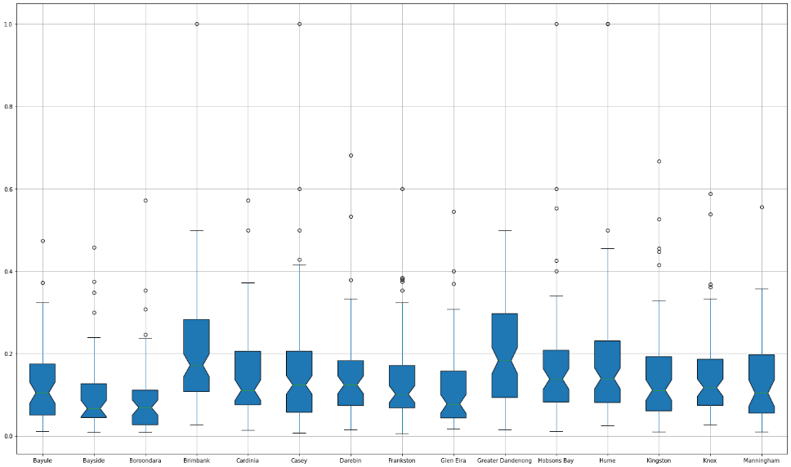

Figure 5: The distribution of low English proficiency per LGA, part 2

Figure 5: Part two of distribution of low English proficiency by LGA starting with Maribyrnong and ending with Yarra Ranges.

The box plots above describe the levels of English proficiency among multicultural communities across Melbourne LGAs. They represent the four quartiles (25 per cent) of language communities, where the first quartile is represented by the line below the blue box, then the next two quartiles of communities are represented by the box, with the line inside the box marking the 50 per cent mark, and the last quartile is represented by the line above the box.

Key points:

* In Boroondara and Bayside, 25 per cent of multicultural communities report high English proficiency, with only up to 5 per cent of community members reporting low English proficiency. the communities reporting low levels (up to 5 per cent).
* The highest values of low English proficiency of the 25 per cent of the multicultural communities are in Brimbank and Greater Dandenong and go up to 12 per cent.

The boxes in the boxplots above represent two quartiles of the communities and the larger it is, the higher the low English proficiency in the LGA.

* The highest values of low English proficiency among 75 per cent of the multicultural communities are in Brimbank, Greater Dandenong and Yarra, with up to 30 per cent of low English proficiency across each.
* The lowest values of low English proficiency among 75 per cent of the multicultural communities are in Boroondara, Bayside and Melbourne, with up to 15 per cent. And in Port Phillip, Mornington Peninsula, Monash, Knox, Kingston, Glen Eira, Frankston, Darebin and Banyule, with up to 20 per cent.

The line above the box represents the last 25 per cent of multicultural communities where at least one person reported low English proficiency. The longer the line is, the higher the level of low English proficiency in that LGA.

The highest levels of low English proficiency are in Brimbank, Greater Dandenong and Yara and go up to almost 60 per cent.

The lowest levels of low English proficiency are in Bayside, Boroondara and Mornington Peninsula, and go up to 28 per cent.

The outliers, which are represented by the dots in the boxplots, represent high levels of low English proficiency in the communities across the LGAs. From the figures above, it is evident that some LGAs have communities with 100 per cent low English proficiency. Such LGAs are: Brimbank, Casey, Hobsons Bay, Hume, Maribyrnong, Melbourne, Monash, Monee Valley, Nillumbik, Port Phillip, Stonnington and Yarra. Such communities usually consist of no more than 10 people and speak the following languages: Iberian-Romance, Turkmen, Gaelic (Scotland), Kanai, Chin Hakka, Tetum, Armenian, Belorussian, Uzbek, French, Creole and Tigre.

## Metropolitan Melbourne LGAs with low English proficiency

The map in Figure 6 shows the number of language communities with low English proficiency in each LGA in metropolitan Melbourne.

Figure 6: Number of language communities with low English proficiency per LGA for communities with 50 or more speakers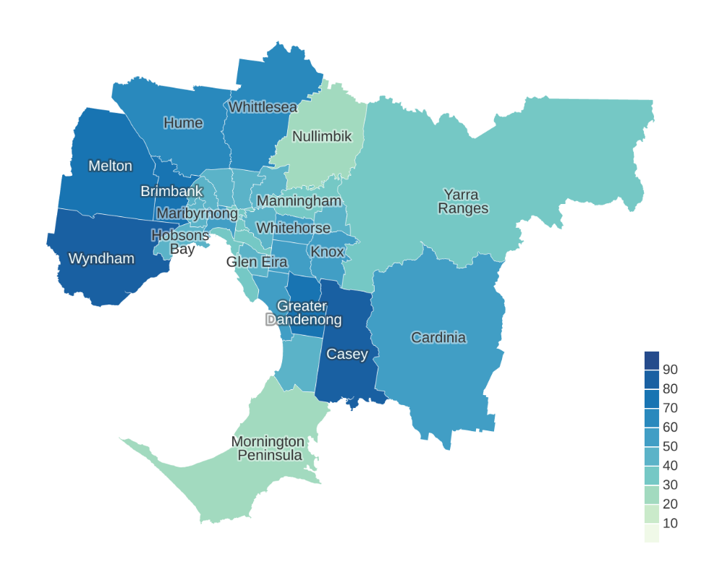

Table 2: Number of language communities with low English proficiency per LGA

| LGA | Number of communities with low English proficiency |
| --- | --- |
| Banyule | 41 |
| Bayside | 37 |
| Boroondara | 43 |
| Brimbank | 74 |
| Cardinia | 52 |
| Casey | 86 |
| Darebin | 48 |
| Frankston | 45 |
| Glen Eira | 47 |
| Greater Dandenong | 77 |
| Hobsons Bay | 49 |
| Hume | 66 |
| Kingston | 57 |
| Knox | 52 |
| Manningham | 39 |
| Maribyrnong | 48 |
| Maroondah | 43 |
| Melbourne | 55 |
| Melton | 70 |
| Monash | 59 |
| Moonee Valley | 47 |
| Moreland | 49 |
| Mornington Peninsula | 24 |
| Nillumbik | 20 |
| Port Phillip | 38 |
| Stonnington | 39 |
| Whitehorse | 53 |
| Whittlesea | 62 |
| Wyndham | 87 |
| Yarra | 33 |
| Yarra Ranges | 38 |

The outer north-west and inner south-east areas (Wyndham, Casey, Greater Dandenong, Brimbank, Melton, Hume and Whittlesea) in metropolitan Melbourne have the highest number of language communities with low English proficiency. These LGAs therefore have a need for resources in a high number of languages.

It is important to note that while Wyndham and Whittlesea have a high number of language communities that reported speakers with low English proficiency, the level of low English proficiency across those LGAs is average.

Table 3 sets out the percentage of the total population of each LGA who reported speaking a language other than English at home and reported a low level of English proficiency. It also compares the data collected in Census 2016 and Census 2021.

From this data, we can conclude that most LGAs either experienced no change in the overall English proficiency level or experienced a small improvement of 1 per cent. The exceptions are Casey and Melton, which experienced a 1 per cent increase.

Table 3: English proficiency of languages communities per LGA, comparison between 2016 and 2021

| LGA | Percentage of population who speak a language other than English at home who reported low English proficiency, 2016 | Percentage of population who speak a language other than English at home who reported low English proficiency, 2021 | Change |
| --- | --- | --- | --- |
| Greater Dandenong | 17% | 16% | –1% |
| Brimbank | 13% | 14% | 1% |
| Maribyrnong | 9% | 8% | –1% |
| Hume | 8% | 8% | 0% |
| Manningham | 8% | 8% | 0% |
| Monash | 8% | 8% | 0% |
| Whitehorse | 8% | 8% | 0% |
| Darebin | 7% | 6% | –1% |
| Melbourne | 7% | 5% | –2% |
| Whittlesea | 7% | 7% | 0% |
| Moreland | 6% | 5% | –1% |
| Wyndham | 6% | 6% | 0% |
| Casey | 5% | 6% | 1% |
| Hobsons Bay | 5% | 4% | –1% |
| Mooney Valley | 5% | 4% | –1% |
| Yarra | 5% | 4% | –1% |
| Boroondara | 4% | 4% | 0% |
| Glen Eira | 4% | 4% | 0% |
| Kingston | 4% | 4% | 0% |
| Knox | 4% | 4% | 0% |
| Maroondah | 4% | 4% | 0% |
| Melton | 4% | 5% | 1% |
| Banyule | 3% | 3% | 0% |
| Port Phillip | 3% | 2% | –1% |
| Stonnington | 3% | 3% | 0% |
| Bayside | 2% | 2% | 0% |
| Cardinia | 1% | 2% | 1% |
| Frankston | 1% | 1% | 0% |
| Mornington Peninsula | 1% | 1% | 0% |
| Nillumbik | 1% | 1% | 0% |
| Yarra Ranges | 1% | 1% | 0% |

## Where do people with low English proficiency live?

The following maps show the geographical spread of each of the 30 languages identified in which a high number of speakers reported low English proficiency.

An analysis of languages reporting low English proficiency spoken in each region indicates that:

* Chinese, nfd, Khmer, Vietnamese, Hakka, Mandarin, Cantonese and Korean language communities can be found across all LGAs of metropolitan Melbourne. Other languages that are widespread but not present in every LGA are Assyrian Neo-Aramaic, Burmese and Dari.
* Chinese, nfd is unique because it reports a high percentage of speakers with low English proficiency across all LGAs.
* Dan (Dan-Gio), Hmong and Georgian language communities with a high percentage of speakers who reported not speaking English well are localised in one LGA. For Dan (Dan-Gio) and Hmong, most people with low English proficiency live in Brimbank. For Georgian, speakers with low English proficiency predominantly live in Glen Eira.

### 

### Zomi

**Figure 7: Level of low English proficiency of Zomi-speaking community by LGA**

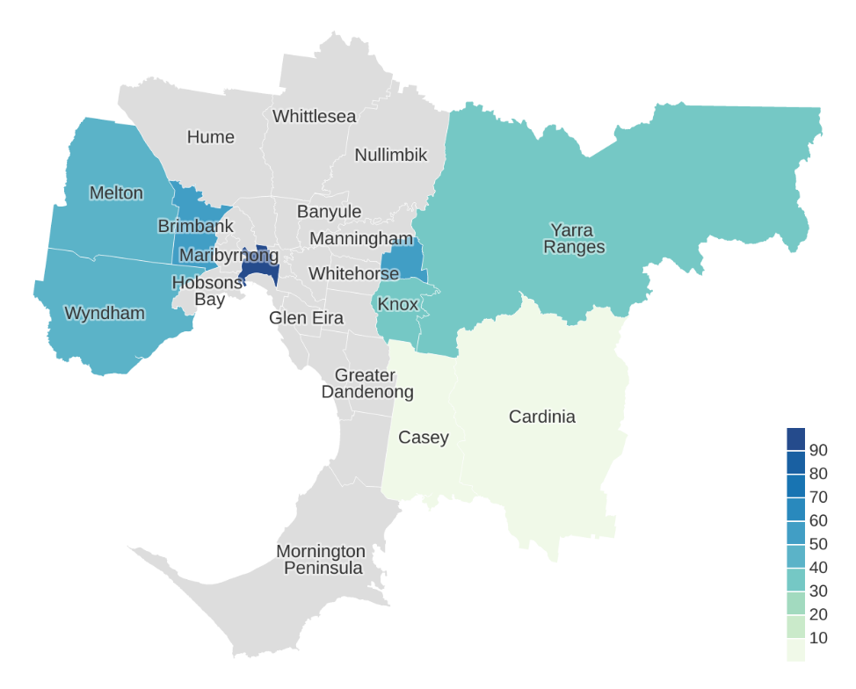

Table 4: English proficiency of Zomi language community per LGA

| LGA | Low English proficiency, % |
| --- | --- |
| Banyule | – |
| Bayside | – |
| Boroondara | – |
| Brimbank | 50% |
| Cardinia | 0% |
| Casey | 0% |
| Darebin | – |
| Frankston | – |
| Glen Eira | – |
| Greater Dandenong | – |
| Hobsons Bay | – |
| Hume | – |
| Kingston | – |
| Knox | 36% |
| Manningham | – |
| Maribyrnong | – |
| Maroondah | 0% |
| Melbourne | 100% |
| Melton | 41% |
| Monash | – |
| Moonee Valley | – |
| Moreland | – |
| Mornington Peninsula | – |
| Nillumbik | – |
| Port Phillip | – |
| Stonnington | – |
| Whitehorse | – |
| Whittlesea | – |
| Wyndham | 46% |
| Yarra | – |
| Yarra Ranges | 36% |

### 

### Karen

Figure 8: Level of low English proficiency of Karen-speaking community by LGA

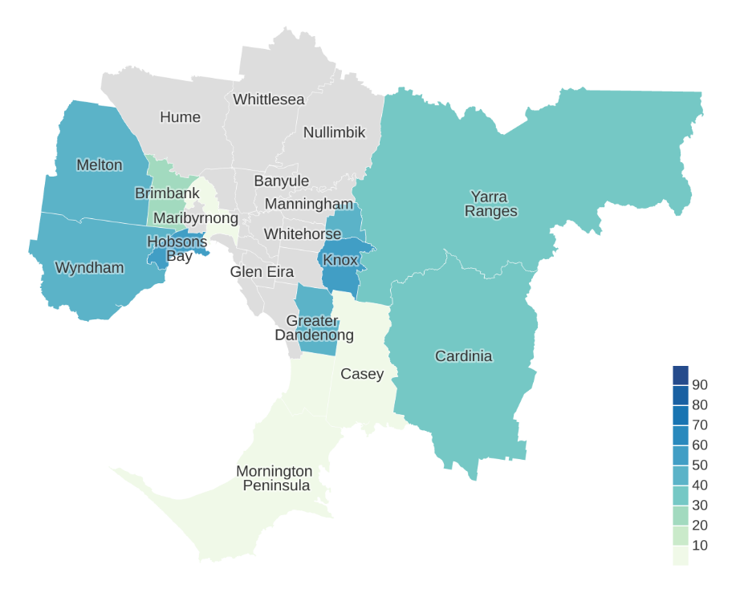

Table 5: English proficiency of the Karen language community per LGA

| LGA | Low English proficiency, % |
| --- | --- |
| Banyule | – |
| Bayside | – |
| Boroondara | – |
| Brimbank | 21% |
| Cardinia | 0% |
| Casey | 34% |
| Darebin | – |
| Frankston | 0% |
| Glen Eira | – |
| Greater Dandenong | 47% |
| Hobsons Bay | 55% |
| Hume | – |
| Kingston | – |
| Knox | 54% |
| Manningham | – |
| Maribyrnong | – |
| Maroondah | 42% |
| Melbourne | 0% |
| Melton | 42% |
| Monash | – |
| Moonee Valley | 0% |
| Moreland | – |
| Mornington Peninsula | 0% |
| Nillumbik | – |
| Port Phillip | – |
| Stonnington | – |
| Whitehorse | – |
| Whittlesea | – |
| Wyndham | 45% |
| Yarra | – |
| Yarra Ranges | 30% |

### Chin Haka

Figure 9: Level of low English proficiency of Chin Haka–speaking community by LGA

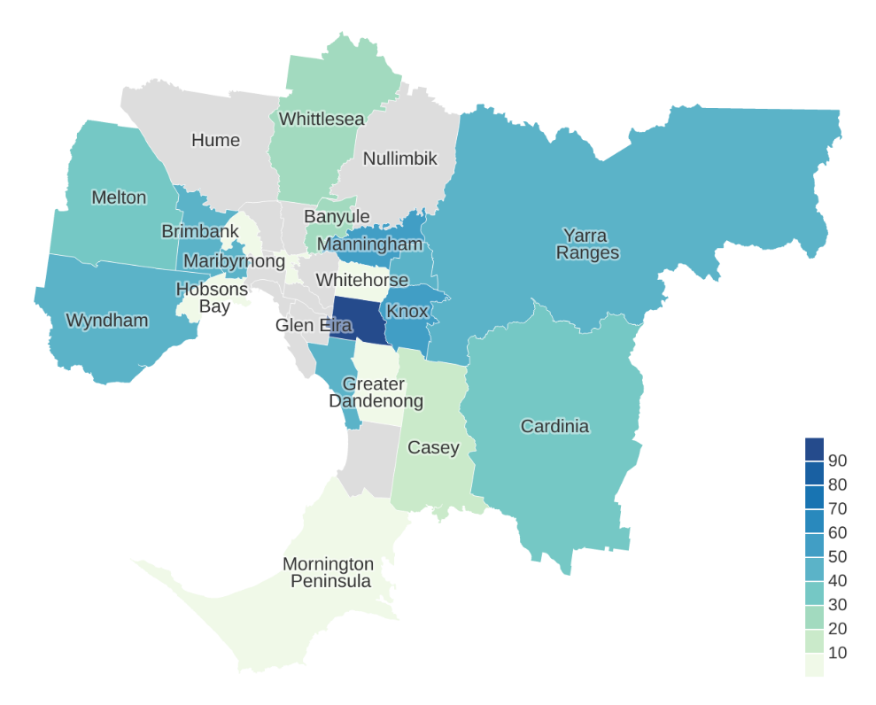

Table 6: English proficiency of Chin Haka language community per LGA

| LGA | Low English proficiency, % |
| --- | --- |
| Banyule | 24% |
| Bayside | – |
| Boroondara | – |
| Brimbank | 41% |
| Cardinia | 31% |
| Casey | 19% |
| Darebin | – |
| Frankston | – |
| Glen Eira | – |
| Greater Dandenong | 0% |
| Hobsons Bay | 0% |
| Hume | – |
| Kingston | 45% |
| Knox | 59% |
| Manningham | 56% |
| Maribyrnong | 42% |
| Maroondah | 45% |
| Melbourne | – |
| Melton | 37% |
| Monash | 100% |
| Moonee Valley | 0% |
| Moreland | – |
| Mornington Peninsula | 0% |
| Nillumbik | – |
| Port Phillip | – |
| Stonnington | – |
| Whitehorse | 0% |
| Whittlesea | 27% |
| Wyndham | 45% |
| Yarra | 0% |
| Yarra Ranges | 40% |

### Rohingya

Figure 10: Level of low English proficiency of Rohingya-speaking community by LGA

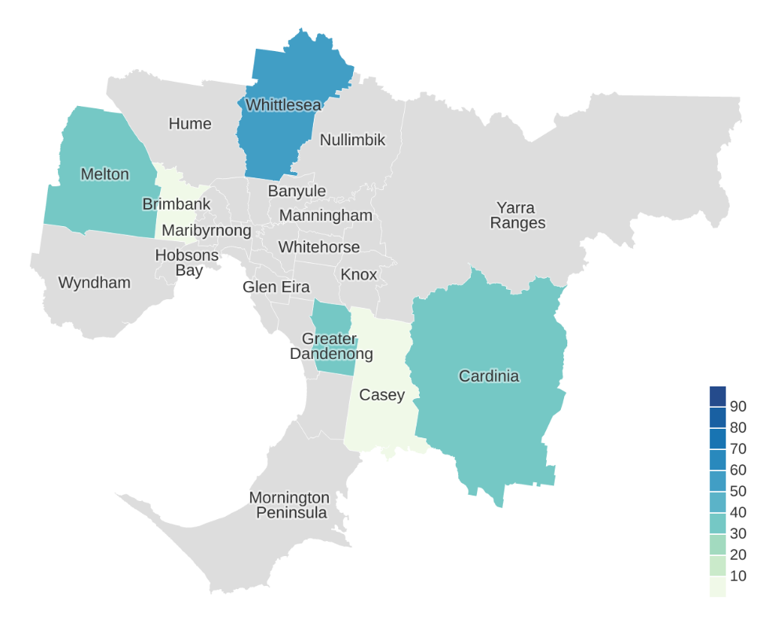

Table 7: English proficiency of Rohingya language community per LGA

| LGA | Low English proficiency, % |
| --- | --- |
| Banyule | – |
| Bayside | – |
| Boroondara | – |
| Brimbank | 0% |
| Cardinia | 37% |
| Casey | 0% |
| Darebin | – |
| Frankston | – |
| Glen Eira | – |
| Greater Dandenong | 39% |
| Hobsons Bay | – |
| Hume | – |
| Kingston | – |
| Knox | – |
| Manningham | – |
| Maribyrnong | – |
| Maroondah | – |
| Melbourne | – |
| Melton | 36% |
| Monash | – |
| Moonee Valley | – |
| Moreland | – |
| Mornington Peninsula | – |
| Nillumbik | – |
| Port Phillip | – |
| Stonnington | – |
| Whitehorse | – |
| Whittlesea | 55% |
| Wyndham | – |
| Yarra | – |
| Yarra Ranges | – |

### Chinese, nfd

**Figure 11: Level of low English proficiency of Chinese, nfd speaking community by LGA**

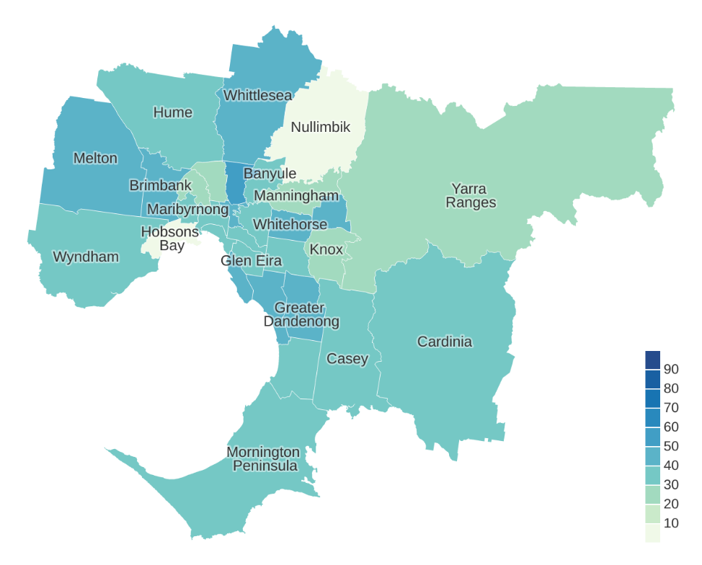

Table 8: English proficiency of Chinese, nfd. language community per LGA

| LGA | Low English proficiency, % |
| --- | --- |
| Banyule | 32% |
| Bayside | 46% |
| Boroondara | 35% |
| Brimbank | 48% |
| Cardinia | 37% |
| Casey | 32% |
| Darebin | 53% |
| Frankston | 35% |
| Glen Eira | 30% |
| Greater Dandenong | 48% |
| Hobsons Bay | 0% |
| Hume | 38% |
| Kingston | 42% |
| Knox | 27% |
| Manningham | 29% |
| Maribyrnong | 34% |
| Maroondah | 45% |
| Melbourne | 31% |
| Melton | 43% |
| Monash | 35% |
| Moonee Valley | 20% |
| Moreland | 22% |
| Mornington Peninsula | 38% |
| Nillumbik | 0% |
| Port Phillip | 33% |
| Stonnington | 33% |
| Whitehorse | 48% |
| Whittlesea | 46% |
| Wyndham | 33% |
| Yarra | 45% |
| Yarra Ranges | 27% |

### Khmer

Figure 12: Level of low English proficiency of Khmer-speaking community by LGA

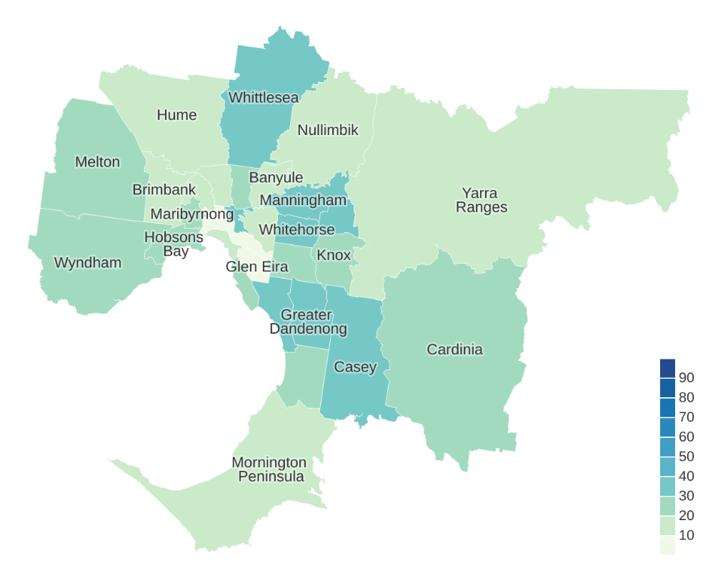

Table 9: English proficiency of Khmer language community per LGA

| LGA | Low English proficiency, % |
| --- | --- |
| Banyule | 20% |
| Bayside | 20% |
| Boroondara | 19% |
| Brimbank | 15% |
| Cardinia | 26% |
| Casey | 31% |
| Darebin | 28% |
| Frankston | 26% |
| Glen Eira | 7% |
| Greater Dandenong | 38% |
| Hobsons Bay | 22% |
| Hume | 14% |
| Kingston | 32% |
| Knox | 28% |
| Manningham | 30% |
| Maribyrnong | 21% |
| Maroondah | 33% |
| Melbourne | 2% |
| Melton | 29% |
| Monash | 21% |
| Moonee Valley | 12% |
| Moreland | 14% |
| Mornington Peninsula | 12% |
| Nillumbik | 19% |
| Port Phillip | 13% |
| Stonnington | 5% |
| Whitehorse | 32% |
| Whittlesea | 30% |
| Wyndham | 22% |
| Yarra | 30% |
| Yarra Ranges | 16% |

### Wu

Figure 13: Level of low English proficiency of Wu-speaking community by LGA

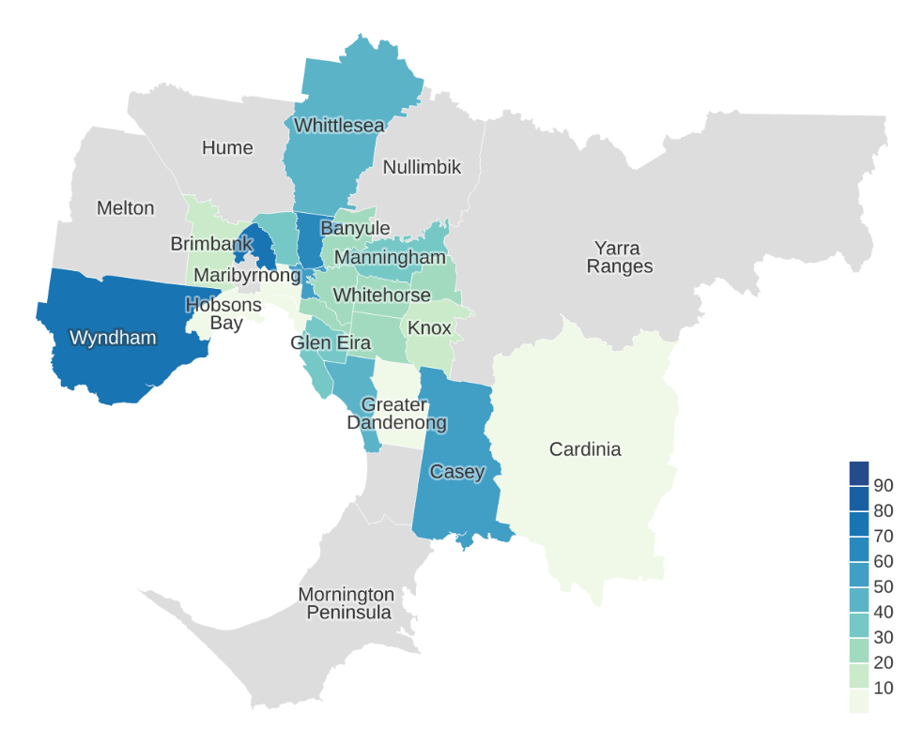

Table 10: English proficiency of Wu language community per LGA

| LGA | Low English proficiency, % |
| --- | --- |
| Banyule | 29% |
| Bayside | 38% |
| Boroondara | 25% |
| Brimbank | 18% |
| Cardinia | 0% |
| Casey | 50% |
| Darebin | 68% |
| Frankston | – |
| Glen Eira | 37% |
| Greater Dandenong | 0% |
| Hobsons Bay | 0% |
| Hume | – |
| Kingston | 45% |
| Knox | 16% |
| Manningham | 30% |
| Maribyrnong | – |
| Maroondah | 26% |
| Melbourne | 0% |
| Melton | – |
| Monash | 29% |
| Moonee Valley | 73% |
| Moreland | 32% |
| Mornington Peninsula | – |
| Nillumbik | – |
| Port Phillip | 0% |
| Stonnington | 25% |
| Whitehorse | 26% |
| Whittlesea | 45% |
| Wyndham | 72% |
| Yarra | 50% |
| Yarra Ranges | – |

### Vietnamese

Figure 14: Level of low English proficiency of Vietnamese-speaking community by LGA

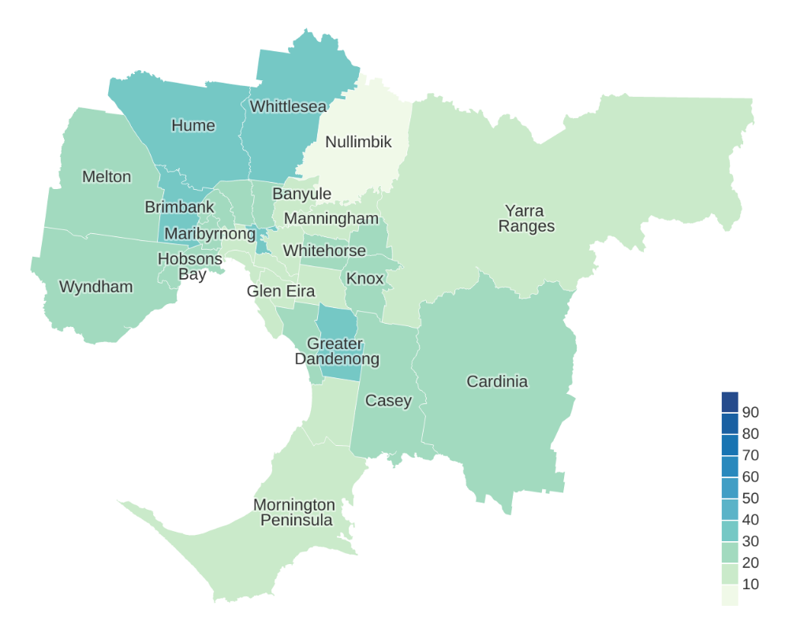

Table 11: English proficiency of Vietnamese language community per LGA

| LGA | Low English proficiency, % |
| --- | --- |
| Banyule | 16% |
| Bayside | 12% |
| Boroondara | 13% |
| Brimbank | 36% |
| Cardinia | 23% |
| Casey | 27% |
| Darebin | 26% |
| Frankston | 19% |
| Glen Eira | 12% |
| Greater Dandenong | 36% |
| Hobsons Bay | 27% |
| Hume | 32% |
| Kingston | 24% |
| Knox | 25% |
| Manningham | 16% |
| Maribyrnong | 29% |
| Maroondah | 21% |
| Melbourne | 14% |
| Melton | 29% |
| Monash | 17% |
| Moonee Valley | 24% |
| Moreland | 21% |
| Mornington Peninsula | 18% |
| Nillumbik | 8% |
| Port Phillip | 15% |
| Stonnington | 15% |
| Whitehorse | 21% |
| Whittlesea | 30% |
| Wyndham | 25% |
| Yarra | 39% |
| Yarra Ranges | 12% |

### Chaldean Neo-Aramaic

Figure 15: Level of low English proficiency of Chaldean Neo-Aramaic–speaking community by LGA

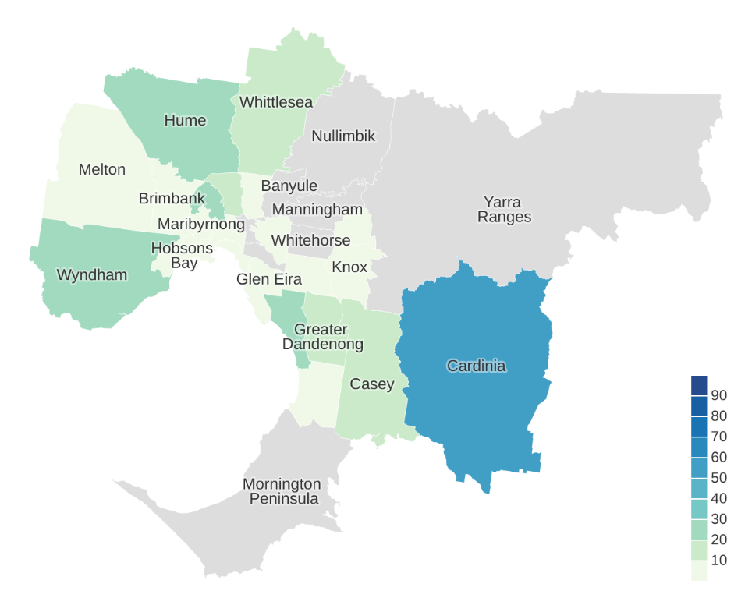

Table 12: English proficiency of Chaldean Neo-Aramaic language community per LGA

| LGA | Low English proficiency, % |
| --- | --- |
| Banyule | – |
| Bayside | 0% |
| Boroondara | 0% |
| Brimbank | 0% |
| Cardinia | 57% |
| Casey | 17% |
| Darebin | 0% |
| Frankston | 0% |
| Glen Eira | 0% |
| Greater Dandenong | 15% |
| Hobsons Bay | 0% |
| Hume | 28% |
| Kingston | 25% |
| Knox | 0% |
| Manningham | – |
| Maribyrnong | 0% |
| Maroondah | 0% |
| Melbourne | 0% |
| Melton | 6% |
| Monash | 0% |
| Moonee Valley | 24% |
| Moreland | 20% |
| Mornington Peninsula | – |
| Nillumbik | – |
| Port Phillip | 0% |
| Stonnington | – |
| Whitehorse | – |
| Whittlesea | 16% |
| Wyndham | 27% |
| Yarra | – |
| Yarra Ranges | – |

### Burmese and related languages, nfd

Figure 16: Level of low English proficiency of Burmese and related languages, nfd speaking community by LGA

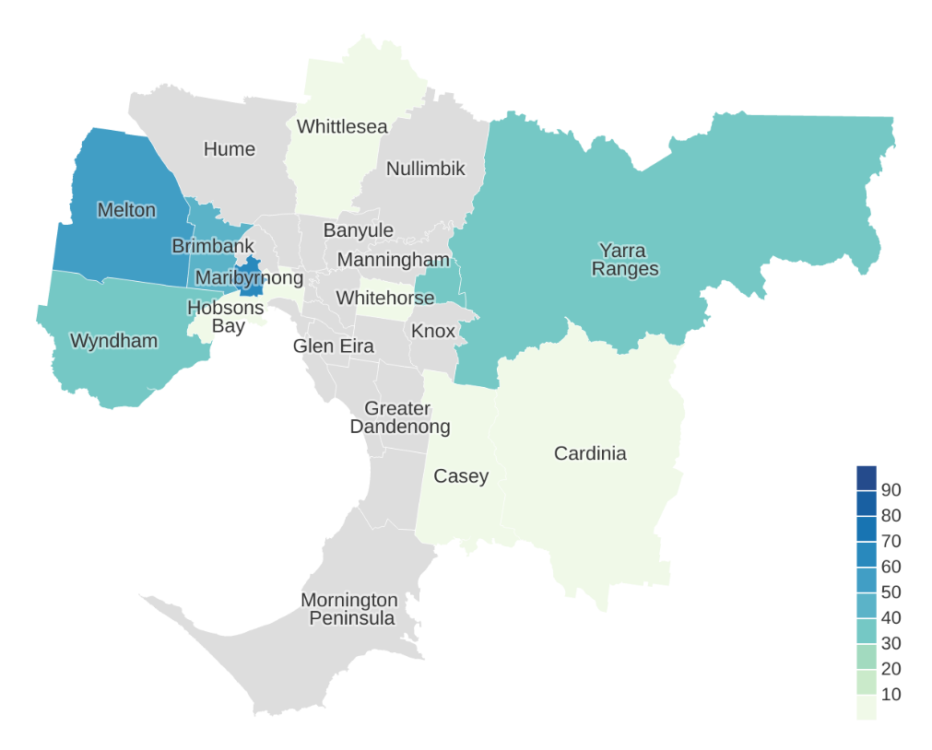

Table 13: English proficiency of Burmese and related languages, nfd language community per LGA

| LGA | Low English proficiency, % |
| --- | --- |
| Banyule | – |
| Bayside | – |
| Boroondara | – |
| Brimbank | 43% |
| Cardinia | 0% |
| Casey | 0% |
| Darebin | – |
| Frankston | – |
| Glen Eira | – |
| Greater Dandenong | – |
| Hobsons Bay | 0% |
| Hume | – |
| Kingston | – |
| Knox | – |
| Manningham | – |
| Maribyrnong | 63% |
| Maroondah | 37% |
| Melbourne | 0% |
| Melton | 50% |
| Monash | – |
| Moonee Valley | – |
| Moreland | – |
| Mornington Peninsula | – |
| Nillumbik | – |
| Port Phillip | – |
| Stonnington | – |
| Whitehorse | 0% |
| Whittlesea | 0% |
| Wyndham | 32% |
| Yarra | – |
| Yarra Ranges | 37% |

### Burmese and related languages, nec

Figure 17: Level of low English proficiency of Burmese and related languages, nec. speaking community by LGA

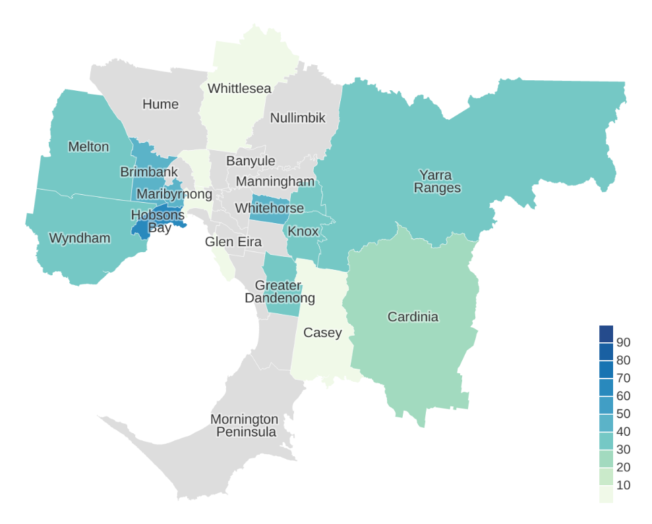

Table 14: English proficiency of Burmese and related languages, nec. language community per LGA

| LGA | Low English proficiency, % |
| --- | --- |
| Banyule | – |
| Bayside | 0% |
| Boroondara | – |
| Brimbank | 45% |
| Cardinia | 26% |
| Casey | 0% |
| Darebin | – |
| Frankston | – |
| Glen Eira | – |
| Greater Dandenong | 36% |
| Hobsons Bay | 60% |
| Hume | – |
| Kingston | – |
| Knox | 37% |
| Manningham | – |
| Maribyrnong | 48% |
| Maroondah | 38% |
| Melbourne | 0% |
| Melton | 38% |
| Monash | – |
| Moonee Valley | – |
| Moreland | 0% |
| Mornington Peninsula | – |
| Nillumbik | – |
| Port Phillip | – |
| Stonnington | – |
| Whitehorse | 43% |
| Whittlesea | 0% |
| Wyndham | 38% |
| Yarra | – |
| Yarra Ranges | 38% |

### Burmese

Figure 18: Level of low English proficiency of Burmese-speaking community by LGA

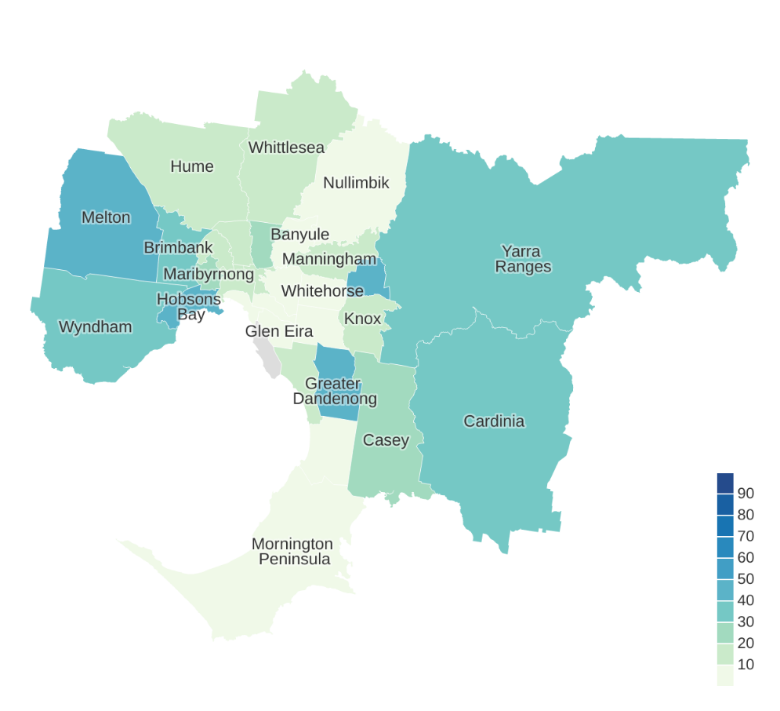

Table 15: English proficiency of Burmese language community per LGA

| LGA | Low English proficiency, % |
| --- | --- |
| Banyule | 0% |
| Bayside | – |
| Boroondara | 8% |
| Brimbank | 36% |
| Cardinia | 34% |
| Casey | 25% |
| Darebin | 22% |
| Frankston | 9% |
| Glen Eira | 0% |
| Greater Dandenong | 44% |
| Hobsons Bay | 43% |
| Hume | 16% |
| Kingston | 20% |
| Knox | 18% |
| Manningham | 16% |
| Maribyrnong | 27% |
| Maroondah | 44% |
| Melbourne | 14% |
| Melton | 45% |
| Monash | 9% |
| Moonee Valley | 17% |
| Moreland | 14% |
| Mornington Peninsula | 0% |
| Nillumbik | 0% |
| Port Phillip | 0% |
| Stonnington | 0% |
| Whitehorse | 7% |
| Whittlesea | 15% |
| Wyndham | 34% |
| Yarra | 19% |
| Yarra Ranges | 34% |

### Assyrian Neo-Aramaic

Figure 19: Level of low English proficiency of Assyrian Neo-Aramaic–speaking community by LGA

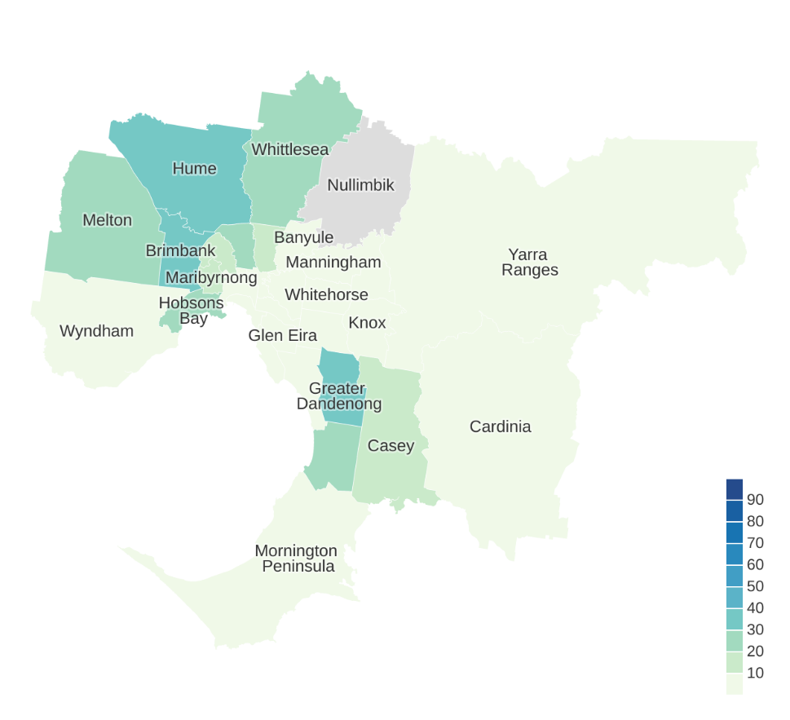

Table 16: English proficiency of Assyrian Neo-Aramaic language community per LGA

| LGA | Low English proficiency, % |
| --- | --- |
| Banyule | 0% |
| Bayside | 0% |
| Boroondara | 0% |
| Brimbank | 37% |
| Cardinia | 0% |
| Casey | 15% |
| Darebin | 13% |
| Frankston | 23% |
| Glen Eira | 0% |
| Greater Dandenong | 37% |
| Hobsons Bay | 20% |
| Hume | 30% |
| Kingston | 0% |
| Knox | 0% |
| Manningham | 0% |
| Maribyrnong | 11% |
| Maroondah | 0% |
| Melbourne | 0% |
| Melton | 29% |
| Monash | 0% |
| Moonee Valley | 16% |
| Moreland | 25% |
| Mornington Peninsula | 0% |
| Nillumbik | – |
| Port Phillip | 0% |
| Stonnington | 0% |
| Whitehorse | 0% |
| Whittlesea | 23% |
| Wyndham | 0% |
| Yarra | 0% |
| Yarra Ranges | 0% |

### 

### Hakka

Figure 20: Level of low English proficiency of Hakka-speaking community by LGA

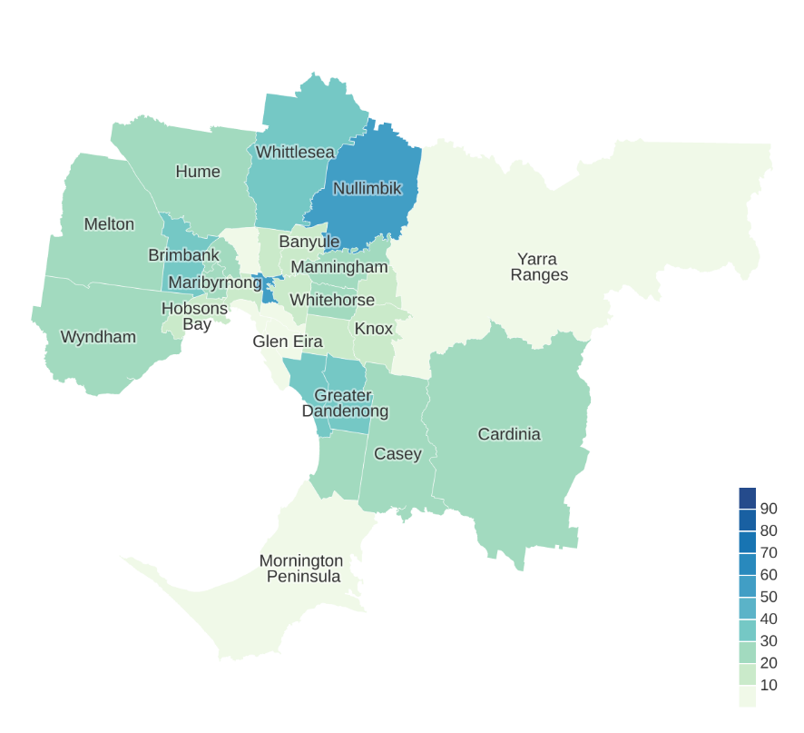

Table 17: English proficiency of Hakka language community per LGA

| LGA | Low English proficiency, % |
| --- | --- |
| Banyule | 18% |
| Bayside | 0% |
| Boroondara | 12% |
| Brimbank | 33% |
| Cardinia | 24% |
| Casey | 24% |
| Darebin | 19% |
| Frankston | 23% |
| Glen Eira | 0% |
| Greater Dandenong | 36% |
| Hobsons Bay | 14% |
| Hume | 24% |
| Kingston | 31% |
| Knox | 19% |
| Manningham | 22% |
| Maribyrnong | 22% |
| Maroondah | 18% |
| Melbourne | 12% |
| Melton | 21% |
| Monash | 15% |
| Moonee Valley | 26% |
| Moreland | 0% |
| Mornington Peninsula | 0% |
| Nillumbik | 50% |
| Port Phillip | 0% |
| Stonnington | 0% |
| Whitehorse | 24% |
| Whittlesea | 33% |
| Wyndham | 25% |
| Yarra | 55% |
| Yarra Ranges | 0% |

### Tibetan

Figure 21: Level of low English proficiency of Tibetan-speaking community by LGA

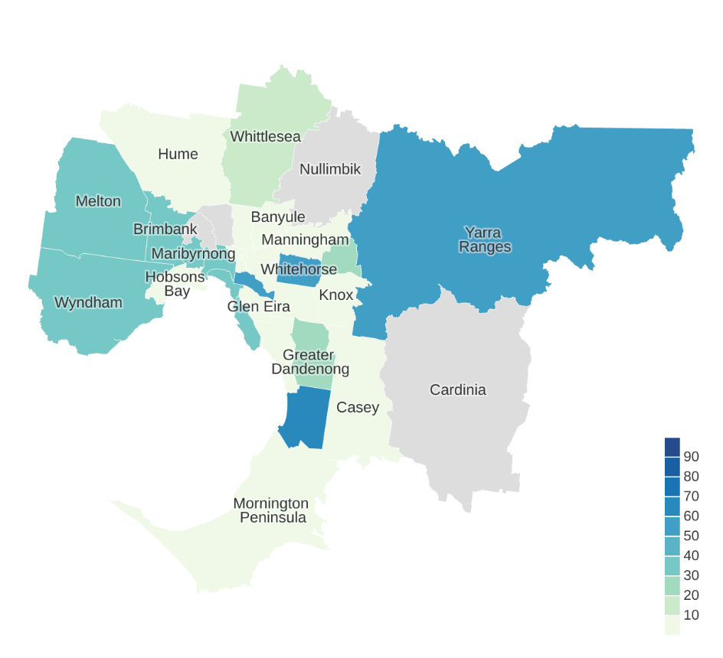

Table 18: English proficiency of Tibetan language community per LGA

| LGA | Low English proficiency, % |
| --- | --- |
| Banyule | 0% |
| Bayside | 30% |
| Boroondara | 0% |
| Brimbank | 30% |
| Cardinia | – |
| Casey | 0% |
| Darebin | 0% |
| Frankston | 60% |
| Glen Eira | 0% |
| Greater Dandenong | 27% |
| Hobsons Bay | 0% |
| Hume | 0% |
| Kingston | 0% |
| Knox | 0% |
| Manningham | 0% |
| Maribyrnong | 34% |
| Maroondah | 21% |
| Melbourne | 30% |
| Melton | 39% |
| Monash | 0% |
| Moonee Valley | – |
| Moreland | – |
| Mornington Peninsula | 0% |
| Nillumbik | – |
| Port Phillip | 33% |
| Stonnington | 50% |
| Whitehorse | 57% |
| Whittlesea | 13% |
| Wyndham | 34% |
| Yarra | 0% |
| Yarra Ranges | 50% |

### Lao

Figure 22: Level of low English proficiency of Lao-speaking community by LGA

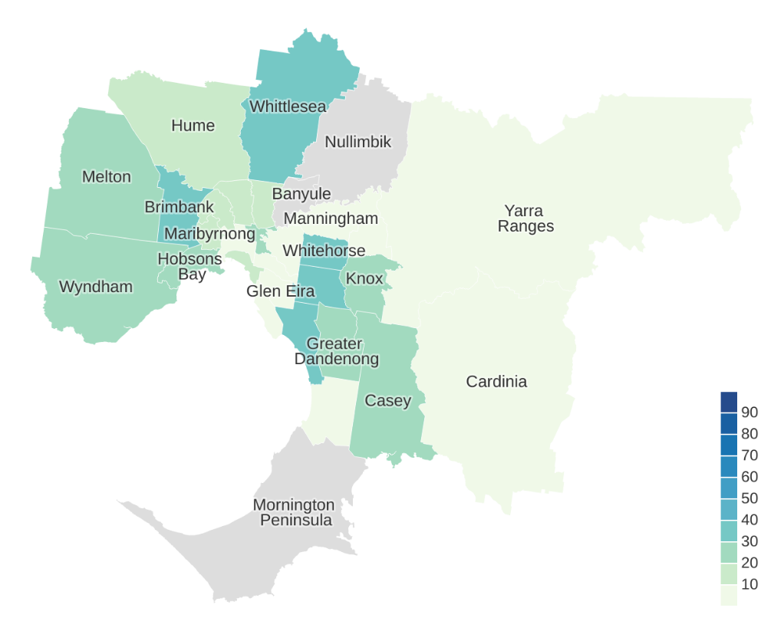

Table 19: English proficiency of Lao language community per LGA

| LGA | Low English proficiency, % |
| --- | --- |
| Banyule | – |
| Bayside | 0% |
| Boroondara | 0% |
| Brimbank | 31% |
| Cardinia | 0% |
| Casey | 28% |
| Darebin | 14% |
| Frankston | 0% |
| Glen Eira | 0% |
| Greater Dandenong | 26% |
| Hobsons Bay | 23% |
| Hume | 19% |
| Kingston | 30% |
| Knox | 21% |
| Manningham | 0% |
| Maribyrnong | 18% |
| Maroondah | 0% |
| Melbourne | 7% |
| Melton | 27% |
| Monash | 31% |
| Moonee Valley | 18% |
| Moreland | 11% |
| Mornington Peninsula | – |
| Nillumbik | – |
| Port Phillip | 19% |
| Stonnington | 0% |
| Whitehorse | 35% |
| Whittlesea | 30% |
| Wyndham | 22% |
| Yarra | 29% |
| Yarra Ranges | 0% |

### Hazaragi

Figure 23: Level of low English proficiency of Hazaragi-speaking community by LGA

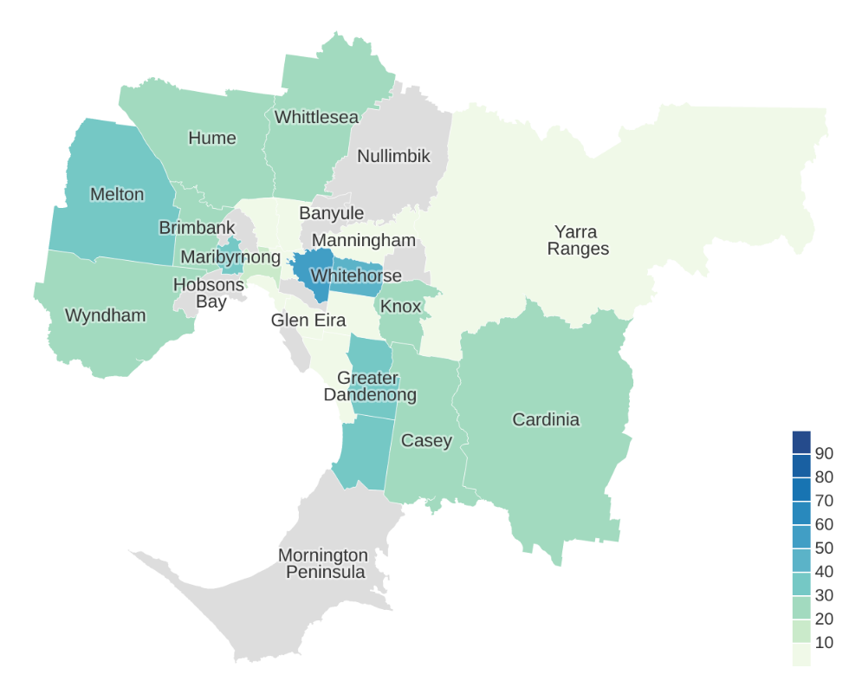

Table 20: English proficiency of Hazaragi language community per LGA

| LGA | Low English proficiency, % |
| --- | --- |
| Banyule | – |
| Bayside | – |
| Boroondara | 57% |
| Brimbank | 26% |
| Cardinia | 22% |
| Casey | 29% |
| Darebin | 0% |
| Frankston | 32% |
| Glen Eira | 0% |
| Greater Dandenong | 31% |
| Hobsons Bay | – |
| Hume | 25% |
| Kingston | 0% |
| Knox | 21% |
| Manningham | 0% |
| Maribyrnong | 33% |
| Maroondah | – |
| Melbourne | 16% |
| Melton | 31% |
| Monash | 7% |
| Moonee Valley | – |
| Moreland | 0% |
| Mornington Peninsula | – |
| Nillumbik | – |
| Port Phillip | 0% |
| Stonnington | – |
| Whitehorse | 45% |
| Whittlesea | 20% |
| Wyndham | 23% |
| Yarra | 0% |
| Yarra Ranges | 0% |

### Mandarin

Figure 24: Level of low English proficiency of Mandarin-speaking community by LGA

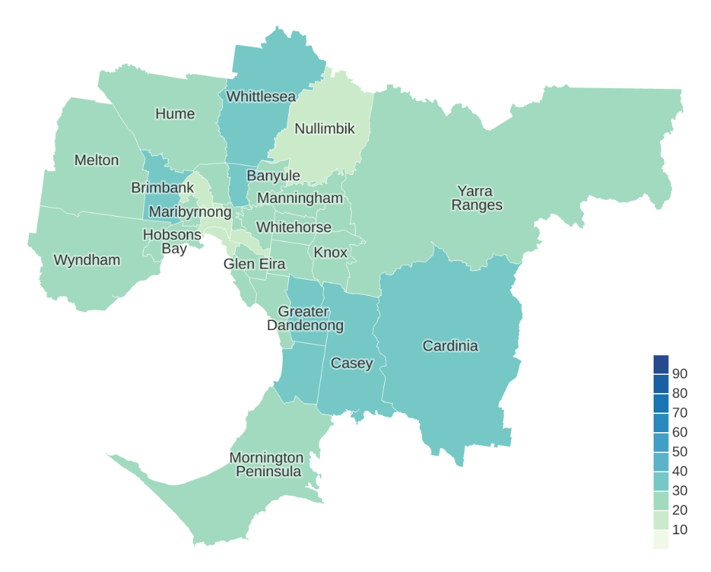

Table 21: English proficiency of Mandarin language community per LGA

| LGA | Low English proficiency, % |
| --- | --- |
| Banyule | 25% |
| Bayside | 24% |
| Boroondara | 23% |
| Brimbank | 33% |
| Cardinia | 32% |
| Casey | 31% |
| Darebin | 38% |
| Frankston | 31% |
| Glen Eira | 21% |
| Greater Dandenong | 36% |
| Hobsons Bay | 24% |
| Hume | 24% |
| Kingston | 27% |
| Knox | 24% |
| Manningham | 25% |
| Maribyrnong | 28% |
| Maroondah | 26% |
| Melbourne | 16% |
| Melton | 24% |
| Monash | 25% |
| Moonee Valley | 18% |
| Moreland | 23% |
| Mornington Peninsula | 24% |
| Nillumbik | 17% |
| Port Phillip | 15% |
| Stonnington | 17% |
| Whitehorse | 29% |
| Whittlesea | 33% |
| Wyndham | 28% |
| Yarra | 27% |
| Yarra Ranges | 25% |

### Hmong

Figure 25: Level of low English proficiency of Hmong-speaking community by LGA

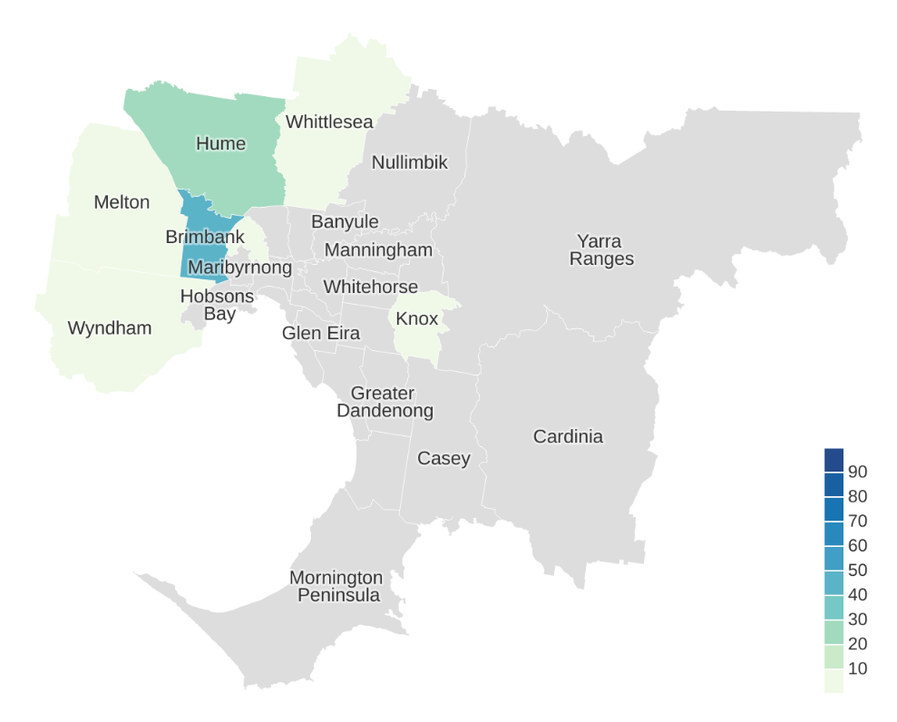

Table 22: English proficiency of Hmong language community per LGA

| LGA | Low English proficiency, % |
| --- | --- |
| Banyule | – |
| Bayside | – |
| Boroondara | – |
| Brimbank | 43% |
| Cardinia | – |
| Casey | – |
| Darebin | – |
| Frankston | – |
| Glen Eira | – |
| Greater Dandenong | – |
| Hobsons Bay | – |
| Hume | 26% |
| Kingston | – |
| Knox | 0% |
| Manningham | – |
| Maribyrnong | – |
| Maroondah | – |
| Melbourne | – |
| Melton | 0% |
| Monash | – |
| Moonee Valley | 0% |
| Moreland | – |
| Mornington Peninsula | – |
| Nillumbik | – |
| Port Phillip | – |
| Stonnington | – |
| Whitehorse | – |
| Whittlesea | 0% |
| Wyndham | 0% |
| Yarra | – |
| Yarra Ranges | – |

### Dan (Gio-Dan)

Figure 26: Level of low English proficiency of Dan (Gio-Dan)-speaking community by LGA

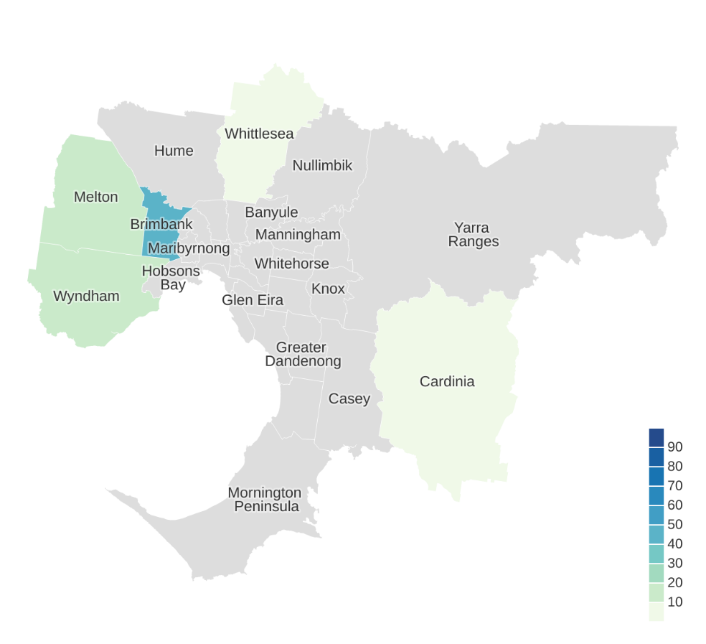

Table 23: English proficiency of Dan (Gio-Dan) language community per LGA

| LGA | Low English proficiency, % |
| --- | --- |
| Banyule | – |
| Bayside | – |
| Boroondara | – |
| Brimbank | 47% |
| Cardinia | 0% |
| Casey | – |
| Darebin | – |
| Frankston | – |
| Glen Eira | – |
| Greater Dandenong | – |
| Hobsons Bay | – |
| Hume | – |
| Kingston | – |
| Knox | – |
| Manningham | – |
| Maribyrnong | – |
| Maroondah | – |
| Melbourne | – |
| Melton | 12% |
| Monash | – |
| Moonee Valley | – |
| Moreland | – |
| Mornington Peninsula | – |
| Nillumbik | – |
| Port Phillip | – |
| Stonnington | – |
| Whitehorse | – |
| Whittlesea | 0% |
| Wyndham | 18% |
| Yarra | – |
| Yarra Ranges | – |

### Cantonese

Figure 27: Level of low English proficiency of Cantonese-speaking community by LGA

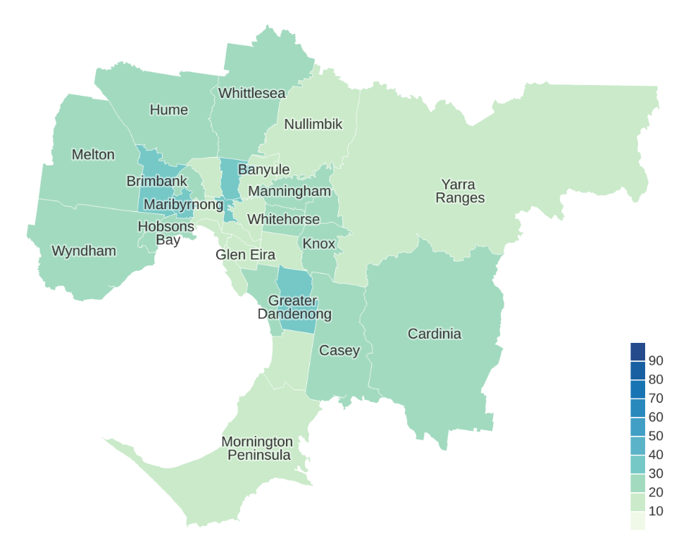

Table 24: English proficiency of Cantonese language community per LGA

| LGA | Low English proficiency, % |
| --- | --- |
| Banyule | 17% |
| Bayside | 16% |
| Boroondara | 15% |
| Brimbank | 32% |
| Cardinia | 21% |
| Casey | 23% |
| Darebin | 32% |
| Frankston | 19% |
| Glen Eira | 16% |
| Greater Dandenong | 36% |
| Hobsons Bay | 25% |
| Hume | 26% |
| Kingston | 24% |
| Knox | 21% |
| Manningham | 20% |
| Maribyrnong | 31% |
| Maroondah | 21% |
| Melbourne | 15% |
| Melton | 23% |
| Monash | 20% |
| Moonee Valley | 30% |
| Moreland | 20% |
| Mornington Peninsula | 15% |
| Nillumbik | 15% |
| Port Phillip | 13% |
| Stonnington | 12% |
| Whitehorse | 24% |
| Whittlesea | 27% |
| Wyndham | 21% |
| Yarra | 31% |
| Yarra Ranges | 14% |

### Kirundi (Rundi)

Figure 28: Level of low English proficiency of Kirundi (Rundi)-speaking community by LGA

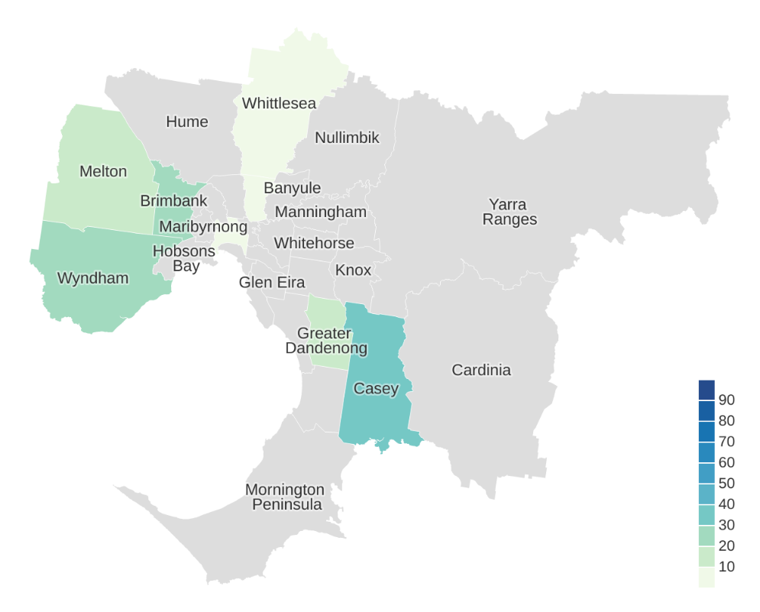

Table 25: English proficiency of Kirundi (Rundi) language community per LGA

| LGA | Low English proficiency, % |
| --- | --- |
| Banyule | – |
| Bayside | – |
| Boroondara | – |
| Brimbank | 23% |
| Cardinia | – |
| Casey | 33% |
| Darebin | 0% |
| Frankston | – |
| Glen Eira | – |
| Greater Dandenong | 19% |
| Hobsons Bay | – |
| Hume | – |
| Kingston | – |
| Knox | – |
| Manningham | – |
| Maribyrnong | – |
| Maroondah | – |
| Melbourne | 0% |
| Melton | 13% |
| Monash | – |
| Moonee Valley | – |
| Moreland | – |
| Mornington Peninsula | – |
| Nillumbik | – |
| Port Phillip | – |
| Stonnington | – |
| Whitehorse | – |
| Whittlesea | 0% |
| Wyndham | 28% |
| Yarra | – |
| Yarra Ranges | – |

### Timorese

Figure 29: Level of low English proficiency of Timorese-speaking community by LGA

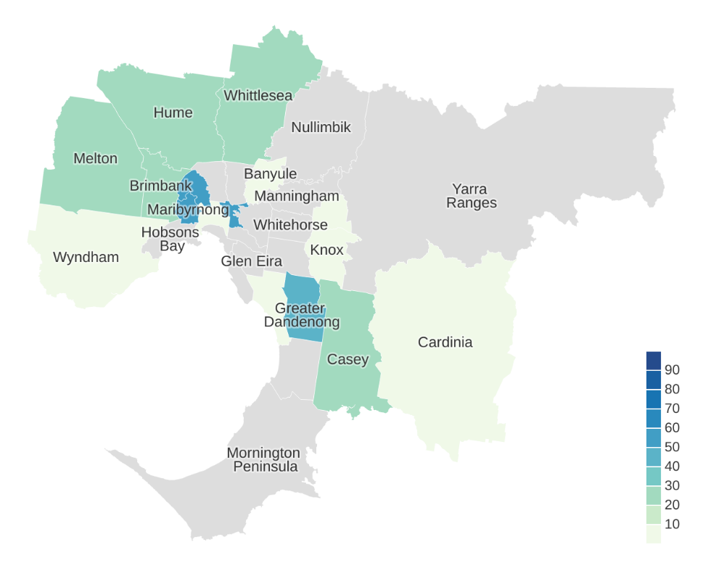

Table 26: English proficiency of Timorese language community per LGA

| LGA | Low English proficiency, % |
| --- | --- |
| Banyule | 0% |
| Bayside | – |
| Boroondara | – |
| Brimbank | 27% |
| Cardinia | 0% |
| Casey | 24% |
| Darebin | – |
| Frankston | – |
| Glen Eira | – |
| Greater Dandenong | 40% |
| Hobsons Bay | – |
| Hume | 22% |
| Kingston | 0% |
| Knox | 0% |
| Manningham | – |
| Maribyrnong | 50% |
| Maroondah | 0% |
| Melbourne | 0% |
| Melton | 27% |
| Monash | – |
| Moonee Valley | 50% |
| Moreland | – |
| Mornington Peninsula | – |
| Nillumbik | – |
| Port Phillip | – |
| Stonnington | – |
| Whitehorse | – |
| Whittlesea | 25% |
| Wyndham | 0% |
| Yarra | 53% |
| Yarra Ranges | – |

### Dari

Figure 30: Level of low English proficiency of Dari-speaking community by LGA

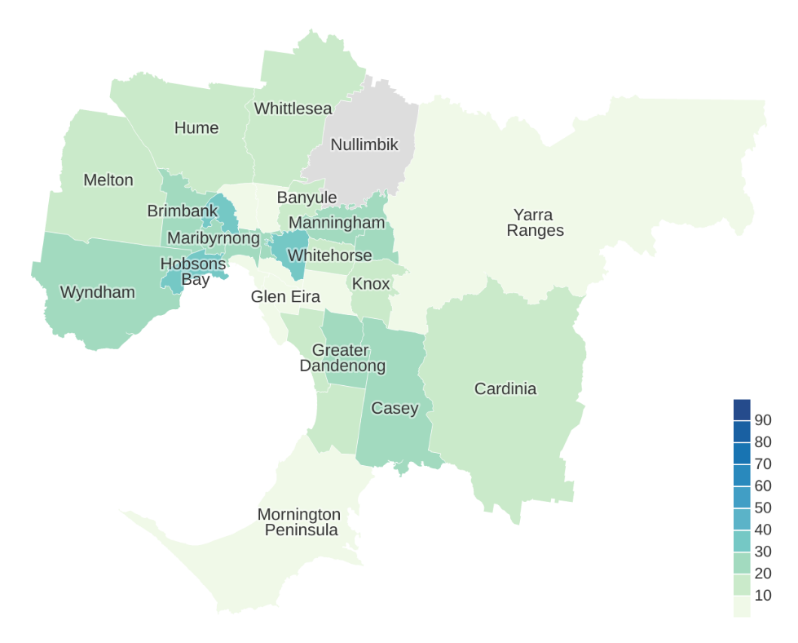

Table 27: English proficiency of Dari language community per LGA

| LGA | Low English proficiency, % |
| --- | --- |
| Banyule | 11% |
| Bayside | 0% |
| Boroondara | 31% |
| Brimbank | 20% |
| Cardinia | 19% |
| Casey | 24% |
| Darebin | 0% |
| Frankston | 14% |
| Glen Eira | 0% |
| Greater Dandenong | 26% |
| Hobsons Bay | 30% |
| Hume | 14% |
| Kingston | 11% |
| Knox | 13% |
| Manningham | 20% |
| Maribyrnong | 22% |
| Maroondah | 23% |
| Melbourne | 27% |
| Melton | 17% |
| Monash | 9% |
| Moonee Valley | 39% |
| Moreland | 0% |
| Mornington Peninsula | 0% |
| Nillumbik | – |
| Port Phillip | 0% |
| Stonnington | 0% |
| Whitehorse | 11% |
| Whittlesea | 20% |
| Wyndham | 21% |
| Yarra | 23% |
| Yarra Ranges | 0% |

### Kurdish

Figure 31: Level of low English proficiency of Kurdish-speaking community by LGA

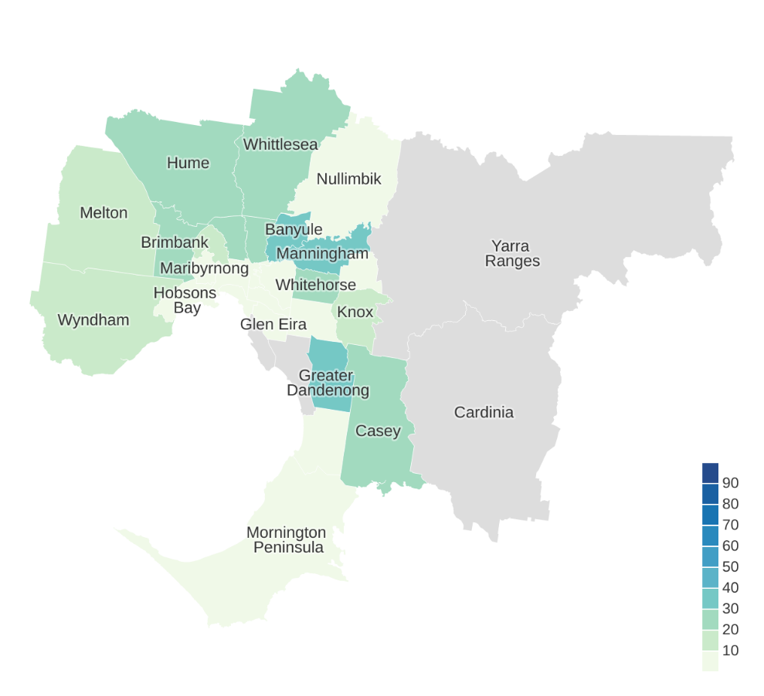

Table 28: English proficiency of Kurdish language community per LGA

| LGA | Low English proficiency, % |
| --- | --- |
| Banyule | 37% |
| Bayside | – |
| Boroondara | 0% |
| Brimbank | 23% |
| Cardinia | – |
| Casey | 24% |
| Darebin | 27% |
| Frankston | 0% |
| Glen Eira | 0% |
| Greater Dandenong | 30% |
| Hobsons Bay | 0% |
| Hume | 25% |
| Kingston | – |
| Knox | 18% |
| Manningham | 30% |
| Maribyrnong | 0% |
| Maroondah | 0% |
| Melbourne | 0% |
| Melton | 18% |
| Monash | 0% |
| Moonee Valley | 16% |
| Moreland | 21% |
| Mornington Peninsula | 0% |
| Nillumbik | 0% |
| Port Phillip | 0% |
| Stonnington | 0% |
| Whitehorse | 28% |
| Whittlesea | 21% |
| Wyndham | 17% |
| Yarra | 0% |
| Yarra Ranges | – |

### Mongolian

Figure 32: Level of low English proficiency of Mongolian-speaking community by LGA

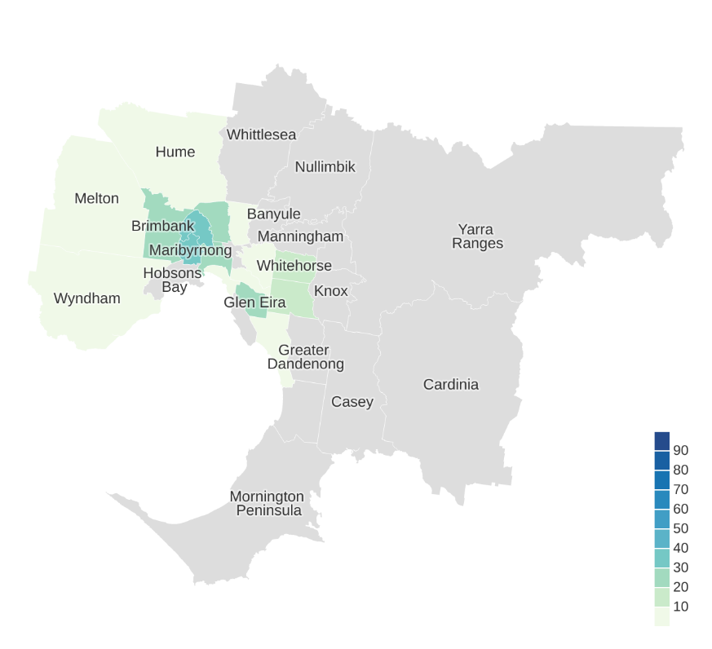

Table 29: English proficiency of Mongolian language community per LGA

| LGA | Low English proficiency, % |
| --- | --- |
| Banyule | – |
| Bayside | – |
| Boroondara | 0% |
| Brimbank | 28% |
| Cardinia | – |
| Casey | – |
| Darebin | 0% |
| Frankston | – |
| Glen Eira | 25% |
| Greater Dandenong | – |
| Hobsons Bay | – |
| Hume | 0% |
| Kingston | 0% |
| Knox | – |
| Manningham | – |
| Maribyrnong | 30% |
| Maroondah | – |
| Melbourne | 22% |
| Melton | 0% |
| Monash | 15% |
| Moonee Valley | 38% |
| Moreland | 22% |
| Mornington Peninsula | – |
| Nillumbik | – |
| Port Phillip | 0% |
| Stonnington | 0% |
| Whitehorse | 18% |
| Whittlesea | – |
| Wyndham | 0% |
| Yarra | – |
| Yarra Ranges | – |

### Uygur

Figure 33: Level of low English proficiency of Uygur-speaking community by LGA

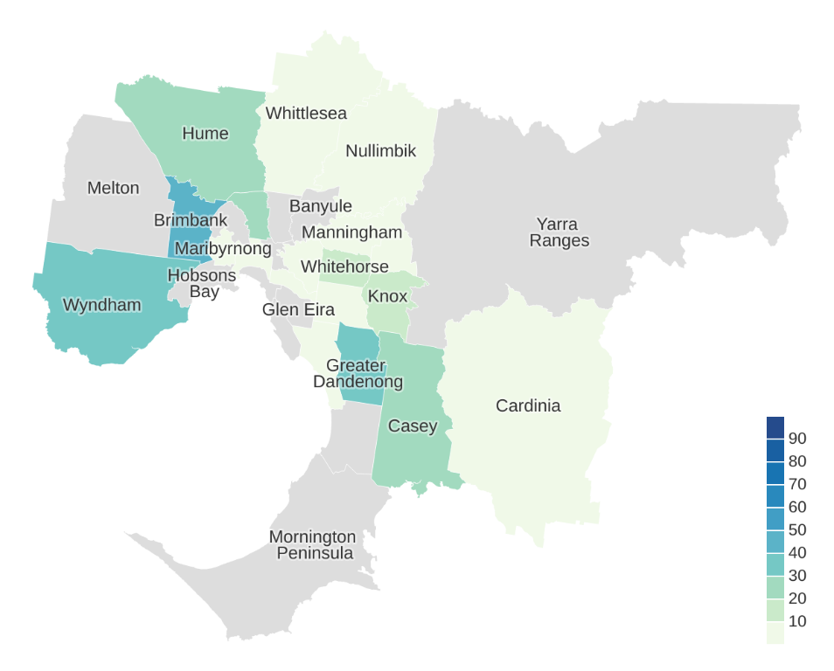

Table 30: English proficiency of Uygur language community per LGA

| LGA | Low English proficiency, % |
| --- | --- |
| Banyule | – |
| Bayside | – |
| Boroondara | 0% |
| Brimbank | 43% |
| Cardinia | 0% |
| Casey | 22% |
| Darebin | – |
| Frankston | – |
| Glen Eira | – |
| Greater Dandenong | 35% |
| Hobsons Bay | – |
| Hume | 23% |
| Kingston | 0% |
| Knox | 17% |
| Manningham | 0% |
| Maribyrnong | 0% |
| Maroondah | 0% |
| Melbourne | 0% |
| Melton | – |
| Monash | 0% |
| Moonee Valley | – |
| Moreland | 29% |
| Mornington Peninsula | – |
| Nillumbik | 0% |
| Port Phillip | – |
| Stonnington | 0% |
| Whitehorse | 18% |
| Whittlesea | 0% |
| Wyndham | 38% |
| Yarra | – |
| Yarra Ranges | – |

### Georgian

Figure 34: Level of low English proficiency of Georgian-speaking community by LGA

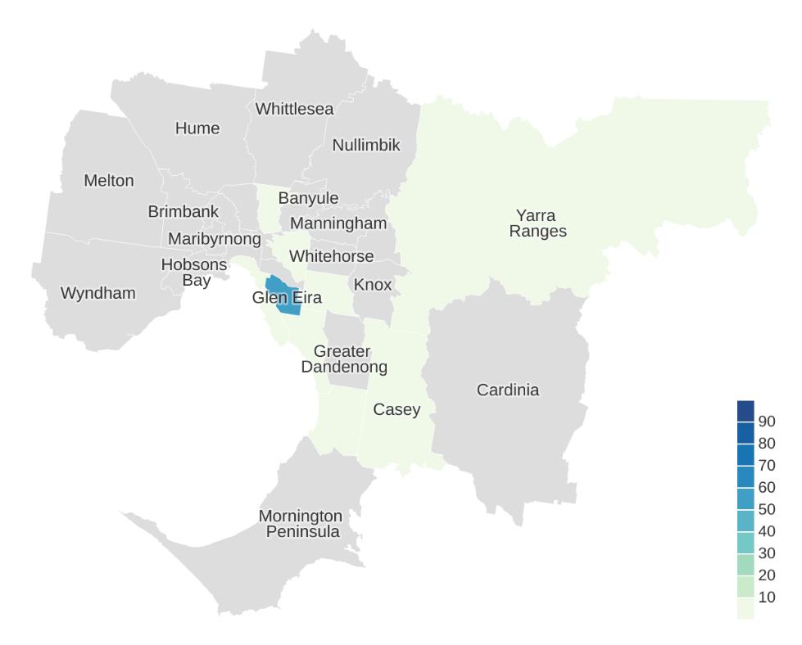

Table 31: English proficiency of Georgian language community per LGA

| LGA | Low English proficiency, % |
| --- | --- |
| Banyule | – |
| Bayside | 0% |
| Boroondara | 0% |
| Brimbank | – |
| Cardinia | – |
| Casey | 0% |
| Darebin | 0% |
| Frankston | 0% |
| Glen Eira | 55% |
| Greater Dandenong | – |
| Hobsons Bay | – |
| Hume | – |
| Kingston | 0% |
| Knox | – |
| Manningham | – |
| Maribyrnong | – |
| Maroondah | – |
| Melbourne | – |
| Melton | – |
| Monash | 0% |
| Moonee Valley | – |
| Moreland | – |
| Mornington Peninsula | – |
| Nillumbik | – |
| Port Phillip | 0% |
| Stonnington | – |
| Whitehorse | – |
| Whittlesea | – |
| Wyndham | – |
| Yarra | – |
| Yarra Ranges | 0% |

### Korean

Figure 35: Level of low English proficiency of Korean-speaking community by LGA

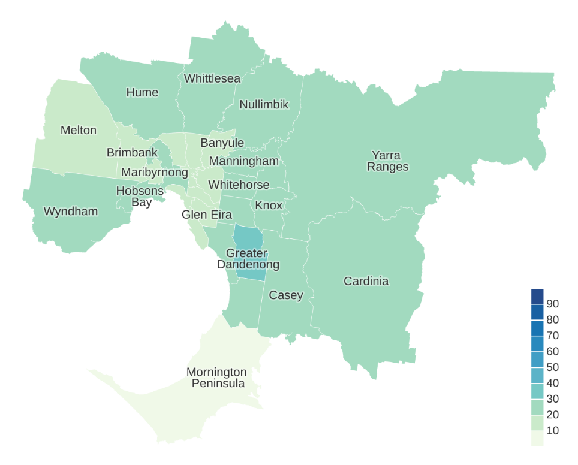

Table 32: English proficiency of Korean language community per LGA

| LGA | Low English proficiency, % |
| --- | --- |
| Banyule | 18% |
| Bayside | 11% |
| Boroondara | 16% |
| Brimbank | 15% |
| Cardinia | 25% |
| Casey | 23% |
| Darebin | 13% |
| Frankston | 25% |
| Glen Eira | 19% |
| Greater Dandenong | 30% |
| Hobsons Bay | 25% |
| Hume | 26% |
| Kingston | 21% |
| Knox | 21% |
| Manningham | 21% |
| Maribyrnong | 20% |
| Maroondah | 24% |
| Melbourne | 20% |
| Melton | 16% |
| Monash | 23% |
| Moonee Valley | 20% |
| Moreland | 14% |
| Mornington Peninsula | 0% |
| Nillumbik | 26% |
| Port Phillip | 15% |
| Stonnington | 11% |
| Whitehorse | 22% |
| Whittlesea | 21% |
| Wyndham | 24% |
| Yarra | 14% |
| Yarra Ranges | 23% |

# Important languages with higher English proficiency

Arabic, Greek, Italian and Punjabi are four of the most commonly spoken languages in Victoria. However, their speakers overall have a higher level of English proficiency, so they did not make the top 30 list above. We have included these languages below for your information. Please note, while they have higher proficiency overall, they still have significant levels of low English proficiency in some areas.

## Greek

Figure 36: Level of low English proficiency of Greek-speaking community by LGA

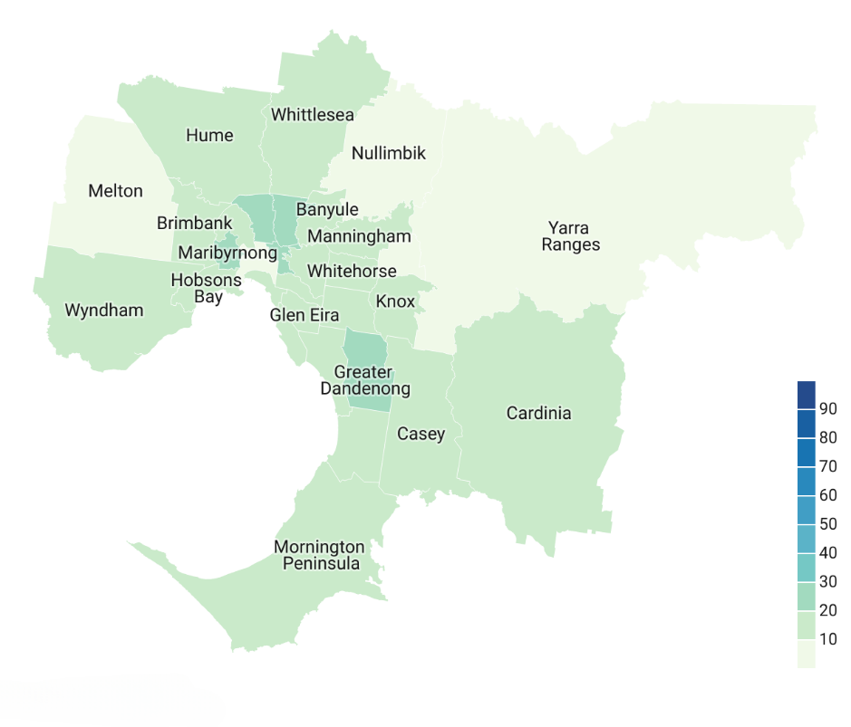

Table 33: English proficiency of Greek language community per LGA

|  |  |  |
| --- | --- | --- |
| LGA | Total number of speakers | Low English proficiency |
| **Banyule** | 2,466 | 11.60% |
| **Bayside** | 2,019 | 10.80% |
| **Boroondara** | 4,553 | 11.33% |
| **Brimbank** | 4,615 | 18.83% |
| **Cardinia** | 318 | 11.01% |
| **Casey** | 2677 | 11.28% |
| **Darebin** | 8,515 | 22.52% |
| **Frankston** | 1,244 | 12.30% |
| **Glen Eira** | 5,360 | 15.69% |
| **Greater Dandenong** | 3,516 | 22.07% |
| **Hobsons Bay** | 2,261 | 18.05% |
| **Hume** | 2,771 | 13.93% |
| **Kingston** | 6,622 | 19.24% |
| **Knox** | 1,707 | 10.90% |
| **Manningham** | 6,869 | 13.60% |
| **Maribyrnong** | 1,632 | 22.92% |
| **Maroondah** | 614 | 9.28% |
| **Melbourne** | 707 | 5.52% |
| **Melton** | 1,636 | 8.74% |
| **Monash** | 10,253 | 18.67% |
| **Moonee Valley** | 3,484 | 15.21% |
| **Mornington Peninsula** | 1,339 | 14.19% |
| **Moreland** | 6,789 | 22.82% |
| **Nillumbik** | 539 | 6.31% |
| **Port Phillip** | 2,581 | 17.86% |
| **Stonnington** | 3,418 | 19.75% |
| **Whitehorse** | 3,823 | 15.54% |
| **Whittlesea** | 7,205 | 17.21% |
| **Wyndham** | 1,447 | 10.85% |
| **Yarra** | 1,979 | 23.70% |
| **Yarra Ranges** | 402 | 9.20% |

## Arabic

Figure 37: Level of low English proficiency of Arabic-speaking community by LGA

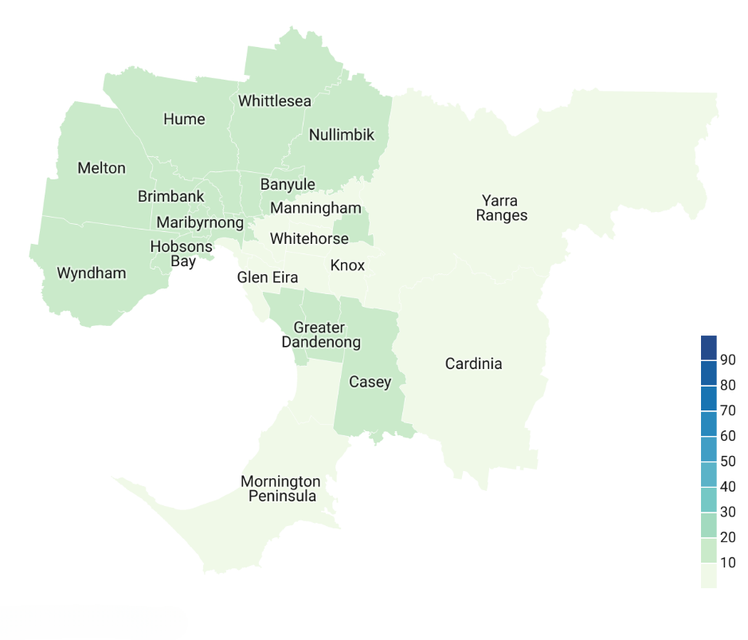

Table 34: English proficiency of Arabic language community per LGA

|  |  |  |
| --- | --- | --- |
| LGA | Total number of speakers | Low English proficiency |
| **Banyule** | 1,209 | 12.99% |
| **Bayside** | 346 | 4.91% |
| **Boroondara** | 697 | 6.74% |
| **Brimbank** | 4,282 | 15.81% |
| **Cardinia** | 769 | 8.32% |
| **Casey** | 5,184 | 10.67% |
| **Darebin** | 3,635 | 14.83% |
| **Frankston** | 547 | 9.87% |
| **Glen Eira** | 502 | 7.17% |
| **Greater Dandenong** | 2,517 | 15.22% |
| **Hobsons Bay** | 2,779 | 13.64% |
| **Hume** | 22,664 | 19.79% |
| **Kingston** | 1,065 | 13.05% |
| **Knox** | 1,166 | 8.49% |
| **Manningham** | 2,313 | 7.26% |
| **Maribyrnong** | 738 | 13.01% |
| **Maroondah** | 446 | 11.21% |
| **Melbourne** | 1,739 | 12.13% |
| **Melton** | 3,679 | 10.22% |
| **Monash** | 1,408 | 6.04% |
| **Moonee Valley** | 1,858 | 11.19% |
| **Mornington Peninsula** | 191 | 8.90% |
| **Moreland** | 7,769 | 14.64% |
| **Nillumbik** | 234 | 14.10% |
| **Port Phillip** | 394 | 7.36% |
| **Stonnington** | 343 | 4.08% |
| **Whitehorse** | 580 | 8.62% |
| **Whittlesea** | 11,912 | 15.83% |
| **Wyndham** | 5,577 | 11.82% |
| **Yarra** | 573 | 13.96% |
| **Yarra Ranges** | 201 | 9.45% |

## Italian

Figure 38: Level of low English proficiency of Italian-speaking community by LGA

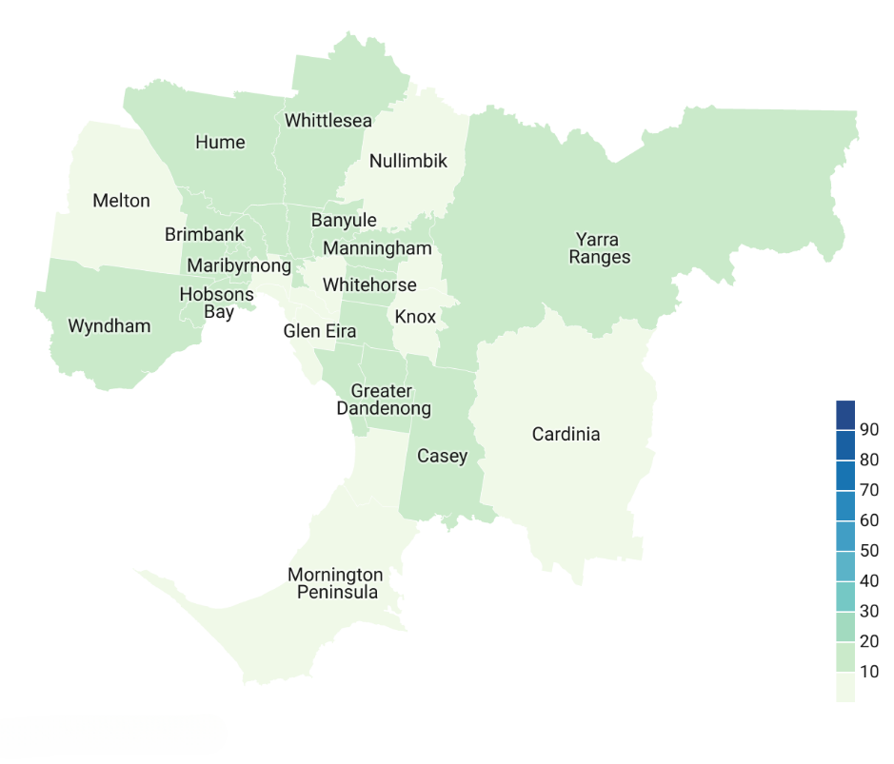

Table 35: English proficiency of Italian language community per LGA

|  |  |  |
| --- | --- | --- |
| LGA | Total number of speakers | Low English proficiency |
| **Banyule** | 2,994 | 10.96% |
| **Bayside** | 1,022 | 7.73% |
| **Boroondara** | 2,312 | 7.48% |
| **Brimbank** | 3,866 | 14.20% |
| **Cardinia** | 488 | 9.63% |
| **Casey** | 2,237 | 10.91% |
| **Darebin** | 7,811 | 18.73% |
| **Frankston** | 711 | 7.17% |
| **Glen Eira** | 1,534 | 9.00% |
| **Greater Dandenong** | 1,867 | 19.60% |
| **Hobsons Bay** | 1,826 | 15.12% |
| **Hume** | 4,877 | 10.13% |
| **Kingston** | 1,997 | 11.12% |
| **Knox** | 1,391 | 8.84% |
| **Manningham** | 3,885 | 10.53% |
| **Maribyrnong** | 1,217 | 17.34% |
| **Maroondah** | 689 | 8.42% |
| **Melbourne** | 1,484 | 6.94% |
| **Melton** | 1,726 | 7.47% |
| **Monash** | 3,089 | 15.90% |
| **Moonee Valley** | 6,715 | 14.94% |
| **Mornington Peninsula** | 1,498 | 8.08% |
| **Moreland** | 9,978 | 19.86% |
| **Nillumbik** | 792 | 5.30% |
| **Port Phillip** | 1,238 | 5.25% |
| **Stonnington** | 931 | 4.94% |
| **Whitehorse** | 1,752 | 11.82% |
| **Whittlesea** | 8,329 | 15.10% |
| **Wyndham** | 2,450 | 12.16% |
| **Yarra** | 1,249 | 12.73% |
| **Yarra Ranges** | 1,152 | 11.55% |

## Punjabi

Figure 39: Level of low English proficiency of Punjabi-speaking community by LGA

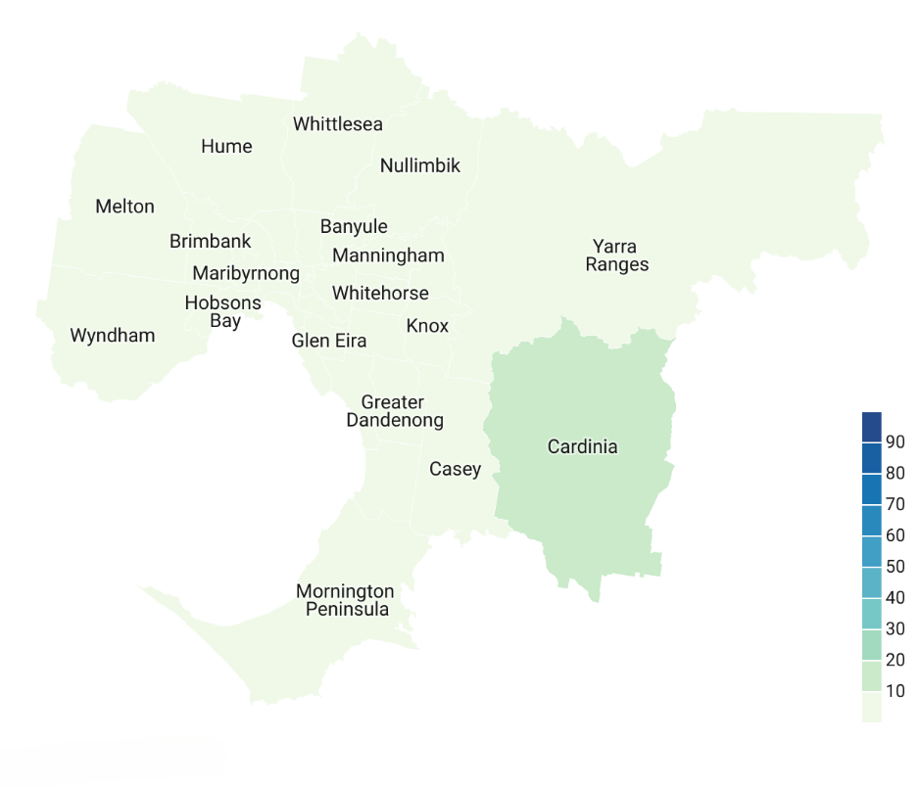

Table 36: English proficiency of Punjabi language community per LGA

|  |  |  |
| --- | --- | --- |
| LGA | Total number of speakers | Low English proficiency |
| **Banyule** | 339 | 5.31% |
| **Bayside** | 93 | 3.23% |
| **Boroondara** | 359 | 4.46% |
| **Brimbank** | 4,368 | 8.08% |
| **Cardinia** | 3,482 | 10.22% |
| **Casey** | 16,859 | 9.34% |
| **Darebin** | 766 | 6.14% |
| **Frankston** | 358 | 7.54% |
| **Glen Eira** | 415 | 4.34% |
| **Greater Dandenong** | 5,408 | 7.56% |
| **Hobsons Bay** | 748 | 9.09% |
| **Hume** | 12,653 | 9.81% |
| **Kingston** | 953 | 5.88% |
| **Knox** | 1,059 | 5.29% |
| **Manningham** | 611 | 6.87% |
| **Maribyrnong** | 259 | 3.86% |
| **Maroondah** | 601 | 7.65% |
| **Melbourne** | 515 | 3.69% |
| **Melton** | 10,640 | 9.82% |
| **Monash** | 1,841 | 5.38% |
| **Moonee Valley** | 339 | 5.01% |
| **Mornington Peninsula** | 118 | 0.00% |
| **Moreland** | 571 | 4.38% |
| **Nillumbik** | 71 | 0.00% |
| **Port Phillip** | 171 | 5.85% |
| **Stonnington** | 178 | 1.69% |
| **Whitehorse** | 1,109 | 6.04% |
| **Whittlesea** | 9,903 | 8.74% |
| **Wyndham** | 20,860 | 8.43% |
| **Yarra** | 52 | 0.00% |
| **Yarra Ranges** | 268 | 6.34% |

# Languages spoken in LGAs of metropolitan Melbourne and level of low English proficiency

An overview of the top 30 languages spoken per LGA derived from 2021 Census data and the levels of low English proficiency are shown in the tables below, with the comparison of number of speakers from Census 2016.

## Banyule

Table 37: Top 30 languages spoken in Banyule and change since Census 2016

| Language | Number of speakers, Census 2021 | Change since Census 2016 | Level of low English proficiency, 2021 |
| --- | --- | --- | --- |
| English | 94,634 | 5.3% | 0.0% |
| Mandarin | 5,013 | 19.8% | 25.3% |
| Italian | 2,994 | –17.1% | 11.0% |
| Greek | 2,466 | –3.2% | 11.6% |
| Cantonese | 1,482 | 13.7% | 17.1% |
| Arabic | 1,209 | 0.2% | 13.0% |
| Vietnamese | 928 | 8.3% | 15.6% |
| Somali | 860 | –14.6% | 10.7% |
| Macedonian | 828 | –2.9% | 11.6% |
| Hindi | 792 | 19.1% | 2.3% |
| Persian (excluding Dari) | 785 | 30.8% | 8.7% |
| Spanish | 716 | 25.6% | 6.6% |
| Tamil | 552 | 28.7% | 4.9% |
| Croatian | 519 | 0.2% | 9.1% |
| Sinhalese | 500 | 14.4% | 5.2% |
| Malayalam | 483 | 18.4% | 4.8% |
| German | 391 | –24.5% | 4.6% |
| Japanese | 365 | –1.6% | 10.1% |
| French | 356 | –3.8% | 3.9% |
| Punjabi | 339 | 17.3% | 5.3% |
| Thai | 299 | 35.3% | 11.7% |
| Russian | 296 | 0.3% | 9.5% |
| Korean | 283 | 25.8% | 18.0% |
| Serbian | 280 | –4.8% | 15.4% |
| Filipino | 250 | 40.4% | 1.2% |
| Polish | 244 | –12.5% | 5.7% |
| Tagalog | 242 | 5.2% | 2.1% |
| Telugu | 229 | – | 4.4% |
| Indonesian | 220 | 26.4% | 10.5% |
| Urdu | 194 | 14.1% | 3.1% |

Mandarin occupies the second spot in the most commonly spoken languages in Banyule. In that LGA, more than a quarter of community members reported not speaking English well or not at all. The Mandarin-speaking community also grew by almost 20 per cent over the past five years.

Other fast-growing language communities are Cantonese, Hindi, Persian (excluding Dari), Spanish, Tamil, Sinhalese, Malayalam, Punjabi, Thai, Korean, Filipino, Indonesian and Urdu, which all grew by 10 or more per cent.

Similar to trends identified in regional Victoria, communities that reported speaking a European language at home seem to be decreasing. However, the Italian and Greek communities are still large despite decreasing in size.

Language communities where more than 10 per cent of speakers reported low English proficiency are Mandarin, Italian, Greek, Cantonese, Arabic, Vietnamese, Somali, Macedonian, Japanese, Thai, Korean, Serbian and Indonesian.

## Bayside

Table 38: Top 30 languages spoken in Bayside and change since Census 2016

| Language | Number of speakers, Census 2021 | Change since Census 2016 | Level of low English proficiency, 2021 |
| --- | --- | --- | --- |
| English | 82,132 | 5.5% | 0.0% |
| Mandarin | 2,856 | 43.3% | 24.0% |
| Greek | 2,019 | –3.4% | 10.8% |
| Russian | 1,305 | 3.5% | 13.6% |
| Italian | 1,022 | –18.4% | 7.7% |
| Spanish | 694 | 38.5% | 5.3% |
| German | 661 | –11.9% | 2.6% |
| French | 537 | –11.5% | 2.0% |
| Cantonese | 479 | 14.0% | 16.3% |
| Polish | 427 | –3.6% | 9.6% |
| Japanese | 347 | –11.7% | 15.6% |
| Arabic | 346 | 17.3% | 4.9% |
| Hindi | 321 | 18% | 0.9% |
| Vietnamese | 259 | –4.8% | 12.4% |
| Hebrew | 249 | –13.2% | 2.0% |
| Turkish | 238 | –17.1% | 6.7% |
| Dutch | 235 | 2.2% | 2.1% |
| Portuguese | 235 | 42.4% | 4.7% |
| Serbian | 219 | 12.3% | 4.6% |
| Persian (excluding Dari) | 191 | 119.5% | 7.3% |
| Afrikaans | 181 | –5.7% | 0.0% |
| Croatian | 171 | 1.8% | 4.1% |
| Indonesian | 130 | 64.6% | 3.1% |
| Swedish | 128 | 8.5% | 0.0% |
| Thai | 127 | 7.6% | 5.5% |
| Hungarian | 102 | –31.1% | 5.9% |
| Sinhalese | 96 | 26.3% | 0.0% |
| Korean | 95 | 4.4% | 10.5% |
| Punjabi | 93 | –11.4% | 3.2% |
| Tagalog | 92 | – | 6.5% |

Similar to Banyule, the Mandarin-speaking community occupies the second spot in the list of the 30 commonly spoken languages in Bayside. Again, the community reports almost a quarter of speakers who speak English ‘not well’ or ‘not at all’. The Mandarin-speaking population also grew by 43.3 per cent over the past five years.

Other fast-growing language communities are Spanish, Cantonese, Arabic, Hindi, Portuguese, Serbian, Persian (excluding Dari), Indonesian and Sinhalese. Language communities that have decreased in number of speakers in the past five years are Greek, Italian, German, French, Japanese, Vietnamese, Hebrew, Turkish, Afrikaans, Hungarian and Punjabi.

Language communities where more than 10 per cent of speakers reported low English proficiency are Mandarin, Greek, Russian, Cantonese, Japanese, Vietnamese and Korean.

## Boroondara

Table 39: Top 30 languages spoken in Boroondara and change since Census 2016

| Language | Number of speakers, Census 2021 | Change since Census 2016 | Level of low English proficiency, 2021 |
| --- | --- | --- | --- |
| English | 114,556 | 0.6% | 0.0% |
| Mandarin | 17,419 | 27.1% | 22.8% |
| Cantonese | 5,107 | 3.3% | 15.3% |
| Greek | 4,553 | –4.3% | 11.3% |
| Italian | 2,312 | –16.7% | 7.5% |
| Vietnamese | 2,092 | 1.9% | 13.1% |
| Hindi | 1,364 | –2.4% | 1.5% |
| Spanish | 1,050 | 8.4% | 7.0% |
| Persian (excluding Dari) | 867 | 32.8% | 7.6% |
| French | 841 | –18.4% | 2.5% |
| Sinhalese | 700 | 8.7% | 0.9% |
| Arabic | 697 | –23% | 6.7% |
| Tamil | 689 | –3.5% | 15.7% |
| Korean | 689 | 15.6% | 2.6% |
| Indonesian | 622 | –11.1% | 5.3% |
| Gujarati | 604 | –30.4% | 3.6% |
| German | 538 | –20.4% | 3.0% |
| Japanese | 506 | –7.5% | 6.3% |
| Min Nan | 479 | 31.6% | 9.2% |
| Thai | 369 | –6.6% | 9.8% |
| Punjabi | 359 | 21.3% | 4.5% |
| Urdu | 337 | 41.6% | 2.4% |
| Russian | 306 | –5.0% | 6.5% |
| Telugu | 286 | – | 3.8% |
| Polish | 245 | 0.8% | 4.5% |
| Malayalam | 245 | –23.9% | 2.0% |
| Bengali | 227 | 1.3% | 3.1% |
| Marathi | 221 | – | 1.4% |
| Macedonian | 217 | –9.6% | 7.8% |
| Turkish | 217 | –2.3% | 7.8% |

Mandarin is the second most commonly spoken language in Boroondara and has grown by 27 per cent over the past five years. Now, 22.8 per cent of its speakers report low English proficiency.

Other fast-growing language communities are Persian (excluding Dari), Korean, Punjabi, Min Nan and Urdu. Language communities that had fewer speakers in 2021 are Greek, Italian, Hindi, French, Arabic, Tamil, Indonesian, Gujarati, German, Japanese, Thai, Russian, Malayalam, Turkish and Macedonian.

There are only a few language communities in Boroondara that reported low English proficiency for more than 10 per cent of speakers. Those languages are Mandarin, Cantonese, Greek, Vietnamese and Tamil.

## Brimbank

Table 40: Top 30 languages spoken in Brimbank and change since Census 2016

| Language | Number of speakers, Census 2021 | Change since Census 2016 | Level of low English proficiency, 2021 |
| --- | --- | --- | --- |
| English | 70,661 | 2.0% | 0.0% |
| Vietnamese | 36,023 | 14.5% | 35.8% |
| Greek | 4,615 | –12.7% | 18.8% |
| Punjabi | 4,368 | –22.5% | 8.1% |
| Arabic | 4,282 | –0.1% | 15.8% |
| Macedonian | 4,233 | –8.6% | 24.7% |
| Maltese | 4,058 | –19.7% | 11.1% |
| Cantonese | 4,026 | –3.5% | 32.1% |
| Italian | 3,866 | –21.2% | 14.2% |
| Tagalog | 2,936 | –5.5% | 3.6% |
| Croatian | 2,863 | –16.8% | 18.5% |
| Mandarin | 2,718 | –5.9% | 33.4% |
| Spanish | 2,550 | –9.9% | 17.1% |
| Turkish | 2,192 | –6.0% | 21.0% |
| Filipino | 2,013 | –9.0% | 3.1% |
| Hindi | 1,744 | –27.4% | 6.0% |
| Urdu | 1,726 | 19.4% | 8.6% |
| Serbian | 1,471 | –8.2% | 23.1% |
| Samoan | 1,388 | –11.1% | 10.7% |
| Telugu | 1,172 | – | 3.1% |
| Nepali | 1,106 | 72.8% | 4.2% |
| Polish | 1,058 | –21.6% | 16.6% |
| Bosnian | 1,007 | – | 23.7% |
| Assyrian Neo-Aramaic | 1,007 | –5.4% | 37.3% |
| Tamil | 994 | –24.4% | 16.1% |
| Hakka | 958 | –3.7% | 33.3% |
| Sinhalese | 928 | –6.9% | 5.0% |
| Albanian | 896 | –0.2% | 15.6% |
| Amharic | 862 | 12.5% | 11.3% |
| Burmese and related languages, nec | 860 | – | 44.8% |

More than two-thirds of the 30 most common language communities in Brimbank are decreasing in numbers. The only languages that have grown (other than English) are Vietnamese, Urdu, Telugu, Nepali, Bosnian, Amharic and Burmese and related languages, which have all grown by more than 10 per cent.

The Vietnamese-speaking community is the second largest community after the English-speaking community in Brimbank. More than a third of its speakers reported speaking English ‘not well’ or ‘not at all’.

Brimbank has a high number of languages with high levels of low English proficiency. For 21 out of 30 languages, more than 10 per cent of its speakers reported speaking English ‘not well’ or ‘not at all’. These are Vietnamese, Greek, Arabic, Macedonian, Maltese, Cantonese, Italian, Croatian, Mandarin, Spanish, Turkish, Serbian, Samoan, Polish, Bosnian, Assyrian Neo-Aramaic, Tamil, Hakka, Albanian, Amharic and Burmese and related languages.

## Cardinia

Table 41: Top 30 languages spoken in Cardinia and change since Census 2016

| Language | Number of speakers, Census 2021 | Change since Census 2016 | Level of low English proficiency, 2021 |
| --- | --- | --- | --- |
| English | 91,108 | 16.3% | 0.0% |
| Punjabi | 3,482 | 330.4% | 10.2% |
| Sinhalese | 2,069 | 175.5% | 7.2% |
| Hindi | 957 | 133.4% | 4.4% |
| Mandarin | 950 | 132.3% | 31.6% |
| Urdu | 771 | 435.4% | 7.0% |
| Arabic | 769 | 56.3% | 8.3% |
| Spanish | 694 | 52.5% | 8.1% |
| Tamil | 650 | 223.4% | 11.1% |
| Gujarati | 554 | 149.5% | 7.8% |
| Tagalog | 490 | 105.9% | 3.3% |
| Italian | 488 | –10.8% | 9.6% |
| Filipino | 379 | 76.3% | 1.8% |
| Malayalam | 370 | 198.4% | 5.4% |
| Greek | 318 | 18.2% | 11.0% |
| French | 312 | 4.3% | 2.6% |
| Romanian | 307 | 29.0% | 11.7% |
| Dari | 291 | – | 18.9% |
| Bengali | 290 | 133.9% | 3.8% |
| Chin Haka | 284 | – | 31.3% |
| Hazaragi | 240 | – | 22.1% |
| Dinka | 235 | 25.0% | 11.1% |
| Vietnamese | 234 | – | 23.1% |
| German | 228 | –19.4% | 4.4% |
| Cantonese | 214 | 67.2% | 20.6% |
| Croatian | 210 | 5.5% | 10.5% |
| Thai | 196 | – | 14.8% |
| Samoan | 195 | 51.2% | 5.6% |
| Telugu | 194 | – | 4.1% |
| Nuer | 192 | 16.3% | 11.5% |

Cardinia has experienced a massive growth in size of language communities other than English. Ten language communities have more than doubled in the past five years, and the Urdu and Punjabi communities have more than tripled in size. Further, only two communities decreased in size, which were the Italian and German–speaking communities.

Language communities where more than a 10th of speakers reported speaking English ‘not well’ or ‘not at all’ are Punjabi, Mandarin, Tamil, Greek, Romanian, Dari, Chin Haka, Hazaragi, Vietnamese, Cantonese, Croatian, Thai and Nuer.

## Casey

Table 42: Top 30 languages spoken in Casey and change since Census 2016

| Language | Number of speakers, Census 2021 | Change since Census 2016 | Level of low English proficiency, 2021 |
| --- | --- | --- | --- |
| English | 193,800 | 9.3% | 0.0% |
| Punjabi | 16,859 | 151.8% | 9.3% |
| Sinhalese | 12,866 | 43.4% | 5.4% |
| Hazaragi | 11,770 | 198.7% | 28.6% |
| Mandarin | 7,940 | 36.2% | 30.8% |
| Dari | 7,240 | 10.8% | 24.2% |
| Hindi | 6,482 | 37.4% | 4.4% |
| Tamil | 6,043 | 48.1% | 8.5% |
| Malayalam | 5,444 | 76.0% | 6.3% |
| Arabic | 5,184 | 17.4% | 10.7% |
| Spanish | 3,297 | 0.2% | 13.2% |
| Urdu | 3,122 | 67.5% | 10.1% |
| Samoan | 3,062 | 17.1% | 9.8% |
| Tagalog | 3,045 | 43.8% | 2.7% |
| Gujarati | 3,013 | 148.2% | 8.2% |
| Vietnamese | 2,957 | 32.2% | 27.3% |
| Khmer | 2,943 | 24.0% | 31.3% |
| Serbian | 2,882 | 9.5% | 19.3% |
| Greek | 2,677 | 8.5% | 11.3% |
| Filipino | 2,617 | 47.8% | 3.6% |
| Pashto | 2,529 | 53.7% | 20.6% |
| Persian (excluding Dari) | 2,297 | 90.9% | 20.5% |
| Italian | 2,237 | –14.5% | 10.9% |
| Cantonese | 2,121 | 22.5% | 23.3% |
| Telugu | 1,820 | – | 4.6% |
| French | 1,797 | –14.0% | 2.9% |
| Turkish | 1,717 | 8.9% | 17.4% |
| Romanian | 1,517 | –9.6% | 12.8% |
| Polish | 1,379 | –6.1% | 16.0% |
| Croatian | 1,245 | –5.0% | 13.7% |

The Punjabi, Hazaragi and Gujarati communities have more than doubled in size over the past five years, with Punjabi becoming the second largest language community.

Most language communities in Casey have grown, and only five have decreased in size (Italian, French, Romanian, Polish and Croatian).

Language communities with the highest levels of low English proficiency are Hazaragi, Mandarin, Dari, Vietnamese, Khmer, Serbian, Pashto, Persian (excluding Dari), Cantonese, Turkish, Romanian and Polish.

## Darebin

Table 43: Top 30 languages spoken in Darebin and change since Census 2016

| Language | Number of speakers, Census 2021 | Change since Census 2016 | Level of low English proficiency, 2021 |
| --- | --- | --- | --- |
| English | 94,119 | 13.9% | 0.0% |
| Greek | 8,515 | –8.5% | 22.5% |
| Italian | 7,811 | –19.5% | 18.7% |
| Mandarin | 4,597 | –14.0% | 37.9% |
| Arabic | 3,635 | –18.3% | 14.8% |
| Vietnamese | 3,072 | –9.7% | 26.5% |
| Macedonian | 1,969 | –9.3% | 18.5% |
| Cantonese | 1,639 | –7.5% | 32.2% |
| Spanish | 1,479 | 25.2% | 8.2% |
| Hindi | 1,072 | –32.6% | 5.6% |
| Nepali | 1,071 | 16.5% | 3.4% |
| Punjabi | 766 | –41.3% | 6.1% |
| Urdu | 676 | –8.2% | 7.4% |
| Somali | 630 | 10.1% | 12.4% |
| French | 537 | –9.45 | 4.3% |
| German | 520 | 13.5% | 2.3% |
| Telugu | 520 | 27.1% | 4.2% |
| Sinhalese | 512 | 2.8% | 3.7% |
| Japanese | 467 | 14.5% | 8.6% |
| Tamil | 463 | –10.3% | 7.1% |
| Croatian | 439 | –14.4% | 13.7% |
| Turkish | 421 | 12.9% | 15.9% |
| Tagalog | 419 | 0.2% | 4.8% |
| Persian (excluding Dari) | 365 | –27.3% | 15.9% |
| Portuguese | 351 |  | 9.1% |
| Serbian | 348 | 4.8% | 19.3% |
| Thai | 314 | –12.5% | 15.0% |
| Bengali | 311 | –26.3% | 8.4% |
| Filipino | 300 | – | 2.0% |
| Indonesian | 281 | –6.0% | 8.5% |

More than half of the 30 largest language communities in Darebin have decreased in size over the past five years (19 communities in total). Despite reporting fewer speakers in total, the Greek-speaking community is still the second largest in Darebin. More than a fifth (22.5 per cent) of its speakers reported speaking English ‘not well’ or ‘not at all’.

Other fast-growing language communities are Spanish, Nepali, Somali, German, Japanese, Turkish and Telugu.

Language communities with the highest levels of low English proficiency are Greek, Italian, Mandarin, Arabic, Vietnamese, Macedonian, Cantonese, Somali, Croatian, Turkish, Persian (excluding Dari), Serbian and Thai.

## Frankston

Table 44: Top 30 languages spoken in Frankston and change since Census 2016

| Language | Number of speakers, Census 2021 | Change since Census 2016 | Level of low English proficiency, 2021 |
| --- | --- | --- | --- |
| English | 116,411 | 5.2% | 0.0% |
| Mandarin | 1,374 | 26.1% | 30.7% |
| Greek | 1,244 | 8.0% | 12.3% |
| Italian | 711 | –15.7% | 7.2% |
| Russian | 702 | 31.7% | 17.1% |
| Spanish | 665 | 5.1% | 10.5% |
| Malayalam | 567 | –17.2% | 7.2% |
| Arabic | 547 | 6.2% | 9.9% |
| Tagalog | 487 | 7.7% | 3.3% |
| German | 441 | –23.7% | 2.3% |
| Hindi | 434 | –15.4% | 6.0% |
| Filipino | 425 | 25.0% | 3.1% |
| Cantonese | 397 | 5.6% | 18.6% |
| French | 364 | 7.1% | 3.8% |
| Punjabi | 358 | 37.2% | 7.5% |
| Thai | 356 | 30.4% | 16.0% |
| Polish | 350 | 7.4% | 11.4% |
| Tamil | 333 | –4.9% | 6.0% |
| Vietnamese | 324 | 47.9% | 19.1% |
| Serbian | 292 | –4.3% | 12.0% |
| Croatian | 268 | –7.3% | 9.7% |
| Afrikaans | 262 | 6.5% | 1.9% |
| Sinhalese | 257 | –6.9% | 7.4% |
| Dutch | 236 | –38.7% | 3.8% |
| Bosnian | 208 | –6.7% | 18.8% |
| Samoan | 188 | –8.7% | 4.3% |
| Turkish | 181 | 15.3% | 13.3% |
| Indonesian | 157 | – | 4.5% |
| Portuguese | 156 | – | 15.4% |
| Dari | 152 | –31.2% | 13.8% |

The Mandarin-speaking community occupies the second spot in the languages spoken in Frankston, with 30.7 per cent of community members reporting low English proficiency. The Mandarin-speaking population is one of the seven language groups in this list that has grown in the past five years by more than 10 per cent. The other six are Russian, Filipino, Punjabi, Thai, Vietnamese and Turkish.

Some language communities that reported to have 10 per cent fewer speakers in 2021 are Italian, Malayalam, German, Hindi, Dutch and Dari.

Language communities with the highest levels of low English proficiency are Mandarin, Greek, Russian, Spanish, Cantonese, Thai, Polish, Vietnamese, Serbian, Bosnian, Turkish, Dari and Portuguese.

## Glen Eira

Table 45: Top 30 languages spoken in Glen Eira and change since Census 2016

| Language | Number of speakers, Census 2021 | Change since Census 2016 | Level of low English proficiency, 2021 |
| --- | --- | --- | --- |
| English | 97,714 | 8.6% | 0.0% |
| Mandarin | 8,387 | 7.6% | 21.2% |
| Greek | 5,360 | –2.0% | 15.7% |
| Russian | 4,613 | –2.6% | 16.3% |
| Hebrew | 3,186 | 2.8% | 3.3% |
| Hindi | 1,841 | 1.8% | 3.4% |
| Cantonese | 1,830 | 5.7% | 16.3% |
| Italian | 1,534 | –13.2% | 9.0% |
| Spanish | 1,246 | 34.8% | 5.7% |
| French | 1,222 | 9.3% | 4.0% |
| Vietnamese | 1,143 | 55.1% | 12.0% |
| Gujarati | 1,045 | –0.4% | 4.6% |
| Japanese | 1,024 | 14.8% | 15.7% |
| Telugu | 950 | –12.2% | 3.8% |
| Yiddish | 877 | –0.9% | 8.9% |
| Tamil | 816 | 31.8% | 3.1% |
| Korean | 709 | –7.0% | 18.6% |
| Polish | 671 | –23.1% | 7.7% |
| German | 519 | –20.6% | 4.2% |
| Arabic | 502 | 15.7% | 7.2% |
| Indonesian | 487 | 14.9% | 5.1% |
| Nepali | 477 | 74.1% | 1.7% |
| Sinhalese | 442 | 8.9% | 2.9% |
| Serbian | 429 | 31.2% | 8.6% |
| Punjabi | 415 | 0.7% | 4.3% |
| Thai | 347 | 10.2% | 14.7% |
| Portuguese | 342 | – | 4.4% |
| Tagalog | 342 | 18.8% | 2.6% |
| Marathi | 313 | – | 1.9% |
| Filipino | 305 | – | 2.3% |

While most communities either grew or remained a similar size to five years ago, the Italian, Telugu, Polish and German communities all reported to have more than 10 per cent fewer speakers in Glen Eira.

The Mandarin-speaking community kept its spot as the second largest language community even though it has not grown as much in size (percentage wise) compared with the Spanish, Vietnamese, Tamil, Nepali and Serbian communities.

Language communities with the highest levels of low English proficiency are Mandarin, Greek, Russian, Cantonese, Vietnamese, Japanese, Thai and Korean.

## Greater Dandenong

Table 46: Top 30 languages spoken in Greater Dandenong and change since Census 2016

| Language | Number of speakers, Census 2021 | Change since Census 2016 | Level of low English proficiency, 2021 |
| --- | --- | --- | --- |
| English | 46,362 | 2.2% | 0.0% |
| Vietnamese | 18,785 | 10.0% | 35.6% |
| Khmer | 9,664 | 21.2% | 38.2% |
| Mandarin | 6,198 | 14.3% | 36.3% |
| Punjabi | 5,408 | – | 7.6% |
| Cantonese | 4,413 | –2.0% | 36.2% |
| Hazaragi | 4,031 | 28.6% | 30.6% |
| Sinhalese | 3,910 | 11.5% | 6.2% |
| Greek | 3,516 | –3.1% | 22.1% |
| Tamil | 2,793 | –10.4% | 12.3% |
| Arabic | 2,517 | –5.8% | 15.2% |
| Hindi | 2,258 | –10.6% | 6.0% |
| Serbian | 2,015 | –9.1% | 29.2% |
| Dari | 1,935 | –29.9% | 26.4% |
| Italian | 1,867 | –20.5% | 19.6% |
| Malay | 1,789 | – | 30.1% |
| Urdu | 1,714 | 22.4% | 8.5% |
| Albanian | 1,635 | 0.8% | 19.3% |
| Turkish! | 1,520 | 0.7% | 21.3% |
| Burmese | 1,494 | –0.6% | 43.8% |
| Spanish | 1,359 | –7.7% | 20.2% |
| Bosnian | 1,260 | –2.5% | 20.6% |
| Tagalog | 1,156 | 18.4% | 3.5% |
| Malayalam | 1,050 | –7.2% | 6.6% |
| Pashto | 935 | 19.4% | 29.8% |
| Filipino | 931 | – | 1.8% |
| Min Nan | 837 | 5.7% | 31.7% |
| Telugu | 833 | – | 5.4% |
| Indonesian | 809 | – | 20.5% |
| Persian (excluding Dari) | 805 | –7.6% | 26.3% |

Vietnamese remains the second most commonly spoken language in Greater Dandenong, with 35.6 per cent of community members reporting low English proficiency.

While there are some communities that grew and others that shrunk, there is only one community that reported significant growth, being the Hazaragi community. Italian, Hindi and Dari all reported a more than 10 per cent decrease in number of speakers.

Other faster growing language communities are Khmer, Urdu, Tagalog and Pashto.

Language communities in Greater Dandenong appear to have reported higher levels of low English proficiency. For almost half the languages, more than a quarter of the population reported speaking English ‘not well’ or ‘not at all’. These languages are: Vietnamese, Khmer, Mandarin, Cantonese, Hazaragi, Serbian, Dari, Malay, Burmese, Pashto, Min Nan, Indonesian and Persian (excluding Dari).

## Hobsons Bay

Table 47: Top 30 languages spoken in Hobsons Bay and change since Census 2016

| Language | Number of speakers, Census 2021 | Change since Census 2016 | Level of low English proficiency, 2021 |
| --- | --- | --- | --- |
| English | 62,380 | 7.1% | 0.0% |
| Arabic | 2,779 | –8.7% | 13.6% |
| Greek | 2,261 | –4.0% | 18.0% |
| Vietnamese | 1,877 | 5.7% | 27.0% |
| Italian | 1,826 | –23.2% | 15.1% |
| Mandarin | 1,150 | –10.4% | 24.2% |
| Macedonian | 1,027 | –4.6% | 19.6% |
| Maltese | 991 | –19.9% | 9.4% |
| Spanish | 836 | 34.6% | 11.0% |
| Cantonese | 824 | –9.2% | 25.0% |
| Hindi | 750 | –9.7% | 3.6% |
| Punjabi | 748 | –12.1% | 9.1% |
| Croatian | 740 | –2.8% | 14.5% |
| Serbian | 586 | –4.1% | 18.4% |
| Tagalog | 458 | 12.0% | 2.0% |
| Filipino | 388 | –1.5% | 4.1% |
| German | 349 | –6.9% | 2.0% |
| Indonesian | 345 | 13.9% | 8.4% |
| Polish | 333 | –9.0% | 13.5% |
| Telugu | 332 | 12.5% | 3.0% |
| French | 306 | 24.9% | 2.6% |
| Albanian | 306 | 33.0% | 10.5% |
| Portuguese | 287 | 48.7% | 6.6% |
| Karen | 273 | –17.8% | 55.3% |
| Urdu | 261 | –11.2% | 6.5% |
| Nepali | 254 | –30.6% | 1.2% |
| Thai | 236 | 18.6% | 16.1% |
| Persian (excluding Dari) | 203 | – | 8.4% |
| Japanese | 199 | 9.3% | 10.6% |
| Tamil | 198 | 7.0% | 8.1% |

In Hobsons Bay, most language communities are decreasing in size, with Italian, Maltese, Punjabi, Karen, Urdu and Nepali reporting some of the biggest changes over the past five years. Some language communities that have significantly grown in size are the Spanish, Albanian and Portuguese communities.

Even though the number of Arabic speakers in Hobsons Bay has decreased, Arabic is still the most commonly spoken language at home other than English. In total, 13.6 per cent of its community members reporting low English proficiency.

More than half of the most common language communities reported that more than 10 per cent of their speakers have low English proficiency (Arabic, Greek, Vietnamese, Italian, Mandarin, Macedonian, Spanish, Cantonese, Croatian, Serbian, Polish, Albanian, Karen, Thai and Japanese). Notably, the level of low English proficiency for the Karen language community in Hobsons Bay sits at 55.3 per cent.

## Hume

Table 48: Top 30 languages spoken in Hume and change since Census 2016

| Language | Number of speakers, Census 2021 | Change since Census 2016 | Level of low English proficiency, 2021 |
| --- | --- | --- | --- |
| English | 110,184 | 12.9% | 0.0% |
| Arabic | 22,664 | 39.1% | 19.8% |
| Turkish | 14,813 | 9.8% | 21.4% |
| Punjabi | 12,653 | 150.4% | 9.8% |
| Assyrian Neo-Aramaic | 8,451 | 53.2% | 30.4% |
| Chaldean Neo-Aramaic | 7,619 | 18.7% | 28.4% |
| Urdu | 5,415 | 105.9% | 6.1% |
| Italian | 4,877 | –14.4% | 10.1% |
| Hindi | 4,054 | 50.9% | 4.9% |
| Sinhalese | 3,928 | 23.7% | 6.6% |
| Nepali | 3,113 | 243.6% | 14.2% |
| Greek | 2,771 | –1.2% | 13.9% |
| Samoan | 2,103 | 7.2% | 8.7% |
| Vietnamese | 2,080 | 5.8% | 31.8% |
| Tagalog | 1,544 | 14.5% | 2.7% |
| Malayalam | 1,456 | 45.0% | 5.6% |
| Mandarin | 1,340 | 28.1% | 23.7% |
| Filipino | 1,251 | 39.8% | 2.9% |
| Spanish | 1,244 | 11.4% | 14.5% |
| Somali | 1,023 | 39.2% | 11.7% |
| Tamil | 964 | 54.5% | 6.4% |
| Maltese | 941 | –9.7% | 5.6% |
| Telugu | 825 | 87.5% | 4.6% |
| Croatian | 814 | –15.4% | 13.4% |
| Macedonian | 739 | 10.8% | 9.9% |
| Persian (excluding Dari) | 693 | 52.3% | 23.2% |
| Bengali | 688 | – | 7.0% |
| Gujarati | 667 | – | 5.7% |
| Cantonese | 616 | 11.4% | 26.3% |
| Serbian | 570 | 4.0% | 17.4% |

Despite the massive growth of some communities, the Arabic-speaking community is still the second biggest language community in Hume. The Arabic-speaking population also grew substantially by 39.1 per cent over the past five years. The Punjabi, Urdu and Nepali language communities doubled in size in five years.

While most language communities in Hume have grown, the Punjabi, Urdu and Nepali communities have grown substantially, with each of them doubling in size. Only four communities reported fewer speakers in 2021 than in 2016, with only Italian and Croatian speakers reporting a significant decrease (more than 10 per cent).

Many languages in Hume reported a high percentage of speakers who speak English ‘not well’ or ‘not at all’. The languages for which more than a fifth of its population reported to have low English proficiency are Turkish, Assyrian Neo-Aramaic, Chaldean Neo-Aramaic, Vietnamese, Mandarin, Persian (excluding Dari) and Cantonese.

## Kingston

Table 49: Top 30 languages spoken in Kingston and change since Census 2016

| Language | Number of speakers, Census 2021 | Change since Census 2016 | Level of low English proficiency, 2021 |
| --- | --- | --- | --- |
| English | 111,535 | 6.8% | 0.0% |
| Greek | 6,622 | –3.1% | 19.2% |
| Mandarin | 5,465 | 19.5% | 27.1% |
| Russian | 2,083 | 7.5% | 14.8% |
| Italian | 1,997 | –14.4% | 11.1% |
| Vietnamese | 1,725 | 10.2% | 23.5% |
| Cantonese | 1,683 | 3.1% | 24.1% |
| Hindi | 1,516 | 14.8% | 3.2% |
| Spanish | 1,216 | 21.0% | 8.2% |
| Arabic | 1,065 | –14.0% | 13.1% |
| Punjabi | 953 | –25.5% | 5.9% |
| Khmer | 893 | –3.4% | 31.8% |
| Tamil | 777 | 14.1% | 4.6% |
| French | 776 | –3.5% | 3.7% |
| Turkish | 771 | 13.4% | 18.5% |
| Polish | 693 | 2.5% | 8.4% |
| Sinhalese | 667 | 7.9% | 3.0% |
| Gujarati | 663 | 105.9% | 7.1% |
| Tagalog | 600 | –0.3% | 2.0% |
| German | 556 | –13.5% | 2.5% |
| Japanese | 545 | 10.5% | 8.3% |
| Serbian | 523 | 16.2% | 11.5% |
| Croatian | 486 | 5.2% | 11.1% |
| Malayalam | 456 | 4.8% | 3.3% |
| Filipino | 441 | –5.8% | 1.4% |
| Korean | 395 | 24.6% | 21.0% |
| Telugu | 394 | – | 4.3% |
| Thai | 392 | 17.7% | 18.9% |
| Hebrew | 369 | 16.0% | 3.0% |
| Portuguese | 339 | – | 6.2% |

The Gujarati-speaking community in Kingston has more than doubled over the past five years. However, the Greek-speaking community is still the largest language community in Kingston outside of English. In all, 19.2 per cent of its community members reported low English proficiency.

Other fast-growing language communities are the Mandarin, Korean and Spanish–speaking communities. Fast-shrinking communities are the Italian, Punjabi, Arabic and German–speaking communities.

Language communities with high levels of low English proficiency are Greek, Mandarin, Russian, Italian, Vietnamese, Cantonese, Arabic, Khmer, Turkish, Serbian, Croatian, Korean and Thai.

## Knox

Table 50: Top 30 languages spoken in Knox and change since Census 2016

| Language | Number of speakers, Census 2021 | Change since Census 2016 | Level of low English proficiency, 2021 |
| --- | --- | --- | --- |
| English | 108,159 | –1.2% | 0.0% |
| Mandarin | 11,535 | 42.9% | 24.4% |
| Cantonese | 5,514 | 15.3% | 21.3% |
| Sinhalese | 2,702 | 30.0% | 4.5% |
| Greek | 1,707 | –5.0% | 10.9% |
| Hindi | 1,473 | 9.3% | 2.7% |
| Tamil | 1,454 | 31.7% | 4.3% |
| Italian | 1,391 | –22.7% | 8.8% |
| Vietnamese | 1,293 | 8.8% | 24.7% |
| Arabic | 1,166 | 3.2% | 8.5% |
| Persian (excluding Dari) | 1,148 | 63.5% | 16.8% |
| Punjabi | 1,059 | 38.4% | 5.3% |
| Gujarati | 978 | 47.1% | 8.4% |
| Korean | 949 | 33.3% | 21.4% |
| German | 845 | –23.8% | 4.1% |
| Spanish | 736 | –1.7% | 10.9% |
| Indonesian | 677 | 16.3% | 6.5% |
| Tagalog | 626 | 2.5% | 3.0% |
| Malayalam | 575 | 24.7% | 3.0% |
| Min Nan | 536 | 5.3% | 12.7% |
| Polish | 530 | –12.4% | 10.6% |
| Filipino | 516 | 11% | 2.9% |
| Khmer | 421 | –0.2% | 27.8% |
| Urdu | 366 | – | 4.4% |
| Thai | 360 | 20.0% | 10.0% |
| Telugu | 354 | – | 4.5% |
| Serbian | 330 | 12.6% | 15.2% |
| Marathi | 319 | – | 4.4% |
| Hungarian | 315 | –21.4% | 14.9% |
| French | 295 | –18.7% | 3.7% |

Similar to 2016, Knox’s Mandarin-speaking community is the largest language community other than English and has reported significant growth (42.9 per cent) over the past five years.

Other language communities with a growth of more than 20 per cent are the Sinhalese, Tamil, Persian (excluding Dari), Punjabi, Gujarati, Korean, Malayalam and Thai language communities. European language communities in Knox have generally shrunk (Italian, Greek, German, Polish and Hungarian).

Language communities with more than 10 per cent of speakers reporting low English proficiency are the Mandarin, Cantonese, Greek, Vietnamese, Persian (excluding Dari), Korean, Spanish, Min Nan, Polish, Khmer, Thai, Serbian and Hungarian language communities.

It is also interesting to note that Knox is one of only two LGAs where the number of English speakers has decreased. The other is Whitehorse.

## Manningham

Table 51: Top 30 languages spoken in Manningham and change since Census 2016

| Language | Number of speakers, Census 2021 | Change since Census 2016 | Level of low English proficiency, 2021 |
| --- | --- | --- | --- |
| English | 63,188 | 1.4% | 0.0% |
| Mandarin | 17,336 | 39.0% | 25.0% |
| Cantonese | 10,560 | 12.4% | 20.5% |
| Greek | 6,869 | –2.6% | 13.6% |
| Italian | 3,885 | –20.5% | 10.5% |
| Persian (excluding Dari) | 3,308 | 52.1% | 12.8% |
| Arabic | 2,313 | 28.1% | 7.3% |
| Korean | 1,063 | 16.7% | 20.8% |
| Hindi | 1,049 | 38.0% | 3.4% |
| Vietnamese | 825 | 14.1% | 15.9% |
| Urdu | 625 | 70.3% | 4.3% |
| Punjabi | 611 | 37.6% | 6.9% |
| Indonesian | 516 | 23.2% | 5.8% |
| Macedonian | 507 | –6.1% | 11.2% |
| Spanish | 494 | 24.4% | 5.3% |
| Sinhalese | 455 | 59.6% | 3.1% |
| Min Nan | 452 | 1.8% | 11.7% |
| Tamil | 426 | 21.7% | 4.7% |
| Croatian | 366 | 0.5% | 9.8% |
| German | 315 | –20.9% | 1.0% |
| Turkish | 298 | 32.4% | 15.4% |
| Japanese | 251 | –7.0% | 10.4% |
| Albanian | 246 | 22.4% | 7.7% |
| Gujarati | 240 | 37.1% | 2.1% |
| Afrikaans | 233 | –10.0% | 0.0% |
| Tagalog | 195 | – | 0.0% |
| Malayalam | 183 | – | 0.0% |
| Polish | 177 | –6.8% | 4.5% |
| French | 170 | –17.9% | 0.0% |
| Pashto | 167 | – | 23.4% |

Similar to 2016, the largest language community other than English in Manningham is the Mandarin-speaking community. It follows the same trend as other LGAs where it is part of the largest language communities, with a high proportion of its speakers reporting low English proficiency (25.0 per cent), as well as significant growth (39 per cent).

Other fast-growing language communities (growth of more than 20 per cent) are the Persian (excluding Dari), Arabic, Urdu, Punjabi, Indonesian, Spanish, Sinhalese, Tamil, Turkish, Albanian and Gujarati language communities.

Language communities with high levels of low English proficiency are Mandarin, Cantonese, Greek, Italian, Persian (excluding Dari), Korean, Vietnamese, Macedonian, Min Nan, Turkish, Japanese and Pashto.

## Maribyrnong

Table 52: Top 30 languages spoken in Maribyrnong and change since Census 2016

| Language | Number of speakers, Census 2021 | Change since Census 2016 | Level of low English proficiency, 2021 |
| --- | --- | --- | --- |
| English | 48,241 | 14.7% | 0.0% |
| Vietnamese | 9,920 | 1.6% | 29.2% |
| Cantonese | 2,420 | –1.2% | 30.7% |
| Mandarin | 2,047 | –22.1% | 28.4% |
| Greek | 1,632 | –8.4% | 22.9% |
| Spanish | 1,486 | 40.5% | 12.9% |
| Italian | 1,217 | –16.9% | 17.3% |
| Telugu | 962 | 5.0% | 2.5% |
| Arabic | 738 | –7.9% | 13.0% |
| Macedonian | 708 | –1.4% | 24.3% |
| Hindi | 589 | –32.3% | 5.3% |
| Tagalog | 570 | 14.9% | 3.0% |
| Urdu | 544 | –8.7% | 7.5% |
| Nepali | 527 | –12.6% | 3.6% |
| Croatian | 482 | –3.4% | 19.1% |
| Bengali | 459 | –28.1% | 9.2% |
| Serbian | 410 | 1.0% | 23.7% |
| Turkish | 364 | 4.3% | 19.8% |
| Filipino | 334 | 6.0% | 3.3% |
| Gujarati | 292 | –34.4% | 8.6% |
| Indonesian | 292 | 0.7% | 7.9% |
| French | 275 | 12.2% | 6.2% |
| Somali | 275 | –23.4% | 12.4% |
| Japanese | 274 | – | 8.8% |
| Amharic | 271 | –18.4% | 13.3% |
| Punjabi | 259 | –31.7% | 3.9% |
| Polish | 249 | 4.2% | 10.8% |
| Portuguese | 246 | 3.8% | 10.6% |
| Thai | 246 | 2.9% | 11.8% |
| German | 236 | – | 1.7% |

In Maribyrnong, the most common language communities outside of the English-speaking community are mainly shrinking in size. Only a minority has grown, and only three language communities have grown by more than 10 per cent (Spanish, Tagalog and French). Communities that had a significant decrease in the number of speakers in Maribyrnong are Mandarin, Hindi, Bengali, Gujarati, Somali and Punjabi.

Regardless of the communities having fewer speakers, most of them still reported high levels of low English proficiency (more than 10 per cent). These language communities are the Vietnamese, Cantonese, Mandarin, Greek, Spanish, Italian, Arabic, Macedonian, Croatian, Serbian, Turkish, Somali, Amharic, Polish, Portuguese and Thai language communities.

## Maroondah

Table 53: Top 30 languages spoken in Maroondah and change since Census 2016

| Language | Number of speakers, Census 2021 | Change since Census 2016 | Level of low English proficiency, 2021 |
| --- | --- | --- | --- |
| English | 88,426 | 1.6% | 0.0% |
| Mandarin | 5,452 | 51.4% | 25.6% |
| Cantonese | 1,906 | 36.3% | 20.8% |
| Chin Haka | 1,066 | –7.9% | 44.8% |
| Persian (excluding Dari) | 809 | 49.8% | 15.1% |
| Hindi | 804 | 27.4% | 4.2% |
| Italian | 689 | –16.5% | 8.4% |
| Greek | 614 | 0.2% | 9.3% |
| Punjabi | 601 | 2.0% | 7.7% |
| Vietnamese | 553 | 27.7% | 21.3% |
| Spanish | 552 | 18.2% | 8.9% |
| Sinhalese | 550 | 29.7% | 5.1% |
| Zomi | 506 | 16.9% | 51.0% |
| Burmese and related languages, nec | 499 | – | 38.3% |
| Korean | 452 | 60.3% | 23.7% |
| Arabic | 446 | 24.9% | 11.2% |
| German | 387 | –24.9% | 2.3% |
| Malayalam | 310 | 29.7% | 6.5% |
| Gujarati | 310 | 21.6% | 5.8% |
| Burmese | 281 | 37.1% | 43.8% |
| Thai | 279 | 39.5% | 12.9% |
| Tamil | 267 | – | 4.1% |
| Tagalog | 259 | 25.7% | 1.5% |
| Indonesian | 246 | 15.0% | 5.7% |
| Polish | 212 | –36.0% | 10.8% |
| Karen | 212 | –20.9% | 41.5% |
| Dutch | 208 | –29.5% | 1.9% |
| Filipino | 199 | – | 3.0% |
| Afrikaans | 196 | –5.8% | 0.0% |

In contrast to Maribyrnong, almost half of the language communities in Maroondah have increased by more than 20 per cent. The Mandarin-speaking community remains the second largest community, with a growth of 25.6 per cent.

Language communities that reported fewer speakers in 2021 were mainly related to languages spoken in Europe (Italian, German, Polish and Dutch). The Karen-speaking community also reported a significant decrease in number of speakers compared with 2016.

The Mandarin-speaking community occupies the second spot in the languages spoken in Maroondah, with 25.6 per cent of community members reporting low English proficiency. The Mandarin-speaking population also grew by 51.4 per cent over the past five years.

Other fast-growing language communities are the Cantonese, Persian (excluding Dari), Hindi, Vietnamese, Sinhalese, Korean, Burmese and Thai language communities.

Language communities with high levels of low English proficiency are Mandarin, Cantonese, Chin Haka, Persian (excluding Dari), Vietnamese, Zomi, Burmese and related languages, Korean, Arabic, Burmese, Thai, Polish and Karen.

## Melbourne

Table 54: Top 30 languages spoken in Melbourne and change since Census 2016

|  |  |  |  |
| --- | --- | --- | --- |
| Language | Number of speakers, Census 2021 | Change since Census 2016 | Level of low English proficiency, 2021 |
| English | 69,367 | 26.1% | 0.0% |
| Mandarin | 21,392 | –15.8% | 16.1% |
| Cantonese | 5,149 | –2.6% | 14.8% |
| Spanish | 4,003 | 74.6% | 8.6% |
| Hindi | 3,589 | 57.1% | 2.1% |
| Vietnamese | 3,180 | 57.0% | 14.2% |
| Indonesian | 2,708 | –7.5% | 2.9% |
| Korean | 2,320 | –18.9% | 20.3% |
| Thai | 1,917 | 21.6% | 20.7% |
| Arabic | 1,739 | –0.2% | 12.1% |
| Italian | 1,484 | –13.5% | 6.9% |
| Japanese | 1,154 | 7.4% | 13.7% |
| Tamil | 1,145 | 35.5% | 5.1% |
| Telugu | 1,059 | 31.4% | 3.5% |
| French | 889 | –3.3% | 2.9% |
| Somali | 872 | –20.8% | 13.9% |
| Persian (excluding Dari) | 841 | 59.0% | 6.8% |
| Filipino | 830 | 127.4% | 1.0% |
| Tagalog | 772 | 99.0% | 0.4% |
| Portuguese | 737 | – | 4.2% |
| Nepali | 737 | 14.3% | 0.9% |
| Greek | 707 | 8.4% | 5.5% |
| Marathi | 676 | 111.3% | 3.1% |
| Malayalam | 667 | 81.3% | 1.9% |
| Bengali | 587 | 75.7% | 1.7% |
| Sinhalese | 582 | 55.2% | 1.5% |
| Punjabi | 515 | – | 3.7% |
| German | 500 | –11.7% | 1.0% |
| Russian | 485 | 23.1% | 9.5% |
| Turkish | 471 | 48.1% | 11.9% |

The landscape of the Melbourne LGA has changed over the past five years. A third of the most common language communities have either doubled or experienced growth of more than 50 per cent since 2016. These language communities are Spanish, Hindi, Vietnamese, Persian (excluding Dari), Filipino, Tagalog, Marathi, Malayalam, Bengali and Sinhalese.

Despite a decrease in speakers of 15.8 per cent, Mandarin is still the second largest language community in Melbourne.

Language communities with high levels of low English proficiency are not as common as in other LGAs. These language communities are Mandarin, Cantonese, Vietnamese, Korean, Thai, Arabic, Japanese, Somali and Turkish.

## Melton

Table 55: Top 30 languages spoken in Melton and change since Census 2016

|  |  |  |  |
| --- | --- | --- | --- |
| Language | Number of speakers, Census 2021 | Change since Census 2016 | Level of low English proficiency, 2021 |
| English | 97,261 | 17.2% | 0.0% |
| Punjabi | 10,640 | 307.4% | 9.8% |
| Vietnamese | 4,548 | 66.4% | 28.6% |
| Arabic | 3,679 | 48.3% | 10.2% |
| Hindi | 3,491 | 81.9% | 4.6% |
| Tagalog | 2,989 | 43.5% | 2.5% |
| Macedonian | 2,684 | 15.7% | 10.2% |
| Urdu | 2,493 | 161.6% | 7.6% |
| Maltese | 2,319 | –8.5% | 6.2% |
| Filipino | 2,181 | 46.6% | 2.3% |
| Spanish | 2,072 | 12.1% | 11.4% |
| Italian | 1,726 | –13.3% | 7.5% |
| Greek | 1,636 | 5.6% | 8.7% |
| Sinhalese | 1,502 | 49.9% | 6.1% |
| Samoan | 1,437 | 59.5% | 8.2% |
| Croatian | 1,423 | 11.4% | 10.8% |
| Mandarin | 1,352 | 14.3% | 24.1% |
| Dinka | 1,340 | 10.2% | 12.2% |
| Turkish | 1,307 | 16.9% | 12.0% |
| Tamil | 1,291 | 129.3% | 8.8% |
| Telugu | 1,255 | 280.3% | 5.7% |
| Serbian | 1,130 | 21.1% | 14.0% |
| Bengali | 1,015 | 248.8% | 10.4% |
| Assyrian Neo-Aramaic | 908 | – | 29.4% |
| Cantonese | 856 | 10.6% | 23.2% |
| Malayalam | 774 | 113.8% | 5.6% |
| Albanian | 718 | 43.6% | 15.6% |
| Amharic | 664 | 58.1% | 8.9% |
| Gujarati | 622 | – | 7.1% |
| Hakka | 594 | –0.7% | 20.7% |

There are six language communities (Punjabi, Urdu, Tamil, Telugu, Bengali and Malayalam) in Melton that have more than doubled in number of speakers. For Punjabi, the 2021 Census data even reports four times the number of speakers compared with 2016, meaning it has overtaken Vietnamese and is now the second largest language community after English.

Besides languages mentioned above, another ten language communities reported a growth of more than 20 per cent.

While some language communities have grown significantly, they don’t necessarily report higher levels of low English proficiency. Language communities reporting to have more than 10 per cent of speakers having low levels of English proficiency are all different from the ones reporting growth of more than 20 per cent. Two exceptions are Arabic and Bengali.

Only one language community in the top 30 most commonly spoken languages reported a notable decrease in number of speakers. This was the Italian-speaking community.

## Monash

Table 56: Top 30 languages spoken in Monash and change since Census 2016

|  |  |  |  |
| --- | --- | --- | --- |
| Language | Number of speakers, Census 2021 | Change since Census 2016 | Level of low English proficiency, 2021 |
| English | 83,546 | 0.7% | 0.0% |
| Mandarin | 29,009 | 8.2% | 25.0% |
| Greek | 10,253 | –0.7% | 18.7% |
| Cantonese | 8,727 | 0.2% | 19.9% |
| Sinhalese | 5,567 | 19.8% | 3.9% |
| Hindi | 4,200 | 35.1% | 3.1% |
| Vietnamese | 3,497 | 17.5% | 17.0% |
| Tamil | 3,179 | 19.1% | 3.9% |
| Italian | 3,089 | –19.6% | 15.9% |
| Korean | 2,222 | –5.9% | 22.9% |
| Punjabi | 1,841 | 19.3% | 5.4% |
| Gujarati | 1,671 | 92.3% | 4.8% |
| Indonesian | 1,637 | –6.5% | 5.8% |
| Telugu | 1,538 | 84.9% | 3.1% |
| Arabic | 1,408 | 6.7% | 6.0% |
| Spanish | 1,121 | 17.0% | 7.9% |
| Bengali | 1,067 | 17.9% | 3.1% |
| Persian (excluding Dari) | 1,015 | 31.0% | 10.0% |
| Malayalam | 982 | 13.8% | 2.2% |
| Urdu | 972 | 36.3% | 4.2% |
| Japanese | 952 | 7.0% | 11.0% |
| Russian | 919 | –2.1% | 15.5% |
| Marathi | 858 | – | 1.6% |
| Min Nan | 765 | 15.9% | 12.2% |
| French | 697 | –9.8% | 3.9% |
| Polish | 648 | –15.7% | 9.4% |
| Tagalog | 637 | 33.0% | 2.4% |
| Nepali | 630 | – | 3.8% |
| Kannada | 627 | – | 3.0% |
| Filipino | 559 | – | 2.1% |

Mandarin remains the second most commonly spoken language in Monash even though the Gujarati and Telugu language communities almost doubled in size. Other communities that seem to be growing at a high rate are Hindi, Persian (excluding Dari), Urdu and Tagalog.

Only Italian and Polish speakers reported a significant decrease (more than 15 per cent) in numbers. Other communities that had a small decrease are the French, Russian, Indonesian, Korean and Greek–speaking communities.

Language communities with high levels of low English proficiency are Mandarin, Greek, Cantonese, Vietnamese, Italian, Korean, Japanese, Russian and Min Nan.

## Moonee Valley

Table 57: Top 30 languages spoken in Moonee Valley and change since Census 2016

|  |  |  |  |
| --- | --- | --- | --- |
| Language | Number of speakers, Census 2021 | Change since Census 2016 | Level of low English proficiency, 2021 |
| English | 82,779 | 10.1% | 0.0% |
| Italian | 6,715 | –15.2% | 14.9% |
| Greek | 3,484 | –4.2% | 15.2% |
| Vietnamese | 2,902 | 6.2% | 23.7% |
| Mandarin | 2,020 | –2.7% | 18.3% |
| Arabic | 1,858 | 7.8% | 11.2% |
| Cantonese | 1,847 | 1.5% | 29.6% |
| Spanish | 1,447 | 19.9% | 10.0% |
| Croatian | 949 | –3.7% | 11.8% |
| Turkish | 886 | 40.0% | 13.9% |
| Hindi | 829 | 28.3% | 4.3% |
| Nepali | 612 | 56.9% | 2.5% |
| Macedonian | 547 | 13.0% | 11.9% |
| Somali | 541 | –14.1% | 17.0% |
| Maltese | 519 | 24.5% | 6.6% |
| Sinhalese | 420 | 25.4% | 5.5% |
| Persian (excluding Dari) | 366 | –12.0% | 13.1% |
| Telugu | 362 | –12.0% | 3.6% |
| Polish | 360 | 0.3% | 5.8% |
| Serbian | 340 | 21.9% | 10.0% |
| Punjabi | 339 | –13.5% | 5.0% |
| Japanese | 328 | 19.3% | 7.3% |
| Tagalog | 323 | 22.8% | 1.5% |
| Urdu | 299 | – | 2.7% |
| German | 289 | –11.1% | 2.1% |
| Tamil | 288 | 0.0% | 5.2% |
| Thai | 275 | – | 16.0% |
| French | 274 | –18.7% | 4.0% |
| Filipino | 263 | – | 1.1% |
| Korean | 244 | –6.2% | 20.1% |

Despite a 15.2 per cent decline in number of speakers, Italian is still the second most spoken language in Moonee Valley. Other languages that reported a significant decline are Somali, Persian (excluding Dari), Telugu, Punjabi, German and French.

The Turkish, Hindi, Nepali, Maltese, Sinhalese, Serbian and Tagalog–speaking communities, on the other hand, grew by more than 20 per cent in five years.

Of note is that the nine largest language communities all reported low English proficiency for 10 per cent or more of speakers. Other languages for which 10 or more per cent of speakers reported speaking English ‘not well’ or ‘not at all’ are Macedonian, Somali, Persian (excluding Dari), Thai, Korean and Serbian.

## Mornington Peninsula

Table 58: Top 30 languages spoken on the Mornington Peninsula and change since Census 2016

|  |  |  |  |
| --- | --- | --- | --- |
| Language | Number of speakers, Census 2021 | Change since Census 2016 | Level of low English proficiency, 2021 |
| English | 150,667 | 9.3% | 0.0% |
| Italian | 1,498 | –3.1% | 8.1% |
| Greek | 1,339 | 15.5% | 14.2% |
| German | 586 | –11.7% | 1.5% |
| Mandarin | 479 | 12.2% | 24.2% |
| Spanish | 455 | 39.6% | 4.6% |
| French | 355 | –7.6% | 3.7% |
| Croatian | 289 | 5.5% | 8.0% |
| Dutch | 222 | –33.1% | 1.4% |
| Thai | 220 | 26.4% | 11.4% |
| Polish | 202 | 14.1% | 6.9% |
| Arabic | 191 | 33.6% | 8.9% |
| Cantonese | 176 | 8.0% | 15.3% |
| Tagalog | 173 | 10.9% | 4.0% |
| Filipino | 150 | 41.5% | 3.3% |
| Russian | 149 | 44.7% | 2.7% |
| Japanese | 144 | 4.3% | 5.6% |
| Afrikaans | 133 | 0.8% | 0.0% |
| Vietnamese | 132 | 97.0% | 18.2% |
| Punjabi | 118 | 90.3% | 11.9% |
| Serbian | 118 | 43.9% | 0.0% |
| Macedonian | 114 | 58.3% | 0.0% |
| Swedish | 97 | 59% | 11.3% |
| Hindi | 94 | – | 8.5% |
| Indonesian | 86 | –15.7% | 0.0% |
| Turkish | 80 | 70.2% | 16.3% |
| Portuguese | 77 | – | 0.0% |
| Hungarian | 77 | –20.6% | 0.0% |
| Maltese | 70 | –34.0% | 11.4% |
| Malayalam | 67 | –31.6% | 4.5% |

There are generally fewer people living on the Mornington Peninsula who speak a language other than English compared with other LGAs. Even though there are quite a few language communities that recorded growth of more than 20 per cent (Thai, Arabic, Filipino, Russian, Vietnamese, Punjabi, Serbian, Macedonian, Swedish and Turkish), their actual numbers are still quite low.

For example, Vietnamese and Punjabi almost doubled, but there are only 132 and 118 speakers living in the LGA respectively. While this is still a significant number of speakers, it is lower than most other LGAs. Bayside and Nillumbik are two other LGAs with lower numbers of people who speak a language other than English at home.

Italian remains the second largest language community on the Mornington Peninsula, with only a small decline of 3.1 per cent over the past five years.

Language communities with high levels of low English proficiency are the Greek, Mandarin, Thai, Cantonese, Vietnamese, Punjabi, Swedish, Maltese and Turkish language communities.

## Moreland

Table 56: Top 30 languages spoken in Moreland and change since Census 2016

| Language | Number of speakers, Census 2021 | Change since Census 2016 | Level of low English proficiency, 2021 |
| --- | --- | --- | --- |
| English | 104,555 | 14.9% | 0.0% |
| Italian | 9,978 | –22.0% | 19.9% |
| Arabic | 7,769 | –1.9% | 14.6% |
| Greek | 6,789 | –8.6% | 22.8% |
| Urdu | 3,816 | –0.5% | 8.1% |
| Nepali | 3,738 | 49.0% | 4.3% |
| Turkish | 3,062 | 3.2% | 20.6% |
| Mandarin | 2,849 | –10.2% | 22.6% |
| Spanish | 2,004 | 29.0% | 6.9% |
| Vietnamese | 1,600 | 9.5% | 20.8% |
| Hindi | 1,073 | –14.6% | 4.1% |
| Cantonese | 1,063 | 1.6% | 19.9% |
| Bengali | 758 | 4.6% | 8.8% |
| Sinhalese | 727 | 1.0% | 3.4% |
| French | 645 | 11.0% | 2.8% |
| German | 611 | 2.5% | 2.5% |
| Punjabi | 571 | –39.4% | 4.4% |
| Tagalog | 538 | 13.5% | 2.0% |
| Croatian | 531 | 4.9% | 14.1% |
| Maltese | 520 | –30.8% | 5.2% |
| Telugu | 501 | 25.3% | 2.0% |
| Indonesian | 494 | –23.1% | 9.1% |
| Portuguese | 490 | 10.6% | 8.2% |
| Japanese | 490 | – | 7.6% |
| Malayalam | 486 | –8.3% | 5.6% |
| Persian (excluding Dari) | 461 | –18.6% | 13.0% |
| Filipino | 440 | 10.8% | 2.7% |
| Tamil | 433 | 9.1% | 7.4% |
| Assyrian Neo-Aramaic | 412 | 6.7% | 24.8% |
| Polish | 388 | –15.5% | 10.8% |

Despite a significant decrease (22 per cent) over the past five years, Italian is still the second most commonly spoken language in Moreland. More than a third of language communities are decreasing, with the Hindi, Punjabi, Maltese, Indonesian, Persian (excluding Dari), Polish and Italian community having shrunk the most.

Only a few communities seem to have grown significantly: Nepali, Spanish and Telugu.

Language communities with high levels of low English proficiency are the Italian, Arabic, Greek, Turkish, Mandarin, Vietnamese, Cantonese, Croatian, Persian (excluding Dari), Assyrian Neo-Amaraic and Polish language communities.

## Nillumbik

Table 60: Top 30 languages spoken in Nillumbik and change since Census 2016

| Language | Number of speakers, Census 2021 | Change since Census 2016 | Level of low English proficiency, 2021 |
| --- | --- | --- | --- |
| English | 55,147 | 3.7% | 0.0% |
| Italian | 792 | –25.3% | 5.3% |
| Mandarin | 733 | 37.5% | 17.3% |
| Greek | 539 | –3.1% | 6.3% |
| Persian (excluding Dari) | 317 | 173.3% | 7.3% |
| German | 262 | –10.6% | 2.3% |
| Macedonian | 245 | –11.9% | 6.1% |
| Arabic | 234 | 45.3% | 14.1% |
| Spanish | 218 | 38.0% | 3.7% |
| Cantonese | 183 | 14.4% | 15.3% |
| French | 166 | –8.8% | 3.0% |
| Hindi | 138 | 43.8% | 0.0% |
| Turkish | 122 | 67.1% | 13.9% |
| Croatian | 118 | –20.3% | 5.9% |
| Sinhalese | 116 | 48.7% | 6.0% |
| Dutch | 115 | –16.7% | 0.0% |
| Afrikaans | 112 | –13.8% | 3.6% |
| Polish | 89 | –2.2% | 3.4% |
| Vietnamese | 89 | 7.2% | 7.9% |
| Serbian | 84 | –17.6% | 3.6% |
| Japanese | 75 | –27.9% | 5.3% |
| Russian | 71 | 14.5% | 8.5% |
| Punjabi | 71 | 16.4% | 0.0% |
| Tamil | 55 | – | 0.0% |
| Indonesian | 54 | 0.0% | 5.6% |
| Thai | 47 | –11.3% | 10.6% |
| Maltese | 45 | –28.6% | 0.0% |
| Malayalam | 45 | – | 0.0% |
| Tagalog | 44 | – | 0.0% |
| Urdu | 41 | – | 0.0% |

Nillumbik, like Bayside and the Mornington Peninsula, has lower numbers of people speaking a language other than English at home. Further, it also has very few language communities that reported lower English proficiency levels for more than 10 per cent of its speakers. Only Mandarin, Arabic, Cantonese, Turkish and Thai reported levels of more than 10 per cent.

Nevertheless, there are still communities that are growing at a rate of more than 20 per cent: Mandarin, Persian (excluding Dari), Arabic, Spanish, Hindi, Turkish and Sinhalese. The number of Persian (excluding Dari) speakers has more than doubled over the past five years.

Other communities have declined in numbers: Italian, German, Macedonian, Croatian, Dutch, Afrikaans, Serbian, Japanese and Thai. Like the Italian-speaking community in Moreland, the Italian community in Nillumbik has significantly declined (by 25.3 per cent) but remains the second largest one.

## Port Phillip

Table 61: Top 30 languages spoken in Port Phillip and change since Census 2016

| Language | Number of speakers, Census 2021 | Change since Census 2016 | Level of low English proficiency, 2021 |
| --- | --- | --- | --- |
| English | 73,895 | 5.6% | 0.0% |
| Greek | 2,581 | –2.5% | 17.9% |
| Mandarin | 2,124 | –4.2% | 15.3% |
| Spanish | 1,924 | 59.1% | 4.9% |
| Italian | 1,238 | –13.7% | 5.3% |
| Russian | 1,155 | –12.6% | 31.2% |
| French | 1,028 | 0.3% | 3.5% |
| Hindi | 727 | –2.7% | 1.7% |
| Cantonese | 721 | –2.2% | 13.3% |
| German | 640 | –9.2% | 2.7% |
| Portuguese | 608 | 48.3% | 3.5% |
| Vietnamese | 529 | 30.9% | 15.1% |
| Polish | 404 | 1.5% | 13.1% |
| Arabic | 394 | 11.6% | 7.4% |
| Hebrew | 354 | –6.3% | 3.1% |
| Japanese | 347 | –10.6% | 10.7% |
| Persian (excluding Dari) | 314 | 28.2% | 7.0% |
| Indonesian | 290 | –21.2% | 4.8% |
| Korean | 285 | 20.8% | 15.1% |
| Thai | 279 | 18.2% | 11.1% |
| Turkish | 267 | 9.0% | 15.7% |
| Gujarati | 257 | –12.9% | 5.4% |
| Serbian | 246 | 7.0% | 2.8% |
| Nepali | 232 | 70.6% | 0.0% |
| Tagalog | 207 | 33.5% | 0.0% |
| Dutch | 203 | –20.4% | 1.5% |
| Yiddish | 191 | –15.1% | 11.0% |
| Croatian | 190 | 3.8% | 6.8% |
| Tamil | 180 | –6.7% | 0.0% |
| Punjabi | 171 | – | 5.8% |

The Greek-speaking community remains the second largest language community in Port Phillip, while declining by 2.5 per cent over the past five years. Other language communities that have declined by more than 10 per cent in numbers are the Italian, Russian, Japanese, Indonesian, Turkish, Dutch and Yiddish language communities.

On the other hand, there are communities that have reported significant growth of more than 20 per cent: Spanish, Portuguese, Vietnamese, Persian (excluding Dari), Korean, Nepali and Tagalog.

Language communities with high levels of low English proficiency are the Greek, Mandarin, Russian, Cantonese, Vietnamese, Polish, Japanese, Korean, Thai, Turkish and Yiddish language communities.

## Stonnington

Table 62: Top 30 languages spoken in Stonnington and change since Census 2016

| Language | Number of speakers, Census 2021 | Change since Census 2016 | Level of low English proficiency, 2021 |
| --- | --- | --- | --- |
| English | 76,544 | 6.0% | 0.0% |
| Mandarin | 4,848 | –3.7% | 16.9% |
| Greek | 3,418 | –2.9% | 19.7% |
| Cantonese | 1,439 | –3.7% | 12.4% |
| Spanish | 1,234 | 33.0% | 5.8% |
| Italian | 931 | –22.5% | 4.9% |
| Hindi | 774 | –11.4% | 1.8% |
| French | 719 | –14.3% | 1.7% |
| Russian | 719 | –9.7% | 33.2% |
| Vietnamese | 664 | 9.2% | 14.6% |
| Japanese | 439 | –7.6% | 13.7% |
| Indonesian | 409 | –17.5% | 7.3% |
| German | 378 | –16.4% | 1.9% |
| Gujarati | 354 | –29.6% | 6.8% |
| Arabic | 343 | –8.8% | 4.1% |
| Thai | 332 | –3.2% | 17.5% |
| Persian (excluding Dari) | 329 | 8.6% | 6.4% |
| Sinhalese | 305 | 2.7% | 2.0% |
| Polish | 271 | –17.4% | 11.8% |
| Tamil | 266 | 26.1% | 4.9% |
| Portuguese | 263 | 13.9% | 2.3% |
| Korean | 262 | –17.4% | 11.5% |
| Turkish | 259 | –1.5% | 20.8% |
| Hebrew | 254 | 22.1% | 1.2% |
| Tagalog | 228 | 12.3% | 2.2% |
| Telugu | 220 | 20.2% | 2.7% |
| Nepali | 200 | – | 1.5% |
| Serbian | 188 | 11.9% | 8.0% |
| Filipino | 186 | – | 0.0% |
| Punjabi | 178 | –0.6% | 1.7% |

More than half of the most commonly spoken languages in Stonnington have declined in number of speakers. Some of the languages that have declined the most are Italian, Hindi, French, Indonesian, German, Gujarati, Polish and Korean.

Only four language communities reported significant growth of 20 or more per cent: Spanish, Tamil, Hebrew and Telugu.

Mandarin remains the second most common spoken language in Stonnington, and 16.9 per cent of its speakers reported low English proficiency. Other languages with low English proficiency of more than 10 per cent of its speakers are Greek, Cantonese, Russian, Vietnamese, Japanese, Thai, Polish, Korean and Turkish.

## Whitehorse

Table 63: Top 30 languages spoken in Whitehorse and change since Census 2016

| Language | Number of speakers, Census 2021 | Change since Census 2016 | Level of low English proficiency, 2021 |
| --- | --- | --- | --- |
| English | 94,609 | –1.7% | 0.0% |
| Mandarin | 27,361 | 30.5% | 29.4% |
| Cantonese | 9,282 | 8.3% | 23.9% |
| Greek | 3,823 | –7.3% | 15.5% |
| Vietnamese | 2,323 | 12.3% | 21.1% |
| Hindi | 2,224 | 24.7% | 2.8% |
| Sinhalese | 1,755 | 24.8% | 2.9% |
| Italian | 1,752 | –21.5% | 11.8% |
| Korean | 1,346 | 9.3% | 22.4% |
| Persian (excluding Dari) | 1,285 | 20.1% | 12.1% |
| Punjabi | 1,109 | 14.0% | 6.0% |
| Tamil | 1,021 | 41.4% | 5.2% |
| Indonesian | 907 | –1.4% | 6.8% |
| Gujarati | 891 | 40.1% | 5.6% |
| Spanish | 768 | 3.2% | 8.7% |
| Japanese | 645 | 12.6% | 10.2% |
| Urdu | 643 | 53.5% | 2.5% |
| Min Nan | 634 | 9.5% | 16.4% |
| Telugu | 597 | 96.4% | 3.0% |
| Arabic | 580 | 3.9% | 8.6% |
| Malayalam | 570 | 58.8% | 4.2% |
| Tagalog | 567 | 40.0% | 2.3% |
| Nepali | 486 | – | 3.1% |
| Thai | 484 | 3.0% | 17.1% |
| German | 481 | –23.4% | 1.0% |
| Filipino | 448 | 25.5% | 1.8% |
| French | 399 | –16.75% | 2.8% |
| Bengali | 371 | 24.9% | 3.2% |
| Marathi | 330 | – | 2.1% |
| Chinese, nfd | 318 | –60.3% | 48.1% |

More than a third of the most commonly spoken languages in Whitehorse grew in number of speakers by more than 20 per cent between 2016 and 2021. These languages are: Mandarin, Hindi, Sinhalese, Persian (excluding Dari), Tamil, Gujarati, Urdu, Telugu, Malayalam, Tagalog, Filipino and Bengali.

The Mandarin-speaking community occupies the second spot in the most common languages spoken in Whitehorse, with 29.4 per cent of community members reporting low English proficiency. The Mandarin-speaking population also grew by 30.5 per cent over the past five years.

Only three communities out of the top 30 saw their numbers of speakers decrease by more than 10 per cent: Italian, German, French and Chinese, nfd.

Language communities with high levels of low English proficiency are Mandarin, Cantonese, Greek, Vietnamese, Italian, Korean, Persian (excluding Dari), Japanese, Min Nan, Thai and Chinese, nfd.

It is interesting to note that Whitehorse is one of only two LGAs where the number of English speakers has decreased. The other is Knox.

## Whittlesea

Table 64: Top 30 languages spoken in Whittlesea and change since Census 2016

| Language | Number of speakers, Census 2021 | Change since Census 2016 | Level of low English proficiency, 2021 |
| --- | --- | --- | --- |
| English | 115,115 | 14.0% | 0.0% |
| Arabic | 11,912 | 20.2% | 15.8% |
| Macedonian | 9,911 | –2.1% | 17.0% |
| Punjabi | 9,903 | 55.5% | 8.7% |
| Italian | 8,329 | –15.2% | 15.1% |
| Greek | 7,205 | –1.3% | 17.2% |
| Vietnamese | 5,281 | 12.6% | 30.3% |
| Mandarin | 5,102 | 11.5% | 33.3% |
| Hindi | 4,688 | 34.0% | 4.4% |
| Malayalam | 2,783 | 78.1% | 5.9% |
| Sinhalese | 2,621 | 33.3% | 5.7% |
| Tamil | 2,536 | 17.7% | 9.0% |
| Urdu | 2,226 | 91.6% | 7.2% |
| Nepali | 2,199 | 304.2% | 8.1% |
| Persian (excluding Dari) | 2,111 | 54.8% | 20.5% |
| Turkish | 1,815 | 3.4% | 20.1% |
| Cantonese | 1,749 | 10.1% | 27.1% |
| Gujarati | 1,420 | 78.8% | 7.2% |
| Tagalog | 1,388 | 28.5% | 2.7% |
| Filipino | 1,204 | 34.4% | 2.2% |
| Spanish | 1,142 | 26.0% | 10.1% |
| Telugu | 978 | – | 2.8% |
| Samoan | 855 | 3.6% | 8.2% |
| Serbian | 852 | 8.7% | 16.2% |
| Croatian | 786 | –6.8% | 15.9% |
| Albanian | 780 | 19.1% | 15.8% |
| Somali | 753 | 43.4% | 7.4% |
| Maltese | 711 | –21.8% | 7.9% |
| Chaldean Neo-Aramaic | 693 | 26.5% | 15.6% |
| Kurdish | 665 | 30.6% | 21.1% |

Whittlesea has experienced much growth in languages other than English being spoken at home. More than half of the languages in the above list have increased their number of speakers by more than 20 per cent. These languages are: Arabic, Punjabi, Hindi, Malayalam, Sinhalese, Urdu, Nepali, Persian (excluding Dari), Gujarati, Tagalog, Filipino, Spanish, Somali, Chaldean Neo-Aramaic and Kurdish. Nepali speakers have tripled over the past five years.

The Arabic-speaking community has overtaken the Macedonian-speaking community in Whittlesea to become the second most commonly spoken language group, growing by 20.2 per cent over the past five years.

Only the Italian and Maltese–speaking communities decreased in numbers by more than 10 per cent between 2016 and 2021.

Language communities with high levels of low English proficiency are the Arabic, Macedonian, Italian, Greek, Vietnamese, Greek, Persian (excluding Dari), Turkish, Cantonese, Spanish, Serbian, Croatian, Albanian, Chaldean Neo-Aramaic and Kurdish language communities.

## Wyndham

Table 65: Top 30 languages spoken in Wyndham and change since Census 2016

| Language | Number of speakers, Census 2021 | Change since Census 2016 | Level of low English proficiency, 2021 |
| --- | --- | --- | --- |
| English | 128,559 | 11.5% | 0.0% |
| Punjabi | 20,860 | 165.7% | 8.4% |
| Hindi | 14,013 | 82.5% | 5.1% |
| Mandarin | 10,461 | 42.7% | 27.8% |
| Urdu | 8,406 | 126.6% | 6.8% |
| Telugu | 7,341 | 161.9% | 5.0% |
| Gujarati | 6,876 | 112.4% | 7.4% |
| Arabic | 5,577 | 32.9% | 11.8% |
| Tamil | 4,278 | 123.0% | 5.1% |
| Bengali | 3,916 | 71.0% | 5.5% |
| Tagalog | 3,756 | 32.0% | 2.7% |
| Vietnamese | 3,164 | 45.1% | 25.0% |
| Karen | 3,013 | 24.7% | 44.8% |
| Filipino | 2,895 | 40.3% | 2.7% |
| Cantonese | 2,634 | 17.5% | 21.1% |
| Italian | 2,450 | –16.6% | 12.2% |
| Sinhalese | 2,401 | 52.4% | 5.3% |
| Malayalam | 2,333 | 117.6% | 5.4% |
| Spanish | 2,261 | 19.3% | 11.5% |
| Indonesian | 1,967 | 28.0% | 7.7% |
| Samoan | 1,928 | 43.9% | 7.2% |
| Nepali | 1,635 | – | 9.1% |
| Amharic | 1,534 | 48.9% | 8.1% |
| Greek | 1,447 | 4.6% | 10.9% |
| Dinka | 1,401 | 18.3% | 14.1% |
| Macedonian | 1,286 | 5.1% | 11.0% |
| Somali | 1,251 | 55.4% | 10.2% |
| Marathi | 1,193 | – | 5.0% |
| Kannada | 1,005 | – | 5.4% |
| Korean | 994 | 17.6% | 23.5% |

Like Whittlesea, Wyndham is experiencing a significant growth in people who reported speaking a language other than English at home. In all, 17 language communities have grown by more than 20 per cent over the past five years. Of those 17 communities, six have doubled in size: Punjabi, Urdu, Telugu, Gujarati, Tamil and Malayalam.

The Punjabi-speaking community remains the second biggest language community in Wyndham.

This trend is reinforced by only one language community reporting a decline in numbers in the past five years: the Italian-speaking community.

Despite the major growth of some language communities, they don’t seem to report a high percentage of speakers with low English proficiency, except for Somali. Language communities where more than 10 per cent of speakers identify as having low English proficiency are the Mandarin, Arabic, Vietnamese, Karen, Cantonese, Italian, Spanish, Greek, Dinka, Macedonian, Somali and Korean language communities.

## Yarra

Table 66: Top 30 languages spoken in Yarra and change since Census 2016

| Language | Number of speakers, Census 2021 | Change since Census 2016 | Level of low English proficiency, 2021 |
| --- | --- | --- | --- |
| English | 67,385 | 13.1% | 0.0% |
| Vietnamese | 2,998 | –11.1% | 39.5% |
| Greek | 1,979 | –13.3% | 23.7% |
| Mandarin | 1,712 | –10.3% | 27.5% |
| Italian | 1,249 | –20.3% | 12.7% |
| Cantonese | 1,079 | –8.2% | 31.4% |
| Spanish | 868 | –1.6% | 7.3% |
| French | 611 | –2.7% | 5.1% |
| Arabic | 573 | –16.8% | 14.0% |
| German | 461 | 9.5% | 1.1% |
| Somali | 408 | 0.0% | 17.6% |
| Oromo | 324 | 25.6% | 23.5% |
| Hakka | 283 | –24.5% | 55.5% |
| Japanese | 276 | 0.4% | 8.0% |
| Turkish | 270 | 13.9% | 21.1% |
| Thai | 228 | –15.2% | 16.7% |
| Hindi | 216 | 20.0% | 0.0% |
| Portuguese | 200 | 14.3% | 6.5% |
| Serbian | 189 | 15.2% | 13.8% |
| Dutch | 175 | 14.4% | 1.7% |
| Macedonian | 162 | –1.2% | 9.3% |
| Polish | 162 | 16.5% | 5.6% |
| Korean | 159 | 8.9% | 13.8% |
| Russian | 157 | 24.6% | 8.9% |
| Persian (excluding Dari) | 157 | 12.9% | 8.3% |
| Tagalog | 154 | – | 1.9% |
| Indonesian | 148 | –17.3% | 4.1% |
| Croatian | 144 | –22.2% | 6.9% |
| Amharic | 133 | –1.5% | 8.3% |
| Tigrinya | 127 | – | 22.8% |

Vietnamese remains the second most commonly spoken language in Yarra despite declining by 11.1 per cent over the past five years. Other communities that reported a decline in number of speakers of more than 10 per cent are the Greek, Mandarin, Italian, Arabic, Hakka, Thai, Indonesian and Croatian language communities.

Fast-growing language communities on the other hand are Oromo, Hindi and Russian.

Language communities with high levels of low English proficiency are Vietnamese, Greek, Mandarin, Italian, Cantonese, Arabic, Somali, Oromo, Hakka, Turkish, Thai, Serbian, Korean and Tigrinya.

## Yarra Ranges

Table 67: Top 30 languages spoken in the Yarra Ranges and change since Census 2016

| Language | Number of speakers, Census 2021 | Change since Census 2016 | Level of low English proficiency, 2021 |
| --- | --- | --- | --- |
| English | 137,846 | 4.8% | 0.0% |
| Mandarin | 1,225 | 45.3% | 25.0% |
| Italian | 1,152 | –16.2% | 11.5% |
| Chin Haka | 1,076 | 65.3% | 40.2% |
| German | 692 | –23.5% | 3.3% |
| Dutch | 498 | –34.6% | 2.4% |
| Cantonese | 406 | 52.1% | 13.5% |
| Greek | 402 | 15.9% | 9.2% |
| Spanish | 346 | 0.0% | 6.9% |
| Persian (excluding Dari) | 331 | 175.8% | 9.1% |
| Hindi | 321 | 57.4% | 4.7% |
| Polish | 285 | –8.1% | 7.7% |
| French | 275 | –8.9% | 3.3% |
| Punjabi | 268 | 58.6% | 6.3% |
| Sinhalese | 248 | 82.4% | 4.4% |
| Thai | 221 | 29.2% | 13.1% |
| Japanese | 217 | 11.3% | 10.1% |
| Arabic | 201 | –3.8% | 9.5% |
| Tagalog | 201 | 3.1% | 2.0% |
| Vietnamese | 198 | 31.1% | 12.1% |
| Afrikaans | 189 | –1.0% | 2.1% |
| Burmese | 174 | 74.0% | 33.9% |
| Malayalam | 173 | – | 11.6% |
| Filipino | 163 | 37.0% | 5.5% |
| Russian | 145 | 2.8% | 7.6% |
| Karen | 142 | 51.1% | 30.3% |
| Hungarian | 136 | 7.9% | 5.1% |
| Zomi | 135 | – | 36.3% |
| Croatian | 130 | 6.6% | 7.7% |
| Burmese and related languages, nec | 125 | – | 37.6% |

Mandarin has become the second most commonly spoken language in Yarra Ranges due to its increase in speakers of 45.3 per cent and the decrease in numbers of Italian speakers by 16.2 per cent.

Other communities that reported to grow by more than 20 per cent are the Chin Hakka, Cantonese, Persian (excluding Dari), Hindi, Punjabi, Sinhalese, Thai, Vietnamese, Burmese, Filipino and Karen language communities. The Persian-speaking community doubled its number of speakers.

Italian, German and Dutch speakers on the other hand declined in numbers by more than 10 per cent over the past five years.

Language communities with high levels of low English proficiency are Mandarin, Italian, Chin Hakka, Cantonese, Thai, Japanese, Vietnamese, Burmese, Malayalam, Karen, Zomi, Burmese and related languages, nec.

# Sex and English language proficiency

There are languages for which data suggest that one particular sex has no speakers with low English proficiency. Be cautious about drawing any conclusions for these languages because this could lead to misleading insights.

Figure 40 and Table 68 show the language with the highest gender gaps in the levels of low English proficiency in metropolitan Melbourne.

Of particular note is that women generally reported higher levels of low English proficiency, except for Mongolian, Romany and Gaelic speakers. Several reasons could be contributing to this:

* access to education before migration or settlement
* employment is a major determinant in developing English skills, which women tend to miss out on due to several reasons, including family and childcare responsibilities.[6]

While most languages have a difference lower than 15 per cent, Dan (Gio-Dan) and Uzbek have an exceptionally big difference in English proficiency of 34 and 27 per cent respectively. Of interest is that for Dan (Gio-Dan) no male speakers reported to have low levels of English proficiency. Other languages with larger differences are Pashto and Kirundi (Rundi).

If we compare these figures with data from regional Victoria, we can see there tends to be more languages with a bigger gender gap in metropolitan Melbourne. However, the differences are small. The languages that reported the highest gap in English proficiency are very different in metropolitan Melbourne compared with regional Victoria.

Figure 41 and Table 69 show the gender gap in low English proficiency among the 30 languages that reported the highest levels of low English proficiency in metropolitan Melbourne.

For languages reporting low English proficiency generally, women show lower levels of English proficiency compared with men, except for Mongolian and Tibetan speakers. This is different from regional Victoria where slightly more than a third of the languages reported men having lower levels than women. In regional Victoria, Chinese languages generally reported lower levels for men. However, in metropolitan Melbourne this is not the case.

More than two-thirds of the languages in the 30 languages most commonly reporting low English proficiency, are also among the languages reporting the highest gender gap. The remainder of languages with low English proficiency all reported gender gaps of 3 per cent or less, except for Rohingya.

**Figure 40: Difference in low English proficiency between sexes, in communities of 50 or more people aged over 10 years old**

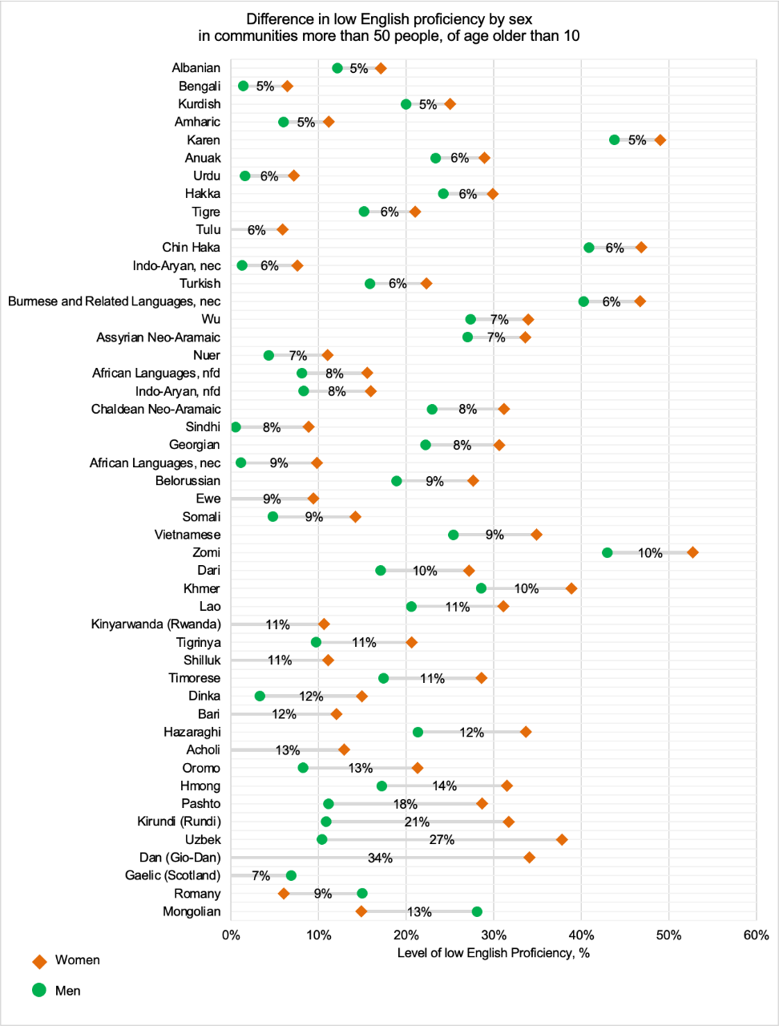

Table 68: Difference in low English proficiency between sexes, in communities of 50 or more people aged over 10 years old

| Language | Female | Male | Difference |
| --- | --- | --- | --- |
| Mongolian | 15% | 28% | 13% |
| Romany | 6% | 15% | 9% |
| Gaelic (Scotland) | 0% | 7% | 7% |
| Dan (Gio-Dan) | 34% | 0% | 34% |
| Uzbek | 38% | 10% | 27% |
| Kirundi (Rundi) | 32% | 11% | 21% |
| Pashto | 29% | 11% | 18% |
| Hmong | 32% | 17% | 14% |
| Oromo | 21% | 8% | 13% |
| Acholi | 13% | 0% | 13% |
| Hazaragi | 34% | 21% | 12% |
| Bari | 12% | 0% | 12% |
| Dinka | 15% | 3% | 12% |
| Timorese | 29% | 17% | 11% |
| Shilluk | 11% | 0% | 11% |
| Tigrinya | 21% | 10% | 11% |
| Kinyarwanda (Rwanda) | 11% | 0% | 11% |
| Lao | 31% | 21% | 11% |
| Khmer | 39% | 29% | 10% |
| Dari | 27% | 17% | 10% |
| Zomi | 53% | 43% | 10% |
| Vietnamese | 35% | 25% | 9% |
| Somali | 14% | 5% | 9% |
| Ewe | 9% | 0% | 9% |
| Belorussian | 28% | 19% | 9% |
| African languages, nec | 10% | 1% | 9% |
| Georgian | 31% | 22% | 8% |
| Sindhi | 9% | 0% | 8% |
| Chaldean Neo-Aramaic | 31% | 23% | 8% |
| Indo-Aryan, nfd | 16% | 8% | 8% |
| African languages, nfd | 16% | 8% | 8% |
| Nuer | 11% | 4% | 7% |
| Assyrian Neo-Aramaic | 34% | 27% | 7% |
| Wu | 34% | 27% | 7% |
| Burmese and related languages, nec | 47% | 40% | 6% |
| Turkish | 22% | 16% | 6% |
| Indo-Aryan, nec | 8% | 1% | 6% |
| Chin Haka | 47% | 41% | 6% |
| Tulu | 6% | 0% | 6% |
| Tigre | 21% | 15% | 6% |
| Hakka | 30% | 24% | 6% |
| Urdu | 7% | 2% | 6% |
| Anuak | 29% | 23% | 6% |
| Karen | 49% | 44% | 5% |
| Amharic | 11% | 6% | 5% |
| Kurdish | 25% | 20% | 5% |
| Bengali | 6% | 1% | 5% |
| Albanian | 17% | 12% | 5% |

**Figure 41: Difference in low English proficiency between sexes, in the language communities with the highest levels of low English proficiency**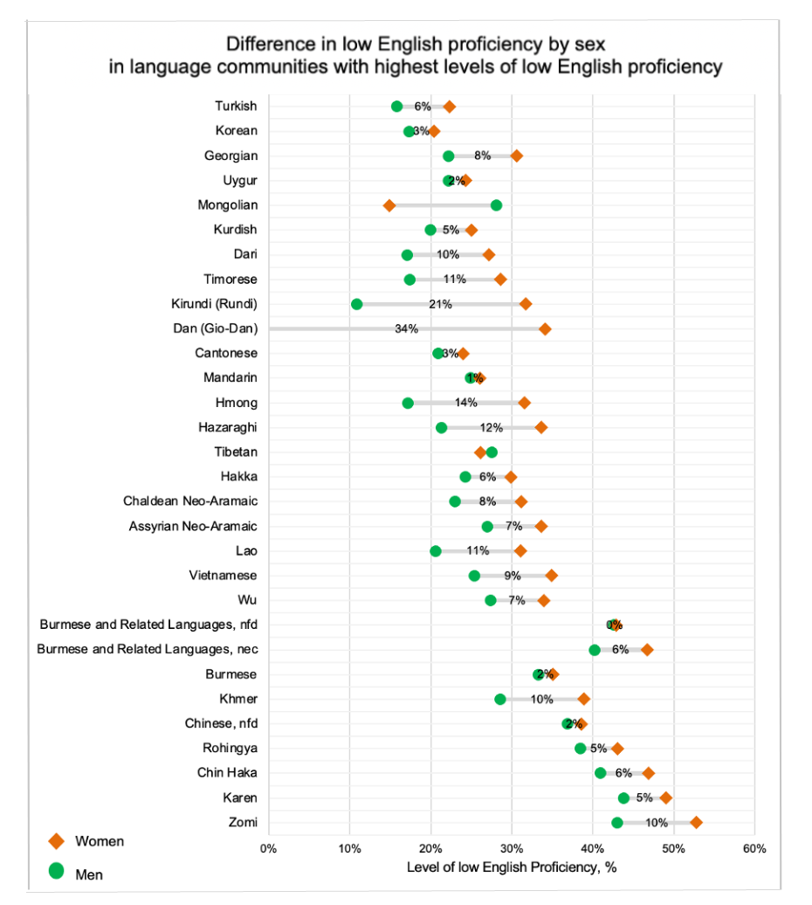

Table 69: Difference in low English proficiency between sexes, in the language communities with the highest levels of low English proficiency

| Language | Female | Male | Difference |
| --- | --- | --- | --- |
| Zomi | 53% | 43% | 10% |
| Karen | 49% | 44% | 5% |
| Chin Haka | 47% | 41% | 6% |
| Rohingya | 43% | 38% | 5% |
| Chinese, nfd | 39% | 37% | 2% |
| Khmer | 39% | 29% | 10% |
| Burmese | 35% | 33% | 2% |
| Burmese and related languages, nec | 47% | 40% | 6% |
| Burmese and related languages, nfd | 43% | 43% | 0% |
| Wu | 34% | 27% | 7% |
| Vietnamese | 35% | 25% | 9% |
| Lao | 31% | 21% | 11% |
| Assyrian Neo-Aramaic | 34% | 27% | 7% |
| Chaldean Neo-Aramaic | 31% | 23% | 8% |
| Hakka | 30% | 24% | 6% |
| Tibetan | 26% | 28% | 1% |
| Hazaragi | 34% | 21% | 12% |
| Hmong | 32% | 17% | 14% |
| Mandarin | 26% | 25% | 1% |
| Cantonese | 24% | 21% | 3% |
| Dan (Gio-Dan) | 34% | 0% | 34% |
| Kirundi (Rundi) | 32% | 11% | 21% |
| Timorese | 29% | 17% | 11% |
| Dari | 27% | 17% | 10% |
| Kurdish | 25% | 20% | 5% |
| Mongolian | 15% | 28% | 13% |
| Uygur | 24% | 22% | 2% |
| Georgian | 31% | 22% | 8% |
| Korean | 20% | 17% | 3% |
| Turkish | 22% | 16% | 6% |

More details on English language proficiency between the sexes across LGAs can be found in Appendix 4.

# The variations of English proficiency among different age groups

Figures 43–45 represent the levels of English proficiency among age groups in the top 30 language communities with the highest levels of low English proficiency. Please note that some data might have been excluded from the database for age and English language proficiency to protect people’s privacy.

Similar to trends in regional Victoria, we can see that English language proficiency generally declines with age, meaning that more people of older age reported speaking English ‘not well’ or ‘not at all’. For instance, more than 80 per cent of people over the age of 80 reported speaking English ‘not well’ or ‘not at all’ for more than half of the 30 languages with the highest levels of low English proficiency.

While for more than half of these 30 languages, 20- to 29-year-olds generally reported better levels of English proficiency, there are still certain languages for which a large percentage of this age group reports speaking English ‘not well’ or ‘not at all’. Those languages are the Zomi, Karen, Burmese and related languages nfd and nec, Chin Hakka, Rohingya, Chinese nfd, Mongolian and Burmese language communities.

The tendency for English language proficiency to decrease with age can be attributed to multiple reasons. Often, the age at migration is provided as a main factor because learning a second language, in this instance English, can be more challenging. However, research suggests other characteristics can lessen the direct impact of age at migration on English language proficiency. These include educational history and current family and activity characteristics. The more social interaction and communication, the easier it becomes to learn a new language.[7]

The values for Figures 38–40 are available in Appendix 3.

Figure 43: The distribution of low English proficiency in language groups spoken by more than 50 people aged older than 10 years of age, part 1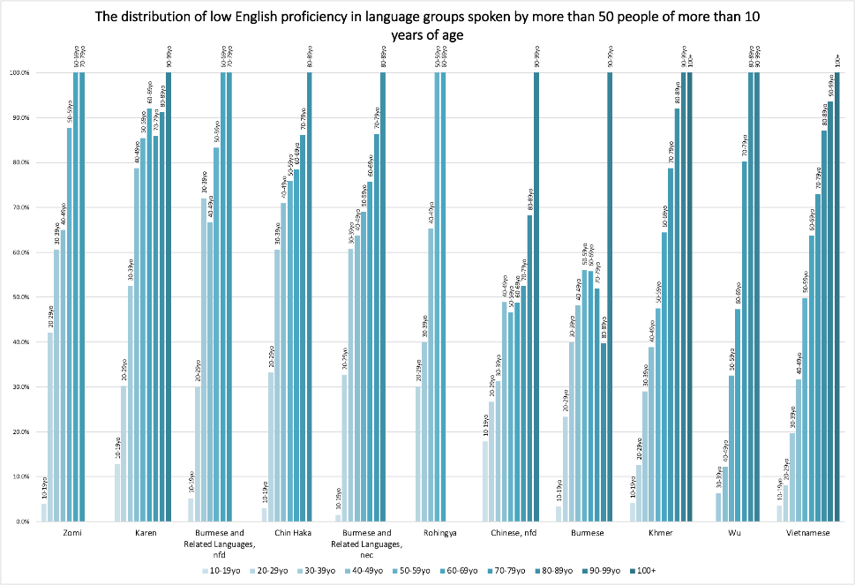

Figure 44: The distribution of low English proficiency in language groups spoken by more than 50 people aged older than 10 years of age, part 2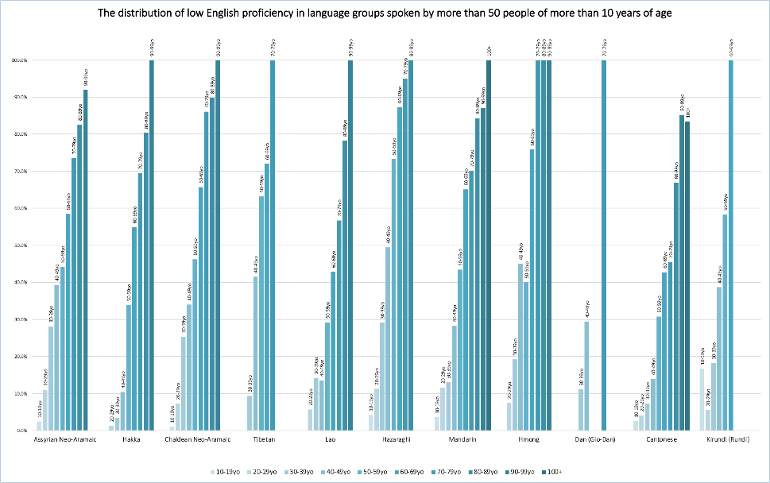

Figure 45: The distribution of low English proficiency in language groups spoken by more than 50 people aged older than 10 years of age, part 3

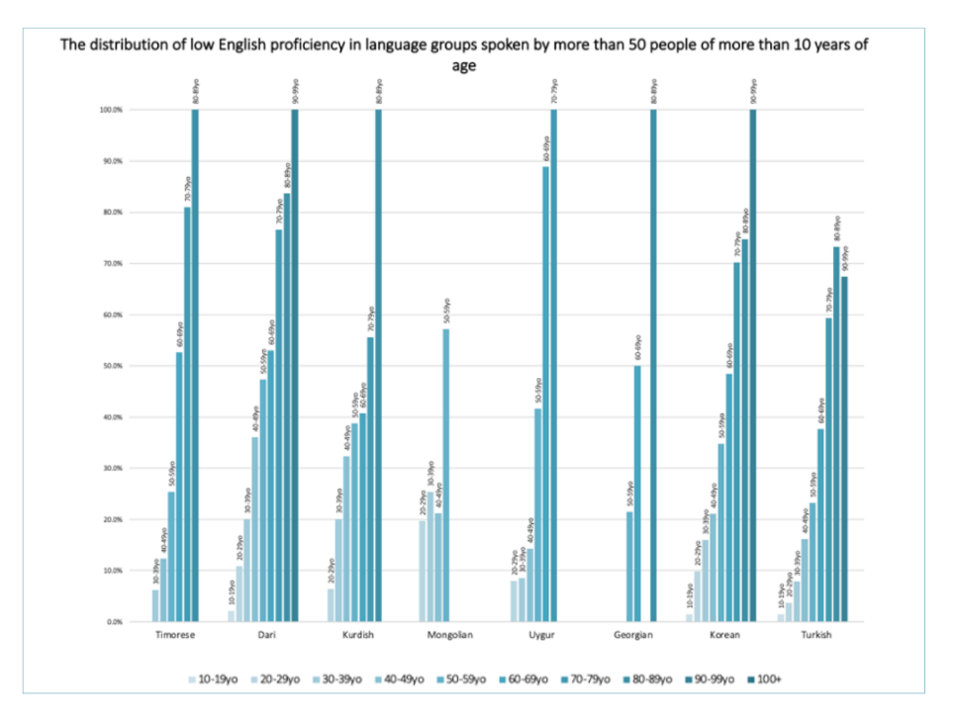

# Appendix 1: Country of birth of metropolitan Melbourne population

| Country | Number of people |
| --- | --- |
| Australia | 2,947,136 |
| India | 242,635 |
| Not stated | 214,972 |
| China (excludes SARs[8] and Taiwan) | 166,023 |
| England | 132,912 |
| Vietnam | 90,552 |
| New Zealand | 82,939 |
| Sri Lanka | 65,152 |
| Philippines | 58,935 |
| Italy | 58,081 |
| Malaysia | 57,345 |
| Greece | 44,956 |
| Pakistan | 29,067 |
| South Africa | 27,056 |
| Iraq | 25,041 |
| Hong Kong (SAR of China) | 24,428 |
| Afghanistan | 23,525 |
| Iran | 20,922 |
| United States of America | 20,231 |
| Scotland | 19,539 |
| Indonesia | 19,294 |
| Germany | 19,125 |
| Nepal | 18,510 |
| Lebanon | 18,333 |
| North Macedonia | 18,028 |
| Turkey | 17,716 |
| Thailand | 17,360 |
| Singapore | 17,087 |
| Cambodia | 16,277 |
| Malta | 15,128 |
| Ireland | 14,742 |
| Korea, Republic of (South) | 14,730 |
| Egypt | 13,312 |
| Poland | 13,052 |
| Croatia | 12,902 |
| Myanmar | 12,392 |
| Mauritius | 11,700 |
| Netherlands | 11,558 |
| Fiji | 11,450 |
| Colombia | 9,940 |
| Bangladesh | 9,693 |
| Taiwan | 9,362 |
| Bosnia and Herzegovina | 8,502 |
| Japan | 8,476 |
| Canada | 8,449 |
| Serbia | 7,969 |
| Chile | 7,870 |
| Ethiopia | 7,576 |
| Syria | 7,549 |
| Samoa | 7,200 |
| Cyprus | 7,171 |
| France | 7,063 |
| Russian Federation | 6,575 |
| South Eastern Europe, nfd | 5,829 |
| Brazil | 5,427 |
| Romania | 5,221 |
| Sudan | 5,119 |
| Ukraine | 5,092 |
| Zimbabwe | 5,075 |
| Timor-Leste | 4,917 |
| Israel | 4,644 |
| Kenya | 4,634 |
| Argentina | 4,355 |
| Northern Ireland | 4,334 |
| Somalia | 4,229 |
| United Arab Emirates | 4,070 |
| Inadequately described | 4,069 |
| Saudi Arabia | 3,812 |
| Hungary | 3,759 |
| Wales | 3,623 |
| El Salvador | 3,249 |
| Spain | 3,236 |
| Austria | 2,882 |
| South Sudan | 2,839 |
| Portugal | 2,810 |
| Eritrea | 2,576 |
| Nigeria | 2,429 |
| Switzerland | 2,110 |
| Laos | 2,106 |
| Cook Islands | 2,031 |
| Papua New Guinea | 2,023 |
| Kuwait | 1,970 |
| Sweden | 1,895 |
| Mexico | 1,864 |
| Albania | 1,741 |
| Peru | 1,647 |
| Slovenia | 1,596 |
| Uruguay | 1,485 |
| Venezuela | 1,477 |
| Tonga | 1,456 |
| Jordan | 1,339 |
| Czechia | 1,320 |
| Belgium | 1,298 |
| Denmark | 1,267 |
| United Kingdom, Channel Islands and Isle of Man, nfd | 1,200 |
| Ghana | 1,055 |
| Finland | 984 |
| Bulgaria | 971 |
| Libya | 969 |
| Congo, Democratic Republic of | 917 |
| Belarus | 910 |
| Eastern Europe, nfd | 889 |
| Seychelles | 882 |
| Latvia | 831 |
| Zambia | 810 |
| Liberia | 806 |
| Bhutan | 778 |
| Brunei Darussalam | 776 |
| Uganda | 765 |
| Gaza Strip and West Bank | 749 |
| Macau (SAR of China) | 720 |
| Kosovo | 715 |
| Slovakia | 690 |
| Morocco | 680 |
| Southern Asia, nfd | 664 |
| Tanzania | 660 |
| Norway | 630 |
| Lithuania | 613 |
| Montenegro | 606 |
| Bahrain | 566 |
| Kazakhstan | 535 |
| Moldova | 526 |
| Oman | 526 |
| Uzbekistan | 521 |
| Qatar | 506 |
| Sierra Leone | 474 |
| Mongolia | 422 |
| Estonia | 336 |
| Armenia | 316 |
| Algeria | 303 |
| Congo, Republic of | 302 |
| Malawi | 286 |
| Botswana | 276 |
| Ecuador | 265 |
| Georgia | 255 |
| Yemen | 252 |
| Trinidad and Tobago | 220 |
| Burundi | 207 |
| Jamaica | 204 |
| Azerbaijan | 199 |
| Tunisia | 190 |
| Namibia | 188 |
| Nauru | 185 |
| Maldives | 185 |
| Guinea | 161 |
| Cuba | 158 |
| Mozambique | 157 |
| Guatemala | 156 |
| Bolivia | 148 |
| Solomon Islands | 143 |
| Middle East, nfd | 143 |
| Cote d’Ivoire | 136 |
| Cameroon | 135 |
| Niue | 132 |
| Vanuatu | 125 |
| Guyana | 121 |
| Rwanda | 121 |
| New Caledonia | 118 |
| Jersey | 118 |
| Kyrgyzstan | 111 |
| Samoa, American | 110 |
| Djibouti | 107 |
| Paraguay | 101 |
| Costa Rica | 100 |
| Guernsey | 99 |
| Angola | 99 |
| Isle of Man | 97 |
| Kiribati | 82 |
| Bermuda | 75 |
| Senegal | 75 |
| Madagascar | 71 |
| Gibraltar | 70 |
| Honduras | 70 |
| Nicaragua | 70 |
| Southern and East Africa, nfd | 68 |
| Luxembourg | 66 |
| Tajikistan | 66 |
| Barbados | 59 |
| Dominican Republic | 54 |
| North Africa, nfd | 50 |
| South America, nfd | 49 |
| Iceland | 48 |
| Panama | 43 |
| Cayman Islands | 40 |
| French Polynesia | 39 |
| Tuvalu | 39 |
| Turkmenistan | 39 |
| Eswatini | 39 |
| Togo | 36 |
| Bahamas | 31 |
| Gambia | 31 |
| Reunion | 28 |
| Lesotho | 27 |
| Haiti | 26 |
| Puerto Rico | 26 |
| Tokelau | 24 |
| North Africa and the Middle East, nfd | 24 |
| At sea | 23 |
| Guam | 21 |
| Comoros | 21 |
| Suriname | 20 |
| Monaco | 18 |
| Curacao | 17 |
| Falkland Islands | 16 |
| Caribbean, nfd | 16 |
| Chad | 16 |
| Norfolk Island | 15 |
| Antigua and Barbuda | 15 |
| Benin | 15 |
| Belize | 14 |
| Maritime South-East Asia, nfd | 13 |
| Korea, Democratic People’s Republic of (North) | 13 |
| Southern and Central Asia, nfd | 13 |
| Central and West Africa, nfd | 13 |
| Mali | 11 |
| Burkina Faso | 10 |
| Cabo Verde | 10 |
| Northern Mariana Islands | 9 |
| Grenada | 9 |
| St Lucia | 9 |
| Greenland | 8 |
| Northern America, nfd | 8 |
| St Helena | 8 |
| Aruba | 7 |
| Oceania and Antarctica, nfd | 6 |
| Dominica | 6 |
| Central African Republic | 6 |
| Gabon | 6 |
| Marshall Islands | 5 |
| Wallis and Futuna | 5 |
| Guadeloupe | 5 |
| Mauritania | 5 |
| Palau | 4 |
| Faroe Islands | 4 |
| Central America, nfd | 4 |
| Anguilla | 4 |
| St Vincent and the Grenadines | 4 |
| Sint Maarten (Dutch part) | 4 |
| Niger | 4 |
| Sao Tome and Principe | 4 |
| Australian Antarctic Territory | 3 |
| Liechtenstein | 3 |
| Andorra | 3 |
| Central Asia, nfd | 3 |
| Montserrat | 3 |
| St Kitts and Nevis | 3 |
| Turks and Caicos Islands | 3 |
| Equatorial Guinea | 3 |
| Australia (includes external territories), nfd | 0 |
| Australian External Territories, nec | 0 |
| Melanesia, nfd | 0 |
| Micronesia, nfd | 0 |
| Micronesia, Federated States of | 0 |
| Polynesia (excludes Hawaii), nfd | 0 |
| Pitcairn Islands | 0 |
| Polynesia (excludes Hawaii), nec | 0 |
| Antarctica, nfd | 0 |
| Adelie Land (France) | 0 |
| Argentinian Antarctic Territory | 0 |
| British Antarctic Territory | 0 |
| Chilean Antarctic Territory | 0 |
| Queen Maud Land (Norway) | 0 |
| Ross Dependency (New Zealand) | 0 |
| North-West Europe, nfd | 0 |
| Western Europe, nfd | 0 |
| Northern Europe, nfd | 0 |
| Aland Islands | 0 |
| Southern and Eastern Europe, nfd | 0 |
| Southern Europe, nfd | 0 |
| Holy See | 0 |
| San Marino | 0 |
| Western Sahara | 0 |
| Spanish North Africa | 0 |
| South-East Asia, nfd | 0 |
| Mainland South-East Asia, nfd | 0 |
| North-East Asia, nfd | 0 |
| Chinese Asia (includes Mongolia), nfd | 0 |
| Japan and the Koreas, nfd | 0 |
| Americas, nfd | 0 |
| St Pierre and Miquelon | 0 |
| French Guiana | 0 |
| South America, nec | 0 |
| Martinique | 0 |
| Virgin Islands, British | 0 |
| Virgin Islands, United States | 0 |
| St Barthelemy | 0 |
| St Martin (French part) | 0 |
| Bonaire, Sint Eustatius and Saba | 0 |
| Sub-Saharan Africa, nfd | 0 |
| Guinea-Bissau | 0 |
| Mayotte | 0 |
| Southern and East Africa, nec | 0 |

# Appendix 2: Top 30 languages in metropolitan Melbourne reporting low English proficiency

| Language | Low English proficiency, %, 2021 |
| --- | --- |
| Zomi | 48% |
| Karen | 46% |
| Burmese and related languages, nfd | 45% |
| Chin Haka | 44% |
| Burmese and related languages, nec | 44% |
| Rohingya | 39% |
| Chinese, nfd | 37% |
| Burmese | 34% |
| Khmer | 34% |
| Wu | 31% |
| Vietnamese | 31% |
| Assyrian Neo-Aramaic | 30% |
| Hakka | 27% |
| Chaldean Neo-Aramaic | 27% |
| Tibetan | 27% |
| Lao | 27% |
| Hazaragi | 26% |
| Mandarin | 26% |
| Hmong | 24% |
| Dan (Gio-Dan) | 24% |
| Cantonese | 23% |
| Kirundi (Rundi) | 22% |
| Timorese | 22% |
| Dari | 22% |
| Kurdish | 22% |
| Mongolian | 21% |
| Uygur | 21% |
| Georgian | 19% |
| Korean | 19% |
| Turkish | 19% |

# Appendix 3: English Language proficiency among age groups of top 30 language groups reporting low English proficiency

| Language | 10–19 yo | 20–29 yo | 30–39 yo | 40–49 yo | 50–59 yo | 60–69 yo | 70–79 yo | 80–89 yo | 90–99 yo | 100+ |
| --- | --- | --- | --- | --- | --- | --- | --- | --- | --- | --- |
| Zomi | 4% | 42% | 61% | 65% | 88% | 100% | 100% |  |  |  |
| Karen | 13% | 30% | 52% | 79% | 85% | 92% | 86% | 91% | 100% |  |
| Burmese and related languages, nfd | 5% | 30% | 72% | 67% | 83% | 100% | 100% |  |  |  |
| Chin Haka | 3% | 33% | 61% | 71% | 76% | 78% | 86% | 100% |  |  |
| Burmese and related languages, nec | 1% | 33% | 61% | 64% | 69% | 76% | 86% | 100% |  |  |
| Rohingya |  | 30% | 40% | 65% | 100% | 100% |  |  |  |  |
| Chinese, nfd | 18% | 27% | 31% | 49% | 47% | 49% | 53% | 68% | 100% |  |
| Burmese | 3% | 23% | 40% | 48% | 56% | 56% | 52% | 40% | 100% |  |
| Khmer | 4% | 13% | 29% | 39% | 47% | 64% | 79% | 92% | 100% | 100% |
| Wu |  |  | 6% | 12% | 33% | 47% | 80% | 100% | 100% |  |
| Vietnamese | 4% | 8% | 20% | 32% | 50% | 64% | 73% | 87% | 94% | 100% |
| Assyrian Neo-Aramaic | 2% | 11% | 28% | 39% | 44% | 58% | 74% | 83% | 92% |  |
| Hakka |  | 1% | 3% | 10% | 34% | 55% | 70% | 80% | 100% |  |
| Chaldean Neo-Aramaic | 1% | 7% | 25% | 34% | 46% | 66% | 86% | 90% | 100% |  |
| Tibetan |  |  | 9% | 42% | 63% | 72% | 100% |  |  |  |
| Lao |  | 6% | 14% | 14% | 29% | 43% | 57% | 78% | 100% |  |
| Hazaragi | 4% | 11% | 29% | 49% | 73% | 87% | 95% | 100% |  |  |
| Mandarin | 4% | 12% | 13% | 28% | 43% | 65% | 70% | 84% | 87% | 100% |
| Hmong |  | 8% | 19% | 45% | 40% | 76% | 100% | 100% | 100% |  |
| Dan (Gio-Dan) |  |  | 11% | 29% |  |  | 100% |  |  |  |
| Cantonese | 3% | 4% | 7% | 14% | 31% | 43% | 46% | 67% | 85% | 83% |
| Kirundi (Rundi) | 17% | 6% | 18% | 39% | 58% | 100% |  |  |  |  |
| Timorese |  |  | 6% | 12% | 25% | 53% | 81% | 100% |  |  |
| Dari | 2% | 11% | 20% | 36% | 47% | 53% | 77% | 84% | 100% |  |
| Kurdish |  | 6% | 20% | 32% | 39% | 41% | 56% | 100% |  |  |
| Mongolian |  | 20% | 25% | 21% | 57% |  |  |  |  |  |
| Uygur |  | 8% | 9% | 14% | 42% | 89% | 100% |  |  |  |
| Georgian |  |  |  |  | 21% | 50% |  | 100% |  |  |
| Korean | 1% | 10% | 16% | 21% | 35% | 48% | 70% | 75% | 100% |  |
| Turkish | 1% | 4% | 8% | 16% | 23% | 38% | 59% | 73% | 67% |  |

## 

# Appendix 4: English language proficiency by sex and LGA of the top 30 language communities reporting low English proficiency

| Language | Banyule; male | Banyule; female | Bayside; male | Bayside; female | Boroondara; male | Boroondara; female | Brimbank; male | Brimbank; female | Cardinia; male | Cardinia; female | Casey; male | Casey; female |
| --- | --- | --- | --- | --- | --- | --- | --- | --- | --- | --- | --- | --- |
| Kurdish | 23% | 47% |  |  | 0% | 0% | 33% | 24% |  |  | 10% | 17% |
| Hazaragi |  |  |  |  | 0% |  | 20% | 37% | 19% | 26% | 20% | 34% |
| Dari | 0% | 25% | 0% | 0% | 0% | 40% | 19% | 20% | 13% | 18% | 17% | 29% |
| Assyrian Neo-Aramaic | 0% | 0% | 0% | 0% | 0% | 0% | 37% | 39% | 0% | 0% | 16% | 26% |
| Chaldean Neo-Aramaic |  |  | 0% |  |  | 0% | 0% | 0% | 100% |  | 16% | 23% |
| Turkish | 0% | 9% | 5% | 9% | 7% | 9% | 17% | 26% | 0% | 19% | 13% | 21% |
| Uygur |  |  |  |  | 0% | 0% | 100% |  |  |  | 15% | 19% |
| Georgian |  |  |  | 0% |  |  |  |  |  |  |  | 0% |
| Burmese and related languages, nfd |  |  |  |  |  |  | 48% | 41% |  | 0% | 0% | 0% |
| Burmese | 0% | 0% |  |  | 0% | 19% | 37% | 43% | 33% | 47% | 27% | 30% |
| Chin Haka | 40% | 36% |  |  |  |  | 39% | 49% | 30% | 37% | 17% | 50% |
| Karen |  |  |  |  |  |  | 24% | 42% |  |  | 47% | 60% |
| Rohingya |  |  |  |  |  |  | 0% |  | 36% | 52% | 0% | 0% |
| Zomi |  |  |  |  |  |  | 43% | 133% | 0% |  | 0% | 0% |
| Burmese and related languages, nec |  |  |  | 0% |  |  | 48% | 56% | 0% | 0% | 0% |  |
| Hmong |  |  |  |  |  |  | 0% | 0% |  |  |  |  |
| Khmer | 30% | 17% | 0% | 41% | 13% | 11% | 11% | 13% | 19% | 27% | 25% | 37% |
| Vietnamese | 12% | 18% | 10% | 12% | 11% | 13% | 31% | 42% | 22% | 23% | 23% | 32% |
| Lao |  |  |  | 0% | 0% | 0% | 23% | 38% | 0% |  | 23% | 44% |
| Timorese |  |  |  |  |  |  | 28% | 17% |  |  | 18% | 28% |
| Chinese, nfd | 33% | 58% | 64% | 65% | 29% | 36% | 43% | 68% | 57% | 100% | 46% | 20% |
| Cantonese | 17% | 18% | 13% | 18% | 13% | 16% | 28% | 36% | 17% | 25% | 22% | 25% |
| Mandarin | 26% | 25% | 20% | 27% | 20% | 25% | 34% | 34% | 35% | 30% | 31% | 33% |
| Wu | 0% | 0% | 43% | 0% | 22% | 23% | 0% | 0% |  |  | 0% | 100% |
| Korean | 12% | 22% | 0% | 10% | 11% | 15% | 11% | 19% | 11% | 25% | 14% | 25% |
| Tibetan | 0% | 0% | 0% | 100% | 0% | 0% | 54% | 40% |  |  | 0% | 50% |
| Mongolian |  |  |  |  |  | 0% | 0% | 45% |  |  |  |  |
| Dan (Gio-Dan) |  |  |  |  |  |  | 0% | 100% |  |  |  |  |
| Kirundi (Rundi) |  |  |  |  |  |  | 0% | 50% |  |  | 38% |  |

| Language | Darebin; male | Darebin; female | Frankston; male | Frankston; female | Glen Eira; male | Glen Eira; female | Greater Dandenong; male | Greater Dandenong; female | Hobsons Bay; male | Hobsons Bay; female | Hume; male | Hume; female |
| --- | --- | --- | --- | --- | --- | --- | --- | --- | --- | --- | --- | --- |
| Kurdish | 14% | 28% | 0% |  | 0% |  | 43% | 25% | 0% | 0% | 26% | 25% |
| Hazaragi | 0% | 0% | 27% | 0% | 0% |  | 26% | 35% |  |  | 15% | 29% |
| Dari | 0% | 0% | 9% | 20% | 0% | 0% | 21% | 32% | 0% | 100% | 13% | 18% |
| Assyrian Neo-Aramaic | 11% | 21% | 0% | 0% |  |  | 0% | 60% | 0% | 0% | 28% | 35% |
| Chaldean Neo-Aramaic | 0% | 0% | 0% |  | 0% | 0% | 0% | 0% |  | 0% | 25% | 33% |
| Turkish | 14% | 21% | 13% | 18% | 11% | 9% | 17% | 26% | 4% | 21% | 18% | 25% |
| Uygur |  |  |  |  |  |  | 20% | 38% |  |  | 23% | 20% |
| Georgian |  |  |  | 0% | 50% | 56% |  |  |  |  |  |  |
| Burmese and related languages, nfd |  |  |  |  |  |  |  |  |  | 0% |  |  |
| Burmese | 0% | 0% | 17% | 6% | 0% | 0% | 41% | 46% | 50% | 58% | 19% | 15% |
| Chin Haka |  |  |  |  |  | 0% |  |  |  | 0% |  |  |
| Karen |  |  |  |  |  |  | 37% | 44% | 57% | 57% |  |  |
| Rohingya |  |  |  |  |  |  | 41% | 47% |  |  |  |  |
| Zomi |  |  |  |  |  |  |  |  |  |  |  |  |
| Burmese and related languages, nec |  |  |  |  |  |  | 43% | 100% | 0% | 60% |  |  |
| Hmong |  |  |  |  |  |  |  |  |  |  | 16% | 35% |
| Khmer | 10% | 35% | 0% | 24% | 18% | 14% | 33% | 44% | 9% | 35% | 0% | 24% |
| Vietnamese | 23% | 29% | 11% | 18% | 10% | 13% | 30% | 42% | 23% | 30% | 24% | 39% |
| Lao | 0% | 17% |  | 0% | 50% | 45% | 29% | 31% | 40% | 12% | 19% | 14% |
| Timorese |  |  |  |  |  |  | 15% | 56% |  |  | 0% | 0% |
| Chinese, nfd | 48% | 62% | 33% | 100% | 43% | 30% | 48% | 48% | 0% | 0% | 0% | 33% |
| Cantonese | 31% | 34% | 21% | 19% | 15% | 17% | 33% | 40% | 25% | 28% | 26% | 25% |
| Mandarin | 41% | 36% | 31% | 32% | 21% | 22% | 37% | 38% | 28% | 22% | 23% | 24% |
| Wu | 0% | 79% |  |  | 36% | 51% | 0% | 100% |  | 0% |  |  |
| Korean | 9% | 18% | 18% | 27% | 17% | 20% | 23% | 28% | 34% | 21% | 12% | 15% |
| Tibetan |  |  | -80% | 50% | 0% | 0% | 38% | 0% |  | 0% | 0% |  |
| Mongolian |  | 0% |  |  |  | 0% |  |  |  |  | 0% |  |
| Dan (Gio-Dan) |  |  |  |  |  |  |  |  |  |  |  |  |
| Kirundi (Rundi) |  |  |  |  |  |  | 0% | 27% |  |  |  |  |

| Language | Kingston; male | Kingston; female | Knox; male | Knox; female | Manningham; male | Manningham; female | Maribyrnong; male | Maribyrnong; female | Maroondah; male | Maroondah; female |
| --- | --- | --- | --- | --- | --- | --- | --- | --- | --- | --- |
| Kurdish |  |  | 0% | 50% | 0% | 0% | 43% |  | 0% | 0% |
| Hazaragi | 0% | 0% | 0% | 25% |  | 0% | 39% | 50% |  |  |
| Dari | 14% | 15% | 19% | 10% | 0% | 0% | 0% | 0% | 0% | 14% |
| Assyrian Neo-Aramaic | 0% | 0% |  |  | 0% | 0% | 0% | 27% |  |  |
| Chaldean Neo-Aramaic | 21% | 28% |  |  |  |  |  |  | 0% | 0% |
| Turkish | 17% | 21% | 13% | 17% | 15% | 14% | 14% | 25% | 0% | 21% |
| Uygur |  |  | 33% | 20% | 0% | 0% | 0% |  | 0% |  |
| Georgian |  | 0% |  |  |  |  |  |  |  |  |
| Burmese and related languages, nfd |  |  |  |  |  |  |  | 50% | 30% | 37% |
| Burmese | 21% | 22% | 14% | 12% | 0% | 25% | 38% | 38% | 40% | 39% |
| Chin Haka | 0% | 100% | 100% |  | 0% | 100% | 40% | 75% | 46% | 50% |
| Karen |  |  | 53% | 46% |  |  |  |  | 42% | 51% |
| Rohingya |  |  |  |  |  |  |  |  |  |  |
| Zomi |  |  | 11% | 48% |  |  |  | 100% | 48% | 54% |
| Burmese and related languages, nec |  | 0% | 64% | 0% |  |  | 56% | 60% | 37% | 47% |
| Hmong |  |  |  | 0% |  |  |  |  |  |  |
| Khmer | 27% | 38% | 17% | 37% | 33% | 32% | 20% | 27% | 35% | 39% |
| Vietnamese | 21% | 27% | 20% | 29% | 14% | 17% | 24% | 34% | 18% | 27% |
| Lao | 14% | 33% | 18% | 23% | 0% | 0% | 29% | 43% | 0% | 0% |
| Timorese | 0% |  | 0% |  |  |  | 0% | 0% |  | 0% |
| Chinese, nfd | 31% | 49% | 14% | 29% | 29% | 29% | 47% | 28% | 31% | 56% |
| Cantonese | 24% | 25% | 19% | 23% | 19% | 22% | 29% | 33% | 18% | 23% |
| Mandarin | 27% | 27% | 23% | 26% | 23% | 27% | 32% | 26% | 24% | 27% |
| Wu | 47% | 48% | 0% | 20% | 19% | 41% |  |  | 0% | 27% |
| Korean | 17% | 19% | 17% | 23% | 18% | 20% | 10% | 12% | 21% | 27% |
| Tibetan | 0% |  | 0% | 0% | 0% | 0% | 32% | 33% | 19% | 0% |
| Mongolian |  |  |  |  |  |  | 57% | 0% |  |  |
| Dan (Gio-Dan) |  |  |  |  |  |  |  |  |  |  |
| Kirundi (Rundi) |  |  |  |  |  |  |  |  |  |  |

| Language | Melbourne; male | Melbourne; female | Melton; male | Melton; female | Monash; male | Monash; female | Moonee Valley; male | Moonee Valley; female | Moreland; male | Moreland; female |
| --- | --- | --- | --- | --- | --- | --- | --- | --- | --- | --- |
| Kurdish | 0% | 0% | 0% | 14% | 0% | 0% | 0% | 42% | 14% | 25% |
| Hazaragi | 29% | 0% | 16% | 25% | 0% | 0% |  |  | 0% | 0% |
| Dari | 0% | 20% | 18% | 15% | 12% | 11% | 0% | 0% | 0% | 0% |
| Assyrian Neo-Aramaic | 0% | 0% | 27% | 33% | 0% | 0% | 15% | 22% | 22% | 28% |
| Chaldean Neo-Aramaic |  | 0% | 0% | 11% | 0% | 0% | 0% | 43% | 16% | 28% |
| Turkish | 11% | 11% | 10% | 13% | 10% | 19% | 10% | 16% | 17% | 25% |
| Uygur | 0% | 0% |  |  | 0% | 0% |  |  | 0% | 0% |
| Georgian |  |  |  |  | 0% | 100% |  |  |  |  |
| Burmese and related languages, nfd | 0% |  | 56% | 36% |  |  |  |  |  |  |
| Burmese | 18% | 13% | 47% | 44% | 15% | 10% | 0% | 24% | 19% | 10% |
| Chin Haka |  |  | 36% | 52% |  |  |  | 0% |  |  |
| Karen |  |  | 35% | 49% |  |  |  | 0% |  |  |
| Rohingya |  |  | 0% |  |  |  |  |  |  |  |
| Zomi |  | 100% | 30% | 50% |  |  |  |  |  |  |
| Burmese and related languages, nec | 0% | 0% | 39% | 38% |  |  |  |  |  | 0% |
| Hmong |  |  |  | 0% |  |  | 0% |  |  |  |
| Khmer | 0% | 0% | 20% | 27% | 20% | 22% | 0% | 13% | 0% | 33% |
| Vietnamese | 12% | 15% | 25% | 32% | 13% | 20% | 18% | 29% | 18% | 24% |
| Lao | 0% | 11% | 17% | 30% | 28% | 18% | 16% | 19% | 0% | 13% |
| Timorese |  |  | 38% | 18% |  |  | 0% | 100% |  |  |
| Chinese, nfd | 32% | 32% | 58% | 54% | 36% | 35% | 0% | 47% | 0% | 50% |
| Cantonese | 14% | 14% | 24% | 24% | 18% | 21% | 27% | 33% | 20% | 19% |
| Mandarin | 16% | 15% | 26% | 25% | 23% | 27% | 18% | 18% | 23% | 21% |
| Wu | 0% | 12% |  |  | 29% | 34% | 100% | 100% | 50% | 25% |
| Korean | 19% | 19% | 7% | 21% | 21% | 23% | 17% | 22% | 11% | 10% |
| Tibetan | 0% | 0% | 64% | 0% | 0% |  |  |  |  |  |
| Mongolian | 30% | 19% |  |  | 0% | 0% | 0% | 47% | 57% | 0% |
| Dan (Gio-Dan) |  |  | 0% | 20% |  |  |  |  |  |  |
| Kirundi (Rundi) | 0% |  | 0% | 0% |  |  |  |  |  |  |

| Language | Mornington Peninsula; male | Mornington Peninsula; female | Nillumbik; male | Nillumbik; female | Port Phillip; male | Port Phillip; female | Stonnington; male | Stonnington; female | Whitehorse; male | Whitehorse; female |
| --- | --- | --- | --- | --- | --- | --- | --- | --- | --- | --- |
| Kurdish | 0% |  |  | 0% | 0% |  |  |  | 44% | 0% |
| Hazaragi |  |  |  |  | 0% |  |  |  | 0% |  |
| Dari | 0% | 0% |  |  |  |  | 0% | 0% | 15% | 0% |
| Assyrian Neo-Aramaic | 0% | 0% |  |  |  |  |  | 0% | 0% | 0% |
| Chaldean Neo-Aramaic |  |  |  |  |  |  |  |  |  |  |
| Turkish | 23% | 11% | 10% | 17% | 13% | 11% | 18% | 27% | 5% | 23% |
| Uygur |  |  |  |  |  |  |  |  | 0% |  |
| Georgian |  |  |  |  | 0% | 0% |  |  |  |  |
| Burmese and related languages, nfd |  |  |  |  |  |  |  |  | 0% |  |
| Burmese | 0% | 0% | 0% |  | 0% | 0% | 0% | 0% | 9% | 0% |
| Chin Haka |  |  |  |  |  |  |  |  | 0% |  |
| Karen |  |  |  |  |  |  |  |  |  |  |
| Rohingya |  |  |  |  |  |  |  |  |  |  |
| Zomi |  |  |  |  |  |  |  |  |  |  |
| Burmese and related languages, nec |  |  |  |  |  |  |  |  | 38% |  |
| Hmong |  |  |  |  |  |  |  |  |  |  |
| Khmer | 35% | 0% | 0% |  | 0% | 24% | 14% | 8% | 26% | 35% |
| Vietnamese | 12% | 21% | 11% | 14% | 16% | 14% | 15% | 12% | 19% | 12% |
| Lao | 0% |  |  |  | 0% | 0% | 0% |  | 33% | 0% |
| Timorese |  |  |  |  |  |  |  |  |  |  |
| Chinese, nfd |  |  |  |  |  | 15% | 56% | 12% | 48% |  |
| Cantonese | 25% | 16% | 14% | 21% | 12% | 13% | 11% | 15% | 23% | 25% |
| Mandarin | 28% | 22% | 16% | 15% | 14% | 15% | 15% | 18% | 30% | 28% |
| Wu |  |  |  |  |  | 0% | 0% | 31% | 21% |  |
| Korean | 0% | 0% | 19% | 21% | 11% | 17% | 15% | 9% | 19% | 0% |
| Tibetan | 0% |  |  |  | 62% | 0% | 33% | 27% | 63% | 0% |
| Mongolian |  |  |  |  | 0% | 0% |  | 0% | 0% |  |
| Dan (Gio-Dan) |  |  |  |  |  |  |  |  |  |  |
| Kirundi (Rundi) |  |  |  |  |  |  |  |  |  |  |

| Language | Whittlesea; male | Whittlesea; female | Wyndham; male | Wyndham; female | Yarra; male | Yarra; female | Yarra Valley; male | Yarra Valley; female |
| --- | --- | --- | --- | --- | --- | --- | --- | --- |
| Kurdish | 17% | 22% | 20% | 0% | 0% |  |  |  |
| Hazaragi | 15% | 23% | 25% | 24% | 0% | 0% | 0% |  |
| Dari | 13% | 14% | 8% | 27% | 42% | 0% |  | 0% |
| Assyrian Neo-Aramaic | 20% | 25% | 0% | 0% | 0% | 0% |  | 0% |
| Chaldean Neo-Aramaic | 15% | 20% | 0% |  |  |  |  |  |
| Turkish | 18% | 22% | 12% | 11% | 11% | 22% | 0% | 0% |
| Uygur | 0% | 0% | 58% | 67% |  |  |  |  |
| Georgian |  |  |  |  |  |  |  |  |
| Burmese and related languages, nfd |  |  | 36% | 31% |  |  | 33% | 33% |
| Burmese | 0% | 20% | 37% | 36% | 0% | 31% | 35% | 43% |
| Chin Haka | 33% | 57% | 50% | 55% |  |  | 40% | 44% |
| Karen |  |  | 44% | 50% |  |  | 29% | 40% |
| Rohingya | 42% | 0% |  |  |  |  |  |  |
| Zomi |  |  | 45% | 28% |  |  | 38% | 52% |
| Burmese and related languages, nec |  |  | 40% | 42% |  |  | 26% | 47% |
| Hmong |  | 0% | 0% |  |  |  |  |  |
| Khmer | 24% | 35% | 15% | 23% | 0% | 23% | 18% | 21% |
| Vietnamese | 26% | 35% | 21% | 29% | 31% | 47% | 17% | 10% |
| Lao | 0% | 33% | 13% | 30% | 0% | 31% |  | 0% |
| Timorese | 60% | 0% | 0% |  | 0% | 50% |  |  |
| Chinese, nfd | 43% | 40% | 42% | 33% | 0% | 82% | 56% | 0% |
| Cantonese | 28% | 27% | 20% | 22% | 31% | 34% | 12% | 13% |
| Mandarin | 35% | 33% | 27% | 29% | 24% | 31% | 26% | 24% |
| Wu | 0% | 82% | 50% | 77% | 56% | 27% |  |  |
| Korean | 11% | 23% | 19% | 22% | 0% | 16% | 4% | 13% |
| Tibetan | 0% | 0% | 28% | 36% |  |  |  |  |
| Mongolian |  |  | 0% | 0% |  |  |  |  |
| Dan (Gio-Dan) |  | 0% | 0% | 0% |  |  |  |  |
| Kirundi (Rundi) |  | 0% | 17% | 18% |  |  |  |  |

1. Australian Bureau of Statistics (2022). *Snapshot of Victoria*. Australian Bureau of Statistics. Retrieved December 20, 2022, from https://www.abs.gov.au/articles/snapshot-vic-2021
2. ‘nfd’ stands for not further defined. This term is used in Census data when only enough information is provided to partially categorise a response.
3. Department of Social Services (2017). ‘*Building a New Life in Australia (BNLA): The Longitudinal Study of Humanitarian Migrants’* and Blake L, et al. (2019). The Impact of oral English proficiency on humanitarian migrants’ experiences of settling in Australia. *International Journal of Bilingual Education and Bilingualism*, 22:6, 689–705.
4. ‘nec’ stands for not elsewhere classified. It allows for responses that don’t fit into a suitable category to be included.
5. ‘nfd’ stands for not further defined. This term is used in Census data when only enough information is provided to partially categorise a response.
6. Piller, I. (2019). What makes it hard for migrants to learn the language of their new home? OpenLearn Free Learning from The Open University; and Harmony Alliance (2019). A strategic approach to improving employment outcomes of women from migrant and refugee backgrounds in Australia.
7. Stevens, G. (1999). Age at immigration and second language proficiency among foreign-born adults. *Language in Society*, *28*(4), 555–578
8. SARs are special administrative regions. China has two: Hong Kong and Macau, which are reported separately below.