

|  |
| --- |
| External Research Application (ERA) form |
| Centre for Evaluation and Research Evidence (CERE)  Department of Families, Fairness and Housing (DFFH) |
|  |

Contents

ERA requirements 1

ERA instructions 2

ERA process 2

ERA assessment criteria 2

External Research Application Form 3

Researchers contact details 3

Departmental sponsors 4

Research ethics 4

Alignment to one or more departmental strategic directions, reform areas or priority activities 5

How the research team will work with departmental staff 5

Building on existing knowledge/research/best practice 5

Risks to departmental staff, service delivery or clients 6

Impact on the department (time, resourcing) 6

Dissemination of research findings 8

Proposed research/evaluation 8

Detailed research/evaluation proposal 8

# ERA requirements

The Centre for Evaluation and Research Evidence (CERE) welcomes research requests that improve data and evidence to enable delivery of the Department of Families, Fairness and Housing (DFFH) strategic directions. Throughout the form the DFFH is referenced as the department.

Prior to submitting an External Research Application (ERA) you will need to obtain a minimum of two departmental sponsors. Sponsors are typically the person based in the program area in the department/s which most closely relates to the topic of the research project. Applicants are required to speak with their nominated sponsors *before* submitting an ERA. Applications **will not** be accepted without these conversations having taken place and the sponsors agreement to undertake the role.

It is essential that your ERA align with one or more of the strategic directions, reform areas or priority activities as outlined in the department’s strategic plan <https://www.dffh.vic.gov.au/strategic-plan>.

## ERA instructions

This application form must be completed by researchers or research teams wishing to obtain approval from the department to undertake a research or evaluation project that involves departmental **staff, clients, or data**.

**Exclusions**: The ERA process is **not** applicable to activities the department has funded, contracted, or will undertake through a collaborative agreement with relevant parties.

The ERA process is separate to **human research ethics approval**. Information about the department’s human research ethics approval is available on the department’s ethics committee website <https://www.health.vic.gov.au/clinical-trials-and-research/department-of-health-human-research-ethics-committee>.

**Students** are requested to obtain ethics approval from their own University (or another properly constituted ethics committee) and submit this approval to the CERE either with their ERA or ***as soon as possible after submitting*** their ERA.

A copy of all ERA projects ethics ***approvals*** must be submitted before final approval can be provided by the CERE. A formal letter of approval must also be received by the researcher from the CERE ***before*** commencing the research activities with departmental clients, data or staff.

**Please submit the completed ERA form as a word document.**

## ERA process

##### Figure 1. ERA process

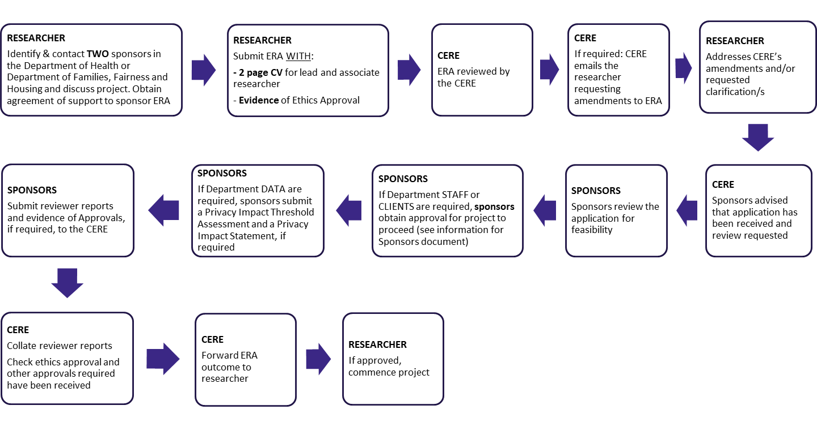

## ERA assessment criteria

ERAs are assessed on the following six criteria:

1. Alignment to one or more of the Strategic Plan Priority actions, directions, reform areas and priority activities
2. Benefits gained from the research activity to the department’s clients, staff, communities, service systems or wider public
3. Extent of resourcing (staff, facilitation, data access, client access) required and availability of staff to support the research activity
4. Risks to departmental reputation, staff or clients associated with supporting the activity
5. Duplication of effort, coordination with similar or complimentary activities
6. Dissemination strategy to provide evidence publications, reports and tools to participants, department staff and stakeholders

# External Research Application Form

|  |  |
| --- | --- |
| **Research/Project title** |  |
| **Chief Investigator (Name and title)** |  |
| **Department sponsor 1 (Name and title)** |  |
| **Department sponsor 2 (Name and title)** |  |
| **Ethics approval (Y/N)** |  |

## Researchers contact details

Please list the details of the chief and associate investigators for the project. Add additional tables if needed.

Students are eligible to apply and should be listed as the chief investigator. The supervisor/s of any student projects should be listed as the associate investigator/s.

#### Chief investigator

|  |  |
| --- | --- |
| **Title** |  |
| **First name** |  |
| **Last name** |  |
| **Qualifications** |  |
| **Department** |  |
| **Organisation** |  |
| **Postal address** |  |
| **Work phone** |  |
| **Mobile phone** |  |
| **Email** |  |
| **Fax** |  |

#### Associate investigator/Primary supervisor

|  |  |
| --- | --- |
| **Title** |  |
| **First name** |  |
| **Last name** |  |
| **Qualifications** |  |
| **Department** |  |
| **Organisation** |  |
| **Postal address** |  |
| **Work phone** |  |
| **Mobile phone** |  |
| **Email** |  |
| **Fax** |  |

## Departmental sponsors

Please confirm who in the department has agreed to sponsor the project.

Add additional contact tables as needed. Please **do not:**

* provide contact details for people you have not had direct phone or email contact with.
* identify the coordinators of the ERA process as sponsors.

Please ensure that sponsors **do not** have potential conflicts of interest such as concomitant roles on project governance committees or similar. Both sponsors must have contact numbers and email provided.

#### Sponsor 1

|  |  |
| --- | --- |
| **Program area** |  |
| **Title** |  |
| **First name** |  |
| **Last name** |  |
| **Position** |  |
| **Area** |  |
| **Work phone** |  |
| **Mobile phone** |  |
| **Email** |  |

#### Sponsor 2

|  |  |
| --- | --- |
| **Program area** |  |
| **Title** |  |
| **First name** |  |
| **Last name** |  |
| **Position** |  |
| **Area** |  |
| **Work phone** |  |
| **Mobile phone** |  |
| **Email** |  |

Note: for department program areas/divisions please refer to the organisation link provided, <https://www.dffh.vic.gov.au/our-structure and <https://www.dffh.vic.gov.au/portfolios>.

## Research ethics

ERA applicants are required to have research ethics approval. Please provide the details below. If ethics approval **is not** required please provide evidence of exemption, such as a letter from a Human Research Ethics Committee or a justification why ethics approval is not required. Attach this evidence to the ERA.

| **Approval from other organisations** | **Mark with x** | **Reason why ethics not required** | **Evidence Attached? Y/N** |
| --- | --- | --- | --- |
| Not required |  |  |  |
| Required |  |  |  |

|  |  |  |  |  |  |
| --- | --- | --- | --- | --- | --- |
| **HREC institution/s** | **HREC application submitted** | **HREC application in progress** | **Anticipated approval date if HREC application in progress** | **HREC application reference** | **HREC approval letter attached** |
|  |  |  |  |  |  |
|  |  |  |  |  |  |

Please mark with an x, add extra rows if required.

Note:

* If ethics approval is in progress, please indicate when approval is anticipated.
* ERA approval is contingent upon research or evaluation ethics approval (if required).

## Alignment to one or more departmental strategic directions, reform areas or priority activities

Applicants should ensure that they have read the department’s plan as outlined <https://www.dffh.vic.gov.au/strategic-plan>.

Outline how the application directly addresses one of the department’s strategic directions, reform areas or priority activities. List the area followed by a short description of how the ERA addresses this area.

Note, if your research does not align with any departmental areas **please do not continue with this ERA**. The department does not have capacity to support initiatives that do not align with its priority areas. Add more rows as needed. (Maximum of 50 words for each priority area)

| **Detail for how the application directly addresses one of the department’s priority actions** | |
| --- | --- |
| **Priority area** | **How ERA addresses this area** |
|  |  |
|  |  |

## How the research team will work with departmental staff

Please describe how the research team will work with policy and program staff to ensure that research is relevant and applicable to the departments’ service delivery (maximum 200 words).

|  |
| --- |
|  |

## Building on existing knowledge/research/best practice

Outline how this application adds to existing knowledge, research, or best practice in this area (maximum 200 words).

|  |
| --- |
|  |

## Risks to departmental staff, service delivery or clients

Please identify any risks that the application may pose for the departments’ clients, staff or service delivery activities. Provide a brief description of how these risks will be mitigated or addressed. Add more rows if required.

| **Risk** | **How will risk be mitigated/addressed? (maximum 100 words/risk)** |
| --- | --- |
|  |  |
|  |  |

## Impact on the department (time, resourcing)

Please outline the assistance and/or effort required by the department to support the research.

##### Intangible costs (in-kind support)

Please indicate who will provide the in-kind assistance and what activities that assistance will comprise. Add more rows if required.

| **Who provides in-kind assistance** | **Detail of assistance required by researchers** |
| --- | --- |
|  |  |

##### **Staff time**

Please indicate what research or evaluation activities departmental staff will need to assist with. This topic should be part of your discussions with your sponsors. Include the number of staff to be involved and an estimate of the time commitment required. Add additional rows as needed.

| **Assistance or engagement** | **Mark with x** | **Number of staff** | **Estimated time commitment** |
| --- | --- | --- | --- |
| Interviews |  |  |  |
| Focus groups |  |  |  |
| Surveys |  |  |  |
| Accessing and/or extracting data |  |  |  |
| Interpreting data |  |  |  |
| Facilitating access and communications to clients |  |  |  |
| Providing project, policy, service information |  |  |  |

##### Access to identifiable information. If you require access to identifiable departmental information, please provide a rationale for that access.

| **Access to identifiable information** | **Mark with x** | **Rationale for access to identifiable data** |
| --- | --- | --- |
| Not required |  |  |
| Required |  |  |

##### Access to data

Mark as many as are relevant. Please indicate the level of data (i.e. aggregate – deidentified or individual – identifiable) that will be required by your research or evaluation. Please note that approval to access departmental information is limited to this project. If you wish to use departmental information for other research purposes, you must submit a separate ERA to the department to seek further approval.

|  | | **Data level (Mark with an x)** | |  | |
| --- | --- | --- | --- | --- | --- |
| **Data type** | **Mark with x** | **Aggregate** | **Individual** | **Description of the data required** | **Number of records required** |
| No access required |  |  |  |  |  |
| Administrative |  |  |  |  |  |
| Client details |  |  |  |  |  |
| Staff details |  |  |  |  |  |
| Service, policy, project details |  |  |  |  |  |

##### Client access

If in your research you need to access clients, please indicate in the table how many, an estimate of their time commitment and a brief description of access required. Add additional rows as needed.

| **Activity type client access is required for** | **Mark with x** | **Number of clients** | **Estimated time commitment per individual** | **Description e.g. focus group at the local library, how surveys will be disseminated** |
| --- | --- | --- | --- | --- |
| Interviews |  |  |  |  |
| Focus groups |  |  |  |  |
| Surveys |  |  |  |  |

##### Access to services

Please indicate if you will need to access services and describe the type of access required. Please provide a brief description of what that access will look like and for how long. Add extra rows as needed.

| **Assistance type** | **Number of sites** | **Purpose** | **Brief description (e.g. frequency of visits, length of visit)** |
| --- | --- | --- | --- |
| e.g. Site visits |  |  |  |

##### Commercial value of proposed research

|  |  |  |
| --- | --- | --- |
| The research does not have primarily commercial or material benefits  **Note:** The department does not provide ERA approval for research which is undertaken primarily for commercial or material gain. |  | [Describe – for example, the research outputs, services or intellectual property are not expected to generate commercial returns via income and/or capital gains. Delete explanatory text] |

## Dissemination of research findings

Please detail how research/evaluation findings will be shared with **the department**. Note that approval of your ERA is contingent upon the researchers providing drafts and interim documents to both project sponsors and the CERE to comment on any materials generated from the research prior to publication. It is expected that if there are any differences of opinion related to the outcomes between the Department and the researchers, that the differences will be acknowledged in any publications. The department has the right to ask for the draft paper before it is published and to ask for changes that are factually incorrect or harmful to the department’s reputation. The researcher/s must not disseminate or publish any findings arising from the research without first obtaining authority from the CERE and your sponsors.

#### Anticipated publications and/or resources

Please indicate the anticipated publications and/or resources that will arise from this research or evaluation. Mark as many as applicable.

| **Publication type** | **Mark with x** |
| --- | --- |
| Framework for use |  |
| Tool for use |  |
| Journal article |  |
| Training |  |
| Report |  |
| Summary report |  |
| Joint publication |  |
| Thesis |  |
| Conference or seminar paper |  |
| Other, please detail |  |

#### Sharing research/evaluation findings with participants

Please detail how your research/evaluation findings (including resources) will be shared with **participants** (department staff, clients, stakeholders). Add extra rows as needed.

| **Method for sharing research findings** | **Mark with x** |
| --- | --- |
| Participant evidence presentation and discussion |  |
| Evidence application roundtable |  |
| Other |  |

# Proposed research/evaluation

## Detailed research/evaluation proposal

Please provide detail for your research, using the sub-headings provided. Alternately you can also attach a research proposal to the ERA, ensuring the same headings are used.

#### Project duration

| **Start date** | **Expected finish date** |
| --- | --- |
|  |  |

### Purpose

#### Rationale/background for research/evaluation

[describe]

#### Research/evaluation aims and objectives

[describe]

#### Research/evaluation questions

[describe]

### Design

#### Design and rationale for design chosen

[describe]

#### Sampling/participation strategy (who, how many and where and when)

[describe]

#### Data collection tools/methods

[describe, including start/end dates for data collection, what data will be collected and how. Please attach relevant instruments, interview schedules or survey questions]

#### Procedures

[describe steps involved]

#### Data analysis

[describe]

#### Ethical considerations

[describe]

#### Communication and dissemination strategy

[describe]

|  |
| --- |
| To receive this publication in an accessible format phone 9456 4450, using the National Relay Service (13 36 77) if required, or email the Centre for Evaluation and Research Evidence <cere@dh.vic.gov.au>.  Authorised and published by the Victorian Government, 1 Treasury Place, Melbourne.  © State of Victoria, Australia, Department of Families, Fairness and Housing, November 2021.  Except where otherwise indicated, the images in this document show models and illustrative settings only, and do not necessarily depict actual services, facilities or recipients of services.  In this document, ‘Aboriginal’ refers to both Aboriginal and Torres Strait Islander people. ‘Indigenous’ or ‘Koori/Koorie’ is retained when part of the title of a report, program or quotation. |