

Safeguarding practice
Victorian Senior Practitioner plan 2026–2030
OFFICIAL

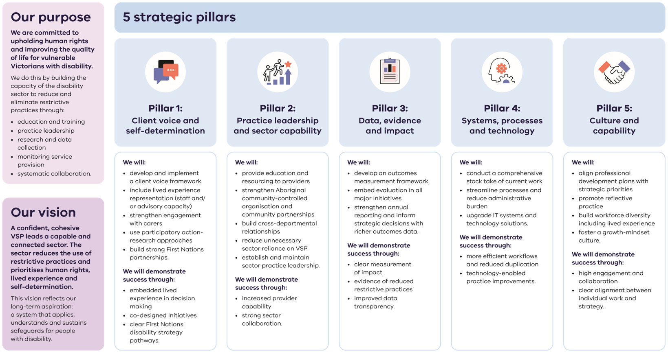

Safeguarding practice: Victorian Senior Practitioner (VSP) plan 2026–2030
image description

Our purpose
We are committed to upholding human rights and improving the quality of life for vulnerable Victorians with disability.
We do this by building the capacity of the disability sector to reduce and eliminate restrictive practices through:
- education and training
- practice leadership
- research and data collection
- monitoring service provision
- systematic collaboration

Our vision
A confident, cohesive VSP leads a capable and connected sector. The sector reduces the use of restrictive practices and prioritises human rights, lived experience and self-determination.
This vision reflects our long-term aspiration: a system that applies, understands and sustains safeguards for people with disability.

5 strategic pillars

Pillar 1: Client voice and self-determination
We will:
- develop and implement a client voice framework
- include lived experience representation (staff and/ or advisory capacity)
- strengthen engagement with carers
- use participatory action research approaches
- build strong First Nations partnerships.

We will demonstrate success through:
- embedded lived experience in decision making
- co designed initiatives
- clear First Nations disability strategy pathways.

Pillar 2: Practice leadership and sector capability
We will:
- provide education and resourcing to providers
- strengthen Aboriginal community-controlled organisation and community partnerships
- build cross departmental relationships
- reduce unnecessary sector reliance on VSP
- establish and maintain sector practice leadership.
We will demonstrate success through:
- increased provider capability
- strong sector collaboration.

Pillar 3: Data, evidence and impact
We will:
- develop an outcomes measurement framework
- embed evaluation in all major initiatives
- strengthen annual reporting and inform strategic decisions with richer outcomes data.
We will demonstrate success through:
- clear measurement of impact
- evidence of reduced restrictive practices
- improved data transparency.

Pillar 4: Systems, processes and technology
We will:
- conduct a comprehensive stock take of current work
- streamline processes and reduce administrative load
- enhance IT systems and technology solutions.
We will demonstrate success through:
- more efficient workflows and reduced duplication
- technology enabled practice improvements.

Pillar 5: Culture and capability
We will:
- align professional development plans with strategic priorities
- uplift VSP team capability to strengthen operational leadership
- promote reflective practice
- build workforce diversity including lived experience
- use stakeholder feedback to inform practice.
We will demonstrate success through:
- development of the VSP learning and development framework
- high engagement and collaboration within the VSP and with stakeholders.
Contact us to receive this document in another format. Please phone Victorian Senior Practitioner at (03) 9096 8427, or email VictorianSeniorPractitioner@dffh.vic.gov.au
If you are d/Deaf, hard of hearing, or have a speech/communication difficulty please contact us through your preferred National Relay Service (NRS) call channel https://www.accesshub.gov.au/about-the-nrs/nrs-call-numbers-and-links. Then, provide the NRS with our phone number [(03) 9096 8427]. For more information, visit About the National Relay Service https://www.accesshub.gov.au/about-the-nrs.
Authorised and published by the Victorian Government, 1 Treasury Place, Melbourne. © State of Victoria, Australia, Department of Families, Fairness and Housing, September 2026. ISBN 978-1-76171-213-5 (pdf/online/MS word). Available at DFFH – About the Senior Practitioner https://www.dffh.vic.gov.au/about-victorian-senior-practitioner (2604567)

