Rental Report

March quarter 2018



Rental Report

March quarter 2018

Contents
List of tables 3
List of figures 3
Overview 4
Trends in rents 4
New Lettings 4
Active bonds 4
Turnover 4
Investor lending 4
Vacancy rates 4
Rental Affordability 5
Current Rents 6
Rent Indices 6
Metropolitan Rent Index 6
Regional Rent Index 7
Median rents by region 7
Median rents by major property types 8
Moving annual median rents by suburb or town 8
Where are median rents highest? Where are median rents lowest? 11
Rental availability 11
New Lettings 12
Active Bonds 13
Turnover and length of tenancy 15
Investor finance 15
Vacancy Rate 16
Rental Market Affordability 17
Overall trends 17
Trends by household type 17
Trends by region 18
Trends by Local Government Area 18
Notes 35

List of tables
Table 1: Median rents and rent indices 6
Table 2: Median rents by statistical region 7
Table 3: Median rents by major property types 8
Table 4: Highest and lowest moving annual median rents in metropolitan Melbourne and regional Victoria 11
Table 5: New lettings for metropolitan Melbourne, regional Victoria and Victoria 12
Table 6: New lettings for statistical regions Victoria 12
Table 7: Turnover and tenancy duration 15
Table 8: Median tenancy duration and turnover by dwelling size 15
Table 9: Rental affordability by indicative households on Centrelink incomes 18
Table 10: Affordable lettings for indicative households on Centrelink incomes 20
Table 11: Moving annual median rents for suburbs/town by major property type 21
Table 12: Median rents for local government areas by DHS region, by major property type 28
Table 13: Affordable lettings for Local Government Areas 31
Table 14: Active bonds by local government area 34

List of figures
Figure 1: Metropolitan Rent Index and Regional Rent Index - annual percentage change 6
Figure 2: Moving annual median rents by suburb for two-bedroom flats, Metropolitan Melbourne 9
Figure 3: Moving annual median rents by suburb for three-bedroom houses, Metropolitan Melbourne 9
Figure 4: Total active residential bonds, Victoria - annual percentage change 13
Figure 5: Number of active bonds (Metropolitan Melbourne and Regional Victoria) 14
Figure 6: Lending to investors in residential housing, Victoria ($2018 March) 16
Figure 7: Rental vacancy rate 16
Figure 8: Affordable rentals as percent of all rentals 17
Figure 9: Affordable dwellings (Metropolitan Melbourne and Regional Victoria) 19

The Rental Report provides key statistics on the private rental market in Victoria. The major source for the statistics presented in the Rental Report is the Residential Tenancies Bond Authority which collects data on all rental bonds lodged under the Residential Tenancies Act 1997 (Vic).

Overview

Trends in rents
The Melbourne Rent Index (MRI) increased by 0.9 per cent in the March quarter. In the twelve months to March 2018, the MRI increased by 4.2 per cent. This annual rate of increase is above that in the twelve months to March 2017 (3.8%) and above the long term average annual increase (over the past ten years) (4.0%).
The Regional Rent Index (RRI) increased by 1.6 per cent in the March quarter. In the twelve months to March 2018, the RRI increased by 3.2 per cent. This annual rate of increase is above that in the twelve months to March 2017 (2.1%) but below the long-term average annual increase (3.8%).
Rent Indices at a glance
 | Median Rent  (per week) | Quarterly Change* | Annual  Change*
Metropolitan Melbourne | $420 | 0.9% | 4.2%
Regional Victoria | $300 | 1.6% | 3.2%
Victoria | $400 | 1.1% | 4.1%
* Percentage change figures are calculated from relevant Rent Index

New Lettings
Across the state, the total number of new lettings this quarter was 60,554, a decrease of 8.3 per cent since the March quarter 2017. In metropolitan Melbourne the number of new lettings decreased by 7.0 per cent since the March quarter 2017. In regional Victoria the number of new lettings decreased by 13.7 per cent since the March quarter 2017. Metropolitan Melbourne accounted for 82.5 per cent of all new lettings in Victoria.

Active bonds
At the end of the March quarter 2018, the total number of active bonds held in Victoria was 586,927, an increase of 2.4 per cent on the size of the rental market in the same quarter of 2017. This is the lowest increase in active bonds since March 2003. The average annual growth in the rental market over the last ten years is 5.8 per cent.

Turnover
The quarterly turnover rate for metropolitan Melbourne was 9.8 per cent, higher than the rate in the March quarter 2017 (9.6%). The quarterly turnover rate in regional Victoria was 9.7 per cent, slightly lower than the rate in the March quarter 2017 (9.8%).

Investor lending
Lending to residential property investors in Victoria was $9.173 billion in the March quarter 2018, 8.6 per cent lower than in the March quarter 2017.

Vacancy rates
The metropolitan trend vacancy rate for March 2018 was 1.9 per cent, compared with 2.1 per cent for December 2017 and 2.2 per cent for March 2017. The regional trend vacancy rate for March 2018 was 1.7 per cent, compared with 1.8 per cent for December 2017 and 2.4 per cent for March 2017.

Rental Affordability
The proportion of all new lettings that were affordable across the state decreased to 12.6 per cent in the March quarter, compared with 15.5 per cent in the December quarter 2017and 14.9 per cent in the March quarter 2017.
In Metropolitan Melbourne, the proportion of affordable new lettings decreased in March 2018 to 4.5 per cent, compared with 6.0 per cent in the December quarter 2017and 5.8 per cent in the March quarter 2017.
In Regional Victoria, the proportion of affordable rental lettings decreased to 50.5 per cent, compared with 53.8 per cent in the December quarter 2017and 54.7 per cent in the March quarter 2017.
The proportion of affordable new lettings across the state, in Metropolitan Melbourne and Regional Victoria has reached its lowest level since this series first began to be measured in March 2000.

Current Rents

Rent Indices
Table 1 shows median rents, rent indices and changes in the rent indices at March 2018. The Metropolitan Rent Index (MRI) increased by 0.9 per cent in the March quarter. The median rent for Melbourne increased by $15 to $420 per week. The Regional Rent Index (RRI) increased by 1.6 per cent in the March quarter and the median rent for Regional Victoria remained steady on $300 per week.
The Rent Indices are a better measure of changes in rents over time than the simple median price measure because the indices control for changes from quarter to quarter in the share of new lettings between both geographic areas and property types. (Median rents represent the mid-point in the distribution of all rents with fifty per cent of rents at or above the median and fifty per cent at or below the median. A number of properties on the median rent can disguise overall changes in rents over time.)
Table 1: Median rents and rent indices
 | Median Rent  (per week) | Rent Index | Quarterly  Change* | Annual  Change*
Metropolitan Melbourne | $420 | 232.2 | 0.9% | 4.2%
Regional Victoria | $300 | 223.1 | 1.6% | 3.2%
Victoria | $400 | 228.8 | 1.1% | 4.1%
* Percentage change figures are calculated from relevant Rent Index
Figure 1 shows the annual percentage change in the Metropolitan Rent Index and the Regional Rent Index over the past 10 years.
Figure 1: Metropolitan Rent Index and Regional Rent Index - annual percentage change

Metropolitan Rent Index
The annual increase of 4.2 per cent in the MRI to the March quarter 2018 is above that of a year ago (3.8%).The annual change in the MRI is above the long term (10 years) average of 4.0 per cent.
In the March quarter, the MRI increased by 0.9 per cent, compared with a 1.7 per cent increase in the previous quarter and a 1.2 per cent increase in the March quarter last year.

Regional Rent Index
The annual increase of 3.2 per cent in the RRI to the March quarter 2018 is above that of a year ago (2.1%) but below the long term average increase of 3.8 per cent. The annual change in the RRI has remained below the long term average since the March quarter of 2012.
In the March quarter, the RRI increased by 1.6 per cent compared with a 0.8 per cent increase in the last quarter and a 1.1 per cent increase in the March quarter last year.

Median rents by region
Table 2 shows the median rents for new lettings in the March quarter 2018 for 14 statistical regions in Victoria (9 in metropolitan Melbourne and 5 in regional Victoria).
In metropolitan Melbourne, median rents ranged from $370 per week for South Eastern Melbourne to $479 for Inner Melbourne. In regional Victoria median rents ranged from $275 per week for Gippsland to $340 per week for Barwon-South West.
In the March quarter, the median rent in Metropolitan Melbourne increased in North Western Melbourne (2.6%), Southern Melbourne (2.2%), Western Melbourne (1.4%) and Mornington Peninsula (1.3%). It decreased in Inner Melbourne (-0.2%) but remained steady in all other regions. In regional Victoria, the median rent increased in all regions: Goulburn-Ovens-Murray (3.6%), Central Highlands-Wimmera (3.6%), Loddon-Mallee (3.5%), Gippsland (1.9%) and Barwon-South West (0.6%).
Table 2: Median rents by statistical region
Region | Median Rent | Quarterly Change* | Annual Change*

Metropolitan Melbourne
Inner Melbourne | $479 | -0.2% | 5.3%
Inner Eastern Melbourne | $450 | 0.0% | 4.7%
Southern Melbourne | $460 | 2.2% | 2.2%
Western Melbourne | $375 | 1.4% | 4.2%
North Western Melbourne | $400 | 2.6% | 5.3%
North Eastern Melbourne | $390 | 0.0% | 5.4%
Outer Eastern Melbourne | $400 | 0.0% | 2.6%
South Eastern Melbourne | $370 | 0.0% | 2.8%
Mornington Peninsula | $380 | 1.3% | 5.6%

Regional Victoria
Barwon-South West | $340 | 0.6% | 6.3%
Gippsland | $275 | 1.9% | 1.9%
Goulburn-Ovens-Murray | $290 | 3.6% | 5.5%
Loddon-Mallee | $295 | 3.5% | 5.4%
Central Highlands-Wimmera | $290 | 3.6% | 7.4%
* Percentage change figures are calculated from median rents in the region
Over the 12 months to the March quarter, the median rent in metropolitan Melbourne increased in all regions, ranging from 2.2 per cent in Southern Melbourne to 5.6 per cent in Mornington Peninsula. In regional Victoria, the median rent increased in all regions, ranging from 1.9 per cent in Gippsland to 7.4 per cent in Central Highlands-Wimmera.

Median rents by major property types
Table 3 provides the median rents for new lettings in the March quarter 2018 for the six major property types for metropolitan Melbourne and regional Victoria as well as the quarterly and annual change in the relevant Rent Index for each property type.
In metropolitan Melbourne, the highest median rent is for three-bedroom flats ($480 per week). The lowest median rent is for one-bedroom flats ($360 per week). In the March quarter, the Rent Index has increased for all property types except for one-bedroom flats (-0.6%), with increases ranging from 1.0 per cent for two-bedroom flats and three-bedroom houses to 2.5 per cent for two-bedroom houses. Over the twelve months to March quarter, the property type Rent Index in metropolitan Melbourne increased in for property types, with increases ranging from 3.4 per cent for one-bedroom flats and four-bedroom houses to 5.0 per cent for two-bedroom flats.
In regional Victoria, the highest median rent is for four-bedroom houses ($390 per week). The lowest median rent is for one-bedroom flats ($185 per week). In the March quarter, the Rent Index increased for all property types, with increases ranging from 0.2 per cent for three-bedroom flats to 3.7 per cent for one-bedroom flats. Over the twelve months to the March quarter, the property type Rent Index increased for all property types, with increases ranging from 2.4 per cent for three-bedroom flats to 4.2% per cent for two-bedroom flats.
Note: The metropolitan Melbourne medians reflect the geographic distribution of different property types. Houses tend to be the dominant rental property type in outer metropolitan areas, whereas flats are more prevalent in areas closer to the centre of Melbourne.
Table 3: Median rents by major property types
 | Property Type | Median Rent | Quarterly Change* | Annual Change*
Metropolitan  Melbourne | 1 Bed Flat | $360 | -0.6% | 3.4%
Metropolitan  Melbourne | 2 Bed Flat | $440 | 1.0% | 5.0%
Metropolitan  Melbourne | 3 Bed Flat | $480 | 1.9% | 4.3%
Metropolitan  Melbourne | 2 Bed House | $450 | 2.5% | 3.6%
Metropolitan  Melbourne | 3 Bed House | $400 | 1.0% | 4.2%
Metropolitan  Melbourne | 4 Bed House | $450 | 1.1% | 3.4%
Regional  Victoria | 1 Bed Flat | $185 | 3.7% | 4.1%
Regional  Victoria | 2 Bed Flat | $250 | 2.6% | 4.2%
Regional  Victoria | 3 Bed Flat | $320 | 0.2% | 2.4%
Regional  Victoria | 2 Bed House | $260 | 1.5% | 3.0%
Regional  Victoria | 3 Bed House | $310 | 1.7% | 3.0%
Regional  Victoria | 4 Bed House | $390 | 0.7% | 2.7%
* Percentage change figures are calculated from relevant Rent Index

Moving annual median rents by suburb or town
Table 11 shows the moving annual median rents for suburbs and towns across Victoria by major property type. (Note that the medians in Table 11 are moving annual medians, not quarterly medians, and that the annual percentage change is calculated from these moving annual medians.)
Figure 2 and Figure 3 show the moving annual median rents in metropolitan Melbourne for two-bedroom flats and for three-bedroom houses, respectively. They show the pattern of concentration of the highest median rents in Inner Melbourne, large portions of Inner Eastern Melbourne and Southern Melbourne and the inner parts of North Western Melbourne and North Eastern Melbourne.
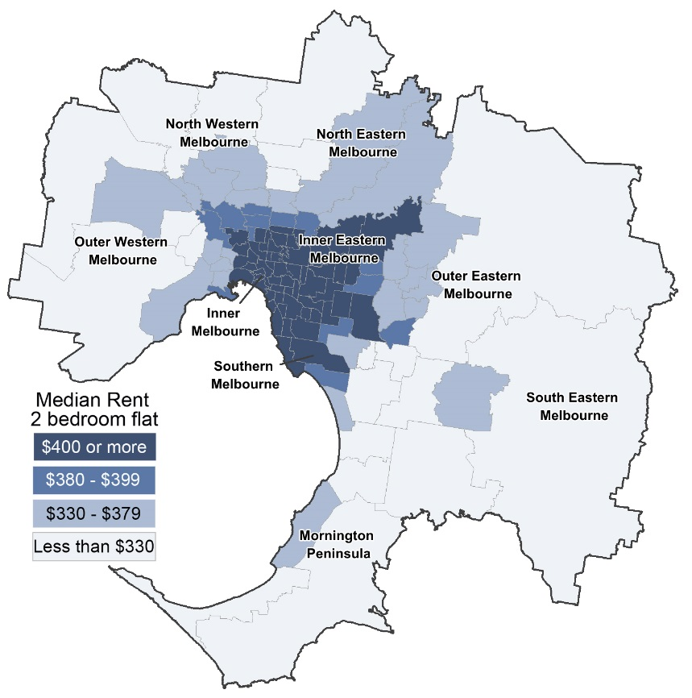
Figure 2: Moving annual median rents by suburb for two-bedroom flats, Metropolitan Melbourne

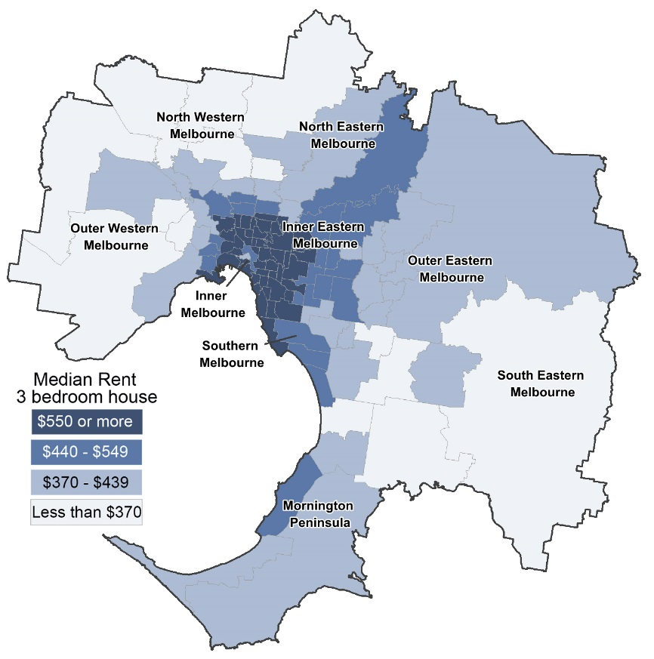
Figure 3: Moving annual median rents by suburb for three-bedroom houses, Metropolitan Melbourne

For two-bedroom flats in metropolitan Melbourne, the moving annual median rents to the March quarter increased in all suburbs except Elwood, Sydenham and Rowville where it remained steady. The suburbs with the highest increases were Armadale (19.0%), Box Hill (15.4%), Williamstown (11.4%), Thornbury (9.6%), Burwood-Ashburton (9.2%), Yarraville-Seddon (8.8%), Nunawading-Mitcham (8.6%) and Fairfield-Alphington (8.1%).
For two-bedroom flats in regional Victoria, the towns with the highest increases in moving annual median rents to the March quarter were North Geelong (10.7%), Wangaratta (10.0%), Bendigo (9.6%) and Horsham (8.6%). Moving annual median rents decreased in Torquay (-5.7%), North Bendigo (-2.0%), Mount Clear-Buninyong (-2.0%), Portland (-1.7%) and Sale-Maffra (-0.9%). It remained steady in six towns: Geelong-Newcomb, Herne Hill-Geelong West, Echuca, Morwell, Ocean Grove-Barwon Heads and Shepparton.
For three-bedroom houses in metropolitan Melbourne, the suburbs with the highest increases in moving annual median rents to the March quarter were South Yarra (11.8%), Toorak (11.4 %), Reservoir (9.6%), Clayton (9.5%), Fitzroy (9.3%), Williamstown (8.6%), Murrumbeena-Hughesdale (8.4%) and Burwood-Ashburton (8.3%). Moving annual median rents decreased in South Melbourne (-6.3%), East Hawthorn (-2.8%), Port Melbourne (-2.4%), Carnegie (-0.5%) and Prahran-Windsor (-0.3%). Moving annual median rents remained steady in nine suburbs: Balwyn. Box Hill, Doncaster East-Donvale, Hampton-Beaumaris, Mentone-Parkdale-Mordialloc, East Brunswick, Keilor, Moonee Ponds-Ascot Vale and Mt Eliza-Mornington-Mt Martha.
For three-bedroom houses in regional Victoria, the towns with the highest increases in moving annual median rents to the March quarter were Ocean Grove-Barwon Heads (8.1%), Seymour (7.7%), Mount Clear-Buninyong (6.7%), Warragul (6.7%), Castlemaine (6.3%) and Geelong-Newcomb (6.3%). Moving annual median rents decreased in only one town, Sale-Maffra (-1.8%) and remained steady in five towns: Wendouree-Alfredton, Flora Hill-Bendigo East, Benalla, Horsham and Moe-Newborough.

Where are median rents highest? Where are median rents lowest?
Table 4 provides the highest and lowest median rents for metropolitan Melbourne and regional Victoria.
Table 4: Highest and lowest moving annual median rents in metropolitan Melbourne and
regional Victoria
Where are median rents highest? |  | Where are median rents lowest?

2-bedroom flat

Metropolitan Melbourne
Docklands | $615 | Melton | $260
CBD-St Kilda Rd | $580 | Pakenham | $285
Fitzroy | $580 | Whittlesea | $290
Port Melbourne | $580 | Cranbourne | $300
 |  | Dandenong | $300
 |  | St Albans-Deer Park | $300
 |  | Sunshine | $300
 |  | Werribee-Hoppers Crossing | $300

Regional Victoria
Torquay | $330 | Moe-Newborough | $170
North Geelong | $310 | Portland | $170
Ocean Grove-Barwon Heads | $310 | Morwell | $180
Belmont-Grovedale | $300 | Hamilton | $190
Geelong-Newcomb | $300
Newtown | $300

3-bedroom house

Metropolitan Melbourne
Toorak | $1,000 | Melton | $310
South Yarra | $950 | Pakenham | $345
Albert Park-Middle Park-West St Kilda | $920 | Broadmeadows-Roxburgh Park | $350
Brighton | $900 | Dandenong North-Endeavour Hills | $350
Armadale | $890 | St Albans-Deer Park | $350
Elwood | $838 | Sunbury | $350
Fitzroy | $820 | Sunshine | $350
 |  | Werribee-Hoppers Crossing | $350

Regional Victoria
Torquay | $460 | Morwell | $230
Newtown | $400 | Hamilton | $250
Ocean Grove-Barwon Heads | $400 | Moe-Newborough | $250
Belmont-Grovedale | $370 | Portland | $250
Herne Hill-Geelong West | $360
Lara | $360

Rental availability
An expanded version of Table 11 containing extra property types as well as lower and upper quartile information can be found in the Rental Report December Quarter 2018 data tables available for download from the Office of Housing website: https://dhhs.vic.gov.au/publications/rental-report.

New Lettings
The number of new lettings provides an indicator of the overall availability of rental housing for a specific period. A new letting can result from two main sources: turnover in existing rental housing or new additions to the stock of rental housing.
Table 5 shows the total number of new rental lettings for the March quarter 2018. Across the state the total number of new lettings was 60,554, a decrease of 8.3 per cent on the same quarter of 2017. Metropolitan Melbourne recorded a decrease of 7.0 per cent in new lettings and regional Victoria a decrease of 13.7 per cent on the same quarter of last year. Metropolitan Melbourne accounted for 82.5 per cent of all new lettings in Victoria.
Table 5: New lettings for metropolitan Melbourne, regional Victoria and Victoria
 | March-17 | March-16 | Change
Metropolitan Melbourne | 49,974 | 53,744 | -7.0%
Regional Victoria | 10,580 | 12,260 | -13.7%
Victoria | 60,554 | 66,004 | -8.3%

Table 6 lists the total number of new lettings across each of the 14 statistical regions. In the twelve months to March quarter 2018, the number of new lettings decreased in all of the nine metropolitan regions, ranging from a decrease of 3.0 per cent in the South Eastern Melbourne region to a decrease of 10.7 per cent in the Outer Eastern Melbourne region.
In regional Victoria, all regions also recorded an annual decrease in the number of new lettings, ranging from a decrease of 10.0 per cent in the Central Highlands-Wimmera region to a decrease of 17.4 per cent in the Goulburn-Ovens-Murray region.
Table 6: New lettings for statistical regions Victoria
Region | March-17 | March-16 | Change

Metropolitan Melbourne
Inner Melbourne | 14,956 | 16,667 | -10.3%
Inner Eastern Melbourne | 7,235 | 7,471 | -3.2%
Southern Melbourne | 4,396 | 4,574 | -3.9%
Western Melbourne | 6,241 | 6,657 | -6.2%
North Western Melbourne | 4,681 | 4,911 | -4.7%
North Eastern Melbourne | 4,591 | 5,035 | -8.8%
Outer Eastern Melbourne | 2,029 | 2,272 | -10.7%
South Eastern Melbourne | 3,955 | 4,078 | -3.0%
Mornington Peninsula | 1,890 | 2,079 | -9.1%

Regional Victoria
Barwon-South West | 3,161 | 3,559 | -11.2%
Gippsland | 1,922 | 2,240 | -14.2%
Goulburn-Ovens-Murray | 1,967 | 2,380 | -17.4%
Loddon-Mallee | 1,839 | 2,202 | -16.5%
Central Highlands-Wimmera | 1,691 | 1,879 | -10.0%

Active Bonds
The number of active bonds provides an indicator of the total stock of rental housing, based on the total number of bonds held by the RTBA at a given point in time.
At the end of the March quarter 2018, the total number of active bonds held in Victoria was 586,927, an increase of 2.4 per cent on the size of the rental market in the same quarter of 2017. This is the lowest increase in active bonds since March 2003. The average annual growth in the rental market over the last ten years is 5.8 per cent. The annual increase in active bonds in metropolitan Melbourne (3.0%) continues to be higher than for regional Victoria (0.1%), a trend started in the March quarter 2010.
Figure 4 shows trends in active bonds for the past five years. The annual increase in active bonds continues to reduce from a high of 7.9 per cent in the June quarter 2012. While the average annual increase in the number active bonds over the past 10 years is 5.8 per cent, the average increase over the past two years has been lower (4.7%).
Figure 4: Total active residential bonds, Victoria - annual percentage change
Table 14 below shows the number of active bonds for each local government area in March 2018 and, the change in active bonds in the past twelve months and over the past five years. The largest numbers of active bonds in metropolitan Melbourne are in the municipalities of Melbourne (50,062 - 10.5% of metropolitan Melbourne bonds), Moreland (24,145 – 5.1%), Stonnington (22,720 - 4.8%), Port Phillip (21,570 - 4.5%), Glen Eira (21,390 - 4.5%), Wyndham (20,542 - 4.3%), Boroondara (19,974 – 4.2%), Casey (19,274 - 4.1%) and Darebin (19,019 - 4.0%). Over the five-year period to March 2018, the highest increases have been mainly in municipalities on the fringe of metropolitan Melbourne. The highest increases were in Melbourne (54.6%), Hume (50.6%), Whittlesea (46.1%), Melton (44.6%), Casey (42.3%), Wyndham (39.3%), Nillumbik (36.6%) and Cardinia (34.3%). The lowest increases have been in the municipalities of Port Phillip (7.0%), Mornington Peninsula (8.5%), Yarra Ranges (10.9%) and Frankston (13.7%).
The largest numbers of active bonds in regional Victoria are in the municipalities of Greater Geelong (22,179 - 19.8% of regional Victoria bonds), Ballarat (10 932 - 9.7%), Greater Bendigo (10,193 - 9.1%), Latrobe (6,137 - 5.5%), Greater Shepparton (5,201 - 4.6%) and Mildura (4,867 - 4.3%). Over the past five years, the highest increases have been in the municipalities of Mitchell (31.8%), Greater Geelong (26.0%), Baw Baw (25.5%), West Wimmera (21.6%), Greater Bendigo (21.3%), Buloke (21.3%) Ballarat (20.7%) and Golden Plains (20.4%). The number of active bonds has decreased in Queenscliffe (-9.6%), Gannawarra (-8.4%) and Swan Hill (-4.5%) while they remained steady in the municipalities of Campaspe and Yarriambiack.
Figure 5a illustrates the distribution of active bonds by suburb for metropolitan Melbourne. Figure 5b illustrates the distribution of active bonds by local government area for regional Victoria.
Figure 5: Number of active bonds (Metropolitan Melbourne and Regional Victoria)

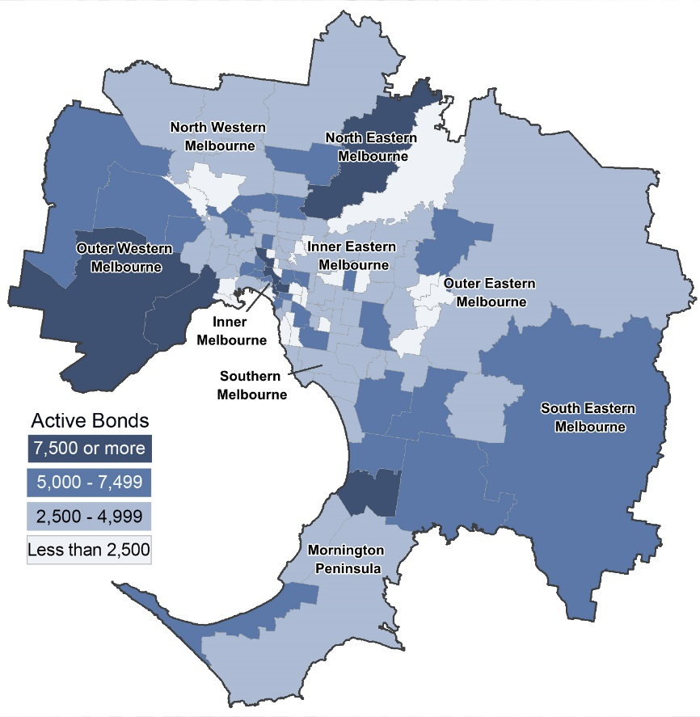
Metropolitan Melbourne by suburb

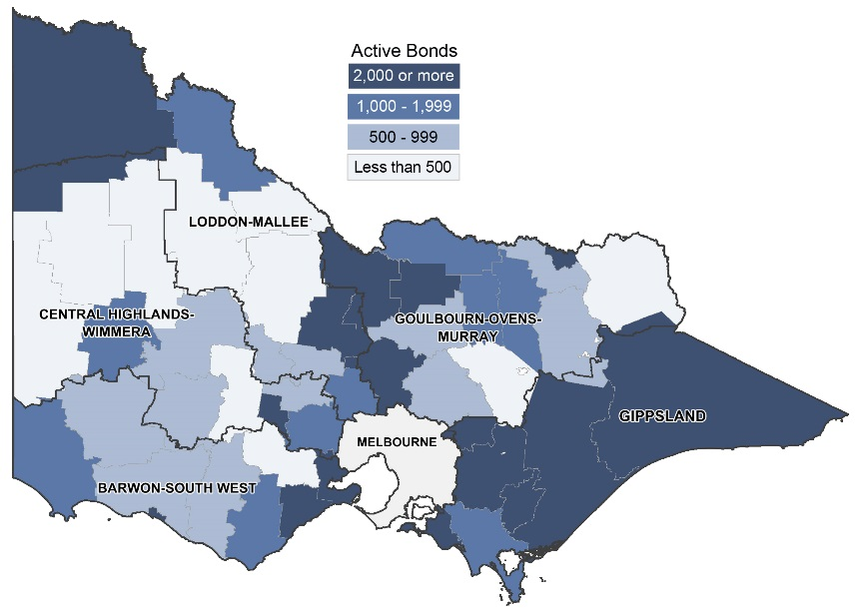
Regional Victoria by Local Government Area

Turnover and length of tenancy
The number of bond refunds in a quarter, if expressed as a percentage of all bonds held, can be used to provide an estimate of the ‘turnover rate’ in the rental market. The ‘turnover rate’ is an important indicator of the level of natural vacancies which are occurring in the market due to tenancies ending.
Table 7 shows the turnover rate and, the median length of tenancy (based on bond refunds during the quarter) for both metropolitan Melbourne and regional Victoria.
For the March quarter 2018, the quarterly turnover rate for metropolitan Melbourne was 9.8 per cent (that is, 9.8 per cent of all bonds were refunded in the quarter), compared to 9.6 per cent a year earlier. The turnover rate in regional Victoria for the March quarter 2018 was 9.7 per cent, compared to 9.8 per cent in the same quarter last year.
The median length of tenancy for bonds refunded in the March quarter 2018 was 19 months for metropolitan Melbourne and 17 months for regional Victoria.
Table 7: Turnover and tenancy duration
 | March 2018 | March 2017

Metropolitan Melbourne
Turnover rate | 9.8% | 9.6%
Median tenancy duration | 19 months | 17 months

Regional Victoria
Turnover rate | 9.7% | 9.8%
Median tenancy duration | 17 months | 16 months
Notes:
1. Turnover rate is the number of bond refunds (moving annual total) as % of total active bonds.
2. Median tenancy duration (months) is the period from bond lodgement date to bond claim date for refunds in that quarter.
Table 8 shows the median length of tenancy and turnover by dwelling size for both metropolitan Melbourne and regional Victoria. In metropolitan Melbourne one-bedroom dwellings have the lowest median length of tenancy (14 months) and the highest turnover rates (14.1%). In regional Victoria, one-bedroom dwellings have the lowest median length of tenancy (13 months) and four-bedroom plus dwellings have the highest turnover rate higher (10.1%).
Table 8: Median tenancy duration and turnover by dwelling size
 | Metropolitan Melbourne |  | Regional Victoria
 | Duration  (months) | Turnover | Duration  (months) | Turnover
1 bedroom | 14 | 14.1% | 13 | 9.8%
2 bedrooms | 19 | 9.9% | 17 | 9.5%
3 bedrooms | 21 | 8.5% | 17 | 9.9%
4+ bedrooms | 19 | 8.6% | 16 | 10.1%
All properties | 19 | 9.8% | 17 | 9.7%

Investor finance
Loan approvals for the purchase or construction of dwellings for purposes of investment (not owner-occupation) provide a measure of investor activity levels in the Victorian housing market.
Figure 6 presents a summary of lending for housing investment in Victoria over the past five years.
In the March quarter 2018, the lending to investors in Victoria was $9.173 billion which was 33.5 per cent of the total lending for the purchase or construction of dwellings. Lending to investors was 8.6 per cent lower than the level of lending in the same quarter of 2017 and 8.3 per cent lower than the level in the last quarter.
Figure 6: Lending to investors in residential housing, Victoria ($2018 March)
Note: Lending to investors in the March quarter 2013 and June quarter 2013 is an estimate - see Note 6

Vacancy Rate
Figure 7 shows the trend vacancy rate over the past five years for metropolitan Melbourne and regional Victoria.
The trend vacancy rate for metropolitan Melbourne in March 2018 was 1.9 per cent, compared with a rate of 2.1 per cent in December 2017 and 2.2 per cent in March 2017. The average vacancy rate for the four years from January 2000 to December 2004 was 3.8 per cent, for the seven years from January 2005 to December 2012 was 1.7 per cent and for the last two years has been 2.2 per cent. The trend vacancy rate reached its lowest point of 1.0 per cent in early 2008.
The trend vacancy rate for Regional Victoria in March 2018 was 1.7 per cent, compared with a rate of 1.8 per cent in December 2017 and 2.4 per cent in March 2017. The March 2018 rate (the same as the February 2018 rate) is the lowest rate since March 2012.
Figure 7: Rental vacancy rate

Rental Market Affordability
This section of the Rental Report provides a summary of the affordability of rental housing for lower income households in Victoria. The method used in this section measures the supply of affordable new lettings based on RTBA data. The affordability benchmark used is that no more than 30 per cent of gross income is spent on rent. Lower income households are defined as those receiving Centrelink incomes.

Overall trends
In the March quarter 2018, 12.6 per cent of all new lettings across the state were affordable to lower income households. The proportion of affordable new lettings across the state has reached its lowest level since this series first began to be measured in March 2000.
Figure 8 shows the trend in these figures over the past five years for Victoria, metropolitan Melbourne and regional Victoria.
Figure 8: Affordable rentals as percent of all rentals
In the March quarter 2018, 4.5 per cent of all new lettings in metropolitan Melbourne were affordable to lower income households. This compares with a rate of 6.0 per cent in the previous quarter and 5.8 per cent in the same quarter of 2017. The availability of affordable housing has generally declined from a high in the September quarter 2005 (30.2% of dwellings) to a new low of 4.5 per cent in this quarter, the lowest level since this series first began to be measured.
In Regional Victoria, the proportion of affordable dwellings has generally declined from a high of 82.7 per cent in the September quarter 2002 to reach a new low of 50.5 per cent in the March quarter 2018, the lowest since this series first began to be measured. This compares with a rate of 53.8 per cent in the previous quarter and 54.7 per cent in the same quarter of 2017.

Trends by household type
In metropolitan Melbourne, the availability of affordable rental lettings varies between different types of households. The rental affordability situation for different low-income households is summarised in Table 9.
Due to a limited supply of affordable one-bedroom dwellings, low-income single person households face the most difficulties in accessing affordable rental housing. Across Melbourne, just 0.5 per cent of one-bedroom dwellings let in the March quarter were affordable to low-income singles. For a single parent with one child on Centrelink income, 1.5 per cent of two-bedroom dwellings across Melbourne were affordable. A couple on Newstart with two dependent children could afford 5.5 per cent of three-bedroom new lettings in Melbourne in the March quarter. A couple on Newstart with four dependent children could afford 17.5 per cent of four-bedroom new lettings in Melbourne in the March quarter. For larger families, the supply of affordable three and four-bedroom dwellings is better and reflects the predominantly outer suburban location of this size of dwelling.
Table 9: Rental affordability by indicative households on Centrelink incomes
Household type |  | Singles on Newstart | Single Parent with 1 child | Couple on Newstart with  2 children | Couple on Newstart with  4 children | Total
Assumed property size |  | 1 bedroom | 2 bedroom | 3 bedroom | 4+ bedroom
Weekly income  (net of RA) |  | $273 | $573 | $790 | $1,001
Affordable weekly rent |  | $150 | $255 | $320 | $390
Affordable rentals (number) | Metropolitan | 58 | 260 | 809 | 1,139 | 2,266
Affordable rentals (number) | Regional | 163 | 1,467 | 2,687 | 1,025 | 5,342
Affordable rentals (number) | State total | 221 | 1,727 | 3,496 | 2,164 | 7,608
Affordable rentals  (% of total) | Metropolitan | 0.5% | 1.5% | 5.5% | 17.5% | 4.5%
Affordable rentals  (% of total) | Regional | 23.6% | 52.1% | 52.3% | 53.1% | 50.5%
Affordable rentals  (% of total) | State total | 1.9% | 8.4% | 17.7% | 25.7% | 12.6%

Trends by region
Table 10 shows the availability of affordable lettings for each of the statistical regions of Victoria. In metropolitan Melbourne, Western Melbourne (15.7%) has the highest proportion of new lettings affordable to lower income households, with South Eastern Melbourne (10.3%) and Mornington Peninsula (7.5%) also having relatively high proportions. Western Melbourne has the highest number and proportion of three-bedroom lettings (348 or 12.4%) and four-bedroom lettings (571 or 35.6%). Western Melbourne has the highest number (57) whereas Mornington Peninsula has the highest proportion (7.2%) of affordable two-bedroom lettings. Inner Melbourne (1.0%), Southern Melbourne (1.1%) and Inner Eastern Melbourne (1.2%) have the lowest proportions of affordable new lettings.
In regional Victoria, Gippsland (63.7%) has the highest proportion of affordable new lettings while Barwon-South West (28.9%) has the lowest proportion.

Trends by Local Government Area
Table 13 provides data on the number of new lettings affordable to households on Centrelink incomes for all Victorian Local Government Areas (LGA).
Figures 9, drawn from Table 13, show the proportion of affordable dwellings in each local government area (LGA) across metropolitan Melbourne and regional Victoria.
LGAs with the highest proportion of affordable dwellings in metropolitan Melbourne are Melton (29.3%), Cardinia (24.1%), Wyndham (22.9%), Nillumbik (17.2%), Brimbank (13.7%) and Casey (10.1%). The LGAs with lowest proportion are Bayside, Boroondara, Port Phillip, Stonnington and Yarra (all with less than 1.0%) and, Banyule, Darebin, Glen Eira, Kingston, Manningham, Melbourne, Monash, Moonee Valley, Moreland and Whitehorse (all with less than 2.0%).
The LGAs with the highest proportion of affordable dwellings in regional Victoria are Hindmarsh, West Wimmera and Yarriambiack (all with 100%) and, Buloke, Loddon, Northern Grampians and Southern Grampians (all above 90%). The LGAs with the lowest proportion of affordable dwellings are Queenscliffe (0.0%), Surf Coast (4.2%) and Macedon Ranges (8.4%).
Figure 9: Affordable dwellings (Metropolitan Melbourne and Regional Victoria)

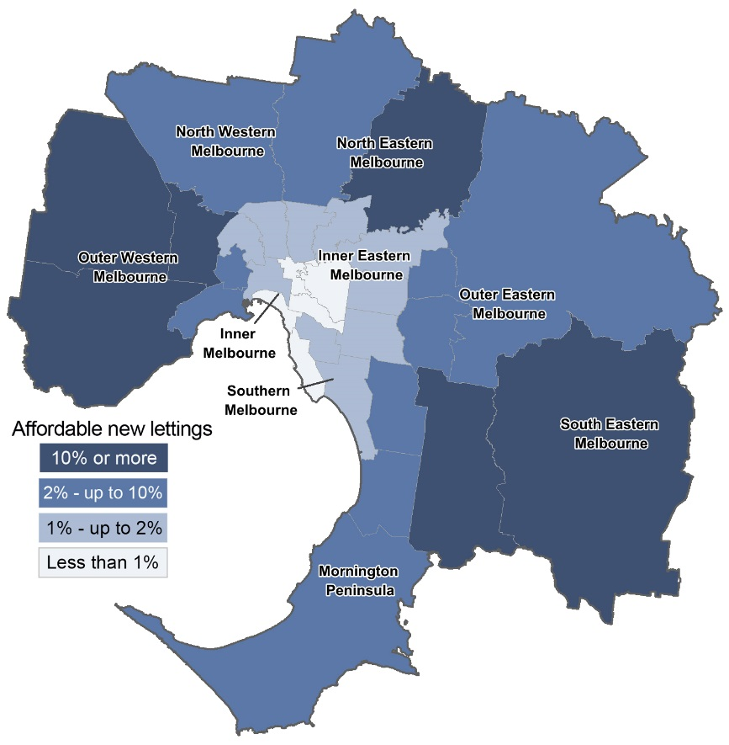
Metropolitan Melbourne

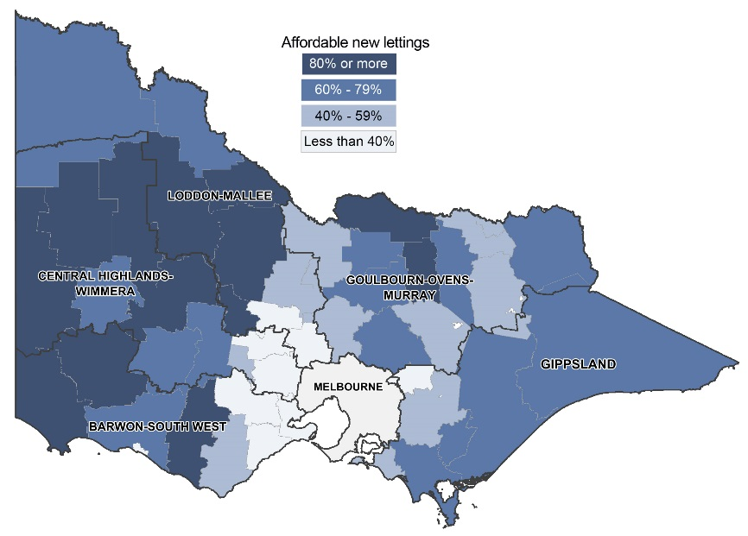
Regional Victoria

Table 10: Affordable lettings for indicative households on Centrelink incomes
(See Table 9 for indicative households)
Region | 1 Bedroom |  | 2 Bedroom |  | 3 Bedroom |  | 4+ Bedroom |  | Total
Region | # | % | # | % | # | % | # | % | # | %
Inner Melbourne | 37 | 0.5% | 46 | 0.7% | 56 | 4.0% | 17 | 6.5% | 156 | 1.0%
Inner Eastern Melbourne | 5 | 0.4% | 19 | 0.8% | 37 | 1.7% | 23 | 1.9% | 84 | 1.2%
Southern Melbourne | 3 | 0.3% | 13 | 0.7% | 14 | 1.2% | 17 | 3.5% | 47 | 1.1%
Western Melbourne | 3 | 0.7% | 57 | 4.1% | 348 | 12.4% | 571 | 35.6% | 979 | 15.7%
North Western Melbourne | 3 | 0.5% | 21 | 1.1% | 72 | 4.6% | 76 | 15.0% | 172 | 3.7%
North Eastern Melbourne | - | 0.0% | 23 | 1.4% | 50 | 3.0% | 141 | 21.4% | 214 | 4.7%
Outer Eastern Melbourne | 4 | 5.3% | 11 | 1.9% | 24 | 2.4% | 24 | 6.4% | 63 | 3.1%
South Eastern Melbourne | 1 | 0.5% | 37 | 4.6% | 134 | 7.0% | 237 | 22.5% | 409 | 10.3%
Mornington Peninsula | 2 | 1.8% | 33 | 7.2% | 74 | 7.5% | 33 | 10.1% | 142 | 7.5%
Metropolitan Melbourne | 58 | 0.5% | 260 | 1.5% | 809 | 5.5% | 1,139 | 17.5% | 2,266 | 4.5%
Barwon-South West | 14 | 5.8% | 206 | 26.0% | 503 | 33.6% | 190 | 30.2% | 913 | 28.9%
Gippsland | 52 | 37.1% | 309 | 63.3% | 651 | 65.8% | 212 | 69.7% | 1,224 | 63.7%
Goulburn-Ovens-Murray | 32 | 33.0% | 384 | 68.4% | 539 | 57.0% | 221 | 60.7% | 1,176 | 59.8%
Loddon-Mallee | 30 | 27.0% | 314 | 58.6% | 489 | 55.4% | 187 | 60.5% | 1,020 | 55.5%
Central Highlands-Wimmera | 35 | 34.0% | 254 | 57.7% | 505 | 61.4% | 215 | 66.0% | 1,009 | 59.7%
Regional Victoria | 163 | 23.6% | 1,467 | 52.1% | 2,687 | 52.3% | 1,025 | 53.1% | 5,342 | 50.5%
Victoria | 221 | 1.9% | 1,727 | 8.4% | 3,496 | 17.7% | 2,164 | 25.7% | 7,608 | 12.6%

Table 11: Moving annual median rents for suburbs/town by major property type
Suburb/town | 1 Bed Flat |  |  | 2 Bed Flat |  |  | 2 Bed House |  |  | 3 Bed House
Suburb/town | Count | Median | Annual  % change | Count | Median | Annual  % change | Count | Median | Annual  % change | Count | Median | Annual  % change

Inner Melbourne
Albert Park-Middle Park-West St Kilda | 232 | $350 | 2.9% | 228 | $498 | 3.8% | 124 | $668 | 2.8% | 111 | $920 | 7.6%
Armadale | 269 | $390 | 21.9% | 442 | $500 | 19.0% | 31 | $620 | -1.6% | 63 | $890 | 4.7%
Carlton North | 74 | $350 | 6.1% | 91 | $480 | 6.7% | 87 | $550 | 5.2% | 71 | $750 | 7.4%
Carlton-Parkville | 2,824 | $376 | 5.9% | 1,218 | $520 | 4.0% | 51 | $550 | 10.0% | 53 | $775 | 3.3%
CBD-St Kilda Rd | 5,137 | $420 | 5.3% | 4,716 | $580 | 5.5% | 14 | $425 | -10.5% | - | - | -
Collingwood-Abbotsford | 677 | $400 | 5.3% | 749 | $520 | 4.0% | 114 | $593 | 4.0% | 84 | $750 | 7.1%
Docklands | 1,166 | $450 | 4.7% | 1,365 | $615 | 7.7% | - | - | - | - | - | -
East Melbourne | 211 | $400 | 2.6% | 173 | $575 | 4.5% | - | - | - | - | - | -
East St Kilda | 555 | $320 | 6.7% | 838 | $420 | 2.4% | 51 | $570 | 0.0% | 66 | $750 | 4.9%
Elwood | 522 | $335 | 4.7% | 890 | $450 | 0.0% | 26 | $645 | 12.2% | 62 | $838 | 4.8%
Fitzroy | 204 | $420 | 7.7% | 202 | $580 | 4.5% | 69 | $600 | 0.8% | 40 | $820 | 9.3%
Fitzroy North-Clifton Hill | 241 | $350 | 0.0% | 252 | $490 | 2.1% | 158 | $575 | 2.7% | 120 | $750 | 3.4%
Flemington-Kensington | 424 | $365 | 14.1% | 587 | $410 | 5.1% | 142 | $490 | 2.1% | 142 | $600 | 6.6%
North Melbourne-West Melbourne | 1,240 | $375 | 4.2% | 936 | $510 | 5.2% | 75 | $550 | 10.0% | 74 | $710 | 6.0%
Port Melbourne | 310 | $430 | 0.0% | 457 | $580 | 0.9% | 108 | $600 | 4.3% | 163 | $800 | -2.4%
Prahran-Windsor | 1,104 | $350 | 6.1% | 715 | $500 | 4.2% | 196 | $620 | 5.1% | 150 | $778 | -0.3%
Richmond-Burnley | 855 | $390 | 2.6% | 857 | $550 | 5.8% | 330 | $600 | 2.6% | 280 | $773 | 3.1%
South Melbourne | 429 | $410 | 2.5% | 416 | $550 | 3.8% | 82 | $600 | 5.3% | 52 | $790 | -6.3%
South Yarra | 1,629 | $385 | 4.1% | 1,463 | $550 | 3.8% | 73 | $650 | 4.0% | 109 | $950 | 11.8%
Southbank | 1,029 | $440 | 2.3% | 1,540 | $575 | 2.7% | - | - | - | - | - | -
St Kilda | 1,392 | $365 | 4.3% | 1,176 | $475 | 3.3% | 41 | $590 | 2.6% | 58 | $750 | 4.2%
Toorak | 200 | $335 | 1.5% | 308 | $493 | 4.9% | 16 | $665 | 4.7% | 51 | $1,000 | 11.4%
Inner Melbourne - Total | 20,724 | $398 | 6.1% | 19,619 | $550 | 5.8% | 1,799 | $595 | 6.3% | 1,769 | $775 | 3.3%

Inner Eastern Melbourne
Balwyn | 80 | $380 | 7.0% | 325 | $425 | 6.3% | 34 | $433 | 6.9% | 225 | $550 | 0.0%
Blackburn | 124 | $350 | 6.1% | 234 | $400 | 3.9% | 36 | $390 | 2.6% | 273 | $440 | 4.8%
Box Hill | 652 | $300 | 15.4% | 1,073 | $450 | 15.4% | 76 | $400 | 0.0% | 310 | $450 | 0.0%
Bulleen-Templestowe-Doncaster | 172 | $360 | 2.9% | 579 | $440 | 4.8% | 31 | $395 | -1.3% | 405 | $475 | 5.6%
Burwood-Ashburton | 332 | $235 | 4.4% | 287 | $440 | 9.2% | 65 | $410 | 3.8% | 286 | $498 | 8.3%
Camberwell-Glen Iris | 317 | $350 | 6.1% | 804 | $440 | 4.8% | 45 | $520 | 5.1% | 231 | $660 | 4.8%
Canterbury-Surrey Hills-Mont Albert | 25 | $365 | 0.6% | 344 | $430 | 7.5% | 31 | $440 | -1.1% | 105 | $630 | 5.0%
Chadstone-Oakleigh | 95 | $350 | 0.0% | 351 | $400 | 2.6% | 41 | $410 | 7.9% | 229 | $450 | 4.7%
Clayton | 398 | $279 | 7.3% | 633 | $380 | 4.1% | 47 | $380 | 0.0% | 230 | $438 | 9.5%
Doncaster East-Donvale | 21 | $360 | 6.5% | 215 | $400 | 1.8% | 19 | $390 | -2.0% | 265 | $450 | 0.0%
East Hawthorn | 332 | $360 | 2.9% | 484 | $450 | 3.4% | 42 | $563 | 2.4% | 79 | $700 | -2.8%
Glen Waverley-Mulgrave | 55 | $370 | 0.0% | 206 | $400 | 1.3% | 27 | $395 | 1.3% | 683 | $450 | 2.3%
Hawthorn | 1,039 | $310 | 3.3% | 866 | $450 | 4.7% | 47 | $600 | 9.1% | 82 | $715 | 2.1%
Kew | 84 | $375 | 0.0% | 566 | $423 | 0.7% | 47 | $510 | -2.9% | 158 | $650 | 4.0%
Mount Waverley | 21 | $350 | 11.1% | 166 | $400 | 2.6% | 31 | $395 | 3.9% | 290 | $456 | 2.9%
Nunawading-Mitcham | 89 | $330 | 3.1% | 316 | $380 | 8.6% | 47 | $385 | 1.3% | 253 | $430 | 2.4%
Vermont-Forest Hill-Burwood East | 24 | $285 | -5.0% | 163 | $380 | 3.0% | 28 | $398 | 9.0% | 367 | $440 | 7.3%
Inner Eastern Melbourne - Total | 3,860 | $320 | 6.7% | 7,612 | $420 | 5.0% | 694 | $420 | 5.0% | 4,471 | $465 | 3.3%

Southern Melbourne
Aspendale-Chelsea-Carrum | 54 | $300 | 3.4% | 519 | $370 | 2.8% | 62 | $395 | 8.2% | 356 | $450 | 2.3%
Bentleigh | 207 | $305 | 3.4% | 761 | $425 | 6.3% | 101 | $460 | 7.0% | 477 | $550 | 5.8%
Brighton | 94 | $400 | 5.3% | 340 | $539 | 3.7% | 20 | $610 | 5.2% | 113 | $900 | 2.9%
Brighton East | - | - | - | 68 | $450 | 3.4% | 23 | $550 | 10.0% | 126 | $668 | 2.8%
Carnegie | 327 | $300 | 5.3% | 534 | $440 | 7.3% | 23 | $450 | 0.0% | 76 | $550 | -0.5%
Caulfield | 642 | $290 | -3.3% | 890 | $440 | 2.3% | 79 | $520 | 13.0% | 162 | $660 | 1.5%
Cheltenham | 139 | $340 | 13.3% | 732 | $400 | 5.3% | 74 | $448 | 4.2% | 498 | $520 | 4.0%
Elsternwick | 246 | $330 | 11.9% | 321 | $445 | 3.5% | 14 | $490 | 0.0% | 51 | $750 | 7.9%
Hampton-Beaumaris | 159 | $345 | -1.1% | 390 | $473 | 5.1% | 46 | $500 | -2.0% | 223 | $700 | 0.0%
Malvern | 109 | $350 | -0.8% | 214 | $450 | 3.4% | 18 | $650 | 8.3% | 51 | $800 | 3.9%
Malvern East | 390 | $285 | 1.8% | 343 | $430 | 3.6% | 38 | $460 | 0.0% | 124 | $600 | 0.8%
Mentone-Parkdale-Mordialloc | 262 | $294 | 1.4% | 624 | $395 | 3.9% | 47 | $440 | 3.5% | 201 | $520 | 0.0%
Murrumbeena-Hughesdale | 245 | $290 | 1.8% | 330 | $420 | 5.0% | 28 | $440 | 7.3% | 84 | $518 | 8.4%
Southern Melbourne - Total | 2,879 | $300 | 0.0% | 6,066 | $420 | 3.7% | 573 | $470 | 4.4% | 2,542 | $550 | 0.0%

Outer Western Melbourne
Altona | 80 | $270 | 3.8% | 602 | $340 | 6.3% | 134 | $350 | 6.1% | 1,402 | $380 | 5.6%
Footscray | 413 | $270 | 0.0% | 499 | $370 | 1.4% | 123 | $430 | 3.6% | 147 | $470 | 4.4%
Keilor East-Avondale Heights | 181 | $340 | 3.0% | 427 | $395 | 2.6% | 36 | $385 | 6.9% | 370 | $420 | 5.0%
Melton | 38 | $324 | 3.2% | 99 | $260 | 4.0% | 32 | $268 | 3.1% | 996 | $310 | 5.1%
Newport-Spotswood | 55 | $280 | 3.7% | 150 | $360 | 2.9% | 89 | $450 | 3.4% | 249 | $520 | 4.0%
St Albans-Deer Park | 52 | $230 | 4.5% | 358 | $300 | 7.1% | 74 | $320 | 8.5% | 989 | $350 | 6.1%
Sunshine | 125 | $230 | 4.5% | 287 | $300 | 1.7% | 85 | $320 | 6.7% | 624 | $350 | 2.9%
Sydenham | - | - | - | 142 | $340 | 0.0% | 56 | $343 | 3.9% | 854 | $380 | 2.7%
Werribee-Hoppers Crossing | 53 | $260 | 4.0% | 497 | $300 | 5.3% | 151 | $310 | 3.3% | 2,562 | $350 | 6.1%
West Footscray | 161 | $250 | 2.0% | 421 | $350 | 2.9% | 139 | $380 | 0.5% | 314 | $420 | 7.7%
Williamstown | 78 | $360 | 22.0% | 137 | $390 | 11.4% | 60 | $480 | 3.2% | 120 | $630 | 8.6%
Yarraville-Seddon | 151 | $280 | 5.7% | 247 | $370 | 8.8% | 234 | $470 | 2.2% | 332 | $545 | 4.8%
Outer Western Melbourne - Total | 1,393 | $275 | 5.8% | 3,866 | $340 | 6.3% | 1,213 | $380 | 5.6% | 8,959 | $360 | 2.9%

North Western Melbourne
Broadmeadows-Roxburgh Park | 58 | $258 | 14.7% | 230 | $340 | 4.6% | 62 | $330 | 6.5% | 776 | $350 | 3.2%
Brunswick | 487 | $350 | 9.4% | 715 | $450 | 7.1% | 248 | $500 | 0.0% | 206 | $650 | 3.5%
Coburg-Pascoe Vale South | 152 | $320 | 3.2% | 469 | $395 | 3.9% | 153 | $450 | 7.1% | 341 | $520 | 5.1%
Craigieburn | 12 | $275 | -2.8% | 149 | $320 | 3.2% | 78 | $325 | 2.5% | 689 | $360 | 2.9%
East Brunswick | 383 | $370 | 5.7% | 468 | $460 | 2.2% | 88 | $528 | 3.5% | 86 | $650 | 0.0%
Essendon | 403 | $320 | 6.7% | 874 | $380 | 2.7% | 103 | $400 | 2.6% | 353 | $450 | 2.3%
Gladstone Park-Tullamarine | - | - | - | 131 | $330 | 3.1% | 13 | $340 | 6.3% | 254 | $375 | 7.1%
Keilor | - | - | - | - | - | - | - | - | - | 23 | $400 | 0.0%
Moonee Ponds-Ascot Vale | 300 | $313 | 9.8% | 511 | $400 | 3.9% | 162 | $483 | 7.3% | 256 | $550 | 0.0%
Oak Park-Glenroy-Fawkner | 54 | $270 | 6.7% | 661 | $360 | 4.3% | 126 | $350 | 2.9% | 556 | $397 | 4.5%
Pascoe Vale-Coburg North | 68 | $219 | 4.3% | 468 | $380 | 5.6% | 107 | $400 | 5.3% | 253 | $450 | 7.1%
Sunbury | 16 | $253 | 20.5% | 129 | $320 | 6.7% | 28 | $320 | 7.4% | 405 | $350 | 6.1%
West Brunswick | 412 | $298 | 6.4% | 458 | $380 | 5.6% | 63 | $485 | 3.2% | 80 | $555 | 0.9%
North Western Melbourne - Total | 2,356 | $320 | 6.7% | 5,266 | $380 | 5.6% | 1,235 | $430 | 4.9% | 4,278 | $390 | 5.4%

North Eastern Melbourne
Bundoora-Greensborough-Hurstbridge | 282 | $285 | 0.0% | 609 | $350 | 2.9% | 103 | $360 | 9.8% | 978 | $400 | 5.3%
Eltham-Research-Montmorency | 24 | $290 | 11.5% | 145 | $360 | 2.9% | 26 | $410 | 13.9% | 206 | $460 | 7.0%
Fairfield-Alphington | 221 | $295 | 5.4% | 252 | $400 | 8.1% | 24 | $500 | 6.4% | 93 | $620 | 0.8%
Heidelberg-Heidelberg West | 103 | $330 | 0.0% | 434 | $390 | 5.4% | 144 | $360 | 5.9% | 347 | $430 | 7.5%
Ivanhoe-Ivanhoe East | 108 | $363 | -1.9% | 312 | $420 | 5.0% | 26 | $435 | 1.2% | 90 | $590 | 7.3%
Mill Park-Epping | 71 | $290 | 3.6% | 333 | $320 | 1.6% | 96 | $330 | 4.8% | 853 | $370 | 5.7%
Northcote | 417 | $335 | 8.1% | 440 | $480 | 6.7% | 154 | $570 | 4.2% | 183 | $675 | 7.1%
Preston | 243 | $315 | 5.0% | 598 | $395 | 3.9% | 148 | $420 | 5.0% | 307 | $480 | 6.7%
Reservoir | 231 | $300 | 5.3% | 746 | $350 | 2.9% | 162 | $350 | 2.9% | 477 | $400 | 9.6%
Thomastown-Lalor | 43 | $290 | 3.6% | 275 | $320 | 3.2% | 33 | $335 | 4.7% | 518 | $360 | 5.9%
Thornbury | 335 | $295 | 5.4% | 463 | $400 | 9.6% | 96 | $520 | 6.1% | 159 | $580 | 3.6%
Whittlesea | 13 | $270 | 3.8% | 68 | $290 | 1.8% | 48 | $310 | 3.3% | 382 | $355 | 2.9%
North Eastern Melbourne - Total | 2,091 | $300 | 3.4% | 4,675 | $370 | 5.7% | 1,060 | $390 | 9.9% | 4,593 | $390 | 5.4%

Outer Eastern Melbourne
Bayswater | - | - | - | 220 | $340 | 3.0% | 13 | $350 | 6.1% | 219 | $390 | 5.4%
Boronia | 34 | $298 | 14.6% | 285 | $350 | 2.9% | 23 | $350 | 10.1% | 248 | $393 | 6.2%
Croydon-Lilydale | 90 | $270 | 3.8% | 542 | $350 | 2.9% | 92 | $360 | 4.3% | 925 | $400 | 1.3%
Ferntree Gully | - | - | - | 111 | $345 | 3.0% | - | - | - | 267 | $395 | 3.9%
Ringwood | 71 | $305 | 7.0% | 602 | $350 | 1.4% | 81 | $360 | 1.4% | 405 | $410 | 2.5%
Rowville | - | - | - | 50 | $380 | 0.0% | - | - | - | 240 | $420 | 2.4%
Wantirna-Scoresby | 38 | $340 | 6.3% | 96 | $375 | 4.2% | 19 | $390 | 11.4% | 440 | $420 | 6.3%
Yarra Ranges | 55 | $255 | 13.3% | 91 | $315 | 5.0% | 130 | $335 | 8.1% | 495 | $385 | 1.3%
Outer Eastern Melbourne - Total | 312 | $280 | 5.7% | 1,997 | $350 | 2.9% | 372 | $350 | 2.9% | 3,239 | $400 | 2.6%

South Eastern Melbourne
Berwick | - | - | - | 98 | $330 | 3.1% | 33 | $340 | 1.5% | 721 | $370 | 0.3%
Cranbourne | 30 | $270 | 3.8% | 164 | $300 | 1.7% | 90 | $310 | -3.1% | 1,366 | $360 | 2.9%
Dandenong | 198 | $250 | 4.2% | 854 | $300 | 5.3% | 80 | $335 | 8.1% | 427 | $380 | 2.7%
Dandenong North-Endeavour Hills | 55 | $250 | 0.0% | 228 | $320 | 6.7% | 55 | $295 | 1.7% | 690 | $350 | 2.9%
Narre Warren-Hampton Park | 21 | $250 | 7.8% | 190 | $315 | 1.6% | 48 | $320 | 0.0% | 1,185 | $360 | 2.9%
Noble Park | 195 | $225 | 4.7% | 522 | $320 | 3.2% | 41 | $330 | 4.8% | 315 | $370 | 5.7%
Pakenham | 19 | $240 | 0.0% | 195 | $285 | 3.6% | 76 | $300 | 3.4% | 998 | $345 | 4.5%
Springvale | 137 | $260 | 4.0% | 525 | $350 | 2.9% | 56 | $340 | 0.0% | 560 | $385 | 3.8%
South Eastern Melbourne - Total | 664 | $240 | 3.4% | 2,776 | $315 | 5.0% | 479 | $320 | 3.2% | 6,262 | $360 | 2.9%

Mornington Peninsula
Dromana-Portsea | 28 | $248 | 7.8% | 203 | $315 | 5.0% | 205 | $310 | 3.3% | 907 | $370 | 5.7%
Frankston | 362 | $235 | 4.4% | 722 | $310 | 6.9% | 108 | $335 | 4.7% | 933 | $380 | 5.6%
Hastings-Flinders | 13 | $275 | 0.7% | 168 | $310 | 6.9% | 45 | $315 | 0.0% | 343 | $375 | 5.6%
Mt Eliza-Mornington-Mt Martha | 20 | $278 | 20.9% | 226 | $360 | 2.9% | 44 | $390 | 8.3% | 479 | $450 | 0.0%
Seaford-Carrum Downs | 37 | $240 | 0.0% | 267 | $320 | 6.7% | 60 | $340 | 6.3% | 759 | $360 | 2.9%
Mornington Peninsula - Total | 460 | $240 | 4.3% | 1,586 | $320 | 6.7% | 462 | $325 | 4.8% | 3,421 | $380 | 5.6%

Geelong
Belmont-Grovedale | 141 | $230 | -3.4% | 407 | $300 | 3.4% | 99 | $320 | 4.9% | 750 | $370 | 4.2%
Corio | 65 | $185 | 0.0% | 115 | $260 | 2.0% | 130 | $240 | 4.3% | 543 | $275 | 5.8%
Geelong-Newcomb | 178 | $230 | 0.0% | 321 | $300 | 0.0% | 150 | $310 | 3.3% | 486 | $340 | 6.3%
Herne Hill-Geelong West | 120 | $220 | 10.0% | 160 | $280 | 0.0% | 92 | $330 | 6.5% | 279 | $360 | 2.9%
Lara | - | - | - | 63 | $285 | 1.8% | 14 | $295 | -1.7% | 153 | $360 | 2.9%
Newtown | 39 | $220 | 4.8% | 114 | $300 | 1.7% | 37 | $325 | -7.1% | 125 | $400 | 2.6%
North Geelong | 48 | $200 | 2.6% | 133 | $310 | 10.7% | 69 | $305 | 8.9% | 356 | $340 | 3.7%
Geelong - Total | 599 | $220 | 4.8% | 1,313 | $295 | 3.5% | 591 | $300 | 3.4% | 2,692 | $345 | 4.5%

Ballarat
Ballarat | 93 | $180 | 5.9% | 271 | $250 | 2.0% | 247 | $250 | 0.0% | 824 | $290 | 3.6%
Mount Clear-Buninyong | - | - | - | 34 | $240 | -2.0% | 13 | $240 | -8.7% | 115 | $320 | 6.7%
Sebastopol-Delacombe | 50 | $300 | 62.2% | 167 | $235 | 4.4% | 80 | $250 | 4.2% | 338 | $275 | 1.9%
Wendouree-Alfredton | 101 | $165 | 3.1% | 154 | $235 | 2.2% | 94 | $250 | 4.2% | 556 | $300 | 0.0%
Ballarat - Total | 254 | $175 | 6.1% | 626 | $240 | 2.1% | 434 | $250 | 0.0% | 1,833 | $290 | 1.8%

Bendigo
Bendigo | 35 | $190 | 5.6% | 133 | $250 | 9.6% | 86 | $260 | 4.0% | 225 | $300 | 1.7%
Flora Hill-Bendigo East | 34 | $170 | 0.0% | 287 | $245 | 2.1% | 102 | $260 | 0.0% | 430 | $300 | 0.0%
Golden Square-Kangaroo Flat | 34 | $240 | 41.2% | 102 | $253 | 1.2% | 63 | $250 | -3.8% | 305 | $293 | 1.0%
North Bendigo | 19 | $180 | -1.6% | 172 | $245 | -2.0% | 91 | $250 | 0.0% | 405 | $290 | 3.6%
Bendigo - Total | 122 | $185 | 4.5% | 694 | $250 | 4.2% | 342 | $260 | 4.0% | 1,365 | $300 | 3.4%

Other Regional Centres
Bairnsdale | 15 | $170 | 0.0% | 74 | $240 | 4.3% | 61 | $250 | 0.0% | 219 | $300 | 3.4%
Benalla | 24 | $150 | 0.0% | 97 | $200 | 2.6% | 31 | $240 | 9.1% | 150 | $270 | 0.0%
Castlemaine | - | - | - | 31 | $280 | 1.8% | 54 | $300 | 3.4% | 134 | $340 | 6.3%
Echuca | 24 | $150 | -2.0% | 113 | $250 | 0.0% | 22 | $280 | 2.6% | 209 | $330 | 3.1%
Hamilton | 29 | $150 | 7.1% | 55 | $190 | 5.6% | 39 | $220 | 7.3% | 176 | $250 | 4.2%
Horsham | 45 | $235 | 48.7% | 155 | $215 | 8.6% | 36 | $250 | 19.0% | 273 | $270 | 0.0%
Mildura | 92 | $185 | -2.6% | 298 | $208 | 4.0% | 119 | $250 | 4.2% | 640 | $300 | 1.7%
Moe-Newborough | 111 | $135 | 1.5% | 105 | $170 | 6.3% | 62 | $195 | 0.0% | 225 | $250 | 0.0%
Morwell | 38 | $155 | 6.9% | 130 | $180 | 0.0% | 81 | $195 | 8.3% | 293 | $230 | 4.5%
Ocean Grove-Barwon Heads | - | - | - | 72 | $310 | 0.0% | 33 | $345 | 9.5% | 196 | $400 | 8.1%
Portland | 22 | $158 | 1.9% | 62 | $170 | -1.7% | 28 | $220 | 4.8% | 140 | $250 | 4.2%
Sale-Maffra | 93 | $160 | -3.0% | 204 | $228 | -0.9% | 67 | $240 | 2.1% | 396 | $275 | -1.8%
Seymour | 11 | $170 | -8.1% | 35 | $220 | 5.8% | - | - | - | 93 | $280 | 7.7%
Shepparton | 135 | $170 | 0.0% | 390 | $220 | 0.0% | 124 | $250 | 0.0% | 740 | $290 | 1.8%
Swan Hill | 65 | $145 | 3.6% | 96 | $225 | 2.3% | 23 | $220 | 0.0% | 153 | $270 | 1.9%
Torquay | 14 | $250 | -10.7% | 51 | $330 | -5.7% | 26 | $390 | -1.3% | 223 | $460 | 2.2%
Traralgon | 67 | $170 | 1.2% | 182 | $225 | 2.3% | 86 | $250 | 0.0% | 545 | $290 | 3.6%
Wangaratta | 37 | $170 | -2.9% | 137 | $220 | 10.0% | 43 | $240 | 4.3% | 295 | $290 | 1.8%
Warragul | 14 | $195 | 1.0% | 87 | $265 | 6.0% | 40 | $260 | 0.0% | 192 | $320 | 6.7%
Warrnambool | 80 | $200 | 5.3% | 342 | $250 | 4.2% | 74 | $280 | 3.7% | 419 | $325 | 1.6%
Wodonga | 71 | $170 | -2.9% | 324 | $230 | 4.5% | 63 | $260 | 4.0% | 572 | $315 | 5.0%
Other Regional Centres Total | 999 | $165 | 0.0% | 3,040 | $225 | 2.3% | 1,121 | $250 | 4.2% | 6,283 | $295 | 1.7%

Table 12: Median rents for local government areas by DHS region, by major property type
LGA | 1 Bed Flat |  |  | 2 Bed Flat |  |  | 2 Bed House |  |  | 3 Bed House
LGA | Count | Median | Annual  % change | Count | Median | Annual  % change | Count | Median | Annual  % change | Count | Median | Annual  % change
Colac-Otway | 14 | $190 | -2.6% | 15 | $240 | -4.0% | 14 | $265 | 6.0% | 74 | $290 | 1.8%
Corangamite | - | - | - | - | - | - | - | - | - | 38 | $250 | 0.0%
Glenelg | 6 | $160 | 0.0% | 14 | $173 | -3.9% | 7 | $220 | 12.8% | 38 | $260 | 13.0%
Greater Geelong | 179 | $225 | 4.7% | 375 | $300 | 3.4% | 147 | $320 | 6.7% | 836 | $350 | 2.9%
Moyne | - | - | - | 5 | $250 | 0.0% | - | - | - | 36 | $265 | -8.6%
Queenscliffe | - | - | - | 5 | $370 | - | - | - | - | - | - | -
Southern Grampians | 7 | $150 | 7.1% | 17 | $180 | -10.0% | 17 | $230 | 15.0% | 49 | $250 | 0.0%
Surf Coast | 7 | $265 | -5.4% | 19 | $375 | 13.6% | 10 | $350 | -12.5% | 86 | $450 | 2.7%
Warrnambool | 21 | $195 | 14.7% | 87 | $245 | 6.5% | 24 | $283 | 1.1% | 123 | $330 | 3.1%
Barwon-South West | 237 | $215 | 2.4% | 539 | $295 | 5.4% | 227 | $300 | 3.4% | 1,283 | $345 | 4.5%
Ararat | - | - | - | 15 | $220 | 22.2% | 10 | $220 | -2.2% | 26 | $250 | -3.8%
Ballarat | 62 | $173 | 1.8% | 170 | $250 | 4.2% | 105 | $260 | 4.0% | 463 | $300 | 3.4%
Golden Plains | - | - | - | - | - | - | - | - | - | 16 | $330 | -5.7%
Hepburn | - | - | - | 6 | $235 | -26.6% | 23 | $320 | 10.3% | 35 | $350 | 9.4%
Hindmarsh | - | - | - | - | - | - | - | - | - | 13 | $210 | 7.7%
Horsham | 13 | $160 | 3.2% | 43 | $210 | 7.7% | 9 | $250 | 8.7% | 83 | $270 | 3.8%
Moorabool | - | - | - | 14 | $290 | 5.5% | 6 | $300 | 13.2% | 52 | $340 | 9.7%
Northern Grampians | 10 | $140 | 9.4% | 7 | $150 | -16.7% | 12 | $200 | -2.4% | 29 | $240 | 9.1%
Pyrenees | - | - | - | - | - | - | - | - | - | 6 | $275 | 10.0%
West Wimmera | - | - | - | - | - | - | - | - | - | - | - | -
Yarriambiack | - | - | - | - | - | - | - | - | - | 14 | $180 | 0.0%
Grampians | 102 | $165 | 1.2% | 261 | $240 | 4.3% | 175 | $260 | 8.3% | 741 | $295 | 3.5%
Buloke | - | - | - | - | - | - | 5 | $160 | - | 9 | $200 | 0.0%
Campaspe | 8 | $150 | -8.0% | 37 | $230 | 2.2% | 15 | $260 | 4.0% | 94 | $300 | 7.1%
Central Goldfields | - | - | - | 10 | $230 | 17.9% | 11 | $220 | 2.3% | 35 | $250 | 0.0%
Gannawarra | - | - | - | 6 | $203 | 24.5% | 11 | $184 | -5.6% | 16 | $210 | 5.0%
Greater Bendigo | 45 | $200 | 13.6% | 190 | $253 | 3.3% | 83 | $260 | 4.0% | 374 | $310 | 5.1%
Loddon | - | - | - | - | - | - | - | - | - | 7 | $220 | 18.9%
Macedon Ranges | 8 | $210 | -16.0% | 13 | $330 | 13.8% | 13 | $350 | 4.5% | 71 | $420 | 10.5%
Mildura | 31 | $175 | 2.9% | 85 | $205 | 2.5% | 44 | $240 | 4.3% | 185 | $300 | 0.0%
Mount Alexander | - | - | - | 8 | $280 | 2.6% | 8 | $305 | 5.2% | 44 | $330 | 0.0%
Swan Hill | 14 | $145 | 3.6% | 25 | $225 | 2.3% | 9 | $205 | -8.9% | 38 | $265 | -1.9%
Loddon Mallee | 118 | $180 | 5.9% | 378 | $240 | 4.3% | 201 | $250 | 0.0% | 873 | $305 | 1.7%
Alpine | 6 | $215 | 26.5% | 12 | $228 | 8.6% | 6 | $225 | 9.8% | 30 | $305 | 3.4%
Benalla | - | - | - | 20 | $208 | 4.0% | 14 | $235 | 9.3% | 38 | $268 | -0.7%
Greater Shepparton | 30 | $168 | 1.8% | 96 | $230 | 9.5% | 41 | $250 | 4.2% | 189 | $290 | 0.0%
Indigo | - | - | - | 6 | $258 | 29.0% | 9 | $260 | -1.9% | 23 | $300 | -3.2%
Mansfield | - | - | - | 11 | $220 | 4.8% | 5 | $220 | -25.4% | 17 | $335 | 1.5%
Mitchell | - | - | - | 28 | $260 | 0.0% | - | - | - | 71 | $340 | 12.2%
Moira | 9 | $150 | 17.2% | 41 | $210 | 0.0% | 12 | $223 | -7.1% | 71 | $265 | 1.9%
Murrindindi | - | - | - | 14 | $208 | -6.7% | - | - | - | 31 | $320 | 6.7%
Strathbogie | 6 | $185 | 0.0% | 13 | $240 | 18.2% | 7 | $240 | 4.3% | 26 | $300 | 7.1%
Towong | - | - | - | - | - | - | - | - | - | 19 | $260 | 11.6%
Wangaratta | 7 | $180 | 5.9% | 30 | $228 | 3.6% | 18 | $240 | 4.3% | 77 | $310 | 6.9%
Wodonga | 17 | $170 | -2.9% | 87 | $230 | 0.0% | 17 | $280 | 6.5% | 147 | $320 | 3.2%
Hume | 87 | $170 | 0.0% | 359 | $230 | 4.5% | 138 | $240 | 0.0% | 739 | $300 | 1.7%
Bass Coast | 8 | $250 | 2.0% | 14 | $265 | 10.4% | 25 | $260 | 13.0% | 72 | $298 | 6.4%
Baw Baw | 10 | $193 | 4.3% | 44 | $265 | 0.0% | 15 | $270 | 1.9% | 121 | $330 | 6.5%
East Gippsland | 13 | $200 | 19.0% | 36 | $240 | 6.7% | 40 | $248 | -0.8% | 112 | $300 | 3.4%
Latrobe | 62 | $150 | 7.1% | 97 | $200 | 5.3% | 64 | $215 | 4.9% | 309 | $260 | 0.0%
South Gippsland | 9 | $180 | - | 20 | $235 | 6.8% | 15 | $245 | 6.5% | 67 | $270 | 0.0%
Wellington | 24 | $160 | 0.0% | 70 | $230 | 4.5% | 23 | $240 | 4.3% | 161 | $270 | 1.9%
Gippsland | 126 | $160 | 0.0% | 281 | $230 | 4.5% | 182 | $240 | 2.1% | 842 | $280 | 1.8%
Banyule | 161 | $300 | 0.0% | 347 | $380 | 2.7% | 69 | $375 | 7.1% | 313 | $440 | 4.8%
Brimbank | 49 | $240 | 3.0% | 196 | $320 | 3.2% | 50 | $320 | 0.0% | 513 | $350 | 0.0%
Darebin | 349 | $310 | 3.3% | 697 | $390 | 2.6% | 164 | $450 | 4.7% | 361 | $480 | 4.3%
Hobsons Bay | 47 | $300 | 5.3% | 167 | $360 | 5.9% | 63 | $460 | 7.0% | 225 | $440 | 4.0%
Hume | 24 | $255 | 10.9% | 141 | $330 | 3.1% | 45 | $330 | 3.1% | 523 | $360 | 2.9%
Maribyrnong | 295 | $275 | -7.1% | 423 | $380 | 2.7% | 129 | $440 | 2.3% | 247 | $480 | 1.5%
Melbourne | 4,308 | $410 | 3.8% | 3,409 | $575 | 4.5% | 92 | $550 | 5.8% | 84 | $688 | 0.7%
Melton | 12 | $328 | 3.5% | 52 | $330 | 13.8% | 19 | $330 | 22.2% | 449 | $350 | 2.9%
Moonee Valley | 202 | $310 | 3.3% | 506 | $400 | 3.1% | 77 | $470 | 8.0% | 215 | $500 | 3.1%
Moreland | 419 | $330 | 6.5% | 946 | $400 | 3.9% | 191 | $480 | 6.7% | 393 | $480 | 4.3%
Nillumbik | - | - | - | 13 | $380 | 13.4% | - | - | - | 94 | $390 | 8.3%
Whittlesea | 31 | $290 | 3.6% | 170 | $320 | 1.6% | 42 | $330 | 4.8% | 401 | $370 | 5.7%
Wyndham | 16 | $268 | -7.6% | 150 | $310 | 6.9% | 50 | $310 | 0.0% | 738 | $350 | 2.9%
Yarra | 583 | $400 | 5.3% | 619 | $530 | 3.9% | 174 | $610 | 6.1% | 168 | $798 | 9.3%
North and West Metro | 6,500 | $390 | 6.8% | 7,836 | $465 | 3.3% | 1,169 | $450 | 2.5% | 4,724 | $380 | 2.7%
Boroondara | 638 | $310 | 0.0% | 875 | $440 | 2.3% | 63 | $530 | 1.9% | 251 | $650 | 4.8%
Knox | 19 | $330 | 8.2% | 179 | $350 | 0.0% | 9 | $350 | 2.9% | 314 | $410 | 2.5%
Manningham | 52 | $370 | 5.7% | 202 | $430 | 0.0% | 17 | $380 | -13.6% | 154 | $478 | 6.2%
Maroondah | 27 | $310 | 9.5% | 231 | $350 | 1.4% | 31 | $350 | 0.0% | 182 | $428 | 7.0%
Monash | 226 | $280 | 6.5% | 461 | $400 | 5.3% | 38 | $395 | 5.3% | 402 | $450 | 0.0%
Whitehorse | 462 | $241 | 2.6% | 739 | $430 | 10.3% | 55 | $400 | -1.2% | 412 | $450 | 0.0%
Yarra Ranges | 22 | $248 | -0.8% | 75 | $350 | 7.7% | 42 | $350 | 6.1% | 242 | $400 | 3.9%
Eastern Metro | 1,446 | $295 | 3.5% | 2,762 | $410 | 3.8% | 255 | $400 | 3.9% | 1,957 | $450 | 4.7%
Bayside | 68 | $355 | 4.4% | 259 | $465 | 1.8% | 24 | $528 | 5.6% | 145 | $695 | 3.0%
Cardinia | - | - | - | 46 | $290 | 3.6% | 18 | $300 | 0.7% | 277 | $350 | 2.9%
Casey | 18 | $260 | 0.0% | 98 | $320 | 3.2% | 36 | $330 | 3.1% | 857 | $360 | 1.4%
Frankston | 99 | $240 | 4.3% | 222 | $320 | 8.5% | 37 | $340 | 3.7% | 390 | $380 | 5.6%
Glen Eira | 570 | $300 | 0.0% | 963 | $450 | 4.7% | 64 | $470 | -0.6% | 266 | $600 | 8.1%
Greater Dandenong | 135 | $240 | 4.3% | 434 | $320 | 5.6% | 53 | $330 | 0.0% | 337 | $380 | 4.1%
Kingston | 121 | $300 | 7.1% | 463 | $390 | 5.4% | 53 | $420 | 6.3% | 292 | $483 | 1.7%
Mornington Peninsula | 10 | $258 | 12.2% | 118 | $330 | 4.8% | 58 | $325 | 1.6% | 367 | $400 | 5.3%
Port Phillip | 806 | $385 | 6.9% | 861 | $500 | 2.0% | 100 | $630 | 5.0% | 122 | $850 | 2.4%
Stonnington | 1,171 | $340 | 0.0% | 914 | $520 | 6.1% | 99 | $630 | 5.0% | 155 | $825 | 3.8%
Southern Metro | 3,002 | $335 | 3.1% | 4,378 | $430 | 2.4% | 542 | $450 | 0.0% | 3,208 | $394 | 3.7%

Table 13: Affordable lettings for Local Government Areas
(See Note 8 on method)
LGA | 1 Bedroom |  | 2 Bedrooms |  | 3 Bedrooms |  | 4+ Bedrooms |  | Total
LGA | # | % | # | % | # | % | # | % | # | %
Alpine | 1 | 16.7% | 12 | 66.7% | 21 | 65.6% | 5 | 41.7% | 39 | 57.4%
Ararat | 1 | 33.3% | 19 | 76.0% | 22 | 71.0% | 11 | 78.6% | 53 | 72.6%
Ballarat | 11 | 17.2% | 147 | 52.5% | 326 | 62.0% | 135 | 63.4% | 619 | 57.2%
Banyule | 0 | 0.0% | 7 | 1.6% | 8 | 1.7% | 9 | 6.0% | 24 | 1.9%
Bass Coast | 2 | 11.8% | 21 | 35.6% | 65 | 47.1% | 17 | 42.5% | 105 | 41.3%
Baw Baw | 1 | 10.0% | 20 | 33.9% | 54 | 37.8% | 42 | 56.0% | 117 | 40.8%
Bayside | 0 | 0.0% | 4 | 1.4% | 1 | 0.4% | 0 | 0.0% | 5 | 0.7%
Benalla | 2 | 50.0% | 27 | 79.4% | 36 | 85.7% | 15 | 100% | 80 | 84.2%
Boroondara | 1 | 0.2% | 3 | 0.3% | 4 | 0.9% | 2 | 0.8% | 10 | 0.4%
Brimbank | 0 | 0.0% | 30 | 11.7% | 77 | 11.2% | 57 | 28.5% | 164 | 13.7%
Buloke | 3 | 100% | 8 | 88.9% | 9 | 100% | 1 | 100% | 21 | 95.5%
Campaspe | 4 | 50.0% | 34 | 60.7% | 54 | 52.9% | 10 | 50.0% | 102 | 54.8%
Cardinia | 0 | 0.0% | 4 | 6.1% | 38 | 11.7% | 112 | 46.1% | 154 | 24.1%
Casey | 1 | 3.6% | 5 | 3.5% | 74 | 7.6% | 101 | 15.8% | 181 | 10.1%
Central Goldfields | 0 | 0.0% | 14 | 63.6% | 35 | 94.6% | 7 | 100% | 56 | 83.6%
Colac-Otway | 3 | 20.0% | 15 | 50.0% | 49 | 62.8% | 8 | 72.7% | 75 | 56.0%
Corangamite | 1 | 50.0% | 4 | 66.7% | 35 | 81.4% | 10 | 90.9% | 50 | 80.6%
Darebin | 0 | 0.0% | 8 | 0.9% | 18 | 3.4% | 10 | 10.0% | 36 | 1.9%
East Gippsland | 0 | 0.0% | 49 | 62.8% | 71 | 56.8% | 37 | 88.1% | 157 | 60.9%
Frankston | 2 | 1.9% | 24 | 8.9% | 45 | 8.6% | 23 | 15.3% | 94 | 9.0%
Gannawarra | 2 | 50.0% | 18 | 100% | 15 | 88.2% | 6 | 85.7% | 41 | 89.1%
Glen Eira | 3 | 0.5% | 6 | 0.6% | 7 | 1.4% | 12 | 6.8% | 28 | 1.2%
Glenelg | 2 | 33.3% | 17 | 81.0% | 38 | 86.4% | 9 | 100% | 66 | 82.5%
Golden Plains | 0 | 0.0% | 2 | 66.7% | 7 | 38.9% | 1 | 10.0% | 10 | 31.3%
Greater Bendigo | 5 | 10.9% | 132 | 47.3% | 241 | 54.9% | 114 | 67.1% | 492 | 52.7%
Greater Dandenong | 0 | 0.0% | 28 | 5.5% | 21 | 4.2% | 22 | 15.1% | 71 | 5.5%
Greater Geelong | 0 | 0.0% | 71 | 13.1% | 249 | 25.6% | 132 | 29.5% | 452 | 21.1%
Greater Shepparton | 8 | 26.7% | 93 | 66.0% | 138 | 61.6% | 45 | 65.2% | 284 | 61.2%
Hepburn | 0 | 0.0% | 9 | 31.0% | 11 | 29.7% | 3 | 50.0% | 23 | 30.7%
Hindmarsh | 4 | 100% | 5 | 100% | 13 | 100% | 1 | 100% | 23 | 100%
Hobsons Bay | 2 | 4.3% | 5 | 2.0% | 11 | 3.5% | 6 | 9.2% | 24 | 3.6%
Horsham | 5 | 38.5% | 42 | 80.8% | 73 | 71.6% | 22 | 73.3% | 142 | 72.1%
Hume | 0 | 0.0% | 3 | 1.3% | 52 | 7.9% | 63 | 20.1% | 118 | 9.6%
Indigo | 1 | 100% | 6 | 40.0% | 14 | 60.9% | 6 | 75.0% | 27 | 57.4%
Kingston | 0 | 0.0% | 5 | 0.9% | 5 | 1.0% | 8 | 4.8% | 18 | 1.4%
Knox | 2 | 9.5% | 4 | 2.1% | 10 | 2.4% | 12 | 6.2% | 28 | 3.4%
Latrobe | 35 | 53.8% | 124 | 76.1% | 261 | 79.1% | 54 | 77.1% | 474 | 75.5%
Loddon | 3 | 100% | 1 | 50.0% | 7 | 100% | 3 | 100% | 14 | 93.3%
Macedon Ranges | 0 | 0.0% | 2 | 7.7% | 6 | 7.0% | 6 | 12.8% | 14 | 8.4%
Manningham | 0 | 0.0% | 3 | 1.3% | 2 | 0.8% | 5 | 2.1% | 10 | 1.3%
Mansfield | 0 | 0.0% | 12 | 75.0% | 4 | 21.1% | 3 | 30.0% | 19 | 41.3%
Maribyrnong | 1 | 0.3% | 8 | 1.3% | 23 | 6.1% | 4 | 5.4% | 36 | 2.7%
Maroondah | 2 | 6.7% | 3 | 1.1% | 6 | 2.1% | 6 | 5.4% | 17 | 2.4%
Melbourne | 34 | 0.8% | 27 | 0.8% | 41 | 7.4% | 8 | 7.8% | 110 | 1.3%
Melton | 0 | 0.0% | 8 | 10.1% | 128 | 23.7% | 177 | 40.5% | 313 | 29.3%
Mildura | 7 | 22.6% | 108 | 83.7% | 129 | 64.2% | 36 | 70.6% | 280 | 68.0%
Mitchell | 1 | 25.0% | 15 | 46.9% | 35 | 40.7% | 42 | 64.6% | 93 | 49.7%
Moira | 5 | 55.6% | 45 | 83.3% | 67 | 77.9% | 14 | 87.5% | 131 | 79.4%
Monash | 2 | 0.9% | 7 | 1.4% | 15 | 1.9% | 7 | 1.6% | 31 | 1.6%
Moonee Valley | 0 | 0.0% | 5 | 0.8% | 5 | 1.4% | 3 | 3.8% | 13 | 1.0%
Moorabool | 3 | 75.0% | 5 | 25.0% | 8 | 13.8% | 29 | 61.7% | 45 | 34.9%
Moreland | 3 | 0.7% | 14 | 1.1% | 15 | 2.4% | 10 | 8.6% | 42 | 1.7%
Mornington Peninsula | 0 | 0.0% | 9 | 4.8% | 29 | 6.2% | 10 | 5.6% | 48 | 5.7%
Mount Alexander | 0 | 0.0% | 3 | 17.6% | 16 | 36.4% | 6 | 46.2% | 25 | 33.3%
Moyne | 0 | 0.0% | 4 | 44.4% | 26 | 68.4% | 6 | 46.2% | 36 | 60.0%
Murrindindi | 2 | 66.7% | 14 | 77.8% | 17 | 50.0% | 9 | 69.2% | 42 | 61.8%
Nillumbik | 0 | 0.0% | 2 | 9.5% | 7 | 5.3% | 40 | 31.7% | 49 | 17.2%
Northern Grampians | 9 | 90.0% | 19 | 90.5% | 29 | 96.7% | 6 | 85.7% | 63 | 92.6%
Port Phillip | 1 | 0.1% | 3 | 0.3% | 3 | 1.1% | 0 | 0.0% | 7 | 0.3%
Pyrenees | 0 | 0.0% | 1 | 100% | 4 | 66.7% | 1 | 100% | 6 | 75.0%
Queenscliffe | 0 | 0.0% | 0 | 0.0% | 0 | 0.0% | 0 | 0.0% | 0 | 0.0%
South Gippsland | 3 | 30.0% | 28 | 77.8% | 58 | 81.7% | 11 | 78.6% | 100 | 76.3%
Southern Grampians | 5 | 71.4% | 32 | 94.1% | 49 | 94.2% | 11 | 84.6% | 97 | 91.5%
Stonnington | 1 | 0.1% | 8 | 0.8% | 8 | 2.4% | 8 | 8.3% | 25 | 0.9%
Strathbogie | 0 | 0.0% | 15 | 75.0% | 17 | 60.7% | 6 | 75.0% | 38 | 61.3%
Surf Coast | 1 | 14.3% | 1 | 3.3% | 6 | 5.5% | 1 | 1.4% | 9 | 4.2%
Swan Hill | 10 | 71.4% | 28 | 82.4% | 32 | 72.7% | 8 | 80.0% | 78 | 76.5%
Towong | 0 | 0.0% | 2 | 100% | 15 | 78.9% | 4 | 80.0% | 21 | 77.8%
Wangaratta | 2 | 28.6% | 37 | 77.1% | 49 | 57.0% | 15 | 65.2% | 103 | 62.8%
Warrnambool | 2 | 9.5% | 60 | 53.6% | 44 | 31.4% | 12 | 27.3% | 118 | 37.2%
Wellington | 11 | 44.0% | 67 | 72.0% | 140 | 77.3% | 51 | 81.0% | 269 | 74.3%
West Wimmera | 1 | 100% | 1 | 100% | 4 | 100% | 3 | 100% | 9 | 100%
Whitehorse | 2 | 0.4% | 5 | 0.6% | 16 | 2.5% | 7 | 2.5% | 30 | 1.4%
Whittlesea | 0 | 0.0% | 6 | 2.5% | 17 | 3.4% | 82 | 29.4% | 105 | 9.9%
Wodonga | 6 | 35.3% | 72 | 67.3% | 72 | 43.9% | 47 | 47.0% | 197 | 50.8%
Wyndham | 0 | 0.0% | 6 | 2.8% | 109 | 12.6% | 327 | 39.5% | 442 | 22.9%
Yarra | 1 | 0.2% | 6 | 0.7% | 6 | 2.1% | 2 | 4.0% | 15 | 0.9%
Yarra Ranges | 0 | 0.0% | 4 | 3.2% | 10 | 3.5% | 6 | 8.8% | 20 | 4.0%
Yarriambiack | 1 | 100% | 6 | 100% | 14 | 100% | 4 | 100% | 25 | 100%
Total | 221 | 1.9% | 1,727 | 8.4% | 3,496 | 17.7% | 2,164 | 25.7% | 7,608 | 12.6%

Table 14: Active bonds by local government area
LGA | March  2018 | % change |  |  | LGA | March  2018 | % change
LGA | March  2018 | 1 year | 5 years |  | LGA | March  2018 | 1 year | 5 years
Alpine | 794 | -1.9% | 1.5% |  | Mansfield | 393 | -1.5% | 19.1%
Ararat | 733 | 5.2% | 10.2% |  | Maribyrnong | 12,761 | 0.8% | 29.1%
Ballarat | 10,932 | -0.1% | 20.7% |  | Maroondah | 9,013 | 2.4% | 24.9%
Banyule | 11,905 | 3.1% | 24.9% |  | Melbourne | 50,062 | 5.4% | 54.6%
Bass Coast | 2,900 | -2.9% | 14.2% |  | Melton | 11,839 | 7.8% | 44.6%
Baw Baw | 3,019 | 1.1% | 25.5% |  | Mildura | 4,867 | -0.4% | 5.3%
Bayside | 7,946 | 0.6% | 19.8% |  | Mitchell | 2,492 | -0.4% | 31.8%
Benalla | 1,013 | -6.5% | 1.5% |  | Moira | 1,917 | -0.5% | 13.7%
Boroondara | 19,974 | 0.1% | 17.8% |  | Monash | 16,728 | 1.4% | 20.3%
Brimbank | 15,384 | 2.3% | 20.4% |  | Moonee Valley | 12,549 | 3.3% | 22.2%
Buloke | 182 | 3.4% | 21.3% |  | Moorabool | 1,580 | 0.4% | 19.4%
Campaspe | 2,182 | -2.2% | 0.0% |  | Moreland | 24,145 | 4.3% | 31.1%
Cardinia | 7,253 | 6.2% | 34.3% |  | Mornington Peninsula | 10,897 | -0.9% | 8.5%
Casey | 19,274 | 7.0% | 42.3% |  | Mount Alexander | 908 | -3.2% | 6.2%
Central Goldfields | 796 | -1.1% | 11.0% |  | Moyne | 642 | 0.0% | 6.1%
Colac-Otway | 1,316 | 0.8% | 12.6% |  | Murrindindi | 641 | 0.0% | 7.6%
Corangamite | 677 | -4.5% | 2.1% |  | Nillumbik | 3,163 | 1.5% | 36.6%
Darebin | 19,019 | 2.4% | 20.5% |  | Northern Grampians | 679 | 0.1% | 4.1%
East Gippsland | 3,000 | 0.8% | 15.0% |  | Port Phillip | 21,570 | -0.7% | 7.0%
Frankston | 13,429 | 0.4% | 13.7% |  | Pyrenees | 194 | -2.0% | 4.3%
Gannawarra | 491 | -5.0% | -8.4% |  | Queenscliffe | 113 | -1.7% | -9.6%
Glen Eira | 21,390 | 2.4% | 20.0% |  | South Gippsland | 1,348 | -2.3% | 9.4%
Glenelg | 1,156 | -5.0% | 6.1% |  | Southern Grampians | 929 | -1.2% | 8.5%
Golden Plains | 395 | -3.2% | 20.4% |  | Stonnington | 22,720 | 0.3% | 20.7%
Greater Bendigo | 10,193 | 0.3% | 21.3% |  | Strathbogie | 543 | 6.1% | 12.9%
Greater Dandenong | 15,638 | 1.3% | 21.5% |  | Surf Coast | 2,216 | 3.0% | 17.7%
Greater Geelong | 22,179 | 3.2% | 26.0% |  | Swan Hill | 1,290 | -2.8% | -4.5%
Greater Shepparton | 5,201 | -1.6% | 9.5% |  | Towong | 251 | -6.0% | 2.9%
Hepburn | 782 | -0.4% | 9.2% |  | Wangaratta | 1,968 | 0.1% | 15.9%
Hindmarsh | 271 | -0.7% | 2.7% |  | Warrnambool | 3,231 | -2.7% | 8.2%
Hobsons Bay | 8,235 | 1.7% | 14.0% |  | Wellington | 2,815 | 1.1% | 12.9%
Horsham | 1,629 | 1.7% | 9.1% |  | West Wimmera | 90 | 12.5% | 21.6%
Hume | 13,810 | 5.9% | 50.6% |  | Whitehorse | 16,527 | 6.1% | 32.0%
Indigo | 750 | -0.4% | 5.0% |  | Whittlesea | 12,916 | 4.6% | 46.1%
Kingston | 13,906 | 2.1% | 17.4% |  | Wodonga | 4,037 | -0.6% | 13.0%
Knox | 10,246 | 5.5% | 30.3% |  | Wyndham | 20,542 | 7.7% | 39.3%
Latrobe | 6,137 | -2.3% | 8.0% |  | Yarra | 17,345 | -0.6% | 31.5%
Loddon | 191 | 3.8% | 14.4% |  | Yarra Ranges | 6,641 | 0.3% | 10.9%
Macedon Ranges | 1,925 | -1.4% | 14.0% |  | Yarriambiack | 240 | -4.0% | 0.0%
Manningham | 7,844 | 4.6% | 29.9% |  | Total | 586,899 | 2.4% | 25.0%

Notes
1. Major data source
The Rental Report provides the most accurate information on the private rental market in Victoria. The data come from records kept by the Residential Tenancies Bond Authority (RTBA). The RTBA is responsible for receiving, registering and refunding all bonds associated with private residential leases in Victoria.

2. Rent indices methodology
The Rent Indices have been developed because of strong seasonality in the rental data, especially in metropolitan areas. The share of new rental lettings, accounted for by different suburbs and/or property types, can show significant variation over the course of a typical year. A simple median price measure will tend to reflect those compositional shifts and be pushed higher or lower as a result.

The method used to calculate the Rent Indices used in this report is based on the methodology proposed by Nalini Prasad and Anthony Richards in their paper ‘Measuring housing price growth — using stratification to improve median based measures’, Research Discussion Paper 2006–4, Reserve Bank of Australia.

The method uses stratification to control for compositional change. Two variables have been used to stratify the RTBA data: geography (suburbs for metropolitan Melbourne and LGAs for regional Victoria) and dwelling type/size (the six major property types as used in Table 3).

For each of the major property types, metropolitan suburbs were ranked by median weekly rent for the five year period 2002/03 to 2006/07. From this ranking 6 median rent based strata were derived for each property type, from least expensive to most expensive. The size of each strata was made, as far as possible, equal on the basis of the number of new lettings. This method yielded 36 strata for the metropolitan market. For regional Victoria the number of strata derived for each property type was 4, yielding a total of 24 strata. Median rents for each of the 60 strata were produced and the arithmetic mean of the strata medians for each property type calculated. To produce aggregate metropolitan and regional figures the six dwelling type means were then weighted together (based on the average number of new lettings for each property type over the past five years) and this aggregated mean converted to an index with June quarter 1999 = 100.

A detailed methodology paper is available on request.

Reviewing the strata for the Metropolitan Rent Index
In the March 2009 Rental Report, the Metropolitan Rent Index (MRI) was adjusted resulting from a review of the strata on which it is based. Growth in many suburbs, predominantly on Melbourne’s fringe, along with shifts in stock composition, prompted this review of the strata. The strata were reviewed in line with the process outlined above but using the latest property and rental prices.

To avoid a sudden shift in the indices due to this change, the new index was linked to the old index back to March 2009. The change has had a small but noticeable effect on the MRI over that time. In light of this change, MRI values viewed in editions of the Rental Report between March 2009 and December 2010 will differ from those cited in the current and future editions that relate to those earlier years.

To re-reference the Metropolitan Rent Index (MRI) from the June quarter 1999 to the March quarter 2009 the index for the March quarter was divided by 100 (176.8/100 = 1.768) and all index numbers were subsequently adjusted by this figure. To then link the two index series the index number for June 2009 is the multiple of 100 and the ratio of the weighted median for June 2009 and the weighted median for March 2009 (the link period) (100 * $337/$335 = 100.6) which is then adjusted by the factor derived above (100.6*1.768 = 177.9). Note that this is equivalent to the simpler calculation of the multiple of the pre-review link period index and the ratio of the weighted median for June 2009 and the weighted median for March 2009 (176.8 * $337/$335 = 177.9).

3. Median rents
The rent figures included in the Rental Report are weekly median rents. Median rents represent the mid point in the distribution of all rents. Fifty per cent of rents are higher than the median and fifty per cent are below the median.

4. Rental report geography
The Rental Report presents statistics at four main geographic levels:
Metropolitan Melbourne and Regional Victoria
Regions
Local Government Areas, and
Suburbs and towns

The Regions used for the Rental Report are derived from the Australian Bureau of Statistics (ABS) Australian Standard Geographical Classification (ASGC) Statistical Regions (ABS Ref 1216.0). There are fourteen statistical regions in Victoria (9 metropolitan and 5 regional). The Mornington Peninsula is a metropolitan region.

Local Government Areas have been included because there are many administrative uses for housing market statistics, particularly in local government housing strategies (Tables 12 & 13).

The suburbs and towns are derived from the Victorian Gazetted localities. Suburbs have been combined into synthetic suburbs where the distribution of rental properties is insufficient for regular statistical reporting of median rents for at least two-bedroom flats or three-bedroom houses. In combining suburbs, consideration was given to joining with adjacent suburbs of similar housing market characteristics (for example, Albert Park, Middle Park and West St Kilda have been combined into one). For towns, only those large enough to sustain regular statistical reporting have been included.

5. Tenancy duration and turnover
Tenancy duration is measured (in months) from bond lodgement date to bond claim date for refunds made in the current quarter. The turnover rate is calculated based on bond refunds (moving annual total) as a percentage of total active bonds. Median tenancy duration represents the midpoint in the distribution of all tenancies terminated in the quarter - fifty per cent of tenancies were longer than the median and fifty per cent shorter than the median.

6. Investor finance
Figure 6 on lending to investors in residential housing in Victoria is constructed from data produced by the ABS. Lending to investors is derived from ‘Lending Finance, Australia (Cat. No. 5671.0), Table 20, Commercial Finance Commitments, Fixed Loans & Revolving Credit: State (Vic), Original’. Finance for owner-occupied housing is derived from ‘Housing Finance, Australia (Cat. No. 5609.0), Table 10b, Housing Finance Commitments (Owner Occupation), by Purpose: State, Original’. The monthly values are smoothed to dampen random fluctuations using the Henderson 13 term moving average. These values are converted in current dollars using the Consumer Price Index.

In December 2011, February 2013 and June 2013, the Australian Bureau of Statistics (ABS) did not provide data for one of the components of investor finance. Since this ABS series began in January 1985, it is rare that data for a component is not provided. In these months, the ABS provided data for Australia as a whole but not for three States/Territories (Victoria, Northern Territory and the Australian Capital Territory). Data for Northern Territory and the Australian Capital Territory is regularly not provided and the amount attributed to these Territories can be calculated. To derive an estimate for Victoria for December 2011, February 2013 and June 2013, the median proportion of the Australian total attributed to the two Territories was deducted from the Australian total and the difference attributed to Victoria. The financial commitment to the construction of dwellings for rent/resale attributed to the two Territories has been approximately 5% of the Australian total. The resulting amount attributed to Victoria is estimated at $225m for December 2011 and $157 for June 2013. The financial commitment to the purchase of dwellings for rent/resale (by other) attributed to the two Territories has been approximately 1.6% of the Australian total and the resulting amount attributed to Victoria in February 2013 is estimated at $307m.

7. Vacancy rate
The rental vacancy rate is calculated monthly by the Real Estate Institute of Australia based on a survey of real estate agents and measures the proportion of all rental properties managed by agents which are unlet at a given point in time. The Vacancy Rate chart shows a smoothed vacancy rate using the Henderson 13 term moving average. The Henderson averages are calculated by the ABS as a form of weighted moving mean to dampen random fluctuations in the data and highlight the trend.

The Real Estate Institute of Australia did not collect data on vacancy rates for January 2012. For the purposes of calculating the Henderson 13 term moving average, an average of December 2011 and February 2012 was used.

8. Rental market affordability - methods used
Fitting statutory income households to dwellings by bedroom number
These calculations show the distribution of private rental properties in Victoria affordable to households on statutory incomes by bedroom number for newly leased properties during the current quarter. It shows the number of properties by region that were affordable for different bedroom numbers, and the proportion of that municipality’s stock of those properties. For example, if there are 100 one-bedroom properties deemed to be affordable in Port Phillip, and there are 1000 one-bedroom properties leased during that quarter, then the percentage of affordable one-bedroom properties in Port Phillip during the quarter will be 10.0 per cent.

Calculating affordability – net rent method
The assessment of affordable supply is based on the number of suitably-sized properties that are within 30 per cent of gross income for low-income households. The rental thresholds are taken from the household incomes for whom that number of bedrooms is a minimum and may have been rounded up to the nearest $5 increment. For one-bedroom properties, we have taken the income of singles on Newstart allowance; for two-bedroom properties, we have taken a single parent pensioner with one child aged under 5; for three-bedroom properties we have taken a couple on Newstart with two children; and for four-bedroom properties, we have taken a couple on Newstart with four children.

The method used in these calculations assumes rent assistance is fully offset against the weekly rent by subtracting rent assistance from the rent and then calculating the resulting rent as a proportion of the Centrelink income. This is the net-rent method which treats rent assistance as a housing payment, not an income supplement. Other methods are available, such as used by the Australian Institute of Health and Welfare.

9. Cells with no data
Where tables have cells with no data (particularly Table 11 and Table 12), this is because we have limited the reporting of median rents to cells with at least 10 cases to report. A blank cell, therefore, means there may have been no lettings, or fewer than 10 for the year to that quarter (Table 11) or that quarter (Table 12).

10. Spreadsheets
Tables 1–14 are available for download in Excel format from the Department of Health and Human Services website: https://dhhs.vic.gov.au/publications/rental-report

Published by the Department of Health and Human Services, Victorian Government, Australia.
March 2018
© Copyright State of Victoria 2018
This publication is copyright; no part may be reproduced by any process except in accordance with the provisions of the Copyright Act 1968.
ISBN 978-0-7311-6446-2
This document may also be downloaded from: https://dhhs.vic.gov.au/publications/rental-report
Authorised by the State Government of Victoria, 50 Lonsdale Street, Melbourne.
For further information about the Rental Report contact the Centre for Human Services Research and Evaluation. Email chsre@dhhs.vic.gov.au Telephone enquiries: 03 9096 7045

If you would like to receive this publication in an accessible format, please phone 1300 650 172 using the National Relay Service 13 36 77 if required.

