

Process 4: Apply for a supervised treatment order – existing clients
Compulsory treatment – Senior Practitioner
OFFICIAL
Contents
Acronyms 1
Supervised treatment orders 1
Application process 1
Figure 1: STO application process for existing clients 3

Acronyms
- APO: Authorised Program Officer
- OPA: Office of the Public Advocate
- SDA: Specialist disability accommodation
- SP: Senior Practitioner
- STO: Supervised treatment order
- VCAT: Victorian Administrative and Civil Tribunal

Supervised treatment orders

Application process
The person is subject to a supervised treatment order (STO).

Step 1: APO lodges s196A application
The Authorised Program Officer (APO) lodges a s196A application for determination regarding expiry of STO.
The APO must file the s196A application as soon as practicable within 60 days of the day the STO will expire. VCAT will send an email reminding the APO to make an application 35 days before the STO expires.
In the s196A application, the APO must indicate whether:
- a new STO is required
- the STO should be revoked
- the STO should be allowed to expire at term.
If the APO wants the STO to expire or be revoked, they must include all relevant documentation and supporting evidence in the s196A application.
Ensure the person, their legal representative, OPA and the Senior Practitioner are notified that an application has been made.

Step 2: VCAT emails APO if application not already received
VCAT emails the APO around 35 days before the STO expires, if an application has not already been received.

Step 3: VCAT makes a directions order
Once VCAT receives the s196A application, it will make a directions order.
VCAT will direct one of the following:
- the matter will be listed for a hearing date and order the APO to apply under s191 for a new STO
- dismiss the application, allowing the STO to expire at term
- revoke the STO (with consent of all parties)
- if the APO is recommending the matter be revoked and all parties do not consent, the VCAT may list the matter for a hearing on that issue.

Step 4: If VCAT directs APO file new STO, APO completes necessary actions
If VCAT directs the APO to file an application for a new STO, the APO must:
- ensure the hearing date set by the VCAT is before the expiry of the current STO
- ensure the SP is given the treatment plan and supporting materials by the date directed by VCAT
- file the s191 application accompanied by a new treatment plan and a treatment plan certificate from the SP by the date set by the VCAT
- ensure the person, their legal representation and OPA are notified.
Note: if the person on the STO is an SDA recipient living in an SDA-enrolled dwelling, an APO of a registered NDIS provider must apply under s 191(1A). If the person on the STO is living in a residential service, an APO of a disability service provider must apply under s 191(1).
Figure 1: STO application process for existing clients
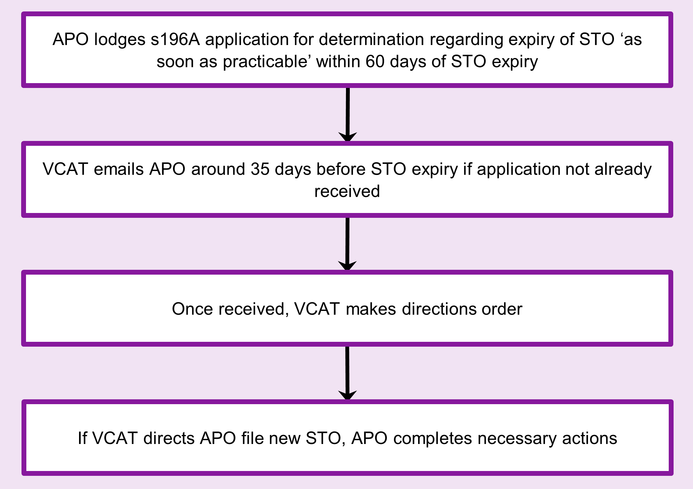

To receive this document in another format phone 03 9096 8427, using the National Relay Service 13 36 77 if required, or email the Senior Practitioner <VictorianSeniorPractitioner@dffh.vic.gov.au>.
Authorised and published by the Victorian Government, 1 Treasury Place, Melbourne.
© State of Victoria, Australia, Department of Families, Fairness and Housing, April 2021.
Available on the DHHS website’s Senior Practitioner page <https://www.dhhs.vic.gov.au/victorian-senior-practitioner>.

