

Process 2: Apply for a supervised treatment order – new clients
Compulsory treatment – Senior Practitioner
OFFICIAL
Contents
Acronyms 1
Supervised treatment orders 1
Section 191 criteria 1
Application process 2
Figure 1: Application process 4
APO to do list 5

Acronyms
- APO: Authorised Program Officer
- BSP: Behaviour support plan
- NDIS: National Disability Insurance Scheme
- OPA: Office of the Public Advocate
- SDA: Specialist disability accommodation
- SP: Senior Practitioner
- STO: Supervised treatment order
- VCAT: Victorian Administrative and Civil Tribunal

Supervised treatment orders

Section 191 criteria
Under section 191 of the Disability Act 2006, the person must:
- have an intellectual disability
- receive residential services or SDA under a residency agreement (refer to section 3 of the Act for definitions)
- have a treatment plan approved by the Senior Practitioner (SP) that addresses criteria s191(6) and s191(7) and, for SDA recipients, with the person’s NDIS behaviour support plan attached:

VCAT can only make a STO if VCAT is satisfied that:
- the person has previously exhibited a pattern of violent or dangerous behaviour causing serious harm to another person or exposing another person to a significant risk of serious harm
- there is a significant risk of serious harm to another person which cannot be substantially reduced by using less restrictive means
- the services to be provided to the person in line with the treatment plan (or NDIS behaviour support plan if written by a registered NDIS behaviour support practitioner) will be beneficial to the person and substantially reduce the significant risk of serious harm to another person
- the person is unable or unwilling to consent to voluntarily complying with a treatment plan or NDIS behaviour support plan to substantially reduce the significant risk of serious harm to another person
- it is necessary to detain the person to ensure compliance with the treatment plan or NDIS behaviour plan and prevent a significant risk of serious harm to another person.

Application process

Step 1: Gather your evidence
- Review relevant assessments and documentation from multiple sources to inform the application (such as quality of life information, adaptive behavioural assessments, functional behaviour analysis, behavioural data recording, mental health)
- A current assessment of the person’s risk towards others and individual needs is required to inform the application. If a recent one has not been undertaken, this should be completed as soon as possible by an appropriately qualified clinician
NDIS consideration: all assessments listed in this step are considered critical to identify the needs of the person with a disability and behaviours of concern, and to ensure restrictive practices meet their needs effectively

Step 2: Talk to Compulsory Treatment team as soon as possible
Talk to a member of the Compulsory Treatment team as early as possible.
Outcomes of this discussion may include:
- further assessments to be completed
- confirming the behaviour support plan (BSP)
- developing a treatment plan
- sourcing a lead clinician to oversee the implementation of the treatment.
These requests are likely to be needed to verify that detention and supervision is necessary to manage risk and are the least restrictive under the circumstances.

Step 3: Are the STO criteria met?
After reviewing further assessments, the APO and care team considers if the person meets the section 191 criteria for a STO.
- If Yes: go to Step 4A: Prepare treatment plan.
- If No: go to Step 4B Update BSP to reflect assessment findings.

Step 4A: Prepare treatment plan
Prepare a treatment plan in RIDS outlining what you will do over the next time period to reduce the risk the client poses to others, address pro-social behaviour change and enhance their quality of life.
Contact SP’s Office on 9096 8427 for help setting up a new entry in RIDS.
Note: you cannot make an application to VCAT without an approved treatment plan and certificate from SP.

NDIS considerations:
- The APO authorises the treatment plan, but an NDIS registered behaviour support practitioner should help write the plan.
- The APO and a National Disability Insurance Agency planner need to work together to ensure funding is secured to implement the plan and address directions.
- Both the ‘offending behaviour’ and ‘behaviours of concern’ sections need to be completed in the treatment plan for the treatment plan to be used as the behaviour support plan (facilitating reporting to the NDIS Quality and Safeguards Commission).

Step 4B: Update BSP to reflect assessment findings
Update the BSP to reflect the assessment findings and include all types of behavioural interventions and restrictive practices used to manage any behaviours of concern.
Additional practices should include:
- set up care team meetings
- set goals and action plan
- define roles within the team
- track outcomes and review.
For NDIS BSP, request an NDIS behaviour support practitioner to the NDIS BSP.
Figure 1: Application process
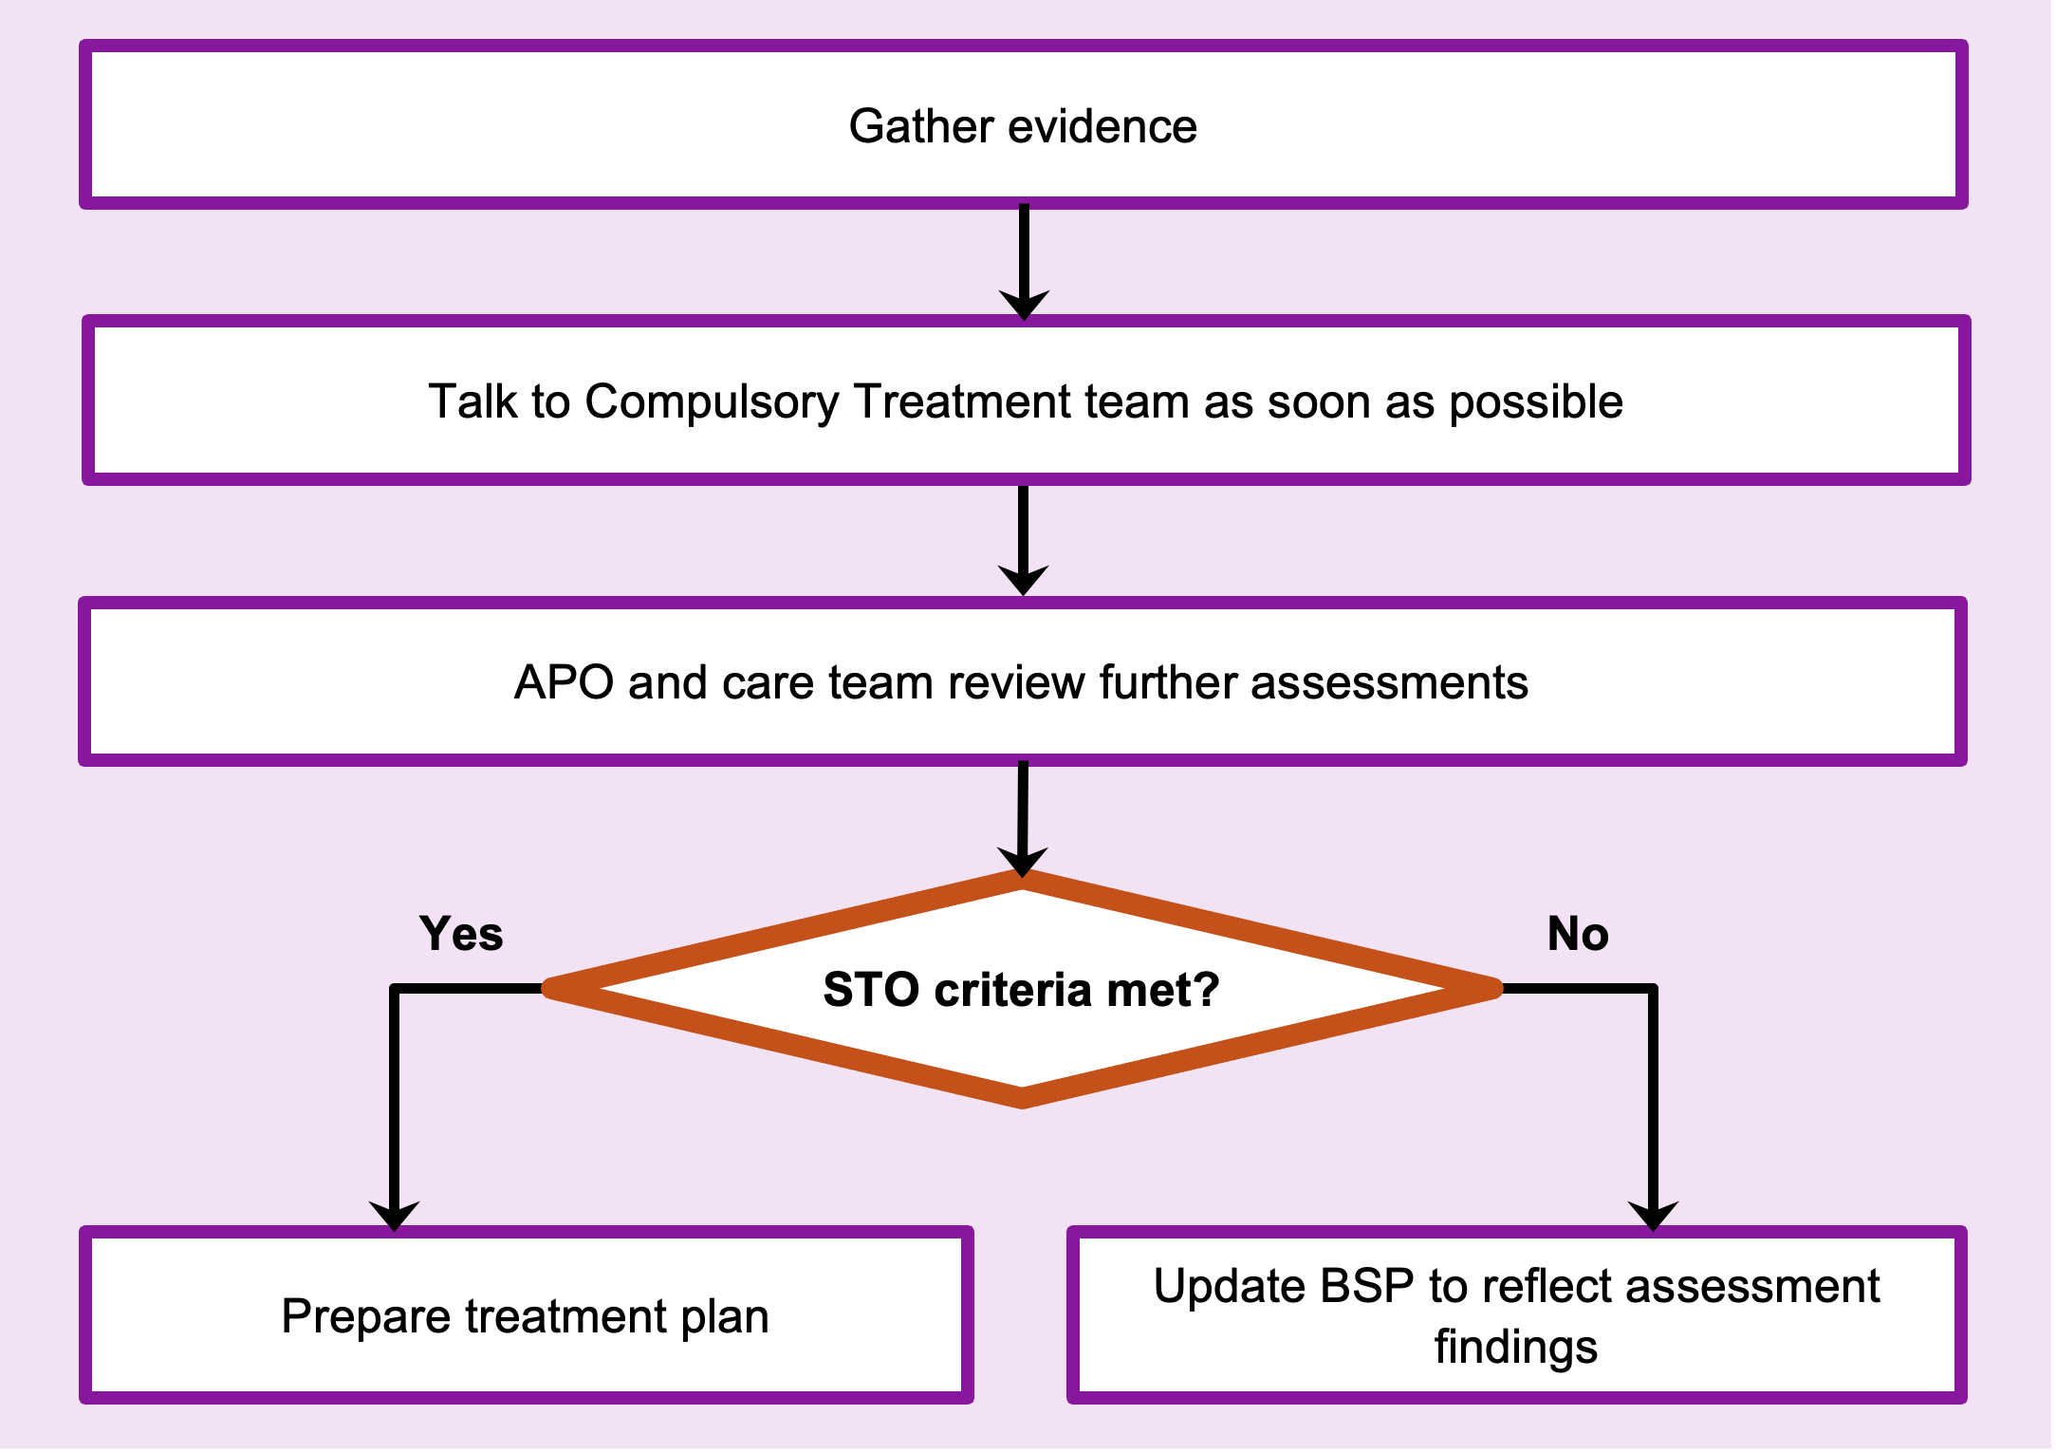

APO to do list
- Submit an online application with VCAT for a new STO (tick s193 box) – s 191(1) for people living in residential services by a disability service provider and s 191(1A) for people living in an SDA-enrolled dwelling under an SDA residency agreement
See the VCAT website’s Apply for an order under the Disability Act page <https://www.vcat.vic.gov.au/disability-act/apply-for-an-order-under-the-disability-act>.
- Save the completed application and upload to RIDS by setting up a new compulsory treatment file.
- Submit an electronic treatment plan to the SP, which requires the APO to authorise the plan.
- Upload any supporting materials (including a risk assessment and any other assessments) to RIDS.
- SP will review and approve the plan, and submit a treatment plan certificate via RIDS before the hearing date or by the date set by VCAT’s directions order. The certificate must be attached to the VCAT application – this should be one of the first steps.
- Ensure the person to be subject to the STO and OPA have been notified that an application for a STO has been made.
- Support the person to access legal representation and provide copies of all supporting materials to the legal representative as soon as possible.
- Before the hearing, SP will provide the certificate. The APO should review the directions and either update the plan with track changes, circulate to parties before the hearing, bring it to the hearing or mentally prepare responses to the directions.
- Attend the hearing with the person, review the s191 criteria (Appendix A to the plan) and summarise the goals proposed in the plan.
- The APO is responsible for implementing the treatment plan. Changes to the plan requires either SP or VCAT approval or both.
- Ensure a care team is set up to monitor progress against treatment goals and manage the person’s risk towards others.

To receive this document in another format phone 03 9096 8427, using the National Relay Service 13 36 77 if required, or email the Senior Practitioner <VictorianSeniorPractitioner@dffh.vic.gov.au>.
Authorised and published by the Victorian Government, 1 Treasury Place, Melbourne.
© State of Victoria, Australia, Department of Families, Fairness and Housing, April 2021.
Available on the DHHS website’s Senior Practitioner page <https://www.dhhs.vic.gov.au/victorian-senior-practitioner>.

