

Process 12: Revoke a supervised treatment order
Compulsory treatment – Senior Practitioner
OFFICIAL
Contents
Acronyms 1
Revoking a supervised treatment order (STO) 1
Process 1
Figure 1: How to revoke a STO 3

Acronyms
- APO: Authorised Program Officer
- RIDS: Restrictive Intervention Data System
- STO: Supervised treatment order
- VCAT: Victorian Administrative and Civil Tribunal

Revoking a supervised treatment order (STO)

Process

Step 1: Gather your evidence
Gather and review relevant assessments and documentation from multiple sources to inform the application. This may include:
- quality of life information
- adaptive behavioural assessments
- functional behaviour assessment and behaviour support plan
- behavioural data records
- mental health plan.
A current assessment of the person’s risk towards others and individual needs is required to inform the application. If a recent risk assessment has not been completed, arrange one with an appropriately qualified clinician as soon as possible.

Step 2: Talk to Compulsory Treatment team
Talk to a member of the Compulsory Treatment team as early as possible.
This should happen at least 75 days before the order expires to allow enough time for any further assessments to be conducted and reports to be made available.

Things to consider
- What has changed since the last application? What has influenced these changes?
- What criteria are no longer met and why? You must support this with objective evidence and documentation. Refer to section 191(6)(a to e) of the Disability Act 2006.
- How long have the changes been noted? That is, has there been a consistent change over time, backed by evidence from objective sources like incident reports and other data.

Step 3: Does the person meet all s191 criteria?
Does the person meet all the criteria set out in s191 of the Disability Act that allows a STO to be made?
- No: Go to Step 4: Prepare revocation submission to VCAT
- Yes: Prepare a revised treatment plan and reapply for a STO before the current order expires [process ends].

Step 4: Prepare revocation submission to VCAT
The submission needs to address the criteria in the Disability Act. It should set out all evidence for the criteria that the person continues to meet and, importantly, the criteria that are no longer meet.
The submission should also include what the plan for the person will look like after revocation, including:
- a crisis plan, in the case of increased risk and what the ongoing supports for the person will be
- a behaviour support plan or NDIS behaviour support plan for NDIS participants if there are ongoing restrictive practices.

Step 5: APO applies to VCAT for revocation
The APO applies to VCAT under s196(1)(c) to have the order revoked.
On the VCAT form, choose ‘revocation’ instead of a review of the plan.
Figure 1: How to revoke a STO
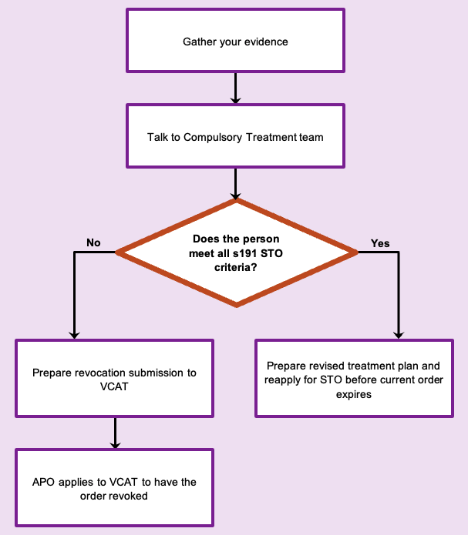

To receive this document in another format phone 03 9096 8427, using the National Relay Service 13 36 77 if required, or email the Senior Practitioner <VictorianSeniorPractitioner@dffh.vic.gov.au>.
Authorised and published by the Victorian Government, 1 Treasury Place, Melbourne.
© State of Victoria, Australia, Department of Families, Fairness and Housing, April 2021.
Available on the DHHS website’s Senior Practitioner page <https://www.dhhs.vic.gov.au/victorian-senior-practitioner>.

