

Process 10: Submit a treatment plan with amendments
Compulsory treatment – Senior Practitioner
OFFICIAL
Contents
Acronyms 1
Track changes 1
Process 1
Figure 1: Track changes process 2
Material changes 3
Material change process 3
VCAT process 3
No VCAT process 4
RIDS material change process 4
Figure 2: Material changes process 5

Acronyms
- APO: Authorised Program Officer
- RIDS: Restrictive Intervention Data System
- SP: Senior Practitioner
- VCAT: Victorian Administrative and Civil Tribunal

Track changes
Track changes refer to any changes required to the treatment plan as requested by the Senior Practitioner (SP) in a treatment certificate and as agreed between parties at a VCAT hearing.

Process

Step 1: APO gives SP track changes version of treatment plan
The Authorised Program Office (APO) gives the SP (and other parties if directed at a hearing) with a track changes version (via RIDS) for review within the required timeframe as directed at the hearing.

Step 2: Compulsory Treatment team reviews track changes
The Compulsory Treatment team reviews the track changes submitted and gives the APO feedback if needed.

Step 3: SP approves plan
Following review by the Compulsory Treatment team, the SP approves the plan in RIDS.
Figure 1: Track changes process
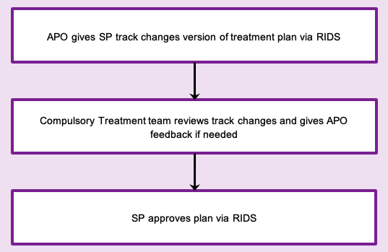

Material changes
Material changes occur when significant changes must be made during the life of the plan, for example:
- an increase in chemical restraint where this is outside the therapeutic range in the plan
- an additional restrictive practice requiring authorisation
- significant changes to the content of the plan.
A material change hearing at VCAT is required to make such significant changes.
If the changes refer to a reduction in restrictive practices, this can be approved by the SP.
For clarification on specific changes and required processes, talk to the Compulsory Treatment team.

Material change process

Step 1: Email SP, detailing change and context
For material changes going to SP for approval, send SP an email detailing the change needed and the context for the change.

Step 2: SP reviews request
SP reviews the email request and responds to the APO via email with their decision.

Step 3: Does the material change need VCAT approval?
- Yes: Go to VCAT process.
- No: Go to No VCAT process.

VCAT process

Step 1: Complete VCAT application
For material changes requiring a VCAT hearing, complete the VCAT application form and include the treatment plan with variations shown as clear track changes. See RIDS material change process.
Where appropriate, the application should include a request that the hearing be held in chambers.

Step 2: APO supports the person to access legal representation
The APO should support the person to access legal representation.
All materials for hearing should be supplied to the person’s legal representation.

Step 3: Where appropriate, VCAT emails all parties
For VCAT material changes, VCAT will email all parties seeking consent for the hearing to be held in chambers, if appropriate.

Step 4: APO completes material change process in RIDS
Once VCAT issue an order, the APO follows the material change process in RIDS and submits the draft plan in RIDS for SP approval. See RIDS material change process.

Step 5: SP approves change
The SP approves the change in RIDS.

No VCAT process

Step 1: APO finalises treatment plan
The APO finalises the treatment plan and follows the material change process in RIDS. See RIDS material change process.

Step 2: SP approves change
The SP approves the change in RIDS.

RIDS material change process
- Select ‘Edit/modify restrictive interventions’ in the treatment plan and confirm notification has occurred with the SP.
- Describe the change in detail.
- Provide a rationale for the application.
- Provide information on how long the change will be in place.
- Describe how the change will be implemented and monitored.
- Once the plan has been edited, save it in draft.
Figure 2: Material changes process
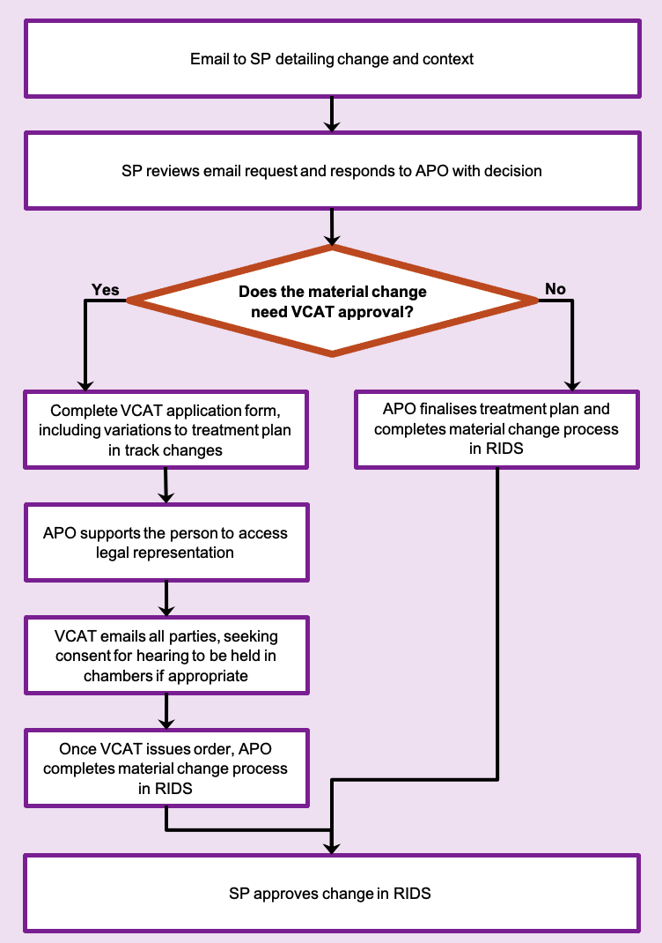
To receive this document in another format phone 03 9096 8427, using the National Relay Service 13 36 77 if required, or email the Senior Practitioner <VictorianSeniorPractitioner@dffh.vic.gov.au>.
Authorised and published by the Victorian Government, 1 Treasury Place, Melbourne.
© State of Victoria, Australia, Department of Families, Fairness and Housing, April 2021.
Available on the DHHS website’s Senior Practitioner page <https://www.dhhs.vic.gov.au/victorian-senior-practitioner>.

