Partnership Agreement between the Department of Health and Human Services and the Municipal Association of Victoria 2018–2023
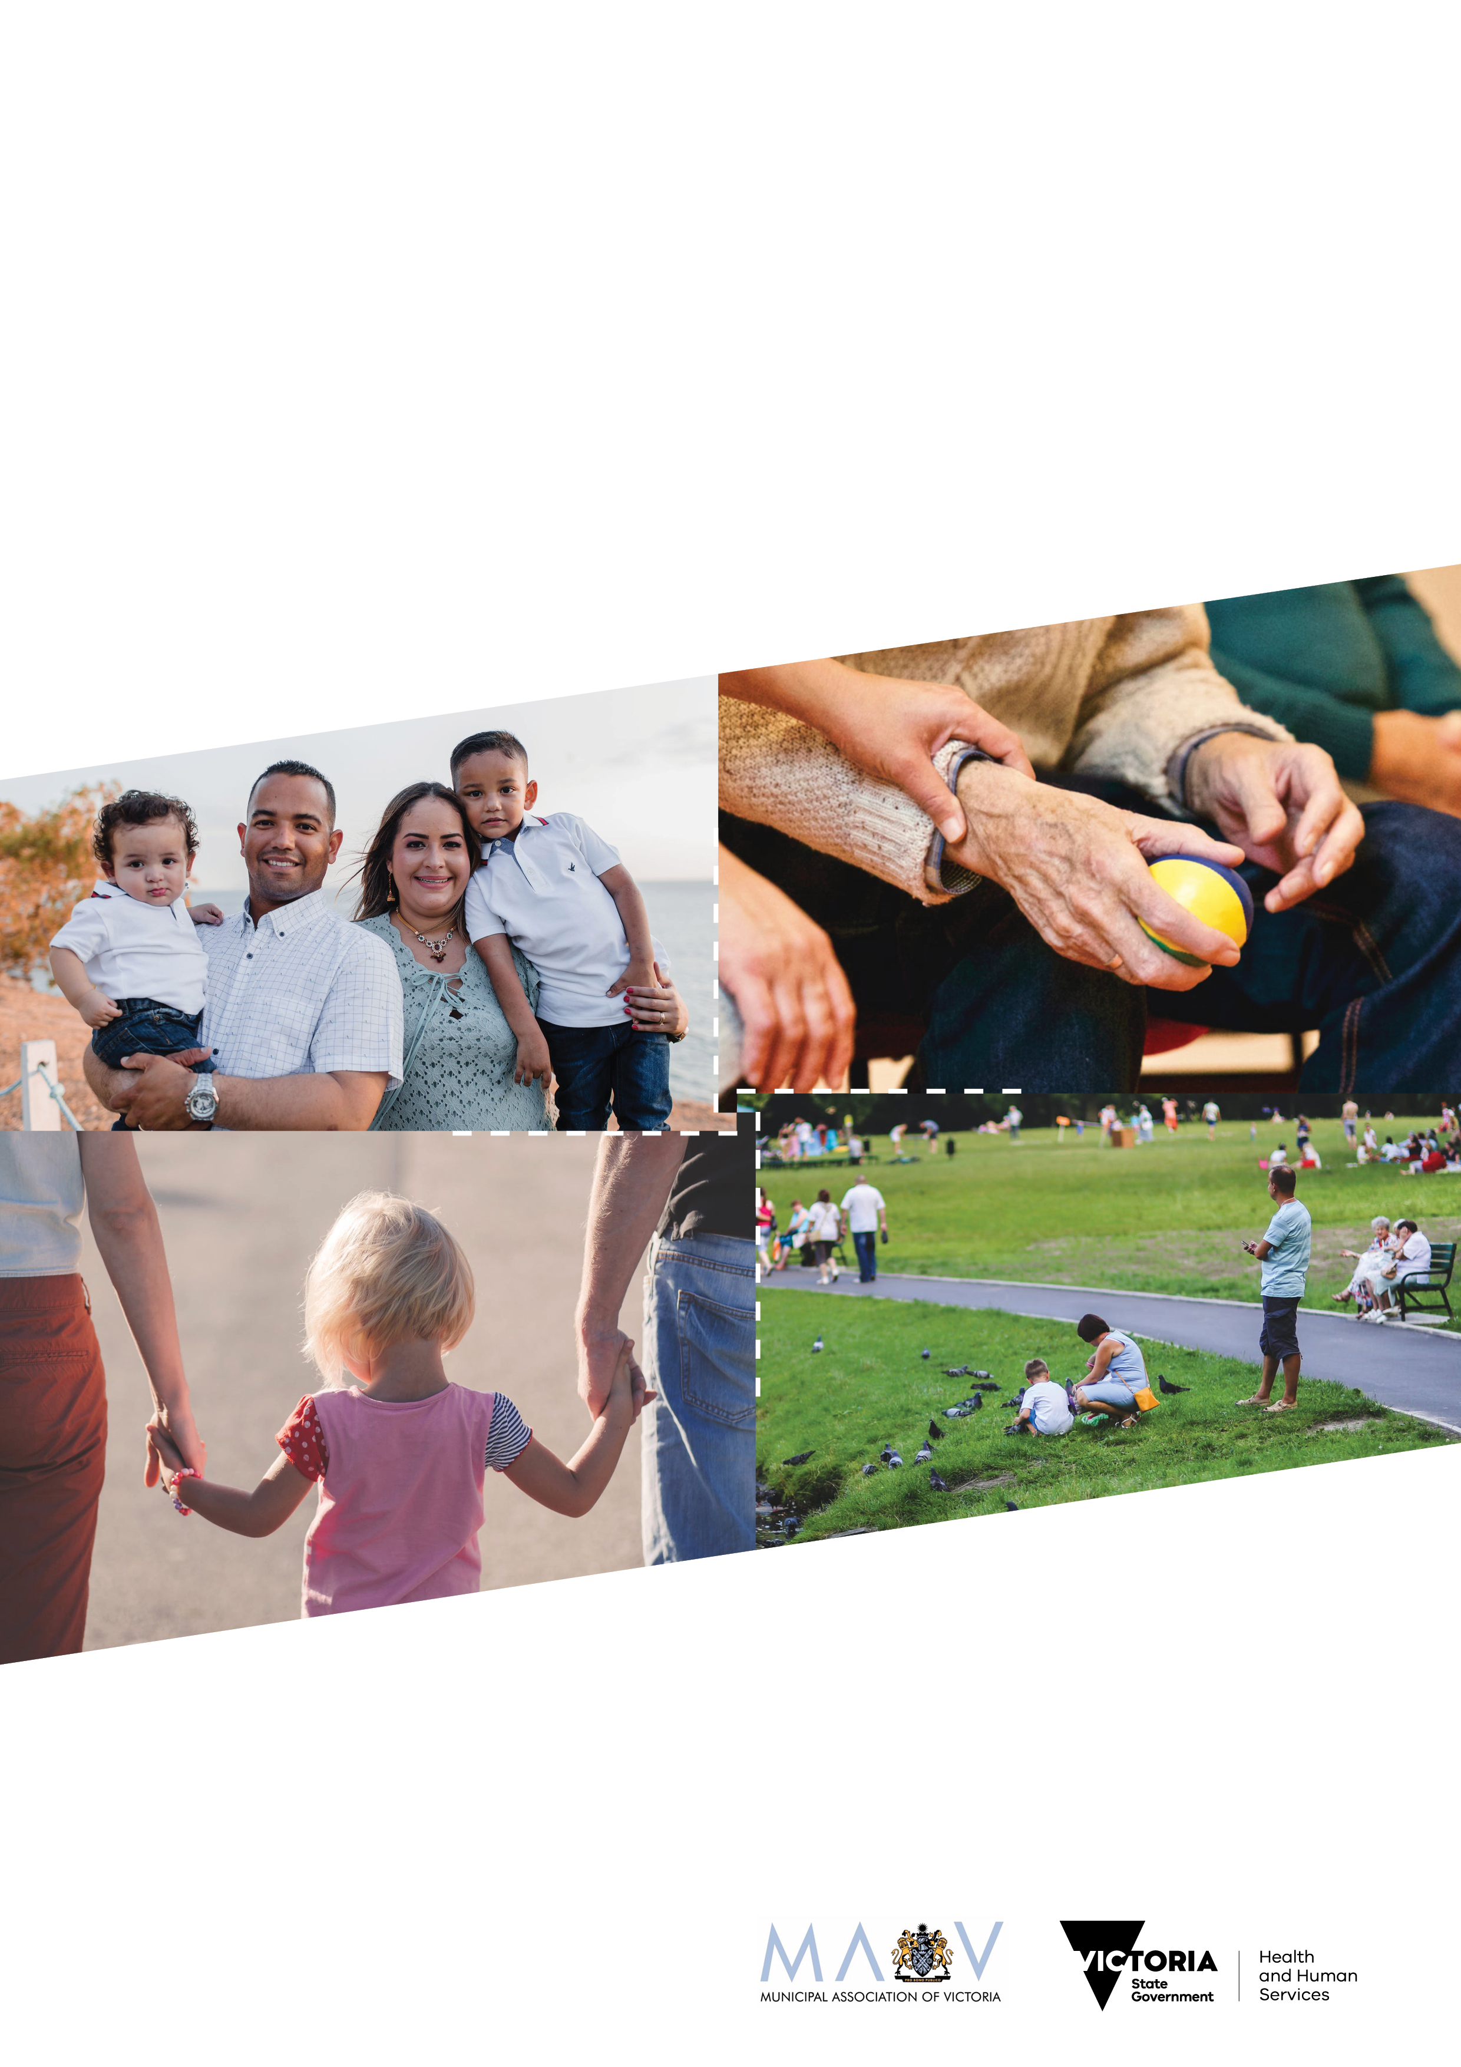

To receive this publication in an accessible format email commstate@dhhs.vic.gov.au
Authorised and published by the Victorian Government, 1 Treasury Place, Melbourne.
© State of Victoria, Department of Health and Human Services December, 2018
Except where otherwise indicated, the images in this publication show models and illustrative settings only, and do not necessarily depict actual services, facilities or recipients of services.
Where the term ‘Aboriginal’ is used it refers to both Aboriginal and Torres Strait Islander people.
ISBN 978-1-76069-739-6

Contents
Preamble 4
Agreement 5
1. Aim 5
2. Principles 5
3. Related Agreements 5
4. Respective Roles and Responsibilities 6
5. Mutual areas of interest 8
6. Implementing this agreement 8
7. Managing Difference 9
8. Monitor and Review 9
9. Term of Agreement 9

Preamble
The Department of Health and Human Services and the Municipal Association Victoria commit to a formal partnership that is based on a spirit of cooperation and shared commitment to achieve better health and wellbeing outcomes for the Victorian community.
This Partnership Agreement (the Agreement) is entered into by the Department of Health and Human Services (the department) and the Municipal Association of Victoria (MAV), representing local government.
The Agreement acknowledges the important working partnership between the department and local government in the areas of health and human services. It recognises the complementary roles played by the Victorian Government and local government in planning, funding and delivering these services.
This Agreement, together with the Victorian State Local Government Agreement, provides an overarching framework to guide the range of existing and future relationships, agreements and activities undertaken by the department and local government, including:
        - the negotiation of memoranda of understanding on specific programs between the MAV and the department
        - the negotiation of funding and service agreements between the department’s regional offices and specific local government councils
        - planning, policy, program development, service coordination and evaluation at state-wide, regional and local government levels.
This agreement is the third update of this department and MAV agreement, reflecting changes in the machinery of government as well as the introduction of major social programs such as the National Disability Insurance Scheme and changes to the aged care system.
This Agreement replaces the Partnership Protocol entered into between the department and MAV in October 2010.

Kym Peake
Secretary
Department of Health and Human Services

Kerry Thompson
Chief Executive Officer
Municipal Association of Victoria on behalf of local councils in Victoria

Agreement

Aim
This Agreement formalises a set of principles for the partnership between Department of Health and Human Services (the department) and the Municipal Association of Victoria (the MAV), on behalf of local government.
The parties acknowledge and agree that this is not intended to create legal obligations between the parties but instead is intended to support a positive working relationship between the parties.

Principles
A successful partnership requires a spirit of cooperation and commitment based on the following principles:
- understanding and respect for each party’s specific legislative and electoral mandates and responsibilities
- shared focus on outcomes for local and regional communities
- open and timely communication and consultation
  - understanding of the resource capacities of each party.

Related Agreements
The Victorian state local government agreement strengthens state–local government relations by formally committing to principles and guidelines that clarify roles, responsibilities and financial arrangements.
In addition, departmental agreements provide clarity about programs, planning and responsibilities at a departmental level. These include the following, as shown in figure 1:
- The department is a signatory with the MAV on a Tripartite Statement of Intent with the Commonwealth on aged and disability matters.
- Supporting children and families in the early years: a compact between DET, DHHS and local government (represented by MAV) aims to strengthen the collaborative relationship between these departments and local government in the planning, development and provision of early years services. The compact demonstrates a shared focus on improving and sustaining outcomes for children and families across all Victorian communities.
- The Early childhood agreement for children in out-of-home care is an agreement between the department, the Department of Education and Training, the MAV and Early Learning Association Australia which aims to support the development and wellbeing of young children in out-of-home care.
- The DET-MAV partnership agreement builds on mutual support and collaboration in order to improve outcomes for children, young people and their families. It recognises the collaborative relationship between the Department of Education and Training and councils in the planning, development and provision of initiatives, infrastructure and services across early childhood, schools, TAFE and training.
- The department also has a Service Agreement with MAV which includes a number of service plans, currently covering:
    - aged community care, diversity and positive ageing
    - NDIS disability services reform transition and disability employment / economic development
    - family violence prevention
    - tobacco control activity
    - food safety reform and street trader system maintenance
    - public health regulation review

Figure 1: Related agreements
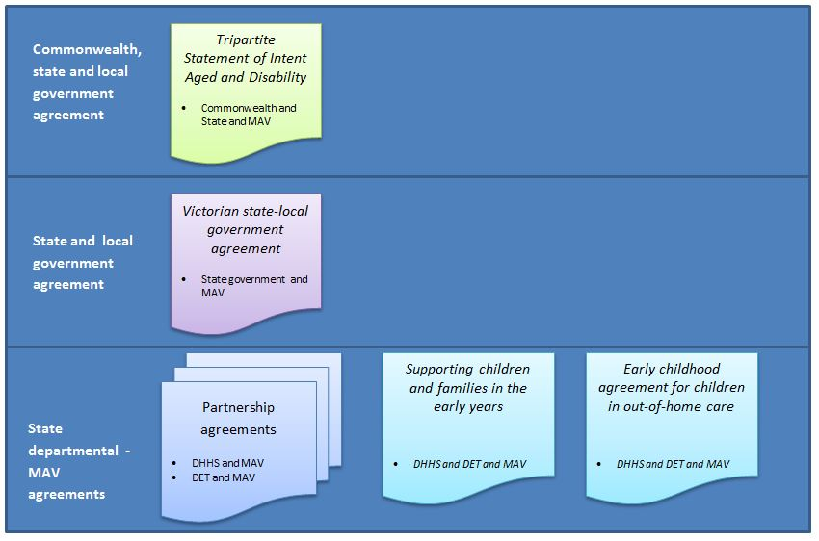

Respective Roles and Responsibilities
State and local government share governance and planning responsibilities for the social, economic, physical and environmental wellbeing of the community. This involves policy and planning, facilitation of infrastructure development and maintenance and the resourcing of services to meet community needs. Each sphere of government recognises each other’s specific obligations as well as its complementary roles and capacities.

The Department of Health and Human Services
The department brings together the functions of health and human services. It takes a broad view of the causes of ill health, the drivers of good health, the social and economic context in which people live, and the incidence and experience of vulnerability. This allows the department to place people at the heart of policy making, service design and service delivery.
The department’s structure provides for integrated stewardship of the systems and outcomes in health and human services. Central divisions lead policy development, service and funding design and system management. Four operational divisions oversee and coordinate the delivery and funding of services and initiatives across 17 areas of the state. Each division covers a mix of rural, outer-metropolitan and inner metropolitan areas of Victoria.
The department’s principal responsibilities include provision of:
- a range of accommodation and support services aimed at enhancing the quality of life of people with disabilities
- housing assistance and support for homeless people and for people experiencing family violence
- early intervention and family support services for Victorian families
- child protection functions which meet the State’s statutory responsibilities for vulnerable children and young people
- secure, affordable and appropriate housing for low-income Victorians
- government concessions to low-income groups to improve the affordability of services
- health care services through the public hospital system, community health services and ambulance services
- prevention and health promotion activities through public health and education
- health protection though emergency management, including regional relief and recovery, regional health coordination, education and regulation
- public mental health services, comprising clinical services and psychiatric disability rehabilitation and support services
  - residential and rehabilitation care for older people, along with support and assistance to enable them to remain independently in their own homes.
The department is a direct service provider in disability services, child protection and public rental housing, and also allocates funds for the provision of services by non-government organisations, government related agencies and local government in relation to a range of community services.
In ensuring the provision of wide ranging health and human services, the department has outlined the following priority actions to assist in realising the mission to achieve the best health and wellbeing outcomes for all Victorians:
- support people to live healthier, more active lives and participate in their local communities
- empowering patients, clients and carers
- build the capacity of universal services to better respond to risk and vulnerability
- increase earlier intervention
- reduce waits for health and human services
- make it easier to access better connected care
- improve Aboriginal health and wellbeing
- support better safer care
  - planning together for the future.

The Municipal Association of Victoria
The MAV is a statutory body established by the Municipal Association Act 1907. The Act vests the MAV with the responsibility to promote the interests of local government and represent all Victorian councils. In this capacity, the MAV has negotiated and entered into this Agreement on behalf of Victorian local government.
The MAV is not a provider of community services, but may be funded by the department to deliver agreed strategic initiatives through the existing Service Agreement.
Councils are elected by their communities and have legislative and community responsibility based on an electoral mandate to plan for local areas and to ensure community health and wellbeing.
Local government’s power to promote community-based planning and to negotiate resource allocation and service agreements with other spheres of government is principally derived from the Victorian Local Government Act 1989.
There are other statutory responsibilities conferred on local government such as under the Public Health and Wellbeing Act 2008 (and Public Health and Wellbeing Regulations 2009), which requires that local government councils ‘seek to protect, improve and promote public health and wellbeing within the municipal district'. The Food Act 1984 and the Emergency Management Act 1986 also require councils to provide designated services. These services are funded and delivered by local government.
Local government takes a lead role in local planning and coordination of community health and wellbeing initiatives across a broad range of functions and with a broad range of stakeholders.
The range of services delivered by local government includes: housing, health, cultural development, leisure and recreation, arts, Aboriginal and Torres Strait Islander relations, ethnic relations, public libraries, community information, education, employment, family and children’s services, services for young people, services for older people and services for people with disabilities and emergency management. Some of these services are mandated by statute and others by the identification of community need.
Victorian local government is acknowledged as a national leader in the planning and provision of universal and targeted health and human services, including public health and emergency management.

Mutual areas of interest
Particular mutual areas of interest for the department and MAV are:
- strategic planning, including local area and place-based planning
- research and evaluation
- needs analysis and priority setting
- community consultation
- policy and program development
- resource allocation and funding criteria
- service models and service delivery
- public health and wellbeing
- emergency management community support and recovery
  - community building.

Implementing this agreement
With the support and assistance of the MAV, the department and local government will, to the extent that it is appropriate in the circumstances:
- engage in timely, cooperative and meaningful consultation on the formation of policies which affect the other party and agree to negotiate on issues of mutual concern
- encourage the development of local and program specific agreements between elements of each party within the framework of this Agreement
- share relevant data and information to inform strategic and program/service planning, subject to any relevant laws
- develop a common understanding of priority needs, which will inform the department’s and local government’s respective resource allocation decisions
  - review the effectiveness of this Agreement at the request of either party.

As individual organisations we:

Department of Health and Human Services
- acknowledge local government as a sphere of government as well as a service provider and regulator within its jurisdiction
- acknowledge the important role of local government in health and human services
- recognise the diverse responsibility of local government for service provision
- acknowledge the additional funding for health and human services provided by individual councils
- recognise that advocacy is a legitimate role undertaken by local government on behalf of their communities
- understand and accept the role of local government and its ability to accurately reflect community needs
- plan in a proactive and coordinated way with local government to enhance the health and wellbeing of each region’s communities and individuals, through the department’s area offices
- maintain a focus on outcomes in setting health and human services policy objectives which address community needs and expectations
- recognise the representational and advocacy role of the MAV on behalf of local government
- engage with the MAV, as the statutory body representing Victorian local government, to negotiate state-wide program arrangements as required
  - relate to local government in a manner that is coordinated and consistent.

Municipal Association of Victoria
- acknowledge the important regional and whole-of-Victoria role of the department in health and human services planning, regulation, monitoring and service delivery
- acknowledge and support the existing relationships between local government and the department’s area offices
- facilitate local government’s involvement in and implementation of the Agreement
- encourage program-related agreements on behalf of the local government sector with the department at the state-wide level
- communicate to the department opportunities for structural and program reform identified by local government
- support capacity development of local government to plan in a proactive and co-ordinated way to enhance the health and wellbeing of each region’s communities and individuals
- encourage local government in its pursuit of efficiency and effectiveness in the exercise of its governance and operational responsibilities
  - meet specific requirements of the Service Agreement with the department.

Managing Difference
The parties agree to work constructively in a spirit of goodwill, recognising that the positions of each sphere of government may at times differ. If one party believes the Agreement is not being fulfilled, they will initiate discussions with the other party to resolve the issue or concern.
The Agreement also recognises that local government and the department have a contractual relationship in a range of program delivery areas and the existing mechanisms for dispute resolution contained in those contracts will be retained and adhered to.

Monitor and Review
The parties agree to monitor the implementation of the Agreement through a mid-way scan of our joint activities and intersections after the first two years and following that as agreed on a joint basis.

Term of Agreement
This agreement will have a five year term, commencing from the date of signing.

