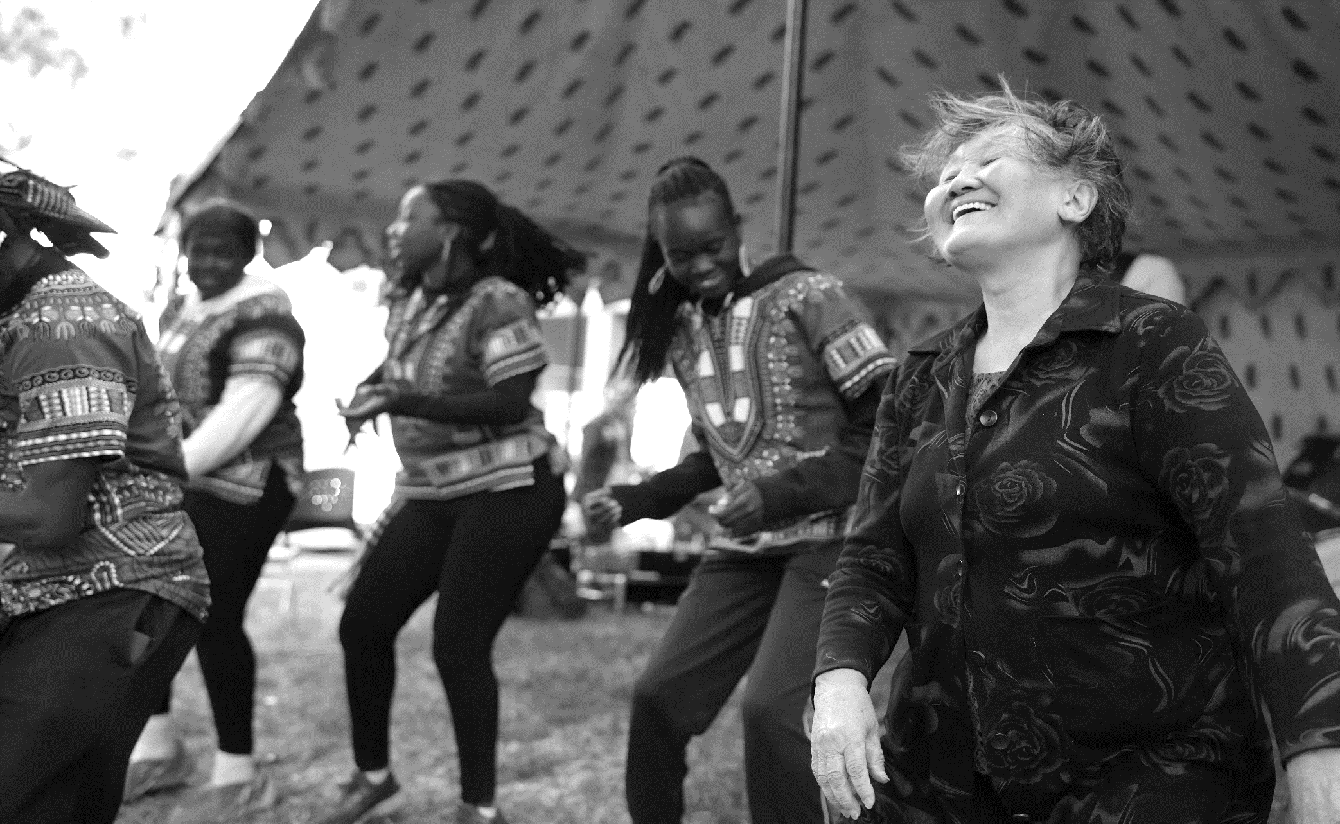

NORTH RICHMOND PRECINCT
COMMUNITY GRANTS PROGRAM GUIDELINES 2023 – 2024


LANGUAGE ASSISTANCE
Applications for the 2023-2024 North Richmond Precinct Community Grants open on Wednesday 15 November and close 11.59pm on Sunday 14 January. In-language support with writing and submitting grant applications will be provided. More information will be available from 15 November.
2023-2024年北里士满社区拨款申请将于11月15日星期三开放，截止时间为1月14日星期日晚上11:59。将提供以语言为基础的支持，帮助撰写和提交拨款申请。更多信息将于11月15日公布。

Đăng ký xin tài trợ cộng đồng khu vực Bắc Richmond năm 2023-2024 sẽ mở vào Thứ Tư, ngày 15 tháng 11 và kết thúc lúc 11:59 tối Chủ Nhật, ngày 14 tháng 1. Hỗ trợ ngôn ngữ trong việc viết và nộp đơn đăng ký tài trợ sẽ được cung cấp. Thêm thông tin sẽ có từ ngày 15 tháng 11.

تفتح طلبات الدعم المجتمعي لمنطقة نورث ريتشموند للمشاريع عام 2023-2024 يوم الأربعاء الموافق 15 نوفمبر وتغلق في تمام الساعة 11:59 مساءً يوم الأحد الموافق 14 يناير.
سيتم توفير دعم باللغة لكتابة وتقديم طلبات التمويل. ستتاح مزيد من المعلومات اعتبارًا من 15 نوفمبر.

AKNOWLEDGEMENT OF COUNTRY
The Department of Families, Fairness and Housing acknowledges the Traditional Owners of the land on which the North Richmond Precinct is located, the Wurundjeri people of the Kulin Nation. We pay respect to their Elders past and present and to the ongoing living culture of all Aboriginal and Torres Strait Islander peoples.

CONTENTS

WHAT IS THE NORTH RICHMOND PRECINCT COMMUNITY GRANTS PROGRAM? 4
KEY DATES 5
HOW TO USE THESE GUIDELINES 6
NORTH RICHMOND COMMUNITY GRANT PROGRAM OBJECTIVES 7
COMMUNITY STRENGTHENING GRANTS 8
COMMUNITY STRENGTHENING GRANTS ASSESSMENT CRITERIA: $1,000 - $5,000 GRANTS 12
COMMUNITY STRENGTHENING GRANTS ASSESSMENT CRITERIA: $5,001 - $30,000 GRANTS 13
COMMUNITY INFRASTRUCTURE GRANTS 14
COMMUNITY INFRASTRUCTURE PLANNING GRANTS ASSESSMENT CRITERIA 18
COMMUNITY INFRASTRUCTURE CAPITAL WORKS GRANTS ASSESSMENT CRITERIA 20
HOW TO APPLY FOR A NORTH RICHMOND PRECINCT COMMUNITY GRANT 21
KEY STEPS 21
WHAT SUPPORTING DOCUMENTATION DO I NEED? 22
CHECKLIST: PREPARING YOUR APPLICATION 23
SUBMITTING YOUR ONLINE APPLICATION 24
HOW IS MY GRANT APPLICATION ASSESSED? 25
WHAT HAPPENS NEXT? 26
GRANT SUPPORT 27
RESOURCES 28
APPENDIX ONE: NORTH RICHMOND PRECINCT MAP 30

WHAT IS THE NORTH RICHMOND PRECINCT COMMUNITY GRANTS PROGRAM?

The North Richmond Precinct Community Grants Program (the grants program) is funded by the Victorian Government. The program provides funding to support community-identified projects to strengthen and enrich community life and create a safer, more connected and vibrant North Richmond Precinct.
The Department of Families, Fairness and Housing (the department) partners with North Richmond residents and community groups to develop partnerships, build capacity and strengthen skills, knowledge and experience. Refer to Appendix 1 for a map of the North Richmond Precinct.
The department welcomes applications from all eligible groups and organisations. Aboriginal organisations and groups are particularly encouraged to apply.
As a result of direct feedback from the North Richmond Precinct Community Committee members, the
2023-2024 grants program is made up of two categories, with two streams in each:
Category | Streams | Go to
Community Strengthening | $1000 - $5000 grants  $5001 - $30,000 grants | Page 11
Community Infrastructure | Planning grants: up to $30,000  Capital Works grants: $50,000 - $300,000 | Page 17


KEY DATES

February- April
2023 - 2024 North Richmond Precinct Community Grant applications open
Community information and support sessions held

Applications close
Applications assessed
Grant recipient approval
Funding agreements (contracts) produced and signed
Project funding transferred to grant recipients
Projects commence

Community Infrastructure Planning projects complete

Community Strengthening projects and final reporting complete

Community Infrastructure Capital Works projects and final reporting complete

November
January 2024
June
October
June 2025

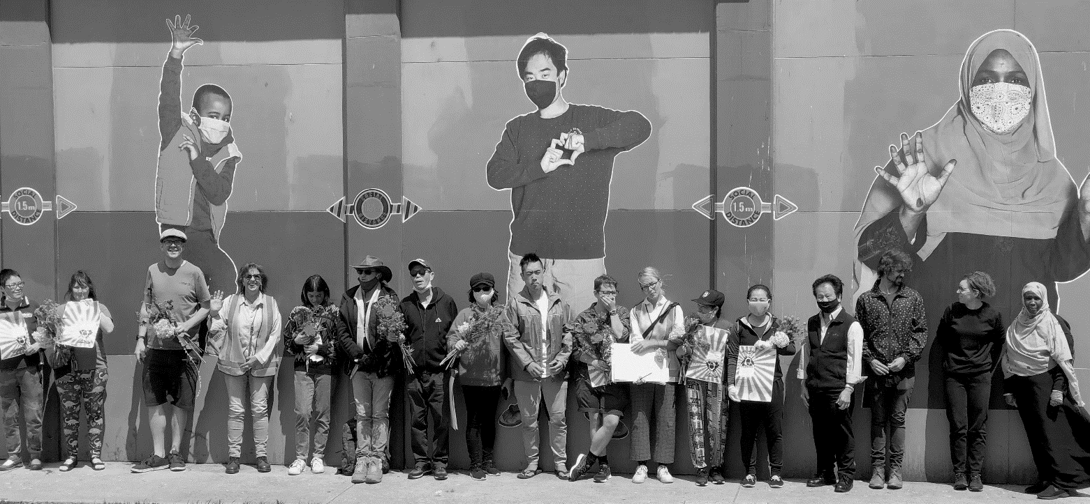

HOW TO USE THESE GUIDELINES

Grant guidelines are a set of specific instructions. They outline the information to include in your proposal to demonstrate that your project will respond to a community need. Reading the Program Guidelines is an essential first step before you start planning your application.
North Richmond Precinct Grant guidelines vary from year to year to allow for continuous improvement, so even if you have applied for grants in previous rounds, please read these guidelines carefully.
Please note that throughout this document, two key Precinct partners, Belgium Avenue Neighbourhood House and North Richmond Community Health, are referred to by their acronyms – BANH and NRCH.



NORTH RICHMOND COMMUNITY GRANT
PROGRAM OBJECTIVES
The objectives of this grants program are aligned with the key priority areas in the North Richmond Precinct Community Action Plan (2022-24), that was shaped by the voice of the community:

Safety, neighbourhood and amenity
To create and maintain inclusive, safe and vibrant spaces for everyone

Health, wellbeing and community participation
To ensure everyone has access to services and opportunities to support health, wellbeing and connection to the community

Economic revitalisation and inclusion
To revive Victoria Street as a cultural and commercial destination, building on the community’s diversity and delivering long-lasting and sustainable outcomes.

Local jobs for local people
To break down barriers that job seekers face and encourage local employers to actively support local people into employment.
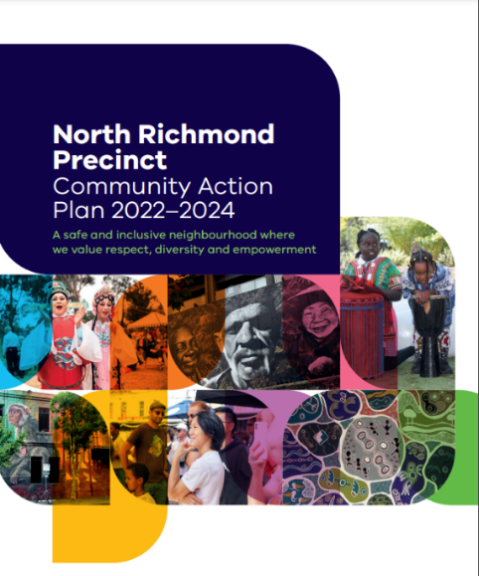

THE NORTH RICHMOND PRECINCT

COMMUNITY ACTION PLAN

The Action Plan was co-designed with North Richmond Precinct Community Committee (NRPCC) and reference groups as a long-term vision for change.
It serves as a roadmap, outlining community-identified goals and strategies
to provide a clear story of what a strong, healthy and safe North Richmond looks like.
We encourage you to refer to pages 12-15 of the Action Plan for some potential project ideas.

Read the Action Plan

Our project could not have gone ahead without this funding. It allowed us to scale the project, improve communication and create a strong community collaboration.
2023 grants recipient

COMMUNITY STRENGTHENING GRANTS

Stream 1: $1000 - $5000

Stream 2: $5001 - $30,000


Community Strengthening Grants are available for projects that:

- Identify and commemorate the history, heritage and culture of Aboriginal and Torres Strait Islander people
- Increase social connection and participation in local activities
- Respond to existing and emerging community needs
- Enhance current services within the North Richmond Precinct
- Increase skills, knowledge and leadership
- Job creation and employment pathways
- Revitalise the Victoria Street shopping strip
- Support environmental sustainability
- Activate existing infrastructure such as open spaces and sports facilities.

WHAT TYPES OF PROJECTS CAN BE FUNDED?
- Education programs
- Social inclusion
- Health promotion
- Sports programs
- Sustainability projects
- Community/public art
- Festivals, markets, events
- Programs to increase access to support services
- Guest speakers, classes and workshops
- Social outings
- Training and capacity building
- Programs that provide support to access employment and education.

WHAT CAN I USE MY FUNDING FOR?
- Temporary staff costs
- Promotional activities
- Printing, translations
- Costs to encourage participation including transport, interpreters
- Volunteer expenses
- Room and equipment hire
- Purchases of small equipment useful for the community and needed for the project (up to $500).

ELIGIBILITY

- Applicant can demonstrate an existing connection with the North Richmond Precinct
- All applications must be submitted by an incorporated organisation or auspiced by an incorporated organisation.
- Applications must include certificate of currency as evidence of public liability insurance with a minimum value of $20 million.
- No outstanding acquittal reports or unspent funds from previous grants rounds (except for projects that were funded in the previous (2022-23) grants round and are currently underway).



WHAT CAN’T BE FUNDED?
Funding for Community Strengthening Grants cannot be used to cover:

- Projects that do not align with these guidelines
- Projects that predominantly take place outside the North Richmond Precinct
- Projects that are the funding responsibility of the Commonwealth, state or local government
- Projects that have already started or have been completed
- Projects to support private business with no demonstrated community benefit
- Applications from individual applicants
- Applications from individual small businesses
- Costs for feasibility studies, research / study placements, business cases
- Ongoing maintenance costs
- Operational expenses that are ongoing costs for a business, such as rent, utilities, insurance, legal and marketing costs, wages, personal expenses
- Refurbishments and improvements to businesses, for example shopfronts (facades), fit outs
- Gifts and prizes
- Fundraising activities
- Repair works to broken items and equipment
- Equipment and appliances including barbeques, dishwashers, commercial kitchen equipment
- Proposals that are identical to previously funded projects
- Projects undertaken for profit
- Projects that cannot be delivered by 31 October 2024.



PAYMENT GUIDE
All Community Strengthening Grant recipients will receive 100 per cent of their grant funding upfront.

MONITORING AND REPORTING
$1000 - $5,000 stream:
- Evidence of expenditure of grant funding including all receipts and invoices.
- Monitoring (progress) reports and a final acquittal report are not required.

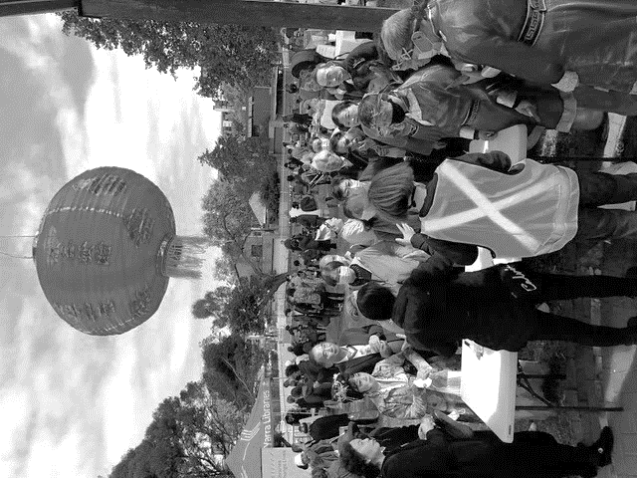
$5,001 - $30,000 stream:
- One monitoring / progress meeting between project leads or your auspice organisation and the North Richmond Precinct team.
- Final acquittal report must be submitted by 30 October 2024 on a template provided by the North Richmond Precinct Team, including supporting documentation
(eg photos, social media posts) and evidence of expenditure of grant funding including all receipts and invoices.

COMMUNITY STRENGTHENING GRANTS ASSESSMENT CRITERIA:
$1,000 - $5,000 GRANTS

A copy of the application form questions is available in the Resources and Support section of the Precinct website.

Criteria | Demonstration | Weighting
The project responds to community need | - What is your project?  - Why is this project needed?  - Who is your target audience? | 40%
Members of the North Richmond community will participate in project planning and/or delivery | - How will your project engage community members in planning and/or delivery? | 20%
The project aligns with one or more of the key priority areas outlined in the Action Plan | - Describe how the project aligns with each of the priority areas addressed in the application:  - Community safety and amenity  - Health and wellbeing  - Revitalising retail and hospitality strips in North Richmond  - Creating local job opportunities | 20%
The project will be successfully delivered on time | - Demonstration that the project will be successfully delivered by 31 October 2024. | 20%



COMMUNITY STRENGTHENING GRANTS ASSESSMENT CRITERIA:
$5,001 - $30,000 GRANTS

A copy of the application form questions is available in the Resources and Support section of the Precinct website.

Criteria | Demonstration | Weighting
The project responds to community need | - Why is this project needed?  - What evidence is there to demonstrate this need?  - Who is your target audience?  - Describe the project, including whether there are short-term or longer-term community benefits beyond the life of the project. | 25%
Members of the North Richmond community will participate in project planning and/or delivery | - Describe the connection or relationship with the community  - How will the project engage community members in project planning and/or delivery | 15%
The project aligns with one or more of the key priority areas outlined in the Action Plan | - Describe how the project aligns with each of the priority areas addressed in the application:  - Community safety and amenity  - Health and wellbeing  - Revitalising retail and hospitality strips in North Richmond  - Creating local job opportunities | 15%
The project will deliver benefits to the community in a cost-effective way | - Does the application include an itemised budget?  - How well thought out and realistic is the budget for the project?  - Is the budget based on sound estimates?  - Does it identify other sources of funding and in-kind support (where available)? | 25%
The project will be successfully delivered on time | - Include a project plan that demonstrates the project will be successfully delivered by 301 October 2024 | 20%

COMMUNITY INFRASTRUCTURE GRANTS

Community Infrastructure Grants are available for projects that will help meet current and future community demand by improving accessibility, safety, amenity, participation and social connectedness. Priority will be given to projects that:
- Commemorate the history, heritage and culture of Aboriginal and Torres Strait Islander people
- Improve existing infrastructure
- Create new facilities
- Reduce environmental impact or improve the local environment
- Improve accessibility and / or safety.

The design for the Community Infrastructure Grants includes two streams to manage budget and timing risks associated with infrastructure projects:

- Planning grants
Available funding: up to $30,000
Designed to fund the development of a preliminary infrastructure business case

- Capital works grants
Available funding: $50,000 - $300,000
Designed to fund costs associated with ready-to-go infrastructure projects

HOW DO THE TWO INFRASTRUCTURE FUNDING STREAMS WORK?
- Preliminary business cases assessed as suitable for capital funding may apply for a Capital Works Grant in the 2024-2025 Community Grants Program
- A successfully completed Planning Grant business case will not guarantee a Capital Works grant; all grants are subject to funding and Ministerial approval.
- Planning and capital works funding cannot exceed a combined total $300,000 for a single project.
- If you have an infrastructure project that is ‘ready-to-go’ within the 2023-2024 grant application period, you can apply directly for a Capital Works Grant. However, your application must demonstrate it meets the Planning Grant assessment criteria and you will need to discuss your proposal with the North Richmond Precinct team prior to applying.

WHAT TYPES OF COMMUNITY INFRASTRUCTURE PROJECTS CAN BE FUNDED?
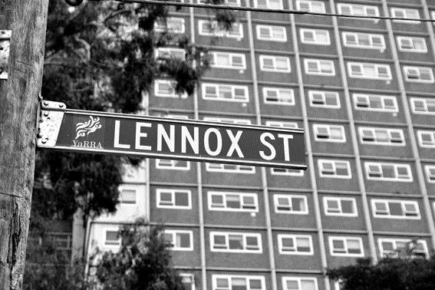
- Landscaping improvements including tree planting
- Bike paths and cycling infrastructure
- Playgrounds, skate parks, climbing walls
- Public art
- Storage improvements
- Community gardens.

WHAT CAN I USE MY FUNDING FOR?
- Indoor and outdoor building materials
- Costs of permits, audits
- Infrastructure design
- Detailed plans
- Contractor fees including builders, architects, building surveyors.

ELIGIBILITY
- Existing connection with the North Richmond Precinct
- Incorporated or auspiced by an incorporated organisation
- Public liability insurance policy (certificate of currency), with a minimum value of $20 million
- A discussion with the North Richmond Precinct Team (and Homes Victoria if the Precinct team considers this is necessary) about your project idea prior to submitting your application
- Where applicable, a clear list of assets you wish to purchase must be included in your application form
- Signed permission from landowner, where applicable.

Note:
- Proposals for projects taking place on Homes Victoria land must include a maintenance plan for the new infrastructure after completion
- Subject to project scope and scale, Homes Victoria may reserve the right to manage projects on Homes Victoria-owned land.

WHAT CAN’T BE FUNDED?
Funding for Community Infrastructure Grants cannot be used to cover:

- Projects that do not align with these guidelines
- Projects that take place outside the North Richmond Precinct
- Applications from individual small businesses
- Research projects
- Service mapping
- Service needs analysis
- Service planning
- Community consultation
- Projects that are the funding responsibility of other government departments or levels of government
- Projects that have already started or have been completed
- Purchase of land
- Items and expenses that are part of an organisation’s core business or normal operating expenses, including salaries, insurance, utilities
- Refurbishments and improvements to businesses, for example shopfronts (facades), fit outs
- Repair works to broken items and equipment
- Equipment and appliances including barbeques, dishwashers, commercial kitchen equipment
- Projects that cannot be delivered by 30 June 2025.

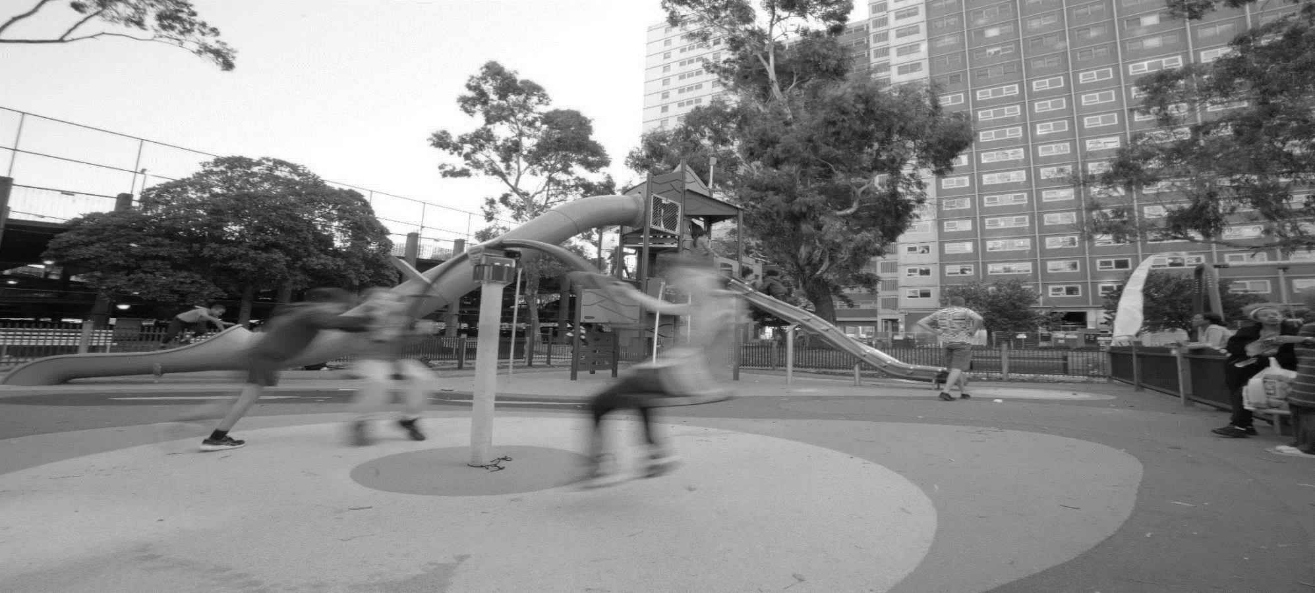

PAYMENT GUIDE

Community Infrastructure Planning Grants
All Infrastructure Planning Grant recipients will receive 100 per cent of their grant funding upfront.

Community Infrastructure Capital Works Grants
25% of your total grant funding is available once you have signed your funding agreement
65% will be paid based on milestone deliverables
10% of your funding will be paid following submission of final acquittal report (prepared by the grant recipient and auspice organisation when applicable).

MONITORING AND REPORTING

Community Infrastructure Planning Grants
Milestones and monitoring
- One monitoring / progress meeting between project leads or auspice organisation and the North Richmond Precinct Team.
- Business case, including supporting documentation, must be submitted by 30 June 2024 on a template provided by the North Richmond Precinct Team

Community Infrastructure Capital Works Grants
Milestones and monitoring
Payments for Community Infrastructure Capital Works projects will be structured around delivery of at least two milestones. Larger projects may require additional milestones. Milestone deliverables will be negotiated between the department and project lead / auspice organisation.

Final report and financial acquittal
- Detailed final report (template will be provided) demonstrating outcomes of funding
- Supporting documentation demonstrating project completion e.g., photographs, media
- Signed declaration certifying that the funding has been used for the intended purpose
- Detailed evidence of expenditure of grant funds including invoices, receipts, and bank transactions for all items purchased
- An audited financial acquittal statement

COMMUNITY INFRASTRUCTURE PLANNING GRANTS ASSESSMENT CRITERIA

A copy of the application form questions is available in the Resources and Support section of the Precinct website.

Assessment of planning grant applications will be merit-based. The preliminary business case must include:
Criteria | Demonstration | Weighting
Community need | - Evidence that demonstrates your proposal responds to a clear community need  - Clear explanation of how the project will:  - Strengthen the capacity of an organisation or group to deliver existing programs  - Meet a demonstrated community infrastructure need  And / or  - Provide or generate additional services for the community  - Alignment with one or more of the key priority areas outlined in the Action Plan:  - Community safety and amenity  - Health and wellbeing  - Revitalising the local retail and hospitality scene  - Creating local job opportunities  - Evidence of community consultation. | 10%
Preliminary plans | - Detailed designs  - Potential project risks and risk mitigation strategies  - Where applicable:  - Site condition report including location of underground services and soil remediation requirements  - Building condition reports (for existing buildings)  - Landscaping plans  - Engineering plans as required  - Evidence of building and planning permit requirements (evidence of Council’s advice around permit requirements for proposed project is required for planning grant applications. Applicants are not expected to have secured permits at this stage)  - Signed permission from landowner. | 25%

Criteria | Demonstration | Weighting
Preliminary budget | - Clear, balanced budget showing total income equals total expenditure  - Total project costs, including a minimum contingency of 10%  - Evidence that the project will represent strong value for money:  - Three current written quotes that accurately reflect the complete scope of proposed works:  - Evidence of in-kind and partner contributions, where applicable | 25%
Preliminary project plan | - Draft implementation plan, including timelines, key activities and milestones  - Evidence of capacity to successfully complete the project on time, and to adequately manage and maintain completed infrastructure project. | 20%
Organisational capability | - Demonstrated project management experience, sufficient for the scale and complexity of the project  - Financial statements showing the organisation has contingency funds and is financially stable  - Demonstrated grants management experience or partnership with an organisation with this experience and clearly described funding sources and outcomes. | 10%

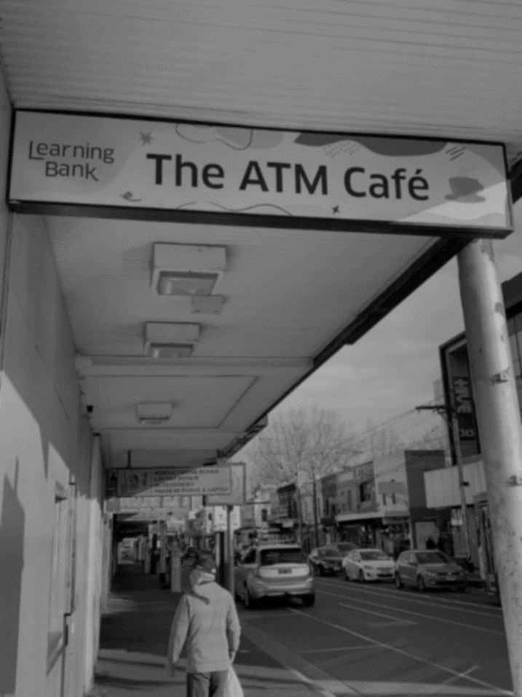

COMMUNITY INFRASTRUCTURE CAPITAL WORKS GRANTS
ASSESSMENT CRITERIA
A copy of the application form questions is available in the Resources and Support section of the Precinct website.
Criteria | Demonstration | Weighting
Community need | Evidence and outcomes of community consultation  Demographic / other data that demonstrates community need | 20%
Business case | Finalised business case including:  - Full costings  - Evidence of building and planning permit requirements (evidence of Council’s advice around permit requirements for proposed project)  - Contractors and suppliers identified to undertake works | 80%

If you have a ready-to-go infrastructure project and wish to apply for a Capital Works Grant in 2023 – 2024, it is essential you refer to the Planning Grant assessment criteria to ensure your proposal fulfils departmental requirements.

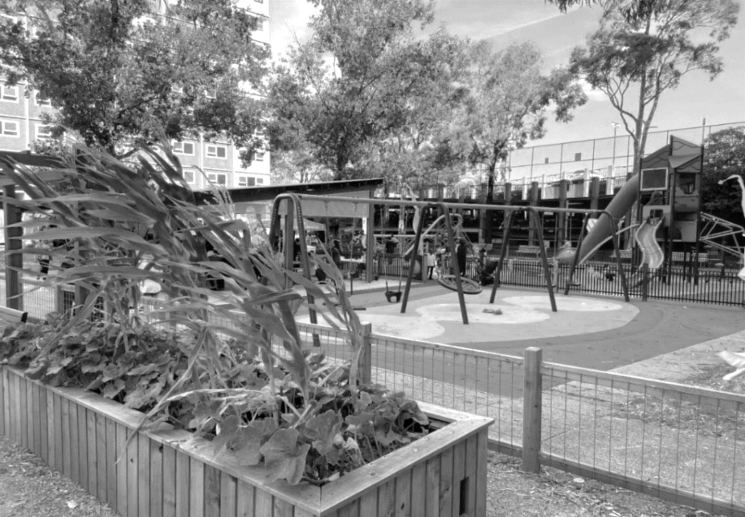

HOW TO APPLY FOR A NORTH RICHMOND PRECINCT COMMUNITY GRANT

KEY STEPS
- Carefully read these grant guidelines.
- Check your eligibility and your project idea’s eligibility against the eligibility criteria.
- If you have any questions, email the Precinct Team: engagenorthrichmond@dffh.vic.gov.au
- Read the online application form carefully. The application form questions are available in the Resources and Support section of the Precinct website.
- Complete the application form, ensuring you have provided all information requested, including supporting documentation
- Submit your application through Grants Gateway before the due date. You will receive an email instantly confirming your application has been submitted.



WHAT SUPPORTING DOCUMENTATION DO I NEED?

- Project plan
A clear project plan help you articulate your project’s objectives and key activities and increases your chance of receiving funding.
In the Resources and Support section of the Precinct website, you will find:
- Project plan templates for Community Strengthening grant applications
- Business case template for Community Infrastructure grant applications, which includes a project plan template.

- Financial and legal requirements

Australian Business Number (ABN) and tax status
All project proposals must be submitted by a legally incorporated organisation. If you are unsure whether your organisation is incorporated, you can check the Australian Business Register’s ABN Lookup. To do this, you will need your organisation’s legal name and ABN. Please note that having an ABN does not automatically mean your organisation is incorporated.

Signed auspice agreement, as required
if your organisation is not incorporated you will need to enter into an auspice agreement with an incorporated organisation. Entering into an auspice agreement means that if your application is successful, the auspice organisation takes legal and financial responsibility for your project. While you will still manage the project, the auspice organisation receives and manages your funding.
A signed auspice agreement must be included with your application. For more information about auspice organisations, refer to the Resources and Support Section of the Precinct website.

Public liability insurance / certificate of currency
All applicants are required to hold current public liability insurance to the value of $20 million. You can request your insurer issues you with a certificate of currency as confirmation of your public liability insurance.

CHECKLIST: PREPARING YOUR APPLICATION
- Carefully read the Program Guidelines and contact the North Richmond Precinct Team if you have any questions.
- Check eligibility:
- Can you or your organisation demonstrate a connection to North Richmond?
- Is your organisation incorporated?
- Do you have appropriate insurance?
- Have you finalised all reporting from previous grant rounds?
- Familiarise yourself with the key priority areas in the North Richmond Precinct Community Action Plan
- If your organisation is incorporated you will need:
      - ABN number
      - GST status
      - Certificate of currency demonstrating current public liability insurance
- If you are being auspiced, obtain the following from your auspice organisation:
- Incorporation number
- GST status
- ABN
- Certificate of currency demonstrating current public liability insurance
- Attend a community grants information session
- If you are applying for a Community Infrastructure grant, you must speak to the Precinct Team before submitting your proposal
- Select the appropriate grant category and funding stream for your project idea
- Review the application form – a copy is available on the Precinct website. Contact the Precinct Team if you have any questions
- Log in or register with Grants Gateway to create your application
- Review the relevant assessment criteria
- Complete the application form, ensuring you save your progress as you go
- Collate all supporting documentation and submit with your application.

SUBMITTING YOUR ONLINE APPLICATION
When you are ready to submit your application, you will use an online program called Grants Gateway. The program lets you save, edit and print out applications before submitting.
If you submitted an application in the previous funding round, you can log into Grants Gateway with your previous login details. You will need to register if this is the first time you are using Grants Gateway.

A Grants Gateway tip sheet is available in the Resources and Support section of the Precinct Website.
While Grants Gateway is a friendly system to use, please keep the following in mind:
- Allow plenty of time to complete your application so that you can ask for help if you have any difficulties.
- All fields on the application form must be completed.
- You will need to upload your supporting documents. If you aren’t familiar with how to upload files, speak to the Precinct Team or BANH.
- When completing the application form, remember to save your progress every 10-15 minutes.
- Carefully review your responses before submitting your application.
- You will receive an email instantly confirming your application has been submitted.

You can access Grants Gateway here.

Applications close at 11.59pm on Sunday 14 January. Late submissions will be deemed ineligible and will not be considered for funding.

If you need assistance submitting your application through Grants Gateway:
- Book a support appointment with BANH or
- Contact the Precinct Team via email

HOW IS MY GRANT APPLICATION ASSESSED?

There are several steps to the assessment and approval process, which is why it takes a little time before you find out the outcome of your application.

- The North Richmond Precinct Team conducts eligibility checks for all applications, based on the Community Grants Guidelines. Applications that meet the eligibility criteria continue to the next assessment stage (eligibility checks relate to the information in the Who can apply and What we won’t fund sections).
- Eligible $1,000 - $5,000 Community Strengthening applications are assessed by the department.
- Eligible $5,001 - $30,000 Community Strengthening applications are assessed by the department with the support of a Community Advisory Panel.
- All eligible Community Infrastructure applications are assessed by the department with the support of a Community Advisory Panel and Homes Victoria, as required.
- Funding recommendations are presented to the Minister for Housing for approval.



WHAT HAPPENS NEXT?

IF YOUR APPLICATION IS SUCCESSFUL
- Successful applicants will be notified in writing.
- The department will send your organisation or your auspice organisation a funding agreement which will outline the grant terms, conditions and payment details.
- Grant payments cannot be paid without a signed funding agreement, so please do not start your project until you have returned a signed agreement.
- Applicants should note that there may be considerable time between close of applications and finalising a funding agreement. This should be factored into project timelines, expiry dates on quotes and project cashflow.

IF YOUR APPLICATION IS UNSUCCESSFUL
- Unsuccessful applicants will be notified in writing.
- As grants are a competitive process, even if an application meets the criteria, it may not be competitive against other applications. If you would like further feedback on why your application was unsuccessful, please contact engagenorthrichmond@dffh.vic.gov.au.
- While unsuccessful applicants are eligible to reapply, we would recommend revising the application to make sure it fits the assessment criteria before doing so.



GRANT SUPPORT

The department, with the support of Belgium Avenue Neighbourhood House (BANH), will run information sessions and throughout the grant application period.

COMMUNITY INFORMATION SESSIONS: TUESDAY 28 NOVEMBER
The department will run two information sessions on Tuesday 28 November at the Learning Bank, 124 Victoria St, Richmond. These sessions will provide an overview of the grants program, guidelines and using Grants Gateway.
Session 1: 12.00pm – 1.30pm
Session 2: 5.30pm – 7.00pm
Interpreters are available on request. Let the North Richmond Precinct Team know what language support you need: engagenorthrichmond@dffh.vic.gov.au / 0477 756 743.

APPLICATION SUPPORT

IN-LANGUAGE SUPPORT
BANH are running support sessions to help with preparing, writing and submitting grant applications. They are also holding separate in-language sessions for:
- Chinese community members
- Vietnamese community members
- Arabic-speaking community members.
Interpreters will be available at these sessions.
To find out more contact BANH:
Sally Anthony: sally@banhinc.com.au / 0406 493 551
Lydia Dobbin: lydia@banhinc.com.au
Session times will be announced closer to the time.

FUNDING AGREEMENT SUPPORT
Appointments with BANH staff will be available for successful applicants who require support to sign and submit funding agreements. More details will be available once the application period has closed.

RESOURCES

There is a comprehensive list of tools, templates and ‘how to’ tip sheets available in the Grant Resources and support section of the North Richmond Precinct website. Click here to view all resources which include:
- Frequently Asked Questions
- Commonly used grant terms
- Using Grants Gateway
- Community Strengthening application forms questions and guidance
- Community Infrastructure application forms questions and guidance
- Community Strengthening project plan template
- Community Strengthening risk management template
- Community Infrastructure business case template (includes project and risk management plan templates)
- Application writing tips
- Auspice information
- North Richmond Precinct Community Action Plan

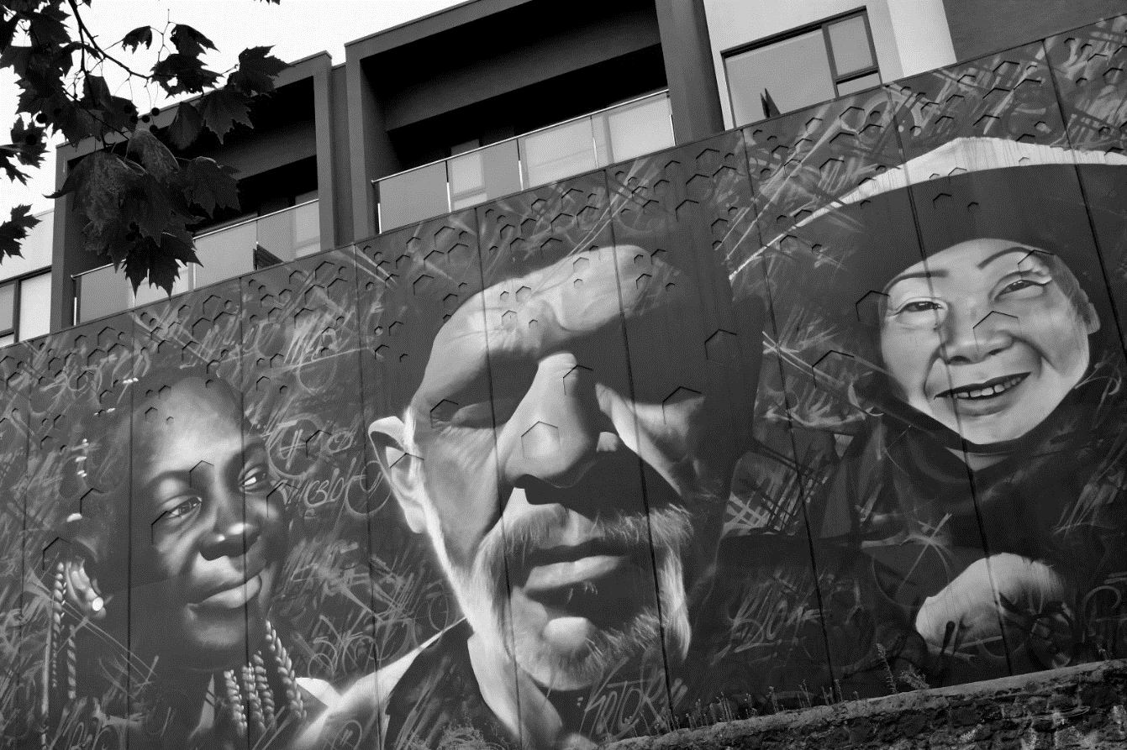

APPENDIX ONE: NORTH RICHMOND PRECINCT MAP

The North Richmond Precinct boundaries are Hoddle, Church, Highett and Langridge Streets.
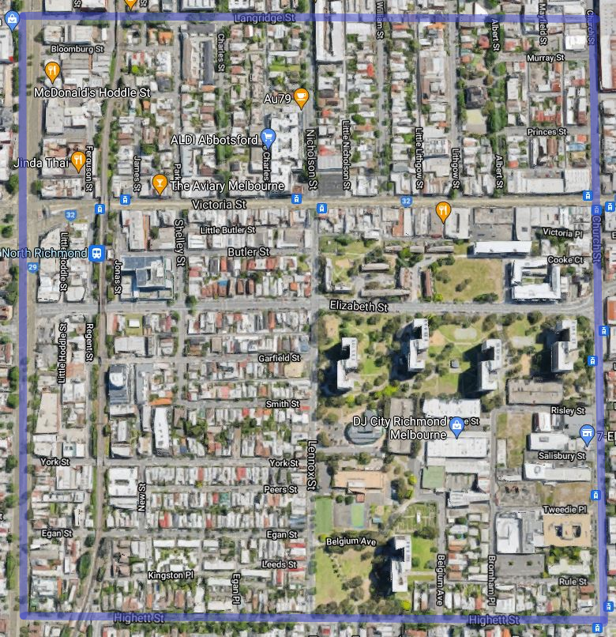
Contact the North Richmond Precinct Team if you are unsure whether the location for your proposed project is within this area.

