Homes Victoria
Rental Report
December Quarter 2025


Contents
Contents 2
List of tables 3
List of figures 3
Overview 4
Trends in rents 4
New lettings 4
Active bonds 4
Turnover 4
Investor lending 4
Vacancy rates 5
Rental affordability 5
Current rents 6
Rent Indices 6
Median rents by statistical region 7
Median rents by major property type 8
Moving annual median rents by suburb or town 9
Where are median rents highest? Where are median rents lowest? 11
Rental availability 12
New lettings 12
Active bonds 13
Turnover and length of tenancy 15
Investor lending 16
Vacancy rate 17
Rental market affordability 18
Overall trends 18
Trends by household type 18
Trends by statistical region 20
Trends by Local Government Area 20
Notes 38

List of tables
Table 1: Median rents and metropolitan Melbourne and regional Victoria Rent Indices 6
Table 2: Median rents for new lettings by statistical region 7
Table 3: Median rents for new lettings by major property type 8
Table 4: Highest and lowest moving annual median rents in metropolitan Melbourne and regional Victoria 11
Table 5: New lettings for metropolitan Melbourne, regional Victoria and Victoria 12
Table 6: New lettings by statistical region, Victoria 12
Table 7: Turnover and tenancy duration 15
Table 8: Median tenancy duration and turnover by dwelling size 15
Table 9: Rental affordability for indicative households on Centrelink incomes 19
Table 10: Rental affordability for households on the Age Pension or Disability Support Pension 19
Table 11: Affordable rental dwellings by region for indicative households on Centrelink incomes 20
Table 12: Moving annual median rents for suburbs and towns by major property type 22
Table 13: Quarterly median rents for Local Government Areas by major property type 30
Table 14: Affordable rental dwellings by Local Government Area 34
Table 15: Active bonds by Local Government Area 37

List of figures
Figure 1: Metropolitan Rent Index and Regional Rent Index - annual percentage change 6
Figure 2: Moving annual median rents by suburb for two‑bedroom flats, metropolitan Melbourne 10
Figure 3: Moving annual median rents by suburb for three‑bedroom houses, metropolitan Melbourne 10
Figure 4: Total active residential bonds, Victoria – annual percentage change 13
Figure 5: Number of active bonds, metropolitan Melbourne and regional Victoria 14
Figure 6: Lending to household investors in residential housing, Victoria ($2025 December) 16
Figure 7: Rental vacancy rate 17
Figure 8: Affordable rental dwellings as a percentage of all new rentals 18
Figure 9: Affordable rental dwellings, metropolitan Melbourne and regional Victoria 21

Overview

Trends in rents
The Metropolitan Rent Index (MRI) rose 0.7 per cent over the December quarter 2025. Over the past year the MRI rose 3.8 per cent. This is below both the annual increase to the December quarter of last year (5.9%) and the long-term average annual increase over the past 10 years (4.3%).
The Regional Rent Index (RRI) rose 0.8 per cent over the December quarter 2025. Over the past year the RRI rose 4.4 per cent. This is below both the annual increase to the December quarter of last year (6.5%) and the long‑term average increase over the past 10 years (5.1%).
Rent Indices at a glance
 | Median Rent  (per week) | Quarterly Change* | Annual  Change*
Metropolitan Melbourne | $580 | 0.7% | 3.8%
Regional Victoria | $480 | 0.8% | 4.4%
* Percentage change figures are calculated from relevant Rent Index

New lettings
Across the state 47,488 bonds have been lodged for new lettings beginning in the December quarter 2025, 10.4 per cent fewer than the current figure for the December quarter 2024. Fewer bonds have been lodged in both metropolitan Melbourne (-10.6%) and regional Victoria (-9.5%) compared to the current figures for the December quarter of last year (see note 4 for qualifications).
Metropolitan Melbourne accounted for 81.5 per cent of all new lettings in Victoria.

Number of dwellings with active bonds
As of the end of the December quarter 2025, the Residential Tenancies Bond Authority recorded a total of 656,463 individual dwellings with active bonds for residential properties in Victoria, 0.9 per cent fewer than the current figure for the December quarter 2024 (see note 4 for qualifications). On average the total number of dwellings with active bonds has increased 0.8 per cent annually over the past 5 years, and 2.2 per cent annually over the past 10 years.

Turnover
The quarterly turnover rate for rental properties in metropolitan Melbourne over the December quarter 2025 was 7.8 per cent, down 0.5 percentage points compared to the December quarter 2024 (8.3%). The median length of tenancy in metropolitan Melbourne was 23 months, down from 24 months in the December quarter of last year.
In regional Victoria, the quarterly turnover rate was 7.0 per cent, down 0.5 percentage points compared to the December quarter 2024 (7.5%). The median length of tenancy in regional Victoria was 23 months, up from 22 months in the December quarter of last year.

Investor lending
In the December quarter 2025, Victorian households borrowed $9.718 billion for the purpose of investment in residential housing, 36.5 per cent more than in the December quarter 2024.

Vacancy rates
In metropolitan Melbourne, the trend vacancy rate in December 2025 fell to 2.3 per cent, a decrease of 0.1 percentage points, compared to September 2025. This was a decrease of 0.2 percentage points compared to December of last year (2.5%).
In regional Victoria, the trend vacancy rate in December 2025 rose to 2.4 per cent, an increase of 0.4 percentage points, compared to September 2025. This was an increase of 0.3 percentage points compared to December of last year (2.1%).

Rental affordability
Statewide, 17.0 per cent of new lettings over the December quarter 2025 met affordability criteria for low-income households, an increase of 2.6 percentage points over the previous quarter and 1.0 percentage points over the past year.
In metropolitan Melbourne, 11.7 per cent of new lettings met affordability criteria an increase of 1.9 percentage points over the previous quarter and 2.1 percentage points over the past year.
In regional Victoria, 40.5 per cent of new lettings met affordability criteria, an increase of 4.1 percentage points over the previous quarter, but a decline of 4.1 percentage points over the past year.

Current rents

Rent Indices
Table 1 shows median rents and rent indices for both metropolitan Melbourne and regional Victoria for the December quarter 2025.
The Metropolitan Rent Index (MRI) increased 0.7 per cent over the December quarter 2025, while the Regional Rent Index (RRI) increased 0.8 per cent.
The median rent for metropolitan Melbourne remained stable at $580 per week, and in regional Victoria the median rent increased $10 to $480 per week.
The Metropolitan and Regional Rent Indices are a better measure of changes in rents over time than the simple median price measure, because they control for variation in the share of new lettings by geographical area and property type. Median rent is a measure of the mid‑point in the distribution of all rents (with 50 per cent of rents at or above the median and 50 per cent of rents at or below). Several properties on the median rent can disguise overall changes in rents over time.
Table 1: Median rents and metropolitan Melbourne and regional Victoria Rent Indices
 | Median Rent | Rent Index | Quarterly  Change* | Annual Change*
Metropolitan Melbourne | $580 | 318.1 | 0.7% | 3.8%
Regional Victoria | $480 | 345.4 | 0.8% | 4.4%
* Percentage change figures are calculated from the relevant Rent Index.
Figure 1 shows the annual percentage change in the Metropolitan Rent Index and the Regional Rent Index over the past 10 years.
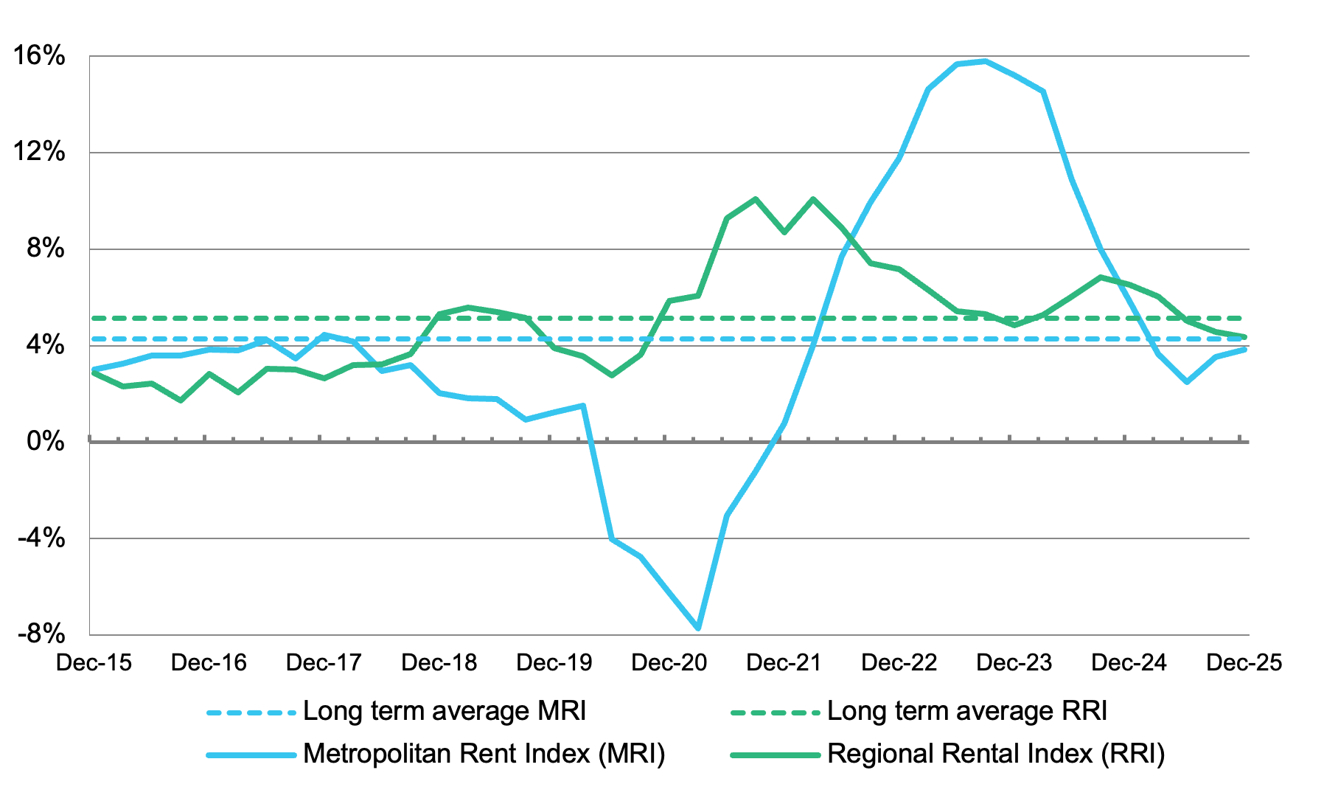
Figure 1: Metropolitan Rent Index and Regional Rent Index annual percentage change
The Metropolitan Rent Index (MRI) rose 0.7 per cent over the December quarter 2025. This compares with a quarterly increase of 1.1 per cent last quarter, and 0.4 per cent over the December quarter of last year. Over the past year the MRI increased 3.8 per cent. This is below both the annual increase to the December quarter 2024 (5.9%) and the long‑term average annual increase over the past 10 years (4.3%).
The Regional Rent Index (RRI) rose 0.8 per cent over the December quarter 2025. This compares with a quarterly increase of 1.1 per cent last quarter, and 1.0 per cent over the December quarter of last year. Over the past year the RRI rose 4.4 per cent. This is below both the annual increase to the December quarter of last year (6.5%) and the long‑term average annual increase over the past 10 years (5.1%).

Median rents by statistical region
Table 2 shows median rents for new lettings in the December quarter 2025 for 14 statistical regions in Victoria (9 in metropolitan Melbourne and 5 in regional Victoria).
In metropolitan Melbourne, median rents ranged from $500 per week in Western Melbourne to $650 per week in Inner Melbourne, Inner Eastern Melbourne and Southern Melbourne. Median rents increased over the quarter in the Mornington Peninsula (2.0%) and remained stable in all other metropolitan areas: Inner Melbourne, Inner Eastern Melbourne, Southern Melbourne, Western Melbourne, North Western Melbourne, North Eastern Melbourne, Outer Eastern Melbourne and South Eastern Melbourne.
Over the past year, median rents increased in Inner Melbourne (6.6%), Inner Eastern Melbourne (4.0%), Southern Melbourne (2.4%), North Western Melbourne (1.9%), Outer Eastern Melbourne (3.4%), South Eastern Melbourne (2.7%) and the Mornington Peninsula (4.7%), and remained stable in Western Melbourne and North Eastern Melbourne.
In regional Victoria, median rents ranged from $434 per week in Central Highlands‑Wimmera to $510 per week in Barwon‑South West. Median rents increased over the quarter in all regional areas: Barwon-South West (2.0%), Gippsland (2.6%), Goulburn-Ovens-Murray (1.1%), Loddon-Mallee (3.1%) and Central Highlands-Wimmera (3.3%).
Median rents also increased in all regional areas over the past year: Barwon-South West (4.1%), Gippsland (5.6%), Goulburn-Ovens-Murray (5.6%), Loddon-Mallee (6.4%) and Central Highlands-Wimmera (3.3%).
Table 2: Median rents for new lettings by statistical region
Region | Median Rent | Quarterly Change* | Annual Change*
Metropolitan Melbourne
Inner Melbourne | $650 | 0.0% | 6.6%
Inner Eastern Melbourne | $650 | 0.0% | 4.0%
Southern Melbourne | $650 | 0.0% | 2.4%
Western Melbourne | $500 | 0.0% | 0.0%
North Western Melbourne | $550 | 0.0% | 1.9%
North Eastern Melbourne | $550 | 0.0% | 0.0%
Outer Eastern Melbourne | $600 | 0.0% | 3.4%
South Eastern Melbourne | $575 | 0.0% | 2.7%
Mornington Peninsula | $600 | 2.0% | 4.7%
Regional Victoria
Barwon‑South West | $510 | 2.0% | 4.1%
Gippsland | $470 | 2.6% | 5.6%
Goulburn‑Ovens‑Murray | $475 | 1.1% | 5.6%
Loddon‑Mallee | $500 | 3.1% | 6.4%
Central Highlands‑Wimmera | $434 | 3.3% | 3.3%
* Percentage change figures are calculated from median rents in the statistical region.

Median rents by major property type
Table 3 provides the median rents for new lettings in the December quarter 2025 for six major property types, in both metropolitan Melbourne and regional Victoria, as well as the quarterly and annual change in the relevant Rent Index for each property type.
In metropolitan Melbourne, the highest median rent is for three‑bedroom flats ($680 per week), and the lowest median rent is for one‑bedroom flats ($500 per week).
The Rent Index in metropolitan Melbourne increased over the quarter for one-bedroom flats (0.7%), three-bedroom flats (1.3%), two-bedroom houses (2.0%), three-bedroom houses (1.0%) and four-bedroom houses (1.9%), and decreased for two-bedroom flats (-0.3%). Over the 12 months to the December quarter the Rent Index increased for all property types: one-bedroom flats (4.8%), two-bedroom flats (4.0%), three-bedroom flats (4.4%), two-bedroom houses (3.7%), three-bedroom houses (3.2%) and four-bedroom houses (2.8%).
In regional Victoria, the highest median rent is for four‑bedroom houses ($550 per week), and the lowest median rent is for one‑bedroom flats ($320 per week).
The Rent Index in regional Victoria increased over the quarter for all property types: one-bedroom flats (2.5%), two-bedroom flats (0.6%), three-bedroom flats (1.9%), two-bedroom houses (1.8%), three-bedroom houses (0.8%) and four-bedroom houses (0.5%). The Rent Index also increased for all property types in regional Victoria over the last 12 months. Increases ranged from 2.3 per cent for four-bedroom houses to 8.0 per cent for one-bedroom flats.
Note that the metropolitan Melbourne medians reflect the geographic distribution of the different property types. Houses tend to be the dominant rental property type in outer metropolitan areas, whereas flats are more prevalent in areas closer to the centre of Melbourne.
Table 3: Median rents for new lettings by major property type
 | Property Type | Median Rent | Quarterly Change* | Annual  Change*
Metropolitan  Melbourne | 1 bedroom flat | $500 | 0.7% | 4.8%
Metropolitan  Melbourne | 2 bedroom flat | $600 | -0.3% | 4.0%
Metropolitan  Melbourne | 3 bedroom flat | $680 | 1.3% | 4.4%
Metropolitan  Melbourne | 2 bedroom house | $580 | 2.0% | 3.7%
Metropolitan  Melbourne | 3 bedroom house | $560 | 1.0% | 3.2%
Metropolitan  Melbourne | 4 bedroom house | $590 | 1.9% | 2.8%
Regional  Victoria | 1 bedroom flat | $320 | 2.5% | 8.0%
Regional  Victoria | 2-bedroom flat | $400 | 0.6% | 6.1%
Regional  Victoria | 3 bedroom flat | $470 | 1.9% | 3.3%
Regional  Victoria | 2 bedroom house | $400 | 1.8% | 5.2%
Regional  Victoria | 3 bedroom house | $480 | 0.8% | 4.9%
Regional  Victoria | 4 bedroom house | $550 | 0.5% | 2.3%
* Percentage change figures are calculated from the Rent Index for each property type.

Moving annual median rents by suburb or town
Table 12 shows the moving annual median rents for suburbs and towns across Victoria by major property type. Note that the medians in Table 12 are moving annual medians, not quarterly medians, and that the annual percentage change is calculated from these moving annual medians.
For two-bedroom flats in metropolitan Melbourne, the moving annual median rent decreased in Wantirna-Scoresby (-3.8%), Whittlesea (-2.3%), Albert Park-Middle Park-West St Kilda (-1.8%), Footscray (-1.8%) and Sunshine (-0.7%), remained stable in Vermont-Forest Hill-Burwood East and Craigieburn, and increased in all other suburbs. The highest increases occurred in Yarra Ranges (12.4%), Flemington-Kensington (11.5%), Brighton (10.4%), Bayswater (8.7%), St Kilda (8.3%) and East Brunswick (8.3%).
In regional Victoria, the moving annual median rent for two-bedroom flats decreased in Geelong-Newcomb
(-2.7%), remained stable in Golden Square-Kangaroo Flat, Portland and Wangaratta, and increased in all other regional centres. The highest increases occurred in Shepparton (14.3%), Echuca (13.2%), Wodonga (11.4%), Ocean Grove-Barwon Heads (11.1%) and Castlemaine (11.0%).
For three-bedroom houses in metropolitan Melbourne, the moving annual median rent decreased in East Melbourne (-15.1%), Toorak (-9.8%), East St Kilda (-2.4%), Elsternwick (-2.2%) and Werribee-Hoppers Crossing (-2.1%), remained stable in Armadale, North Melbourne-West Melbourne, South Yarra, Chadstone-Oakleigh, Footscray, Melton, Newport-Spotswood, West Footscray, Craigieburn, Fairfield-Alphington, Heidelberg-Heidelberg West, Whittlesea, Rowville, Noble Park, and increased in all other suburbs. The highest increases occurred in East Hawthorn (12.8%), Keilor (11.8%), Balwyn (11.4%), Brighton East (10.6%), Fitzroy (10.0%), Albert Park-Middle Park-West St Kilda (9.6%), Elwood (9.5%), Nunawading-Mitcham (8.3%), Keilor East-Avondale Heights (8.2%), Yarra Ranges (8.2%) and Fitzroy North-Clifton Hill (8.1%).
In regional Victoria, the moving annual median rent for three‑bedroom houses increased in all regional centres. The highest increases occurred in Swan Hill (11.6%), Wodonga (10.6%), Horsham (10.0%), Morwell (9.2%), Mildura (8.9%), Castlemaine (8.3%), Golden Square-Kangaroo Flat (7.8%), Mount Clear-Buninyong (7.5%), Seymour (7.5%), Newtown (7.3%) and Portland (7.1%).
Figure 2 and Figure 3 show moving annual median rents in metropolitan Melbourne, for two‑bedroom flats and for three‑bedroom houses, respectively. They show the pattern of concentration of the highest median rents in Inner Melbourne and in parts of Inner Eastern Melbourne and Southern Melbourne.

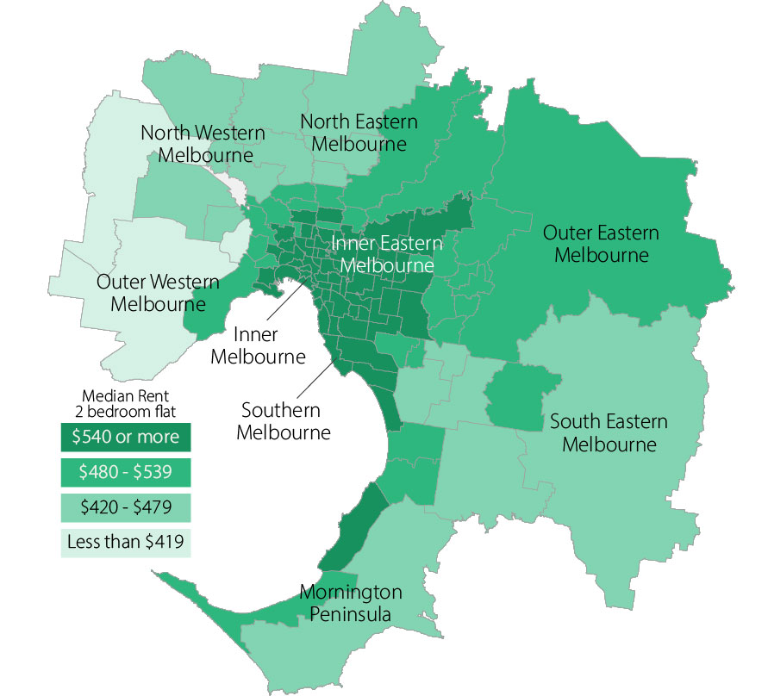
Figure 2: Moving annual median rents by suburb for two‑bedroom flats, metropolitan Melbourne

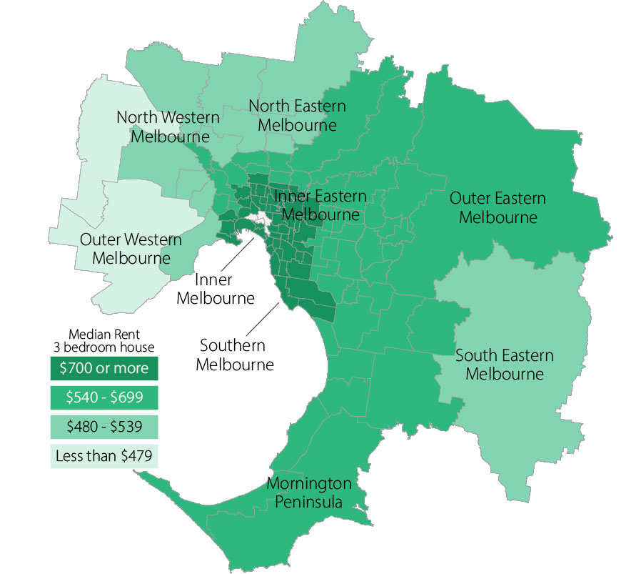
Figure 3: Moving annual median rents by suburb for three‑bedroom houses, metropolitan Melbourne

Where are median rents highest? Where are median rents lowest?
Table 4 provides the highest and lowest median rents for metropolitan Melbourne and regional Victoria.
Table 4: Highest and lowest moving annual median rents in metropolitan Melbourne and
regional Victoria
Where are median rents highest? |  | Where are median rents lowest?
2 bedroom flat
Metropolitan Melbourne
Docklands | $780 | Melton | $370
CBD-St Kilda Rd | $750 | Werribee-Hoppers Crossing | $403
Fitzroy | $750 | Sunshine | $410
Port Melbourne | $750 | St Albans-Deer Park | $428
Southbank | $730 | Whittlesea | $430
Regional Victoria
Ocean Grove-Barwon Heads | $500 | Moe-Newborough | $315
Torquay | $500 | Hamilton | $320
Geelong-Newcomb | $465 | Morwell | $320
Belmont-Grovedale | $440 | Horsham | $330
Newtown | $440
3 bedroom house
Metropolitan Melbourne
Albert Park-Middle Park-West St Kilda | $1,200 | Melton | $420
Brighton | $1,150 | Werribee-Hoppers Crossing | $460
Toorak | $1,150 | St Albans-Deer Park | $480
Armadale | $1,100 | Sydenham | $480
East Melbourne | $1,100 | Sunbury | $497
Fitzroy | $1,100 | Craigieburn | $500
South Yarra | $1,100 | Sunshine | $500
Regional Victoria
Torquay | $680 | Hamilton | $400
Newtown | $590 | Sebastopol-Delacombe | $400
Ocean Grove-Barwon Heads | $560 | Ballarat | $415
Warrnambool | $550 | Morwell | $415
 |  | Wendouree-Alfredton | $420

More detail on median rents by location and property type is presented in Table 12 towards the end of this document. Still further information (including extra property types and upper and lower quartile rents) can be found in the Excel worksheet “Table 12: Moving annual median rents for suburbs and towns by major property type” in the Excel workbook “Tables from Rental Report – December Quarter 2025.xlsx” available for download from the Homes Victoria website: https://www.dffh.vic.gov.au/publications/rental‑report.

Rental availability

New lettings
The number of new lettings provides an indicator of the overall availability of rental housing for a specific period. A new letting usually results either from turnover in an existing rental property or a new addition to the stock of rental housing. Table 5 shows the number of new rental lettings for the December quarter 2025 and the December quarter 2024.
Currently, 47,488 bonds have been lodged statewide for new lettings commenced during the December quarter 2025, 10.4 per cent fewer than for the December quarter 2024. This is 10.6 per cent fewer in metropolitan Melbourne and 9.5 per cent fewer in regional Victoria. Note that these figures are subject to upward revision due to the late lodgement of bonds (see note 4 for detail).
Metropolitan Melbourne accounted for 81.5 per cent of all new lettings in Victoria.
Table 5: New lettings for metropolitan Melbourne, regional Victoria and Victoria
 | Dec-25 | Dec-24 | Change
Metropolitan Melbourne | 38,700 | 43,273 | -10.6%
Regional Victoria | 8,788 | 9,715 | -9.5%
Victoria | 47,488 | 52,988 | -10.4%
Table 6 lists the number of new lettings across each of the 14 statistical regions.
In metropolitan Melbourne, fewer new lettings were registered this quarter (compared to the current figures for the December quarter last year) in all metropolitan areas: Inner Melbourne (-11.7%), Inner Eastern Melbourne (-16.7%), Southern Melbourne (-15.8%), Western Melbourne (-8.1%), North Western Melbourne (-4.8%), North Eastern Melbourne (-5.1%), Outer Eastern Melbourne (-19.6%), South Eastern Melbourne
(-7.6%) and the Mornington Peninsula (-11.2%).
Fewer new lettings were also registered this quarter in all regional areas: Barwon-South West (-10.1%), Gippsland (-12.5%), Goulburn-Ovens-Murray (-10.2%), Loddon-Mallee (-1.7%) and Central Highlands-Wimmera (-11.8%).
Table 6: New lettings by statistical region, Victoria
Region | Dec-25 | Dec-24 | Change
Metropolitan Melbourne
Inner Melbourne | 9,657 | 10,931 | -11.7%
Inner Eastern Melbourne | 4,397 | 5,281 | -16.7%
Southern Melbourne | 2,839 | 3,371 | -15.8%
Western Melbourne | 7,344 | 7,994 | -8.1%
North Western Melbourne | 4,122 | 4,332 | -4.8%
North Eastern Melbourne | 3,786 | 3,988 | -5.1%
Outer Eastern Melbourne | 1,370 | 1,704 | -19.6%
South Eastern Melbourne | 3,767 | 4,075 | -7.6%
Mornington Peninsula | 1,418 | 1,597 | -11.2%
Regional Victoria
Barwon-South West | 2,816 | 3,134 | -10.1%
Gippsland | 1,341 | 1,533 | -12.5%
Goulburn-Ovens-Murray | 1,795 | 1,998 | -10.2%
Loddon-Mallee | 1,427 | 1,452 | -1.7%
Central Highlands-Wimmera | 1,409 | 1,598 | -11.8%

Number of dwellings with active bonds
The total number of individual dwellings with active bonds held by the Residential Tenancies Bond Authority (RTBA) at a given point in time provides an indicator of the total stock of rental housing.
The RTBA recorded a total of 656,463 individual dwellings with active bonds statewide this quarter, 0.9 per cent fewer than currently registered for the December quarter of last year. Note that this figure is subject to upward revision due to the late lodgement of bonds (see note 4 for detail). On average, the number of dwellings with active bonds has increased 0.8 per cent annually over the past 5 years, and 2.2 per cent annually over the past 10 years.
Over the past 5 years the number of dwellings with active bonds has, on average, increased by 0.8 per cent annually in metropolitan Melbourne, and by 0.7 per cent annually in regional Victoria.
Figure 4 shows the trend in the number of dwellings with active bonds over the past five years.
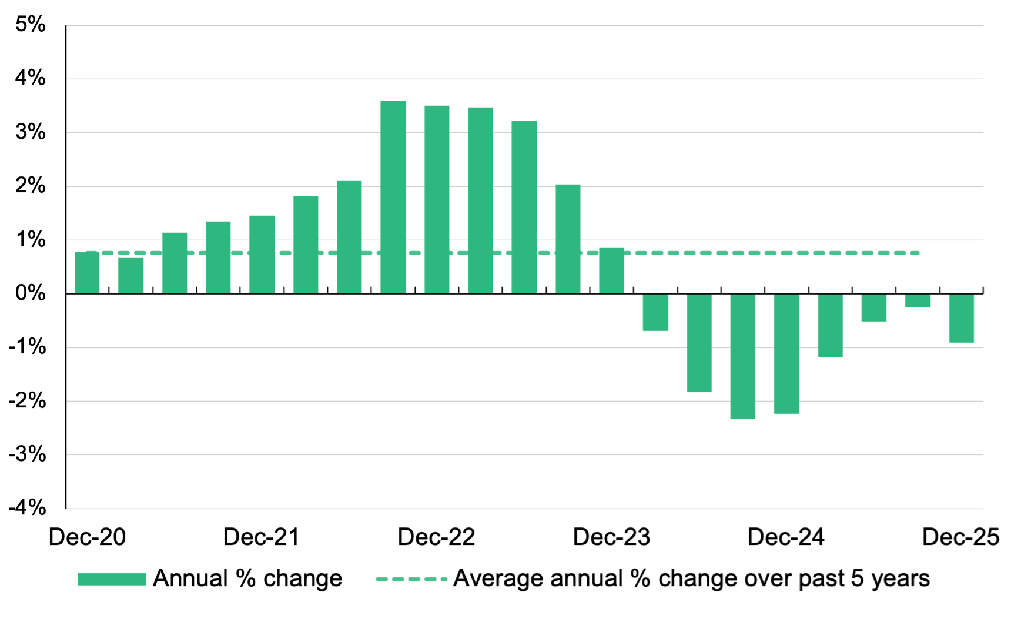
Figure 4: Total number of dwellings with active residential bonds, Victoria – annual percentage change
Table 15 below shows the number of dwellings with active bonds in each Local Government Area, as well as change in the number of dwellings with active bonds over the past 12 months, and over the past 5 years.
The largest numbers of dwellings with active bonds in metropolitan Melbourne occur in the municipalities of Melbourne (61,655 – 11.6% of the total number of dwellings with active bonds in metropolitan Melbourne), Wyndham (31,916 - 6.0%), Casey (26,994 - 5.1%), Merri-bek (25,032 - 4.7%), Melton (23,693 - 4.5%), Glen Eira (21,943 - 4.1%), Stonnington (21,082 - 4.0%), Port Phillip (19,929 - 3.8%), Hume (19,055 - 3.6%) and Darebin (19,007 - 3.6%).
Over the past 5 years, dwellings with active bonds have increased by the greatest number in the municipality of Melbourne, where 11,762 more dwellings with active bonds are registered this quarter than for the December quarter 2020, an increase of 23.6 per cent. Other substantial increases have occurred in municipalities on Melbourne’s outer fringe: Melton (50.0%), Wyndham (19.2%), Casey (13.0%), Whittlesea (12.6%) and Hume (12.0%). The number of dwellings with active bonds also increased in Maribyrnong (6.0%).
In all other metropolitan municipalities, the number of dwellings with active bonds has decreased over this period. The greatest decreases occurred in Nillumbik (-14.3%), Yarra Ranges (-13.4%), Maroondah (-11.9%), Mornington Peninsula (-11.8%) and Frankston (-11.0%).
In regional Victoria, the largest numbers of dwellings with active bonds occur in the municipalities of Greater Geelong (26,221 - 20.8% of the total number of dwellings with active bonds in regional Victoria), Ballarat (14,139 - 11.2%), Greater Bendigo (10,345 - 8.2%), Latrobe (6,778 - 5.4%), Greater Shepparton (5,878 - 4.7%) and Mildura (5,257 - 4.2%).
Over the past 5 years the total number of dwellings with active bonds has increased in only fifteen of Victoria’s forty-eight regional municipalities. Increases were most pronounced in Mitchell (45.3%), Surf Coast (34.4%), Golden Plains (32.8%), West Wimmera (12.5%) and Ballarat (11.3%). Decreases were most pronounced in Queenscliffe (-23.6%), Yarriambiack (-23.2%), Gannawarra (-17.6%), Towong (-13.8%), Corangamite (-13.4%) and Campaspe (-13.4%).
Figure 5 illustrates the distribution of dwellings with active bonds for metropolitan Melbourne by suburb, and for regional Victoria by Local Government Area.
Figure 5: Number of dwellings with active bonds, metropolitan Melbourne and regional Victoria
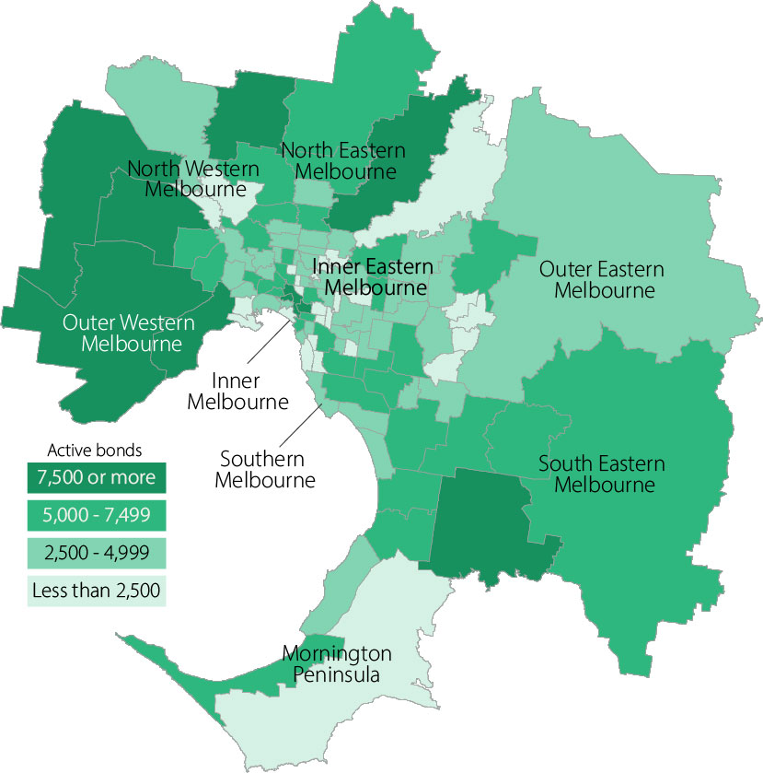
Number of dwellings with active bonds, metropolitan Melbourne by suburb

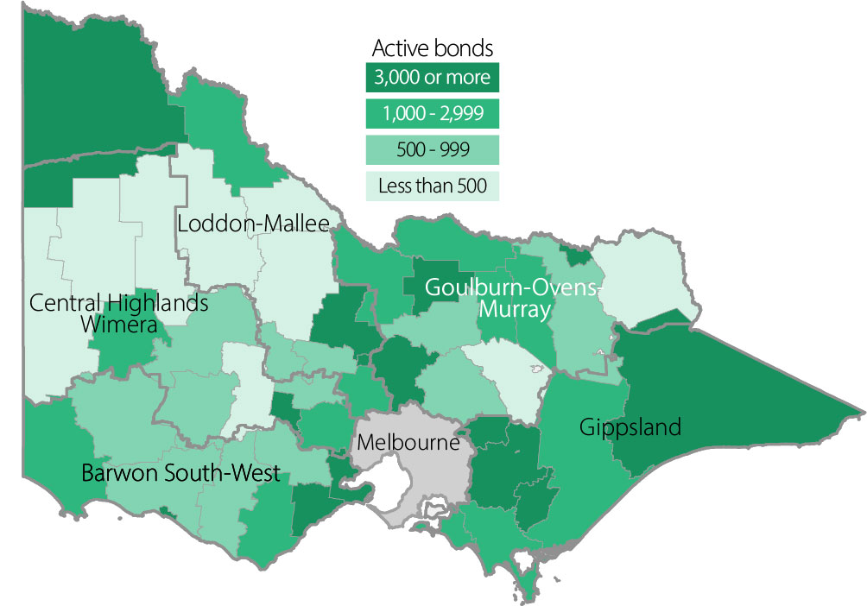
Number of dwellings with active bonds, regional Victoria by Local Government Area

Turnover and length of tenancy
The number of bond refunds in a quarter, if expressed as a percentage of all bonds held, can be used to provide an estimate of the ‘turnover rate’ in the rental market. The turnover rate is an important indicator of the level of natural vacancies that are occurring in the market due to tenancies ending.
Table 7 shows the turnover rate as well as the median length of tenancy (based on the dates indicated on bonds refunded during the quarter) for both metropolitan Melbourne and regional Victoria.
The quarterly turnover rate in metropolitan Melbourne was 7.8 per cent over the December quarter 2025 (that is, 7.8% of all active bonds were refunded over the quarter), down 0.5 percentage points compared to the December quarter of last year (8.3%).
In regional Victoria, the quarterly turnover rate was 7.0 per cent, down 0.5 per centage points compared to the December quarter of last year (7.5%).
The median length of tenancy for bonds refunded over the December quarter 2025 decreased over the year from 24 to 23 months in metropolitan Melbourne, and increased from 22 to 23 months in regional Victoria.
Table 7: Turnover and tenancy duration
 | Dec-25 | Dec-24
Metropolitan Melbourne
Turnover rate | 7.8% | 8.3%
Average tenancy duration | 23 | 24
Regional Victoria
Turnover rate | 7.0% | 7.5%
Average tenancy duration | 23 | 22
* The turnover rate is the number of bond refunds (moving annual total) as a percentage of total dwellings with active bonds. Average tenancy duration (months) is the median length of the period from the date of bond lodgement to the date of bond claim for all bonds refunded in that quarter.
Table 8 shows the turnover rate and the median length of tenancy by dwelling size for both metropolitan Melbourne and regional Victoria.
In metropolitan Melbourne, one‑bedroom dwellings have both the shortest median length of tenancy (13 months) and the highest turnover rate (11.3%). In regional Victoria, one-bedroom dwellings have the shortest median length of tenancy (16 months), and four-bedroom plus dwellings have the highest turnover rate (7.7%).
Table 8: Median tenancy duration and turnover by dwelling size
 | Metropolitan Melbourne |  | Regional Victoria
 | Duration  (months) | Turnover | Duration  (months) | Turnover
1 bedroom | 13 | 11.3% | 16 | 6.5%
2 bedroom | 24 | 8.1% | 24 | 6.5%
3 bedroom | 25 | 7.3% | 24 | 7.2%
4+ bedroom | 21 | 7.6% | 19 | 7.7%
All properties | 23 | 7.8% | 23 | 7.0%

Investor lending
Loan commitments made by Victorian households for the purpose of investment in residential housing are an indicator of investor activity within the Victorian housing market.
In the December quarter 2025 Victorian households borrowed $9.718 billion for the purpose of investment in residential housing. Household investment in residential housing increased by 15.6 per cent over the quarter, and by 36.5 per cent compared to the December quarter of last year.
Of the total value of all loan commitments made by Victorian households for the purchase or construction of residential dwellings (both investors and owner‑occupiers), 34.0 per cent was borrowed for the purpose of investment.
Figure 6 provides an overview of lending to households for investment in residential housing in Victoria over the past 5 years.
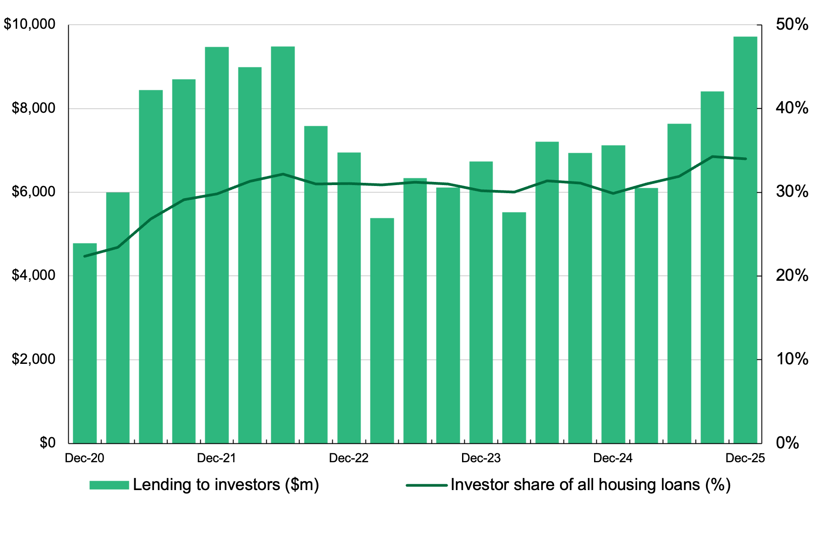
Figure 6: Lending to household investors in residential housing, Victoria ($2025 December)
* Refer to note 7 for details of the data sources and method used in this figure.

Vacancy rate
Figure 7 shows the trend vacancy rate over the past 5 years for metropolitan Melbourne and regional Victoria.
In metropolitan Melbourne, the trend vacancy rate in December 2025 fell to 2.3 per cent. This was a decrease of 0.1 percentage points compared to September 2025 (2.4%) and 0.2 percentage points compared to December last year (2.5%).
Excluding the anomalous period of the coronavirus (COVID-19) pandemic* (during which vacancy rates increased substantially), the average trend vacancy rate in metropolitan Melbourne over the past 20 years was 2.1 per cent, with monthly rates ranging from 1.0 to 3.2 per cent. The last of the unusually high vacancy rates that occurred in metropolitan Melbourne during the coronavirus pandemic can be seen in Figure 7, followed by a return in recent years to trend vacancy rates more closely comparable to this long-term average.
In regional Victoria, the trend vacancy rate in December 2025 rose to 2.4 per cent, an increase of 0.4 percentage points compared to September 2025 (2.0%), and 0.3 percentage points compared to December last year (2.1%). This marks the highest vacancy rate in regional Victoria since April 2017.
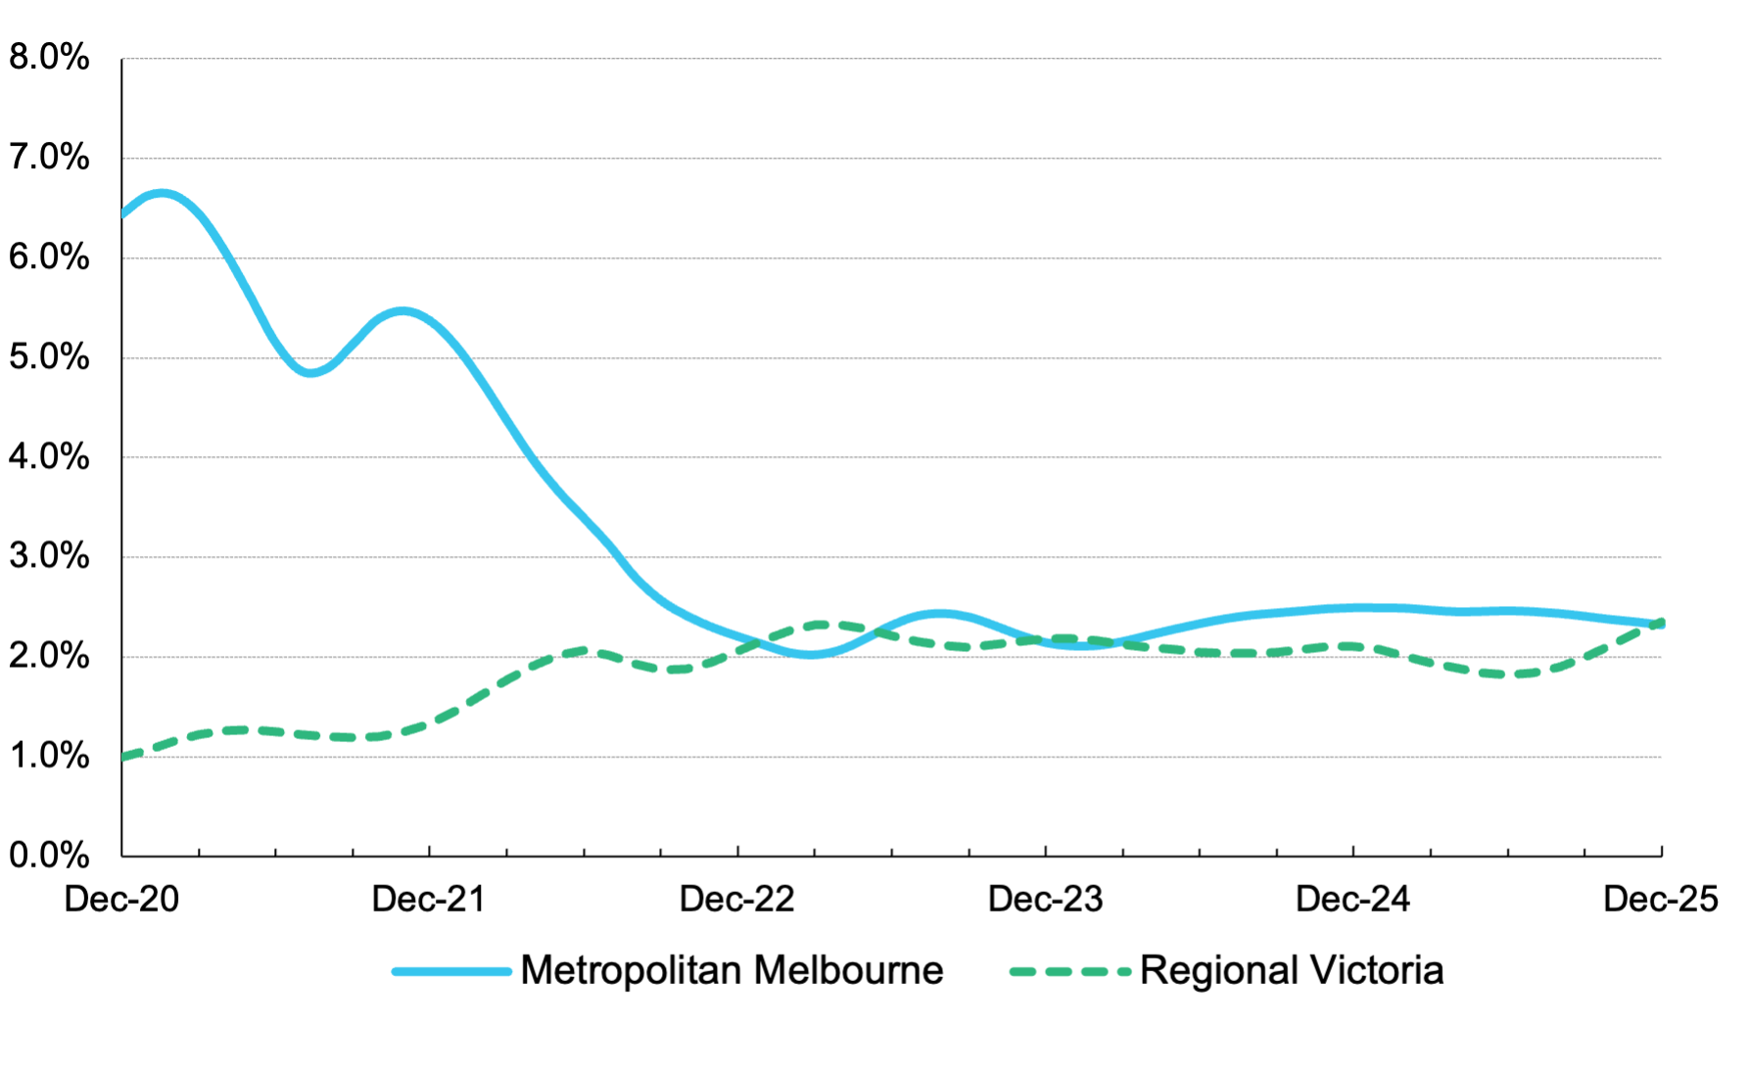
Figure 7: Rental vacancy rate
*The period of the coronavirus (COVID-19) pandemic is here defined as beginning in March 2020 with the declaration, by the Victorian Minister of Health, of a State of Emergency and continuing until the revocation of the Pandemic (Public Safety) Order in October 2022. The highest vacancy rate recorded in metropolitan Melbourne during this period occurred in January and February of 2021 (6.6%).

Rental market affordability
This section of the Rental Report provides a summary of the affordability of rental housing for low‑income households in Victoria. The method used in this section measures the supply of affordable rental dwellings based on RTBA data. The benchmark used is that an affordable rent must not exceed 30 per cent of gross income (plus rent assistance). Low‑income households are defined as those receiving Centrelink incomes.

Overall trends
In the December quarter 2025, 17.0 per cent of all new lettings across the state were affordable to low￼income households. This was an improvement of 2.6 percentage points compared to the previous quarter (14.4%) and 1.0 percentage points compared to the December quarter of last year (16.0%).
Figure 8 shows the trend in rental affordability over the past 5 years for Victoria, metropolitan Melbourne and regional Victoria.
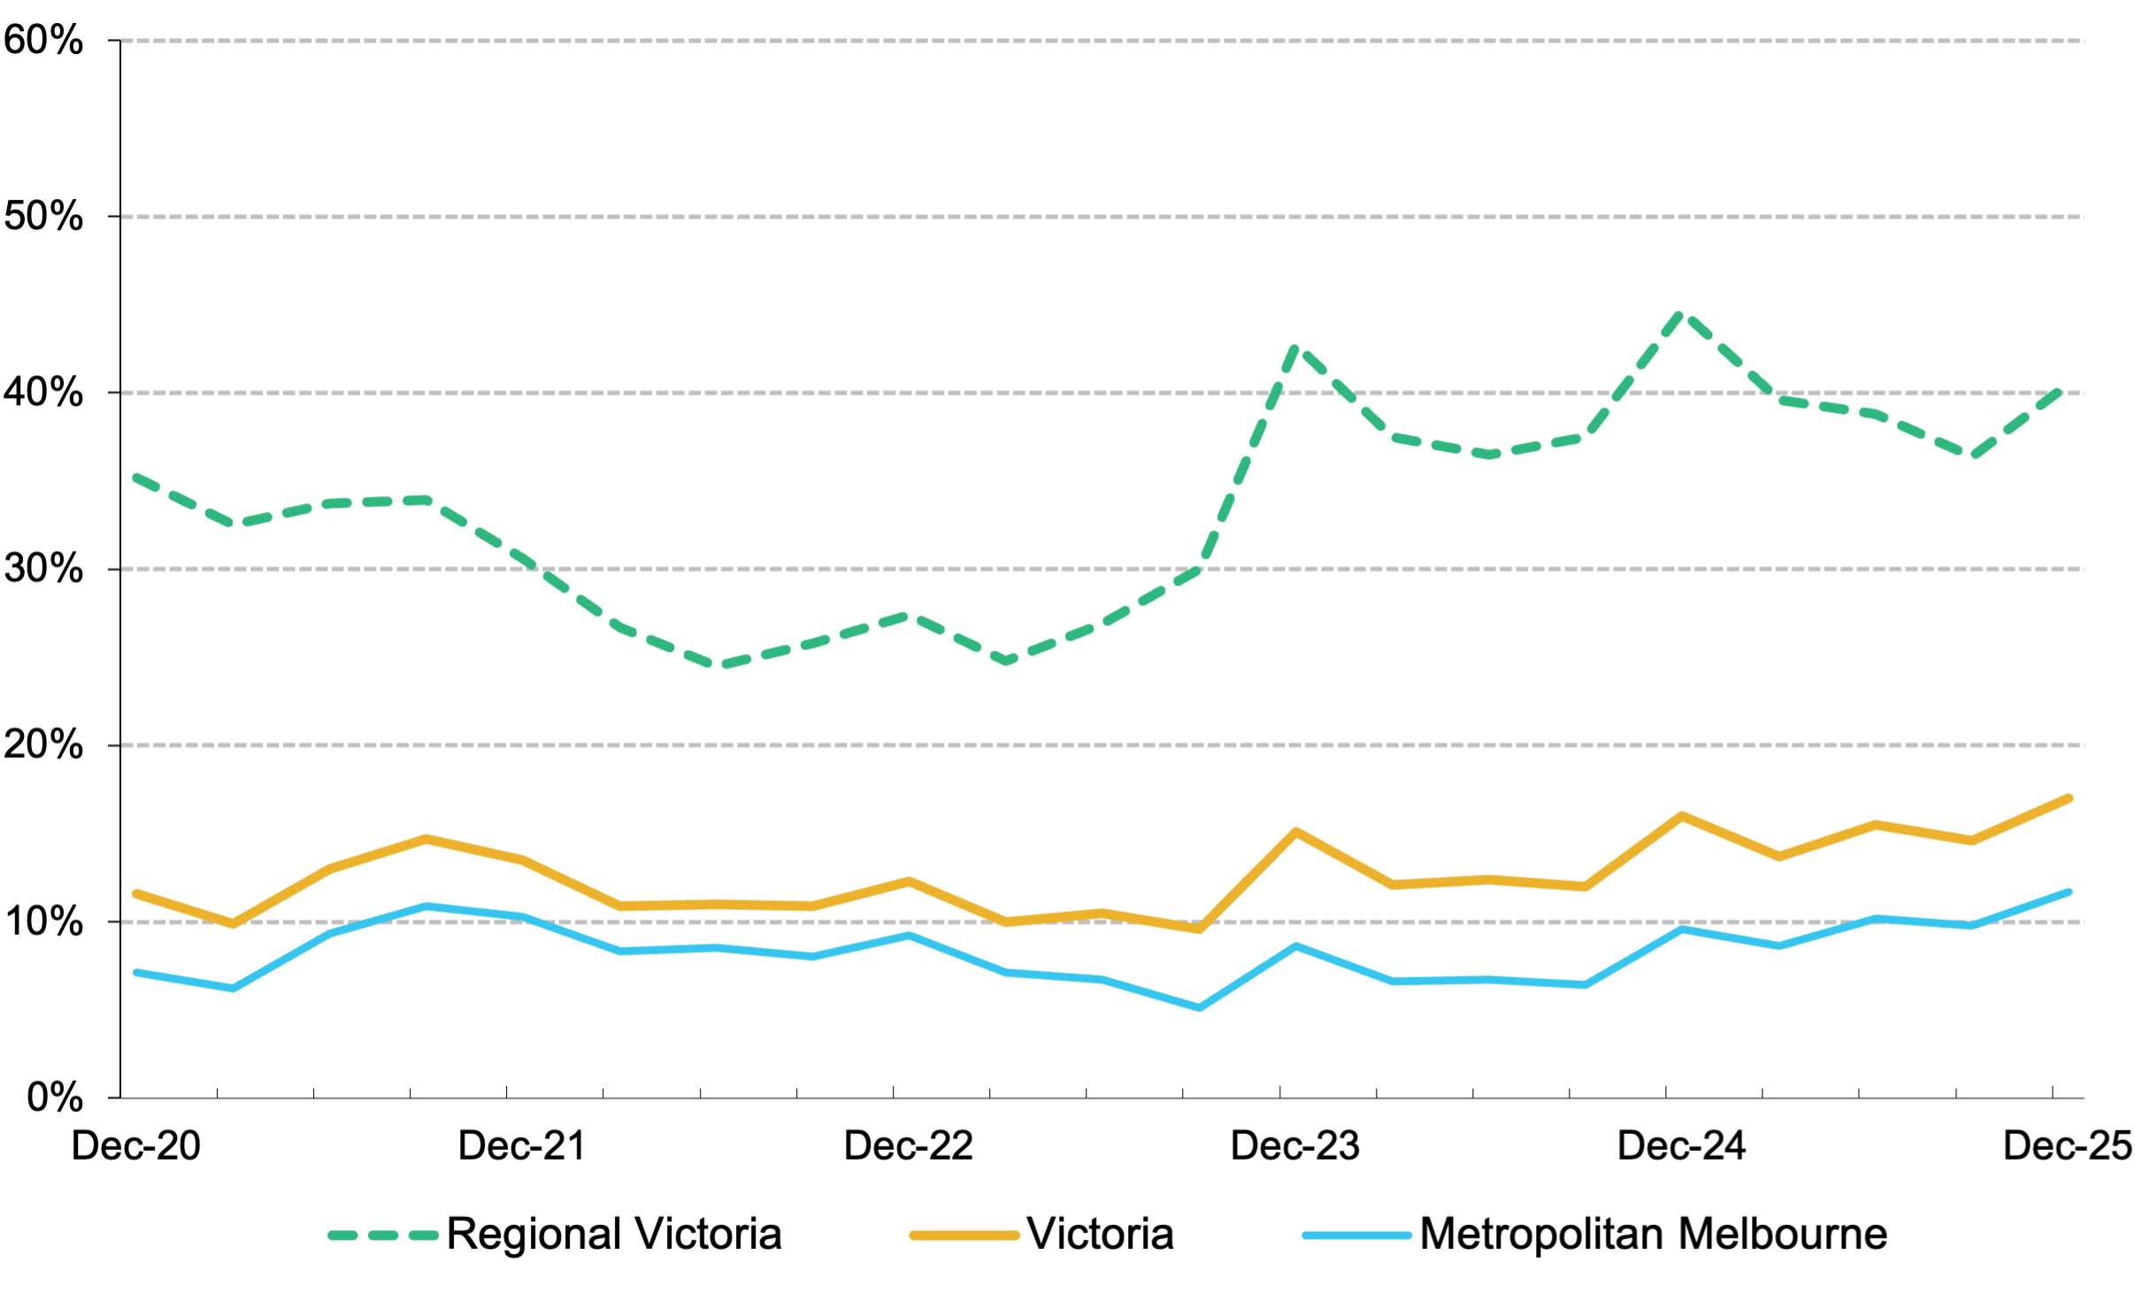
Figure 8: Affordable rental dwellings as a percentage of all new rentals
* Figure 8 does not consider the change in household income resulting from the temporary coronavirus supplement from 27 April 2020 to 31 March 2021.
In metropolitan Melbourne, 11.7 per cent of new lettings in the December quarter 2025 were affordable to low‑income households, improving 1.9 percentage points over the previous quarter (9.8%) and 2.1 percentage points compared to the December quarter 2024 (9.6%). The availability of affordable rental dwellings in metropolitan Melbourne has generally declined from a high of 30.9 per cent in the December quarter 2003 to a low of 5.0 per cent in the March quarter 2018.
In regional Victoria, 40.5 per cent of new lettings in the December quarter 2025 were affordable to low‑income households, improving 4.1 percentage points over the previous quarter (36.4%), but declining 4.1 percentage points compared to the December quarter 2024 (44.6%). The availability of affordable rental dwellings in regional Victoria has generally declined from a high of 88.3 per cent in the September quarter 2001 to a low of 24.5 per cent in the June quarter 2022.

Trends by household type
In metropolitan Melbourne the availability of affordable housing varies according to the size and the type of household. The rental affordability situation for different low‑income households is summarised in Table 9 and Table 10. Table 9 outlines to what extent rental housing is affordable for four types of households on Centrelink incomes by an assumed property size, in metropolitan Melbourne, regional Victoria, and statewide. Table 10 is a supplementary table which indicates the extent to which rental dwellings are affordable to singles and couples on the Age Pension or Disability Support Pension.
Table 9 shows that, due to a limited supply of affordable one‑ and two‑bedroom dwellings, low‑income households of a single person, or a single parent with one child, face the greatest difficulty accessing affordable rental housing. Across Melbourne just 1.1 per cent of one‑bedroom dwellings let during the December quarter 2025 were affordable to a single person on JobSeeker. For a single parent on the Parenting Payment with one child, only 1.8 per cent of two‑bedroom dwellings let across Melbourne this quarter were affordable.
For larger families the supply of affordable three- and four‑bedroom dwellings is better, although these figures do reflect the predominantly outer suburban location of this size of dwelling. A couple on JobSeeker with two dependent children could afford 12.8 per cent of three‑bedroom dwellings let in Melbourne during the December quarter 2025. A couple on JobSeeker with four dependent children could afford 32.8 per cent of four‑bedroom plus dwellings let in Melbourne during the December quarter 2025.
Table 10 shows that only 1.2 per cent of one‑ and two‑bedroom dwellings in metropolitan Melbourne are affordable to single persons on the Age Pension or Disability Support Pension, and that only 4.4 per cent are affordable to couples on the Age Pension or Disability Support Pension.
Table 9: Rental affordability for indicative households on Centrelink incomes
Household type |  | Singles on JobSeeker | Single parent on Parenting Payment with 1 child | Couple on JobSeeker with 2 children | Couple on JobSeeker with 4 children | Total
Assumed property size |  | 1 Bed | 2 Bed | 3 Bed | 4+ Bed
Weekly income (net of Rent Assistance) |  | $397 | $736 | $1,095 | $1,359
Affordable weekly rent |  | $230 | $350 | $460 | $555
Affordable rental dwellings (number) | Metropolitan | 71 | 219 | 1,424 | 2,793 | 4,507
Affordable rental dwellings (number) | Regional | 65 | 425 | 1,693 | 1,378 | 3,561
Affordable rental dwellings (number) | Victoria | 136 | 644 | 3,117 | 4,171 | 8,068
Affordable rental dwellings  (% of total) | Metropolitan | 1.1% | 1.8% | 12.8% | 32.8% | 11.7%
Affordable rental dwellings  (% of total) | Regional | 13.6% | 25.1% | 43.3% | 51.0% | 40.5%
Affordable rental dwellings  (% of total) | Victoria | 1.9% | 4.6% | 20.7% | 37.2% | 17.0%
Table 10: Rental affordability for households on the Age Pension or Disability Support Pension
Household type |  | Singles on Age/Disability | Couples on Age/Disability
Assumed property size |  | 1 or 2 bedroom
Weekly income (net of RA) |  | $540 | $814
Affordable weekly rent |  | $270 | $350
Affordable rental dwellings  (number) | Metropolitan | 227 | 846
Affordable rental dwellings  (number) | Regional | 184 | 736
Affordable rental dwellings  (number) | Victoria | 411 | 1,582
Affordable rental dwellings  (% of total) | Metropolitan | 1.2% | 4.4%
Affordable rental dwellings  (% of total) | Regional | 8.5% | 33.8%
Affordable rental dwellings  (% of total) | Victoria | 1.9% | 7.5%

Trends by statistical region
Table 11 shows the number and proportion of newly let rental dwelling that are affordable for households on a Centrelink income for each of the statistical regions of Victoria.
In metropolitan Melbourne, Western Melbourne has the highest number (3,199) and the highest proportion (43.6%) of affordable rental dwellings. Western Melbourne has the highest number (70) and the highest proportion (6.0%) of two-bedroom affordable dwellings, the highest number (1,085) and the highest proportion (40.0%) of three‑bedroom affordable dwellings, and the highest number (2,029) and highest proportion (66.8%) of four‑bedroom plus affordable dwellings.
The lowest proportions of affordable rental dwellings are found in Southern Melbourne (0.7%), Inner Melbourne (1.1%), Inner Eastern Melbourne (1.4%) and the Mornington Peninsula (2.4%).
In regional Victoria, Central Highlands‑Wimmera has the highest number (1,011) and the highest proportion (71.8%) of affordable rental dwellings. Loddon‑Mallee has the lowest number (425) and Barwon‑South West the lowest proportion (27.1%) of affordable rental dwellings.
Table 11: Affordable rental dwellings by region for indicative households on Centrelink incomes
Region | 1 bedroom |  | 2 bedroom |  | 3 bedroom |  | 4+ bedroom |  | Total
Region | # | % | # | % | # | % | # | % | # | %
Inner Melbourne | 28 | 0.7% | 45 | 1.0% | 28 | 3.2% | 5 | 3.1% | 106 | 1.1%
Inner Eastern Melbourne | 4 | 0.8% | 18 | 1.1% | 17 | 1.3% | 24 | 2.5% | 63 | 1.4%
Southern Melbourne | 3 | 0.7% | 5 | 0.4% | 9 | 1.2% | 3 | 0.7% | 20 | 0.7%
Western Melbourne | 15 | 3.4% | 70 | 6.0% | 1,085 | 40.0% | 2,029 | 66.8% | 3,199 | 43.6%
North Western Melbourne | 7 | 1.2% | 20 | 1.5% | 132 | 10.5% | 294 | 32.6% | 453 | 11.0%
North Eastern Melbourne | 9 | 2.1% | 37 | 3.1% | 84 | 6.5% | 310 | 35.2% | 440 | 11.6%
Outer Eastern Melbourne | 3 | 5.4% | 5 | 1.4% | 11 | 1.7% | 5 | 1.6% | 24 | 1.8%
South Eastern Melbourne | 2 | 1.4% | 10 | 1.7% | 40 | 2.6% | 116 | 7.7% | 168 | 4.5%
Mornington Peninsula | - | 0.0% | 9 | 3.1% | 18 | 2.4% | 7 | 2.2% | 34 | 2.4%
Metropolitan Melbourne | 71 | 1.1% | 219 | 1.8% | 1,424 | 12.8% | 2,793 | 32.8% | 4,507 | 11.7%
Barwon‑South West | 8 | 4.0% | 70 | 13.1% | 352 | 28.9% | 332 | 38.5% | 762 | 27.1%
Gippsland | 4 | 5.3% | 82 | 32.8% | 332 | 55.6% | 196 | 46.8% | 614 | 45.8%
Goulburn‑Ovens‑Murray | 18 | 26.5% | 83 | 22.8% | 292 | 39.4% | 356 | 57.3% | 749 | 41.7%
Loddon‑Mallee | 20 | 29.9% | 83 | 27.9% | 196 | 28.2% | 126 | 34.2% | 425 | 29.8%
Central Highlands‑Wimmera | 15 | 21.1% | 107 | 42.8% | 521 | 79.5% | 368 | 85.0% | 1,011 | 71.8%
Regional Victoria | 65 | 13.6% | 425 | 25.1% | 1,693 | 43.3% | 1,378 | 51.0% | 3,561 | 40.5%
Victoria | 136 | 1.9% | 644 | 4.6% | 3,117 | 20.7% | 4,171 | 37.2% | 8,068 | 17.0%

Trends by Local Government Area
Table 14 shows the number and proportion of newly let rental dwelling that are affordable for households on a Centrelink income for all Victorian Local Government Areas (LGAs).
The LGAs with the highest proportion of affordable rental dwellings in metropolitan Melbourne are Melton (where 63.8% of all rental dwellings are affordable to low-income households), Wyndham (60.2%), Hume (25.6%), Whittlesea (25.4%) and Brimbank (21.0%). The LGAs with lowest proportion are Bayside, Kingston, Knox, Manningham, Port Phillip and Stonnington (where less than 1.0% of properties were affordable), and Boroondara, Frankston, Glen Eira, Maroondah, Melbourne, Monash, Moonee Valley and Whitehorse (all between 1.0% and 2.0% affordable).
In regional Victoria, the LGAs with the highest proportion of affordable rental dwellings are West Wimmera (where 100.0% of dwellings are affordable), and Ararat, Ballarat, Buloke, Central Goldfields, Hindmarsh, Mitchell, Northern Grampians, Pyrenees, Southern Grampians, Towong and Yarriambiack (all between 70.0% and 95.0% affordable). The LGAs with the lowest proportion of affordable rental dwellings are Queenscliffe (0.0%), Macedon Ranges (3.5%), Warrnambool (8.6%), Mansfield (11.1%), Mount Alexander (11.3%) and Surf Coast (14.1%).
Figure 9, drawn from Table 14, show the proportion of affordable dwellings in each Local Government Area (LGA) across metropolitan Melbourne and regional Victoria.
Figure 9: Affordable rental dwellings, metropolitan Melbourne and regional Victoria
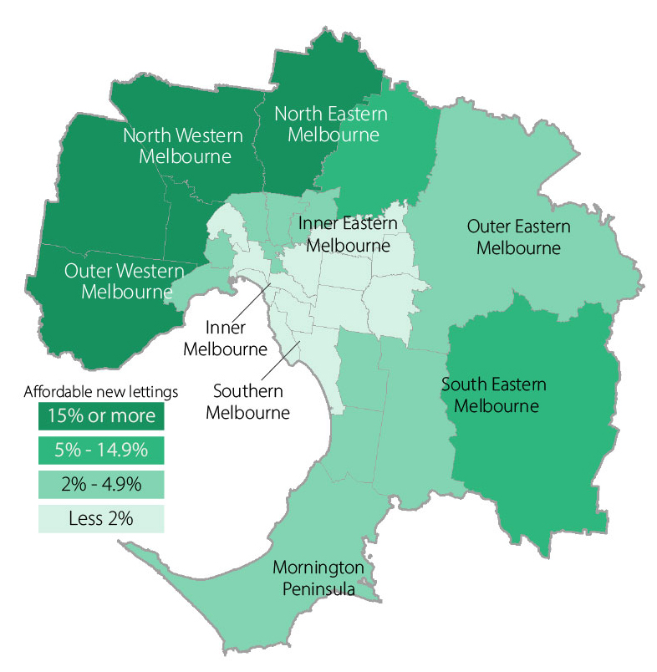
Affordable rental dwellings, metropolitan Melbourne by Local Government Area

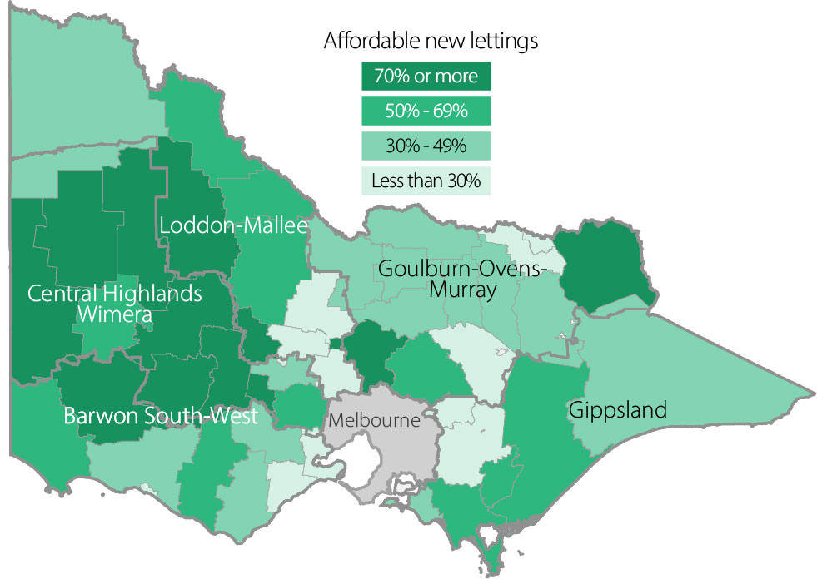
Affordable rental dwellings, regional Victoria by Local Government Area
Table 12: Moving annual median rents for suburbs and towns by major property type
* Medians shown in Table 12 are moving annual medians, not quarterly medians, and the annual percentage change is calculated between these moving annual medians.
Suburb/town |  | 1 bedroom flat |  |  |  | 2 bedroom flat |  |  |  |  |  | 2 bedroom house |  |  |  |  |  | 3 bedroom house
 |  | Count | Median | Annual  % change |  | Count |  | Median |  | Annual  % change |  | Count |  | Median |  | Annual  % change |  | Count |  | Median |  | Annual  % change
Inner Melbourne
Albert Park‑Middle Park‑West St Kilda | 180 |  | $456 |  | 1.3% |  | 138 |  | $638 |  | -1.8% |  | 80 |  | $793 |  | 2.3% |  | 75 |  | $1,200 | 9.6%
Armadale | 174 |  | $465 |  | 3.3% |  | 280 |  | $650 |  | 4.0% |  | 29 |  | $830 |  | 13.5% |  | 50 |  | $1,100 | 0.0%
Carlton North | 41 |  | $438 |  | 4.3% |  | 64 |  | $600 |  | 5.3% |  | 105 |  | $760 |  | 7.8% |  | 78 |  | $950 | 5.6%
Carlton‑Parkville | 973 |  | $510 |  | 4.1% |  | 1,244 |  | $680 |  | 4.6% |  | 56 |  | $700 |  | 7.7% |  | 48 |  | $950 | 5.6%
CBD‑St Kilda Rd | 6,122 |  | $570 |  | 3.6% |  | 6,557 |  | $750 |  | 4.2% |  | - |  | - |  | - |  | - |  | - | -
Collingwood‑Abbotsford | 639 |  | $525 |  | 2.9% |  | 663 |  | $700 |  | 3.7% |  | 86 |  | $733 |  | 4.7% |  | 54 |  | $950 | 5.6%
Docklands | 1,260 |  | $600 |  | 7.1% |  | 1,475 |  | $780 |  | 6.8% |  | - |  | - |  | - |  | - |  | - | -
East Melbourne | 165 |  | $525 |  | 5.0% |  | 170 |  | $700 |  | 7.7% |  | 15 |  | $850 |  | -15.0% |  | 17 |  | $1,100 | -15.1%
East St Kilda | 424 |  | $430 |  | 7.5% |  | 666 |  | $580 |  | 5.5% |  | 40 |  | $750 |  | 0.3% |  | 57 |  | $925 | -2.4%
Elwood | 319 |  | $450 |  | 1.1% |  | 603 |  | $620 |  | 4.2% |  | 38 |  | $810 |  | 8.0% |  | 59 |  | $1,095 | 9.5%
Fitzroy | 211 |  | $530 |  | 0.0% |  | 214 |  | $750 |  | 2.7% |  | 53 |  | $825 |  | 10.0% |  | 43 |  | $1,100 | 10.0%
Fitzroy North‑Clifton Hill | 222 |  | $500 |  | 6.4% |  | 259 |  | $690 |  | 6.2% |  | 131 |  | $750 |  | 3.4% |  | 90 |  | $1,000 | 8.1%
Flemington‑Kensington | 496 |  | $473 |  | 18.3% |  | 670 |  | $580 |  | 11.5% |  | 165 |  | $620 |  | 0.0% |  | 126 |  | $773 | 3.1%
North Melbourne‑West Melbourne | 1,232 |  | $530 |  | 6.0% |  | 1,251 |  | $660 |  | 1.5% |  | 55 |  | $640 |  | -1.5% |  | 61 |  | $850 | 0.0%
Port Melbourne | 228 |  | $550 |  | 3.8% |  | 356 |  | $750 |  | 7.1% |  | 98 |  | $750 |  | 7.1% |  | 131 |  | $1,000 | 2.8%
Prahran‑Windsor | 734 |  | $475 |  | 8.0% |  | 689 |  | $650 |  | 6.6% |  | 171 |  | $780 |  | 4.0% |  | 132 |  | $1,000 | 5.3%
Richmond‑Burnley | 889 |  | $515 |  | 3.0% |  | 837 |  | $700 |  | 1.4% |  | 233 |  | $750 |  | 1.4% |  | 198 |  | $1,000 | 5.3%
South Melbourne | 422 |  | $550 |  | 3.8% |  | 517 |  | $700 |  | 2.9% |  | 65 |  | $750 |  | 2.7% |  | 64 |  | $998 | 0.3%
South Yarra | 1,421 |  | $520 |  | 6.1% |  | 1,265 |  | $710 |  | 2.9% |  | 99 |  | $780 |  | 0.6% |  | 87 |  | $1,100 | 0.0%
Southbank | 1,606 |  | $580 |  | 5.5% |  | 2,341 |  | $730 |  | 2.1% |  | - |  | - |  | - |  | - |  | - | -

Suburb/town | 1 bedroom flat |  |  | 2 bedroom flat |  |  | 2 bedroom house |  |  | 3 bedroom house
Suburb/town | Count | Median | Annual  % change | Count | Median | Annual  % change | Count | Median | Annual  % change | Count | Median | Annual  % change
St Kilda | 1,283 | $470 | 4.4% | 1,040 | $650 | 8.3% | 33 | $730 | -2.7% | 48 | $950 | 7.0%
Toorak | 150 | $450 | 2.7% | 235 | $650 | 3.2% | 14 | $735 | 8.9% | 31 | $1,150 | -9.8%
Inner Melbourne – Total | 19,191 | $540 | 5.9% | 21,534 | $700 | 2.2% | 1,574 | $750 | 4.2% | 1,455 | $995 | 4.7%
Inner Eastern Melbourne
Balwyn | 31 | $500 | 5.3% | 230 | $595 | 4.4% | 23 | $600 | 7.1% | 127 | $780 | 11.4%
Blackburn | 89 | $475 | 5.6% | 185 | $560 | 2.8% | 34 | $560 | 0.9% | 187 | $630 | 5.0%
Box Hill | 448 | $490 | 0.0% | 1,179 | $620 | 3.3% | 60 | $550 | 7.8% | 232 | $655 | 4.0%
Bulleen‑Templestowe‑Doncaster | 125 | $495 | 3.1% | 437 | $600 | 3.4% | 42 | $593 | 6.8% | 259 | $670 | 4.7%
Burwood‑Ashburton | 80 | $430 | 16.2% | 179 | $580 | 5.5% | 43 | $570 | 1.8% | 182 | $665 | 2.3%
Camberwell‑Glen Iris | 198 | $450 | 2.3% | 544 | $600 | 4.3% | 57 | $660 | 1.5% | 149 | $850 | 3.9%
Canterbury‑Surrey Hills‑Mont Albert | 24 | $468 | 11.4% | 196 | $580 | 5.5% | 28 | $618 | 3.0% | 87 | $800 | 6.7%
Chadstone‑Oakleigh | 111 | $500 | 3.1% | 317 | $580 | 5.5% | 26 | $570 | 3.6% | 169 | $630 | 0.0%
Clayton | 414 | $495 | 10.0% | 751 | $600 | 7.1% | 46 | $555 | 0.9% | 195 | $640 | 6.7%
Doncaster East‑Donvale | 30 | $480 | 2.1% | 163 | $580 | 3.6% | 20 | $525 | -4.5% | 175 | $695 | 6.9%
East Hawthorn | 208 | $500 | 5.3% | 387 | $610 | 2.5% | 22 | $765 | 13.3% | 38 | $970 | 12.8%
Glen Waverley‑Mulgrave | 51 | $540 | 3.8% | 267 | $640 | 3.2% | 35 | $610 | 5.2% | 528 | $650 | 4.8%
Hawthorn | 463 | $450 | 5.9% | 694 | $610 | 6.1% | 50 | $723 | -0.3% | 66 | $988 | 7.4%
Kew | 51 | $490 | 8.9% | 357 | $580 | 5.5% | 36 | $675 | -1.5% | 101 | $865 | 4.2%
Mount Waverley | 28 | $480 | 83.2% | 118 | $550 | 5.8% | 30 | $565 | 0.0% | 196 | $655 | 0.8%
Nunawading‑Mitcham | 53 | $440 | 4.8% | 212 | $520 | 4.0% | 49 | $525 | 5.2% | 199 | $650 | 8.3%
Vermont‑Forest Hill‑Burwood East | 46 | $550 | 7.8% | 163 | $550 | 0.0% | 27 | $550 | 5.8% | 262 | $630 | 5.0%
Inner Eastern Melbourne ‑ Total | 2,450 | $480 | 6.7% | 6,379 | $600 | 5.3% | 628 | $595 | 4.4% | 3,152 | $670 | 3.1%

Suburb/town | 1 bedroom flat |  |  | 2 bedroom flat |  |  | 2 bedroom house |  |  | 3 bedroom house
Suburb/town | Count | Median | Annual  % change | Count | Median | Annual  % change | Count | Median | Annual  % change | Count | Median | Annual  % change
Southern Melbourne
Aspendale‑Chelsea‑Carrum | 36 | $398 | -9.5% | 356 | $550 | 7.8% | 57 | $560 | 3.7% | 213 | $675 | 1.5%
Bentleigh | 164 | $413 | 3.3% | 611 | $590 | 5.4% | 52 | $645 | 7.5% | 341 | $740 | 2.8%
Brighton | 79 | $520 | 25.3% | 264 | $690 | 10.4% | 21 | $760 | 1.3% | 79 | $1,150 | 4.5%
Brighton East | 88 | $265 | -26.4% | 66 | $625 | 4.2% | 21 | $740 | 13.8% | 71 | $940 | 10.6%
Carnegie | 295 | $415 | 3.8% | 490 | $600 | 3.4% | 27 | $600 | 1.7% | 44 | $760 | 3.7%
Caulfield | 589 | $500 | 0.0% | 975 | $640 | 6.7% | 65 | $650 | 4.0% | 125 | $880 | 6.3%
Cheltenham | 97 | $460 | 4.5% | 591 | $550 | 3.8% | 65 | $595 | 2.9% | 312 | $730 | 4.3%
Elsternwick | 159 | $450 | 4.7% | 271 | $615 | 2.5% | 18 | $710 | 1.4% | 37 | $880 | -2.2%
Hampton‑Beaumaris | 103 | $485 | 3.2% | 344 | $650 | 4.3% | 40 | $650 | 1.6% | 156 | $900 | 2.7%
Malvern | 97 | $481 | 6.9% | 172 | $625 | 7.8% | 17 | $780 | -1.6% | 45 | $1,050 | 5.0%
Malvern East | 190 | $490 | 6.5% | 350 | $600 | 2.6% | 40 | $640 | -3.8% | 111 | $775 | 3.3%
Mentone‑Parkdale‑Mordialloc | 167 | $410 | 2.5% | 390 | $550 | 3.8% | 46 | $600 | 0.0% | 159 | $750 | 3.4%
Murrumbeena‑Hughesdale | 199 | $420 | 9.1% | 252 | $580 | 5.5% | 18 | $595 | 8.2% | 88 | $743 | 0.4%
Southern Melbourne ‑ Total | 2,263 | $450 | 4.7% | 5,132 | $600 | 5.3% | 487 | $620 | 2.5% | 1,781 | $775 | 3.3%
Outer Western Melbourne
Altona | 74 | $388 | 10.9% | 441 | $480 | 4.3% | 203 | $485 | 1.0% | 1,294 | $530 | 1.9%
Footscray | 572 | $445 | 3.5% | 767 | $560 | -1.8% | 133 | $580 | 5.5% | 141 | $650 | 0.0%
Keilor East‑Avondale Heights | 160 | $460 | 2.2% | 314 | $530 | 3.3% | 36 | $523 | 4.6% | 285 | $595 | 8.2%
Melton | 40 | $368 | -0.3% | 83 | $370 | 6.9% | 62 | $375 | -1.3% | 1,319 | $420 | 0.0%
Newport‑Spotswood | 100 | $450 | -4.3% | 212 | $585 | 1.7% | 61 | $585 | 6.4% | 147 | $700 | 0.0%
St Albans‑Deer Park | 49 | $350 | 12.9% | 280 | $428 | 7.0% | 64 | $420 | 0.0% | 668 | $480 | 6.7%

Suburb/town | 1 bedroom flat |  |  | 2 bedroom flat |  |  | 2 bedroom house |  |  | 3 bedroom house
Suburb/town | Count | Median | Annual  % change | Count | Median | Annual  % change | Count | Median | Annual  % change | Count | Median | Annual  % change
Sunshine | 143 | $340 | 6.3% | 321 | $410 | -0.7% | 102 | $460 | 2.2% | 501 | $500 | 6.4%
Sydenham | - | - | - | 111 | $460 | 3.4% | 63 | $440 | 2.3% | 1,378 | $480 | 1.5%
Werribee‑Hoppers Crossing | 68 | $350 | 0.0% | 454 | $403 | 0.8% | 228 | $420 | 0.0% | 3,681 | $460 | -2.1%
West Footscray | 135 | $365 | 4.3% | 325 | $490 | 3.2% | 111 | $510 | 2.0% | 265 | $600 | 0.0%
Williamstown | 50 | $420 | -8.7% | 122 | $550 | 4.8% | 37 | $620 | 1.6% | 111 | $800 | 6.7%
Yarraville‑Seddon | 120 | $390 | 2.6% | 231 | $520 | 4.0% | 201 | $610 | -1.6% | 296 | $725 | 3.6%
Outer Western Melbourne ‑ Total | 1,517 | $400 | 0.0% | 3,661 | $480 | 2.1% | 1,301 | $490 | 0.0% | 10,086 | $480 | 0.0%
North Western Melbourne
Broadmeadows‑Roxburgh Park | 155 | $330 | -4.6% | 186 | $465 | 1.1% | 99 | $470 | 2.2% | 725 | $508 | 1.6%
Brunswick | 542 | $480 | 6.0% | 635 | $610 | 5.2% | 174 | $675 | 3.8% | 181 | $850 | 2.4%
Coburg‑Pascoe Vale South | 179 | $420 | -2.3% | 393 | $550 | 2.8% | 150 | $600 | 7.1% | 233 | $720 | 2.9%
Craigieburn | - | - | - | 114 | $440 | 0.0% | 104 | $450 | 2.3% | 1,079 | $500 | 0.0%
East Brunswick | 328 | $500 | 2.0% | 395 | $650 | 8.3% | 59 | $700 | -2.8% | 75 | $895 | 2.5%
Essendon | 306 | $430 | 2.4% | 643 | $520 | 4.0% | 69 | $550 | 4.8% | 273 | $650 | 1.1%
Gladstone Park‑Tullamarine | - | - | - | 81 | $470 | 4.4% | 16 | $495 | 4.2% | 190 | $530 | 2.9%
Keilor | - | - | - | - | - | - | - | - | - | 10 | $615 | 11.8%
Moonee Ponds‑Ascot Vale | 359 | $475 | 5.6% | 458 | $550 | 3.8% | 129 | $640 | 3.2% | 186 | $750 | 5.6%
Oak Park‑Glenroy‑Fawkner | 64 | $395 | 1.8% | 536 | $495 | 3.1% | 134 | $500 | 2.0% | 351 | $560 | 1.8%
Pascoe Vale‑Coburg North | 79 | $280 | 0.0% | 339 | $510 | 2.0% | 82 | $550 | 3.8% | 147 | $630 | 3.3%
Sunbury | - | - | - | 95 | $440 | 4.8% | 25 | $440 | 2.3% | 328 | $497 | 5.7%
West Brunswick | 384 | $420 | 10.5% | 397 | $525 | 1.4% | 52 | $600 | -1.6% | 58 | $785 | 4.7%
North Western Melbourne ‑ Total | 2,416 | $450 | 4.7% | 4,273 | $530 | 6.0% | 1,093 | $550 | 0.0% | 3,836 | $530 | 0.0%

Suburb/town | 1 bedroom flat |  |  | 2 bedroom flat |  |  | 2 bedroom house |  |  | 3 bedroom house
Suburb/town | Count | Median | Annual  % change | Count | Median | Annual  % change | Count | Median | Annual  % change | Count | Median | Annual  % change
North Eastern Melbourne
Bundoora‑Greensborough‑Hurstbridge | 132 | $420 | 5.0% | 378 | $490 | 2.1% | 110 | $520 | 4.0% | 720 | $580 | 5.5%
Eltham‑Research‑Montmorency | 30 | $365 | 4.3% | 89 | $510 | 6.3% | 25 | $500 | 0.0% | 144 | $660 | 4.8%
Fairfield‑Alphington | 242 | $420 | 7.7% | 247 | $590 | 3.5% | 29 | $650 | -0.8% | 63 | $850 | 0.0%
Heidelberg‑Heidelberg West | 133 | $450 | 2.3% | 415 | $535 | 0.9% | 74 | $500 | 0.0% | 221 | $600 | 0.0%
Ivanhoe‑Ivanhoe East | 180 | $495 | 1.0% | 336 | $600 | 7.1% | 23 | $630 | 11.5% | 75 | $750 | 6.4%
Mill Park‑Epping | 33 | $400 | 5.3% | 202 | $460 | 2.2% | 115 | $480 | 2.1% | 795 | $530 | 1.9%
Northcote | 295 | $410 | -2.4% | 282 | $600 | 0.8% | 120 | $720 | 2.9% | 125 | $860 | 1.2%
Preston | 245 | $450 | 12.5% | 519 | $550 | 5.8% | 104 | $600 | 5.3% | 234 | $695 | 6.9%
Reservoir | 142 | $420 | 5.5% | 644 | $500 | 4.2% | 193 | $500 | 0.0% | 372 | $570 | 3.6%
Thomastown‑Lalor | 16 | $400 | 11.1% | 200 | $450 | 2.3% | 55 | $480 | 6.7% | 501 | $520 | 4.0%
Thornbury | 240 | $400 | 3.9% | 277 | $525 | 5.0% | 79 | $650 | 0.0% | 91 | $800 | 2.6%
Whittlesea | - | - | - | 53 | $430 | -2.3% | 53 | $450 | 0.0% | 641 | $510 | 0.0%
North Eastern Melbourne ‑ Total | 1,694 | $420 | 5.0% | 3,642 | $520 | 4.0% | 980 | $525 | 0.0% | 3,982 | $550 | 0.0%
Outer Eastern Melbourne
Bayswater | - | - | - | 132 | $500 | 8.7% | 35 | $510 | 2.2% | 153 | $590 | 5.4%
Boronia | 21 | $370 | -10.8% | 122 | $500 | 4.2% | 54 | $530 | 17.8% | 178 | $590 | 5.4%
Croydon‑Lilydale | 46 | $380 | 15.9% | 309 | $510 | 4.1% | 113 | $530 | 6.0% | 583 | $620 | 6.9%
Ferntree Gully | - | - | - | 62 | $520 | 6.1% | 16 | $503 | 4.8% | 204 | $600 | 3.4%

Suburb/town | 1 bedroom flat |  |  | 2 bedroom flat |  |  | 2 bedroom house |  |  | 3 bedroom house
Suburb/town | Count | Median | Annual  % change | Count | Median | Annual  % change | Count | Median | Annual  % change | Count | Median | Annual  % change
Ringwood | 48 | $445 | 11.3% | 397 | $520 | 4.0% | 80 | $540 | 8.0% | 292 | $620 | 5.4%
Rowville | - | - | - | 22 | $525 | 1.0% | 13 | $560 | 1.8% | 151 | $600 | 0.0%
Wantirna‑Scoresby | 49 | $322 | -26.0% | 104 | $510 | -3.8% | 31 | $550 | 6.8% | 285 | $600 | 5.3%
Yarra Ranges | 41 | $350 | -2.8% | 48 | $500 | 12.4% | 82 | $498 | -0.4% | 283 | $595 | 8.2%
Outer Eastern Melbourne ‑ Total | 223 | $380 | 0.0% | 1,196 | $513 | 4.7% | 424 | $525 | 5.0% | 2,129 | $600 | 3.4%
South Eastern Melbourne
Berwick | - | - | - | 63 | $500 | 5.3% | 60 | $500 | 3.5% | 713 | $560 | 1.8%
Cranbourne | 32 | $365 | -8.8% | 103 | $470 | 4.4% | 131 | $495 | 3.1% | 1,644 | $550 | 2.8%
Dandenong | 97 | $380 | 8.6% | 606 | $450 | 4.7% | 59 | $520 | 4.0% | 310 | $580 | 5.3%
Dandenong North‑Endeavour Hills | 36 | $350 | 2.9% | 145 | $470 | 2.2% | 41 | $480 | 7.9% | 440 | $543 | 4.4%
Narre Warren‑Hampton Park | 24 | $323 | -17.2% | 114 | $478 | 3.9% | 81 | $475 | -2.1% | 950 | $550 | 4.8%
Noble Park | 150 | $380 | 8.6% | 369 | $500 | 6.4% | 44 | $495 | 1.0% | 262 | $550 | 0.0%
Pakenham | - | - | - | 76 | $450 | 4.7% | 84 | $470 | 4.4% | 712 | $530 | 3.9%
Springvale | 134 | $373 | 3.6% | 456 | $530 | 6.0% | 38 | $520 | 4.0% | 358 | $590 | 5.4%
South Eastern Melbourne ‑ Total | 480 | $375 | 7.1% | 1,932 | $480 | 4.3% | 538 | $490 | 2.1% | 5,389 | $550 | 1.9%
Mornington Peninsula
Dromana‑Portsea | 16 | $395 | -1.3% | 164 | $480 | 4.8% | 141 | $490 | 4.3% | 641 | $575 | 4.5%
Frankston | 173 | $355 | 2.9% | 409 | $480 | 6.7% | 97 | $495 | 4.7% | 751 | $580 | 5.5%
Hastings‑Flinders | 38 | $360 | 1.4% | 68 | $470 | 4.4% | 27 | $540 | 20.0% | 222 | $600 | 6.2%
Mt Eliza‑Mornington‑Mt Martha | 11 | $470 | 17.5% | 174 | $543 | 4.4% | 23 | $570 | 3.6% | 270 | $680 | 1.5%
Seaford‑Carrum Downs | 61 | $385 | 10.0% | 213 | $480 | 6.7% | 49 | $495 | 3.1% | 677 | $560 | 3.7%
Mornington Peninsula ‑ Total | 299 | $370 | 5.7% | 1,028 | $490 | 6.5% | 337 | $500 | 4.6% | 2,561 | $580 | 5.5%

Suburb/town | 1 bedroom flat |  |  | 2 bedroom flat |  |  | 2 bedroom house |  |  | 3 bedroom house
Suburb/town | Count | Median | Annual  % change | Count | Median | Annual  % change | Count | Median | Annual  % change | Count | Median | Annual  % change
Geelong
Belmont‑Grovedale | 108 | $340 | 7.9% | 280 | $440 | 4.8% | 68 | $450 | 2.3% | 712 | $500 | 2.0%
Corio | 51 | $320 | 6.7% | 77 | $385 | 2.7% | 125 | $380 | 2.7% | 559 | $425 | 6.3%
Geelong‑Newcomb | 209 | $420 | 5.0% | 321 | $465 | -2.7% | 111 | $450 | 4.7% | 442 | $480 | 4.3%
Herne Hill‑Geelong West | 109 | $350 | 6.1% | 128 | $415 | 3.8% | 71 | $460 | 1.1% | 217 | $530 | 6.0%
Lara | - | - | - | 22 | $415 | 3.8% | 17 | $430 | 4.9% | 171 | $500 | 3.5%
Newtown | 35 | $320 | 0.0% | 78 | $440 | 2.3% | 38 | $483 | 7.3% | 91 | $590 | 7.3%
North Geelong | 42 | $340 | 6.3% | 80 | $430 | 2.4% | 67 | $440 | 4.8% | 315 | $500 | 5.7%
Geelong ‑ Total | 558 | $350 | 6.1% | 986 | $430 | 2.4% | 497 | $430 | 2.4% | 2,507 | $490 | 4.3%
Ballarat
Ballarat | 82 | $284 | 2.2% | 172 | $360 | 2.9% | 165 | $370 | 3.4% | 570 | $415 | 3.8%
Mount Clear‑Buninyong | 12 | $285 | 1.4% | 23 | $360 | 3.4% | 11 | $370 | 3.4% | 61 | $430 | 7.5%
Sebastopol‑Delacombe | 80 | $295 | 1.7% | 105 | $350 | 2.9% | 62 | $360 | 2.9% | 392 | $400 | 2.6%
Wendouree‑Alfredton | 57 | $280 | 0.0% | 78 | $360 | 5.9% | 76 | $375 | 4.2% | 540 | $420 | 5.0%
Ballarat ‑ Total | 231 | $285 | 1.8% | 378 | $360 | 5.9% | 314 | $370 | 4.2% | 1,563 | $410 | 2.5%
Bendigo
Bendigo | 17 | $320 | 8.5% | 55 | $420 | 5.0% | 45 | $470 | 8.0% | 132 | $480 | 4.3%
Flora Hill‑Bendigo East | 45 | $350 | 19.5% | 129 | $390 | 5.4% | 68 | $430 | 10.3% | 266 | $480 | 6.7%
Golden Square‑Kangaroo Flat | 16 | $330 | 16.6% | 57 | $380 | 0.0% | 41 | $430 | 7.5% | 322 | $485 | 7.8%
North Bendigo | 17 | $320 | 28.5% | 80 | $400 | 8.1% | 65 | $420 | 7.7% | 421 | $480 | 6.7%
Bendigo ‑ Total | 95 | $350 | 25.0% | 321 | $400 | 6.7% | 219 | $430 | 7.5% | 1,141 | $480 | 6.7%

Suburb/town | 1 bedroom flat |  |  | 2 bedroom flat |  |  | 2 bedroom house |  |  | 3 bedroom house
Suburb/town | Count | Median | Annual  % change | Count | Median | Annual  % change | Count | Median | Annual  % change | Count | Median | Annual  % change
Other Regional Centres
Bairnsdale | 15 | $300 | 0.0% | 40 | $370 | 5.7% | 40 | $390 | 3.2% | 129 | $460 | 2.2%
Benalla | 21 | $350 | 47.1% | 54 | $365 | 4.3% | 43 | $380 | 2.7% | 153 | $470 | 6.1%
Castlemaine | - | - | - | 17 | $425 | 11.0% | 27 | $450 | 4.7% | 57 | $520 | 8.3%
Echuca | 11 | $280 | 3.7% | 73 | $430 | 13.2% | 17 | $440 | 10.0% | 124 | $523 | 6.7%
Hamilton | 24 | $260 | 4.0% | 37 | $320 | 6.7% | 19 | $350 | 6.1% | 102 | $400 | 5.3%
Horsham | 26 | $280 | -6.7% | 85 | $330 | 4.8% | 45 | $340 | -2.9% | 223 | $440 | 10.0%
Mildura | 86 | $281 | 8.1% | 199 | $350 | 4.5% | 123 | $380 | 3.3% | 654 | $490 | 8.9%
Moe‑Newborough | 67 | $260 | 8.3% | 56 | $315 | 7.5% | 46 | $350 | 6.7% | 180 | $423 | 5.8%
Morwell | 43 | $275 | 10.0% | 74 | $320 | 6.7% | 70 | $350 | 6.1% | 279 | $415 | 9.2%
Ocean Grove‑Barwon Heads | - | - | - | 47 | $500 | 11.1% | 15 | $500 | 4.2% | 153 | $560 | 3.7%
Portland | 15 | $340 | 25.9% | 80 | $350 | 0.0% | 28 | $388 | 1.3% | 126 | $450 | 7.1%
Sale‑Maffra | 26 | $263 | 5.2% | 130 | $370 | 2.8% | 36 | $400 | 5.3% | 253 | $450 | 2.3%
Seymour | 13 | $254 | -11.8% | 22 | $360 | 2.9% | 19 | $380 | -3.8% | 70 | $430 | 7.5%
Shepparton | 116 | $293 | 6.5% | 329 | $400 | 14.3% | 75 | $390 | 5.4% | 649 | $480 | 6.7%
Swan Hill | 40 | $243 | 13.0% | 53 | $360 | 2.9% | 14 | $400 | 9.6% | 97 | $480 | 11.6%
Torquay | - | - | - | 27 | $500 | 2.0% | 30 | $530 | -3.6% | 156 | $680 | 6.3%
Traralgon | 82 | $300 | 7.1% | 95 | $365 | 1.4% | 42 | $395 | 3.9% | 388 | $470 | 6.8%
Wangaratta | 64 | $265 | -7.0% | 115 | $350 | 0.0% | 29 | $420 | 10.5% | 220 | $480 | 6.7%
Warragul | 10 | $250 | 0.0% | 56 | $408 | 7.4% | 20 | $433 | 5.6% | 133 | $490 | 6.5%
Warrnambool | 40 | $360 | 12.5% | 226 | $420 | 5.0% | 68 | $450 | 0.0% | 328 | $550 | 5.8%
Wodonga | 41 | $290 | 7.4% | 186 | $390 | 11.4% | 38 | $425 | 6.3% | 498 | $520 | 10.6%
Other Regional Centres - Total | 755 | $280 | 7.7% | 2,001 | $375 | 7.1% | 844 | $390 | 2.6% | 4,972 | $480 | 6.7%

Table 13: Quarterly median rents for Local Government Areas by major property type
LGA | 1 bed flat |  |  | 2 bed flat |  |  | 2 bed house |  |  | 3 bed house
LGA | Count | Median | Annual  % change | Count | Median | Annual  % change | Count | Median | Annual  % change | Count | Median | Annual  % change
Colac‑Otway | - | - | - | 12 | $405 | 12.5% | 10 | $415 | 6.4% | 39 | $450 | 4.7%
Corangamite | - | - | - | - | - | - | - | - | - | 17 | $450 | 18.4%
Glenelg | - | - | - | 14 | $350 | -6.7% | 14 | $388 | 16.5% | 38 | $460 | 15.0%
Greater Geelong | 152 | $405 | 22.7% | 226 | $440 | 3.5% | 126 | $440 | 4.8% | 795 | $500 | 4.2%
Moyne | - | - | - | - | - | - | - | - | - | 10 | $450 | 0.0%
Queenscliffe | - | - | - | - | - | - | - | - | - | - | - | -
Southern Grampians | - | - | - | 10 | $335 | - | - | - | - | 32 | $400 | 5.3%
Surf Coast | - | - | - | - | - | - | 10 | $523 | -4.9% | 68 | $598 | 4.0%
Warrnambool | 12 | $363 | 11.7% | 44 | $438 | 9.5% | 15 | $460 | 2.2% | 82 | $575 | 13.9%
Barwon‑South West | 176 | $385 | 20.3% | 321 | $440 | 4.8% | 191 | $430 | 2.4% | 1,082 | $500 | 4.2%
Ararat | - | - | - | - | - | - | - | - | - | 39 | $390 | 0.5%
Ballarat | 42 | $282 | -1.1% | 74 | $360 | 2.9% | 71 | $380 | 5.6% | 364 | $420 | 5.0%
Golden Plains | - | - | - | - | - | - | - | - | - | - | - | -
Hepburn | - | - | - | - | - | - | 14 | $440 | -1.1% | 21 | $450 | -3.2%
Hindmarsh | - | - | - | - | - | - | - | - | - | 10 | $330 | -
Horsham | - | - | - | 19 | $340 | 7.9% | 10 | $335 | 1.5% | 51 | $430 | 7.5%
Moorabool | - | - | - | 11 | $380 | -5.0% | 12 | $294 | - | 68 | $463 | 1.8%
Northern Grampians | - | - | - | - | - | - | - | - | - | 16 | $413 | 3.3%
Pyrenees | - | - | - | - | - | - | - | - | - | - | - | -
West Wimmera | - | - | - | - | - | - | - | - | - | - | - | -
Yarriambiack | - | - | - | - | - | - | - | - | - | - | - | -
Grampians | 60 | $284 | 1.4% | 125 | $360 | 5.9% | 124 | $370 | 2.8% | 595 | $425 | 3.7%

LGA | 1 bed flat |  |  | 2 bed flat |  |  | 2 bed house |  |  | 3 bed house
LGA | Count | Median | Annual  % change | Count | Median | Annual  % change | Count | Median | Annual  % change | Count | Median | Annual  % change
Buloke | - | - | - | - | - | - | - | - | - | - | - | -
Campaspe | - | - | - | 29 | $410 | 12.3% | 10 | $405 | 7.7% | 48 | $470 | 1.1%
Central Goldfields | - | - | - | - | - | - | - | - | - | 21 | $385 | 1.3%
Gannawarra | - | - | - | - | - | - | - | - | - | - | - | -
Greater Bendigo | 16 | $350 | 22.8% | 81 | $400 | 8.1% | 49 | $450 | 9.8% | 327 | $500 | 7.5%
Loddon | - | - | - | - | - | - | - | - | - | - | - | -
Macedon Ranges | - | - | - | - | - | - | 12 | $455 | - | 29 | $550 | 3.2%
Mildura | 26 | $284 | 13.6% | 48 | $350 | 0.0% | 37 | $390 | 6.8% | 182 | $490 | 6.5%
Mount Alexander | - | - | - | - | - | - | 11 | $470 | 14.6% | 21 | $540 | 13.7%
Swan Hill | - | - | - | 17 | $350 | 0.0% | - | - | - | 29 | $480 | 7.9%
Loddon Mallee | 57 | $290 | 11.5% | 192 | $390 | 8.3% | 138 | $420 | 6.3% | 674 | $500 | 8.7%
Alpine | - | - | - | 13 | $375 | 2.7% | - | - | - | 28 | $480 | 0.4%
Benalla | - | - | - | 17 | $360 | - | 15 | $400 | 5.3% | 40 | $480 | 7.1%
Greater Shepparton | 23 | $260 | -3.7% | 73 | $400 | 8.1% | 22 | $395 | 2.6% | 163 | $480 | 6.7%
Indigo | - | - | - | - | - | - | - | - | - | 15 | $500 | 11.1%
Mansfield | - | - | - | - | - | - | - | - | - | - | - | -
Mitchell | - | - | - | 18 | $388 | 3.5% | 12 | $400 | 0.0% | 81 | $450 | 0.0%
Moira | - | - | - | 23 | $370 | 8.8% | - | - | - | 46 | $500 | 11.1%
Murrindindi | - | - | - | - | - | - | - | - | - | 18 | $430 | 2.9%
Strathbogie | - | - | - | - | - | - | - | - | - | 18 | $450 | 0.0%
Towong | - | - | - | - | - | - | - | - | - | - | - | -
Wangaratta | 11 | $232 | -20.0% | 19 | $360 | 2.9% | - | - | - | 51 | $490 | 8.9%
Wodonga | - | - | - | 46 | $400 | 8.1% | - | - | - | 144 | $520 | 8.3%
Hume | 56 | $260 | -7.1% | 224 | $388 | 7.8% | 95 | $400 | 5.3% | 620 | $490 | 6.5%

LGA | 1 bed flat |  |  | 2 bed flat |  |  | 2 bed house |  |  | 3 bed house
LGA | Count | Median | Annual  % change | Count | Median | Annual  % change | Count | Median | Annual  % change | Count | Median | Annual  % change
Bass Coast | - | - | - | 12 | $395 | 1.3% | 10 | $430 | 8.0% | 60 | $480 | 2.1%
Baw Baw | - | - | - | 21 | $435 | 10.1% | - | - | - | 59 | $500 | 2.0%
East Gippsland | - | - | - | 24 | $380 | 10.1% | 20 | $410 | 6.5% | 74 | $460 | 2.2%
Latrobe | 46 | $275 | 3.8% | 41 | $340 | 6.3% | 34 | $380 | 8.6% | 239 | $440 | 4.8%
South Gippsland | - | - | - | - | - | - | 10 | $380 | 2.7% | 29 | $440 | 2.3%
Wellington | - | - | - | 38 | $373 | 3.6% | 11 | $380 | 5.6% | 82 | $450 | 7.1%
Gippsland | 68 | $283 | 2.9% | 144 | $370 | 2.8% | 94 | $390 | 2.6% | 543 | $450 | 0.0%
Banyule | 84 | $468 | 4.0% | 243 | $540 | 3.8% | 47 | $540 | 8.0% | 186 | $620 | 3.3%
Brimbank | 54 | $363 | 10.0% | 133 | $440 | 4.8% | 38 | $450 | 0.0% | 341 | $500 | 4.2%
Darebin | 275 | $430 | 6.2% | 490 | $550 | 3.8% | 116 | $593 | -1.2% | 191 | $690 | 4.5%
Hobsons Bay | 56 | $435 | -5.4% | 120 | $528 | -5.7% | 44 | $550 | 2.8% | 200 | $620 | 6.3%
Hume | 21 | $350 | -1.4% | 108 | $450 | 0.0% | 65 | $460 | 0.0% | 516 | $500 | 0.0%
Maribyrnong | 259 | $420 | -1.2% | 376 | $525 | 1.0% | 112 | $600 | 7.1% | 184 | $680 | 4.6%
Melbourne | 2,136 | $550 | 3.8% | 2,420 | $700 | 2.9% | 75 | $710 | 4.0% | 64 | $910 | 5.8%
Melton | 11 | $355 | 1.4% | 40 | $407 | 1.8% | 23 | $430 | 1.2% | 664 | $450 | -2.2%
Merri‑bek | 364 | $475 | 11.0% | 623 | $550 | 3.8% | 146 | $600 | 3.4% | 214 | $700 | 7.7%
Moonee Valley | 248 | $450 | 5.9% | 331 | $550 | 10.0% | 64 | $630 | 8.1% | 130 | $680 | 3.0%
Nillumbik | - | - | - | - | - | - | - | - | - | 67 | $550 | 0.0%
Whittlesea | 15 | $395 | 2.6% | 99 | $465 | 3.3% | 60 | $475 | 3.3% | 428 | $520 | 0.0%
Wyndham | 19 | $380 | 8.6% | 117 | $420 | 0.0% | 70 | $420 | -2.3% | 831 | $455 | -3.2%
Yarra | 476 | $510 | 2.0% | 435 | $690 | 2.2% | 107 | $765 | 4.8% | 100 | $1,000 | 5.3%
North and West Metro | 4,023 | $500 | 3.1% | 5,544 | $620 | 5.1% | 972 | $570 | 1.6% | 4,116 | $515 | 1.0%

LGA | 1 bed flat |  |  | 2 bed flat |  |  | 2 bed house |  |  | 3 bed house
LGA | Count | Median | Annual  % change | Count | Median | Annual  % change | Count | Median | Annual  % change | Count | Median | Annual  % change
Boroondara | 206 | $490 | 8.9% | 491 | $600 | 5.3% | 43 | $700 | 7.7% | 119 | $870 | 9.0%
Knox | 23 | $400 | 1.3% | 95 | $520 | 4.0% | 26 | $550 | 5.8% | 198 | $610 | 3.4%
Manningham | 38 | $500 | 4.2% | 128 | $600 | 4.3% | 14 | $620 | 3.3% | 102 | $698 | 3.4%
Maroondah | 12 | $418 | 26.3% | 140 | $530 | 3.9% | 20 | $550 | 6.8% | 123 | $650 | 8.3%
Monash | 99 | $490 | 4.3% | 294 | $580 | 3.6% | 36 | $600 | 9.1% | 268 | $660 | 4.8%
Whitehorse | 177 | $480 | 2.6% | 504 | $580 | 3.6% | 43 | $560 | 5.7% | 258 | $650 | 3.2%
Yarra Ranges | 12 | $350 | 0.0% | 37 | $550 | 10.0% | 28 | $548 | 7.5% | 137 | $630 | 7.1%
Eastern Metro | 567 | $480 | 6.7% | 1,689 | $580 | 5.5% | 210 | $575 | 4.5% | 1,205 | $650 | 4.8%
Bayside | 57 | $500 | 6.4% | 180 | $647 | 6.1% | 19 | $650 | 4.8% | 92 | $900 | 5.9%
Cardinia | - | - | - | 19 | $450 | 7.1% | 23 | $480 | 2.1% | 224 | $540 | 1.9%
Casey | 24 | $365 | -8.8% | 80 | $490 | 3.2% | 51 | $500 | 3.1% | 747 | $550 | 0.0%
Frankston | 43 | $380 | 15.2% | 135 | $490 | 6.5% | 31 | $515 | 3.6% | 346 | $580 | 5.5%
Glen Eira | 342 | $430 | 2.9% | 567 | $600 | 3.4% | 42 | $630 | -3.1% | 132 | $823 | 2.9%
Greater Dandenong | 82 | $370 | 7.9% | 284 | $470 | 2.2% | 38 | $540 | 12.5% | 220 | $573 | 4.2%
Kingston | 67 | $430 | 1.2% | 316 | $550 | 3.8% | 35 | $595 | 8.2% | 162 | $700 | 1.7%
Mornington Peninsula | 11 | $470 | 30.6% | 80 | $515 | 5.1% | 31 | $500 | 4.2% | 221 | $620 | 5.4%
Port Phillip | 576 | $500 | 4.2% | 665 | $675 | 5.5% | 68 | $783 | 4.7% | 78 | $1,050 | 10.5%
Stonnington | 625 | $500 | 11.1% | 675 | $685 | 5.4% | 67 | $790 | 1.9% | 95 | $1,000 | 5.3%
Southern Metro | 1,829 | $480 | 6.7% | 3,001 | $600 | 5.3% | 405 | $600 | 4.3% | 2,317 | $580 | 1.8%

Table 14: Affordable rental dwellings by Local Government Area
* See note 9 on method
LGA | 1 bedroom |  | 2 bedroom |  | 3 bedroom |  | 4+ bedroom |  | Total
LGA | # | % | # | % | # | % | # | % | # | %
Alpine | 0 | 0.0% | 6 | 31.6% | 9 | 31.0% | 4 | 36.4% | 19 | 30.6%
Ararat | 0 | 0.0% | 7 | 63.6% | 38 | 92.7% | 10 | 100.0% | 55 | 85.9%
Ballarat | 11 | 22.9% | 44 | 29.5% | 355 | 86.6% | 305 | 91.0% | 715 | 75.9%
Banyule | 2 | 2.3% | 3 | 0.9% | 10 | 3.1% | 5 | 4.3% | 20 | 2.3%
Bass Coast | 0 | 0.0% | 7 | 21.2% | 34 | 40.5% | 30 | 50.0% | 71 | 39.2%
Baw Baw | 0 | 0.0% | 3 | 10.0% | 14 | 19.2% | 29 | 22.8% | 46 | 19.3%
Bayside | 0 | 0.0% | 1 | 0.5% | 0 | 0.0% | 0 | 0.0% | 1 | 0.2%
Benalla | 2 | 33.3% | 8 | 25.0% | 17 | 39.5% | 7 | 33.3% | 34 | 33.3%
Boroondara | 2 | 1.0% | 5 | 0.9% | 4 | 1.6% | 2 | 1.0% | 13 | 1.1%
Brimbank | 3 | 5.4% | 19 | 9.9% | 112 | 25.6% | 45 | 27.1% | 179 | 21.0%
Buloke | 0 | 0.0% | 0 | 0.0% | 5 | 71.4% | 2 | 100.0% | 7 | 70.0%
Campaspe | 0 | 0.0% | 11 | 28.2% | 26 | 50.0% | 14 | 58.3% | 51 | 42.1%
Cardinia | 1 | 50.0% | 2 | 4.0% | 9 | 3.2% | 42 | 12.6% | 54 | 8.1%
Casey | 1 | 2.9% | 2 | 1.4% | 18 | 2.1% | 70 | 6.6% | 91 | 4.3%
Central Goldfields | 1 | 100.0% | 10 | 76.9% | 21 | 95.5% | 3 | 100.0% | 35 | 89.7%
Colac‑Otway | 0 | 0.0% | 3 | 13.6% | 26 | 59.1% | 5 | 38.5% | 34 | 41.0%
Corangamite | 0 | 0.0% | 6 | 50.0% | 10 | 58.8% | 9 | 75.0% | 25 | 58.1%
Darebin | 5 | 1.8% | 27 | 4.3% | 10 | 3.0% | 2 | 2.9% | 44 | 3.4%
East Gippsland | 0 | 0.0% | 11 | 25.0% | 41 | 51.9% | 34 | 60.7% | 86 | 46.5%
Frankston | 0 | 0.0% | 5 | 2.9% | 8 | 1.8% | 4 | 2.4% | 17 | 2.0%
Gannawarra | 0 | 0.0% | 3 | 50.0% | 7 | 77.8% | 0 | 0.0% | 10 | 66.7%
Glen Eira | 3 | 0.9% | 3 | 0.5% | 7 | 2.2% | 2 | 1.1% | 15 | 1.0%
Glenelg | 0 | 0.0% | 16 | 51.6% | 23 | 53.5% | 7 | 77.8% | 46 | 54.1%
Golden Plains | 0 | 0.0% | 1 | 16.7% | 1 | 11.1% | 17 | 65.4% | 19 | 45.2%
Greater Bendigo | 1 | 5.0% | 13 | 9.8% | 72 | 20.2% | 75 | 36.4% | 161 | 22.5%
Greater Dandenong | 0 | 0.0% | 6 | 1.8% | 11 | 3.3% | 4 | 3.7% | 21 | 2.5%

LGA | 1 bedroom |  | 2 bedroom |  | 3 bedroom |  | 4+ bedroom |  | Total
LGA | # | % | # | % | # | % | # | % | # | %
Greater Geelong | 5 | 3.0% | 24 | 6.7% | 248 | 27.7% | 255 | 42.6% | 532 | 26.3%
Greater Shepparton | 7 | 30.4% | 17 | 17.5% | 70 | 37.8% | 24 | 30.0% | 118 | 30.6%
Hepburn | 0 | 0.0% | 7 | 35.0% | 14 | 60.9% | 4 | 40.0% | 25 | 41.0%
Hindmarsh | 1 | 100.0% | 1 | 100.0% | 9 | 90.0% | 2 | 100.0% | 13 | 92.9%
Hobsons Bay | 2 | 3.3% | 4 | 2.3% | 13 | 4.9% | 9 | 12.2% | 28 | 4.9%
Horsham | 2 | 28.6% | 25 | 86.2% | 37 | 66.1% | 7 | 53.8% | 71 | 67.6%
Hume | 2 | 7.7% | 4 | 1.9% | 113 | 18.0% | 285 | 39.9% | 404 | 25.6%
Indigo | 0 | 0.0% | 0 | 0.0% | 5 | 31.3% | 0 | 0.0% | 5 | 15.2%
Kingston | 0 | 0.0% | 1 | 0.3% | 5 | 1.9% | 1 | 0.8% | 7 | 0.9%
Knox | 0 | 0.0% | 2 | 1.6% | 1 | 0.4% | 2 | 1.3% | 5 | 0.9%
Latrobe | 4 | 8.5% | 36 | 48.0% | 160 | 66.1% | 74 | 58.7% | 274 | 55.9%
Loddon | 0 | 0.0% | 0 | 0.0% | 2 | 100.0% | 2 | 66.7% | 4 | 57.1%
Macedon Ranges | 1 | 50.0% | 2 | 10.0% | 1 | 2.3% | 0 | 0.0% | 4 | 3.5%
Manningham | 0 | 0.0% | 1 | 0.7% | 2 | 1.1% | 2 | 1.1% | 5 | 0.9%
Mansfield | 0 | 0.0% | 0 | 0.0% | 1 | 11.1% | 2 | 22.2% | 3 | 11.1%
Maribyrnong | 7 | 2.6% | 27 | 5.1% | 16 | 5.8% | 3 | 4.8% | 53 | 4.7%
Maroondah | 1 | 5.6% | 3 | 1.8% | 4 | 2.0% | 1 | 1.1% | 9 | 1.9%
Melbourne | 11 | 0.5% | 22 | 0.9% | 13 | 3.9% | 3 | 5.8% | 49 | 1.0%
Melton | 1 | 6.3% | 8 | 12.1% | 428 | 55.5% | 829 | 73.2% | 1,266 | 63.8%
Merri‑bek | 5 | 1.3% | 15 | 1.8% | 12 | 2.8% | 8 | 7.0% | 40 | 2.3%
Mildura | 10 | 32.3% | 40 | 46.5% | 74 | 36.5% | 36 | 45.0% | 160 | 40.0%
Mitchell | 1 | 50.0% | 8 | 26.7% | 65 | 68.4% | 263 | 92.0% | 337 | 81.6%
Moira | 2 | 40.0% | 9 | 30.0% | 17 | 35.4% | 9 | 26.5% | 37 | 31.6%
Monash | 0 | 0.0% | 4 | 1.2% | 3 | 0.7% | 11 | 3.4% | 18 | 1.5%
Moonee Valley | 0 | 0.0% | 2 | 0.5% | 7 | 3.1% | 2 | 2.6% | 11 | 1.1%
Moorabool | 1 | 50.0% | 12 | 50.0% | 39 | 47.6% | 32 | 59.3% | 84 | 51.9%
Mornington Peninsula | 0 | 0.0% | 4 | 3.5% | 10 | 3.4% | 3 | 2.0% | 17 | 2.9%
Mount Alexander | 0 | 0.0% | 2 | 14.3% | 3 | 13.0% | 1 | 7.7% | 6 | 11.3%

LGA | 1 bedroom |  | 2 bedroom |  | 3 bedroom |  | 4+ bedroom |  | Total
LGA | # | % | # | % | # | % | # | % | # | %
Moyne | 0 | 0.0% | 2 | 20.0% | 7 | 63.6% | 0 | 0.0% | 9 | 31.0%
Murrindindi | 0 | 0.0% | 4 | 33.3% | 12 | 66.7% | 5 | 83.3% | 21 | 58.3%
Nillumbik | 0 | 0.0% | 1 | 6.7% | 3 | 3.7% | 24 | 27.6% | 28 | 14.6%
Northern Grampians | 0 | 0.0% | 7 | 63.6% | 14 | 87.5% | 3 | 75.0% | 24 | 75.0%
Port Phillip | 3 | 0.5% | 6 | 0.8% | 2 | 1.0% | 0 | 0.0% | 11 | 0.7%
Pyrenees | 0 | 0.0% | 2 | 100.0% | 6 | 75.0% | 2 | 100.0% | 10 | 76.9%
Queenscliffe | 0 | 0.0% | 0 | 0.0% | 0 | 0.0% | 0 | 0.0% | 0 | 0.0%
South Gippsland | 0 | 0.0% | 7 | 38.9% | 21 | 70.0% | 11 | 68.8% | 39 | 58.2%
Southern Grampians | 1 | 33.3% | 10 | 66.7% | 28 | 84.8% | 6 | 85.7% | 45 | 77.6%
Stonnington | 2 | 0.3% | 1 | 0.1% | 3 | 1.4% | 0 | 0.0% | 6 | 0.4%
Strathbogie | 0 | 0.0% | 2 | 40.0% | 11 | 55.0% | 2 | 28.6% | 15 | 44.1%
Surf Coast | 0 | 0.0% | 2 | 10.5% | 4 | 5.3% | 28 | 19.4% | 34 | 14.1%
Swan Hill | 7 | 77.8% | 12 | 52.2% | 11 | 36.7% | 7 | 58.3% | 37 | 50.0%
Towong | 0 | 0.0% | 0 | 0.0% | 8 | 88.9% | 1 | 100.0% | 9 | 81.8%
Wangaratta | 5 | 45.5% | 9 | 33.3% | 20 | 35.1% | 10 | 47.6% | 44 | 37.9%
Warrnambool | 2 | 15.4% | 6 | 9.7% | 5 | 5.5% | 5 | 11.6% | 18 | 8.6%
Wellington | 0 | 0.0% | 18 | 36.0% | 62 | 69.7% | 18 | 52.9% | 98 | 54.4%
West Wimmera | 0 | 0.0% | 2 | 100.0% | 6 | 100.0% | 1 | 100.0% | 9 | 100.0%
Whitehorse | 2 | 1.1% | 8 | 1.4% | 8 | 1.8% | 9 | 4.1% | 27 | 1.9%
Whittlesea | 1 | 5.0% | 5 | 2.6% | 61 | 11.3% | 279 | 46.0% | 346 | 25.4%
Wodonga | 1 | 33.3% | 10 | 16.4% | 31 | 19.3% | 15 | 13.0% | 57 | 16.8%
Wyndham | 2 | 5.7% | 12 | 6.0% | 517 | 54.7% | 1,143 | 71.3% | 1,674 | 60.2%
Yarra | 13 | 2.7% | 16 | 2.7% | 8 | 4.3% | 1 | 3.1% | 38 | 2.9%
Yarra Ranges | 2 | 13.3% | 0 | 0.0% | 6 | 3.7% | 2 | 3.0% | 10 | 3.2%
Yarriambiack | 0 | 0.0% | 0 | 0.0% | 3 | 100.0% | 2 | 100.0% | 5 | 83.3%
Total | 136 | 1.9% | 644 | 4.6% | 3,117 | 20.7% | 4,171 | 37.2% | 8,068 | 17.0%

Table 15: Active bonds by Local Government Area
LGA | Dec  2025 | % change |  |  | LGA | Dec  2025 | % change
LGA | Dec  2025 | 1 year | 5 years |  | LGA | Dec  2025 | 1 year | 5 years
Alpine | 838 | -0.7% | -1.3% |  | Mansfield | 416 | -5.5% | -11.7%
Ararat | 811 | -1.3% | 5.2% |  | Maribyrnong | 14,509 | -3.3% | 6.0%
Ballarat | 14,139 | 2.4% | 11.3% |  | Maroondah | 8,633 | -4.9% | -11.9%
Banyule | 12,866 | -4.7% | -0.7% |  | Melbourne | 61,655 | 0.8% | 23.6%
Bass Coast | 2,947 | -0.1% | -5.9% |  | Melton | 23,693 | 7.3% | 50.0%
Baw Baw | 3,414 | -2.6% | -0.8% |  | Merri‑bek | 25,032 | -3.2% | -5.2%
Bayside | 7,790 | -2.1% | -7.7% |  | Mildura | 5,257 | 4.7% | 2.4%
Benalla | 1,166 | 1.2% | 2.8% |  | Mitchell | 4,303 | 8.1% | 45.3%
Boroondara | 17,850 | -5.6% | -8.1% |  | Moira | 1,956 | 0.3% | -1.2%
Brimbank | 15,993 | -3.2% | -3.4% |  | Monash | 18,276 | -2.4% | -0.1%
Buloke | 208 | 1.5% | 5.1% |  | Moonee Valley | 13,658 | -4.3% | -1.7%
Campaspe | 2,015 | -3.4% | -13.4% |  | Moorabool | 1,995 | 0.8% | 6.5%
Cardinia | 8,869 | 1.2% | -1.0% |  | Mornington Peninsula | 10,230 | -1.9% | -11.8%
Casey | 26,994 | 3.1% | 13.0% |  | Mount Alexander | 898 | -3.3% | -6.7%
Central Goldfields | 789 | -3.9% | -7.4% |  | Moyne | 598 | 0.2% | -11.0%
Colac‑Otway | 1,346 | -5.1% | -7.9% |  | Murrindindi | 642 | -2.4% | -5.2%
Corangamite | 631 | -3.5% | -13.4% |  | Nillumbik | 3,062 | -3.2% | -14.3%
Darebin | 19,007 | -3.7% | -5.8% |  | Northern Grampians | 728 | -0.1% | -2.0%
East Gippsland | 3,006 | -1.6% | -4.5% |  | Port Phillip | 19,929 | -3.3% | -5.7%
Frankston | 12,884 | -1.3% | -11.0% |  | Pyrenees | 220 | -3.1% | -5.6%
Gannawarra | 411 | -4.6% | -17.6% |  | Queenscliffe | 94 | -7.8% | -23.6%
Glen Eira | 21,943 | -3.8% | -2.5% |  | South Gippsland | 1,322 | -0.5% | -3.8%
Glenelg | 1,098 | 0.8% | -1.3% |  | Southern Grampians | 839 | -3.9% | -4.9%
Golden Plains | 648 | 3.8% | 32.8% |  | Stonnington | 21,082 | -4.0% | -2.6%
Greater Bendigo | 10,345 | 1.3% | -4.5% |  | Strathbogie | 618 | -1.1% | -2.2%
Greater Dandenong | 15,596 | -2.9% | -7.6% |  | Surf Coast | 3,927 | -2.6% | 34.4%
Greater Geelong | 26,221 | 1.8% | 3.5% |  | Swan Hill | 1,293 | -2.0% | -5.0%
Greater Shepparton | 5,878 | 4.1% | 5.4% |  | Towong | 231 | -8.0% | -13.8%
Hepburn | 787 | -0.8% | -6.0% |  | Wangaratta | 2,086 | -0.1% | -2.5%
Hindmarsh | 278 | 4.9% | -5.4% |  | Warrnambool | 3,011 | 0.7% | -7.6%
Hobsons Bay | 8,339 | -4.4% | -5.4% |  | Wellington | 2,669 | -4.3% | -9.4%
Horsham | 1,682 | -2.8% | -7.0% |  | West Wimmera | 108 | 0.0% | 12.5%
Hume | 19,055 | 4.8% | 12.0% |  | Whitehorse | 17,522 | -2.9% | -0.5%
Indigo | 706 | -5.4% | -11.3% |  | Whittlesea | 16,907 | 4.2% | 12.6%
Kingston | 14,151 | -2.7% | -6.9% |  | Wodonga | 4,425 | 1.7% | 3.0%
Knox | 10,600 | -3.4% | -7.4% |  | Wyndham | 31,916 | 3.0% | 19.2%
Latrobe | 6,778 | 1.3% | 3.9% |  | Yarra | 17,755 | -4.6% | -3.0%
Loddon | 186 | -6.5% | -10.6% |  | Yarra Ranges | 6,204 | -4.8% | -13.4%
Macedon Ranges | 1,865 | -4.6% | -9.7% |  | Yarriambiack | 202 | -1.5% | -23.2%
Manningham | 8,432 | -4.0% | -6.0% |  | Total | 656,463 | -0.9% | 2.6%

Notes

1. Major data source
The Rental Report provides the most accurate information on the private rental market in Victoria. The data come from records kept by the Residential Tenancies Bond Authority (RTBA). The RTBA is responsible for receiving, registering and refunding all bonds associated with private residential leases in Victoria.
Where known, some tenancies are excluded from the Rental Report, viz. student housing, rooming houses, caravans, rooms in dwellings, carparks and storage units. Both student housing and rooming houses are different to normal tenancies as other costs (such as internet, utilities (water, gas, electricity), food and outings) may be included in rents for these properties. At times, the data is reviewed retrospectively to exclude these types of tenancies.

2. Rent Indices methodology
The Rent Indices have been developed because of strong seasonality in the rental data, especially in metropolitan areas. The share of new rental lettings, accounted for by different suburbs and/or property types, can show significant variation over the course of a typical year. A simple median price measure will tend to reflect those compositional shifts and be pushed higher or lower as a result.
The method used to calculate the Rent Indices used in this report is based on the methodology proposed by Nalini Prasad and Anthony Richards in their paper ‘Measuring housing price growth — using stratification to improve median based measures’, Research Discussion Paper 2006–4, Reserve Bank of Australia.
The method uses stratification to control for compositional change. Two variables have been used to stratify the RTBA data: geography (suburbs for metropolitan Melbourne and LGAs for regional Victoria) and dwelling type/size (the six major property types as used in Table 3).
For each of the major property types, metropolitan suburbs were ranked by median weekly rent for the five‑year period 2002/03 to 2006/07. From this ranking 6 median rent-based strata were derived for each property type, from least expensive to most expensive. The size of each stratum was made, as far as possible, equal on the basis of the number of new lettings. This method yielded 36 strata for the metropolitan market. For regional Victoria the number of strata derived for each property type was 4, yielding a total of 24 strata. Median rents for each of the 60 strata were produced and the arithmetic mean of the strata medians for each property type calculated. To produce aggregate metropolitan and regional figures the six dwelling type means were then weighted together (based on the average number of new lettings for each property type over the past 5 years) and this aggregated mean converted to an index with June quarter 1999 = 100.
A detailed methodology paper is available on request.
Reviewing the strata for the Metropolitan Rent Index
In the March 2009 Rental Report, the Metropolitan Rent Index (MRI) was adjusted resulting from a review of the strata on which it is based. Growth in many suburbs, predominantly on Melbourne’s fringe, along with shifts in stock composition, prompted this review of the strata. The strata were reviewed in line with the process outlined above but using the latest property and rental prices.
To avoid a sudden shift in the indices due to this change, the new Index was linked to the old Index back to March 2009. The change has had a small but noticeable effect on the MRI over that time. Because of this change, MRI values viewed in editions of the Rental Report between March 2009 and December 2010 will differ from those cited in the current and future editions that relate to those earlier years.
To re‑reference the Metropolitan Rent Index (MRI) from the June quarter 1999 to the March quarter 2009 the index for the March quarter was divided by 100 (176.8/100 = 1.768) and all index numbers were subsequently adjusted by this figure. To link the two index series in the June quarter 2009, take the ratio of the weighted median for the June quarter 2009 and March quarter 2009 and multiply by 100 (100 * $337/$335 = 100.6). Then adjust this figure by the factor derived above (100.6*1.768 = 177.9). Note that this is equivalent to the simpler calculation of the multiple of the pre‑review link period index and the ratio of the weighted median for June 2009 and the weighted median for March 2009 (176.8 * $337/$335 = 177.9).

3. Median rents
The rent figures included in the Rental Report are weekly median rents. Median rents represent the mid‑point in the distribution of all rents. Fifty per cent of rents are higher than the median and fifty per cent are below the median.

4. Dwellings with active bonds and new bonds
The Homes Victoria Rental Report uses rental bond data as a proxy to count private rental market dwellings (and excludes student housing, rooming houses, caravans, multiple bonds for share houses, and rooms in dwellings). This differs from the Department of Government Services Annual Report which reports on the total number of individual people who have bonds lodged with the RTBA.

Data on active bonds and new bonds is based on the data available from the RTBA at the end of quarter. It should be noted, however, that the data presented in this Report are subject to upward revision over time due to two factors: some bonds are lodged late with the RTBA, and; the Residential Tenancies Act 1997 (VIC) allows for the preparation of residential rental agreements with a commencement date that predates the written agreement. These revisions are included in subsequent quarterly Reports.
The Rental Report completed a comprehensive periodic review of RTBA bond records in preparation for the release of the December Quarter 2024 edition, correcting inaccurate records, excluding student housing and rooming houses, and removing duplications to ensure the integrity of the data used in this report.

5. Rental Report geography
The Rental Report presents statistics at four main geographic levels:
- Metropolitan Melbourne and regional Victoria
- Regions
- Local Government Areas, and
- Suburbs and towns.
The Regions used for the Rental Report are derived from the Australian Bureau of Statistics (ABS) Australian Standard Geographical Classification (ASGC) Statistical Regions (ABS Ref 1216.0). There are fourteen statistical regions in Victoria (9 metropolitan and 5 regional). The Mornington Peninsula is a metropolitan region.
Local Government Areas have been included because there are many administrative uses for housing market statistics, particularly in local government housing strategies (Tables 12 & 13).
The suburbs and towns are derived from the Victorian Gazetted localities. Where the distribution of rental properties in a suburb is insufficient for regular statistical reporting of median rents (for at least two‑bedroom flats or three‑bedroom houses) suburbs have been aggregated into synthetic suburbs. In combining suburbs, consideration was given to joining with adjacent suburbs of similar housing market characteristics (for example, Albert Park, Middle Park and West St Kilda have been combined into one). For towns, only those large enough to sustain regular statistical reporting have been included.

6. Tenancy duration and turnover
Tenancy duration is measured (in months) from bond lodgement date to bond claim date for refunds made in the current quarter. The turnover rate is calculated based on bond refunds (moving annual total) as a percentage of the total number of dwellings with active bonds. Median tenancy duration represents the midpoint in the distribution of all tenancies terminated in the quarter ‑ fifty per cent of tenancies were longer than the median and fifty per cent shorter than the median.

7. Investor lending
Figure 6 presents data from ABS publication ‘Lending Indicators - 5601.0’. Data for household investors is derived from Table 16: Households; Housing finance; Investors; By detailed purpose; New loan commitments; Victoria; Numbers and values (A130268325L). Data for owner-occupied housing finance is derived from Table 6: Households; Housing finance; Owner occupiers; By detailed purpose; New loan commitments; Victoria; Numbers and values (A130268524C). The values presented in Figure 6 have been adjusted for inflation according to the Consumer Price Index.
Figure 6 is not comparable with Figure 6 in editions of the Rental Report prior to the December quarter 2024. In February 2025, the Australian Bureau of Statistics made changes to ABS publication ‘Lending Indicators’- 5601.0’, excluding loan commitments made for the ‘Purchase of residential land’ and ‘Alterations and additions’ that had, until then, been included in that publication. The ABS also transitioned ‘Lending Indicators - 5601.0’ from a monthly to a quarterly release at this time.

8. Vacancy rate
The rental vacancy rate is calculated monthly by the Real Estate Institute of Victoria based on a survey of real estate agents and measures the proportion of all rental properties managed by agents which are unlet at a given point in time. Figure 7 shows a smoothed vacancy rate using the Henderson 13 term moving average. The Henderson averages are calculated by the ABS as a form of weighted moving mean to dampen random fluctuations in the data and highlight the trend.

9. Rental market affordability ‑ methods used
Pairing households on Centrelink incomes to rental dwellings by bedroom number
The Rental Report measures the affordability of rental dwellings for four indicative types of household receiving Centrelink incomes. These are:
- A single person receiving JobSeeker.
- A single person on the Parenting Payment with one child aged under five.
- A couple, both on JobSeeker, with two children.
- A couple, both on JobSeeker with four children.
It is assumed that those households containing children are receiving Family Tax Benefits A and B.
These four types of household are paired to appropriately sized types of dwellings as follows:
- A single person paired to one-bedroom rental dwellings.
- A single person with one child to two-bedroom rental dwellings
- A couple with two children to three-bedroom rental dwellings.
- A couple with four children to four-bedroom rental dwellings.
In addition, the Rental Report includes measures of rental affordability for singles and couples receiving the Age Pension or Disability Support Pension paired to one- and two-bedroom rental dwellings.
Calculating affordable rents
For each type of household an affordable weekly rent is calculated as being 30 per cent of that household’s gross income plus Rent Assistance, rounded up to the nearest $5 increment.
Gross income includes (where applicable) JobSeeker, Parenting Payment, Age Pension or Disability Support Pension, and Family Tax Benefits A and B. Gross income does not include other supplementary payments (e.g. the Energy Supplement, Pension Supplement, Pharmaceutical Allowance etc.) as their purpose is to assist with particular costs, viz. energy, phone and internet, or prescription medication.
These calculations use the net‑rent method which treats Rent Assistance as a housing payment, not an income supplement. Other methods are available, such as that used by the Australian Institute of Health and Welfare.
Calculating the number and proportion of affordable dwellings
To calculate the number of affordable rental dwellings in each geographic area, the affordable rent for each household type has been compared to all new private residential leases registered with the RTBA over the quarter. A dwelling is only considered to be affordable if the rent is at or below the value of the affordable rent for a household type and contains the number of bedrooms required to accommodate that household type. For example, a one-bedroom dwelling is considered to be affordable if it has been rented at or below 30 per cent of the gross income (plus rent assistance) of a single person on the JobSeeker allowance.

10. Cells with no data
Where tables have cells with no data (particularly Table 12 and Table 13), this is because the reporting of median rents has been limited to cells with at least 10 cases to report. A blank cell, therefore, means there may have been no lettings, or fewer than 10 for that quarter (Table 13), or for the year to that quarter (Table 12), or for previous years or quarters to which indicated change is being compared.

11. Spreadsheets
Tables 1–15 are available for download in Excel format from the Homes Victoria website: https://www.dffh.vic.gov.au/publications/rental‑report.

Published by Homes Victoria, Victorian Government, Australia.
December 2025
© Copyright State of Victoria 2025
This publication is copyright; no part may be reproduced by any process except in accordance with the provisions of the Copyright Act 1968.
ISBN 978‑0‑7311‑6446‑2
This document may also be downloaded from: https://www.dffh.vic.gov.au/publications/rental‑report.
Authorised by the State Government of Victoria, 50 Lonsdale Street, Melbourne.
For further information about the Rental Report contact the Social Housing Reform unit, Homes Victoria via email at: shr@homes.vic.gov.au.

To receive this publication in an accessible format, please email the Social Housing Reform unit, Homes Victoria at: shr@homes.vic.gov.au

