

|  |
| --- |
| Editable flowcharts |
| Compulsory treatment – Senior Practitioner |
| OFFICIAL |

Contents

Formatting settings 2

Instructions 4

Process 1: Apply for an assessment order 6

Process 2: Apply for STO – new clients 8

Process 3: Apply for interim STO 9

Process 4: Apply for STO – existing clients (WIP) 10

Process 5: Develop a treatment plan – new clients 11

Process 6: Develop revised treatment plan – existing clients 12

Process 7: Develop a treatment plan – RTF clients 13

Process 8: Apply for treatment plan review – RTF clients 14

Process 9: Extended leave application by RTO clients 15

Process 10: Submit treatment plan with amendments 16

Process 11: Implementation reports process 18

Process 12: Revocation of a supervised treatment order 19

# Formatting settings

The following are formatting settings used to create the look and feel of the flowcharts and timeline images.

Many of these options are available through the ‘Format object’ window (right-click an image to open the context menu and select ‘Format object’), specifically the ‘Shape options’ tab and ‘Fill and line’ sub-tab.

Figure 1: Format Shape

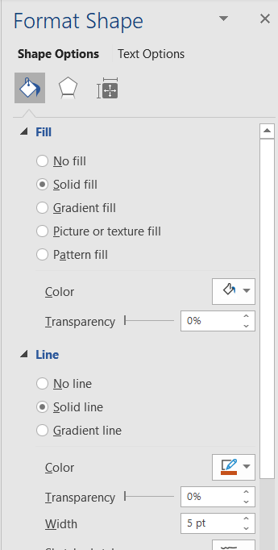

## Text style

Use the in-built departmental styles on the text in shapes. This will keep the images consistent with the department’s visual style. The graphics in this document use ‘DHHS flowchart text’.

* Text style: DHHS flowchart text

## Drawing canvas style

* Fill: Visual style light purple shade – hex #F1E3F3

## Box (rectangle) style

* Line colour: Visual style purple – hex #87189D
* Line weight: 3 pt
* Fill: white

## Decision point style

* Line colour: Visual style orange – hex #C5511A
* Line weight: 5 pt
* Fill: White – hex #FFFFFF

## Arrow head and line style

* End arrow type: Stealth arrow

Figure 2: Stealth arrow

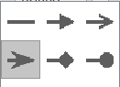

* End arrow size: Arrow R Size 8

Figure 3: End arrow size



* Line weight: 2.25 pt

## Timeline graphic

Timeline created using Word SmartArt graphic to ensure easier updating.

* Text style: DHHS body
* Line colour: Visual style purple – hex #87189D
* Fill colour: Visual style purple – hex #87189D

# Instructions

## Resizing objects

Objects can be resized using a mouse (click and drag) or by changing the height or width values in the ‘Shape format’ menu of the ribbon bar (select an object to make the menu appear).

Figure 4: Shape Format menu

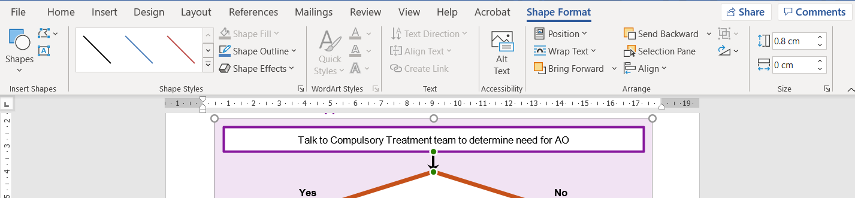

The drawing canvas can be resized in the same way if you need more space (for example, for additional boxes).

Turn on gridlines to make it easier to tell if objects are lined up – select the View menu in the ribbon bar and check the box next to ‘Gridlines’.

## Editing text

To edit the text in an object (like a rectangle), simply place your cursor in the text and type.

## Save the flowchart as an image

1. Select an object in the flowchart (such as one of the boxes), open the context menu (right mouse click) and select Save as Picture…

Figure 5: Save as Picture

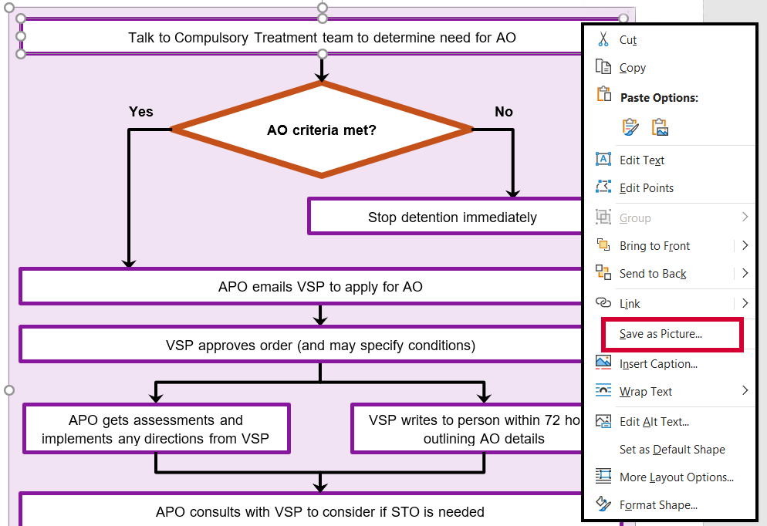

1. Select the folder you want to save the picture in, update the filename and leave the filetype as PNG.

## Update the current flowchart with the updated image

Before you start, copy the alt text of the current image (and paste it into a document) so you can use it for the updated image. Otherwise you will have to redo the alt text.

1. Select the current image and open the context menu (right mouse click).
2. Select ‘Change picture…’ and then ‘From a file…’

Figure 6: Change Picture

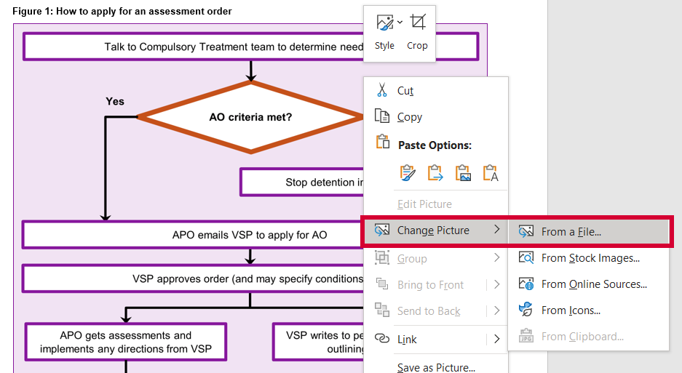

1. Find the folder you saved the image in, choose the updated image and select ‘Insert’
2. Update the alt text

**Note**: The flowcharts in the process documents have a .75 pt line (border) around them in the visual style purple (hex #87189D). Changing the picture this was should maintain the border as well. If it disappears, it can be reapplied in the Format Picture window (right-click the image to open the context menu and select ‘Format Picture…’).

# Process 1: Apply for an assessment order

## Assessment order application

**AO criteria met?**

APO emails SP to apply for AO

Talk to Compulsory Treatment team to determine need for AO

SP approves order (and may specify conditions)

Stop detention immediately

**Yes**

**No**

APO gets assessments and implements any directions from SP

APO consults with SP to consider if STO is needed

If needed, APO submits treatment plan at least 7 days before AO expires

APO applies for new STO

APO informs the person, their legal representative and OPA of application

Talk to VCAT to determine if interim STO under s192 is needed

SP writes to person within 72 hours outlining AO details

## Timeline

# Process 2: Apply for STO – new clients

Update BSP to reflect assessment findings

Prepare treatment plan

Gather evidence

Talk to Compulsory Treatment team as soon as possible

**STO criteria met?**

**Yes**

**No**

APO and care team review further assessments

# Process 3: Apply for interim STO

**Does the client need to be detained?**

Develop a treatment plan

APO contacts VCAT and makes s192 application

Do **not** detain the person – wait for application for STO to be heard

Explain to the person that application for interim STO is being made and help them get legal representation

Talk to Compulsory Treatment team to determine if you need to detain client due to significant risk of serious harm to another while waiting for VCAT determination

**No**

**Yes**

Apply to VCAT for STO under s191

Develop a behaviour support plan if any restrictive practices are in place

Upload all relevant materials to RIDS

Notify person’s legal representative and OPA, ensuring all parties have all relevant materials

# Process 4: Apply for STO – existing clients (WIP)

APO lodges s196A application for determination regarding expiry of STO ‘as soon as practicable’ within 60 days of STO expiry

Once received, VCAT makes directions order

VCAT emails APO around 35 days before STO expiry if application not already received

If VCAT directs APO file new STO, APO completes necessary actions

# Process 5: Develop a treatment plan – new clients

Gather evidence

Prepare treatment plan

Talk to Compulsory Treatment team

Address all legislative criteria in plan and attach all relevant reports, assessment and policies

**STO criteria met?**

Develop behaviour support plan or get an NDIS behaviour support plan

**Yes**

**No**

APO signs approval of plan

APO submits treatment plan to VPS for approval

SP reviews submissions and issues treatment plan certificate

APO applies to VCAT for STO

Inform person to be subject to STO, legal representative and OPA of application

VCAT issues directions order and notice of hearing

# Process 6: Develop revised treatment plan – existing clients

Gather evidence

Prepare treatment plan and give Compulsory Treatment team support provider details and proposed accommodation address before submitting application

Talk to Compulsory Treatment team

Make sure all directions in existing SP certificate and VCAT order completed and documented

**S191(6) STO criteria still met?**

Apply to VCAT for revocation of STO

**Yes**

**No**

Make sure all legislative criteria included in revised plan

APO signs approval of plan and applies to VCAT for review

VCAT issues directions order and notice of hearing

Upload necessary documents to RIDS by date directed by VCAT

SP issues certificate in line with VCAT directions order

# Process 7: Develop a treatment plan – RTF clients

Gather evidence

APO approves and signs treatment plan

Prepare treatment plan within 28 days of admission

APO submits treatment plan via RIDS within 28 days of admission

If necessary, APO makes required changes and resubmits through RIDS

SP provides treatment certificate (or statement) approving plan and makes any relevant directions

**VCAT review needed?**

APO applies to VCAT for plan review within 6 months of admission – within 12 months for admissions under s152(2)(d)

Submit updated treatment plan to SP for review and issuing of treatment plan statement

**Yes**

**No**

# Process 8: Apply for treatment plan review – RTF clients

Person is admitted to residential treatment facility (RTF)

Develop revised treatment plan for SP approval before the end of 6 (or 12) months

Develop treatment plan within 28 days of admission

APO applies to VCAT for s155 review of treatment plan

APO complies with dates and ensures SP is given treatment plan (and supporting materials) by date directed in VCAT order

Print online application and upload to RIDS

Support the person to access legal representation  
Ensure legal representative has access to all relevant materials

APO attends hearing

APO gives SP track changes version of plan for review

# Process 9: Extended leave application by RTO clients

Outline intention that application for extended leave be developed in existing  
VCAT-approved treatment plan

Prepare treatment plan with receiving service, outlining what you will do to reduce risk the person poses to others

Determine where the person will be transitioning to and identify receiving service

APO from receiving service confirms they approve of and will implement  
treatment plan

APO from RTF confirms approval of plan and acknowledges they will implement any suspension or revocation of extended leave

Submit treatment plan to SP for certificate of approval

Submit treatment plan to the court that made the order as part of the application for extended leave

# Process 10: Submit treatment plan with amendments

## Track changes

APO gives SP track changes version of treatment plan via RIDS

SP approves plan via RIDS

Compulsory Treatment team reviews track changes and gives APO feedback if needed

## Material changes

VCAT emails all parties, seeking consent for hearing to be held in chambers if appropriate

Complete VCAT application form, including variations to treatment plan in track changes

APO finalises treatment plan and completes material change process in RIDS

**Yes**

**No**

Once VCAT issues order, APO completes material change process in RIDS

APO supports the person to access legal representation

SP approves change in RIDS

Email to SP detailing change and context

SP reviews email request and responds to APO with decision

**Does the material change need VCAT approval?**

# Process 11: Implementation reports process

Check when next implementation report is due on treatment plan certificate

Report on any data or other evidence that informs your support of the person

Submit implementation report via RIDS by due date

Report progress of any SP or VCAT directions

# Process 12: Revocation of a supervised treatment order

**Does the person meet all s191 STO criteria?**

Gather your evidence

Prepare revocation submission to VCAT

Prepare revised treatment plan and reapply for STO before current order expires

APO applies to VCAT to have the order revoked

Talk to Compulsory Treatment team

**No**

**Yes**

To receive this document in another format phone 03 9096 8427, using the National Relay Service 13 36 77 if required, or [email the Senior Practitioner](mailto:VictorianSeniorPractitioner@dffh.vic.gov.au) <VictorianSeniorPractitioner@dffh.vic.gov.au>.

Authorised and published by the Victorian Government, 1 Treasury Place, Melbourne.

© State of Victoria, Australia, Department of Families, Fairness and Housing, April 2021.