

|  |
| --- |
| Statement of direction |
| Department of Families, Fairness and Housing |

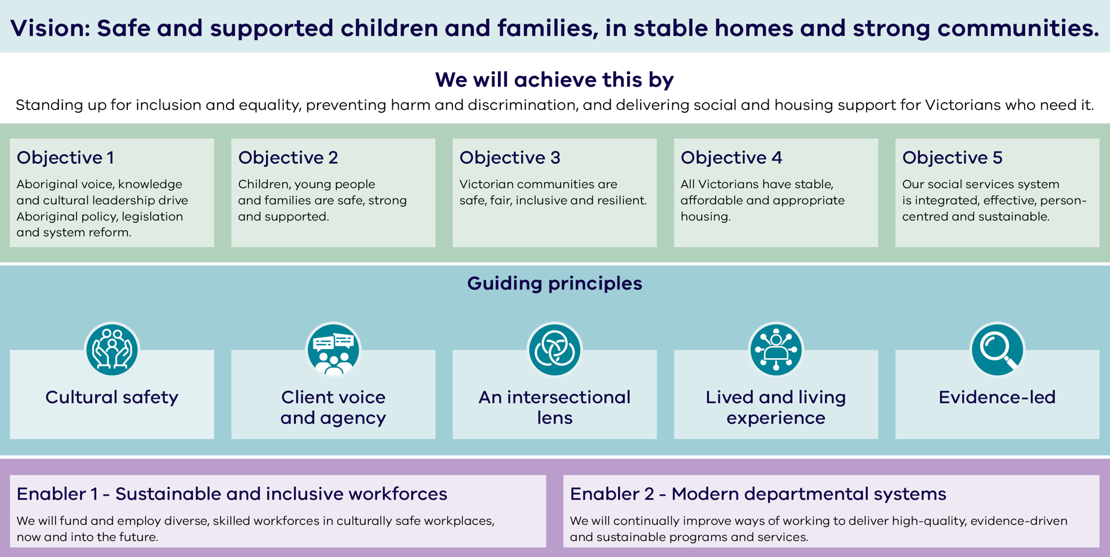

# Statement of direction (figure text)

## Vision

Safe and supported children and families, in stable homes and strong communities.

## How we will achieve it

Standing up for inclusion and equality, preventing harm and discrimination, and delivering social and housing support to Victorians who need it.

## Objectives

* Aboriginal voice, knowledge and cultural leadership drive Aboriginal policy, legislation and system reform.
* Children, young people and families are safe, strong and supported.
* Victorian communities are safe, fair, inclusive and resilient.
* All Victorians have stable, affordable and appropriate housing.
* Our social services system is integrated, effective, person-centred and sustainable.

## Guiding principles

Cultural safety, client voice and agency, an intersectional lens, lived and living experience and evidence led.

## Enablers

### Sustainable and inclusive workforces

We will fund and employ diverse, skilled workforces in culturally ​safe workplaces, now and into the future.

### Modern departmental systems

We will continually improve ways of working to deliver high-quality, evidence-driven and sustainable programs and services.

To receive this document in another format, email Strategic Planning [strategy@dffh.vic.gov.au](mailto:strategy@dffh.vic.gov.au)

Authorised and published by the Victorian Government, 1 Treasury Place, Melbourne. © State of Victoria, Australia, Department of Families, Fairness and Housing, September 2025. Available at [Department of Families, Fairness and Housing strategic plan](https://www.dffh.vic.gov.au/publications/dffh-strategic-plan) https://www.dffh.vic.gov.au/publications/dffh-strategic-plan.