
Conducting joint Client Incident Management System and Reportable Conduct Scheme investigations
Guidance for service providers

This publication has been jointly authored by the Commission for Children and Young People and the Department of Health and Human Services.
It is intended to help community service organisations and investigators better plan and conduct Client Incident Management System and Reportable Conduct Scheme Investigations.
Disclaimer
The information contained within this publication is of a general nature and is not intended to be legal advice. This publication should not be relied upon as a substitute for professional legal advice or reference to relevant legislation and regulatory requirements, which can change over time.
To receive this publication in an accessible format phone 03 9096 0464, using the National Relay Service 13 36 77 if required, or email the Community Service Quality and Safety Office <csqsq@dffh.vic.gov.au>.
Authorised and published by the Victorian Government, 1 Treasury Place, Melbourne.
© State of Victoria, Australia, Commission for Children and Young People and the Department of Health and Human Services January 2020.
ISBN 978-1-76069-164-6 (PDF/online/MS word)
Available at Conducting joint Client Incident Management System and Reportable Conduct Scheme investigations <https://www.dffh.vic.gov.au/publications/incident-and-allegation-investigations>.

Contents
Background 2
Terminology 2
Client Incident Management System 3
Reportable Conduct Scheme 3
Independent Investigation and Suitability Panel 4
Forming a reasonable belief 4
Investigating incidents 5
Understanding the purpose of each investigation type 5
Notification pathways 7
Important timeframes 8
Planning, conducting and reporting an investigation 9
CIMS definitions and RCS thresholds 11
Investigation findings 14
Submitting a joint investigation report 15
Sharing information about an investigation 15
Supporting all parties during an investigation 16
Supporting carers subject to an investigation 16
Supporting alleged victims 16
Further information 18
Client Incident Management System 18
Reportable Conduct Scheme 18
Independent Investigations and Suitability Panel 18
Appendix 1: Text-equivalent descriptions of figures 19
Tables
Table 1: Terminology specific to each incident review and investigation scheme 3
Table 2: Main purposes of each type of investigation 5
Table 3: Considerations when planning, investigating, and analysis and reporting an investigation 9
Table 4: CIMS definitions and RCS thresholds 11
Figures
Figure 1: Determining which notification pathway to use following an incident or allegation 7
Figure 2: Important timeframes for investigations 8

Background
Children and young people in care have a right to be safe from all forms of harm and abuse. When an allegation of abuse is made, or when an event that harms or has the potential to harm a child occurs, service providers must respond effectively and efficiently.
In addition to Child Protection and Victoria Police, there are three schemes that promote the protection of children in care through the reporting and investigation of allegations of abuse and misconduct:
- Client Incident Management System (CIMS)
- Reportable Conduct Scheme (RCS)
- Independent Investigation and Suitability Panel processes.
Service providers may have to report incidents or allegations against staff members, carers or volunteers under all three schemes, if they meet the relevant thresholds. However, not all incidents that require a CIMS investigation will be reportable allegations under the RCS and vice versa. There may also be other types of investigations that need to be undertaken concurrently, such as misconduct or other workplace investigations.
Important: immediately notify Victoria Police if potentially criminal conduct is identified at any point during the investigation.
This information booklet provides guidance to support service providers to plan and conduct a single investigation that meets the requirements of two of these schemes, CIMS and RCS.
A single investigation:
- reduces the risk of further traumatising the child
- enables witnesses to be interviewed on fewer occasions
- supports procedural fairness through timely and effective investigations
- decreases the emotional toll on carers by streamlining the process
- reduces administrative burden.
A well-planned investigation also supports and informs the Independent Investigation and Suitability Panel processes, potentially avoiding unnecessary duplication of investigations.
Important: the information provided in this booklet is not exhaustive and should be read in conjunction with the guidance issued by the Department of Health and Human Services (the department) and the Commission for Children and Young People (the Commission) referred to throughout.
This booklet provides introductory information about streamlining investigation processes that service providers can consider. Not all aspects of this process are covered in this guidance material, however the information will be expanded on over time.
Where the subject of an allegation is engaged through a labour-hire arrangement, there may be added complexities. Seek guidance from the department and the Commission if required.

Terminology
The department and the Commission use some different terminology in their CIMS and RCS guidance materials. This information booklet adopts the following terms:
- ‘staff members’ – describes service staff who are not carers, including temporary or agency staff
- ‘volunteers’ – describes people who have been engaged by a service (entering into an agreement, either verbally or in writing) to provide a service without receiving financial gain
- ‘carers’ – describes foster, kinship and residential carers, including temporary or agency staff
- ‘service providers’ – describes registered care service providers
- ‘head of service’ – describes the most senior person in a registered care service.
The terms ‘client’, ‘child’ and ‘young person’ are used as appropriate. CIMS investigations include allegations of harm to any person who is a client, regardless of their age. The term ‘child’ refers to a person aged under 18 years.
Table 1: Terminology specific to each incident review and investigation scheme
CIMS | RCS | Independent Investigation and Suitability Panel
Staff member or carer | Worker or volunteer | Out-of-home carer
Service provider  Registered care service provider | Organisation | Registered out-of-home care service
Chief executive officer or delegated authority | Head of organisation | Person in charge
Client | Child or young person | Child or young person

Client Incident Management System
Relevant policy: Client incident management guide, Client incident management guide: out-of-home care addendum and any operational updates issued.
The Client Incident Management System, or CIMS, is managed by the Department of Health and Human Services (the department). It empowers service providers to effectively investigate and respond to events that result in harm to clients, to manage the quality of their services, and to make the best use of departmental support and resources, particularly in relation to the most serious incidents. This helps to improve the safety and wellbeing of all clients. Under CIMS, all major-impact incidents must be subject to either an investigation or review (case review or root cause analysis review).
Following a CIMS investigation, a substantiated finding of abuse or neglect may lead to a carer being removed from their role or a child or young person being removed from their care. A substantiated or unsubstantiated finding may also be shared with other regulators or service providers.
For more information about CIMS, see the Client incident management system website <https://providers.dhhs.vic.gov.au/cims>.

Reportable Conduct Scheme
Relevant legislation: Part 5A of the Child Wellbeing and Safety Act 2005.
The Reportable Conduct Scheme, or RCS, is administered by the Commission for Children and Young People (the Commission). It ensures the Commission is aware of every allegation of certain types of abuse and misconduct involving children in relevant organisations that exercise care, supervision and authority over children. The RCS aims to improve how organisations identify and respond to allegations of child abuse and neglect by their workers and volunteers.
A substantiated finding of reportable conduct may be referred to the Department of Justice and Community Safety so the subject of allegation’s Working with Children Check can be reassessed. A substantiated or unsubstantiated finding may also be provided to other relevant regulators.
For more information about the RCS, see the Reportable Conduct Scheme section of Commission for Children and Young People’s website <https://ccyp.vic.gov.au/reportable-conduct-scheme>.

Independent Investigation and Suitability Panel
Relevant legislation: Part 3.4 of the Children, Youth and Families Act 2005.
Authorised investigators examine allegations referred to the Secretary of the department regarding physical and sexual abuse against children placed in care. Where the authorised investigator substantiates allegations of abuse, the Secretary can refer the matter to the Suitability Panel if they determine the carer poses an unacceptable risk of harm to children.
The Suitability Panel is an independent body that decides whether a person should be disqualified from the Victorian Carer Register and therefore can no longer provide out-of-home care.
If the Suitability Panel makes a finding that the abuse occurred and the carer poses an unacceptable risk of harm to children, the carer will be disqualified from being placed on the Victorian Carer Register. This means the carer will be unable to work in out-of-home care in Victoria.
A disqualification by the Suitability Panel will be referred to the Department of Justice and Community Safety so the subject’s Working with Children Check can be reassessed and a notification can made to the Disability Worker Exclusion Scheme.
For more information about Independent Investigations and the Suitability Panel see the Victorian Carer Register website <https://providers.dffh.vic.gov.au/carer-register> and the Suitability Panel website <http://www.suitabilitypanel.vic.gov.au/>.

Forming a reasonable belief
The RCS requires the head of service to notify the Commission if any person has formed a ‘reasonable belief’ a staff member, carer, or volunteer has committed reportable conduct.
Reasonable belief is more than suspicion. There must be some objective basis for the belief. However, it is not the same as having proof and does not require certainty. For example, a person is likely to have a reasonable belief if they observed the conduct themselves, heard directly from a child that the conduct occurred, or received information from another credible source (including another witness).
Similarly, the Independent Investigation process requires the head of service to report allegations of physical or sexual abuse to the Secretary if they are ‘reasonably satisfied’ an independent investigation is warranted. If a report to Victoria Police, a major-impact incident report via CIMS or a report under the RCS has been made, then it is likely that the criteria to be reasonably satisfied has been met, and a report should be submitted to the Secretary.

Investigating incidents

Understanding the purpose of each investigation type
Before conducting a joint CIMS/RCS investigation, service providers and investigators need to understand the purposes of each type of investigation so they can plan and conduct the investigation effectively to meet the requirements of each scheme.
Table 2: Main purposes of each type of investigation
Client Incident Management System investigation | Reportable Conduct Scheme investigation | Independent Investigation and Suitability Panel
A CIMS investigation determines if there has been abuse or neglect of a client by a staff member (including a carer or volunteer) or another client. Investigations focus on client safety and wellbeing by outlining key actions and system-level responses to incidents.  CIMS investigations can include allegations of harm and abuse of all clients, regardless of age. | An RCS investigation establishes facts and makes findings in relation to allegations of reportable conduct against a staff member including a foster or kinship carer or volunteer. RCS investigations are limited to allegations of harm and abuse of children aged up to 18 years when the conduct occurred. | An Independent Investigation determines if a foster carer or staff member has physically and/or sexually abused a child in their care.  A Suitability Panel hearing re-examines the allegation and evidence provided to determine firstly whether the abuse occurred, and secondly if the carer is an unacceptable risk to children.

Notification pathways
Figure 1: Determining which notification pathway to use following an incident or allegation
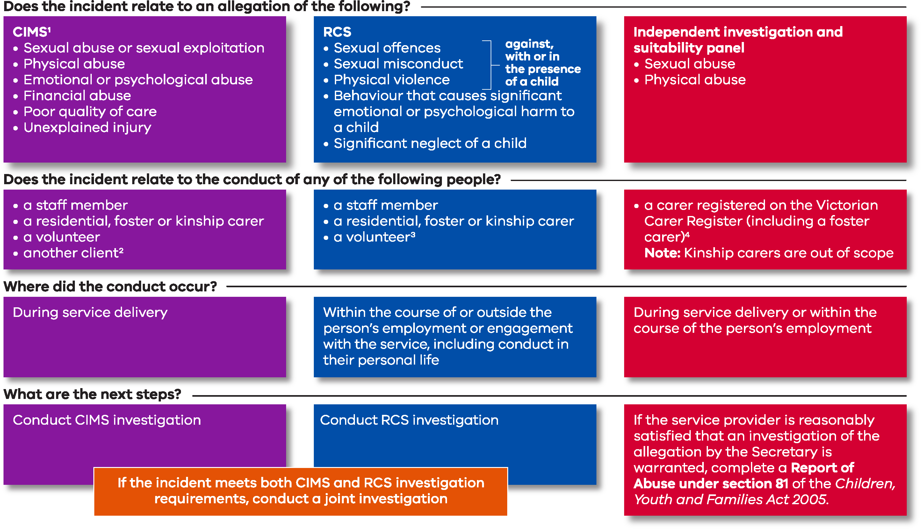
Notes for Figure 1
- This is not an exhaustive list of CIMS incident types. See guidance available on the Client incident management system website <https://providers.dhhs.vic.gov.au/cims> for more information about identifying, reporting and investigating CIMS incidents.
- Where an incident reported under CIMS includes an unexplained injury it may be unclear if it relates to a person’s conduct until an investigation has been completed.
- See s. 74 of the Children, Youth and Families Act 2005, section 3(1) of the Child Wellbeing and Safety Act 2005 and Information sheet 1: About the Victorian Reportable Conduct Scheme available on the Commission for Children and Young People’s Reportable Conduct Information Sheet website https://ccyp.vic.gov.au/child-safety/resources/reportable-conduct-scheme-information-sheets for definitions. Kinship carers are approved or in accordance with an Order under the Children, Youth and Families Act 2005.
- See s. 74 of the Children, Youth and Families Act 2005 and Allegations of abuse of children in out-of-home care available on the Victorian Carer Register website <https://providers.dhhs. vic.gov.au/carer-register>.

Important timeframes
Service providers are required to meet the timeframes outlined in the table below.
Important: immediately notify Victoria Police if potentially criminal conduct is identified at any point throughout the investigation.
Figure 2: Important timeframes for investigations
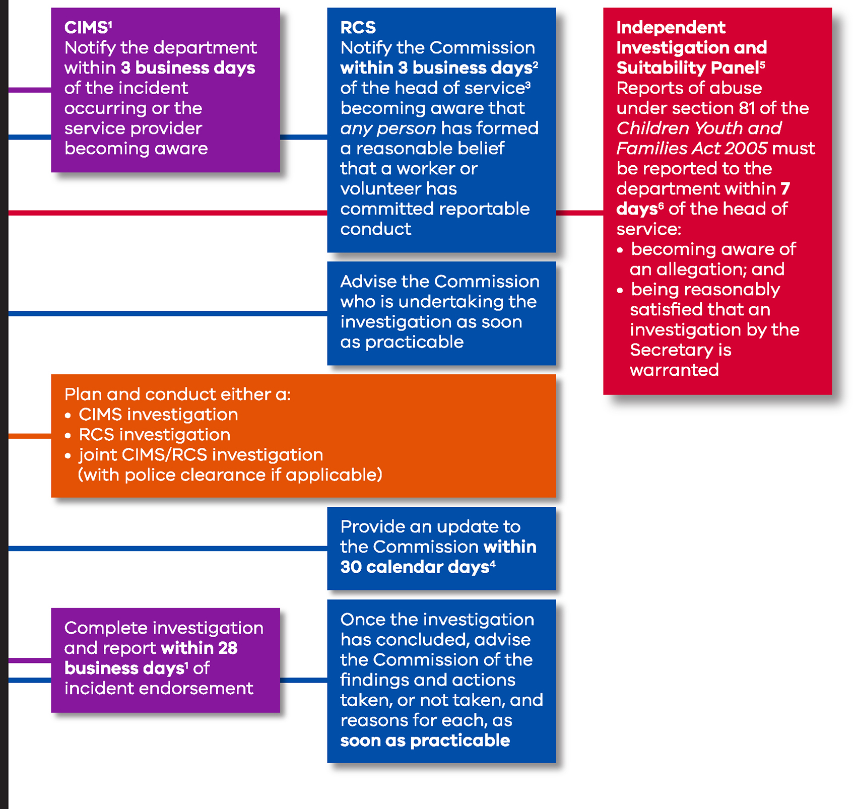
Notes for Figure 2
- This timeframe does not include any time an investigation is placed on hold at police request.
- See s. 16M (1) (a) of the Child Wellbeing and Safety Act 2005.
- The head of service has certain legal obligations that must be met. See Information Sheet 3: Responsibilities of the head of an organisation available on the Commission for Children and Young People’s Reportable Conduct Information Sheet website <https://ccyp.vic.gov.au/child-safety/resources/reportable-conduct-scheme-information-sheets>.
- See s. 16M (1) (b) (i) of the Child Wellbeing and Safety Act 2005.
- The Secretary and the Suitability Panel are also required to adhere to certain timeframes, including notifying and updating carers before and after investigations. See Allegations of abuse of children in out-of-home care available on the Victorian Carer Register website <https://providers.dhhs.vic.gov.au/carer-register>.
- See s. 81 (2) of the Children, Youth and Families Act 2005.

Planning, conducting and reporting an investigation
This table contains some key considerations for investigation managers and investigators when conducting a joint CIMS/RCS investigation to ensure the investigation meets the requirements of each scheme. It is not an exhaustive list of considerations. Investigation managers should refer to the relevant CIMS and RCS guidance materials.
Table 3: Considerations when planning, investigating, analysing and reporting an investigation
Planning | Investigating | Analysis and reporting
If the allegation is potentially criminal in nature, have Victoria Police been notified?  If so, has clearance from Victoria Police to begin the investigation been received? | Have the support needs of all relevant parties been considered?  This includes the alleged victim, parents or carers, the subject of allegation and those with additional vulnerabilities such as disability and cultural safety needs. | Has each piece of evidence been evaluated based on its strength (or weight)?
Have risks to children, the subject of allegation and others been managed?  This includes providing appropriate immediate and ongoing support for the alleged victim. | Has a letter of allegation which separates and particularises the allegation/s been provided to the subject of allegation at the appropriate time?  Is the subject of allegation aware that they are the subject of both CIMS and RCS investigations? | Has the evidence collected enabled the investigator or other decision maker to determine whether, on the balance of probabilities, the conduct occurred?  Are the findings based on the evidence against the different CIMS definitions and RCS thresholds?
Has the allegation been reported to the appropriate bodies within the relevant timeframes?  For example, the department, child protection and the Commission. | Is the subject of allegation aware of the potential actions or implications of substantiated findings? | Does the investigation report clearly separate the findings into a CIMS and an RCS finding based on the relevant definition and thresholds?  Note: evidence to make a substantiated finding under CIMS may not support a substantiated finding for RCS, and vice versa.
Has the decision to conduct a joint investigation been made early enough to ensure the investigator plans the investigation to meet the requirements of each scheme?  Has an independent investigator who is appropriately qualified and experienced been appointed?  Have any conflicts of interest been managed? | Has the subject of allegation been given a reasonable opportunity to respond to the CIMS allegation/s and the RCS allegation/s through an interview and/or a written response?  If not, has the investigator documented the reasons why the interview did not or could not occur? | Where there are multiple allegations that have been investigated, does the investigation report list them separately and make a CIMS and an RCS finding for each?
Does the investigator understand the different purposes of CIMS and RCS investigations? | Have interviews been conducted with all relevant witnesses, including the alleged victim and any child witnesses, unless there is a good reason not to do so?  If not, has the investigator documented the reasons why the interview/s did not or could not occur? | Has the service provider notified all relevant parties in writing of the investigation’s outcomes as per CIMS and RCS guidance?
Does the investigation plan clearly define the roles and powers of the investigator and any other decision maker/s and the requirements of the different schemes? |  | Has the service provider notified the department and the Commission of the investigation’s outcomes, including findings and actions taken or not taken, the reasons for each, and any documents requested?  If no action is taken, has the investigation report outlined the reasons?
Has the investigator determined the evidence required to make findings on the different CIMS definitions and RCS thresholds?

CIMS definitions and RCS thresholds
This table presents a summary of incident types, definitions and thresholds. It illustrates the differences between CIMS and RCS, so an investigation can be properly planned.
Please refer to relevant guidance published by the department and the Commission for more detail.
Note that the department uses the terms ‘types’ and ‘definitions’ and these are policy based. The Commission uses the terms ‘types and thresholds’, which are legislatively based, together with some policy.
The purpose of each investigation is the same, namely to determine on the balance of probabilities whether the incident or conduct occurred or did not occur.
Table 4: CIMS definitions and RCS thresholds
CIMS major impact incident types and definitions | Reportable conduct types and thresholds
Emotional or psychological abuse  Actions or behaviours that reject, isolate, intimidate, or frighten by threats, or the witnessing of family violence, to the extent that the client’s behaviour is disturbed, or their emotional / psychological wellbeing has been, or is at risk of being, seriously impaired.  This includes:  - rejecting, isolating, terrorising and ignoring behaviours  - denying cultural or religious needs and preferences  - emotional abuse perpetrated by other clients.  Service providers should consider any potential power imbalance between the client and the person engaging in the behaviour. | Behaviour that causes significant emotional or psychological harm to a child  There must be a clear link between the staff member, carer or volunteer’s behaviour and the harm to the child, and the harm to the child must be significant.  The behaviour could include severe or sustained:  - verbal abuse  - coercive or manipulative behaviour  - hostility or rejection  - humiliation, belittling or scapegoating.
Poor quality of care  Inappropriate or inadequate care by staff members or carers in the context of service delivery.  Injury  Actions or behaviours that unintentionally cause harm which requires first aid or medical attention. Includes both explained and unexplained injuries. | Significant neglect of a child  There needs to be a failure to meet the basic needs of a child (such as their wellbeing or safety) and that failure needs to be intentional or reckless. The neglect of the child must be significant,³ and it needs to be shown that the worker or volunteer could have met the child’s needs but failed to do so.  Significant neglect includes:  - supervisory neglect  - physical neglect  - educational neglect  - emotional neglect.  Significant neglect can arise as a single recurring adverse circumstance or event (e.g. the child never given enough food) or cumulative neglect (e.g. a combination of different adverse circumstances or events).  There must be a sufficient connection between the staff member, carer or volunteer and the child who has been significantly neglected.  It is not necessary to establish whether any harm was actually suffered or whether any harm that did result could be treated and/or resolved or cured.
Physical abuse  Actions that involve the inappropriate use of physical contact or force against a person that result in major impact harm to the client.  This includes impact resulting from:  - threats of physical abuse made to a client by another person  - excessive use of physical force or restraint by staff members or carers  - physical abuse perpetrated by other clients, staff members or carers.  Physical abuse does not include an act or omission that constitutes a lawful exercise of force, such as the lawful and duly authorised use of physical restraint. | Physical violence (against, with, or in the presence of a child)  The conduct must be intentional or reckless, without lawful reason and must be capable of causing injury or harm. To be lawful, force must be reasonable, and no more force should be used than is necessary.  Physical violence includes:  - actual physical violence such as hitting, punching, kicking, pushing or throwing something that strikes a child or unreasonable physical restraint, and  - apprehended physical violence such as words, gestures or actions where a child thinks that physical force is about to be used against them or another person.
Sexual abuse  Actual or attempted unwanted sexual actions (or allegations of such actions) that result in major impact harm to the client or which are otherwise forced upon a client against their will or without their consent, through the use of physical force, intimidation and/or coercion. | Sexual offences (against, with, or in the presence of a child)  Where potential sexual offences are not prosecuted or do not result in a finding of guilt, they must still be investigated as potential reportable conduct and determined on the balance of probabilities.  Sexual offences include:  - sexual assault  - indecent acts  - possession of child abuse material  - grooming a child in order to commit a sexual offence.  A full list of the relevant sexual offences is set out in clause 1 of Schedule 1 to the Sentencing Act 1991.
Sexual exploitation  Abuse of a person under 18 or a person with a cognitive disability, which may include:  - the exchange of sex or sexual acts for money, goods, substance or favours  - involving a child in creating pornography  - contact with a known sex offender. | Sexual misconduct (against, with, or in the presence of a child)  Sexual misconduct involves a departure from the accepted standards of the staff member, carer or volunteer’s role that is of a sexual nature.  Sexual misconduct can cover a broad range of behaviours and includes:  - unwanted and inappropriate touching  - inappropriate conversations or communication that is of a sexual nature or is about an area of the body or a sexual activity  - exposure to sexual activity by others  - grooming behaviours  - voyeurism.  The factors to consider in determining whether certain types of conduct are of a sexual nature include:  - the area of the body involved in the conduct  - whether at least one of the reasons for the conduct was for sexual arousal or gratification  - whether the conduct was overly personal or intimate.

Investigation findings
When conducting a joint CIMS/RCS investigation, the investigator or other decision maker will need to make separate findings based on the CIMS definitions and the RCS thresholds.
CIMS and RCS have different findings available following an investigation.
Despite the different possible findings, the standard of proof when making a finding is the same under each scheme – the balance of probabilities. Based on the evidence gathered, the investigator should determine whether it is more likely than not that the incident or conduct occurred or did not occur.
This standard of proof is lower than the criminal threshold of ‘beyond reasonable doubt’.
In coming to any determination, an investigator will need to consider the ‘Briginshaw principle’. Briginshaw requires that the more serious the allegation and gravity of a substantiated finding, the more comfortably satisfied by the evidence the decision maker must be before making any substantiated finding. While Briginshaw asks an investigator to more rigorously test the standard of the evidence before making a determination, it does not change the standard of proof, which remains the balance of probabilities. Briginshaw should not be used as a reason to not substantiate an allegation that otherwise meets the balance of probabilities test.

CIMS findings
A CIMS investigation should determine whether abuse or neglect of a client occurred. If the incident or allegation cannot be substantiated, the investigation should determine if any further action is required. The possible CIMS findings are:
- substantiated
- not substantiated – no further action
- not substantiated – further action required.

RCS findings
The information provided in the Commission’s guidance material can be used to assist decision-makers to determine whether conduct meets the threshold under the RCS. The possible RCS findings are:
- substantiated
- unsubstantiated – insufficient evidence
- unsubstantiated – lack of evidence of weight
- unfounded
- conduct outside the scheme.
Note: where an incident contains multiple allegations, a CIMS finding and an RCS finding need to be made for each allegation.
Remember! CIMS and RCS have different definitions and thresholds. A finding made for one does not necessarily mean that the same finding can (or should) be made for the other.

Submitting a joint investigation report
Once a joint CIMS/RCS investigation has been completed, the investigation report, findings and actions taken or not taken, and reasons for each should be submitted to both the department and the Commission without delay.
Service providers should not wait for an investigation report to be endorsed by the department before submitting the report to the Commission or wait to receive feedback from the Commission before submitting the report to the department.
If a subject of allegation requests a review of a CIMS decision, the service provider should still notify the Commission of the findings made without delay and advise the Commission that an appeal has been lodged.

Sharing information about an investigation
Each scheme has different requirements regarding sharing information about the progress and outcome of investigations. Care must be taken when determining what information is shared and to whom.

Client Incident Management System
The service provider is responsible for sharing the outcome of a CIMS investigation with all relevant parties, including:
- the subject of allegation
- the alleged victim
- parents, carers or guardians of the alleged victim who is under the age of 18
- any additional service providers involved with the client or the subject of allegation.

Reportable Conduct Scheme
The RCS contains statutory restrictions on the sharing of information relating to a reportable allegation. However, the Child Wellbeing and Safety Act 2005 allows for the sharing of certain information with certain people.
The head of service:
- can share information about the progress of an RCS investigation and findings and actions taken or not taken with the alleged victim and their parents or carers
- should advise the subject of allegation of the outcome of the investigation.
The head of service can also share information about reportable conduct allegations with other heads of services in certain limited circumstances, however advice should be obtained before disclosing information to other heads of services.
The Commission, Suitability Panel and the Secretary of the department can share information and findings with relevant bodies, including the service provider and the Department of Justice and Community Safety Working with Children Check Unit.

Supporting all parties during an investigation
Investigators should promote the inclusion, participation and safety of all people who are relevant to the investigation. This includes the staff member, carer or volunteer, the alleged victim and other witnesses. Children who are witnesses should also be interviewed, unless there is a good reason not to.
An investigator can gather the best possible evidence when people feel safe, respected and heard when asked to tell their story.
Considerations for investigators include:
- ensuring cultural safety, including acknowledging, respecting and accommodating diversity
- creating an environment where people feel safe and secure in their identity, culture and community
- developing trust and rapport with witnesses
- determining whether witnesses require additional support, such as an assisted communication device a support person or counselling
- carefully planning any interviews with children.

Supporting alleged victims
Providing appropriate support for the alleged victim is critical, both in terms of the impact of the alleged conduct on them, and so they can participate in the investigation. There can be some risks of further traumatising them, and strategies available to manage these risks may include:
- providing suitably qualified professionals to support the alleged victim, including counselling
- minimising or eliminating contact with the subject of allegation
- ensuring any interviews are conducted by appropriately trained people in an appropriate environment
- ensuring the alleged victim has a support person present, if appropriate.
The Commission expects that children will be interviewed unless there is good reason not to. Understanding the impacts of trauma on children and young people will assist organisations to include vulnerable children and young people in investigations and minimise the likelihood of exacerbating their trauma or further traumatising them.
The Commission has developed guidance to help organisations interview children and young people who are the alleged victims or witnesses of reportable conduct allegations. Guidance material is available on the Commission for Children and Young People's Reportable Conduct website <https://ccyp.vic.gov.au/reportable-conduct-scheme/reporting-and-investigating-allegations/including-children-and-young-people-in-reportable-conduct-investigations/>.

Supporting carers subject to an investigation
An investigation can be an unsettling and stressful experience for carers, particularly where a child or young person has been removed from their care.
The department requires service providers to support carers during and after any review or investigation, as part of their funding agreement. This includes:
- allocating a liaison person within their service
- advising carers about procedures and timeframes
- keeping the carer up-to-date with an investigation’s progress, including the reason for any delay
- providing information about the type of support available and how to access it
- making a referral for counselling, if the carer feels this would be beneficial for the carer or their family
- informing carers about how to seek a review, resolve disputes or make a complaint about an investigation.
Service providers should also provide subjects of CIMS and/or RCS investigations with:
- the CIMS carer fact sheet: out-of-home care, which provides detailed information for carers about CIMS investigative processes and is available on the Client Incident Management System website <https://providers.dhhs.vic.gov.au/cims>.
- Information sheet 13: workers and volunteers, which provides information about the RCS investigation process and the type of support available. This can be downloaded from the Commission for Children and Young People’s Reportable Conduct Information Sheet website <https://ccyp.vic.gov.au/child-safety/resources/reportable-conduct-scheme-information-sheets>.

Further information

Client Incident Management System
The Client Incident Management System website <https://providers.dhhs.vic.gov.au/cims> contains guides, templates and operational updates.
Email the Client Incident Management System team <cims@dffh.vic.gov.au>.

Reportable Conduct Scheme
The Commission for Children and Young People’s website <https://ccyp.vic.gov.au> has more information about the RCS, including information sheets <https://ccyp.vic.gov.au/child-safety/resources/reportable-conduct-scheme-information-sheets/> and resources for organisations <https://ccyp.vic.gov.au/child-safety/resources/guides-and-information-sheets/>.
Email the Commission for Children and Young People <contact@ccyp.vic.gov.au> or telephone 03 8601 5281 or 1300 782 978.

Independent Investigations and Suitability Panel
The Victorian Carer Register website <https://providers.dffh.vic.gov.au/carer-register> holds information about Independent Investigations and the Suitability Panel, including guides, factsheets and an eLearning module.
The Suitability Panel website <http://www.suitabilitypanel.vic.gov.au/> also has information about how it conducts hearings.
Email the Carer Register team <carer.register@dffh.vic.gov.au> or telephone 03 9096 8690.

Appendix 1: Text-equivalent descriptions of figures

Figure 1: Determining which notification pathway to use following an incident or allegation

Does the incident relate to an allegation of the following:

CIMS
(This is not an exhaustive list of CIMS incident types. See guidance available on the Client incident management system website <https://providers.dffh.vic.gov.au/cims> for more information about identifying, reporting and investigating CIMS incidents.)
- Sexual abuse or sexual exploitation
- Physical abuse
- Emotional or psychological abuse
- Financial abuse
- Poor quality of care
- Unexplained injury

RCS
- Sexual offences against, with or in the presence of a child
- Sexual misconduct against, with or in the presence of a child
- Physical violence against, with or in the presence of a child
- Behaviour that causes significant emotional or psychological harm to a child
- Significant neglect of a child

Independent investigation and suitability panel
- Sexual abuse
- Physical abuse

Does the incident relate to the conduct of any of the following people?

CIMS
- A staff member
- A resident, foster or kinship carer
- A volunteer
- Another client (where an incident reported under CIMS includes an unexplained injury, it may be unclear if it relates to a person’s conduct until an investigation has been completed.)

RCS
- A staff member
- A residential, foster or kinship carer
- A volunteer (see s. 74 of the Children, Youth and Families Act 2005, section 3(1) of the Child Wellbeing and Safety Act 2005 and Information sheet 1: About the Victorian Reportable Conduct Scheme available on the Commission for Children and Young People’s Reportable Conduct Information Sheet website <https://ccyp.vic.gov.au/child-safety/resources/reportable-conduct-scheme-information-sheets> for definitions. Kinship carers are approved or in accordance with an Order under the Children, Youth and Families Act 2005.)

Independent investigation and suitability panel
A carer registered on the Victorian Carer Register (including a foster carer) (see s. 74 of the Children, Youth and Families Act 2005 and Allegations of abuse of children in out-of-home care available on the Victorian Carer Register website <https://providers.dffh.vic.gov.au/carer-register>).
Note: kinship carers are out of scope

Where did the conduct occur?

CIMS
- During service delivery

RCS
- Within the course of or outside the person’s employment or engagement with the service, including conduct in their personal life

Independent investigation and suitability panel
- During service delivery or within the course of the person’s employment

What are the next steps?

CIMS
- Conduct CIMS investigation

RCS
- Conduct RCS investigation

Independent investigation and suitability panel
- If the service provider is reasonably satisfied that an investigation of the allegation by the Secretary is warranted, complete a report of abuse under section 81 of the Children, Youth and Families Act 2005.

Figure 2: Important timeframes for investigations

CIMS
- Notify the department within three business days of the incident occurring or the service provider becoming aware
- Plan and conduct either a:
  - CIMS investigation
  - RCS investigation
  - joint CIMS/RCS investigation (with police clearance if applicable)
- Complete investigation and report within 28 business days of incident endorsement (this timeframe does not include any time an investigation is placed on hold at police request)

RCS
- Notify the Commission within three business days (see s. 16M (1) (a) of the Child Wellbeing and Safety Act 2005) of the head of service (the head of service has certain legal obligations that must be met. See Information Sheet 3: Responsibilities of the head of an organisation available on the Commission for Children and Young People’s Reportable Conduct Information Sheet website <https://ccyp.vic.gov.au/child-safety/resources/reportable-conduct-scheme-information-sheets>) becoming aware that any person has formed a reasonable belief that a worker or volunteer has committed reportable conduct
- Advise the Commission who is undertaking the investigation as soon as practicable
- Plan and conduct either a:
  - CIMS investigation
  - RCS investigation
  - Joint CIMS/RCS investigation (with police clearance if applicable)
- Provide an update to the Commission within 30 calendar days (see s. 16M (1) (b) (i) of the Child Wellbeing and Safety Act 2005)
- Once the investigation has concluded, advise the Commission of the findings and actions taken, or not taken, and reasons for each, as soon as practicable

Independent investigation and suitability panel
(The Secretary and the Suitability Panel are also required to adhere to certain timeframes, including notifying and updating carers before and after investigations. See Allegations of abuse of children in out-of-home care available on the Victorian Carer Register website <https://providers.dffh.vic.gov.au/carer-register>).)
Reports of abuse under s. 81 of the Children, Youth and Families Act 2005 must be reported to the department within seven days of the head of service (see s. 81 (2) of the Children, Youth and Families Act 2005):
  - becoming aware of an allegation, and
  - being reasonably satisfied that an investigation by the Secretary is warranted

Kinship carers are not in scope for the Victorian Carer Register, and also therefore for the Independent Investigation and Suitability Panel process. They are in scope for the RCS and CIMS.
See Information sheet 1: About the Reportable Conduct Scheme available on the Commission for Children and Young People’s Reportable Conduct Information Sheet website <https://ccyp.vic.gov.au/child-safety/resources/reportable-conduct-scheme-information-sheets> and the definition of employee in s. 3(1) of the Child Wellbeing and Safety Act 2005. Note that this includes staff and volunteers, even when their duties do not involve children.
See s. 74 of the Children, Youth and Families Act 2005 and the resources available on the Victorian Carer Register website <https://providers.dhhs. vic.gov.au/carer-register>.
The head of service has certain legal obligations that must be met. See Information Sheet 3: Responsibilities of the head of an organisation available on the Commission for Children and Young People’s Reportable Conduct Information Sheet website <https://ccyp.vic.gov.au/child-safety/resources/reportable-conduct-scheme-information-sheets>.
See Allegations of abuse of children in out-of-home care available on the Victorian Carer Register website <https://providers.dhhs.vic.gov.au/carer-register> and Information Sheet 2: What is reportable conduct under the Reportable Conduct Scheme available on the Commission for Children and Young People’s Reportable Conduct Information Sheet website <https://ccyp.vic.gov.au/child-safety/resources/reportable-conduct-scheme-information-sheets>.
See Table 4 on pages 13–15 for CIMS definitions and RCS thresholds
The ‘CIMS definitions and RCS thresholds’ section outlines these definitions and thresholds.
See ‘Appendix A: Definitions of incident types’ in the Client incident management guide available on the Client incident management system website <https://providers.dhhs.vic.gov.au/cims>.
See relevant RCS information sheets available on the Commission for Children and Young People’s Reportable Conduct Information Sheet website <https://ccyp.vic.gov.au/child-safety/resources/reportable-conduct-scheme-information-sheets>.
Significant is defined for the purposes of the RCS as something that is more than trivial or insignificant, but need not be as high as serious, and need not have a lasting or permanent effect.
See the CIMS investigative framework available on the Client incident management system website <https://providers.dhhs.vic.gov.au/cims> and Guidance for organisations investigating a reportable conduct allegation available on the Commission for Children and Young People’s Reportable Conduct Information Sheet website <https://ccyp.vic.gov.au/child-safety/resources/guides-and-information-sheets/> for further explanation of how the Briginshaw principle applies.
See Frequently asked questions for service providers available on the Client incident management system website <https://providers.dhhs.vic.gov.au/cims> for further explanation of which outcomes should be substantiated by a CIMS investigation.
See Information sheet 8: Investigation findings available on the Commission for Children and Young People’s Reportable Conduct Information Sheet website <https://ccyp.vic.gov.au/child-safety/resources/reportable-conduct-scheme-information-sheets> for a description of each finding.
See the Client incident management guide available on the Client incident management system website <https://providers.dhhs.vic.gov.au/cims> for more information on reviewing CIMS decisions.

