Strong Carers, stronger children – Victorian Carer Strategy
Findings of the Home-based carer census
Final Report to the Department of Families, Fairness and Housing
Liability limited by a scheme approved under Professional Standards Legislation
EY Sweeney is accredited under the International Standard, ISO 20252.
All aspects of this study will be completed in accordance with the requirements of that scheme.


Release Notice
Ernst & Young ("EY") was engaged on the instructions of Department of Families, Fairness and Housing ("Client") to undertake the Carer Census Research project [("Project"), in accordance with the engagement contract dated 3rd August 2021 (“the Engagement Agreement”).
The results of EY’s work, including the assumptions and qualifications made in preparing the report, are set out in EY's report dated 25th June 2021 ("Report"). You should read the Report in its entirety including any disclaimers and attachments. A reference to the Report includes any part of the Report. No further work has been undertaken by EY since the date of the Report to update it.
Unless otherwise agreed in writing with EY, any party accessing the Report or obtaining a copy of the Report (“Recipient”) agrees that its access to the Report is provided by EY subject to the following terms:
- The Report cannot be altered.
- The Recipient acknowledges that the Report has been prepared for the Client and may not be disclosed to any other party or used by any other party or relied upon by any other party without the prior written consent of EY.
- EY disclaims all liability in relation to any party other than the Client who seeks to rely upon the Report or any of its contents.
- EY has acted in accordance with the instructions of the Client in conducting its work and preparing the Report, and, in doing so, has prepared the Report for the benefit of the Client, and has considered only the interests of the Client. EY has not been engaged to act, and has not acted, as advisor to any other party. Accordingly, EY makes no representations as to the appropriateness, accuracy or completeness of the Report for any other party's purposes.
- No reliance may be placed upon the Report or any of its contents by any party other than the Client. A Recipient must make and rely on their own enquiries in relation to the issues to which the Report relates, the contents of the Report and all matters arising from or relating to or in any way connected with the Report or its contents.
- EY have consented to the Report being published electronically on the Department of Families, Fairness and Housing website and the Outcomes, Practice, Evidence Network (OPEN) https://www.cfecfw.asn.au/open/ for informational purposes only. EY have not consented to distribution or disclosure of the Report beyond this.
- No duty of care is owed by EY to any Recipient in respect of any use that the Recipient may make of the Report.
- EY disclaims all liability, and takes no responsibility, for any document issued by any other party in connection with the Project.
- A Recipient must not name EY in any report or document which will be publicly available or lodged or filed with any regulator without EY’s prior written consent, which may be granted at EY’s absolute discretion.
- A Recipient:
- may not make any claim or demand or bring any action or proceedings against EY or any of its partners, principals, directors, officers or employees or any other Ernst & Young firm which is a member of the global network of Ernst & Young firms or any of their partners, principals, directors, officers or employees (“EY Parties”) arising from or connected with the contents of the Report or the provision of the Report to the recipient; and
- must release and forever discharge the EY Parties from any such claim, demand, action or proceedings.
- If a Recipient discloses the Report to a third party in breach of this notice, it will be liable for all claims, demands, actions, proceedings, costs, expenses, loss, damage and liability made or brought against or incurred by the EY Parties, arising from or connected with such disclosure.

- If a Recipient wishes to rely upon the Report that party must inform EY and, if EY agrees, sign and return to EY a standard form of EY’s reliance letter. A copy of the reliance letter can be obtained from EY. The Recipient’s reliance upon the Report will be governed by the terms of that reliance letter.
Ernst & Young’s liability is limited by a scheme approved under Professional Standards Legislation.

EY Sweeney (a trading name of Ernst & Young)
ABN: 75 288172749
Melbourne
8 Exhibition St
Melbourne VIC 3000 Australia
GPO Box 67 Melbourne VIC 3001
T 61 3 9288 8651
25th June 2021
Department of Families, Fairness and Housing
Attention: Sandy Pitcher, Secretary DFFH
Home-based carer census
Dear Sandy,
Enclosed is the draft report on the Home-based carer census study.
This report has been prepared in accordance with terms and conditions found in Home-based carer census contract variation dated 12th February 2021.
Please contact us if you have any questions regarding this report.
We look forward to discussing this report with you in due course.
Yours sincerely


Lewis Jones
Associate Partner
EY Sweeney

Sonia Sharp
Community Services Alliance Partner
EY

Acknowledgement
We would like to acknowledge the Traditional Owners of the lands that we work on, and recognise the continuing connection to Country, waters and communities. We thank you for sharing and caring for the land we learn, work and play on. We pay respect to Aboriginal cultures; and to Elders both past and present, and to their children and young people who are the future caretakers of this great land.

Table of contents
Release Notice 2
Acknowledgement 3
Executive summary 4
Introduction 11
Objectives 12
Research approach 13
Detailed insight 25
Section 1. Profile of carers 26
Section 2. Characteristics of carers 32
Section 3. Profile of children in care 46
Section 4. Carer experience 58
Section 5. Support for carers 70
Section 6. The future of caring 80
Conclusions 86
Appendix 1: Detailed methodology 89
Appendix 2: The field instruments 95
Carer Census: Final 96
Carer Census Discussion guide for in-depth interviews: Carers 115
Carer Census Discussion guide for in-depth interviews: Stakeholders or Department 123
Accessibility 129

Table of figures
Figure 1: Type of care provided 27
Figure 2: Current overlap in caring types 28
Figure 3: Time spent as a carer 29
Figure 4: Number of children ever cared for 30
Figure 5: Number of children currently cared for 31
Figure 6: Identified gender of carer 33
Figure 7: Age of carer 34
Figure 8: Sexual orientation of carer 35
Figure 9: Household status – carer living situation 36
Figure 10: Family members living at home (in addition to those in care arrangement) 37
Figure 11: Region 38
Figure 12: Household income 39
Figure 13: Highest level of education held 40
Figure 14: Employment status 41
Figure 15: Current occupation among those employed full or part-time 42
Figure 16: Aboriginal carers 43
Figure 17: Carer who speaks a language other than English at home 43
Figure 18: Carer birthplace 44
Figure 19: Carer parent birthplace 45
Figure 20: Gender of children in care 47
Figure 21: Age of children in care 48
Figure 22: Aboriginal identification of children 49
Figure 23: Culturally and linguistically diverse identification 50
Figure 24: Country of birth of children 51
Figure 25: Formal arrangement 52
Figure 26: Type of care arrangement 53
Figure 27: Relationship to carer (kinship carer) 54
Figure 28: Length of time in care 55
Figure 29: Contact with birth parents 56
Figure 30: Support needs of children in care 57
Figure 31: Reasons for becoming a carer 60
Figure 32: Challenges faced as a carer 62
Figure 33: Financial impact of caring responsibilities 63
Figure 34: Placement ending earlier than planned 64
Figure 35: Reasons for placement ending 65
Figure 36: Carer personal ability and attitudes towards caring 66
Figure 37: Impact of being a carer on relationships and life more broadly 68
Figure 38: Sources of support and training previously accessed by carers 73
Figure 39: Awareness of, and access to, support and training 75
Figure 40: Impact of support and training on the ability to care 77
Figure 41: Awareness of, and access to, financial support 78
Figure 42: Extent to which the financial support met carer needs 79
Figure 43: Likelihood to continue caring in the future 81
Figure 44: Reasons for likelihood to care in the future 82
Figure 45: Reasons for not choosing to care in the future 83
Figure 46: Outgoing expenses which should be covered or subsidised 84
Figure 47: Additional support needs to improve ability to care 85

Executive summary
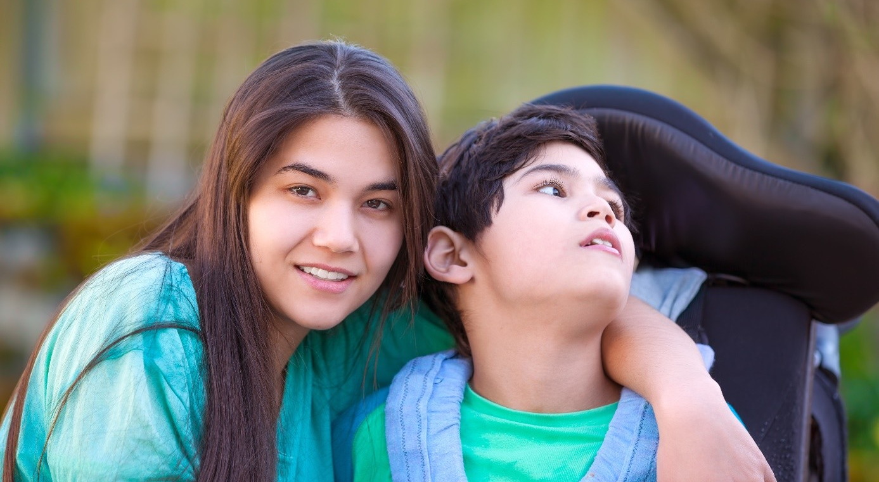
The Victorian government’s Carer Strategy¹ was developed in 2017 by the Department of Health and Human Services (now the Department of Families, Fairness and Housing (DFFH)) and includes a rolling action plan with six specific goals. These goals aim to find children a safe and nurturing home, prepare carers for their caring role, value, inform and empower carers, effectively train carers, provide high quality support and help carers provide nurturing and lifelong relationships which can enable reunification or a permanent care arrangement. The home-based carer census is the plan’s major action for 2020-21.
When parents are unable or unwilling to keep their children safe at home, the care services system is called upon to provide alternative care for children and young people. Alternative care includes a small component of residential care and the preferred option of home-based care provided by kinship carers, foster carers and permanent carers.

Kinship carers
Kinship carers are usually family members, but may be non-family members who are well known to the child and their family. Kinship care is the preferred type of home-based care under Victorian legislation. Kinship carers differ from other types of home-based carers due to their different motivations, intentions and experiences. For example, often a kinship carer will make the decision quickly to become a carer during a stressful family crisis which may involve a grandchild, niece, nephew or family friend. Kinship carers may not have had any involvement with the child protection system and its processes before a child or young person comes into their care.
Kinship carers will often still have a relationship with the parents of the child or young person, which may cause issues during family contact and impact on carers’ and children’s emotional wellbeing. For Aboriginal children and young people, kinship carers are especially important given early identification of Aboriginal kinship networks helps to build and promote positive cultural and community connections for Aboriginal children in care.
Kinship care is temporary and ends when the child can safely return home, transition to independent living, or a permanent care order is put in place. The nature of the caring relationship means kinship carers need different supports to other home-based carers, given their different motivations, intentions and experiences.

Foster Carers
Foster carers are volunteers who provide care for children or young people when a suitable kinship carer cannot be found. Foster carers will typically make a conscious decision to become a carer and undertake a training and accreditation process before becoming a carer. Foster carers are provided support by an agency and generally expect to remain within the care services system and receive multiple children to care for.
Foster carers of Aboriginal children and young people have additional roles and responsibilities, being expected to nurture a child’s Aboriginal identity, help to implement their cultural plan, be aware of and enable participation in cultural events and increase their own cultural awareness through training and support materials.
Foster care is temporary and ends when the child safely returns home, transitions to independent living, or a permanent care order is put in place. At times, foster carers can also become permanent carers.

Permanent Care
Permanent care is arranged for the child or young person if family reunification is not possible. While it is preferred that permanent carers come from the child or young person’s family or kinship care arrangement, permanent carers may also be foster carers who have an existing relationship with the chid or young person. Permanent carers can be someone who has not previously provided kinship or foster care to the child or young person, if they are assessed as a suitable permanent carer.
Permanent carers should be assessed and trained to provide safe and enduring care. Carers assume parental responsibility for the children and young people in their care and are legally recognised as their parents under the Children, Youth and Families Act 2005 (CYFA) through the making of a permanent care order until the child or young person turns 18 years old. \Permanent carers are responsible for long-term decisions about issues like education, changes in residence, health and employment, as well as daily care. The existence of a permanent care order does not prevent children and young people having an ongoing relationship with their family and community, and where appropriate, their parents.
Under the CYFA, the court cannot make a permanent care order for an Aboriginal child with a non-Aboriginal family, unless it has received a report from an Aboriginal agency recommending the order and a cultural plan is in place for the child. A cultural assessment report is also required to determine the carer’s willingness and capacity to keep the child connected to their culture, family and community.
Many permanent carers continue to provide young people with varying degrees of financial and emotional support well into adulthood, as any parent would.

Care Allowances
Foster carers that have been assessed, accredited and registered by a community services organisation or an Aboriginal Community Controlled Organisation (ACCO) are eligible to receive a care allowance. There are five care allowance levels and eligibility is determined and assessed by the department, in consultation with the foster care agency.
Kinship carers that have been assessed and approved by child protection following intervention are eligible to receive the lowest level one care allowance. Where the child is assessed as having higher needs, carers may be eligible for a higher care allowance level through a negotiated adjustment process. Informal kinship care arrangements are ineligible for the care allowance provided by the department.
Permanent carers are automatically eligible for the level one care allowance at the commencement of the placement. Foster carers who convert to permanent care are automatically provided with level one care allowance, irrespective of the allowance level they were previously receiving as foster carers. Requests for permanent carers to receive a higher level of care allowance will only be considered prior to the finalisation of a Permanent Care Order. There are circumstances where flexible funding packages can be sought to support permanent carers.

Carer Census
EY Sweeney was appointed by the Department of Families, Fairness and Housing (DFFH) to undertake the carers census to help understand the profile of carers in Victoria and their experiences.
The results of the census are covered in this report and include:
- Characteristics
- Attitudes
- Experiences and
- Needs of Victorian kinship, foster and permanent carers.
Carers, young care leavers, community services organisations, Aboriginal Community Controlled Organisations, peak bodies and other key stakeholders identified the carer census as the most important action for 2021 under Victoria’s Strong Carers, stronger children Carer Strategy Action Plan.
DFFH commissioned EY Sweeney to undertake the research and analysis of Victoria’s first Home-based Carer Census; inviting kinship, permanent and foster carers to participate. The department understands that improving carer welfare leads to better outcomes for the children and young people in their care. There is a need for more Victorians to take up a home-based caring role to meet the individual needs of children and young people, and the purpose of the carer census was to better understand the home-based carer community to improve the way carers are supported in their critical caring roles.
To meet these objectives, a survey of 1,788 carers was conducted between 26 November 2020 and 1 March 2021 via an online survey. Among the carers who responded to the census, kinship care was marginally the most common care type (41 per cent), ahead of foster care (39 per cent). Twenty-three per cent of children of carers who responded to the survey were being cared for under a permanent care arrangement at the time of the census. Based on data supplied by DFFH, as of the 23rd of November 2020, there were 4,723 kinship carers (59.1 per cent), 2,199 permanent carers (27.5 per cent) and 1,066 foster carers (13.3 per cent) in the total population of currently active carers. Within the census, four in ten survey respondents were currently providing kinship care (41 per cent) or foster care (39 per cent), with one in five (23 per cent) providing permanent care. It is important to note that the proportions add up to over 100 per cent due to some carers undertaking multiple care types.
The sampling approach targeted those caring under a formal arrangement, which includes statutory kinship carers, where a child’s placement was arranged through, or assessed by child protection. However, those caring under an informal arrangement were not prevented from completing the survey, therefore it is not a proportionate reflection of the population under a formal care type.
In order to maximise sample coverage of all formal carer types, a combination of peak body contact lists and the DFFH payment register contact list was used. Data was supplied to EY Sweeney by DFFH, the Foster Carer Association of Victoria (FCAV) and Kinship Carers Victoria (KCV) which allowed EY Sweeney to deduplicate the contact lists and gain certainty of the total number of carers invited to participate. Permanent Care and Adoptive Families (PCAF) managed the mailing to their database without visibility for EY Sweeney.
Due to the methodology adopted in this study, a number of limitations may be considered when interpreting the census findings. These are outlined in detail in the research approach section of the report.

The following summary captures the core themes from the analysis.

Demographic differences exist across carer types
The Victorian DFFH Home-based Carer Census included representation from three carer types. Of those who participated, two in five identified as kinship carers, a further two in five as foster carers, and just under one in four as permanent carers. It was possible for respondents to identify as more than one carer type in the survey.
Strong demographic differences were evident across the carer types, indicating that the personal characteristics of carers shape their experience. The foster carer respondents appear particularly different to other carer types, with the profile of kinship and permanent carer respondents more similar.
Foster carer respondents were more likely to have higher household income than other carer types; a sixth had a household income over $100,000 compared to a seventh of kinship carers and a fifth of permanent carers.
Foster carer respondents were also more likely to be younger. Just over one in ten foster carer respondents were aged 20 to 35 years old, compared to one in twelve kinship carers and one in twenty permanent carers.
Although the majority of all the respondents were female, foster carers had the highest proportion of male carers, with a sixth of foster carer respondents identifying as such. This compares to a sixteenth of kinship carers and a tenth of permanent carer respondents who identified as male. This indicates a more gender diverse representation among the foster carer cohort surveyed than the other carer groups surveyed.

Little overlap in the type of care provided by carers
Although we note that respondents could identify as more than one of the three carer types, at the time of the survey very few were providing more than one type of care. A very small proportion, just two percent, were providing foster care and permanent care. A similar proportion were providing permanent care in conjunction with a kinship care arrangement. Fewer than one percent were providing kinship and foster care, or all three forms of care.

Improved outcomes shape the desire to become a carer
In the early stages of their carer role, seven in ten carers are strongly influenced to become a carer by the desire to make a positive difference in a child’s life. A third of carers are motivated by the opportunity to play a positive part in the community. These reasons were amplified among the foster carer cohort.
Kinship and permanent carers were more likely to have become a carer through factors out of their own control. Typically, kinship carers become carers because the child is part of their family or network. Both kinship and permanent carers are more likely to become a carer due to an obligation to care for a family member or kin. Two-thirds of kinship carers and two-fifths of permanent carers highlight this as one of their key reasons to start caring. This is emphasised by the finding that half of kinship carer respondents were likely to have been approached by child protection services compared to one in twenty foster carers and a quarter of permanent carers.
Over one in ten foster carers were likely to have been influenced by external factors such as ‘seeing family or friends already caring’ or ‘prompted by advertising and communications’. However, these factors were less common among kinship or permanent carers; with under one in twenty identifying with these influences. While advertising is the third most influential motivator for foster carers, it has a relatively low influence overall.
Three-fifths of foster carers felt well prepared in advance of their first care placement compared to two-fifths of kinship carers and over two-fifths of permanent carers. However, a significant proportion across the three carer types felt underprepared. The higher levels of preparedness among foster carers may be a result of four-fifths having accessed introductory training prior to the beginning of their role as a carer. This is compared to a fifth of kinship carers and half of permanent carers. As foster carers are required to participate in this training prior to commencing taking placements, it is worthwhile for the Department to investigate further as to why a fifth do not recollect having done so.
Feelings of preparedness may also be shaped by circumstance. For example, as foster carers elect to become carers, it may create a stronger perception of control over the decision. Foster carers may also have more time to consider the role itself and explore their options and prepare for what’s to come.

Cultural connection between carer and child
As recorded in the Carer Strategy (2017)1; 1,872 Aboriginal children were in care in Victoria, with 57.8 per cent of this cohort living with Aboriginal kin. Among Victorian Aboriginal Childcare Agency (VACCA) carers who completed the research for the strategy, 101 were kinship carers, 35 were foster carers, and one respondent was a permanent carer. The remaining respondents included four respondents who provided more than one care type and eight respondents who did not specify the type of care they provide. Among this group of survey respondents, 60 carers were Aboriginal.
Turning back to the primary research undertaken for this report, cultural background was explored within the census. Aboriginal carers accounted for one in twenty carers who responded to the survey. The findings indicate that Aboriginal respondents share the same demographic characteristics as carers overall, although they are more commonly providing kinship care than any other form of care. Three-fifths are providing kinship care, and four-fifths are caring for children with an Aboriginal identity.
Half of children being cared for by Aboriginal carers were in a long-term care arrangement.
Turning to the financial experience of Aboriginal carers, three in ten were borrowing money from other lenders (such as banks or cash loans) to help meet their caring responsibilities, and a fifth had been unable to pay rent or mortgage repayments on time. Aboriginal carers were more likely to be experiencing these challenging financial situations than other carers.

Confidence in personal ability, but feel challenged by the system
Over nine in ten carers agreed that they are confident in their own ability to provide care. Over four-fifths of carers also felt confident that they are able to support children in their care to maintain connection with their cultural identity and heritage. A further two-thirds of carers agreed that they are able to support LGBTI or gender diverse children in their care.
In saying this, three-fifths of carers felt challenged by the system itself, by the lack of consistency of support provided by care workers. Over half of carers felt challenged by the lack of key documentation available and the challenges of navigating child protection systems and processes. These difficulties were key reasons provided by a third of carers, who indicated they would be unlikely to continue caring in the future beyond their current placements. Further, of those unlikely to continue caring beyond their current placements, a third indicated the reason they would not be likely to continue caring was due to difficulties dealing with the system. Those unlikely to continue caring have more limited awareness of the supports available to them, with the exception of financial support.
Over half of census respondents were unaware of the support available to navigate the system. However, three quarters of those who had accessed support felt it helped them become a better carer. This emphasises the importance of raising awareness of the support available.
Reference: Victorian Government. (2017). Strong carers, stronger children. Retrieved from: https://www.dhhs.vic.gov.au/publications/strong-carers-stronger-children

Caring responsibilities are challenging carers personally
The census explored the impact caring had on the carer personally. A high proportion of respondents felt that aspects of their role had enhanced their lives; over four-fifths of carers identified the difference they had made in the child’s life, and four-fifths of carers recognised that the relationship they had with the child in their care has had a positive effect on them personally.
However, there were also challenges; three-fifths of carers mentioned that that they had been negatively affected by stress, and half of the carers recognized that their work or career had been negatively impacted. Two-fifths of carers identified that their mental health had been negatively impacted. For some carers, relationships were also damaged, with two-fifths of carers indicating their social relationships were being negatively affected, three in ten carers indicated their relationship with their partner had been negatively impacted, and a quarter of carers reported their relationship with immediate family members had deteriorated.
This may explain the desire among a quarter of carers for more support and assistance for them and their families and the wish of one in ten carers for more respite and time off.
While the support and training available to carers was commonly connected to managing the child’s needs, carer mental wellbeing and support was available to carers. However, over two-fifths of respondents were unaware this was an option for them. Again, if accessed, the results are positive, with three quarters of carers indicating it helped them be a better carer.

Personal finances being used to cover the costs of care
Four-fifths of respondents had been financially impacted, personally, as a result of their caring role. For two-thirds of carers this was in the form of using personal savings or using their own funds to pay for other expenses. For one in five carers, the scale extended to the inability to pay utility bills and for one in ten carers their ability to pay mortgage or rent payments on time.
The majority of respondents were accessing financial support in their role, with nine in ten carers accessing a care allowance, seven in ten carers a new placement allowance or childcare subsidies. Access to these particular supports was consistent across care type.
While access is high, perceptions of the adequacy of different financial supports was limited to specific areas, most commonly the school attendance allowance. Two-thirds of carers indicated it is less than they needed. A similar proportion indicated that the care allowance is less than they need, and three -fifths of carers stated that the new placement allowance is less than they need. A quarter of carers indicated the childcare subsidies are less than they need, with three-quarters of carers feeling it was about right.
Carers are also indicated that there is a need to use their personal finances to cover their caring responsibilities.

Low awareness of some supports available
Awareness of system navigation support and carer mental and physical wellbeing support has been highlighted, yet carers also had relatively low levels of awareness of other supports.
Most notably among the whole carer respondent population, was low awareness of the availability of legal support, with seven in ten carers unaware of its availability. Just under half of the carers were unaware of complex needs training, educational training, and support to care for children with a disability.
A key theme among the reasons for placements to end earlier than planned was managing a child’s behaviour. This was reflected in a fifth of carers who had a placement end due to behavioural and mental health issues of the child. A further one in ten carers had a placement end due to anger issues or violent behaviour by the child. This highlights some specific areas for which additional support is required for carers.

Access to supports enhancing carers’ ability to provide care
At an overall level, the support and training had a positive effect on carers. When accessed, the majority of carers agreed that each support or training had helped them be a better carer.
Complex needs training yielded the highest perceived impact, with four-fifths of those carers accessing this type of training acknowledging that it helped them be a better carer. Considering the role of child behaviour or management in the reasons for placements prematurely ending, this support service may have the potential to contribute to extending care arrangements.
Introductory training was also having a positive effect on a carer’s ability to provide care, with over four -fifths of carers feeling it helped them be a better carer. Considering the lower levels of access experienced by the kinship and permanent carer group, and the lack of control they appeared to have over the decision to care, access to this training early on in their caring journey may help build confidence.

Introduction

Kinship, foster and permanent carers (“carers”) are vital to supporting and nurturing thousands of Victorian children and young people whose parents are unable to provide this care. These carers play a critical role in the child and family system, providing essential emotional, environmental and material support which play a key role in improving the wellbeing and outcomes of those in their care.
Carers’ wellbeing is intimately linked to the outcomes of the children and young people for whom they care. While the carer role is a rewarding one, it also involves a range of challenges and demands. In addition to providing emotional and material support, carers are required to engage with and navigate complex systems, including the childcare, family support, educational and healthcare systems. They also often need to address the specialised needs of the children and young people in their care. Given the challenges carers experience, they need a range of supports to assist them in their role and to ensure their wellbeing.
As part of its commitment to supporting the carer network, the Victorian Government has developed and implemented reforms to improve support for carers. This includes the development of the Strong carers, stronger children strategy (the Carer Strategy), which outlines a framework for improving the experiences of carers to better support them in nurturing the children and young people they care for. The Carer Strategy builds on the Victorian Government’s 2016 Roadmap for Reform: Strong families, safe children to reform the child and family system.
The Carer Strategy is being implemented through a series of rolling action plans and the census is a is a major action from the first action plan 2020-21. The results of the census are covered in this report. The census is being conducted to collect information about characteristics, attitudes, experiences and needs of Victorian kinship, foster and permanent carers. Understanding more about these aspects of carers is anticipated to assist in developing supports to improve the carer experience and retain them in their important role . This improved understanding can ensure that policy and support services are targeted towards the specific needs of each carer group to provide them with the support they need. This report presents the findings of the census research.

Objectives
 Collect demographic and attitudinal data on the kinship, foster and permanent carer population to improve support to these cohorts and inform ongoing reform work in the sector.

Specifically, the research addressed the following…
Topic | Detail
Profile of carers | Collect data in relation to carer characteristics:  - Number of carers by carer type  - Types of care provided  - Types of children in their care
Characteristics of carers | Collect key demographic data on carers including:  - Age  - Education  - Location
Attitudes | Understand the attitudes of carers in relation to:  - Motivation to become and remain a carer  - Challenges faced as a carer  - Propensity to continue caring and reasons
Experiences | Carer experiences in relation to:  - Understanding reasons for placement breakdown  - Level of support received and impact on caring ability  - Support gaps

Research approach

Overview of the research program
To achieve the defined research objectives, the following approach was followed as agreed with the [Department]. The approach to each of these phases is explored in greater detail over the following pages.

Phase 01: Co-design workshop
A 2-hour co-design workshop was hosted by the EY team with hey DFFH, peak body and agency representatives. This provided:
- Understanding on knowledge gaps
- Key areas for data collection
- Identification of key challenges related to the collection of data among cohorts and strategies to address these challenges

Phase 02: Qualitative in-depth interviews
A series of 9 in-depth interviews with carers, 3 in-depth interviews with stakeholders (1 held as a small group discussion with Departmental representatives). This provided:
- Alternative and supplementary lens of the experience of carers
- Personal reflections by carer type (Permanent and adoptive parents, Kinship carers and Foster carers)
- Contextual view of the role of service providers and peak bodies and deeper insight into perceptions of the carer experience
Insights from the qualitative phase fed into the development of the census survey tool

Phase 03: Quantitative online census
A quantitative online survey with carers, distributed to the DFFH database, peak body member lists and relevant associations. A total of 1,788 responses were collected during this activity. This provided:
- The ability to profile carer respondents
- Quantitative measurements of the carer motivations, experience, and evaluation of support
The data collection period ran from 26th November 2020 to 1 March 2021.
Note: Greater detail on methodology and approach is provided in appendix one.

How to read this report

Qualitative and quantitative findings
This report focuses on the quantitative carer census data to provide findings that address the research objectives and the general quantitative view of a sample of the census population of carers. The report provides figures which represent the overarching view of the carer cohort survey respondents. The findings are presented for the carer cohort as a whole, with detailed analysis of subgroup results, such as carer types and demographic groups.
The purpose of the qualitative insights was to inform the development of the quantitative census and provide an understanding of some of the attitudes, sentiments and experiences of carers. The qualitative data has been used to provide context to specific sections of the report and explain the transition of these insights into the quantitative census survey. However, it would be inappropriate to deduce any general population insights from the qualitative research findings alone given the small and non-representative sample size.

Important note on language
Where the term Aboriginal is used, it refers to both Aboriginal and Torres Strait Islander people, and where the term permanent care is used, it refers to permanent carers and adoptive parents.

Important note on base sizes for analysis
Carers were asked to provide data for each child in their care on a per child basis. This means the sample size referenced on the relevant questions are greater than the sample size of carers achieved overall, these slides are noted with reference to child data and reflected in the sample sizes. Please note this when reviewing base size information and descriptions.
The purpose of the carer census was to engage as many carers as possible through the means available. During fieldwork, it was evident that not all carers completed a full survey. To ensure representation of those who may not have completed the survey, a decision was made to define a ‘viable complete’ as a respondent who completed question A5: How many children do you currently care for? The core purpose of this study was to understand the profile of current carers. This question gave the ability to do so and was recommended by EY Sweeney and approved by the department as a viable approach. Therefore, reported response numbers for each question will vary by the number of carers who answered each question.

Statistical significance
The statistical significance of one value being different from another is dependent on the amount of random variability (variance or standard error) in each of the subgroups and the size of the sample. A result is statistically significant if it is unlikely to have occurred by chance or random variation.
Statistical significance testing has been carried out throughout this report to determine how likely the observed differences between subgroup scores are to have occurred by chance, or if they are of statistical relevance. The testing throughout this report has been carried out at a 95 per cent confidence level (p=0.05). The probability of accepting a false result as true is five per cent.

Margin of error
Due to the absence of carer data, the margin of error has been calculated assuming the population of Victorian adults aged 18 years’ or more is 4.6 million: ABS, Australian Demographic Statistics.
Maximum margins of error are based on a research finding of 50% at the 95% confidence interval.
Based on 1,788 responses the margin of error ±2.37%. Margin of error by sub-group can be found in Appendix One.

Rounding
In some cases, the results presented may add up to slightly over, or under, 100 per cent. This may be due to a multi-response question (where multiple codes may have been selected by one respondent) or due to rounding to the nearest integer.

Limitations
Due to the research methodology adopted, a number of limitations should be considered when interpreting the census findings. These are outlined below.

Sample sources
In order to maximise sample coverage of all formal carer types, a combination of peak body contact lists and the DFFH payment register contact list was used. Data was supplied to EY Sweeney by DFFH, FCAV and KCV which allowed EY Sweeney to deduplicate the contact lists and gain certainty about the total number of carers invited to participate. PCAF managed the mailing to their database without visibility for EY Sweeney.
This resulted in invitations being sent to 501 permanent carers, 599 foster carers and 1,870 kinship carers on the DFFH payment register, 2,529 members of the FCAV mailing list and 223 members of the KCAV mailing list.
The FCAV mailing list included a range of carer types, including those with an active placement. This mailing list was of individual carers, not carer households, therefore in a situation where carers are co-parenting, both will have had the opportunity to complete the survey.
This information is important, as it reveals that the available sample of carers varied by carer type, and in some cases was greater than the total number of that carer-type households in Victoria, and in some cases less than this number. For example, we sent an invitation to 3,128 foster carers, while based on DFFH data there were 1,066 foster carers in Victoria when the survey launched. As noted elsewhere in this report, where the full sample was not available to access for a specific carer type, additional methods of advertising the census survey were employed.
Representation of carers and associated dissemination of the survey by individual email invitations sent
Carer type | DFFH payment register | Peak body database (KCV, PCAF, FCAV) | Total sample available
Kinship carers | 1,870 | 223 | 2,093
Foster carers | 599 | 2,529 | 3,128
Permanent carers | 501 | - | A minimum of 501
Total sent |  |  | 5,722
Participation in the survey was voluntary and it was administered online. KCV, PCAF and FCAV peak bodies shared the invitation to participate with all carers for whom they had email contact details. DFFH provided a list of carers on their database for EY Sweeney to contact directly.
It should be noted that the designation of kinship, foster and permanent carer is self-identified in this survey. It is possible that a carer who is designated a kinship carer by the Department, will label themselves a foster carer. It is not possible to identify from the census data whether the absolute numbers of care types match the Department’s designated definition.

Representation among those not associated with Peak organisations
Those not engaged with a peak body or industry agency, and those without an email address in the DFFH database would not have received a direct invitation to participate in the survey. However, the peak bodies and DFFH also encouraged participation via their stakeholder communication networks, promotional activities and social media channels. EY Sweeney and DFFH designed the most appropriate sampling method to encourage participation across all carer groups within budgetary and timing constraints.

Representation of children in care
The sampling method was designed to capture as many carers as possible. The analysis of children in care in this report relates to those children cared for by the carer census respondents.

Representation of Aboriginal and culturally and linguistically diverse carers
The sampling method was designed to capture as many Aboriginal and culturally and linguistically diverse carers as possible within budgetary and timing constraints. In addition to surveys being disseminated via the approaches described above, further efforts to engage with Aboriginal carers were undertaken by DFFH. For this study, budget was not available to translate the census into languages other than English.

Involvement of non-statutory kinship carers
Those caring for children under an informal caring arrangement represented 12 per cent of kinship carers responding to the survey, with six per cent of kinship carers unsure of the arrangement type.

Survey design
Overall lines of questioning, including those to identify the type of care being provided, were designed in collaboration with peak organisations and DFFH. This was to ensure the expertise of those connected to carers was reflected in the question design. Due to budgetary and timing limitations, the survey was not cognitively tested with carers.

Treatment of incomplete surveys
To be included within analysis for this report, carers did not have to complete every question. To ensure representation of those who may not have fully completed the survey, a decision was made to define a ‘viable complete’ as a respondent who completed question A5: How many children do you currently care for? The core purpose of this study was to understand the profile of current carers. This question gave the ability to do so and was endorsed by the department as a viable approach.
In total, 1,788 carers responded to A5 and 1,155 carers completed the full survey.

Conclusions

1. Distinct profiles within the carer types
The quantitative findings have gone some way to provide an understanding of the demographic features of people who become foster, kinship and permanent carers.
There were some distinct factors which differentiated the groups demographically. At a high level: there was a higher proportion of; male, younger and higher income carers within the foster carer cohort who responded to the survey. Whereas there were a higher proportion of female, older and lower income carers within the kinship and permanent carer cohorts.
Kinship carers had a higher proportion of Aboriginal carers than other carer types. Aboriginal carers are confident in supporting children in their care to maintain connection with their cultural identity and heritage (91 per cent agree).
Note: However, it is important to acknowledge the sampling limitations associated with this study. If in future, budgetary and timing restraints are lessened, DFFH may wish to consider alternative sampling approaches. The data included in this study provides a foundation on which to build future understanding of specific carer experiences.

2. Engaging with the system and accessing support is building confidence and preparedness
There is a variation in engagement with the system, evidently driven by the type of care that is being provided.
Foster carers are more likely to access various supports and training and as a result are exhibiting higher levels of preparedness, confidence and engagement with support, than other carer types. This indicates that kinship and permanent carers may benefit from greater contact and support from the Department to make sure they have access to support and training.
While foster carers experience some challenges, the higher proportion accessing support and training means a higher proportion are feeling that the department, agencies and advocacy groups are helping them enhance their ability to care.
Currently, kinship carers exhibit the lowest levels of awareness of support and training available to them. There may be an opportunity to encourage access to supports which are available to them in their capacity as a carer.

3. Carers want to feel heard and understand the support on offer
When asked what more could be done to support carers in the future, carers indicated the need to feel respected, and heard. The influence of other carers is playing a role in the propensity to start caring, and currently 22 per cent of carers would not recommend being a carer to others.
The key reason carers are unlikely to continue caring is; difficulties with the system (32 per cent). However, awareness of support is relatively low, with over half (55 per cent) of carers who responded to the survey unaware this was available to them. Twenty per cent of foster carers surveyed are unlikely to continue caring in the future beyond their current placements. This indicates action needs to be tailored to meet specific needs.
Raising awareness of support and training available among the kinship and permanent carer cohorts may be an opportunity to enhance their experience, confidence and preparedness for their carer role, and in turn yield more positive outcomes for the child.
Tailored support, focusing on wellbeing and mental health, is identified as being of benefit. However, there is low awareness of the extent of available training and support in this area. Considering the negative impact caring responsibilities can have on relationships, social life and on work and careers, it is important to ensure carers are aware of and are supported to access such support.

4. Minimising the financial impact of caring
Throughout the census results, despite supports available to carers, the impact on personal finances is highlighted. While the majority of carers are accessing allowances available to them, many feel what they receive is insufficient for their needs. Most kinship carers receive the lowest level of care allowance, but many foster carers receive a higher allowance. This was a key finding of the Victorian Ombudsman’s investigation in 2017 into the financial support provided to kinship carers.
Kinship and permanent carers (both 84 per cent) reported they have had their personal finances impacted in their role as a carer, with 75 per cent of foster carers also impacted. Both kinship and permanent carers are most commonly using their personal savings (kinship: 72 per cent, permanent: 70 per cent).
This means they are accessing personal finances to ensure they can meet their responsibilities, often through personal savings or income. This can be a nominated reason for why a carer may choose to leave the system, with 14 per cent of those unlikely to continue caring stating that the inadequacy of financial support is a key reason they will not continue caring in the future. This area deserves greater exploration with carers to understand what more they feel they need.

5. Next steps
While the carer census has provided a breadth of knowledge about the profile of carers within Victoria, and some insight into their experiences, there is an opportunity for deeper exploration of the specific needs of carers across carer types. The results provide a basis on which to build a regular carer census that can identify trends and be refined over time.
Considering the individual challenges carer types face, highlighted throughout the findings, there is an opportunity to engage with specific cohorts (such as kinship carers) to understand how training and support can be better tailored to meet their challenges and needs. Key characteristics of and challenges experienced by each carer group are outlined in the carer specific infographics that follow.

Kinship carers: Department of Families, Fairness and Housing

Carer profile

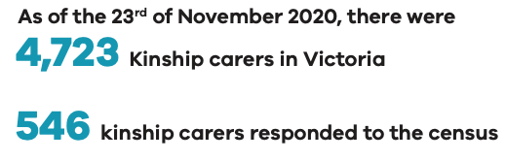

Gender

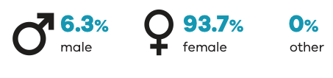Age


Location
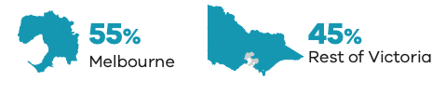

Average number of children cared for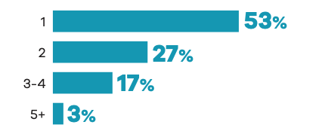

Aboriginal carers
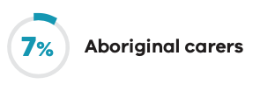

Education
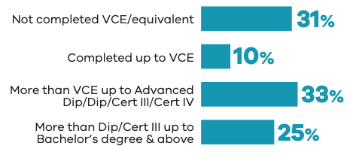

Employment commitment
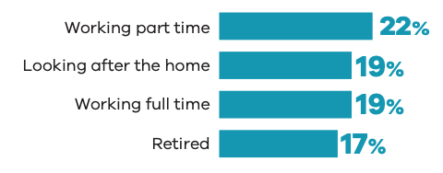

Household income
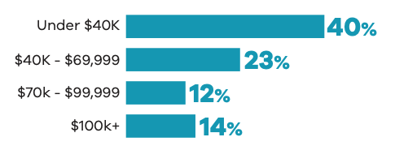

Top 3 relationship to child
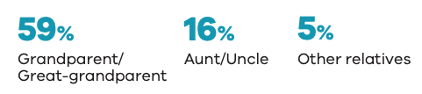

Culturally and linguistically diverse carers
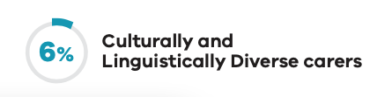

Carer experience

Top 3 motivations
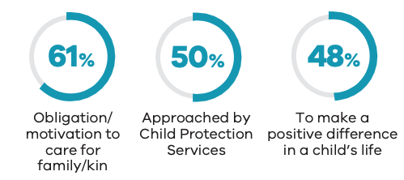

Top 2 reasons for placements ending
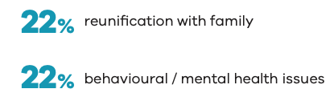

Top 3 financial impacts personally
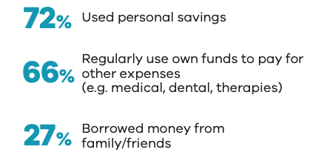

Top 3 child challenges
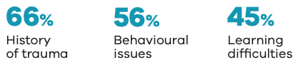

Top 3 system challenges
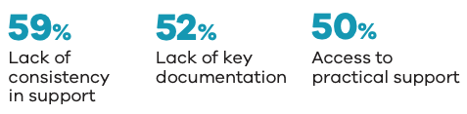

Top 3 sources of support
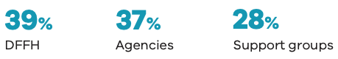

Likelihood to continue caring
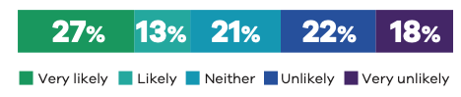

Negative impact on social relationship


Carer needs and possible support

Navigating the system
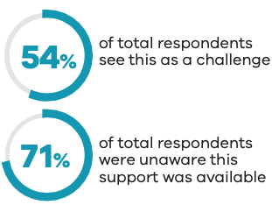

Support for complex needs
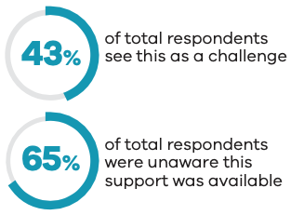

Mental health and wellbeing
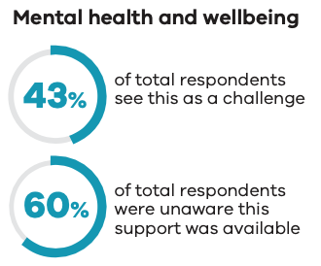

Permanent carers: Department of Families, Fairness and Housing

Carer profile

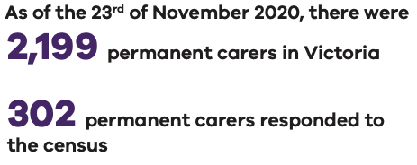

Gender

Age


Location


Average number of children cared for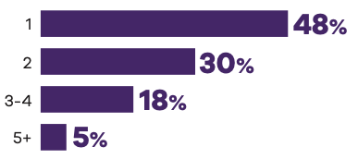

Aboriginal carers


Education
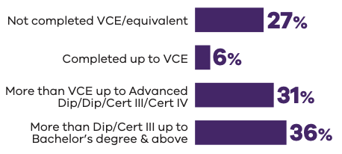

Employment commitment
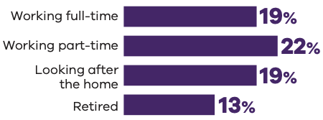

Household income
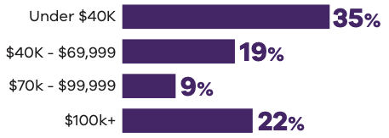

Culturally and linguistically diverse carers


Carer experience

Top 3 motivations
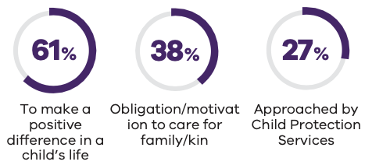

Top 2 reasons for placements ending
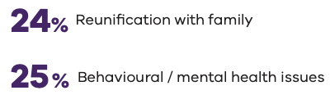

Top 3 financial impacts personally
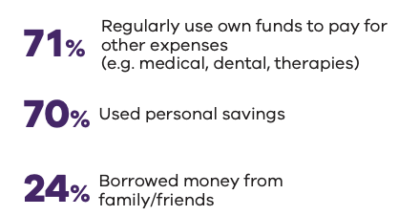

Top 3 child challenges
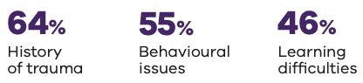

Top 3 system challenges
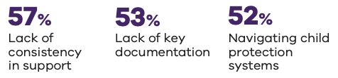

Top 3 sources of support
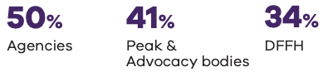

Likelihood to continue caring
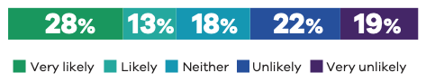

Negative impact on social relationship


Carer needs and possible support

Navigating the system
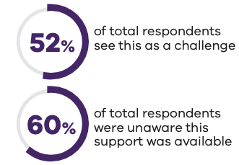

Support for complex needs
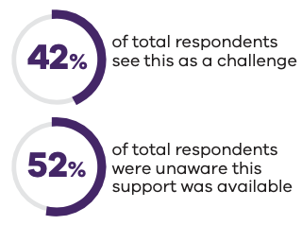

Mental health and wellbeing
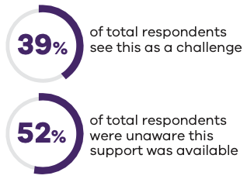

Foster carers: Department of Families, Fairness and Housing

Carer profile

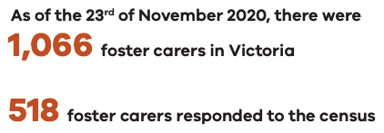

Gender

Age


Location


Average number of children cared for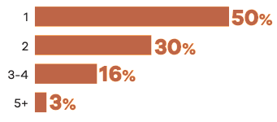

Aboriginal carers


Education
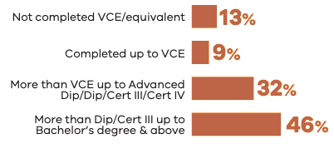

Employment commitment
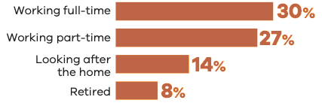

Household income
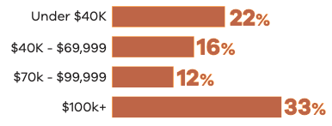

Culturally and linguistically diverse carers


Carer experience

Top 3 motivations
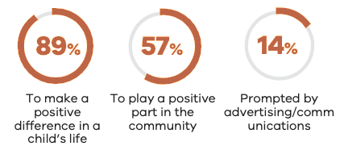

Top 2 reasons for placements ending
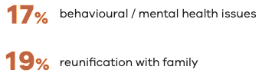

Top 3 financial impacts personally
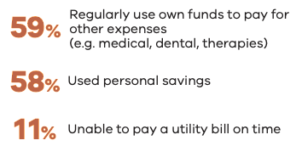

Top 3 child challenges
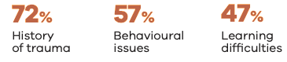

Top 3 system challenges
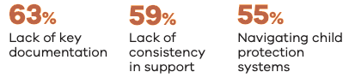

Top 3 sources of support
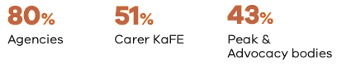

Likelihood to continue caring
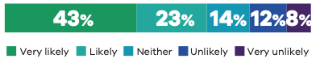

Negative impact on social relationship


Carer needs and possible support

Navigating the system
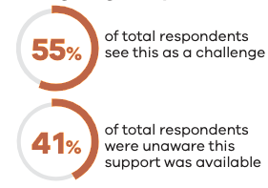

Support for complex needs
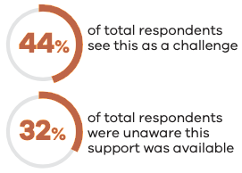

Mental health and wellbeing
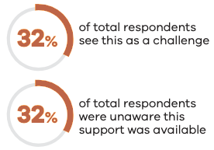


Detailed insight

Section 1. Profile of carers


Section overview
Based on data supplied by DFFH, as of the 23rd of November 2020, there were 4,723 kinship carers (59.1 per cent), 2,199 permanent carers (27.5 per cent) and 1,066 foster carers (13.3 per cent) in the total population of currently active carers. Within the census, four in ten survey respondents were currently providing kinship care (41 per cent) and the same rate for foster care (39 per cent), with one in five (23 per cent) providing permanent care. As carers may be providing more than one type of care, the survey responses equate to more than 100 per cent. Few carers were providing more than one form of care at any one time (4.3 per cent of those surveyed overall), as such the total equates to more than 100 per cent.
The overall profile of foster carers was different from the kinship and permanent care cohort, which were more aligned. Foster carers had higher incomes per household than other carer types (more commonly over $100,000 – 58 per cent). They were younger, with 55 per cent of foster carers surveyed aged 20 to 35 years old, and males were more likely to identify as foster carers (55 per cent). This indicates a more gender diverse representation among the foster carer cohort than the other carer groups.
Foster carers were also more likely to have cared for, or were currently caring for, at the time of asking, more children overall. This is in contrast to permanent carers who were most likely to care for one child, both in the past, and currently.
Carers who identified as Aboriginal were more likely to be kinship carers, with 59 per cent of those surveyed identifying as providing kinship care. The Aboriginal carer cohort were also more likely to be caring for two to three children (28 per cent) than other carer groups (13 per cent).

Carer type

All carer view
Kinship care was marginally the most common care type being provided by carers surveyed (41 per cent), ahead of foster care (39 per cent). Within the broader population, based on data supplied by DFFH (as of the 23rd of November 2020) there were 4,723 kinship carers (59.1 per cent), 2,199 permanent carers (27.5 per cent) and 1,066 foster carers (13.3 per cent) in the total population of currently active carers. Twenty-three per cent of children of carers who responded to the survey were being cared for under a permanent care arrangement at the time of the census.
Forty-seven per cent of carers surveyed had ever provided foster care in their lifetime, and 39 per cent were providing this care at the time of the census. In addition, while 40 per cent of carers had provided permanent care in the past, 23 per cent of children were being cared for under this arrangement at the time of the census.
The proportion of carers who had ever cared for children under a kinship arrangement (45 per cent), is in line with that of the children under this arrangement at the time of the census (41 per cent).
A small proportion of carers indicated they had provided an alternative form of care (ever: 4 per cent, currently: 1 per cent).
Figure 1: Type of care provided
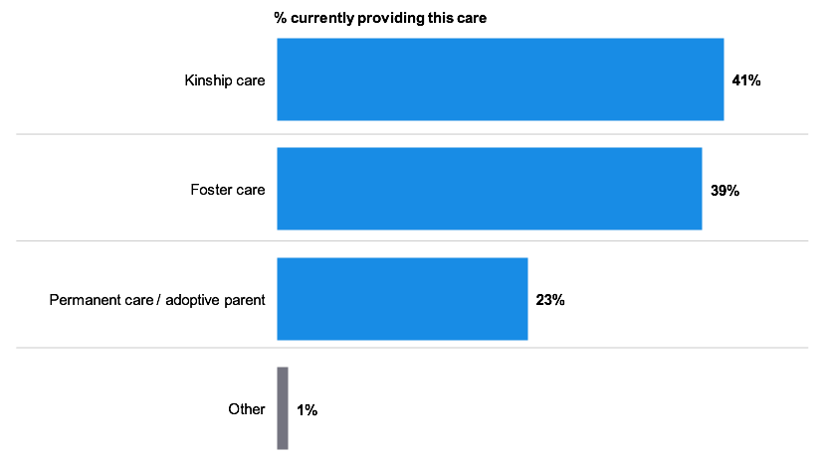
Figure note:
Base: Current carers who responded to the question (B2: n=1.323)
B2. What is the type of care arrangement you have with the child?

Sub-group differences – current placements
- Fifty-six per cent of those who had been caring for less than two years were kinship carers, a significantly higher proportion than the representation of kinship carers at a total level (41 per cent).
- Carers who had been caring for longer (6 years or more) were more likely to be a permanent carer (35 per cent).
- Those caring for a shorter period of two to four years were more likely to be foster carers, with 50 per cent of this cohort identifying as a foster carer.
- Males were more likely to be a foster carer than any other carer type (55 per cent of males were foster carers compared to 40 per cent of females).
- Females more commonly identified as a kinship carer when compared with males (41 per cent versus 22 per cent males). There was no difference by gender within the permanent carer cohort.
- Foster carers were more commonly younger, with 55 per cent of 20- to 35-year-olds undertaking this form of care.
- There were 51 per cent of carers aged 56 years and over identifying as a kinship carer.
- Carers who identified as Aboriginal were over-represented in the kinship carer group, with 59 per cent of Aboriginal carers indicating they were providing kinship care.
- Higher income households ($100,000 a year or more) were more likely to be a foster carer (58 per cent).
- Lower income households (under $40,000 per annum) were more commonly kinship carers (54 per cent).
- Analysis across length of time as a carer, gender, sexual orientation, Aboriginal carers, culturally and linguistically diverse carers, household income and regions aligned to the results of the total carer population.

All respondent view – overlap
- Most carers were providing a single type of care at the time of the census, with 40 per cent of carers providing kinship care only and 37 per cent of carers providing foster care only. Those carers providing permanent care made up 17 per cent of the carer population surveyed.
- While overlap between two care types was uncommon at the time of the census, permanent carers were most commonly providing other care types, with two per cent also providing foster care and two per cent also providing kinship care.
- Those providing kinship and foster care at one time was minimal (0.5 per cent), with those providing all three forms of care even more uncommon (0.1 per cent).
- Some carers indicated they were providing another form of care (than those asked specifically about in the survey) (one per cent).
Figure 2: Current overlap in caring types
Figure note:
Base: Current carers who responded to the question (B2: n=1.323)
B2. What is the type of care arrangement you have with the child?

Sub-group differences
- Carers who had been caring for a shorter time were less likely to provide permanent care, with six per cent of carers who had been caring for less than 2 years providing permanent care only.
- Thirteen percent of carers who had been caring for 10 years or more were providing multiple forms of care at once, more so than any other caring tenure.
- In line with earlier observations, 40 percent of females versus 20 percent of males were more commonly providing kinship care only, with 38 percent of females and 55 per cent of males providing foster care.
- Younger carers were more commonly providing foster care only, 49 per cent of those aged 55 years and below were offering this form of care.
- Carers who identified as Aboriginal were more likely to be kinship carers only (58 per cent).
- Analysis across sexual orientation, culturally and linguistically diverse carers, household income and regions aligned to the results of the total carer population.

All respondent view – time
Twenty-five per cent of the carers surveyed had been caring for 10 years or more at the time of the census, with 20 per cent of carers having provided care for six to 10 years. Twelve per cent of carers had been caring for a shorter time period of either under 12 months or one to two years. Sixteen per cent of carers had been caring for two to four years, with 15 per cent caring for four to six years.
Figure 3: Time spent as a carer
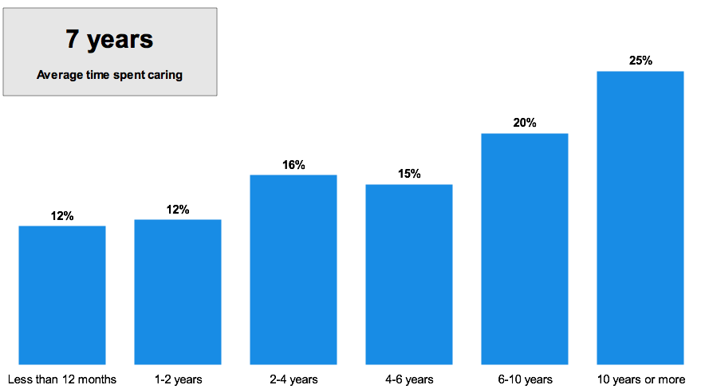
Figure note:
Base: Current carers who responded to the question (n=1,568)
A3. How long have you been a carer?
Kinship carers were more likely to be newer to care, with 31 per cent caring for two years or less, compared with 12 per cent of permanent carers. Twenty-three percent of foster carers have provided care for two years or less.

Other sub-group differences
- Thirty-seven per cent of younger carers aged 45 years and under were more likely to have been caring for two years or less and 22 percent at two to four years when compared to the total results.
Analysis across length of time as a carer, gender, sexual orientation, Aboriginal carers, culturally and linguistically diverse carers, household income and regions aligned to the results of the total carer population.

Children previously, or currently, cared for

All respondent view – how many children
Twenty-eight per cent of carers had cared for one child during their time as a carer, with 18 per cent of carers having cared for two children. Overall, in their time as a carer, 54 per cent of census respondents had provided care for three or more children, with 18 per cent doing so for three to five children, 12 per cent for six to ten children, 10 per cent for 11 to 20 children and 13 per cent for 21 or more children. The median number of children ever cared for is three (among carers who were currently caring for at least one child).
Figure 4: Number of children ever cared for
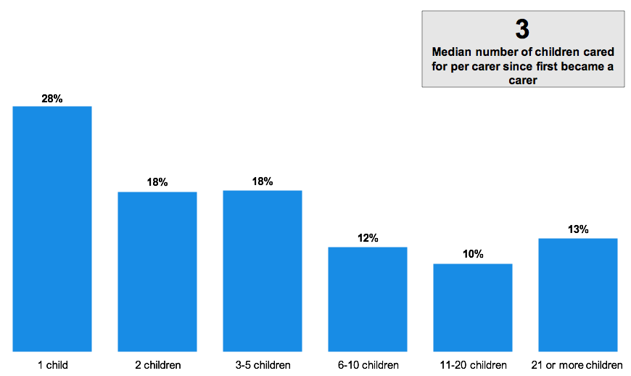
Figure note:
Base: Current carers who responded to the question (n=1,564)
A4. How many children have you cared for since you first became a carer? If you can’t remember, please provide your best estimate.
Those providing foster care were more likely to have cared for more children overall, the median number of children cared for was nine, compared with two children for kinship and permanent carers.

Other sub-group differences
- Carers relatively new to their role (under two years) were more likely to have cared for a median of two children during their time as a carer, compared with three or more children for other caring tenures.
- Those who have provided care for 10 years or more have cared for a median of 10 children over this period.
Analysis across gender, age, sexual orientation, Aboriginal carers, culturally and linguistically diverse carers, household income and regions aligned to the results of the total carer population.

All respondent view – current
Those carers currently caring for children were asked to indicate how many children they currently had in their care. Fifty-two percent of carers were currently caring for one child within their household, with 29 per cent of carers caring for two children. The proportion of carers currently caring for more than three children dropped to 16 per cent, with only two per cent of carers indicating they were caring for 5 to 10 children and one per cent for 11 or more children. As a median, carers had one child currently in a care arrangement in their home at the time of the census.
Figure 5: Number of children currently cared for
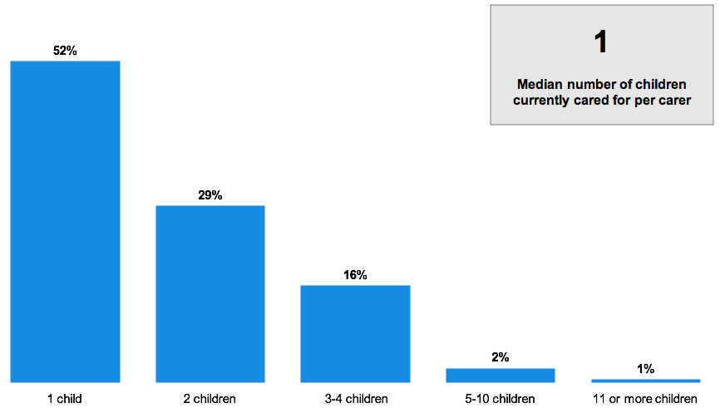
Figure note:
Base: Current carers who responded to the question (n=1,568)
A5. How many children do you currently care for? Again, please think about the number of children under a formal or statutory care arrangement up to the age of 20.
Foster carers were more likely to be caring for two children at the time of the census, compared with one child for kinship and permanent carers.

Other sub-group differences
- As would be expected, there is a strong correlation between the length of time an individual has been a carer and the number of children they have cared for. Those caring for more than 10 years were more likely to have been caring for a median of two children at the time of the census.
- Aboriginal carers were more likely to have been caring for two children (median) currently when compared to others (one child).
Analysis across gender, age, sexual orientation, culturally and linguistically diverse carers, household income and regions aligned to the results of the total carer population.

Section 2. Characteristics of carers


Section overview
Carers surveyed as part of the census were predominantly female, representing 89.4 per cent of carers. Males made up 10.4 per cent of those responding to the survey, with those identifying with another gender making up 0.2 per cent of respondents. The male cohort were predominantly within the foster carer group, though still an overwhelming majority of this cohort were female. Of all carers, males were more likely to identify with a non-heterosexual orientation (12 per cent), have a postgraduate qualification (21 per cent) and be earning a household income of more than $150,000 a year in comparison to their female counterparts (19 per cent males versus 9 per cent females).
The culturally and linguistically diverse cohort made up six per cent of the overall carer population surveyed. These carers were also more likely to have been working full time (35 per cent versus 24 per cent of the total carer group) and have achieved a postgraduate qualification (31 per cent versus 13 per cent of the total carer group).
A small proportion of our carer sample identified with a sexual orientation other than heterosexual; including lesbian, gay, queer or questioning, bisexual or other. Younger carers (aged 35 years or under) were more likely to identify as such, with 12 per cent identifying as lesbian or gay (versus three per cent at a total level), bisexual (six per cent versus one per cent at a total level), or queer or questioning (one per cent versus 0.1% at a total level).
Carers who identified as Aboriginal accounted for five per cent of the carers who responded to the census. There was little to differentiate the demographic profile of this cohort, aside from their over-representation as kinship carers. However, where the experiences of Aboriginal carers differ, this is explored in detail throughout this report.

Carer demographics

All respondent view – gender
The carers responding to the census were primarily female, with 89 per cent identifying as such, and 10 per cent identifying as male. A small proportion of carers surveyed identified as another gender (0.2 per cent).
Figure 6: Identified gender of carer
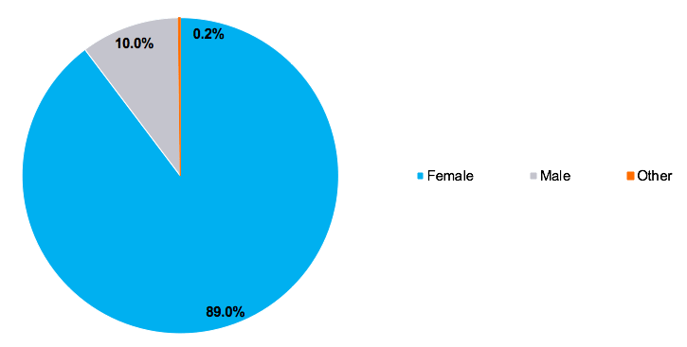
Figure note:
Base: Current carers who responded to the question (n=1,001)
F1. Do you identify as…?
Those carers who have provided foster care were more likely to be male when compared with other care types (foster: 14 per cent, permanent care: 10 per cent and kinship care: six per cent).
Those providing kinship care were more likely to be female (kinship: 94 per cent, permanent care: 90 per cent, foster care: 86 per cent,).

Other sub-group differences
- Those aged 66 years and over were more likely to identify as male (20 per cent) when compared with the total results (11 per cent).
- Those aged 36 to 45 years old were less likely to identify as male (five per cent versus 11 per cent at a total level).
- Those who identify as speaking a language other than English at home were more likely to identify as male (19 per cent).
- Those with an annual household income of $100,000 or more before tax were more likely to identify as male (15 per cent).
Analysis across length of time as a carer, gender, sexual orientation, Aboriginal carers and household income aligned to the results of the total carer population.

All respondent view – age
The majority of carers surveyed as part of the census were over 46 years old, with 71 per cent indicating they were 46 years or older at the time of the census. Thirty-two per cent of carers were 46 to 55 years old, over 27 per cent were 56 to 65 years old, and around 12 per cent were 66 years or over.
Ten per cent of carers fit into the youngest age bracket of 20 to 35 years old, 20 per cent of carers were 36 to 45 years old. On average, the carers currently caring for children within Victoria were around 52 years old.
Figure 7: Age of carer
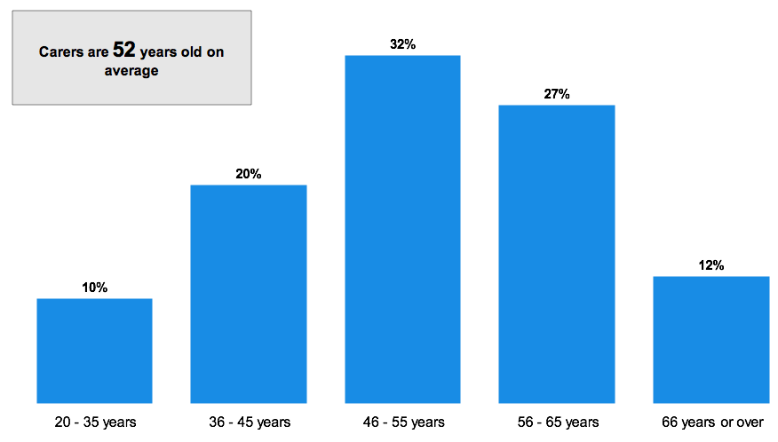
Figure note:
Base: Current carers who responded to the question (n=998)
F3. How old are you?
The average age of those providing foster care was somewhat lower than that of other carer types, with the average age being 49 years old. Those providing kinship care were on average 54 years old and permanent care providers averaged 54 years of age.

Other sub-group differences
- Those who have been caring for 10 years or more were older than average, at 57 years old.
- Those with an annual household income $100,000 or more before tax were more likely to be younger than the average age of a carer (45 years old versus 52 years old on average).
Analysis across gender, age, sexual orientation, Aboriginal carers, culturally and linguistically diverse carers and regions aligned to the results of the total carer population.

All respondent view – sexual orientation
Carers of heterosexual orientation were most commonly currently caring for children in Victoria’s care system, at 86 per cent of carers. A small minority of carers identify as: lesbian or gay orientation (three per cent), bisexual (two per cent), asexual (0.4 per cent), and queer or questioning (0.1 per cent).
A small proportion of carers identified as another sexual orientation (0.4 per cent). It is important to note that eight per cent of the sample were not comfortable volunteering their sexual orientation, and 0.7 per cent were unsure.
Figure 8: Sexual orientation of carer
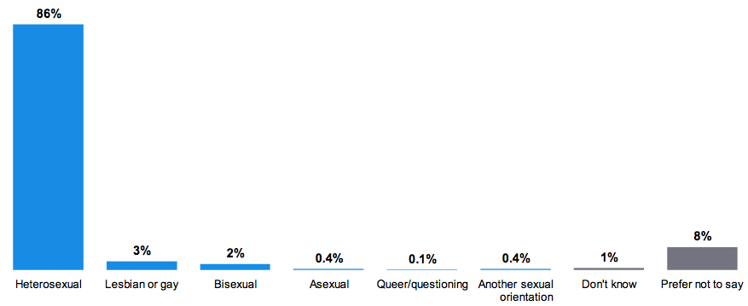
Figure note:
Base: Current carers who responded to the question (n=998)
F3. How would you describe your sexual orientation?
Those providing foster care were more likely to identify as lesbian or gay (five per cent) when compared to other care types (permanent care: two per cent, kinship care: one per cent).

Other sub-group differences
- Males were more likely to identify as gay (12 per cent versus two per cent), or bisexual (five per cent versus two per cent).
- Younger carers aged 20 to 35 years old were more likely to identify as lesbian or gay (12 per cent versus three per cent at a total level), bisexual (six per cent versus one per cent at a total level), or queer or questioning (one per cent versus zero per cent at a total level).
Analysis across length of time as a carer, gender, Aboriginal carers, culturally and linguistically diverse carers, household income and regions aligned to the results of the total carer population.

Household profile

All respondent view – living situation
The carers surveyed are more commonly one of a couple living at home (61 per cent), with 29 per cent of carers indicating they are a single carer living at home, and nine per cent of carers were in an alternative situation. The latter included living with parents, or in a share house.
Figure 9: Household status – carer living situation
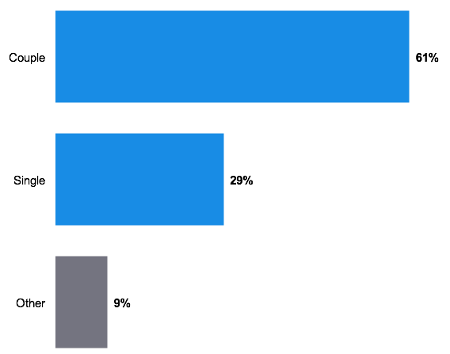
Figure note:
Base: Current carers who responded to the question (n=993)
F11. Which of the following best describes you?
A lesser proportion of those providing kinship care are one of a couple (53 per cent), with 61 per cent of permanent carers, and 65 per cent of foster carers indicating they are one of a couple living at home. The kinship carer cohort are more likely to suggest an alternate living arrangement (14 per cent) when compared with permanent carers (11 per cent) and foster carers (5 per cent) surveyed.

Other sub-group differences
- Those caring for 2 to 4 years are more likely to be one of a couple (71 per cent).
- A higher proportion of the male carers who responded to the census are one of a couple (79 per cent), when compared with females (59 per cent).
- Carers aged 56 years and over are the least likely to be one of a couple (54 per cent).
- A higher proportion of Aboriginal carers indicate they are a single person within the household (60 per cent).
- Lower income households (under $40,000) are more likely to be single (52 per cent), with those with an annual household income of $100,000 or more the most likely to be one of a couple (86 per cent).
Analysis across culturally and linguistically diverse carers and regions aligned to the results of the total carer population.

All respondent view – family members
The qualitative phase of the study uncovered potential strains on broader family members living with a child in a care arrangement, particularly for other children not in a care arrangement themselves.
Fifty-eight percent of carers only have children living with them in a care arrangement, with the remaining 42 per cent of carers living with at least one child not in a care arrangement. Twenty-six percent of carers have more than one child living with them, in addition to those they care for in a care arrangement.
Figure 10: Family members living at home (in addition to those in care arrangement)
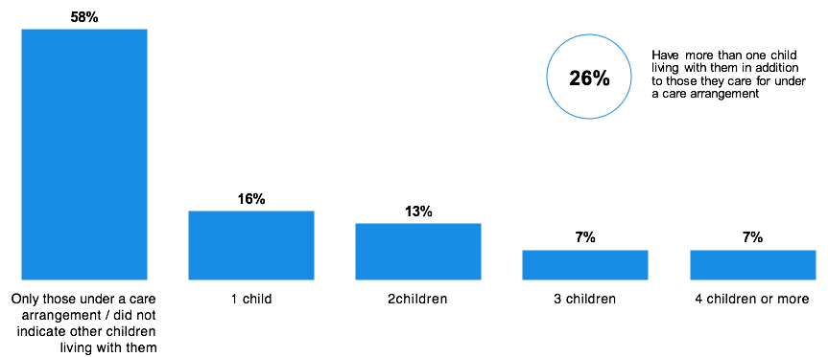
Figure note:
Base: Current carers who responded to the question (n=993)
F11. Which of the following best describes you?
Foster carers are more likely to have more than one child living with them, in addition to those in a care arrangement (31 per cent), than permanent (26 per cent) and kinship (25 per cent) carers.

Other sub-group differences
- Older carers over the age of 56 years, are more likely to be caring only for those children in a care arrangement (74 per cent).
- Those with an annual household income of $100,000 or more have a greater likelihood of more than one additional child living with them, as well as those under a care arrangement (35 per cent).
Analysis across length of time as a carer, gender, sexual orientation, Aboriginal carers, culturally and linguistically diverse carers and regions aligned to the results of the total carer population.

All respondent view – region
Regionally, those from Greater Melbourne make up 58 per cent of the carers surveyed, with 10 percent of carers from Gippsland and nine percent of carers from Loddon Campaspe.
Other regions represented include:
- Barwon (six per cent)
- Central Highlands (seven per cent)
- Goulburn (four per cent)
- Great South Coast (three per cent)
- Mallee (one per cent), and
- Ovens Murray (two per cent).
Figure 11: Region
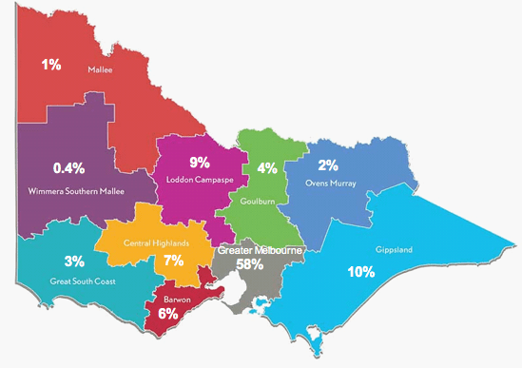
Figure note:
Base: Current carers who responded to the question (n=775) (Excluding those who did not provide a postcode)
F11. What is your postcode?

Other sub-group differences
- Those caring for 10 years or more were more likely to live in Greater Melbourne (68 per cent versus 58 per cent for regional Victoria).
- Those with an annual household income of $40,000 or more were more likely to live in a regional location (58 per cent versus 51 per cent).
The geographical profile by gender, age, sexual orientation, Aboriginal carers, culturally and linguistically diverse carers and regions aligned to the results of the total carer population.

All respondent view – income
The average household income varied across the carer cohort. The smallest proportion of carers reported a household income of under $20,000 annually before tax. Twenty-one per cent of carers reported earning between $20,000 and $39,999 as a household, with a similar proportion of carers earning between $40,000 and $69,999 (20 per cent) as a household.
As a household, fewer carers were earning over $70,000 (37 per cent) than under $70,000 (49 per cent), with 12 per cent of carers earning between $70,000 and $99,999 as a household, 14 per cent of carers were earning between $100,000 and $149,999 as a household, and 10 per cent of carers were earning $150,000 or more as a household. Fifteen per cent of carers preferred not to indicate how much their family earns annually.
Figure 12: Household income
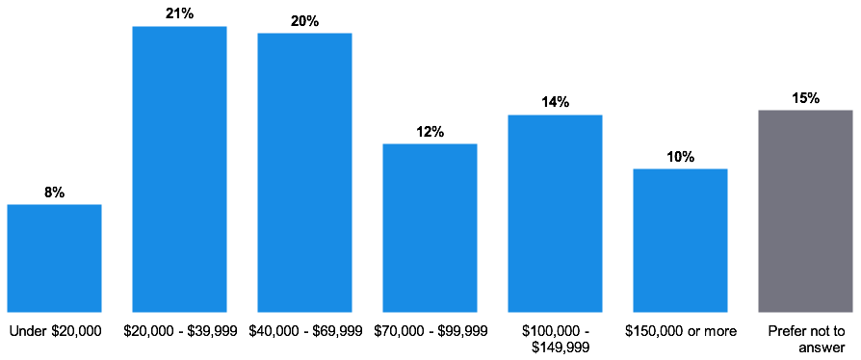
Figure note:
Base: Current carers who responded to the question (n=987)
F11. Which income bracket does your total household annual income before tax fall? It does not matter if you do not know the exact amount, we are interested in your household’s approximate level of income.
Those carers providing foster care were more likely to have a higher income, with 17 per cent of those carers providing this form of care living in a household that earns between $100,000 and $149,999 (permanent care: 12 per cent, kinship care: 10 per cent), and 15 per cent of foster carers earning $150,000 or more (permanent care: nine per cent, kinship care: four per cent).
Kinship and permanent carers are more likely to come from a low-income household, with 40 per cent of those providing kinship care and 35 per cent of those providing permanent care earning under $40,000. Twenty-two per cent of foster carers were earning this amount.

Other sub-group differences
- Those who have been caring for less than two years were more likely to live in a household with an income between $70,000 and $99,999 per year (17 per cent versus 12 per cent at a total level).
- Male carers were more likely to be living in a higher income household earning $150,000 per year or more (19 per cent) when compared to females (nine per cent).
- Strong variance existed by age and household income levels, with older carers more likely to earn under $40,000 per year (66 years old and over: 53 per cent).
- Younger carers aged 20 to 35 years old (26 per cent), and 46 to 55 years old (20 per cent) were more likely to live in a household that earns between $100,000 and $149,999 per year before tax.
Analysis across gender, sexual orientation, Aboriginal carers, culturally and linguistically diverse carers and regions aligned to the results of the total carer population.

Education and employment

All respondent view – education
The level of education achieved by the surveyed carers varied from those who started secondary school but did not complete VCE or equivalent (21 per cent), through to those with a postgraduate qualification (15 per cent).
The most common education level among carers was an Advanced Diploma, Diploma, or Certificate III or IV (32 per cent).
Nine percent of carers completed VCE or equivalent, 18 per cent a Bachelor’s degree, and six per cent a Graduate Diploma or Graduate Certificate.
Figure 13: Highest level of education held
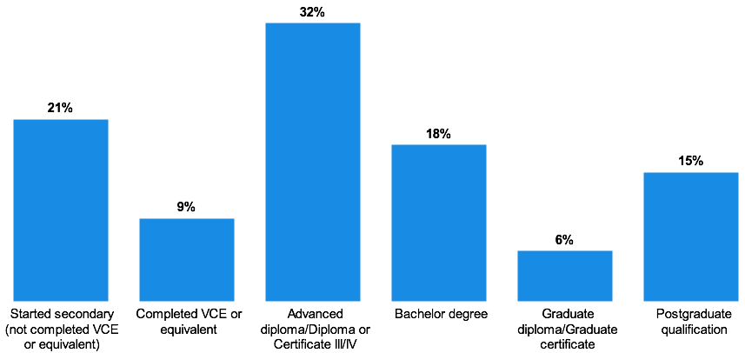
Figure note:
Base: Current carers who responded to the question (n=995)
F6. What is the highest level of education you have completed to date?
Thirty-one per cent of those providing kinship care and 27 percent of permanent carers were more likely than foster carers to have started secondary school, but not completed VCE or the equivalent (foster: 13 per cent).
Foster carers were more likely to have a postgraduate qualification (foster: 21 per cent, permanent care: 14 per cent, kinship care: five per cent).

Other sub-group differences
- Male carers were more likely to have achieved a postgraduate qualification (24 per cent) than female carers (14 per cent).
- Older carers, over the age of 56 years old, were more likely to have started secondary education, but not completed VCE or equivalent (66 years old and over: 40 per cent).
- Those aged 20 to 35 years old were more likely to have achieved a Bachelor’s degree (30 per cent), and those aged 36 to 45 years old a postgraduate qualification (21 per cent).
- Culturally and linguistically diverse carers were more likely to have achieved a postgraduate qualification than those who did not identify as such (32 per cent).
- Those living in a household earning $100,000 or more per year before tax more commonly completed either a Bachelor’s degree (25 per cent) or a postgraduate qualification (34 per cent).
Analysis across length of time as a carer, sexual orientation, Aboriginal carers, and regions aligned to the results of the total carer population.

All respondent view – employment
When providing insight into their current employment status, carers were able to select more than one response to highlight the commitments they had outside of their caring role. In addition to their role as a carer, 25 per cent of those surveyed were working full time, with 26 per cent of carers working part-time.
Sixteen per cent of carers were looking after the home, 12 per cent of carers were retired, with seven per cent of carers studying part time, and two per cent of carers were studying full time. Some carers indicated they were currently unemployed, three per cent of carers were seeking work and two per cent of carers were not seeking work.
Thirty-nine per cent of carers indicated they were caring full time, with no other commitments selected.
Figure 14: Employment status
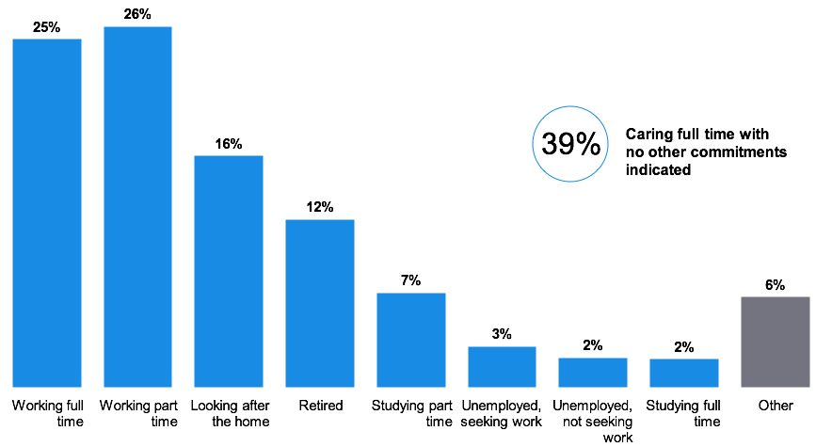
Figure note:
Base: Current carers who responded to the question (n=996)
F6. Which of the following best describes your status?
Those providing foster care were more commonly working full time (30 per cent), when compared with kinship carers and permanent carers (both 19 per cent).
Kinship carers were more likely to be retired, accounting for 17 per cent of the cohort surveyed (compared to 13 per cent of permanent carers and eight per cent of foster carers).

Other sub-group differences
- Male carers were more commonly working full time (45 per cent versus 22 per cent of female carers) and were also more likely to be retired (20 per cent versus 11 per cent of female carers).
- Younger carers under the age of 55 years old, were more likely to be working overall (64 per cent).
- Culturally and linguistically diverse carers were more likely to be working full time (35 per cent).
- Carers living in a household earning over $100,000 per year before tax were more likely to be working full time (51 per cent).
Analysis across length of time as a carer, sexual orientation, Aboriginal carers and regions aligned to the results of the total carer population.

All respondent view – occupation
Among the current carers surveyed who were employed, 34 per cent identified their current occupation to be in a professional role. This was followed by those who were in a managerial or administration role (19 per cent).
Other roles, less common among the employed carer cohort, were: intermediate clerical, sales or service roles (nine per cent), associate professional roles (seven per cent), labourers and related workers (three per cent), tradespersons (two per cent), elementary clerical sales or service (two per cent) and intermediate production and transport roles (one per cent). Sixteen percent of carers identified with another occupation, and two per cent of carers preferred not to disclose.
Figure 15: Current occupation among those employed full or part-time
Figure note:
Base: Working current carers who responded to the question (n=499)
F5. Which of these best describes your current occupation?
Of the carers surveyed who were employed, those who have provided foster care were more likely to be in a professional role (foster: 40 per cent, permanent care: 30 per cent, kinship care: 26 per cent).

Other sub-group differences
- Those carers aged 20 to 35 years old were more likely to be in a professional role (51 per cent).
- Culturally and linguistically diverse carers were more likely to be in an associate professional role (24 per cent).
- Higher income households ($100,000 or more per year), were more likely to be in a professional role (42 per cent) or a manager or administrator role (26 per cent).
Analysis across length of time as a carer, gender, sexual orientation, Aboriginal carers and regions aligned to the results of the total carer population.

Carer cultural profile

All respondent view – Aboriginal
Among the carers responding to the survey, five per cent of carers identified as Aboriginal, with two per cent of carers preferring not to provide a response. The remaining 93 per cent of carers did not identify as Aboriginal.
Figure 16: Aboriginal carers
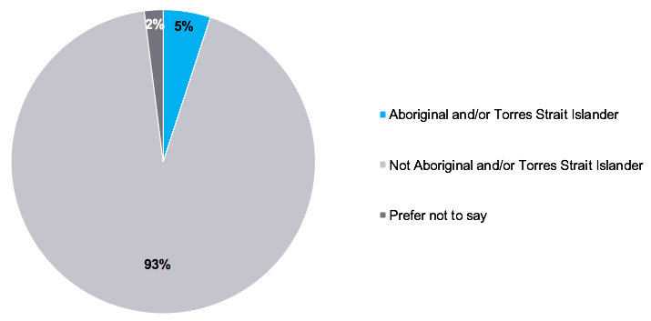
Figure note:
Base: Current carers who responded to the question (n=994)
F5. Do you identify as Aboriginal or Torres Strait Islander?
Analysis across length of time as a carer, gender, age, sexual orientation, culturally and linguistically diverse carers, household income and regions aligned to the results of the total carer population.

All respondent view – language other than English
While the majority of carers who responded to the census only speak English at home (89 per cent), six per cent of carers indicated that they personally speak a language other than English at home. Ten per cent of carers, both personally, and have a family member, who speak a language other than English at home. One per cent of carers chose not to disclose a response to this question.
Figure 17: Carer who speaks a language other than English at home
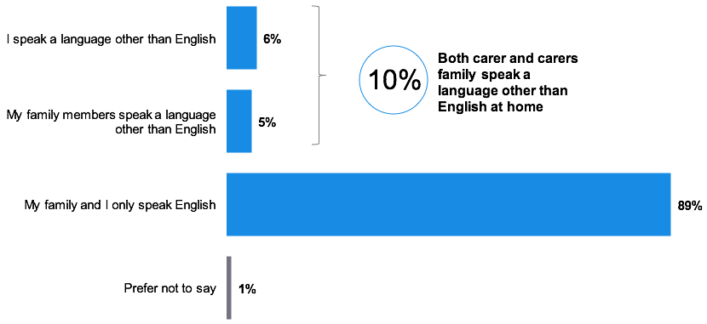
Figure note:
Base: Current carers who responded to the question (n=994)
F10. Do you, or other members of your family, speak a language other than English at home?
Analysis across length of time as a carer, gender, age, sexual orientation, Aboriginal carers, culturally and linguistically diverse carers, household income and regions aligned to the results of the total carer population.
Two per cent of Aboriginal carers indicate they speak a language other than English at home.

All respondent view – birthplace
Australia was the most common birthplace of both carers themselves (86 per cent) and their parents (77 per cent), with England a distant second for personal birthplace (six per cent) and parents’ birthplace (12 per cent).
While there was a breadth of other birth-countries highlighted, each made up three per cent or less of the carer population. These include: New Zealand (three per cent), Germany (0.5 per cent), Netherlands (0.5 per cent), Scotland (0.4 per cent), South Africa (0.4 per cent), Greece (0.3 per cent), Italy (0.3 per cent), Malta (0.3 per cent), Sri Lanka (0.3 per cent), United States of America (0.2 per cent), Canada (0.2 per cent), Vietnam (0.2 per cent), India (0.1 per cent), Indonesia (0.1 per cent), Philippines (0.1 per cent), with 2.2 per cent of carers indicating a country with less than 0.1 per cent representation.
Figure 18: Carer birthplace
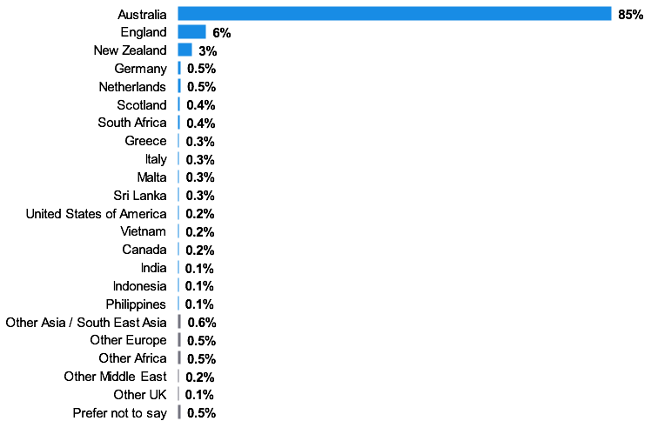
Figure note:
Base: Current carers who responded to the question (n=994)
F10. Where were you born?

Sub-group differences
- Female carers surveyed were more likely to have been born in Australia (86 per cent) than their male counterparts (74 per cent).
- Carers aged 56 to 65 years were more likely to have been born in England (10 per cent) and Scotland (two per cent).
- Carers aged 36 to 45 years old were more likely to have been born in Australia (92 per cent).
- Those carers who speak a language other than English at home (46 per cent) were more likely to have been born outside Australia than those who do not (13 per cent).
- Carers from Greater Melbourne were more likely to have been born outside of Australia (19 per cent) than their regional counterparts (11 per cent).
Analysis across length of time as a carer, sexual orientation, Aboriginal carers and household income aligned to the results of the total carer population.

All respondent view – parent birthplace
Figure 19: Carer parent birthplace
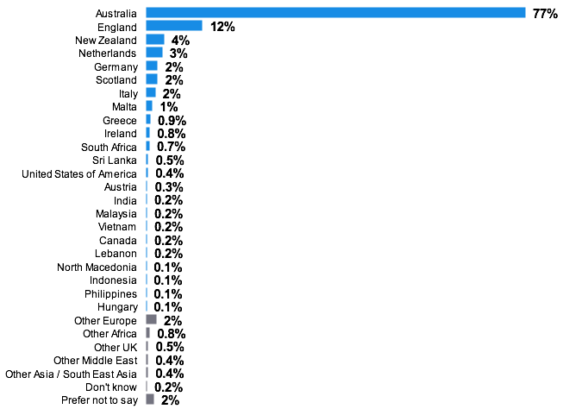
Figure note:
Base: Current carers who responded to the question (n=994)
F9. Where were your parents born?

Sub-group differences
- Those carers who speak a language other than English at home were more likely to have parents born outside Australia (83 per cent).
- Carers living in a household earning between $70,000 and $99,999 per year before tax were more likely to be from Italy (eight per cent).
- Carers from Greater Melbourne were more likely to have had parents born outside Australia (41 per cent).
Analysis across length of time as a carer, gender, age, sexual orientation and Aboriginal carers aligned to the results of the total carer population.

Section 3. Profile of children in care


Section overview
While the profile of children in the care system is well understood by DFFH, the census explored the profile of children within the care of home-based carers. There was relatively equal representation across age and gender, with various differences in the child profile by carer demographics. Of note, the gender of the carer surveyed was often aligned with the gender of the child they care for.
Aboriginal (20 per cent) and Torres Strait Islander (two per cent) children were over-represented within the census, at higher proportions than for the carer population overall. However, these children were more likely to be in multiple child households with three or more children (25 per cent). Carers who identified as Aboriginal were more likely to have children with the same cultural background (81 per cent).
Understanding the relationship between kinship carers and the child was a key objective of the census. We can see that the relationship is dominated by grandparents and great grandparents of the child (59 per cent). This is compared with just 17 per cent of carers who were the child’s aunt or uncle.
When evaluating the support needs that carers were looking for, contextualising this with the needs of the child is important to understand the scale of the issues in the care system. A history of trauma (69 per cent) and behavioural issues (56 per cent) were the most commonplace, impacting more than half of the children in the care of census respondents. Other factors were also evident, with high proportions of children needing support with learning difficulties (46 per cent), attachment issues (44 per cent) and mental health difficulties (40 per cent).

Demographics and location

All respondent view – children’s gender
An almost equal proportion of females (50 per cent) and males (49 per cent) were being cared for by census respondents. A small proportion (0.3 per cent) identified as another gender.
Figure 20: Gender of children in care
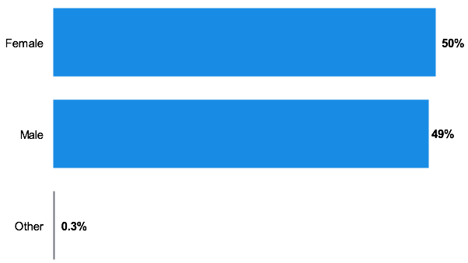
Figure note:
Base: Current carers who responded to the question (n=2,390 children)
B1. What gender is the child or are the children you care for?

Sub-group differences
- Fifty-nine per cent (59 per cent) of male carers were caring for a male child, compared with 48 per cent of female carers caring for a male child.
Analysis across care type, length of time as a carer, age, sexual orientation, Aboriginal carers, culturally and linguistically diverse carers, household income and regions aligned to the results of the total carer population.

All respondent view – age of children
A small proportion of children within the care of those surveyed were aged under one year old (three per cent) with 13 per cent aged between one to three years old.
Seventeen per cent of children were either four to six years old, seven to nine years old (18 per cent), 10 to 12 years old (19 per cent) or 13 to 15 years old (18 per cent). The proportion of children aged 16 to 20 years old was less, with eight per cent of children aged 16 to 17 years old and three per cent of children aged 18 to 20 years old.
Figure 21: Age of children in care
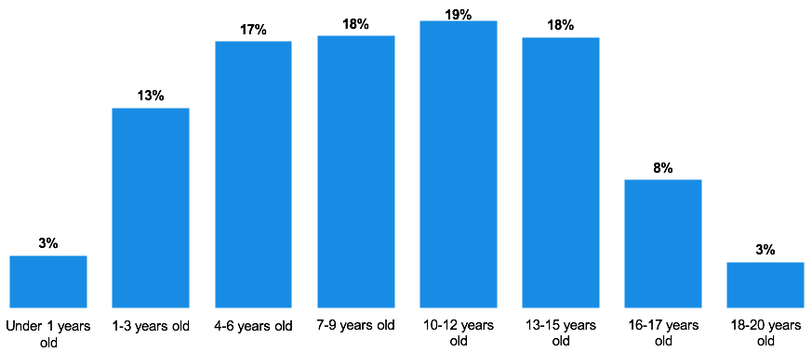
Figure note:
Base: Current carers who responded to this question, by child (n=2,390 children)
B1. How old are they?

Sub-group differences
- Children less than one year old were more commonly placed within foster care (foster: five per cent, kinship: two per cent, permanent: two per cent).
- Children aged 16 to 17 years were most likely to be with a carer who was only caring for one child (11 per cent).
- Children aged under six years old were more likely to be in the care of a younger to middle aged adult (42 per cent aged 20-55 years old).
- Children younger than six years old were also more likely to be cared for by a female carer (37 per cent females versus 25 per cent males). Inversely, older children aged 13 to 15 years old were more likely to be cared for by a male carer (28 per cent male versus 16 per cent female).
- Forty-two per cent of carers who have a household income of over $100,000 care for a child aged under six years old.
Analysis across sexual orientation, Aboriginal carers, culturally and linguistically diverse carers and regions aligned to the results of the total carer population.

Cultural profile

All respondent view – Aboriginal children
As referenced in the ‘Strong carers, stronger children’ Strategy document:
The Victorian Government is committed to advancing Aboriginal self-determination to improve the health, wellbeing, educational outcomes and safety of Aboriginal Victorians. Increasing Aboriginal self-determination ensures that Aboriginal children and young people are safe, resilient and can thrive in culturally rich and strong Aboriginal families and communities. Aboriginal children have the right to be raised in their own family, culture and community. (VACCA 2019)
The proportion of children who identify as Aboriginal within the survey outweighed the proportion of carers who also identify as Aboriginal, at 22 per cent of children in care and 15 per cent of carers. While two per cent of carers were unsure of the heritage of the children in their care, 76 per cent of carers indicated that the children in their care did not identify as Aboriginal.
However, this finding should not lead to the conclusion that the care of Aboriginal children is dominated by carers from a non-Aboriginal background, even though 73 per cent of Aboriginal children cared for by those who responded to the census, are in the care of a non-Aboriginal carer. The finding reflects that Aboriginal carers are more likely to have more than one child from an Aboriginal background in their care.
Figure 22: Aboriginal identification of children
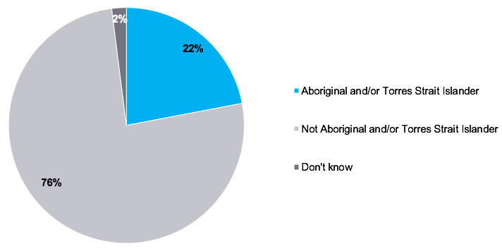
Figure note:
Base: Current carers who responded to this question, by child (n=2,255 children)
B2.5. Do they identify as Aboriginal or Torres Strait Islander (or both)?

Sub-group differences
- Aboriginal carers were more likely to have a child in their carer who also identified as being Aboriginal (81 per cent).
- Children who identify as Aboriginal were more likely to be in the care of a carer who was caring for three or more children (25 per cent).
- With that in mind, children who identify as Aboriginal were also more likely to be in the care of a carer within an area of regional Victoria (27 per cent).
- Twenty-two per cent of kinship carers were caring for an Aboriginal child, with 24 per cent of foster carers and 14 per cent of permanent carers caring for an Aboriginal child.
Analysis across length of time as a carer, gender, age, sexual orientation, culturally and linguistically diverse carers and household income aligned to the results of the total carer population.

All respondent view – cultural and linguistic diversity
Children in care who speak a language other than English were reported as comprising seven per cent of children among the carers surveyed. The majority of carers indicated that the child in their care only speaks English (87 per cent), with seven per cent of carers unsure if the child in their care does or does not speak a language other than English.
Figure 23: Culturally and linguistically diverse identification
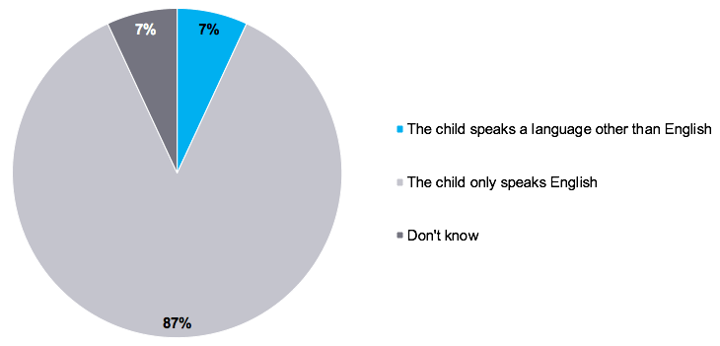
Figure note:
Base: Current carers who responded to this question, by child (n=2,255 children)
B2.4. Do they, or their parents, speak a language other than English at home?

Sub-group differences
- Children in the care of younger carers (20 to 35 years old) were more likely to speak a language other than English (14 per cent).
- Children who do speak a language other than English at home were more likely to also be cared for by a carer who speaks a language other than English at home themselves (32 per cent).
- Children who do not speak a language other than English at home were more likely to be in the care of a carer who has an annual household income of $40,000 - $69,000 (93 per cent).
Analysis across length of time as a carer, gender, sexual orientation, Aboriginal carers and regions aligned to the results of the total carer population.

All respondent view – child birthplace
The vast majority of children in the care of carers surveyed were born in Australia (97 per cent).
Figure 24: Country of birth of children
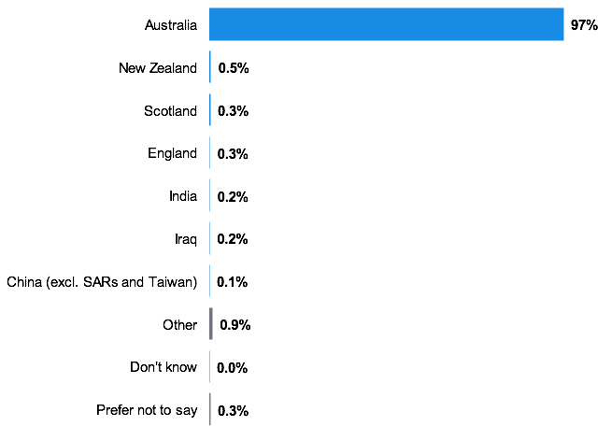
Figure note:
Base: Current carers who responded to this question, by child (n=2,255 children)
B2.3. In which country were they born (if known)?

Sub-group differences
Analysis across length of time as a carer, gender, age, sexual orientation, Aboriginal carers, culturally and linguistically diverse carers, household income and regions aligned to the results of the total carer population.

Child relationship with the care system

All respondent view – formal arrangement
While 82 per cent of children in the care of the carers surveyed were in a formal care arrangement, 12 per cent were not. Six per cent of carers were unsure of the nature of the arrangement.
Figure 25: Formal arrangement
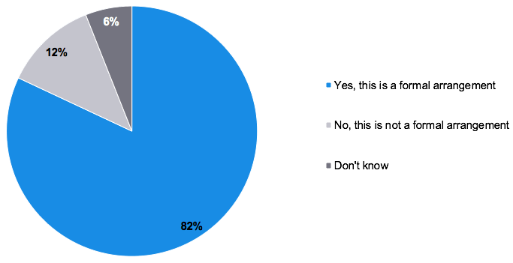
Figure note:
Base: Children under a kinship arrangement whose carer responded to this question (n=859). NA responses excluded from chart
B2. Do you have a formal arrangement for this child, that is a child protection order?

Sub-group differences
Analysis across length of time as a carer, gender, age, sexual orientation, Aboriginal carers, culturally and linguistically diverse carers, household income and regions aligned to the results of the total carer population.

All respondent view – type of arrangement
Thirty eight per cent children in care were in a foster care arrangement, with 33 per cent of these children with a long term carer or care order. Twenty-eight per cent of children were on a longer term care order, 17 per cent of children were on a short term care order, nine per cent of children were in respite care, three per cent of children were in emergency care and five per cent of children were in therapeutic care.
Forty per cent of children were in a kinship care arrangement at the time of the census. The majority of these arrangements were through child protection involvement (67 per cent), 28 per cent of care arrangements were through a Children’s Court order and five per cent of care arrangements were a private non-statutory arrangement.
Twenty per cent of children were in a permanent care arrangement at the time of the census. Forty-four per cent of these arrangements were made through direct recruitment, 29 per cent if arrangements were kinship care under another order, 17 per cent of children were in foster care under another order and 10 per cent of carers identified as an adoptive parent or carer to the child.
Figure 26: Type of care arrangement
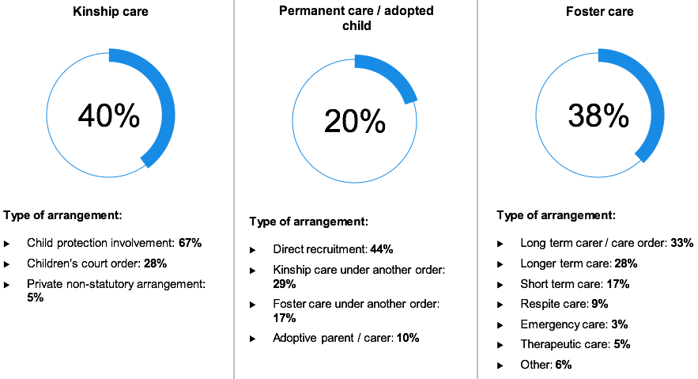
Figure note:
Base: Current carers who responded to this question, by child (n=2,242 children). ‘Other’ forms of care – 1% of children
B2. What is the type of care arrangement you have with the child?

Sub-group differences
- Children in a household of three or more children (32 per cent) were more commonly within kinship care through child protection involvement, while those in a household of two children were in permanent care through direct recruitment (12 per cent).
- Children under the care of younger to middle aged adults aged 20 to 55 years were more likely to be children within foster care (51 per cent).
- Females were more likely to have children placed within kinship care through child protection involvement (28 per cent female versus 11 per cent male kinship carers).
- Carers who identified as Aboriginal were more likely to have children placed with a kinship carer through child protection involvement (55 per cent Aboriginal).
- Those who have a household income of $100,000 to $150,000 or more (56 per cent) were more likely to have children in a foster care (through a Children’s Court order or voluntary agreement) arrangement.
- Analysis across length of time as a carer, sexual orientation, culturally and linguistically diverse carers and regions aligned to the results of the total carer population.

All respondent view – relationship
The most common relationship between kinship carers and the children in their care was a grandparent to the child (59 per cent), with 17 per cent of carers being an aunt or uncle. Much less common was a broader reference to their role as a carer (these included references to being a step grandparent, sibling, cousins) at four per cent, with a similar proportion of carers indicating they were a family friend or friend or a great aunt or uncle (both four per cent).
Figure 27: Relationship to carer (kinship carer)
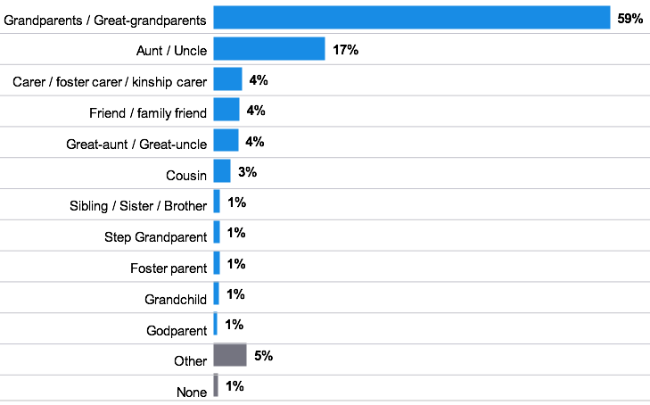
Figure note:
Base: Current kinship carers who responded to this question, by child (n=1,004 children).
B2. Kinship carers only: What is your relationship to the child?

Sub-group differences
- Kinship carers aged 20 to 45 years of age were more likely to be an aunt or uncle (47 per cent) or a friend or family friend (nine per cent). Kinship carers aged 56 years old and above were more likely to be grandparents to the child (79 per cent).
- Those kinship carers with an income of $100,000 or more were more likely to be an aunt or uncle of the child (27 per cent).
Analysis across length of time as a carer, gender, sexual orientation, Aboriginal carers, culturally and linguistically diverse carers and regions aligned to the results of the total carer population.

All respondent view – time in care
Supporting the breadth of time spent caring among the surveyed carers, the time children have spent in their care also varied.
Nineteen per cent of children have been in the care of an individual carer household for less than 12 months, 27 per cent of children for 1 to 3 years, 17 per cent of children for 3 to 5 years and 11 per cent of children for 5 to 7 years. Twenty-six per cent of children in the care of the census respondents have been in their care for more than seven years.
Figure 28: Length of time in care
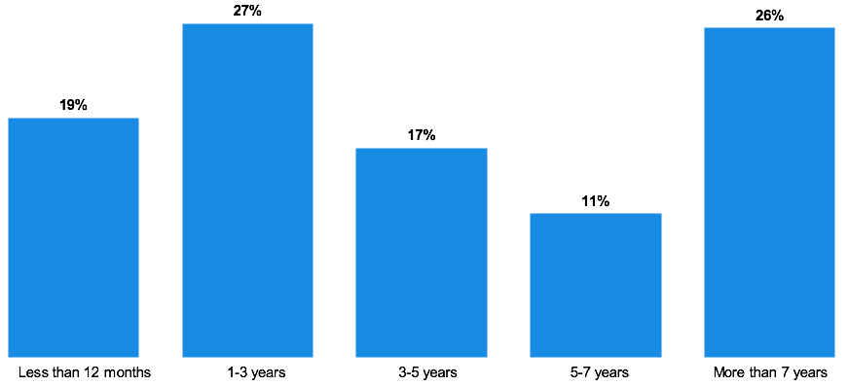
Figure note:
Base: Current carers who responded to this question, by child (n=2,385 children).
B1. How long have they been in your care?

Sub-group differences
- Kinship and foster carers were more commonly caring for children who have been in care for less than 12 months (16 per cent kinship carer and 25 per cent foster carer versus nine per cent permanent carer).
- Carers who identified with a non-heterosexual orientation were more likely to have children who had been in care for 1 to 3 years (45 per cent another sexual orientation versus 27 per cent heterosexual).
- Aboriginal carers were more likely to care for children who have been in care for 1 to 3 years (39 per cent).
- Carers who speak a language other than English at home (32 per cent) more commonly have had children in their care for 3 to 5 years.
- Carers with an annual household income of $40,000 or less were more likely to have children in their care who have been in care for more than seven years (30 per cent).
Analysis across length of time as a carer, gender, age and regions aligned to the results of the total carer population.

All respondent view – contact with parents
For most children in the care of the surveyed carers, connection was still maintained between the child and their parents. Sixty-nine per cent of children in care were in contact with their parents at the time of the census. However, 30 per cent children in care have no contact with their parents, with one per cent of carers unsure of the child’s arrangement.
Figure 29: Contact with birth parents
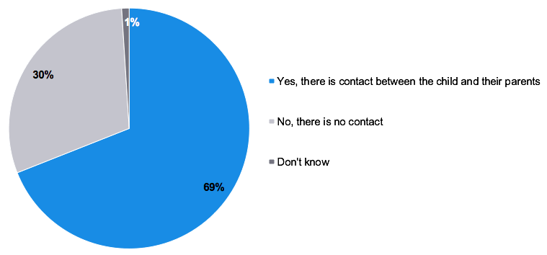
Figure note:
Base: Children under a kinship arrangement whose carer responded to this question (n=2,216 children).
B1. Is there any contact between the child and their parents?

Sub-group differences
Analysis across length of time as a carer, gender, age, sexual orientation, Aboriginal carers, culturally and linguistically diverse carers, household income and regions aligned to the results of the total carer population.

Support needs

All respondent view – support needs
A history of trauma indicated a common support need among children in the care of the census respondents, with 69 per cent of carers indicating this is a key issue. The majority of carers also indicated they were dealing with children’s behavioural issues (56 per cent), which can be understood as a natural consequence of trauma.
Forty-six per cent of children in the care of the census respondents needed support with learning difficulties, attachment issues (44%) and mental health difficulties (40 per cent).
While a smaller proportion of children needed support with grief or loss, 36 per cent of children still required this. Ten per cent of children in the care of the census respondents had a physical disability and 12 per cent of children had other support needs.
Only 12 per cent of children in the care of census respondents did not have support needs, with carers unsure of the needs of five per cent of children in their care.
Figure 30: Support needs of children in care
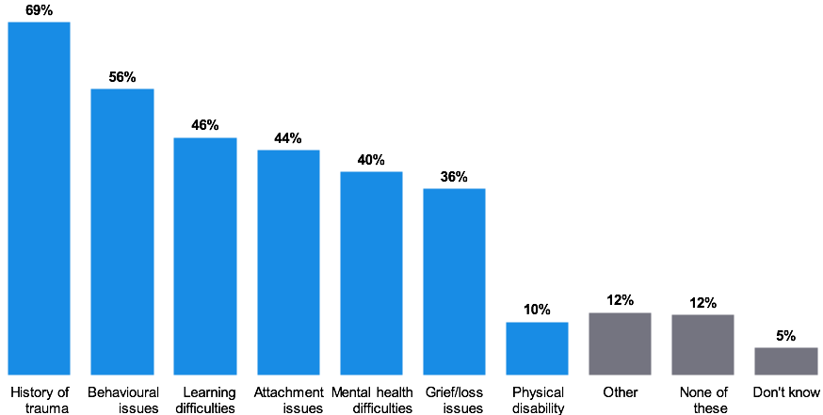
Figure note:
Base: Current carers who responded to this question, by child (n=2,216 children).
B2.8. Do they have any of the following support needs?

Sub-group differences
- Though still a high proportion, those children in the permanent care of the census respondents were less likely to have a history of trauma (64 per cent). On that note, for children placed in the care of a permanent carer, the carer was more likely to indicate the child has none of the support needs listed (15 per cent – ‘none of these’).
- Those carers who care for 3 or more children were more likely to have children in their care who have grief or loss issues (41 per cent) or a physical disability (14 per cent). There is an opportunity to consider the differing challenges among households with more than one child in their care. These children may be presenting differing needs which may present greater challenges for their carers.
- Carers who identified as Aboriginal were more likely to have children with behavioural issues (73 per cent) in their care. Understanding the needs of specific cohorts may present the opportunity to tailor support, which is valuable, and specific to their situation.
Analysis across length of time as a carer, gender, age, sexual orientation, culturally and linguistically diverse carers, household income and regions aligned to the results of the total carer population.

Section 4. Carer experience


Section overview
Carers were motivated by many aspects of taking on a carer role, both factors within their control, and other factors outside. The dominant factor was one of altruism, the desire to make a positive impact on a child’s life (68 per cent) and play a positive part in the community (35 per cent). These motivators were amplified among the foster care cohort (altruism 89 per cent and positive impact 58 per cent respectively) who had specifically chosen to take on a role caring for children outside their existing family and network.
Kinship and permanent carers, while very much still motivated by making a positive impact on a child’s life, felt they had less active choice in taking on the caring role, with 64 per cent of kinship carers and 40 per cent of permanent carers feeling obliged to care for a child. This factor also resonated more strongly among carers who identified as Aboriginal (50 per cent), reflected in their greater representation among kinship carers.
Caring doesn’t come without challenges; the majority of carers have faced challenges in some form during their time as a carer (92 per cent). There was a diversity of responses, providing key themes around documentation, support to manage the child’s needs and their own needs as a carer, and the processes which they had to follow as a carer. These challenges appeared more strongly among the foster carer cohort.
In addition to these challenges, carers often had to invest personally to meet their caring responsibilities. This investment included personal savings (65 per cent) and the use of personal funds to pay for expenses (64 per cent). In some cases, carers had been unable to pay for fundamental aspects of life, including utility bills (18 per cent) and mortgage or rent repayments (nine per cent). These financial impacts were having greater effect on lower income households, with those living in a household earning under $40,000 per annum more likely to have to use their personal finances. Carers identifying as Aboriginal were more likely to have borrowed money (29 per cent versus 10 per cent of total carers), or been unable to meet their mortgage or rent payments (20 per cent versus eight per cent of total carers).
Impacts on the lives of carers are mixed, some of which are positive; particularly in relation to having a positive impact on a child’s life (85 per cent) and in the relationship they have with a child (79 per cent). Factors causing the most negative impact were the levels of stress (62 per cent) and the impact on visiting social events (51 per cent). Kinship carers and permanent carers exhibited the highest levels of negative impact when compared to foster carers.

Reflections from the qualitative in-depth interviews
The qualitative phase of the research highlighted key themes for further clarification and quantification in the census in relation to the carers’ broad experiences. Themes identified spanned motivations for caring, challenges experienced, and the reasons placements break down.
“We thought we just needed to love this child, give them a cuddle, feed them, teach them. Then we realised, the kids are still lovely kids, but they have so many more needs than anyone has prepared us for. All the kids, they all have trauma and they all have issues that needed attention. We were not trained enough to know how to care for them in a system that was very confusing.”
– Foster carer
The carers interviewed found their role fulfilling and rewarding overall, but emphasised that it involved significant and largely unanticipated challenges for which they did not feel adequately prepared and which, they felt, ultimately impacted on their ability to care. These challenges related to the complex needs of the children and the difficulties experienced navigating the carer system.
Carers interviewed stated that children typically presented with complex needs and histories which they often had not been adequately informed about. Examples of such needs included behavioural and learning difficulties, as well as children who had experienced abuse and trauma. These carers also cited challenges associated with navigating complex legislative and administrative requirements, which they could find confusing, difficult to understand and access information about. To understand the scale of these challenges, these factors were explored and quantified in the census.
“It’s very important for him to know his life story and that includes his Aboriginal culture. We go to events and we know the importance of his mob. We read him stories and we have done songs; we have done Aboriginal lullabies. He knows about the flag and he proudly says he’s Aboriginal.”
– Foster carer
Carers interviewed also highlighted a range of attitudes in relation to their ability to care for children with diverse backgrounds and needs. Based on personal experience, these carers displayed differing degrees of preparedness to connect children to their cultural heritage. To gain greater understanding of carers’ overall attitudes, these themes were further explored in the census.
“At times it’s been great, at times it’s been the lowest of lows. It’s caused conflict in mine and my wife’s marriage. … At times it’s affected my mental health to the extreme, it’s affected my work, it’s affected my capacity to be a father and a husband and I’m sure my wife would say the same. We’ve sacrificed ourselves, our own wellbeing and self-care. We’ve come to realise that our self-care is that our kids are alright and put ourselves on the backburner.”
– Kinship carer
Among those interviewed, these challenges were seen to have significant adverse impacts on multiple domains of their lives. These domains included their relationships, mental health, finances and social life. Given the range of impacts on the carers we spoke to, it was important to understand the scale of these impacts more broadly.
The breakdown of placements was a key area of focus for DFFH, and further explored in the interviews. Carers interviewed who had had a placement breakdown were limited. As a result, the reasons for placement breakdowns were explored in the census to capture scale and reasons for the breakdown.

Overall experience of becoming and being a carer

All respondent view – reasons
The carers surveyed were driven by the desire to make a positive difference in a child’s life (68 per cent). The proportion of carers who cite this as a key reason to become a carer in the first place far outweighed the second most common factor of playing a positive part in the community (35 per cent).
Thirty per cent of carers indicated an obligation, or motivation, to care for a family member or kin, with 25 per cent directly approached by child protection services. Both of these factors can indicate a lack of personal control in the decision to start caring.
Some carers were motivated by creating a family environment, both for companionship (10 per cent) or to expand their family and have a sibling for another child (four per cent).
Eight per cent of carers were prompted by seeing others they know caring or by advertising and communications. A small proportion were influenced by their own experience in the care system (five per cent).
While a breadth of reasons were explored for becoming a carer, 11 per cent of carers could offer an alternate explanation to their reasons for becoming a carer, perhaps highlighting the personal reasoning and journey carers come on prior to caring.
Figure 31: Reasons for becoming a carer
Figure note:
Base: Current and former carers who responded to this question (n=1,524).
C1. What were your reasons for becoming a carer in the first place?
Making a positive difference, both in a child’s life (89 per cent), and in the community (57 per cent), played a stronger role in motivating those providing foster care than other care types. In saying this, making a positive impact on a child’s life still had a strong role in motivating kinship carers (48 per cent) and permanent carers (61 per cent), with the community benefit playing a role for a smaller proportion of carers (permanent care: 24 per cent, kinship: 12 per cent,).
Thirteen per cent of foster carers were motivated by seeing family or friends already caring, with 14 per cent prompted by advertising and communications. This was less common among kinship carers (three per cent seeing others and two per cent advertising respectively), and permanent carers (both six per cent).
For the kinship and permanent care cohorts, kin played a key role, much more strongly than for those in foster care. Sixty-four per cent (64 per cent) of kinship carers were motivated by an obligation to care for a family member/kin, as well as 40 per cent of permanent carers and seven per cent of foster carers.
In addition, kinship carers were more commonly being approached by child protection services than other carer types (kinship: 50 per cent, permanent carer: 27 per cent, foster carer: six per cent). While permanent carers were more likely to be actively seeking a family and companionship (permanent: 16 per cent, foster: 10 per cent, kinship: five per cent) or a sibling for another child (permanent: six per cent, both kinship and foster carers: four per cent).

Other sub-group differences
- More recent carers, who have been caring for two years or less, indicated they are more commonly being approached by child protection services (33 per cent) to provide care. Whereas those caring for 10 years or more were more strongly motivated by others (advertising and communication: 13 per cent, family and friends already caring: 11 per cent,). This may be influenced by the skew of carer type on tenure of care.
- The male carers surveyed highlighted benefiting community as a key motivator in their decision to start caring (53 per cent), significantly more so than females (34 per cent).
- Females were more likely to be influenced by factors outside of their control, including more commonly approached by child protection services (26 per cent versus 15 per cent for males) to provide care.
- Again, a potential influence of the type of care being provided may be seen in younger carers (under age of 46 years) being more motivated by making a difference in a child’s life ( 79 per cent compared to community benefit 47 per cent), the idea of companionship (14 per cent) and knowing others who do caring (11 per cent).
- In contrast, those aged 56 years and over were more commonly being approached by child protection services (32 per cent) or felt obligated to a family member or kin (42 per cent) to provide care.
- Those who identify as Aboriginal were more commonly motivated by an obligation to a family member or kin than those who did not identify as Aboriginal (48 per cent versus 27 per cent).
- A small proportion, 13 per cent, of those who identified as culturally and linguistically diverse were influenced to provide care more so due to personal experience in the care system (13 per cent).
- Analysis across sexual orientation, household income and regions aligned to the results of the total carer population.

All respondent view – challenges
Carers are often experiencing challenges in their role as a carer, with 92 per cent of total carers indicating they have experienced at least one of the challenges presented and 14 per cent indicating other challenges.
Fifty-eight per cent of carers are feeling challenged by the lack of consistency in the support provided by care workers, which can be child protection workers, or foster care workers, and so on.
Accessing key documentation (such as birth certificate or Medicare number) for the child was another major challenge faced (56 per cent) by carers, with a similar proportion of carers finding it difficult to navigate the child protection system and processes. All these factors encompass the challenges with the system within which the carers operate.
Further to this, carers are struggling with the restrictions on their ability to make decisions regarding the child in their care (47 per cent). Closely linked to this concern is the speed in which they can get documentation signed for the child, such as approvals to take trips, medication scripts, and so on. (43 per cent).
Support was a key challenge experienced by carers. While support is broader than just with the behaviour of the child, 43 per cent of carers didn’t feel they have support to deal with these issues, and 31 per cent didn’t know how to address these issues with the child. Accessing practical support, such as babysitting, respite care, and so on., was considered a challenge for 46 per cent of carers. Access to specialist and generalist support from practitioners was a challenge for 40 per cent of carers, and access to organisations and people with sufficient knowledge to help address a challenge was at a similar level (39 per cent).
The majority of children in the care of those surveyed have a connection with their parents, an arrangement which 39 per cent of carers were finding difficult to manage.
While a lesser proportion, 24 per cent of carers found it difficult to provide everything the child needs (such as nappies, toothbrush and so on) and 18 per cent of carers suggested they don’t have the time to meet their caring obligations.
Figure 32: Challenges faced as a carer
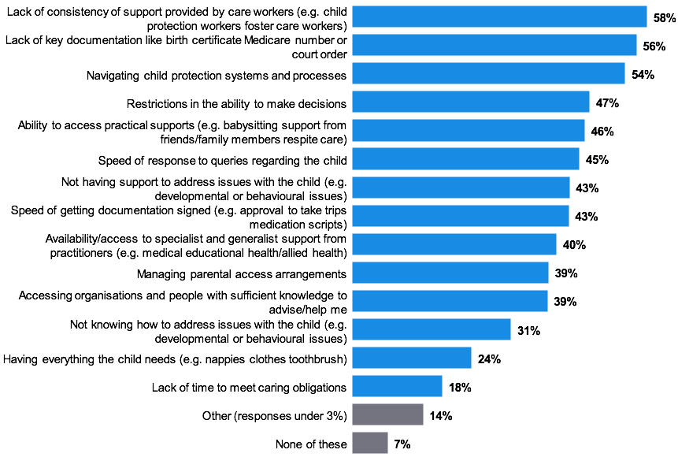
Figure note:
Base: Current and former carers who responded to this question (n=1,495).
C2b. Which of the following, if any, have you found challenging since starting your role as a carer?
Foster carers were more commonly experiencing a breadth of challenges in their role as a carer. While still evident among the kinship and permanent carer cohort, some areas were amplified for foster carers.
At an overall level, a higher proportion of foster carers have experienced challenges in their role (94 per cent, permanent carer: 91 per cent, kinship: 89 per cent). For example, the lack of documentation (63 per cent), restrictions on making decisions (52 per cent) and speed of getting documentation signed (48 per cent) were faced by a higher proportion of foster carers than other carer types.
However, permanent and kinship carers are more commonly struggling to find organisations and people with sufficient knowledge to help them (permanent: 46 per cent, kinship: 43 per cent, foster: 32 per cent.).
Kinship carers were also more strongly challenged in having everything the child needs (kinship: 27 per cent, permanent: 25 per cent, foster: 21 per cent).

Other sub-group differences
- Those carers providing care for 10 years or more were more commonly highlighting key challenges; the ability to access practical support (53 per cent), not having support to address issues with the child (51 per cent), speed of getting documentation signed (51 per cent), access to specialist and generalist support (49 per cent), accessing organisations with sufficient knowledge to help (46 per cent) and managing parental access arrangements (47 per cent).
- Those aged 56 years and over were more likely to experience all challenges compared to other age groups.
- Carers who identified as Aboriginal were more commonly challenged in having everything the child needs (39 per cent versus 24 per cent of the total carers).
- Those living in a household earning under $40,000 per year more commonly highlighted having everything the child needs as a key challenge while caring (32 per cent).
- Those living in a household earning $100,000 or more annually were struggling to navigate the systems and processes (63 per cent), feeling frustrated with the speed of getting documentation signed (52 per cent) and the ability to access specialist and generalist support (50 percent) more so than others who were earning less.
Analysis across gender, sexual orientation, culturally and linguistically diverse carers and regions aligned to the results of the total carer population.

All respondent view – financial impact
While financial support was available to carers within Victoria, there was a desire to understand the broader, personal financial impact of their caring responsibilities.
The scale of the impact was broad, with 79 per cent of carers personally impacted financially. Seventeen per cent of carers indicated caring has not impacted their personal finances, and four per cent were unsure of the impact.
Accessing personal savings (65 per cent), and regularly using their own funds to pay for other expenses of the children in their care (64 per cent) were the most common financial impacts experienced as a result of their caring role. While less common, 14 per cent were actively taking money out of their superannuation to cover the costs of their caring role.
Some carers were borrowing money, either from family and friends (18 per cent), or other lenders such as banks and cash loans (11 per cent).
Eighteen per cent of carers have been unable to pay their utility bills on time, with nine per cent of carers unable to pay their rent and mortgage payments on time.
Figure 33: Financial impact of caring responsibilities
Figure note:
Base: Current and former carers who responded to this question (n=1,281).
E1. Which of the following financial impacts, if any, have you experienced as a result of your caring role?
While the majority of carers within each carer cohort have experienced a negative financial impact on their personal finances, this was less common among the foster carer cohort. Twenty-one per cent of foster carers indicated that being a carer has not impacted their personal finances, with 13 per cent of kinship carers and 12 per cent of permanent carers highlighting the same situation.

Other sub-group differences
- Those who have been caring for less than two years were the least likely to be financially impacted personally, with 28 per cent stating being a carer had not impacted their personal finances.
- Males were less negatively impacted when it comes to personal finances, with 19 per cent of male carers stating their personal finances had not been impacted versus 15 per cent of female carers.
- Carers who identified as Aboriginal were more commonly borrowing money from other lenders to meet their caring responsibilities (29 per cent) and have been unable to meet their mortgage or rent payments on time (20 per cent).
- Those living in a household earning under $40,000 per year were more likely to be using their personal finances, with 89 per cent impacted negatively.
Analysis across age, sexual orientation, culturally and linguistically diverse carers and regions aligned to the results of the total carer population.

All respondent view – early end
Fifty-two per cent of carers surveyed have experienced a placement ending earlier than planned.
Figure 34: Placement ending earlier than planned
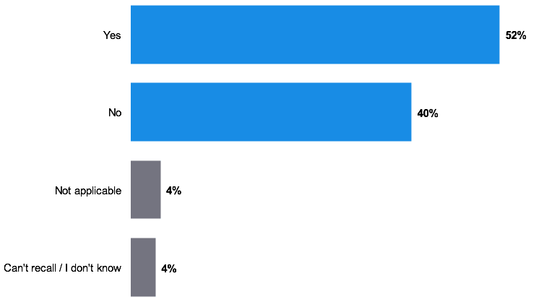
Figure note:
Base: Current and former carers who responded to this question (n=1,007).
A6. Have you ever had a placement end earlier than planned?
Foster carers were more likely to have had a placement end earlier than planned (foster: 57 per cent, permanent: 49 per cent, kinship: 39 per cent).

Other sub-group differences
- Those who have been caring for less than two years were the least likely to have had a placement end earlier than planned (42 per cent), with nine per cent of carers considering this question not applicable to their situation.
Analysis across gender, age, sexual orientation, Aboriginal carers, culturally and linguistically diverse carers, household income and regions aligned to the results of the total carer population.

All respondent view – reason for end
The most common reasons a placement has ended was through reunification with family (20 per cent). However, for a similar proportion of carers, behavioural and mental health issues of the child have played a key role (18 per cent) and for 11 per cent of placements ending, anger issues and violent behaviour of the child led to the ending of the placement.
Ten per cent of carers noted a kinship placement was found, or the child moved in with another family member leading to the placement ending.
The lack of compatibility between carers and the child manifests in various forms, leading to a placement ending. This can be either the inability to meet the child’s needs (10 per cent), unsuitability of the placement (eight per cent), unhappiness of the child (seven per cent), issues with the carer’s biological family (six per cent) or other foster children (six per cent), or a change of circumstances (six per cent) making the placement no longer viable. There were five per cent of carers noting allegations made against them or their family as a reason for the end of a placement.
Some carers have had issues with both the agencies (six per cent) and DHHS (DFFH) (five per cent), with five per cent of carers noting that the reason the placement ended was due to a decision made by DHHS (DFFH).
Ten per cent of carers indicated the placement ended due to a court order. However, a similar proportion suggested a lack of support as a key reason (10 per cent).
While key themes were evident in the reasons for the placements ending, 34 per cent of carers suggested an alternative reason, all responses under five per cent. This highlights the breadth of individual experiences which may lead to a placement ending.
Figure 35: Reasons for placement ending
Figure note:
Base: Those who had a placement end (n=508)
A7. What was the reason the placement ended?
Analysis across length of time as a carer, gender, age, sexual orientation, Aboriginal carers, culturally and linguistically diverse carers, household income and regions aligned to the results of the total carer population.

Attitudes towards being a carer

All respondent view – attitudes
When exploring sentiment and experience with the care system more broadly with carers who responded to the survey, confidence in their own abilities came to the fore.
Almost all carers surveyed agreed that they were confident in their personal ability to provide care (95 per cent). In addition, carers were confident in supporting the children in their care to maintain their connection with their cultural identity and heritage (85 per cent). A lower proportion (67 per cent) of carers understood how to appropriately support an LGBTI or gender diverse child in their care.
Perceptions of personal ability were high, yet 48 per cent of carers did not feel well prepared prior to or at the beginning of their role as a carer. Thirty per cent of carers agreed that the expectations of the department or care agencies placed on them were realistic, with 49 per cent disagreeing with this statement.
Access to and the level of support was another key theme explored, with 53 per cent of carers feeling well supported by carer agencies or 49 per cent of carers felt well supported by peak bodies and carer advocacy groups. However, 23 per cent of carers also felt well supported by the Victorian Department of Health and Human Services (DFFH). Forty-four per cent of carers agreed the department is flexible around their work and family commitments, while 35 per cent of carers disagreed with this statement.
Thirty-seven per cent of carers agreed they have access to the information they need, when they need it, and 50 per cent of carers would recommend being a carer to others.
Figure 36: Carer personal ability and attitudes towards caring
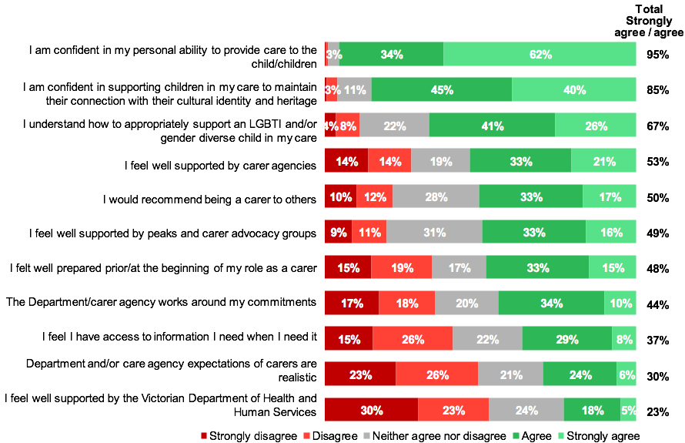
Figure note:
Base: Current and former who responded to this question (base size varies from n=1,132 to n=1,1446)
C3. To what extent do you agree or disagree with the following statements in relation to your role as a carer…? (Excludes don’t know and NA responses)

Foster carers were feeling the most:
- Prepared (foster: 59 per cent, permanent: 45 per cent, kinship: 39 per cent).
- Confident (foster: 97 per cent, kinship: 94 per cent, permanent: 93 per cent).
- Supported by agencies (foster: 62 per cent, permanent: 47 per cent, kinship: 44 per cent,).
- Supported by carer advocacy groups (foster 57 per cent, cent permanent: 51 per cent, kinship: 39 per).
- Feel the expectations placed on them were realistic (foster: 33 per cent, kinship: 28 per cent, permanent: 26 per cent).
- Felt the department and agencies were flexible around their commitments (foster: 49 per cent, kinship: 39 per cent, permanent: 36 per cent).
- They have access to information they need, when they need it (foster: 41 per cent, permanent: 34 per cent, kinship: 33 per cent).
These attitudes of carers translated into higher levels of advocacy for the carer role, with 61 per cent of foster carers agreeing that they would recommend being a carer to others, while 46 per cent of permanent carers and 40 per cent of kinship carers would do the same. ]
Twenty-eight per cent of kinship carers felt well supported by the Victorian Department of Health and Human Services (DFFH), more so than other carer groups (permanent: 23 per cent; foster: 20 per cent).

Other sub-group differences
- Those caring for more than ten years were more likely to feel supported by peak bodies and carer advocacy groups (57 per cent) than other caring tenures.
- Those newer to the role of caring, who had been caring for under two years, did feel more supported overall, by agencies (63 per cent), and the Victorian Department of Health and Human Services (DFFH) (33 per cent). This cohort more commonly felt the department and agencies were flexible (52 per cent), their expectations realistic (40 per cent), and that they had access to information as and when they need it (44 per cent).
- Males were showing greater levels of confidence in their role, with all agreeing they were confident in their personal ability to care for the child or children (100 per cent versus 95 per cent females).
- Carers who identified as Aboriginal were feeling less supported by carer agencies (47 per cent versus 56 per cent of total carers) and were less likely to recommend being a carer to others (41 per cent versus 53 per cent of total carers).
Analysis across age, sexual orientation, culturally and linguistically diverse carers, household income and regions aligned to the results of the total carer population.

Impact of being a carer

All respondent view – impact
The qualitative phase of the research program unveiled the broader impact of caring on other aspects of a carer’s life, both positive and negative. This was explored quantitatively within the census.
Some aspects of care have had a profoundly positive effect on the carers surveyed, with the majority stating that the feeling of making a difference was positive (85 per cent), while 79 per cent of carers have felt their relationship with the child or young person they are caring for has been positively affected.
Relationships of carers have been affected by caring responsibilities, some more so than others. While relationships of carers with immediate family members and partners were relatively unchanged (not affected: 42 per cent family members and 40 per cent partners respectively), some have found these to be negatively affected (29 per cent partners and 25 per cent family members respectively).
For thirty-nine per cent of carers, there was a feeling that their caring responsibilities have had a positive effect on their immediate family members within the household, while 26 per cent of carers have experienced a negative effect. The relationships of carers most strained by caring responsibilities were of a social nature, with friends and extended family members (38 per cent negatively affected), which may be due to the majority of carers indicating the negative affect on their ability to attend social events (51 per cent), perhaps impacting their ability to maintain these social relationships.
Caring can also mean being personally impacted. While most carers considered their physical health relatively unchanged (53 per cent), 33 per cent of carers have felt a negative impact on their physical health. Forty-three per cent of carers felt their caring responsibilities have negatively impacted their mental health, with 62 per cent of carers feeling their levels of stress have been negatively impacted. Stress levels were reported as the most negatively affected aspect of a carer’s life.
Forty-nine percent of carers have seen a negative impact on their work or career, and a slight majority of carers on their personal finances (51 per cent). Thirty-five per cent of carers felt their connection to community has been positively affected as a result of their caring responsibilities.
Figure 37: Impact of being a carer on relationships and life more broadly
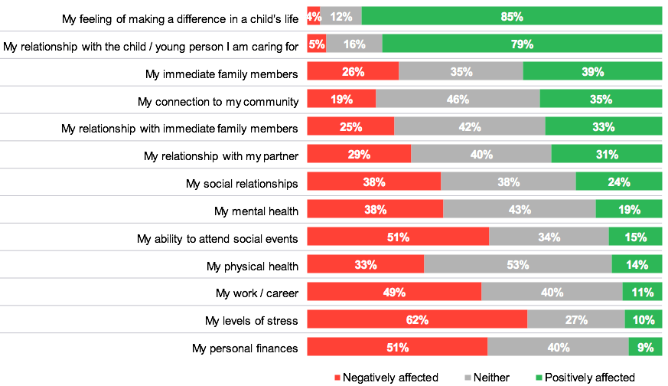
Figure note:
Base: Current and former carers who responded to this question (base size varies from n=1,049 to n=1,403)
C4. To what extent have the following been positively, or negatively, affected as a result of your caring responsibilities…? (Excludes don’t know and NA responses)
Kinship carers and permanent carers appeared to be quite negatively affected as a result of their caring responsibilities, with kinship carers slightly more so.
Forty-nine per cent of kinship carers have had their social relationships negatively affected (permanent: 40 per cent, foster: 29 per cent), as well as their work or career (kinship: 55 per cent, permanent: 48 per cent, foster: 43 per cent) and their personal finances (kinship: 56 per cent, permanent: 55 per cent, foster: 45 per cent,).
Mental health of carers was another key issue which has been affected. While evident across all carer cohorts, it was amplified among the kinship carer cohort (kinship: 43 per cent, permanent: 39 per cent foster: 32 per cent).
In addition, 26 per cent of kinship carers have felt their connection to community has been negatively affected by their caring (permanent: 21 per cent, foster: 15 per cent), and 33 per cent of kinship carers felt their relationship with their immediate family members has been negatively affected (permanent: 27 per cent, foster: 18 per cent).

Other sub-group differences
- Those carers providing care for 10 years or more have seen a greater negative impact on their personal finances (59 per cent), and their connection to their community (27 per cent).
- Those carers providing care for 4 to 6 years were more commonly highlighting the negative impact on their work or career (62 per cent).
- Females were feeling the negative impact of their caring responsibilities more strongly than males, with 51 per cent of female carers stating they had seen a negative impact on their work or career compared to 33 per cent of male carers.
- Those aged 56 years and over appear to have been negatively impacted more strongly than younger carers, with almost 46 per cent of carers aged 56 years and over highlighting the negative impact on their social relationships, 30 per cent of these carers on their relationship with immediate family members, and 26 per cent of the carers on their connection to their community. However, this cohort were the least likely to see a negative impact on their levels of stress (56 per cent), though it is still a high proportion of carers in this cohort.
Analysis across sexual orientation, Aboriginal carers, culturally and linguistically diverse carers, household income and regions aligned to the results of the total carer population.

Section 5. Support for carers


Section overview
The majority of carers have accessed a form of support or training, with only 15 per cent of carers not having accessed any support or training. Carer agencies are the most common sources of training and support for carers (57 per cent). Kinship carers were the least likely to have accessed support in their role as a carer, with foster carers more commonly accessing support at an overall level.
It is evident there was a lack of awareness of some of the support and training on offer. Around 47 per cent of carers were unaware of educational training, complex needs training, support to care for children with a disability, and 46 per cent of carers were unaware of support for the carer’s own mental and physical wellbeing.
Above all, carers’ awareness was lowest for support to navigate the system (55 per cent), which was a key challenge for many of the census respondents, and 70 per cent of carers were unaware of the availability of legal support.
Potentially, supports and training were also being under-accessed, with 31 per cent of carers aware of, but not accessing, Aboriginal cultural awareness training and cultural diversity training.
Considering the impact caring has on many aspects of a carer’s life, it is important to note that carer mental and physical wellbeing support has only been accessed by 27 per cent of carers, indicating there is a major proportion of carers who have not taken advantage of such training. This is reinforced by the finding that among those who accessed carer mental and physical wellbeing support, it was felt to have had a strong impact. This is the case across all the support and training explored within the census of carers.
Considering the breadth of financial pressure experienced by carers in their role, the ability to access funding is particularly important. While some funding was accessed by the majority of carers, such as care allowance (91 per cent), new placement allowance (71 per cent) and childcare subsidies (71 per cent), some were rarely accessed. Of note is the low awareness of carers of the health allowance, where 58 per cent of carers were not aware of this financial support.
While many carers accessed a range of the financial supports available, there was a broad view among carers that the financial support was not enough to meet their needs. This was true across all funding options explored within the census; and helps to explain why many carers used their personal finances to meet their caring responsibilities.

Carer type overviews

Kinship carers
Kinship carers were least likely to have accessed any type of support or training (kinship 26 per cent, permanent: 16 per cent, foster: 6 per cent). The Victorian Department of Health and Human Services (DFFH) and agencies were the most common sources of accessing support for kinship carers (39 per cent and 37 per cent respectively). With that being said, kinship carers were less likely to access support from agencies compared to foster and permanent carers (80 per cent, 50 per cent respectively).
Overall awareness of available support was significantly lower among kinship carers. The types of support and training they were least likely to be aware of included introductory training prior to and at the beginning of the role as a carer (73 per cent) and therapeutic parenting training (63 per cent). While overall access to support was also low for kinship carers, financial support was accessed more compared to foster and permanent carers (kinship: 48 percent, foster: 45 per cent, permanent: 40 per cent). For those who accessed financial support, utilised the care allowance was most common (89 per cent).

Permanent carers
Permanent carers most commonly accessed support through agencies (50 per cent), peak and advocacy bodies (41 per cent) and the Victorian Department of Health and Human Services (DFFH) (34 per cent).
There was a lack of awareness around most of the available training and support. Permanent carers were least aware of respite support (47 per cent unaware) and Aboriginal cultural awareness training (45 per cent unaware). This translated into the accessing of support, where both respite support and Aboriginal cultural awareness support were least accessed (21 per cent and 22 per cent respectively). Permanent carers were more aware of financial support compared to other types of support (32 per cent unaware) which translated into higher levels of access (40 per cent). The most commonly accessed financial supports were flexible funding (by PCA families or Oz Child) (43 per cent) and disability payments (40 per cent) which were both significantly more accessed compared to foster carers (18 per cent and 31 per cent respectively) and kinship carers (28 per cent and 27 per cent respectively).

Foster carers
A majority of foster carers have accessed some type of support or training. The most common sources for accessing this support were agencies (80 per cent), Carer KaFE (51 per cent) and peak and advocacy bodies (43 per cent).
Both overall awareness of available support, as well as access, were high for foster carers compared to kinship and permanent carers. However, this group also has a high proportion of carers who are aware of the support available, but have not accessed it. Respite support and introductory training prior to and at the beginning of the role as a carer were the most commonly accessed types of support (81 per cent and 80 per cent respectively); while financial support was the least commonly accessed (45 per cent). With that in mind, among those foster carers who accessed financial support, the school attendance allowance was more commonly accessed compared to kinship and permanent carers (foster: 70 per cent, kinship: 65 per cent, permanent: 58 per cent).

Reflections from the qualitative in-depth interviews
Interviews with carers highlighted that, due to the demands of their role, they require a range of supports to help them provide the necessary care. While the co-design workshop and the interviews with departmental staff outlined a range of available supports, the carers interviewed reported receiving limited assistance, which they believed adversely impacted their capacity to provide care. To understand this more deeply, carers’ experiences of support were further surveyed and quantified via the census.
“We’ve been promised different things by different case managers at different times, for example, counselling and respite care, but none has been explored or looked at. It’s just never actioned. Total care packages - one person said yes, the other said no… it’s just been mixed messages the whole time.”
– Kinship carer
Peak bodies, agencies, local providers and carer support groups were highlighted as key sources of support for the carers interviewed. The carer cohort reported receiving limited support from departmental sources, however, which was often dependent on the approach and tenure of the case worker assigned to them. They felt their case workers were regularly replaced and that this could impact on the follow-up and resolution of issues and the level of support they received.
“They should be training parents from the start on what supports they can expect, because a lot of parents don’t know where to go and a lot of times carers have to find out themselves. The best thing is to share enough relevant information, so the parents can go to the right people for supports. Carers don’t know the system and it’s a very confusing system.”
– Foster carer
Interviews with carers indicated they had low awareness of the range of available supports and also had difficulty accessing support or information about these supports. Considering these experiences, the inclusion of sources of support, awareness of support and access were probed in the census to measure the experience of carers more broadly.
“We’ve taken out personal loans or sought loans from family members. We had saved $15,000 for our first home, but spent it all on the kids’ clothes, shoes and needs which got rid of our house deposit. We had a five-seater car, but had to trade in to get a 7-seater car which put us further in debt … We had to look at an additional room for our house too.”
– Kinship carer
During the qualitative interviews, carers indicated that they felt the financial support they received was insufficient to perform their role and could impact their personal finances. They highlighted spending well in excess of the financial supplements provided to them to cover essential expenses for their children. To understand the scale of these perceptions, financial support was a focus for the carer census.

Support and training – sources

All respondent view – sources
Carer agencies were the most commonly accessed sources of support for carers surveyed, with 59 per cent of carers stating they have accessed support and training through this means for their role as a carer. Thirty-six per cent of carers have accessed support and training through peak agencies and advocacy bodies, and Carer KaFE.
Government bodies were marginally less utilised, with 29 per cent of carers accessing support or training through the Victorian Department of Health and Human Services (DFFH), and 13 per cent of carers accessed support or training through local government or community agencies.
Twenty per cent of carers had accessed support and training through support groups, such as kinship peer support groups, and so on.
A small proportion of carers had not accessed any support or training in their role as a carer (15 per cent).
Figure 38: Sources of support and training previously accessed by carers
Figure note:
Base: Current and former carers who responded to this question (n=1,369) (At the time of surveying, the department was named ‘Department of Health and Human Services’)
D1. Through which of the following, if any, have you accessed support or training for your role as a carer?
Kinship carers were the least likely to have accessed support or training in their role as a carer, with 26 per cent of carers not accessing any form of support and training (permanent: 16 per cent, foster: 6 per cent).
In saying this, kinship carers and permanent carers, are more commonly accessing support or training through the Victorian Department of Health and Human Services (DFFH), (kinship: 39 per cent, permanent: 34 per cent), or through support groups (kinship: 28 per cent, permanent: 26 per cent) than foster carers (23 per cent department and 12 per cent support groups respectively).
Foster carers were more commonly accessing other forms of support through agencies (foster: 80 per cent, permanent: 50 per cent, kinship: 37 per cent), and training through Carer KaFE (foster: 51 per cent, permanent: 26 per cent, kinship: 22 per cent).
Peak and advocacy bodies were more commonly utilised by both foster carers (43 per cent) and permanent (41 per cent) carers, and less so by kinship carers (24 per cent).

Other sub-group differences
- The male carers surveyed were more commonly sourcing support and training through agencies (71 per cent versus 59 per cent of female carers).
- Female carers are more commonly sourcing support and training through support groups (21 per cent female carers versus 11 per cent of male carers).
- Culturally and linguistically diverse carers were more commonly accessing support through agencies (76 per cent versus 59 per cent of total carers).
- Carers from lower income households were more commonly seeking support from support groups (30 per cent), with households with a higher annual income of $100,000 or more seeking support through agencies (70 per cent) and the department (44 per cent).
Analysis across length of time as a carer, age, sexual orientation, Aboriginal carers and regions aligned to the results of the total carer population.

Support and training – access

All respondent view – access
The most common form of support and training accessed by the carers surveyed was introductory training at the beginning of their role as a carer (57 per cent). However, 33 per cent of carers were unaware that this introductory training was available to them.
Forty-four per cent of carers were accessing training to help them identify a child’s specific needs, however 18 per cent of carers were aware of this training but had not accessed it, with 38 per cent of carers unaware of this support.
The proportion of carers who have accessed behaviour management training presents a similar result (43 per cent), with 19 per cent of carers aware of behaviour management training but had not accessed it and 38 per cent of carers unaware of the existence of the training.
The other form of training most commonly accessed by carers to help them nurture the children within their care was therapeutic parenting training for trauma, with 47 per cent of carers accessing this training, 19 per cent of carers were aware of the training but had not accessed it and 33 percent of carers were unaware of this training.
Development training has been accessed by 39 per cent of carers, educational training by 34 per cent of carers and complex needs training by 27 per cent of carers. Forty-seven per cent of carers were unaware of the latter two training types, educational training (47 per cent unaware) and complex needs training (47 per cent unaware).
Cultural training was explored with those carers who felt it was relevant to them, with Aboriginal Cultural Awareness training accessed by 45 per cent of carers, while cultural diversity training was accessed by 37 per cent of carers. In saying this, levels of awareness were much higher for the Aboriginal cultural awareness training, with 23 per cent of carers unaware of this training compared to 31 per cent of carers being unaware of the cultural diversity training.
Support was a key theme explored within the carer census, as understanding the level of access and awareness of support available can provide context for earlier results. Carers were most commonly accessing financial support (38 per cent) and respite support (35 per cent), however, there were still low levels of awareness among the carer cohort (41 per cent financial support and 38 per cent respite support respectively) of these supports being available.
Navigating the system was highlighted as a key challenge for carers, with the results showing that 31 per cent of carers had accessed support in this space. However, 55 per cent of carers were unaware that support with system navigation was available to them.
Children with disabilities have unique care needs, and 24 per cent of relevant carers indicated they had accessed support in this area previously. Twenty-eight per cent of carers were aware of, but yet to access disability support, and 47 per cent of carers were unaware of this type of support.
Understanding the broad impact that being a carer can have on mental wellbeing and levels of stress, as highlighted earlier within the report, it is important to consider the lack of awareness around the support available for carers to help with their mental and physical wellbeing (46 per cent unaware). Thirty per cent of carers have either accessed this support or are aware of it, but 27 per cent of carers are yet to access mental and physical wellbeing support.
Legal support was yielding the lowest levels of awareness, with 70 per cent of carers unaware that this was available to them. Twelve per cent of carers had accessed this support, with under 18 per cent of carers aware of legal support but yet to access it.
Figure 39: Awareness of, and access to, support and training
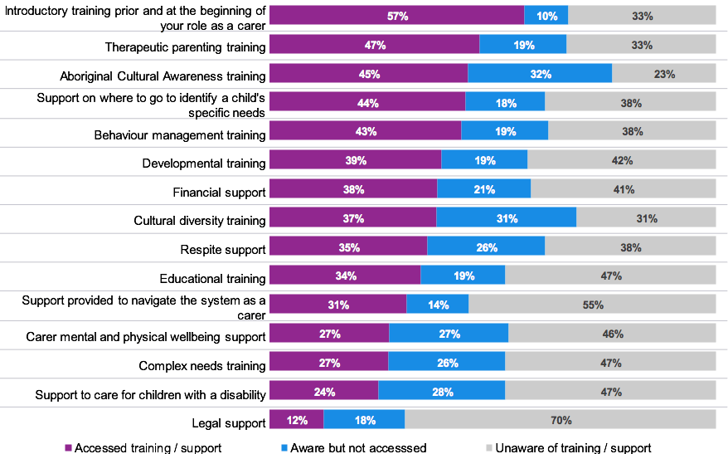
Figure note:
Base: Current and former carers who responded to this question (base size varies from n=699 to n=1,181)
C4. Below is a list of the types of support and training you may or may not have accessed. Using the drop down, please select which of the descriptions best describes you. (Excludes don’t know and NA responses)

Further evaluation of awareness of support and training on offer
Kinship carers exhibited the lowest levels of awareness of the support and training available to them, with 50 per cent of kinship carers unaware of all the options presented, with the exception of financial support (40 per cent unaware), and legal support (72 per cent unaware), which aligned with the results of foster carers (41 per cent unaware of financial support and 66 per cent unaware of legal support respectively) and permanent carers (38 per cent unaware of financial support and 70 per cent unaware of legal support respectively).
While permanent carers were more aware of some support and training available than kinship carers, they were still more commonly unaware of this support and training available when compared with foster carers.
These differences between carer cohorts in lack of awareness of training options include:
- Introductory training (kinship: 67 per cent, permanent: 42 per cent and foster: 10 per cent)
- Therapeutic training (kinship: 55 per cent, permanent: 39 per cent and foster: 15 per cent)
- Developmental training (kinship: 55 per cent, permanent: 50 per cent and foster: 29 per cent)
- Support to identify needs (kinship: 52 per cent, permanent: 48 per cent and foster: 23 per cent)
- Behaviour management training (kinship: 54 per cent, permanent: 43 per cent, and foster: 22 per cent)
- Cultural diversity training (kinship: 56 per cent, permanent: 44 per cent and foster: 16 per cent). and
- Respite support (kinship: 55 per cent, permanent: 53 per cent and foster: 19 per cent).
Carers who identify as Aboriginal in the kinship and permanent carer cohort have lower levels of awareness of the Aboriginal awareness training (kinship: 44 per cent, permanent: 38 per cent and foster: 13 per cent).

Other sub-group differences
- Those caring for less than two years were more likely to be unaware of therapeutic parenting training (43 per cent) and behaviour management training (45 per cent) than other care tenures.
- Female carers were more likely to be unaware of almost all support and training available to them, again perhaps influenced by their over representation in the kinship carer groups.
- Carers who identified as Aboriginal were more likely to be unaware of introductory training prior to and at the beginning of their role as a carer (55 per cent versus 31 per cent of total carers).
- Carers from lower income households, earning $40,000 and below per annum, were less likely to be aware of introductory training (43 per cent), therapeutic parenting training (43 per cent) and cultural diversity training (39 per cent).
- Those with a household income of $100,000 per annum or more had a greater likelihood of being unaware of financial support available to them (51 per cent).
- Analysis across age, sexual orientation, culturally and linguistically diverse carers and regions aligned to the results of the total carer population.

Support and training – impact

All respondent view – impact
Among those carers who had accessed each support, the impact on their ability to care was evaluated. At an overall level, the support and training provided has had a positive impact on carers’ ability to care.
Therapeutic parenting training (89 per cent), complex needs training (86 per cent) and respite support (84 per cent) were the most effective in enhancing the carers’ ability to care. All of this training and support has had a strong impact on helping carers be a much better carer (37 per cent therapeutic parenting training, 37 per cent complex needs training and 36 per cent respite support respectively).
Other supports which have achieved a strong positive evaluation in enhancing a carers’ ability to provide care were:
- Support to care for children with a disability (83 per cent)
- Introductory training prior to starting their role as a carer (83 per cent)
- Behaviour management training (82 per cent)
- Aboriginal cultural awareness training (82 per cent)
- Cultural diversity training (81 per cent)
- Developmental training (81 per cent).
Still achieving high levels of perceived effectiveness among carers who accessed support were; where to go to identify a child’s needs (78 per cent), educational training (77 per cent), support provided to navigate the system as a carer (77 per cent) and carer physical and mental wellbeing support (73 per cent), reinforcing the role of support and training in improving their ability to provide care.
Seventy-three per cent of carers considered that accessing financial support helped them be a better carer, and 60 per cent of carers considered the legal support helped them be a better carer. The proportion of carers unsure of the effect this support has had yielded higher results than for any other support and training, at 15 per cent (financial support) and 24 per cent (legal support) respectively.
Figure 40: Impact of support and training on the ability to care
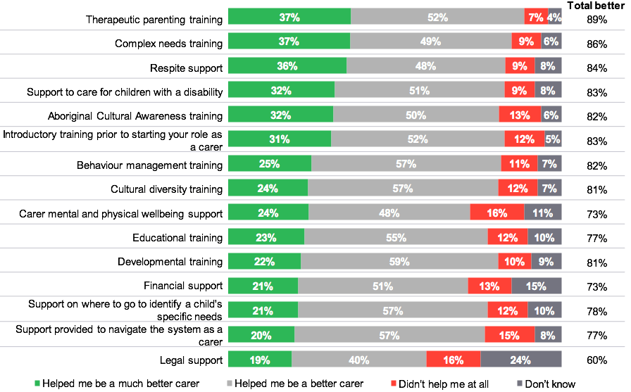
Figure note:
Base: Current and former carers who responded to this question (base size varies from n=119 to n=637)
D3. To what extent did the support or training you accessed improve your ability to provide care?

Further evaluation of those who felt the training made them a better carer
While still a majority of those carers who accessed support, kinship carers were less likely to feel the introductory training helped them be a better carer (foster: 85 per cent, permanent: 81 per cent and kinship: 67 per cent).
Analysis across length of time as a carer, gender, age, sexual orientation, Aboriginal carers, culturally and linguistically diverse carers, household income and regions aligned to the results of the total carer population.

Financial support

All respondent view – financial support
There are a variety of financial supports available to carers within Victoria, and while some are highly utilised, poor utilisation of some financial supports highlight the lack of awareness among carers of their availability.
The care allowance was the most commonly accessed form of financial support, with 91 per cent of carers accessing this support. While not as universally accessed, 71 per cent of carers had received both new placement allowances or childcare subsidies, with 65 per cent of carers receiving a school attendance allowance.
Fifty-four per cent of carers have received family assistance financial support and 30 per cent of carers were unaware this support was available.
Accessing some forms of financial support was uncommon amongst carers who could apply for them, with 30 per cent of carers having received disability payments, flexible funding by PCA Families or Oz Child (27 per cent), flexible funding by DHHS (DFFH) (27 per cent) or a health allowance (26 per cent).
Awareness of these support services was low amongst carers, with more than half of carers unaware of flexible funding by PCA Families or Oz Child (56 per cent), flexible funding by DHHS (DFFH) (52 per cent) or a health allowance (58 per cent). Forty-one per cent of carers were unaware of disability payments being available.
Figure 41: Awareness of, and access to, financial support
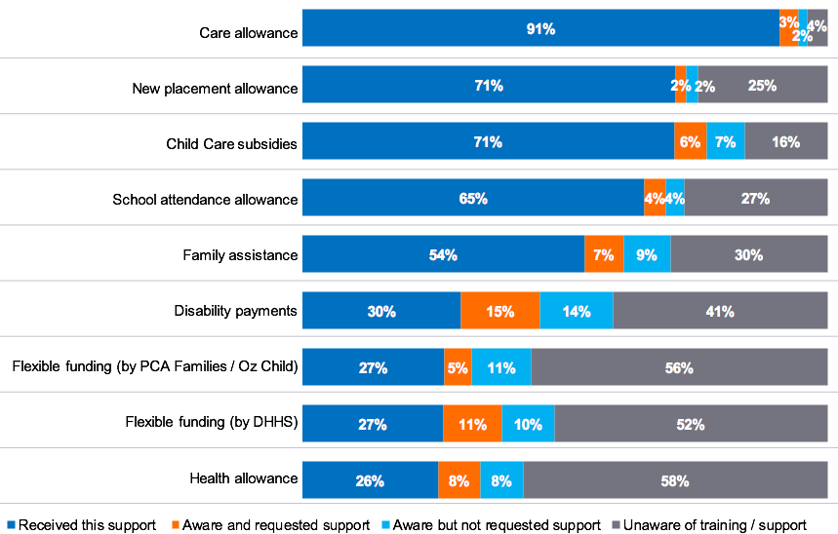
Figure note:
Base: Current and former carers who responded to this question (base size varies from n=449 to n=1,211)
E2. Thinking about the following financial supports you may access, which of the following best describes you? (Excludes don’t know and NA responses)
Note: Flexible funding by PCA families or Oz child is only available to permanent carers. Forty-four per cent of permanent carers have received this support, 7 per cent have requested but not received the support, 15 per cent of carers are aware of it but have not requested the support and 34 per cent of carers were not aware of the support.

Further evaluation of awareness of financial supports on offer
Permanent carers were the least likely to be aware of the school attendance allowance available to contribute to education expenses (permanent: 36 per cent, kinship: 29 per cent and foster: 21 per cent).

Other sub-group differences
- Those aged 66 years and over were less likely to be aware of the new placement allowance (40 per cent unaware).
- Those living in a household with an annual income of $100,000 or more were less likely than other income brackets to be aware of family assistance (45 per cent).
Analysis across length of time as a carer, gender, sexual orientation, Aboriginal carers, culturally and linguistically diverse carers and regions aligned to the results of the total carer population.

All respondent view – effect
At an overall level, the majority of those who have accessed financial support felt it is less than they need. Exceptions to this were: health allowance support (51 per cent feel it covers their needs, while 48 per cent feel it is less than needed), flexible finding by PCA Families or Oz Child (56 per cent feel it covers their needs, while 43 per cent feel it is less than needed), and child care subsidies (75 per cent feel it covers their needs, while 23 per cent feel it is less than needed).
Overall, financial support was not considered to meet the needs of carers, with the majority of those who have received the support stating the funding provided is less than needed. This included carers believing the funding was insufficient for: school attendance allowance (63 per cent), care allowance (62 per cent), new placement allowance (60 per cent), family assistance (59 per cent), disability payments (53 per cent) and flexible funding (53 per cent).
Figure 42: Extent to which the financial support met carer needs
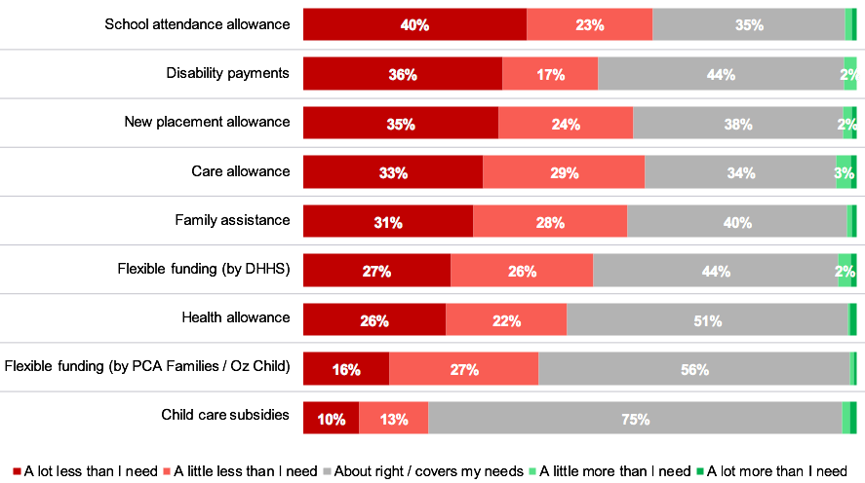
Figure note:
Base: Current and former carers who responded to this question (base size varies from n=113 to n=1,087)
For chart legibility labels less than 2% removed from chart
E3. Thinking about the financial supports you have received, to what extent does it meet your needs as a carer?

Further evaluation of those feeling the funding is less than they need
Permanent carers were more likely to feel the care allowance provided was less than they needed (71 per cent, kinship: 65 per cent, foster: 59 per cent), though the majority of those carers accessing this form of funding felt the same.

Other sub-group differences
- Those living in a household with an income under $40,000 per year before tax were more likely to feel the family assistance funding provided is less than they need (68 per cent).
Analysis across length of time as a carer, gender, age, sexual orientation, Aboriginal carers, culturally and linguistically diverse carers and regions aligned to the results of the total carer population.

Section 6. The future of caring


Section overview
Fifty-one per cent of the carer census respondents would continue caring in the future, beyond their current placements or care arrangements, whereas 32 per cent of carers reported they would be unlikely to do so.
Of those likely to continue caring, 31 per cent of carers love what they are doing and 25 per cent of carers see the difference they are making in a child’s life. Leveraging these factors as a testimonial from carers may be a method by which to attract new carers into the system.
However, among 32 per cent of carers who were unlikely to continue caring, the difficulties with the system itself are negatively impacting their desire to continue. Twenty-nine per cent of carers feel a lack of support, and 26 per cent of carers feel they are getting too old. The former aspects may need to be dealt with to encourage current carers to remain within the caring system moving forward.
Considering the evident financial impact of caring that carers are facing, understanding the key areas in which they need greater support may enhance their view of caring overall, and their ability to operate within it. School fees (29 per cent) and sports expenses and extracurricular activities were areas in which carers want greater levels of financial support. Other common factors were receiving help with school related costs (26 per cent) and various medical expenses (19 per cent). It is important to consider the breadth of responses received for this question, with 64 per cent of carers providing additional responses which were representative of less than eight per cent of carers. This finding highlights the diverse needs of the carer cohort, which may be challenging to satisfy.
When reflecting on their role and considering the support which could improve their ability to care, the carer census respondents were looking for more general support for themselves and their families (24 per cent), financial help (17 per cent) and improved communication at an overall level (16 per cent). Carers wanted to be treated respectfully and were looking for someone to listen, respect and treat them with care and compassion (13 per cent).

Reflections from the qualitative in-depth interviews
“The lack of support makes you question what you’re doing – is it right or is it wrong? Without the support, we kind of think when does this end, when does it get easier. It puts a lot of self-doubt within the placement.”
– Kinship carer
While the carers interviewed stated they were committed to providing ongoing care, those who had experienced significant challenges and hardships related to placements said they had, at times, questioned their ability to continue. Kinship carers cited strong familial and moral obligations as the reasons to continue caring in light of adversity, whereas foster and permanent carers were more likely to be inspired to continue due to the joy the children brought into their lives. To understand the extent to which carers would continue caring in the future, and the reasons for this, this topic was further explored in the census.
“They don’t give carers enough information. For the kids, they say it’s for privacy, but if the child has trauma or mental health issues, we need to know, as we can’t manage the child adequately otherwise. The best thing is to share enough relevant information so the parents can go to the right people for supports. Even if don’t provide the support at least the carers will know where to start.”
– Foster carer
During the interviews, carers suggested a range of supports that would improve their ability to provide care. These supports included a wide range, such as greater access to relevant information about available support, a more supportive approach from the department, consistency of case workers and the information they provide, timely access to specialist care (such as learning assessments and trauma-informed therapy) and increased financial assistance, as well as inclusion of carers in the decision-making processes regarding children. The carer census further explored these themes in order to understand what carers need to improve their ability to provide care.

Likelihood to continue caring

All respondent view – likelihood
Fifty-one per cent of carers surveyed were likely to continue caring in the future, with 34 per cent of carers being very likely to continue caring. While 17 per cent of carers were neither likely nor unlikely to continue caring and 32 per cent of carers were unlikely to continue caring in the future beyond their current placements or care arrangements.
Figure 43: Likelihood to continue caring in the future
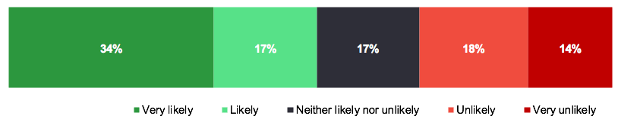
Figure note:
Base: Current and former carers who responded to this question (n=1,391)
C5. How likely, or unlikely, would you be to care in the future? Please think about your likelihood of continuing caring beyond your current placements or care arrangements, if you have them.
Foster carers were the most likely to continue caring in the future, with 66 per cent of carers likely to continue caring compared with 39 per cent of kinship carers and 41 per cent of permanent carers.

Other sub-group differences
- Those caring for less than two years were more likely to consider continuing to care in the future beyond their current placements (59 per cent), with those caring for more than 10 years the least likely to consider continuing care in the future (39 per cent).
Analysis across gender, age, sexual orientation, Aboriginal carers, culturally and linguistically diverse carers, household income and regions aligned to the results of the total carer population.

All respondent view – reasons for likelihood
Of the carers who stated they would be ‘likely’ or ‘very likely’ to care in the future, 31 per cent of carers suggested this was the case because they love caring or find it rewarding. In a similar vein, 25 per cent of carers said they would continue caring as it makes a difference or helps in a child’s life.
Figure 44: Reasons for likelihood to care in the future
Figure note:
Base: Current and former carers who responded to this question and indicated they are likely or very likely to care in the future (n=714)
C6. Please provide as much detail as you can on all the reasons you would be likely, or unlikely, to care in the future.
Of the carers who would be likely to care in the future, 38 per cent of foster carers were more likely to love caring and find it rewarding (permanent or adoptive carer: 25 per cent, kinship: 21 per cent). However, 17 per cent of kinship carers and 18 per cent of permanent carers cite that their current care placement will continue for some time, compared to those in foster care (five per cent).
Analysis across length of time as a carer, gender, age, sexual orientation, Aboriginal carers, culturally and linguistically diverse carers, household income and regions aligned to the results of the total carer population.

All respondent view – reasons not
Of the carers who stated they would be ‘unlikely’ or ‘very unlikely’ to care in the future, 32 per cent of carers suggested this was because of difficulties dealing with the system such as DHHS (DFFH), red tape, and so on., while 29 per cent of carers noted a lack of support.
Figure 45: Reasons for not choosing to care in the future
Figure note:
Base: Current and former carers who responded to this question and indicated they are unlikely or very unlikely to care in the future (n=446)
C6. Please provide as much detail as you can on all the reasons you would be likely, or unlikely, to care in the future.
Foster carers were more likely to nominate dealing with the system (DHHS (DFFH), agencies, legal, red tape and so on) as the reason for being unlikely to care in the future (45 per cent), indicating that this is a pain point for this group.

Sub-group differences
- Male carers were more likely to cite getting old as a reason for being unlikely to care in the future (46 per cent male carers versus the total carers 22 per cent).
- Those aged 46 to 55 years were more likely to cite difficulties dealing with the system for being unlikely to care in the future (46 per cent).
- Those aged 66 years and over were more likely to suggest getting old as the reason for them being unlikely to care in the future (63 per cent).
- Those living in a household earning $100,000 or more per annum were more likely to suggest difficulties dealing with the system as a reason for being unlikely to care in the future (54 per cent).
Analysis across length of time as a carer, sexual orientation, Aboriginal carers, culturally and linguistically diverse carers and regions aligned to the results of the total carer population.

Future support needs

All respondent view – expenses
Currently, carers indicate there are a range of outgoing expenses that should be covered or subsidised. The most commonly cited outgoing expenses were clustered around educational and extracurricular expenses, including education or school fees or private school fees (29 per cent), sports expenses and extracurricular expenses (29 per cent) and school equipment such as uniforms, shoes, books, supplies and technology (26 per cent).
Figure 46: Outgoing expenses which should be covered or subsidised
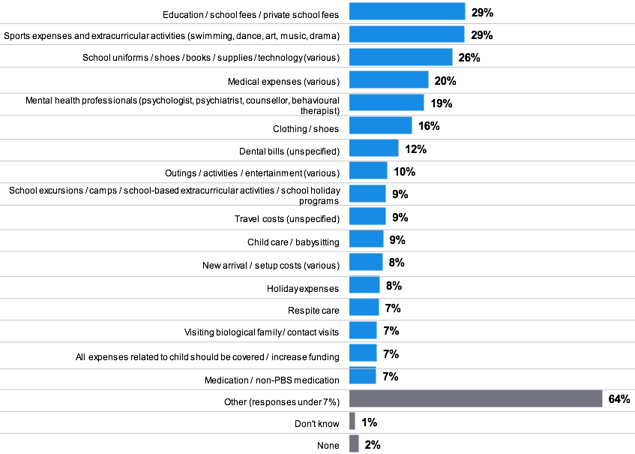
Figure note:
Base: Current and former carers who responded to this question (n=895)
E4. As a carer, what outgoing expenses are not covered, or subsidized, which you think should be.
Thirty-six per cent of permanent carers and 35 per cent of kinship carers were more likely to cite education, school fees or private school fees as outgoing expenses that should be covered or subsidised, compared with a lower proportion of foster carers (24 per cent).
Permanent carers were more likely than foster carers to nominate dental bills as outgoing expenses that should be covered or subsidised (18 per cent permanent carers versus eight per cent foster carers respectively), while kinship carers were more likely to cite respite care as part of this category than foster carers (12 per cent kinship carers versus three per cent foster carers respectively).

Sub-group differences
- Carers who have been caring for more than 10 years were more likely to nominate dental bills as an outgoing expense that should be covered or subsidised (19 per cent compared to 12 per cent at a total level).
- Those who are currently caring were more likely to cite education, school fees, private school expenses (31 per cent) as an outgoing expense that should be covered or subsidised.
- Carers aged 56 to 65 years old were more likely to nominate dental bills (19 per cent) as an outgoing expense that should be covered or subsidised.
- Carers aged 46 to 55 years old were more likely to nominate childcare or babysitting (13 per cent) as an outgoing expense that should be covered or subsidised.
- Carers aged 20 to 35 years old were more likely to nominate new arrival or setup costs (18 per cent) as an outgoing expense that should be covered or subsidised.
- Non-Aboriginal carers were less likely to indicate that all expenses related to a child should be covered or funding increased (six per cent) as an outgoing expense that should be covered or subsidised.
- Those living in a household earning $70,000 to $99,999 per annum were less likely to nominate dental bills as an expense that should be covered or subsidised (three per cent versus the total carers 12 per cent).
- Analysis across gender, sexual orientation, culturally and linguistically diverse carers and regions aligned to the results of the total carer population.

All respondent view – improvements
When asked about how their ability to care could be improved, 24 per cent of carers surveyed suggested broadly that they would like more support or assistance for carers, while 17 per cent of carers indicated that financial help and better communication could help in improving their ability to care.
Figure 47: Additional support needs to improve ability to care
Figure note:
Base: Current and former carers who responded to this question (n=1,172)
E5. Thinking more broadly about your role as a carer, what more could be done to improve your ability to care?
Foster carers were less likely to nominate financial help as a factor that could assist in their ability to care (13 per cent), while on the other hand, permanent carers were more likely to nominate financial help as something that could help them in their caring ability (23 per cent).

Sub-group differences
- Carers who have been caring for less than two years were less likely to cite financial help as something that could improve their ability to care (nine per cent).
Analysis across gender, age, sexual orientation, Aboriginal carers, culturally and linguistically diverse carers, household income and regions aligned to the results of the total carer population.


Conclusions

1. Distinct profiles within the carer types
The quantitative findings have gone some way to provide an understanding of the demographic features of people who become foster, kinship and permanent carers.
There were some distinct factors which differentiated the groups demographically. At a high level: there was a higher proportion of; male, younger and higher income carers within the foster carer cohort who responded to the survey. Whereas there were a higher proportion of female, older and lower income carers within the kinship and permanent carer cohorts.
Kinship carers had a higher proportion of Aboriginal carers than other carer types. Aboriginal carers are confident in supporting children in their care to maintain connection with their cultural identity and heritage (91 per cent agree).
Note: However, it is important to acknowledge the sampling limitations associated with this study. If in future, DFFH may wish to consider alternative sampling approaches. The data included in this study provides a foundation on which to build future understanding of specific carer experiences.

2. Engaging with the system and accessing support is building confidence and preparedness
There is a variation in engagement with the system, evidently driven by the type of care that is being provided.
Foster carers are more likely to access various supports and training and as a result are exhibiting higher levels of preparedness, confidence and engagement with support, than other carer types. This indicates that kinship and permanent carers may benefit from greater contact and support from the Department to make sure they have access to support and training.
While foster carers experience some challenges, the higher proportion accessing support and training means a higher proportion are feeling that the department, agencies and advocacy groups are helping them enhance their ability to care.
Currently, kinship carers exhibit the lowest levels of awareness of support and training available to them. There may be an opportunity to encourage access to supports which are available to them in their capacity as a carer.

3. Carers want to feel heard and understand the support on offer
When asked what more could be done to support carers in the future, carers indicated the need to feel respected, and heard. The influence of other carers is playing a role in the propensity to start caring, and currently 22 per cent of carers would not recommend being a carer to others.
The key reason carers are unlikely to continue caring is; difficulties with the system (32 per cent). However, awareness of support is relatively low, with over half (55 per cent) of carers who responded to the survey unaware this was available to them. Twenty per cent of foster carers surveyed are unlikely to continue caring in the future beyond their current placements. This indicates action needs to be tailored to meet specific needs.
Raising awareness of support and training available among the kinship and permanent carer cohorts may be an opportunity to enhance their experience, confidence and preparedness for their carer role, and in turn yield more positive outcomes for the child.
Tailored support, focusing on wellbeing and mental health, is identified as being of benefit. However, there is low awareness of the extent of available training and support in this area. Considering the negative impact caring responsibilities can have on relationships, social life and on work and careers, it is important to ensure carers are aware of and are supported to access such support.

4. Minimising the financial impact of caring
Throughout the census results, despite supports available to carers, the impact on personal finances is highlighted. While the majority of carers are accessing allowances available to them, many feel what they receive is insufficient for their needs. Most kinship carers receive the lowest level of care allowance, but many foster carers receive a higher allowance. This was a key finding of the Victorian Ombudsman’s investigation in 2017 into the financial support provided to kinship carers.
Kinship and permanent carers (both 84 per cent) reported they have had their personal finances impacted in their role as a carer, with 75 per cent of foster carers also impacted. Both kinship and permanent carers are most commonly using their personal savings (kinship: 72 per cent, permanent: 70 per cent).
This means they are accessing personal finances to ensure they can meet their responsibilities, often through personal savings or income. This can be a nominated reason for why a carer may choose to leave the system, with 14 per cent of those unlikely to continue caring stating that the inadequacy of financial support is a key reason they will not continue caring in the future.

5. Next steps
While the carer census has provided a breadth of knowledge about the profile of carers within Victoria, and some insight into their experiences, there is an opportunity for deeper exploration of the specific needs of carers across carer types. The results provide a basis on which to build a regular carer census that can identify trends and be refined over time.
Considering the individual challenges carer types face, highlighted throughout the findings, there is an opportunity to engage with specific cohorts (such as kinship carers) to understand how training and support can be better tailored to meet their challenges and needs. Key characteristics of and challenges experienced by each carer group are outlined in the carer specific infographics that follow.


Appendix 1: Detailed methodology

Co-design workshop
The co-design workshop was held on the 1st September 2020 from 10am to 12pm. Due to the ongoing COVID-19 pandemic and restrictions at the time, the session was hosted via video conference. This phase of the program was critical in ensuring the proposed methodology and content of the carer census aligned with departmental, peak body and stakeholder needs.
Attendees at the co-design workshop included departmental representatives, representatives from each of the three carer peak bodies (Grandparent Carers Victoria, Kinship Carers Victoria, Permanent Care and Adoptive Families and Foster Carer Association of Victoria). Additional stakeholder representatives who attended included representatives from several metropolitan and regional agencies who engage with a range of carers, including carers from culturally and linguistically diverse backgrounds, carer advisory group representatives, carer support network representatives and carers themselves.
The format of the co-design workshop involved four core phases: an introduction from EY Subject Matter Experts to outline the workshop overview and purpose, as well as the contextual work occurring in the sector. This was followed by an overview of the DFFH strategic context for the research, and the aims and objectives of the carer census. A representative from each of the three peak body associations undertook a short presentation to provide insights into the core priorities of each peak body for the carer census.
Small group sessions were then undertaken with a group of 4 to 6 attendees to develop a deeper understanding of their proposed core priority areas of focus for the census and the way in which they intended to apply its findings. Additionally, potential challenges in recruitment were explored, as well as methods to engage peak body representatives and other stakeholders to maximise carer participation in the census. Connections developed through the co-design workshop were also used to further explore the role of the peak body associations in the promotion of the census.
The co-design workshop provided a deep insight into the carer landscape, highlighting key priority areas of focus. These findings were used to develop the discussion guides for the following qualitative phase of the research which involved in-depth interviews with carers and key stakeholders.

Qualitative research approach
Following the co-design workshop, in-depth interviews with carers and key stakeholders were conducted to further explore the priority areas for the census identified during the workshop. Interviews were conducted with nine carers and two stakeholders between 22 September 2020 and 14 October 2020.
Carer interviews were conducted with kinship, foster and permanent carers. Within each of these carer groups, active and lapsed carers were interviewed. It is important to note that some carers had multiple carer roles and could be classified in more than one carer group, for example a permanent and foster carer. The final sample structure achieved is presented in Table1.
During September 2020, peak body representatives provided EY Sweeney with the names of several carers who could be contacted to participate in the interviews. EY Sweeney requested that the peak bodies’ representatives identify male and female carers from metropolitan and rural locations representing a range of ages and backgrounds, including culturally and linguistically diverse carers and Aboriginal carers.

Table 1: Achieved carer sample structure – depth interview sample structure
Placement type | Carer group | Total depths
Active placement | Kinship | 3
Active placement | Foster | 1
Active placement | Permanent | 2
Lapsed placement | Kinship | 1
Lapsed placement | Foster | 2
Total depth interviews |  | 9
EY Sweeney also conducted two interviews with stakeholders; including one with three departmental representatives identified by the department’s project team. Departmental representatives included executives and individuals who worked with carers directly. The second stakeholder interview was conducted with a carer advocate, who was also a carer. This individual was identified by the department.
The priority areas identified in the co-design workshop were explored more deeply during the qualitative interviews. Discussion guides were developed (Appendix 2) and approved by the department on 17 September 2020. They included key questions within each of the following areas:
- Understanding the interviewees (carers, department or advocate): Understanding the interviewee, their carer roles or ways in which they engage with carers
- Carer experiences: Experiences of carers, impacts of caring, challenges and barriers encountered and engagement with carer-related organisations
- Carer capability and understanding: Carer confidence, attitude towards and experience with children from diverse backgrounds, and carer health and wellbeing
- Support and training assistance needs: Carer support needs, awareness and access, engagement with support organisations, effectiveness of support and support gaps
- Funding and assistance needs: Awareness, availability, access and adequacy of financial support, out-of-pocket expenses, impact of caring on financial wellbeing and funding support gaps.
Upon completion of the interviews, the researchers analysed the key themes that emerged. These themes, their sub-themes and related details were used to develop the census.

Quantitative research approach
The methodology for the DFFH Carer Census was designed by EY Sweeney and the department. A summary of the method is provided below:

Overview
The online survey instrument was co-designed with the DFFH project team. The instrument was then circulated with key stakeholders to ensure coverage, comprehension and completeness for the carer cohort. After further refinement, an online survey of 1,788 carers was undertaken.
The target respondents were current carers within Victoria, with scope to include those who had previously acted as a carer in Victoria.

Survey design
Insights from the co-design workshop and exploratory qualitative in-depth interviews were used to inform the design of the survey, including the wording of questions, definitions within the survey and code frames for various questions.
Due to the breadth and depth of the carer experience, and limitations on census survey length, a mapping exercise was undertaken to prioritise the key areas for inclusion in the census. This was provided to DFFH and circulated with relevant stakeholders. Once the areas for inclusion were confirmed, the final survey instrument was developed in consultation with DFFH.
The draft census was provided to the department on the 20th October 2020.

Survey programming and testing
Once feedback from both DFFH and the peak bodies was incorporated into the census, the final version was approved on the 17th November 2020 by DFFH. A full copy of the online survey is in Appendix 2.
The final version of the survey was then programmed by a senior EY Sweeney analyst. All routing and validations were programmed into the electronic interface of the survey.
Once the survey had been programmed, several checks occurred prior to the commencement of fieldwork. The analyst who was responsible for the survey build conducted the first test and the EY Sweeney project team conducted a second test. Dummy data files were also checked to ensure all routing and filters were functioning as intended. Once the internal checks had been finalised, the department conducted a check of a test survey link and provided approval on the content prior to the commencement of fieldwork.

Sampling and survey launch
The test link was approved for a soft launch with a subset of carers on the 26th November 2020.
DFFH provided a database to EY Sweeney to manage survey distribution. EY Sweeney reviewed the database, isolating the records with email addresses appended and removing any duplications to ensure carers were not receiving the survey invitation multiple times.
A draft invitation email was prepared by the EY Sweeney project team and approved by DFFH. In the first instance, EY Sweeney distributed the survey to 500 carers. Once a sufficient number of responses were collected the EY Sweeney analyst checked the data to ensure all routing and filters were functioning as intended. The EY Sweeney research team conducted a second review of the data. Once accuracy was confirmed, the survey was fully launched to the DFFH database on the 1st December 2020.
In addition to distribution to the DFFH database, a survey link was provided to each of the peak bodies; Foster Care Association of Victoria, Kinship Carers Victoria and Permanent Care and Adoptive Families on the 2nd December 2020. Each of the peak bodies managed the distribution of the carer census to their membership base.
On the 9th December, a reminder email was sent to the DFFH database members who had not yet responded to the survey. Peak bodies managed their own distribution of reminder emails.
The survey was closed on Monday 1st March 2021.

DFFH involvement in maximizing census participation
To promote and raise awareness of Victoria’s first home-based carer census, the department worked closely with the Carer Strategy Working Group (CSWG), including home-based carer peak bodies and home-based care providers.
The purpose of the CSWG is to advise the Roadmap Implementation Ministerial Advisory Group (RIMAG) on the development and implementation of the Carer Strategy Strong carers, stronger children to support kinship, foster and permanent carers and the children they care for.
The department’s awareness raising activities included leveraging its relationships with Melbourne-based and regional CSWG members, for example, Aboriginal Community Controlled Organisations (ACCOs) and Community Service Organisations (CSOs) to help promote the census through local, community-based channels.
In total, 14 CSWG representatives from 12 different ACCOs and CSOs were contacted and encouraged to assist EY Sweeney and the department in reaching out to their carer networks. These organisations were encouraged to assist a diverse group of home-based carers who may experience difficulties to complete the census survey online, for example, through conducting carer group census survey sessions.
In addition, ACCOs and other home-based care service providers were asked to promote the opportunity to participate in the census on their websites, social media accounts and newsletters.
Responses received by the department indicated that our engagement partners successfully encouraged carer participation, with the census being distributed to kinship, foster and permanent carers through their local networks.

Census outcomes
The table below outlines the achieved sample structure by carer type, gender, age and region. The full profile of the carer cohort surveyed is highlighted within the report.

Table 2: Achieved carer sample structure – respondent sample structure
Subject | Groups | Responses (n=) | Maximum margin of error (+ or –) %
Carer type | Foster Carer | 753 | ±3.72
Carer type | Kinship Carer | 923 | ±3.29
Carer type | Permanent Carer or Adoptive Parent | 645 | ±3.94
Carer type | Other | 80 | ±11.25
Gender | Male | 129 | ±8.84
Gender | Female | 1040 | ±3.10
Gender | Other | 3 | NA
Age | 20 to 35 years | 113 | ±9.45
Age | 36 to 45 years | 254 | ±6.29
Age | 46 to 55 years | 374 | ±5.18
Age | 56 to 65 years | 296 | ±5.82
Age | 66 years or over | 131 | ±8.77
Household income before tax | Under $40,000 | 305 | ±5.74
Household income before tax | $40,000 to $69,999 | 222 | ±6.73
Household income before tax | $70,000 to $99,999 | 162 | ±7.88
Household income before tax | $100k or more | 301 | ±5.77
Region | Melbourne | 532 | ±4.34
Region | Rest of Victoria  (Includes regions listed here) | 325 | ±5.55
Region | Barwon | 68 | ±12.22
Region | Central Highlands | 60 | ±13.02
Region | Gippsland | 86 | ±10.85
Region | Goulburn | 33 | ±17.68
Region | Great South Coast | 26 | NA9
Region | Loddon Campaspe | 71 | ±11.95
Region | Mallee | 6 | NA9
Region | Ovens Murray | 18 | NA9
Region | Wimmera Southern Mallee | 5 | NA9
Aboriginal | - | 56 | ±13.48
Culturally and Linguistically Diverse | - | 75 | ±11.62

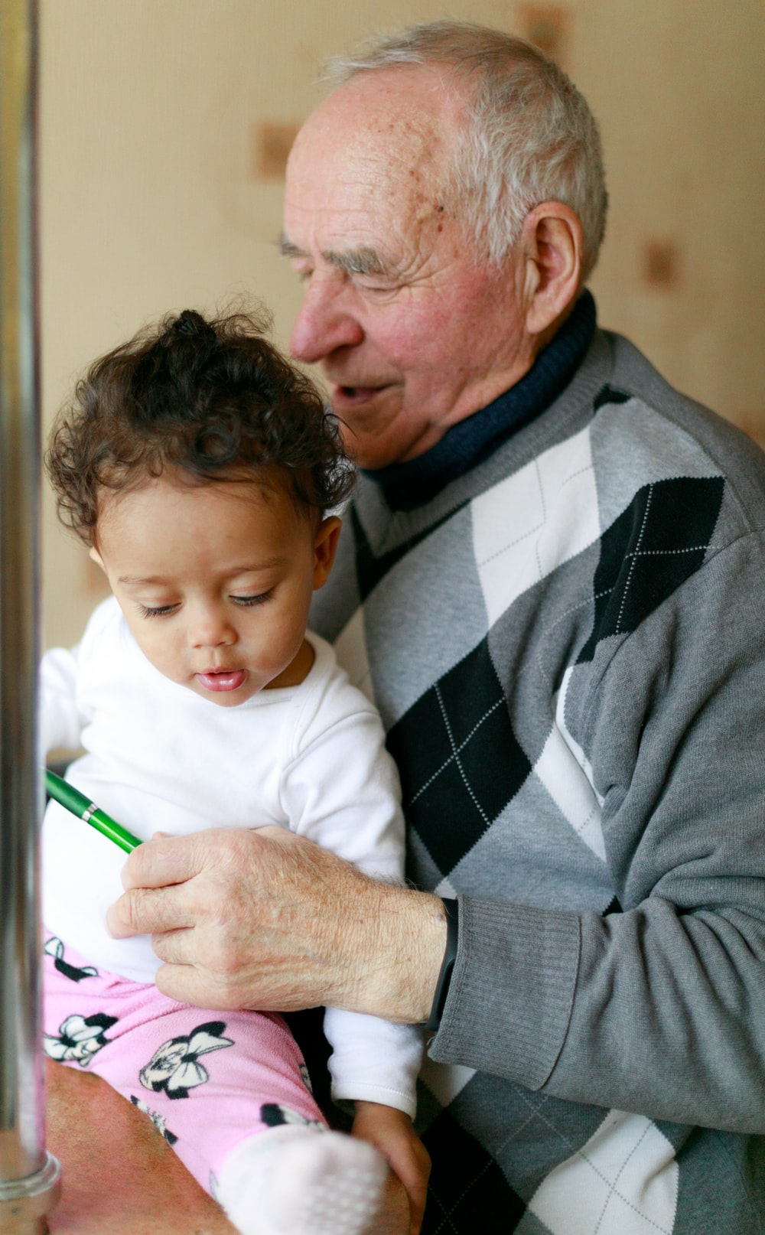
Appendix 2: The field instruments

Carer Census: Final
Study No. | 31076
Client | Department of Health and Human Services
Version | Version 4 – 3rd December 2020

Sample structure
No quotas

Introduction:
Thank you for participating in this survey. It will take about 10 minutes to complete depending on your answers. Your responses will be completely confidential and anonymous.
[Please note that the following two paragraphs were used in the introductory email sent to carers and were not included on the survey landing page]
This survey is designed to understand more about the experiences of carers living in Victoria. By sharing your thoughts, you will be helping to improve experiences of carers in the future.
This survey is part of the Victorian Government’s Home-based Carer Strategy Strong carers, stronger children and will provide information for improving future policy, programs and services. The survey has been endorsed by Kinship Carers Victoria (KCV) and the Foster Carers Association of Victoria (FCAV).
As a kinship carer, foster carer, permanent parent or carer or respite carer, some response options to questions we have offered may not feel applicable to you. If this is the case, you can choose not to select these options.

How To Complete The Survey
"Click" the relevant circles or boxes to mark your selection with a dot or a tick.
You may close the survey down and re-enter at the point you left off using the link emailed to you.
Once you have completed all questions on a page you will need to click the "Next" Button to proceed to the next screen.
In order for your answers to be sent you must click the "Submit" button at the end of the survey.
Thank you for your participation.
Please press NEXT to continue.
For access to the EY Sweeney Privacy Policy, click here ("https://eysweeney.com.au/privacy-policy "). For any technical problems with this survey please send an e-mail by selecting on the link that appears at the bottom of each page.

Section 1: Carer Classification or Level of Experience

A1. Which of the following describes you?

Instructions
- I am, or I have been a…
- Please select for children you either currently care for or have previously cared for.
- Please select all that apply.

Options
- Foster carer: Providing care for a child or young person either through a Children’s Court order or a voluntary childcare agreement 4
- Kinship carer: Providing care for a child or young person who is a relative or a member of a close social network…
through a Children’s Court order 01
through child protection involvement 02
through a private non-statutory arrangement 03
- Permanent carer: Permanent care parent for a child after a permanent care order has been made by the Children’s Court which grants you exclusive parental responsibility for the child via…
direct recruitment as permanent carer 05
- Kinship care under another order 06
- Foster care under another order 07
- Adoptive parent or carer: child has become a member of an adoptive family, such as where they are unable to be taken care of by birth parents or extended families. The child is usually voluntarily placed for adoption by the birth parent or parents. 08
- Other (please type in your response) 97
- I am not currently a carer, nor have I ever been a carer Terminate 99

Programmer note
Allocate as follows:
- Kinship carer: A1=1,2 OR 3
- Foster carer: A1=4
- Permanent carer: A1=5,6,7 or 8
- Other: A1=97

A2. What type of kinship or foster care have you provided?

Instructions
Ask if: kinship or foster carer.
Please select for children you have either currently or have previously cared for.
Please select all that apply.

Options
- Long term carer under a long-term care order: For children and young people who require care for a period longer than six months. 01
- Longer term kinship or foster care: Care arranged when a child or young person cannot return home for some time while future is determined 02
- Short term kinship or foster care: For children and young people who require care ranging from overnight up to about six months 03
- Respite kinship or foster care: Short-term or intermittent care provided for children and young people living with full-time foster and kinship carers or parents 04
- Emergency kinship or foster care: For children and young people who require immediate care due to concerns for their safety 05
- Therapeutic kinship or foster care: having been provided with specialist training, and support to care for children and young people who need therapeutic responses to their specific needs 06
- Other (please type in your response) 97

A3. Please think about the time you cared for a child.

Instructions
The next set of questions are to learn a little more about your role as a <insert bolded response from A1: if more than one selected add ‘and’ to show all> carer. For the rest of the survey we would like you to think about your experience with caring for the children under this arrangement.
How long have you been a carer?
Please type a number.

Options
- <Insert number> years
- More than 30 years 01
- <Insert number> months
- Less than one month 01

Programmer note
No piping for A1=97.
Show A3-A4 on the same page.
Min=1 must enter figure into either years or months or both.

A4. How many children have you cared for since you first became a carer?

Instructions
If you can’t remember the exact number, please provide your best estimate.
Please type a number.

Programmer note
Min = 1

A5. How many children do you currently care for?

Instructions
Again, please think about the number of children under a formal or statutory care arrangement up to the age of 20.
Please type a number.

Programmer note
Min = 0

A6. Have you ever had a placement end earlier than planned?

Instructions
Please select one response only.

Options
- Yes (please specify the number) 01
- No 02
- Can’t recall or I don’t know 99
- Not applicable 98

Programmer note
Ask if A5=less than A4

A7. What was the reasons the placement ended?

Instructions
Please type in your answer.

Programmer note
Ask if A6=1

Section 2: Child Profile

Instructions
We would now like to understand a little more about the children you currently care for, please be assured the information provided is completely confidential and will never be attributable to the child, or you.
Below, we are keen to provide an easy method for you to identify your children, if you are not comfortable providing names or initials, please add in an alternative to help you recognise each child for the purpose of the survey.

Programmer note
If A5=0 skip this section

B1. Please record below the initials (or pseudonym), gender, age and how long they have been in your care for each member of your household you currently care for under the age of 21.
Programmer note: Display number selected A5

Options
First name
- Initials
Postcode of the child’s school
- Please type in the postcode
- Don’t know
- Prefer not to say
What gender is the child or are the children you care for
- Male 1
- Female 2
- Other 3
How old are they?
- Please type in a number
- Programmer note: Max age of 20
How long have they been in your care?
- <Insert number> years
- <Insert number> months
- Less than 1 month
- Programmer note: Must enter response in years or months or both

B2. The next set of questions is to understand the type of arrangement you have with the children in your care, and a little more about their background.

Instructions
Please select from the drop-down options or type in your response.

Programmer note
- Pipe in name or initials of children
- Autocode
- Use drop down lists below. Do not show category names – included only for analysis purpose

Questions for each child

What is the type of care arrangement you have with the child?
(Programmer note: If A1=1 response only autocode response and do not ask)
- Foster carer (Children’s Court order of voluntary agreement)
- Permanent carer (direct recruitment)
- Kinship carer (Children’s Court order)
- Adoptive parent or carer

Foster care only: What type of foster care are you providing this child?
- Long term carer under a Long-term care order
- Long term kinship or foster care
- Short term kinship or foster care
- Respite kinship or foster care
- Emergency kinship or foster care
- Therapeutic kinship or foster care
- Other
- Not applicable for this child

In which country were they born (if known)?
- Australia
- England
- India
- China (excludes SARs and Taiwan)
- New Zealand
- Vietnam
- Italy
- Sri Lanka
- Philippines
- Malaysia
- Greece
- South Africa
- Germany
- Scotland
- Hong Kong (SAR of China)
- Pakistan
- Netherlands
- United States of America
- Iraq
- Afghanistan
- Malta
- Indonesia
- North Macedonia
- Other (please specify)
- Don’t know
- Prefer not to say

Do they, or their parents, speak a language other than English at home?
- Yes – please specify
- No
- Don’t know

Do they identify as Aboriginal or Torres Strait Islander?
- Yes
- No
- Don’t know

Kinship carer only: Do you have a formal arrangement for this child, that is a child protection order?
- Yes
- No
- Don’t know

Is there any contact between the child and their parents?
- Yes
- No
- Don’t know

Do they have any of the following support needs?
- History of trauma
- Attachment issues
- Grief or loss issues
- Behavioural issues
- Physical disability
- Learning difficulties
- Mental health difficulties
- Other
- None of these
- Don’t know

Kinship carer only: What is your relationship to the child?
- (Open-ended reponse)

Section 3: Attitudes and experiences with caring
The next set of questions are focused on your experience as a carer....
Programmer note: Show for those not currently caring A5=0 – Please think about your previous experience as a carer when responding to the following questions.

C1. What were your reasons for becoming a carer in the first place?

Instructions
Please select all that apply

Programmer note
Randomise and anchor 97 at the bottom

Options
- Obligation or motivation to care for family member or kin 01
- To make a positive difference in a child’s life 02
- To play a positive part in the community 03
- Personal experience in the care system 04
- To have a family or companionship 05
- Prompted by seeing advertising or communications 06
- Seeing family or friends already caring 07
- A sibling for another child 08
- I was approached by child protection services 09
- Other (please type in your response) 97

C2b. Which of the following, if any, have you found challenging since starting your role as a carer?

Instructions
Please select all that apply.

Programmer note
Randomise and anchor 97 and 99 at the bottom

Options
- Lack of time to meet caring obligations 01
- Restrictions in the ability to make decisions 02
- Speed of response to queries regarding the child 03
- Lack of consistency of support provided by care workers (such as child protection workers, foster care workers) 04
- Having everything the child needs (such as nappies, clothes, toothbrush and so on) 05
- Speed of getting documentation signed (such as approval to take trips, medication scripts and so on) 06
- Accessing organisations and people with sufficient knowledge to advise or help me 07
- Not knowing how to address issues with the child (such as developmental or behavioural issues) 08
- Not having support to address issues with the child, (such as developmental or behavioural issues) 09
- Managing parental access arrangements 10
- Ability to access practical supports (such as babysitting, support from friends or family members, respite care) 11
- Lack of key documentation like birth certificate, Medicare number or court order 12
- Availability or access to specialist and generalist support from practitioners (such as medical, educational, health or allied health and so on) 13
- Navigating child protection systems and processes 14
- Other (please type in your response) 97
- None of these 99

C3. To what extent do you agree or disagree with the following statements in relation to your role as a carer…?

Instructions
Please select one response per row.

Programmer note
Randomise

Options
- Strongly disagree 1
- Disagree 2
- Neither agree nor disagree 3
- Agree 4
- Strongly agree 5
- Don’t know or Not applicable 99

Questions
- I am confident in my personal ability to provide care to the child or children
- I feel well supported by the Victorian Department of Health and Human Services
- I feel well supported by carer advocacy groups (such as FCAV, PCA Families, KCV)
- The Department or carer agency works around my commitments (work and family)
- I feel well supported by carer agencies (such as Anglicare, Berry Street, OzChild, VACCA)
- Department or care agency expectations of carers are realistic
- I felt well prepared prior or at the beginning of my role as a carer
- I would recommend being a carer to others
- I feel I have access to information I need when I need it
- I’m confident in supporting children in my care to maintain their connection with their cultural identity and heritage
- I understand how to appropriately support an LGBTI or gender diverse child in my care (such as lesbian, gay, bisexual and so on)

C4. To what extent have the following been positively, or negatively, affected as a result of your caring responsibilities…?

Instructions
Please select one response per row.

Programmer note
Show C5 and C6 on same screen.

Options
- Negatively affected 1
- Neither 2
- Positively affected 3
- Don’t know or Not applicable 99

Questions
- My mental health
- My immediate family members (those who live within the household)
- My relationship with immediate family members
- My relationship with my partner
- My relationship with the child or young person I am caring for (such as in kinship care)
- My social relationships (such as with friends and extended family)
- My personal finances
- My work or career
- My physical health
- My ability to attend social events (such as sporting events, holidays, family gatherings and so on)
- My levels of stress
- My connection to my community
- My feeling of making a difference in a child’s life

C5. How likely, or unlikely, would you be to care in the future?

Instructions
Please think about your likelihood of continuing caring beyond your current placements or care arrangements, if you have them.
Please select one response only.

Programmer note
Show C5 and C6 on same screen.

Options
- Very unlikely 1
- Unlikely 2
- Neither likely nor unlikely 3
- Likely 4
- Very likely 5

C6. Please provide as much detail as you can on all the reasons you would be likely, or unlikely, to care in the future…

Instructions
Please type in your response.

Section 4: Support And Training Needs
The next set of questions are focusing on your support and training needs as a carer…

D1. Through which of the following, if any, have you accessed support or training for your role as a carer?

Instructions
Please select all that apply.

Programmer note
Show C5 and C6 on same screen.

Options
- The Department (Victorian Department of Health and Human Services) such as kinship teams, child protection 01
- Peak and advocacy bodies (such as Foster Care Association of Victoria, Kinship Carers Victoria, Permanent Care and Adoptive Families) 02
- Agencies (such as Anglicare, VACCA, McKillop Family Services, Berry Street and so on) 03
- Local government or community agencies (independent agencies based close to where you live) 04
- Support groups, such as kinship peer support groups 05
- Carer KaFE • 06
- Other (please type in your response) 97
- I have not accessed support or training 99

D2. Below are a list of the types of support and training you may or may not have accessed.

Instructions
Using the drop down, please select which of the descriptions best describes you. Please select one response per row.

Programmer note
Set up as drop down.

Options
- I was not aware of support or training in this area 1
- I was aware of support or training in this area but have not accessed it 2
- I have accessed support or training in this area 3
- Not applicable to my situation 99

Questions
- Introductory training prior and at the beginning of your role as a carer (such as First Supports program)
- Support provided to navigate the system as a carer (such as health, education, court and so on)
- Support on where to go to identify a child’s specific needs (such as behavioural, cultural, grief or loss and so on)
- Educational training (such as engage children in learning, supporting literacy or numeracy and so on)
- Developmental training (such as building resilience, supporting participation in sporting activities, music and art activities, community activities and so on)
- Behaviour management training
- Cultural diversity training
- Aboriginal Cultural Awareness training
- Therapeutic parenting training (such as trauma, attachment and resilience-informed and so on)
- Complex needs training
- Carer mental and physical wellbeing support
- Respite support
- Legal support
- Financial support
- Support to care for children with a disability

D3. To what extent did the support or training you accessed improve your ability to provide care?

Instructions
Please select all that apply.

Programmer note
Ask if D2=column 3 and only show these codes.

Options
- Didn’t help me at all 1
- Helped me be a better carer 2
- Helped me be a much better carer 3
- Don’t know 99

Questions
- Introductory training prior to starting your role as a carer
- Support provided to navigate the system as a carer (such as health, education, court and so on)
- Support on where to go to identify a child’s specific needs (such as behavioural, cultural, grief or loss and so on)
- Educational training (such as engage children in learning, supporting literacy or numeracy and so on)
- Developmental training (such as building resilience, supporting participation in sporting activities, music and art activities, community activities and so on)
- Behaviour management training
- Cultural diversity training
- Aboriginal Cultural Awareness training
- Therapeutic parenting training (such as trauma, attachment and resilience-informed and so on)
- Complex needs training
- Carer mental and physical wellbeing support
- Respite support
- Legal support
- Financial support
- Support to care for children with a disability

Section 5: Financial Supports

E1. Which of the following financial impacts, if any, have you experienced as a result of your caring role?

Instructions
Please select all that apply.

Options
- Used my personal savings 01
- Taken money out of my superannuation 02
- Been unable to pay a utility bill on time 03
- Been unable to pay rent or mortgage repayments on time 04
- Borrowed money from family or friends 05
- Borrowed money from other lenders (such as bank, cash loans and so on) 06
- Regularly use my own funds to pay for other expenses for children in my care (such as medical, dental, therapies, sport, recreation, and education) 07
- Other (please type in your response) 97
- None of these 99
- Being a carer has not impacted my personal finances 98

Instructions
The next set of questions are looking more specifically about the financial supports available to you as a carer…

E2. Thinking about the following financial supports you may access, which of the following best describes you?

Instructions
Please select one response per row.

Options
- I was not aware of this support 1
- I was aware of this support but have not requested it 2
- I have requested this support but not received it 3
- I have received this support 4
- Not applicable to my situation 99

Questions
- Care allowance: assists carers with day-to-day costs of providing care to children
- New placement allowance: additional allowance paid for the first six months of a new level one placement
- School attendance allowance: to contribute to education expenses
- Child Care subsidies: for approved child-care situations
- Disability payments: for a child with disabilities
- Family assistance: for those unable to support themselves through paid employment due to demands of carer role
- Health allowance: to aid with costs relating to mental and physical health, dental and so on.
- Flexible funding (by DHHS): for permanent carers to help meet additional needs of a child in their care.
- Flexible funding (by PCA Families or Oz Child): for permanent carers to help meet additional needs of a child in their care

E3. Thinking about the financial supports you have received, to what extent does it meet your needs as a carer?

Instructions
Please select one response per row.

Programmer note
Ask if received support – E2=column 4 and only show those received.

Options
- A lot less than I need 1
- A little less than I need 2
- About right or covers my needs 3
- A little more than I need 4
- A lot more than I need 5 (99 for questions 8 and 9)

Questions
- Care allowance: assists carers with day-to-day costs of providing care to children
- New placement allowance: additional allowance paid for the first six months of a new level one placement
- School attendance allowance: to contribute to education expenses
- Child Care subsidies: for approved child-care situations
- Disability payments: for a child with disabilities
- Family assistance: for those unable to support themselves through paid employment due to demands of carer role
- Health allowance: to aid with costs relating to mental and physical health, dental and so on.
- Flexible funding (by DHHS): for permanent carers to help meet additional needs of a child in their care.
- Flexible funding (by PCA Families or Oz Child): for permanent carers to help meet additional needs of a child in their care

E4. As a carer, what outgoing expenses are not covered, or subsidised, which you think should be…

Instructions
Please type in your answer into the boxes provided.

Programmer note
Provide 10 open-ended boxes.

Options
- Open response
- There are no outgoing expenses I need that are not already covered or subsidised 99

E5. Thinking more broadly about your role as a carer, what more could be done to improve your ability to care?

Instructions
Please type in your answer.

Section 6: Classification

Instructions
And finally, just a few questions to help us understand a little more about you...

F1. Do you identify as…?

Instructions
Please select one response only.

Options
- Male 1
- Female 2
- Other 3

F2. How would you describe your sexual orientation?

Options
- Heterosexual 1
- Lesbian or gay 2
- Bisexual 3
- Transgender or transsexual 4
- Intersex 5
- Queer or questioning 6
- Asexual 7
- Another sexual orientation (please describe) 8
- Don’t know 98
- Prefer not to say 99

F3. How old are you?

Instructions
Please type your response in the box below.

F4. Which of the following best describes your status?

Instructions
Please select all that apply.

Options
- Caring full time 01
- Working full time 02
- Working part time 03
- Unemployed, seeking work 04
- Unemployed, not seeking work 05
- Looking after the home 06
- Studying full time 07
- Studying part time 08
- Retired 09
- Other (please type in your response) 97

F5. Which of these best describes your current occupation?

Instructions
Please elect the option closest to your situation. Please select one response only.

Programmer note
Only ask if F4=2 or 3 (working).

Options
- Manager or Administrator (senior manager, government official, administrator) 01
- Professional (architect, lawyer, accountant, doctor, scientist, teacher, health professional such as optometrist, dentist or registered nurse, professional artist) 02
- Associate professional (technical officer, technician, enrolled nurse, medical officer, police officer, computer programmer) 03
- Trades persons (building, electrical, metal, printing, vehicle, horticulture, marine trades person) 04
- Advanced clerical or service (bookkeeper, library assistant, flight attendant, secretaries or personal assistants) 05
- Intermediate clerical, sales or service (general clerk, receptionist, sales rep, childcare worker, waiter, driving instructor, nursing assistant, teaching or nursing aid) 06
- Intermediate production and transport (road, rail, machine, mobile or stationary plant operators or driver) 07
- Elementary clerical, sales or service (sales assistant, check out operator, mail or filing clerk, courier) 08
- Labourers and related workers (cleaner, process worker, tradesmen’s assistant, construction and mining labourer, food handler) 09
- Other (please type in your response) 97
- Prefer not to say 99

What is the highest level of education you have completed to date?

Instructions
Please select one response only.

Options
- Started secondary (not completed VCE or equivalent) 1
- Completed VCE or equivalent 2
- Advanced diploma, Diploma or Certificate III or IV 3
- Bachelor degree 4
- Graduate diploma or Graduate certificate 5
- Postgraduate qualification 6

F7. Where were you born?

Instructions
Please select one response only.

Options
- Australia 01
- Afghanistan 02
- China (excludes SARs and Taiwan) 03
- England 04
- North Macedonia 05
- Germany 06
- Greece 07
- Hong Kong (SAR of China) 08
- India 09
- Indonesia 10
- Iraq 11
- Italy 12
- Malaysia 13
- Malta 14
- Netherlands 15
- New Zealand 16
- Pakistan 17
- Philippines 18
- Scotland 19
- South Africa 20
- Sri Lanka 21
- United States of America 22
- Vietnam 23
- Other (please type in your response) 97
- Prefer not to say 99

F8. Do you identify as Aboriginal or Torres Strait Islander?

Instructions
Please select one response only.

Options
- Yes – Aboriginal 1
- Yes – Torres Strait Islander 2
- Yes – both 3
- No – neither 4
- I prefer not to say 99

F9. Where were your parents born?

Instructions
Please select all that apply.

Options
- Australia 01
- Afghanistan 02
- China (excludes SARs and Taiwan) 03
- England 04
- North Macedonia 05
- Germany 06
- Greece 07
- Hong Kong (SAR of China) 08
- India 09
- Indonesia 10
- Iraq 11
- Italy 12
- Malaysia 13
- Malta 14
- Netherlands 15
- New Zealand 16
- Pakistan 17
- Philippines 18
- Scotland 19
- South Africa 20
- Sri Lanka 21
- United States of America 22
- Vietnam 23
- Other (please type in your response) 97
- Prefer not to say 99

F10. Do you, or other members of your family, speak a language other than English at home?

Instructions
Please select all that apply.

Options
- Yes – I do (please specify) 1
- Yes – other members of my family do (please specify) 2
- No 3
- I prefer not to say 99

F11. Which of the following best describes you?

Options
- A single person living with parents 01
- A single person living alone or sharing 02
- One of a couple with no children at home 03
- One of a couple with children at home 04
- A single parent with children at home 05
- Other (please specify) 97

F11a. How many children do you have living with you in addition to those you care for under a care arrangement (such as biological children)?

Instructions
Please select all that apply.

Programmer note
Ask if F11=code 4 or 5.

Options
- Under the age of 5 years old <type how many>
- Aged 6 – 10 years old <type how many>
- Aged 11 – 15 years old <type how many>
- Aged 16 – 18 years old <type how many>
- Over the age of 18 years old <type how many>

F13. What is your postcode?

Instructions
Please type in your response.

Options
- Open response
- Don’t know 99

F14. Which income bracket does your total household annual income before tax fall?

Instructions
It does not matter if you do not know the exact amount, we are interested in your household’s approximate level of income.
Please select one response only.

Options
- Under $20,000 1
- $20,000 - $39,999 2
- $40,000 - $69,999 3
- $70,000 - $99,999 4
- $100,000 - $149,999 5
- $150,000 or more 6
- Prefer not to answer 99

That is the end of the survey – thank you
The study has been conducted on behalf of the Victorian Department of Health and Human Services.
As a market research company, we comply with the requirements of the Privacy Act. The information you have provided will be used only for market research purposes.
Should you need to contact us please call us on 1800 35 77 39.

Carer Census Discussion guide for in-depth interviews: Carers

Purpose
The purpose of the interview is to develop understanding of the carer group, and aid in the development of the census topic areas and response options in relation to certain key areas. It is acknowledged the carer experience is deep and complex, and the one-hour sessions are designed to provide an overview of the experience.

Discussion overview
- 60-minute in-depth interviews
The following discussion guide provides an overview of the areas that will be covered in this study. It is not intended to be a prescriptive list of questions. The sessions will be free-flowing and the moderator will pursue issues, reactions or thoughts as they arise, while ensuring all of the key areas are covered off.
The broad flow of the groups can be summarised as follows…
Area | Time
1. Introduction | 5 minutes
2. Understanding the carer | 10 minutes
3. The carer experience | 15 minutes
4. Capability and understanding | 10 minutes
5. Support and training assistance and needs | 10 minutes
6. Funding assistance and needs | 5 minutes
7. Conclusion | 5 minutes

Discussion guide

1. Introduction (5 mins)

Note box
Header and section boxes not explored with respondents
Purpose: To build rapport between the moderator and participants and cover off any administrative requirements prior to starting the core interview.

Guidance
- Topic... The purpose of the interviews is to gain an understanding of carers’ experiences of providing out-of-home care to children and young people, including understanding how people have become carers, motivations to becoming and remaining a carer, satisfaction with the role, any challenges and barriers encountered, and support and training needs.
- Viewing and recording
- Confidentiality and industry code of conduct
- Agreement to pass on the tapes
- Respondent introduction... Could you tell me a little bit about yourself, including how long you’ve been a carer?

2. Understanding the carer (10 mins)

Note box
Header and section boxes not explored with respondents
Purpose: To explore the carer background to provide context to overall discussion and test language of carer definition for the census.
Exploration into the initial journey to becoming a carer to understand motivations and changes over time.

Guidance
- Can you tell me bit more about you and your family?
- PROBE: any children including stepchildren, partner, parents, other, and so on.
- Can you tell me more about the child or children you currently or previously care for?
- Probe for: Child or children’s age, cultural background, and so on.
- How would you describe your caring arrangement? Probe for language around care arrangement formal versus informal and so on.
- Note: Moderator to clarify potential language for the census aligned to carer
- How long have you been caring for them?
- How long have you been caring overall?
- Can you tell me a little about your experience over time?
- Probe: Duration of time other children cared for
- Thinking back, what was the initial reason you became a carer?
  - If cared for more than one child: Have these reasons changed over time? What makes you say that?
  - If relevant: What appealed to you about becoming a carer?
  - Do you feel you were able to make a positive difference in the lives of the children you cared for?
- What did you think being a carer would be like? Do you feel this view has changed since becoming a carer?
- How did you learn about becoming a carer?
  - What did you hear that made you consider becoming a carer?
  - What questions did you have? Were these questions answered?
- What, if anything, did you anticipate would be challenging about the role?
  - Do you still consider these as challenges?
- What continues to motivate you to be a carer?
  - How or why has this changed from your initial motivations?
- If relevant: Do you intend to continue being a carer into the future?
  - For what reasons?

3. The carer experience (15 mins)

Note box
Header and section boxes not explored with respondents
Purpose: To explore what the experience is really like, including benefits and challenges, engagement with organisations or agencies and experiences addressing unique and complex needs of children.

Guidance
- How would you describe being a carer?
  - What does it involve on a day-to-day basis?
  - Beyond the day-to-day aspects, what else does it involve on an ongoing basis?
  - If you had to describe the broad responsibilities or roles as a carer, what would they be?
- How confident do you feel in your caring role?
  - What makes you say that?
  - Does it differ dependent on the roles or responsibilities we talked about earlier?
  - Note: Moderator to consider language for census based on responses
- What do you enjoy most about being a carer?
  - What makes you say that?
- How has it impacted your life?
- Tell me about engaging with the children you care for?
  - What do you enjoy? Find challenging?
  - What changes have you noticed in them since they were first in your care?
  - How have they been impacted since being in your care?
- What are the most challenging aspects of being a carer?
  - Did you expect these challenges? What makes you say that?
  - How do you manage these?
  - Could you have been better supported to address these? If so, how?
  - Do any of these challenges ever deter you from wanting to continue in the role? What makes you say that?
  - Anything else?
- Are there any challenges for you that are specific to the children currently in your care?
  - Probe: Behavioural, learning difficulties, special needs issues, cultural, and so on.
  - How do you address and manage these?
- How do you feel about your involvement in decisions relating to the child or children in your care?
  - What kind of decisions are you easily able to make?
  - What kind of decisions do you have less of a say in?
  - How does this impact upon your ability to provide care?
  - Is there anything you would change about this? If yes, why? How would you change it?
- Has anything deterred or prevented you from being more engaged or involved as a carer?
  - Probe: personal factors, child factors, systemic factors, and so on.
  - Have you tried to address or overcome these matters? In what ways?
  - How successful has this been?
  - What could be done to improve this experience?
- Can you tell me about the contact you have with child or children’s family?
  - Is there a formal arrangement in place? Tell be about this. Probe: frequency, positives, challenges and so on.
  - How does it impact the child? Your ability to provide care?
  - experience? Are there any changes you would like to see in relation to this experience?
- If someone was thinking of becoming a carer, what would you say to them?
  - What do you feel are the most important considerations for those looking to become a carer?
  - What are some of the ways people might learn about and become interested in being a carer?
  - Are there any changes that could be made to make being a carer more attractive to people?
- In your view, what are some of the barriers to people becoming carers?
  - What makes you say that?
  - How can we overcome these barriers to help encourage people to become carers?

Guidance: Organisation engagement
- Tell us about the organisations you engage with in your role as a carer?
- Moderator note: Bring the focus away from informal networks and peer groups – this will be explored in more depth later.
  - Why do you engage with these organisations?
  - Tell me about the experience? Probe: easy or challenging aspects
- What impact have these interactions had on your role as a carer?
  - Moderator to explore fully the impact on providing care
  - Are there any changes you would like to suggest?
- Are some organisations easier to engage with than others?
  - Can you tell me more about this?
  - What makes it easier to engage with these organisations?
- How do you typically engage with these organisations?
  - Probe: Computer, online, phone, and so on.?
  - How do you prefer to communicate with these organisation? Why?
  - Are there any changes you would like to suggest?
- Have you ever had to stop caring for any reason?
  - If yes: What led to this?
  - Could it have been prevented? How?
  - How can it be prevented in future?

4. Capability and understanding (10 mins)

Note box
Header and section boxes not explored with respondents
Purpose: Understanding the perceived capability of being a carer and understanding of the role.

Guidance
- How confident do you feel in your ability to care for the child or children in your care?
  - What makes you feel this way?
  - ASK IF LOW CONFIDENCE: What would improve your confidence?
- How confident do you feel to:
  - … address any behavioural issues that may arise with the child or children you care for?
  - … address any learning or educational difficulties which may arise?
  - Do you think it’s important to receive support or training in these areas and if so, what would support look like?
- If relevant (such as if carer discloses recent migration history): Are you a carer from a non-English speaking background who recently migrated to Australia?
  - If relevant: Do you need any additional support that can assist you caring for a child (from a culturally or linguistically diverse background)?
  - Probe: assistance re language requirements, other settlement needs, such as job assistance, education, health literacy, housing, assistance to "understand the system", community connections...
- Have you cared for a child from a culturally or linguistically diverse background?
- If yes: what do you need to consider when caring for a child from a culturally or linguistically diverse background?
  - to what extent do you think it’s important to understand the child’s cultural backgrounds ?
  - Have you felt prepared to care for children with diverse cultural backgrounds? What makes you say that?
  - Have you experienced any challenges providing this care? What were they?
  - What support was available? Did you access the support?
  - Did you need anything else?
- LGBTI carers: if relevant – such as if carer discloses being from the LGBTIQ community then it may be worth exploring:
  - why they considered caring
  - what factors influenced a successful application and accreditation, and
  - what supports they valued and what the challenges were or are
- How important do you feel it is to understand gender issues, for example, LGBTI issues as a carer?
  - What makes you say that?
  - Would you feel prepared to care for a child who identifies as LGBTI?
- Have you cared for a child who identifies as LGBTI?
  - If yes: What has this experience been like?
  - Have you experienced any challenges?
  - Have you sought any support?
- How would you describe your health and wellbeing generally?
- Has being a carer impacted upon your health and wellbeing? Note: Explore fully
  - Only ask if adverse impacts: Has this impacted on your intention to continue being a carer, if at all?
  - What have you done to address the impact on your health and wellbeing?
  - What support, if any, have you accessed?
- How has the experience of outside factors (such as life stress, other challenges and so on) impacted on your ability to care for the child or children in your care?
  - Probe: Moving home, changing jobs, sickness of a loved one, and so on.
  - Did you seek any support for this?
  - Was there any support you would you have liked to have accessed but were unable to?
- Has the coronavirus (COVID-19) pandemic impacted on your ability to provide care?
  - If yes, how or in what way?
  - Have you sought any supports for this?
  - What support would you like to receive for this?

5. Support and training assistance and needs (10 mins)

Note box
Header and section boxes not explored with respondents
Purpose: Understanding the support and training needs carers have sought and require, as well as what has been effective.

Guidance
- What kind of skills and knowledge do you feel are needed to be a carer?
  - How do these skills or knowledge benefit the child or children?
  - Have you been able to develop these skills or knowledge?
  - How did you develop these skills or knowledge?
- What are some of the greatest support needs for you as a carer? What makes you say that?
- What support is available to carers to help them develop skills or knowledge?
  - Probe: Government, agency, training and program support
- Have you accessed any of these supports?
  - If yes: Where or How did you seek this support?
  - How did it help you as a carer?
  - Could these supports be improved in any way?
- Are you aware of any other organisations or other assistance (not mentioned) that provide support to carers to help them?
  - Probe: Peak bodies, agencies, community groups, and so on.
  - What support do they provide?
  - How did you feel about the support provided?
- Are you aware of any support and information groups for carers?
  - Probe: Facebook groups, carer communities, peer support groups, and networks, and so on.
  - Have you connected with any of these groups?
  - Does participating in these networks or communities appeal to you? In what ways?
  - What has been your experience with these groups? Probe: positives or challenges and so on.
- Have you reached out to any of these organisations for support or training needs?
  - Why did you reach out to these particular organisations?
  - What was your experiences of them?
  - In what ways were they helpful?
  - Are there any ways they could they have provided support or training more effectively?
- Have you accessed any other supports to help you in your carer role?
  - Explore fully – probe: for yourself, for the child and so on.?
- Where would you go to access supports?
  - Have you tried to access these supports? Why or why not?
  - If accessed: Were these supports or training helpful in assisting you to provide care?
  - In what ways were they helpful?
  - How could they be improved?

6. Funding assistance and needs (5 mins)

Note box
Header and section boxes not explored with respondents
Purpose: To explore funding availability in depth, perceived adequacy and experience of access.

Guidance
- As far as you are aware, what financial supports may be available to you as a carer?
  - How did you become aware of these financial supports?
- What financial supports have you received to assist you in your carer role (including care allowance)?
  - How does this help you to provide care?
  - How has it benefited the child or children you care for?
- How do you feel about the adequacy of the financial supports you have received?
  - Do you believe the carer allowance levels are sufficient to contribute to the cost of caring for children with differing requirements?
  - Do you have any comments in relation to financial supports being targeted to each child’s specific needs?
- Does the funding support any complex needs your child or children may have?
- Tell me about the process around accessing this financial support?
- have you found the process to be straight forward, or difficult? Why? -
- Have you ever requested financial support but been unsuccessful??
  - What type of financial support did you apply for?
  - Why was your request unsuccessful?
  - How would this have assisted you to provide care?
  - Would it have improved outcomes for the child or children in your care?
- What aspects of care do you personally fund?
  - Probe: childcare, respite care, and so on.
  - What impact has this had on you as an individual? On your household?
  - Are there any other aspects of care that additional financial supports would assist you with?

7. Conclusion (5 mins)

Note box
Header and section boxes not explored with respondents
Purpose: To close off the discussion and ensure there are no further comments.

Guidance
- To finish:
- What is working well and you would not want to see changed?
- What would be the key improvement you would like to see to support you to deliver the best possible care to the children you care for?
- What would be the key improvement to improve the outcomes for children in your care?
- Are there any further comments you would like to make before we finish?

Closing note – Moderator
- Explain what the findings will be used for: census development and so on.
- Acknowledgement and appreciation and that this information is really important as it will contribute to improving policy, service planning and future carer supports.
- Thanks and close

Carer Census Discussion guide for in-depth interviews: Stakeholders or Department

Purpose
To better understand the environment and context carers experience from the perspective of service providers. Engaging with these stakeholders can also provide an initial insight into some of the challenges and barriers carers face.

Discussion overview
- 45-60-minute depth interviews
The following discussion guide provides an overview of the areas that will be covered in this study. It is not intended to be a prescriptive list of questions. The sessions will be free-flowing and the moderator will pursue issues or reactions or thoughts as they arise, while ensuring all of the key areas are covered off.
The broad flow of the groups can be summarised as follows…
Area | Time
1. Introduction | 2 minutes
2. Interaction with the organisation | 15 minutes
3. The carer experience | 10 minutes
4. Capability and understanding | 10 minutes
5. Sample availability | 5 minutes
6. Conclusion | 2 minutes

Discussion guide

1. Introduction (5 mins)

Note box
Header and section boxes not explored with respondents
Purpose: To outline the purpose of the interview and cover off any administrative requirements prior to starting the core interview.

Guidance
- Topic... The purpose of the interviews is to gain a deeper understanding of your engagement with carers and their interest in the carer census, as well as understanding of carers’ experiences, including motivations to become and remain a carer, satisfaction with the role, any challenges and barriers encountered and support and training needs.
- Viewing and recording
- Confidentiality and industry code of conduct
- Agreement to pass on the tapes
- Respondent introduction... Could tell me a little bit about your organisation?
  - How long has it been in operation?
  - Why was it established?
  - What services does it offer to carers?

2. Interaction with the organisation (15 mins)

Note box
Header and section boxes not explored with respondents
Purpose: To explore why the census is of value and the information gaps key stakeholders would like it to address.
Exploration into the initial journey to becoming a carer to understand motivations and changes over time.

Guidance
- Can you tell me a bit more about your organisation? Your role?
  - How long have you been in this role for?
- In your view, what do you see as the role of the census?
- What aspects of carers experiences, attitudes and challenges would you like to know more about?
- How aware are carers of your organisation and what it offers?
- What are the key reasons carers engage with the Dept?
- How do they find out about your organisation?
  - Probe for proactive engagement from organisation
  - Do you feel you need to improve engagement with your organisation? In what way?
- Tell us more about how carers interact with your organisation?
  - What support do you offer?
  - How important it this to carers?
  - Why is it important?
  - What are they trying to achieve?
  - Any other reasons?
  - Note: Moderator to repeat questioning for all reasons for engagement
- How do they interact with you on an ongoing basis?
- In your opinion, can your organisation better support carers? If so, how?
  - What makes you say that?
- What other organisations do carers engage with? For what purpose?
  - What kind of experiences do they have with these organisations?
  - Probe: positive, negative, challenges, and so on.
  - Could this engagement be improved? If so, how?

3. The carer experience (10 mins)

Note box
Header and section boxes not explored with respondents
Purpose: To explore the carer role and experience from stakeholders’ perspectives, including benefits and challenges. To also explore engagement with stakeholder and other organisations or agencies.

Guidance
The next few questions are to explore your view about the experience of carers in your role…
- What do you think are the main reasons people decide to become carers?
  - What are their hopes and expectations?
  - To what extent are these fulfilled?
- How do people typically learn about becoming a carer?
- What do you think motivates them to initially become or remain a carer?
- To what extent do you think carer experiences and needs are understood?
- What are carers’ broad responsibilities and obligations?
- What factors increase carers’ confidence to perform their role?
  - Does confidence differ based on the roles or responsibilities we talked about earlier?
- What are main challenges carers face?
  - Do they expect these challenges or do they come as a surprise?
  - How are these challenges managed?
- How could carers be better supported to overcome these challenges?
  - What impact do these challenges have on carers’ desire to continue in the role?
- What challenges do carers face when children have specific or complex needs?
  - For example, behavioural, learning difficulties, special needs issues and so on.
- What level of involvement do carers have in decisions relating to the child or children in their care?
  - What kind of decisions are easily made?
  - What kind of decisions do they less of a say in?
  - How does this impact upon their ability to provide care?
  - What could be changed about this? What makes you say that?
- Does anything deter or prevent carers from being more engaged or involved with the children they care for?
  - Probe: personal factors, child factors, systemic factors, and so on.
  - In what ways do they try to address or overcome these barriers?
  - How successful has this been?
  - What could be done to improve this experience?
- In your view, how could the foster and permanent carer roles be better communicated to appeal to more people?
  - How could aspects of the role be improved to appeal to more people?
- What are the most important considerations for anyone thinking of becoming a carer?
- In your view, what are some of the barriers to people becoming carers?
  - What makes you say that?
  - How can these barriers be overcome to help encourage people to become carers?
- What characteristics make people suited to the carer role?
  - To what extent is this understood by or communicated to carers prior to commencing the role?
- What characteristics make people less suited to the role?
  - What impact does this have on placements?
  - How can this be avoided?
- For what reasons are placement disruption or breakdowns experienced?
  - Can disruptions or breakdowns be prevented? How?

4. Capability and understanding (10 mins)

Note box
Header and section boxes not explored with respondents
Purpose: Understanding the perceived preparedness and capability of carers, as well as deeper understanding of the role.

Guidance
- How prepared do you believe carers are to take on the carer role?
  - What influences their confidence?
  - What would improve their confidence?
- How prepared are they to:
  - … address any behavioural issues that may arise with the child or children they care for?
  - … address any learning or educational difficulties which may arise?
  - To what extent do you think it’s important to provide support or training in these areas?
- To what extent do you think it’s important to understand a carer’s cultural background?
  - If required, is there any specific support available to assist culturally diverse carers? Does your organisation provide this support? Are there any other organisations that can assist?
  - What support is needed?
- To what extent do you think it’s important for carers to understand children’s cultural backgrounds?
  - What support is available to assist them? Does your organisation provide this support?
  - What support is needed?
- Have you had any experiences assisting carers who care for a child from a culturally diverse background? Tell us about this…
- To what extent do you think it’s important to understand a carer’s gender, gender identity, sexual orientation or intersex status?
  - If required, is there any specific support available to assist LGBTI carers? Does your organisation provide this support? Are there any other organisations that can assist?
  - What support is needed?
- How important do you feel it is that carers understand gender issues, for example, LGBTI issues?
  - What can be done to improve carers’ preparedness to care for children who identify as LGBTI?
  - What supports do they need?
- Are there any other areas you feel carers should be aware of prior to taking on the role?
  - Probe: age, sex, behavioural difficulties, and so on…
- How does the carer role impact on carers’ health and wellbeing? Note: Explore fully
  - What challenges can it lead to in relation to health and wellbeing?
  - How does this impact on the ability to provide care?
  - What supports do they seek?
  - What support, if any, does your organisation offer?
- Has the coronavirus (COVID-19) pandemic impacted on the caring community?
  - If yes, how or in what way?
  - Could carers be better supported through this time? If so, how?

5. Sample availability (5 mins)

Note box
Header and section boxes not explored with respondents
Purpose: To understand how organisations can support in census engagement.

Guidance
- How can you support us in maximizing participation in the census among carers you engage with?
- What information do you have access to?
  - Do you have email addresses for each carer on your database?
  - If not: what other information is available to contact them?
- How representative are the carers you have access to (proportion of all carers in this group)? Note: Moderator to gauge whether their sample may be more comprehensive of carer group?
- If relevant: How did you build your database?
- Would you be willing to share your database with us to send out the census? Note: Moderator to share information on unique links and so on, and how the process could work.
- What other methods of engagement do you have?
  - Social Media groups and so on.
  - Anything else?
- How can we communicate to ensure carers participate? Language and so on.
  - What do carers need to hear to maximize participation?

6. Conclusion

Note box
Header and section boxes not explored with respondents
Purpose: To close of the discussion and ensure there are no further comments from.

Guidance
- To finish:
  - What is currently working well and does not require any improvement?
  - What key pieces of information would you like to know about carers to help improve the carer experience?
  - What would be the key improvements in support provided to carers to improve outcomes for children in their care?
- Are there any further comments you would like to make before we finish?
- Thank and close

EY | Assurance | Tax | Transactions | Consulting
About EY
EY is a global leader in assurance, tax, transaction and consulting services. The insights and quality services we deliver help build trust and confidence in the capital markets and in economies the world over. We develop outstanding leaders who team to deliver on our promises to all of our stakeholders. In so doing, we play a critical role in building a better working world for our people, for our clients and for our communities.
EY refers to the global organisation, and may refer to one or more, of the member firms of Ernst & Young Global Limited, each of which is a separate legal entity. Ernst & Young Global Limited, a UK company limited by guarantee, does not provide services to clients. For more information about our organisation, please visit ey.com.
© 2021 Ernst & Young, Australia. All Rights Reserved. Liability limited by a scheme approved under Professional Standards Legislation.
ED None
eysweeney.com.au

Accessibility
If you need this in another format, please email DFFH’s Quality Improvement and Service branch <gisr@dffh.vic.gov.au> or phone (03) 9096 2564, using the National Relay Service (13 36 77) if required.

Victorian Government. (2017). Strong carers, stronger children. Retrieved from: https://www.dhhs.vic.gov.au/publications/strong-carers-stronger-children
My Forever Family. (2019). New South Wales Carer Survey. Retrieved from: https://www.myforeverfamily.org.au/page/137/carer-survey
Australian Institute of Family Studies. (2018). Working Together to Care for Kids: Foster and relative/kinship carers and their experiences. Retrieved from: https://aifs.gov.au/publications/foster-and-relativekinship-carers-and-their-experiences
McLean, K. M., Clarke, J., Scott, D., Hiscock, H., & Goldfeld, S. (2020). Foster and kinship carer experiences of accessing healthcare: A qualitative study of barriers, enablers and potential solutions. Children and Youth Services Review, 104976.
Harding, L., Murray, K., Shakespeare-Finch, J., & Frey, R. (2020). The wellbeing of foster and kin carers: A comparative study. Children and Youth Services Review, 108, 104566.
McLean, K. M., Clarke, J., Scott, D., Hiscock, H., & Goldfeld, S. (2020). Foster and kinship carer experiences of accessing healthcare: A qualitative study of barriers, enablers and potential solutions. Children and Youth Services Review, 104976.
Victorian Aboriginal Child Care Agency, Annual Report 2019-2020
Maximum margins of error shown are based on a research finding of 50% at the 95% confidence interval.
Sample less than n=30, no margin of error calculated; results for this subgroup are indicative only and should be treated with caution.

