

|  |
| --- |
| Social Services Regulatory Scheme  A brief summary |
| September 2022 |
|  |

# Background and context

Commencing on 1 July 2024, the social services regulatory scheme gives effect to a comprehensive new regulatory framework for Victorian social services which aims to reduce and prevent harms to social services users.

The regulatory scheme will cover social services including child protection services, community-based child and family services, some disability services, family violence services, homelessness support services, out of home care services, sexual assault services and supported residential services. Section 3 of the *Social Services Regulation Act 2021* (the Act) provides that these services will be prescribed in regulations.

The key elements of the new scheme are:

* a mandatory registration framework for all providers of services that are within scope of the scheme.
* a requirement that all registered providers will be required to comply with a new set of six social service standards. The new standards will replace the current human services standards and will be outcomes focussed and appropriately target risk. These standards will be prescribed in regulation.
* Social Services Regulator, established as a separate statutory body, to administer the registration system and enforce compliance with the new scheme. The Regulator is intended to be appointed in mid 2023.
* Worker and Carer Exclusion Scheme, to replace the current Carers Register, and an independent investigations model. The scheme will be administered by the new Social Services Regulator when the framework is operational.
* a graduated set of enforcement tools to support early intervention and enable the Regulator to respond proportionately to risk.

The government established a Social Services Regulation Taskforce (the taskforce) in April 2022 to support and guide the development of the regulation process, ahead of the scheme’s commencement from 1 July 2024**.**

The taskforce has an independent co-chair to represent both service providers and users and a government co-chair representative. The taskforce comprises representatives with a deep knowledge of the social services sector, including representatives of providers and users of social services, as well as a First Nations representative and a regulatory expert.

The taskforce is advising the government on key regulations, including service requirements for the six Social Service Standards.

# Coverage of the new scheme

Providers within the scope of the new regulatory framework that commences from 1 July 2024, include providers of the following services:

|  |  |
| --- | --- |
| **Out of home care services** | for children and young people established under the *Children, Youth and Families Act 2005* or similar services provided or funded by the Department including   * foster care * kinship care * permanent care |
| **Community based child and family services** | that are required to register under the *Children, Youth and Families Act 2005* such as   * early parenting * intake services * Aboriginal liaison services * counselling services   Maternal and child health services, schooling and early childhood education are out of the scope of the scheme. |
| **Disability services** | provided or funded by the department, Transport Accident Commission or Workcover, including:   * forensic disability services, disability support services, training and skills services that aim to increase a person’s independence * provided or funded by the Transport Accident Commission * funded by the Victorian Workcover Authority for people with a disability |
| **Supported residential services** | registered under the *Supported Residential Services (Private Proprietors) Act 2010*, including privately operated businesses that provide Victorians with accommodation and support with everyday activities. |
| **Family violence services** | provided or funded by the department, including those already required to comply with the Human Services Standards. This includes:   * case management * support and accommodation services provided to people experiencing family violence * services for perpetrators |
| **Sexual assault services** | provided or funded by the department, including those already required to comply with the Human Services Standards. |
| **Homelessness support services** | provided or funded by the department including those already required to comply with the Human Services Standards. This includes:   * referral * support * some specialist accommodation services   Community and public housing are not within the scope of the new regulatory scheme. |
| **Some services delivered by the department** | including child protection services and secure care services |

# Standards, outcomes and service requirements

The Act sets out the following Social Services Standards that will apply to registered social services providers:

**Figure 1: Social Service Standards under Social Services Regulation Act 2021**

Safe service delivery - Services are safety delivered based on assessed needs.
Service user agency and dignity - social services are to be person-centred and respect and upload service user rights and agency.
Safe service environment - Services are provided in a safe, secure and fit-for-purpose environment.
Feedback and complaints - Service users are to be supported to provide feedback, complaints or concerns about service safety.
Accountable organisational governance - Effective governance and organisational systems are to support safe delivery of social services.
Safe workforce - Social services are delivered by a workforce that has knowledge, capability and support to deliver safe services with care and skill.

The Standards are designed to reflect the key regulatory objectives for the scheme, being to ensure safe service delivery and protect the human rights of service users. The Standards reflect contemporary understandings of what service providers can and should reasonably be required to do in order to protect service users from avoidable harm.

This includes taking steps to prevent physical, sexual, psychological, cultural or financial abuse as well as neglect of service users who are at risk.

# Critical timelines

|  |
| --- |
| ***Delayed commencement of the social services regulatory scheme***  *A Bill to delay commencement of the scheme passed Parliament on 1 September 2022. This means that the new social services regulatory scheme will now commence on 1 July 2024 for all social service providers within the scope of the scheme.* |

|  |  |
| --- | --- |
| Key Timelines | Key Milestone |
| 2022 | Engagement period with key stakeholders within and outside government |
| Early 2023 | Formal public consultation period for the Regulatory Impact Assessment and draft regulations |

|  |  |
| --- | --- |
| Mid 2023 | Regulator appointed |

|  |  |
| --- | --- |
| August 2023 | Regulations finalised and published |
| 1 July 2024 | Commencement of the scheme for all in scope social services. This includes supported residential services, disability services provided or funded by the department, Transport Accident Commission or Workcover, children, youth and family services, family violence services, sexual assault services and homelessness support services. |

# Development stages for the new scheme

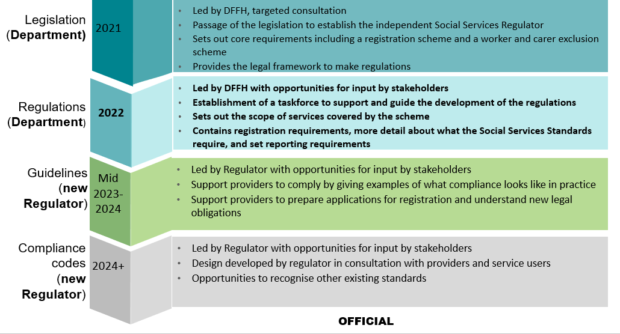

|  |
| --- |
| To receive this information in another format, please email the [Social Services Regulation Reform team](mailto:regulationreform@dffh.vic.gov.au) <regulationreform@dffh.vic.gov.au>.  Authorised and published by the Victorian Government, 1 Treasury Place, Melbourne.  © State of Victoria, Australia, Department of Families, Fairness and Housing, September 2022.  Available on the [Social Services Regulation Reform page](https://www.dffh.vic.gov.au/social-services-regulation-reform) on the Department of Families, Fairness and Housing site  <https://www.dffh.vic.gov.au/social-services-regulation-reform> |