

|  |
| --- |
| Aboriginal Children’s Forum  March 2025 |
| Communique |
| OFFICIAL |

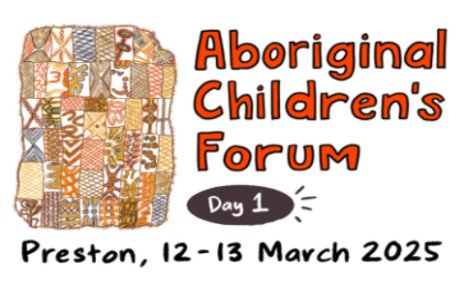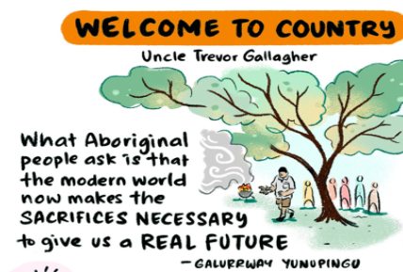

The 31st Aboriginal Children’s Forum (ACF) was held on the lands of the Wurundjeri Woi-wurrung people of the Kulin Nation and hosted by the Victorian Aboriginal Child & Community Agency (VACCA). Participants were warmly welcomed with a Smoking Ceremony conducted by Uncle Trevor Gallagher.

The theme of this ACF was transitioning resources and Aboriginal children to ACCOs. Though work has started toward transitioning resources and Aboriginal children, there is still a lot more to do.

This ACF included many honest and robust conversations about investment in Wungurilwil Gapgapduir. The importance of data became clear so that the ACF can understand what is realistically happening on the ground, and the associated resources.

Each division was allocated time to develop solid plans to bring about action to transition Aboriginal children and resources. This allowed ACF members to gain a clearer picture of how to drive through barriers to increase the Transition of Aboriginal Children (TAC) rate.

On Day Two, the ACF discussed principles and practical solutions for transferring investment to ACCOs.

A key takeaway of this ACF was the importance of empowering local ACCO decision-making for their community.

There is goodwill and commitment to continue beyond the *Beyond Good Intentions* statement. Projects are starting to be rolled out across the state in partnership between ACCOs and CSOs.

We need to keep pushing and providing feedback at the divisional and regional levels about the focus and work of the ACF so that our discussions flow down to all members of our organisations.

|  |
| --- |
| To receive this document in another format, email Aboriginal Children’s Forum [Aboriginal.Childrens.Forum@dffh.vic.gov.au](mailto:Aboriginal.Childrens.Forum@dffh.vic.gov.au)  Authorised and published by the Victorian Government, 1 Treasury Place, Melbourne.  © State of Victoria, Australia, Department of Families, Fairness and Housing, March 2025  Except where otherwise indicated, the images in this document show models and illustrative settings only, and do not necessarily depict actual services, facilities or recipients of services. This document may contain images of deceased Aboriginal and Torres Strait Islander peoples.  In this document, ‘Aboriginal’ refers to both Aboriginal and Torres Strait Islander people. ‘Indigenous’ or ‘Koori/Koorie’ is retained when part of the title of a report, program or quotation.  **ISSN** 2982-3064 **- Online (word)**  Available at [DFFH Aboriginal Children’s Forum](https://www.dffh.vic.gov.au/aboriginal-childrens-forum) https://www.dffh.vic.gov.au/aboriginal-childrens-forum |