
Aboriginal Children’s Forum

Communique March 2022

Communique and Actions
Purpose
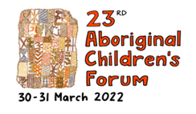
The 23rd Aboriginal Children’s Forum (ACF) was held in-person on Wednesday 30 March and Thursday 31 March 2022, hosted by the Victorian Aboriginal Child Care Agency (VACCA) Morwell Office and the Department of Families, Fairness and Housing. The Minister for Child Protection and Family Services, the Hon. Anthony Carbines gave a welcome speech on day two. This document contains key findings and topics of discussion from the event.

Wungurilwil Gapgapduir: Objective Two
The theme of the forum was how resource and support Aboriginal organisations to care for Aboriginal children, families, and communities
Aboriginal leadership in Victoria is strong and focused on responding to the current and future needs and aspirations of Aboriginal communities. Aboriginal organisations provide a vehicle for strong community leadership, supported through community governance models, programs and services that are culturally appropriate, culturally safe, innovative and inspirational.
Victorian Aboriginal communities have strong leaders and inclusive Aboriginal organisations that provide a range of vital services to support Aboriginal Victorians’ health and wellbeing. Victorian Aboriginal community controlled organisations (ACCOs) continue to express an aspirational vision for their communities. It is their organisational and individual leadership that provides the basis for future and visionary approaches to prevention and long-term achievement for Aboriginal communities across the state.
Aboriginal-led innovation is evident in the way that services have been developed by ACCOs – providing wrap-around services, a culturally safe and effective model of ‘hubs’ that deliver essential services, responsive to the needs of the local Aboriginal community.

The Wungurilwil Gapgadpuir Agreement and the Roadmap for Reform will guide us to achieving genuine reform and ultimately, closing the gap. As we move from a more reactive system to one focused on earlier intervention and prevention, It is encouraged to focus on programs that are now being trialled and rolled out that target more early help to Aboriginal Victorians.
Hon. Anthony Carbines MP, Minister for Child Protection and Family Services

ACCO Aspirations
The Victorian Government is committed to advancing self-determination for Aboriginal Victorians recognising this is critical in improving life outcomes for Aboriginal people. The Department of Families, Fairness and Housing is committed to the transition of children and young people involved with child protection and in the care system to registered ACCOs.
This commitment recognises significant and long standing over representation of Aboriginal children in the child protection system; the criticality of maintaining children’s connections to culture; the negative impacts of care that is not culturally attuned and the need to promote and foster Aboriginal ways of working with Aboriginal children and families that is inherently and structurally difficult for child protection programs and non-Aboriginal services to achieve.
Recognising the Government’s commitment and the significant benefits derived from Aboriginal children and their families being supported by ACCOs, a project has been established to reinvigorate efforts to transition Aboriginal children from child protection and CSOs to ACCOs.

"We would not have our children home with us now if it wasn’t for Section 18."
A quote from a family member serviced by the Aboriginal Children in Aboriginal Care program.

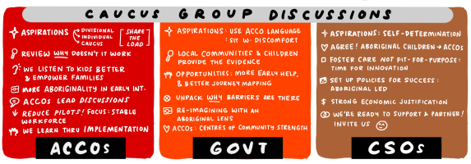
Background
The Aboriginal Children’s Forum gives practical effect to the implementation and monitoring of Wungurilwil Gapgapduir: Aboriginal Children and Families Agreement <https://www.dhhs.vic.gov.au/publications/wungurilwil-gapgapduir-aboriginal-children-and-families-agreement> to promote the safety, health and resilience of Aboriginal children and young people, so they thrive and live in culturally rich and strong Aboriginal families and communities.
Wungurilwil Gapgapduir supports the government’s commitment to increase Aboriginal self-determination for Aboriginal people and is the foundation on how this government and the children and families sector will address the over-representation of Aboriginal children involved within the child protection system.

To receive this document in another format, email Aboriginal Children’s Forum <Aboriginal.Childrens.Forum@dffh.vic.gov.au>
Authorised and published by the Victorian Government, 1 Treasury Place, Melbourne.
© State of Victoria, Australia, Department of Families, Fairness and Housing, March 2022
Except where otherwise indicated, the images in this document show models and illustrative settings only, and do not necessarily depict actual services, facilities or recipients of services.
In this document, ‘Aboriginal’ refers to both Aboriginal and Torres Strait Islander people. ‘Indigenous’ or ‘Koori/Koorie’ is retained when part of the title of a report, program or quotation.
Available at Department of Families, Fairness and Housing <www.dffh.vic.gov.au>
`

