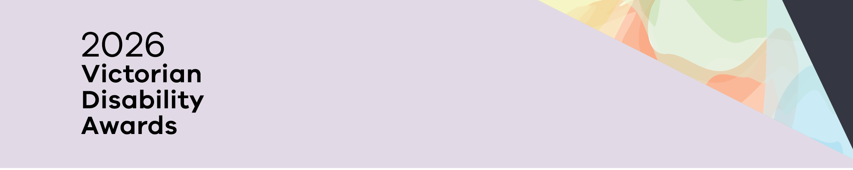

2026 Victorian Disability Awards
Winners and finalists
OFFICIAL
Contents
Advocacy for People 2
Disability Pride Champion 2
Leadership in co-design 2
Lifetime Achievement Award 2

Advocacy for People

Winner – Advocacy for People
ACD - Advocating for Children with Disability
ACD helps families build knowledge, skills, and confidence to advocate for their children through free information, workshops, and individual advocacy.

Finalists – Advocacy for People
Lani Dinh
Traveller’s Aid Australia

Disability Pride Champion

Winner – Disability Pride Champion
William Ward-Boas, VALID
William uses his lived experience to challenge stereotypes, promote disability pride and create opportunities for people with disability to have their voices heard.

Finalist – Disability Pride Champion
Cooper Smith, DJ, and producer

Leadership in co-design

Winner – leadership in co-design
Best Care for People with Communication Disability in Health Emergencies, cross-sector partnership between Scope Australia, Ambulance Victoria, Monash Health, and Latrobe Regional Health
The Best Care for People program equips emergency and healthcare staff with tools, training, and resources to support patients who have a communication disability leading to better health outcomes.

Finalists – Leadership in co-design
Metro Trains Community Education Program, Metro Trains Melbourne
Fleur O’Hare, Centre for Eye Research Australia

Lifetime Achievement Award

Winner – Lifetime Achievement Award
Amanda Robinson, NGO Training Centre
Amanda has championed the rights, inclusion, and self-determination of people with disability through advocacy, education, and leadership. Her commitment to empowering people with disability and carers to self-advocate has had a lasting impact.

Finalist – Lifetime Achievement Award
Nimo Hersi, Inclusion and Diversity Training

To receive this document in another format, phone 1300 880 043 or email awards@dffh.vic.gov.au.
If you are d/Deaf, hard of hearing, or have a speech or communication difficulty, please contact us through your preferred National Relay Service (NRS) call channel – see Access Hub's NRS call numbers and links web page:
https://www.accesshub.gov.au/about-the-nrs/nrs-call-numbers-and-links.
Then give the NRS our phone number: 1300 880 043.
For more information, visit Access Hub's About the National Relay Service (NRS) web page:
https://www.accesshub.gov.au/about-the-nrs.
Authorised and published by the Victorian Government, 1 Treasury Place, Melbourne.
© State of Victoria, Australia, Department of Families, Fairness and Housing, October 2026
ISBN 978-1-76171-224-1 (pdf/online/MS word)
Available at https://www.dffh.vic.gov.au/victorian-disability-awards.

