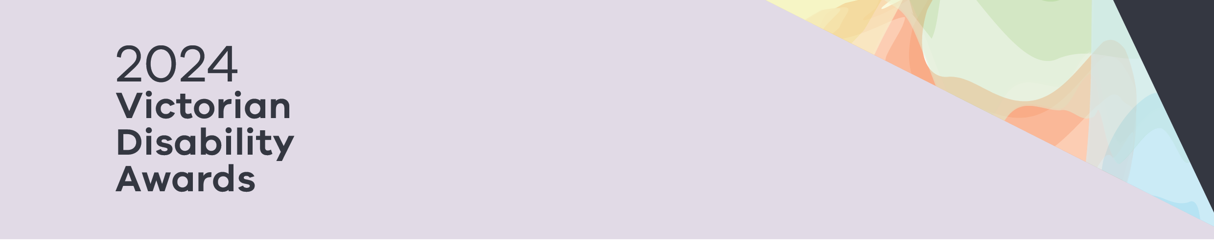

Tips for writing your nomination

2024 Victorian Disability Awards

# Write clearly

The judges will read many nominations. You can help them by writing clearly on your nomination form.

# Stand out from the crowd

A good nomination gets the judges’ attention.

A great way to stand out is to focus on the good things the nominee has done or how they do things differently.

# Include all important information

It’s important that you include all the important information in your nomination. The judges have to base their decision on what is written. If you think a piece of information is important for the judges to know, remember to include it.

# Make sure you answer the question

Every year, some nominations don’t answer the questions. This means the judges can’t progress these nominees as finalists or award recipients.

Make sure you read the questions carefully and take time to think about your response.

Try to use the full word count given. Use the ‘upload’ feature to provide supporting information and don’t forget to provide both referee letters.

# Get someone to read your nomination

While judges won’t worry about incorrect spelling or grammar, getting someone to proofread your nomination makes sure it is easy to understand, flows well and answers the questions.

# Go through the checklist

Please use the checklist to make sure you have included everything.

# Feel free to ask for help

The Awards Team is always happy to help if you get stuck. We can’t write your nomination for you, but we can share some advice about what makes a good nomination.

**For more information:**

Email: [awards@dffh.vic.gov.au](mailto:awards@dffh.vic.gov.au)  
Phone: 03 9285 3873

To receive this information in another format, phone (03) 9285 3873, or email [awards@dffh.vic.gov.au](mailto:awards@dffh.vic.gov.au)

**Help for people with hearing or speech communication difficulties**

Contact us through the National Relay Service (NRS). For more information on the NRS visit National Relay Service https://www.accesshub.gov.au/about-the-nrs or call the NRS Helpdesk on 1800 555 660.

Authorised and published by the Victorian Government, 1 Treasury Place, Melbourne.  
© State of Victoria, Australia, Department of Families, Fairness and Housing, June 2024.  
ISBN 978-1-76130-580-1 (pdf/online/MS word)

Available at [Victorian Disability Awards](https://www.dffh.vic.gov.au/victorian-disability-awards) https://www.dffh.vic.gov.au/victorian-disability-awards