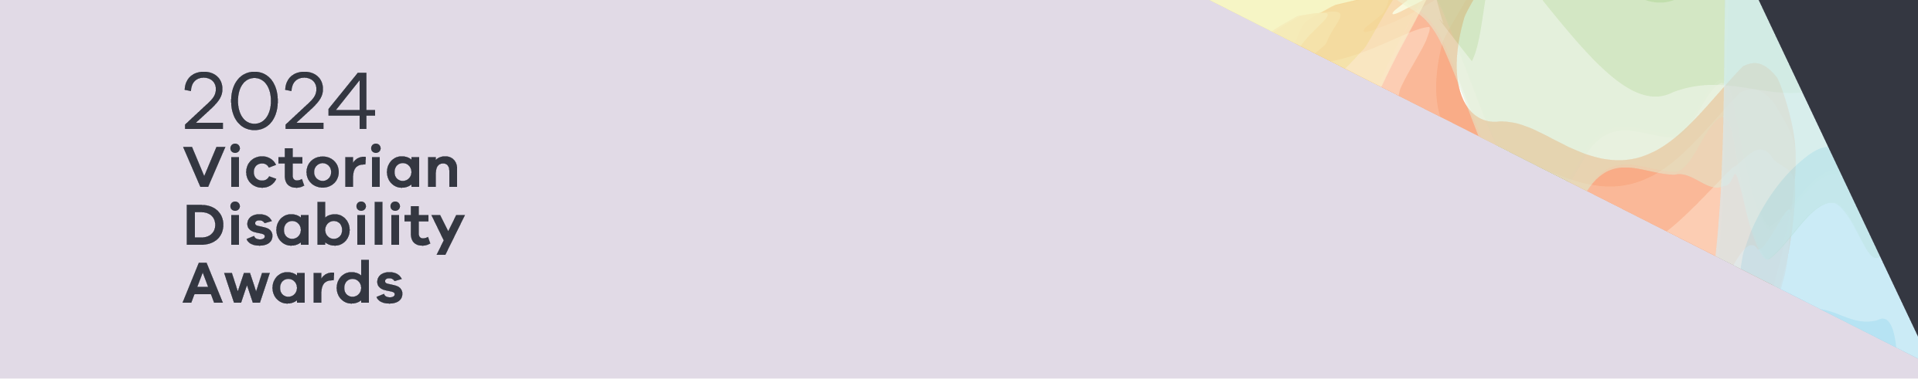

|  |
| --- |
| 2024 Victorian Disability Awards |
| Finalists |
|  |

Contents

Finalists – Advocacy for People 2

Finalists – Disability Pride Champion 2

Finalists – Leadership in Co-design 2

Finalists – Lifetime Achievement Award 2

# Finalists – Advocacy for People

Uli Cartwright, Life is a Battlefield

Dr Jane Hickey, Victoria University

Terry Symonds and Matt Warren, Yooralla

# Finalists – Disability Pride Champion

Cameron Bloomfield, Rainbow Rights and Advocacy

Melanie Lewis

Emily Unity, Children and Young People with Disability Australia

# Finalists – Leadership in Co-design

Co-design for better access to mental health services, Monash Health

Peer Relationship Education Partners Program - Gippsland, Gippsland Centre Against Sexual Assault

Together, Youth Disability Advocacy Service (YDAS)

# Finalists – Lifetime Achievement Award

Marita Baker, Guide Dogs Victoria

Phil Burgoine, Western Autistic School

Heather Forsyth, Victorian Advocacy League for Individuals with Disability (VALID)

|  |
| --- |
| To receive this document in another format, phone (03) 9285 3873, using the National Relay Service 13 36 77 if required, or email the Victorian Disability Awards on <awards@dffh.vic.gov.au>.  Authorised and published by the Victorian Government, 1 Treasury Place, Melbourne.  © State of Victoria, Australia, Department of Families, Fairness and Housing, October 2024.  Available at <https://www.dffh.vic.gov.au/2024-victorian-disability-awards> |