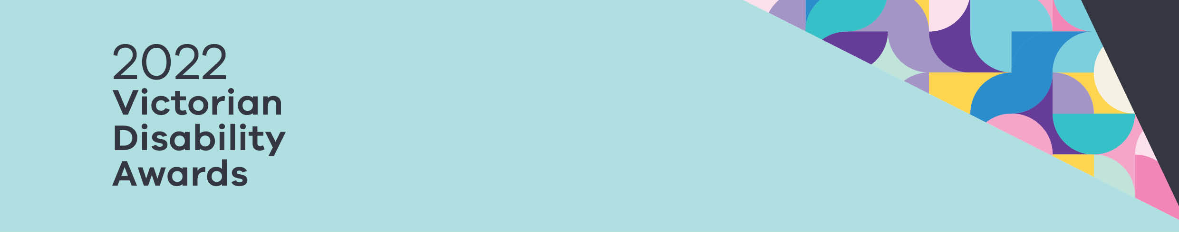

|  |
| --- |
| Frequently Asked Questions |
|  |
| OFFICIAL |

Contents

Eligibility 1

Completing an entry 2

# Eligibility

### My nominee previously won a Victorian Disability Award, can they enter again this year?

Nominees and nominated teams must not have a finalist, be highly commended or the winner of a Victorian Disability Award, in their individual capacity or as part of a team (where applicable) for work of the same nature within the last three (3) years. This means if they were nominated in 2019 or 2021 they cannot be nominated this year.

### Who can submit a nomination?

Anyone can submit a nomination.

### Who can be nominated?

Any Australian resident (temporary or permanent) who has demonstrated excellence in leadership, advocacy, support and education to promote the rights and inclusion of people with disability living in Victoria can be nominated for a Victorian Disability Award, provided they give you consent to do so.

# Completing an entry

### Can I delete or change my entry after it has been submitted?

Yes. Until the submission closing date, you can edit or delete your entry. However, after creating your submission, if you wish to change your award category please get in touch with the award secretariat.

### Can I enter some data and then come back and complete my submission later?

Yes. You can log out, and when you log back in you can go to my entries and click on your award entry and keep updating.

### Can I upload supporting documentation with my entry submission?

Yes. Up to 5 supporting documents can be included (with a maximum of two single-sided A4 pages per document) – in the form of graphs, charts, tables, or other illustrative material.

|  |
| --- |
| To receive this document in another format, phone 8850 6164, using the National Relay Service 13 36 77 if required, or email awards@dffh.vic.gov.au  Authorised and published by the Victorian Government, 1 Treasury Place, Melbourne.  © State of Victoria, Australia, Department of Families, Fairness and Housing, March 2022.  Except where otherwise indicated, the images in this document show models and illustrative settings only, and do not necessarily depict actual services, facilities or recipients of services. This document may contain images of deceased Aboriginal and Torres Strait Islander peoples.  In this document, ‘Aboriginal’ refers to both Aboriginal and Torres Strait Islander people. ‘Indigenous’ or ‘Koori/Koorie’ is retained when part of the title of a report, program or quotation. |